SchoolofComputerScienceandArtificial Intelligence

LabAssignment-15.5

Program :B.Tech(CSE) Specialization :AIML
Course Title :AIAssistedCoding Course Code : 23CS002PC304
Semester : VI AcademicSession:2025-2026
Name of Student :Lasya Priya Enrollment No. : 2303A52102
Batch No. : 34
Date :13/03/26

Task1–StudentAttendanceAPI
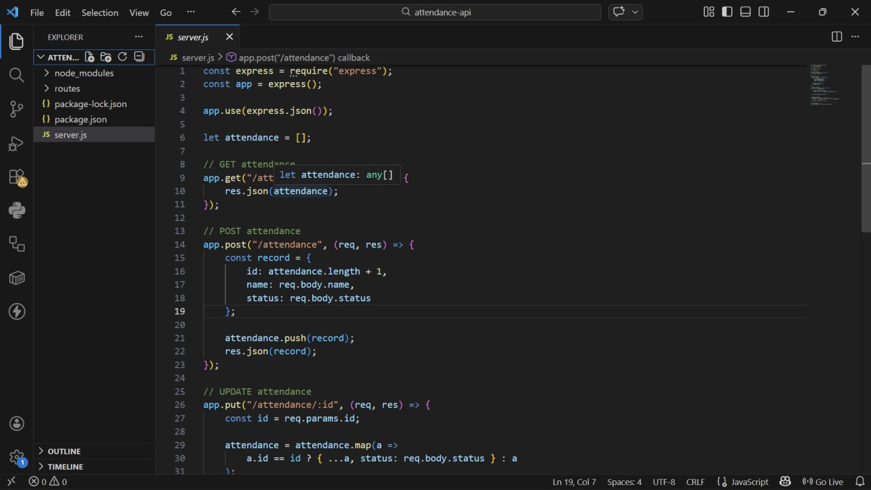
GET/attendance→Viewattendancerecords
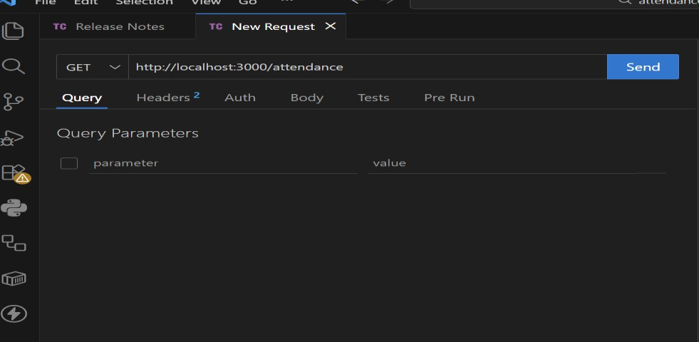

- POST/attendance→Mark attendance
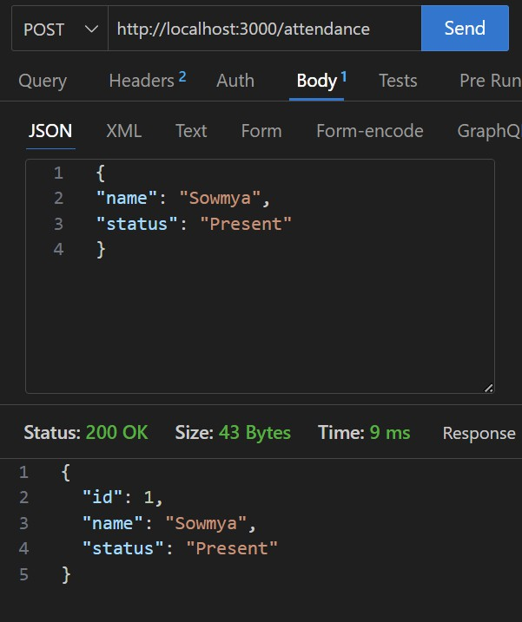
- PUT/attendance/{id}→Updateattendancerecord
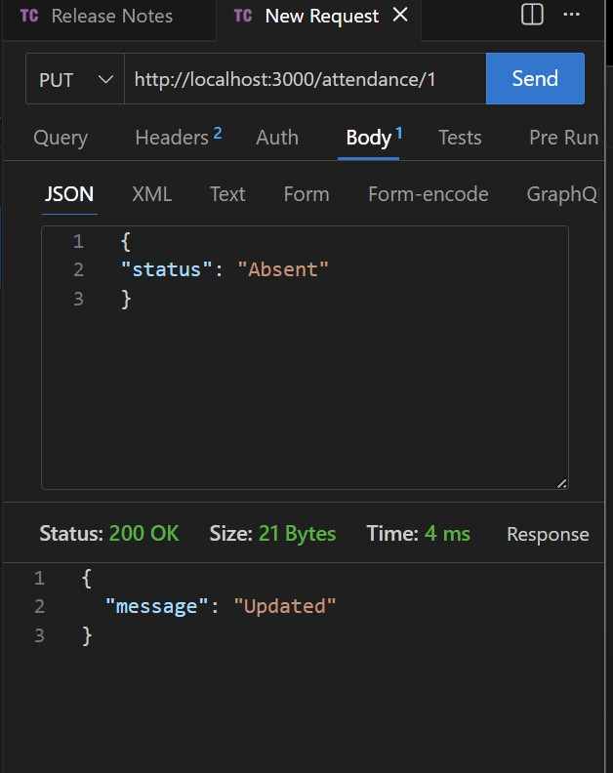

- DELETE/attendance/{id}→Removeattendanceentry
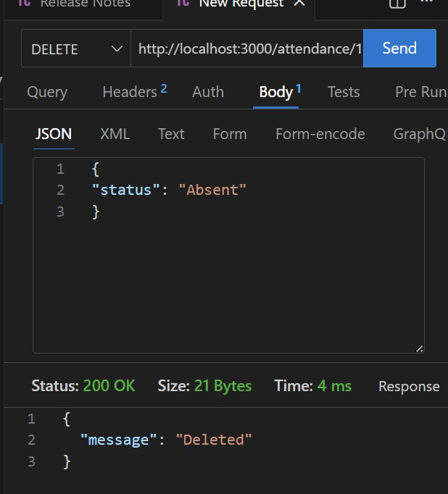

Task2–InventoryManagement API
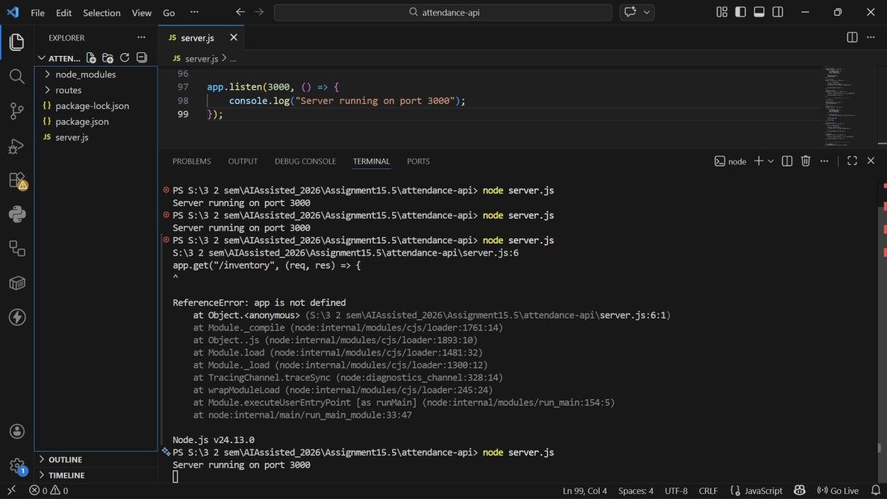
GET/inventory→Listallitems
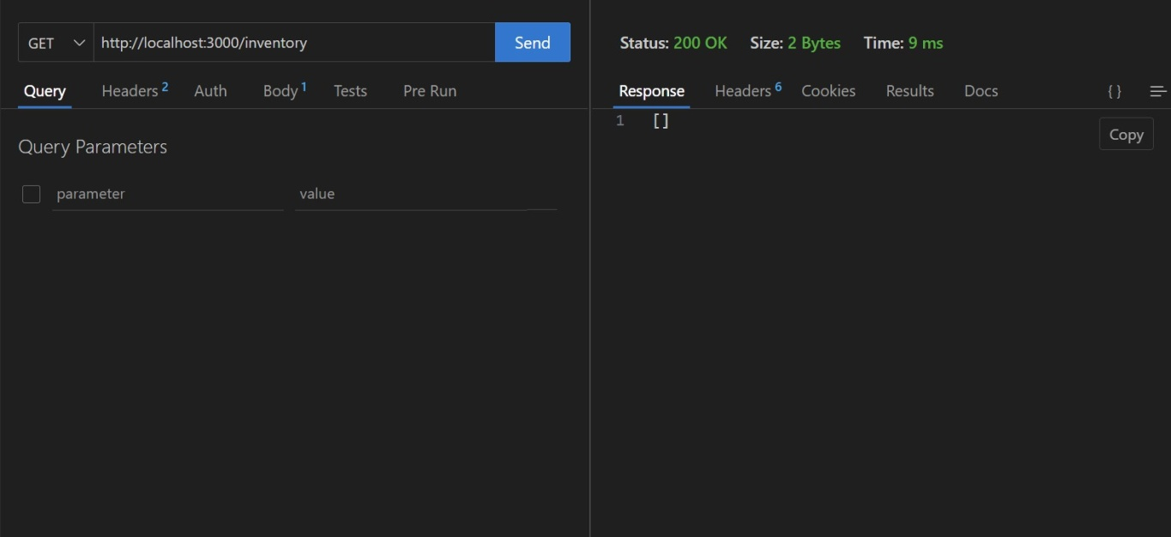
- POST/inventory→Addnewitem

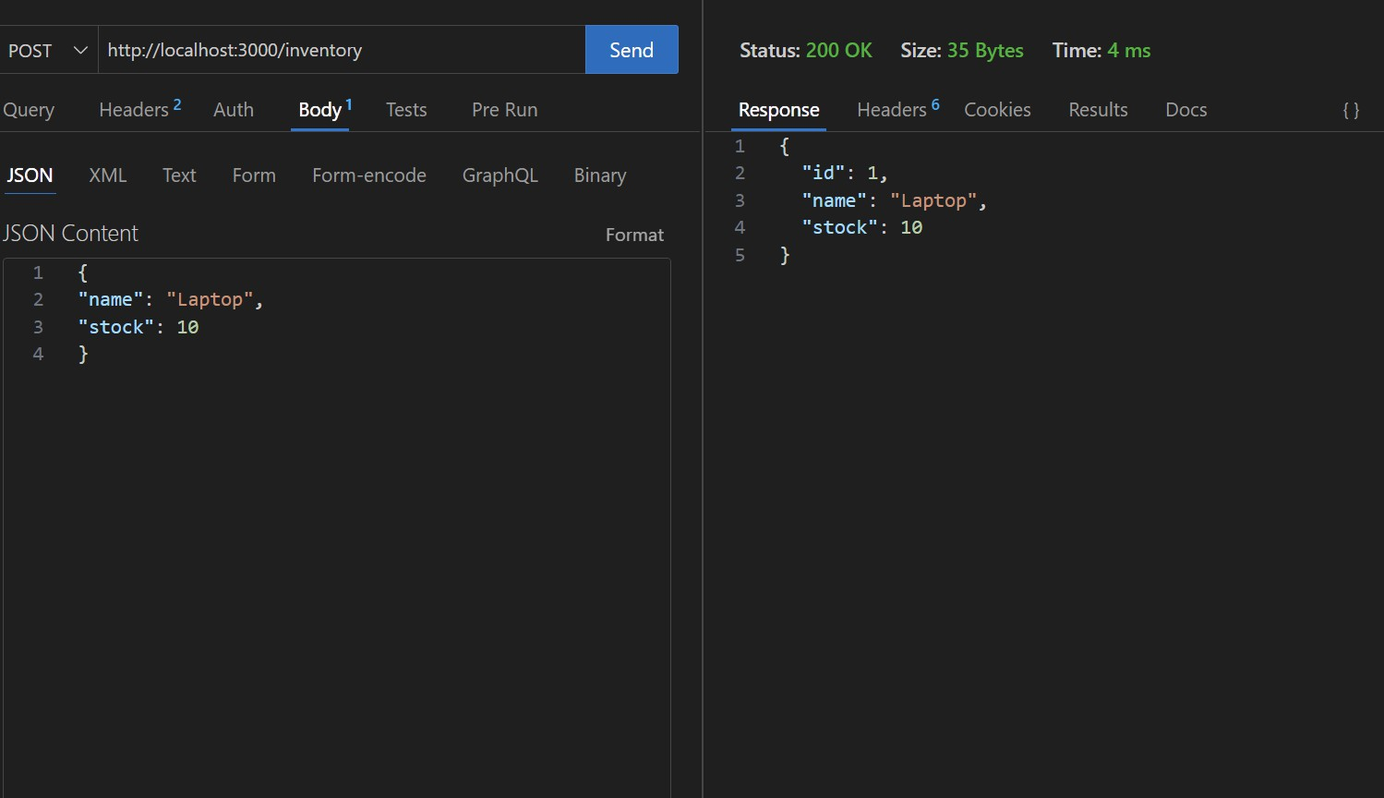
- PUT/inventory/{id}→Updatestockquantity

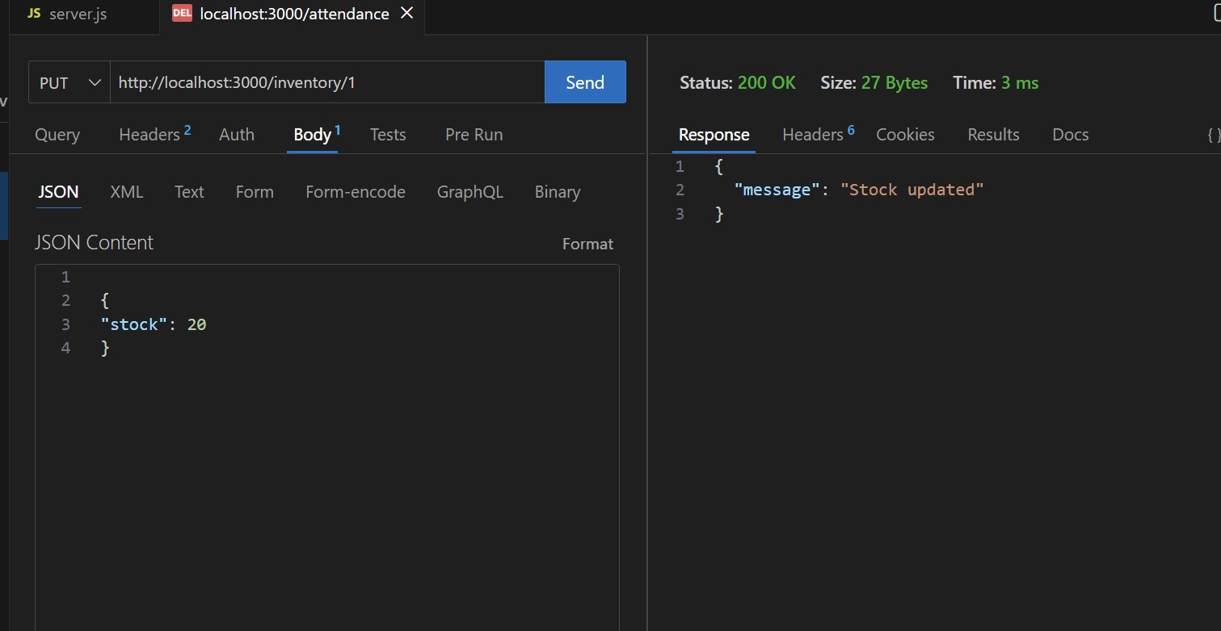
- DELETE/inventory/{id}→Removeanitem

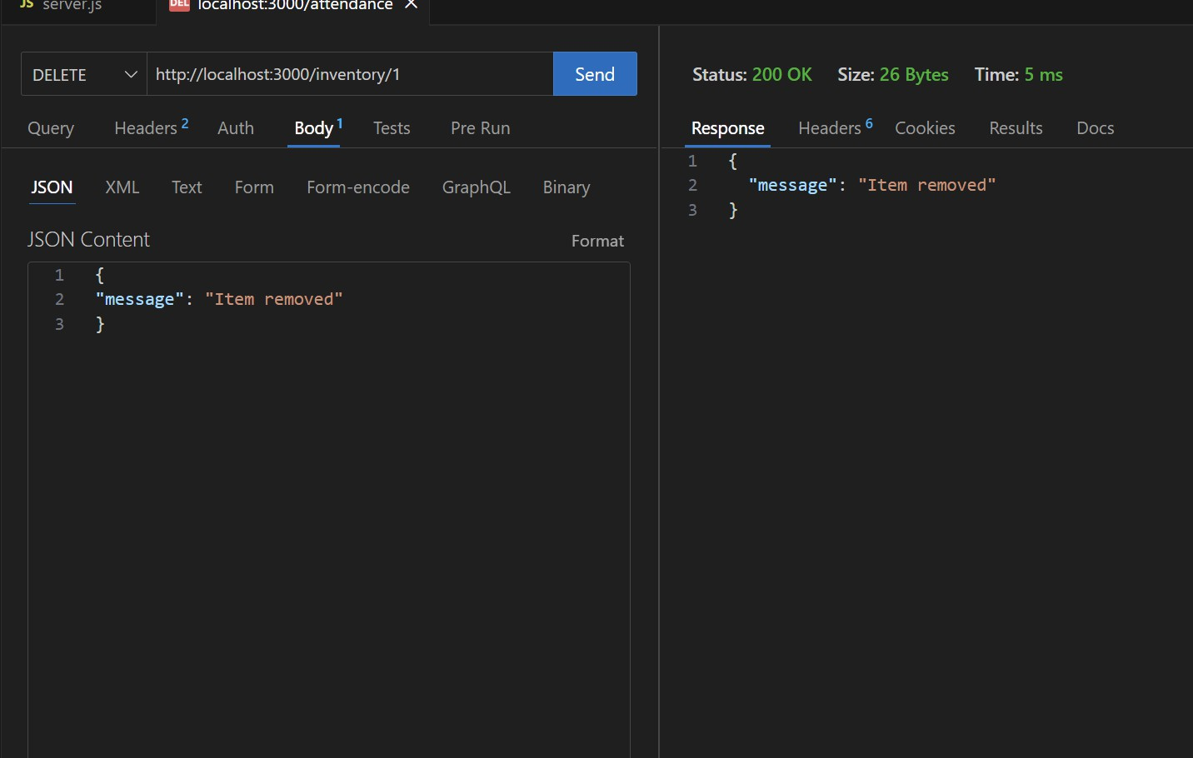

Task3–HotelRoomBookingAPI
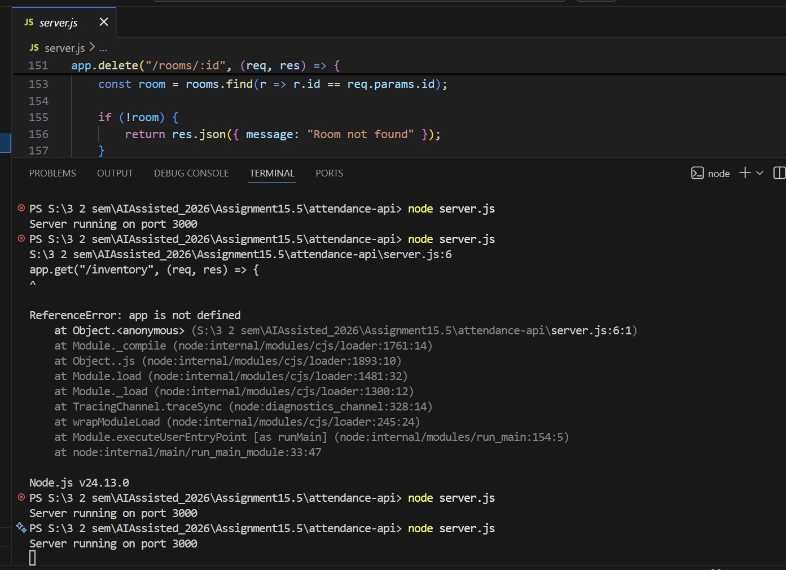

- GET/rooms→Viewavailablerooms

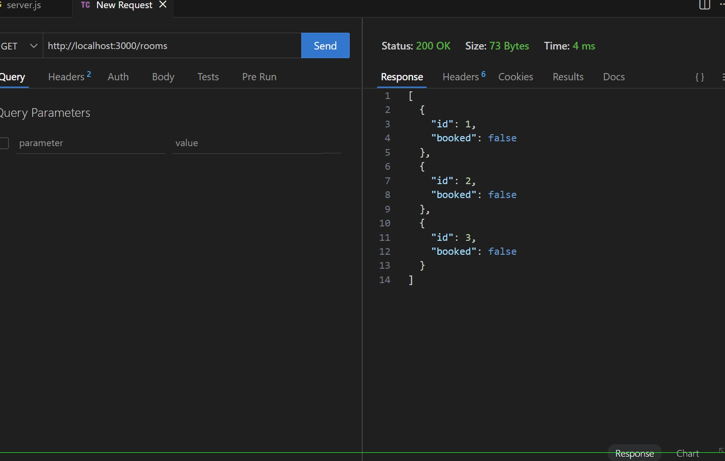
- POST/rooms/book→Booka room
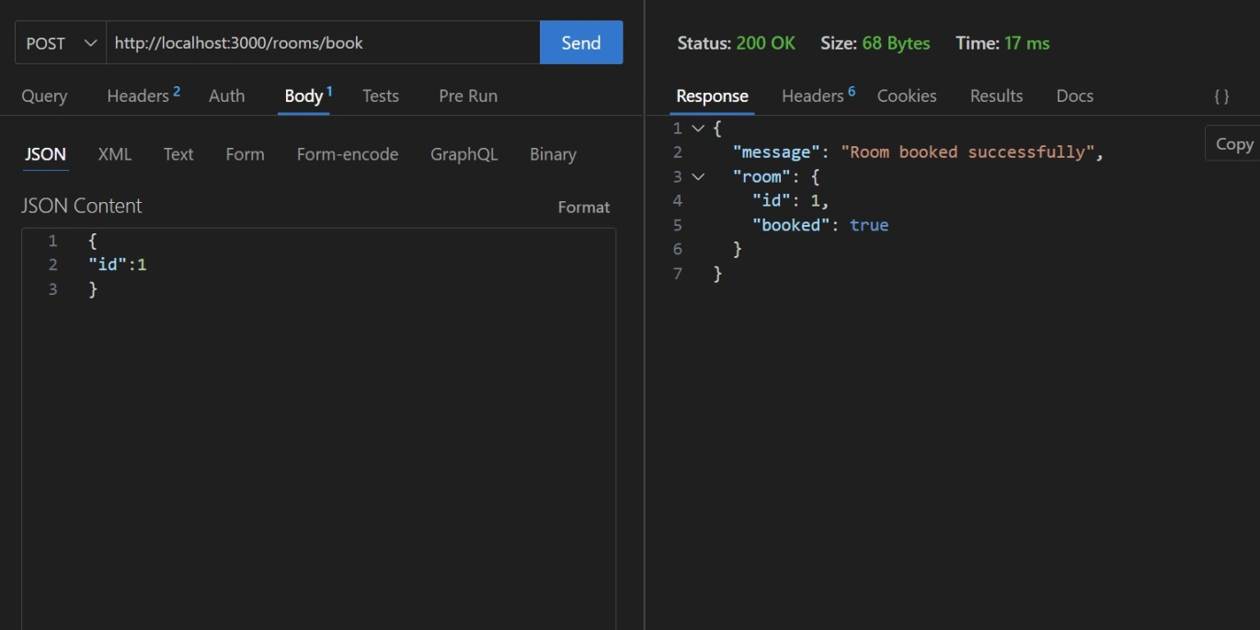

- GET/rooms/{id}→Viewbooking details
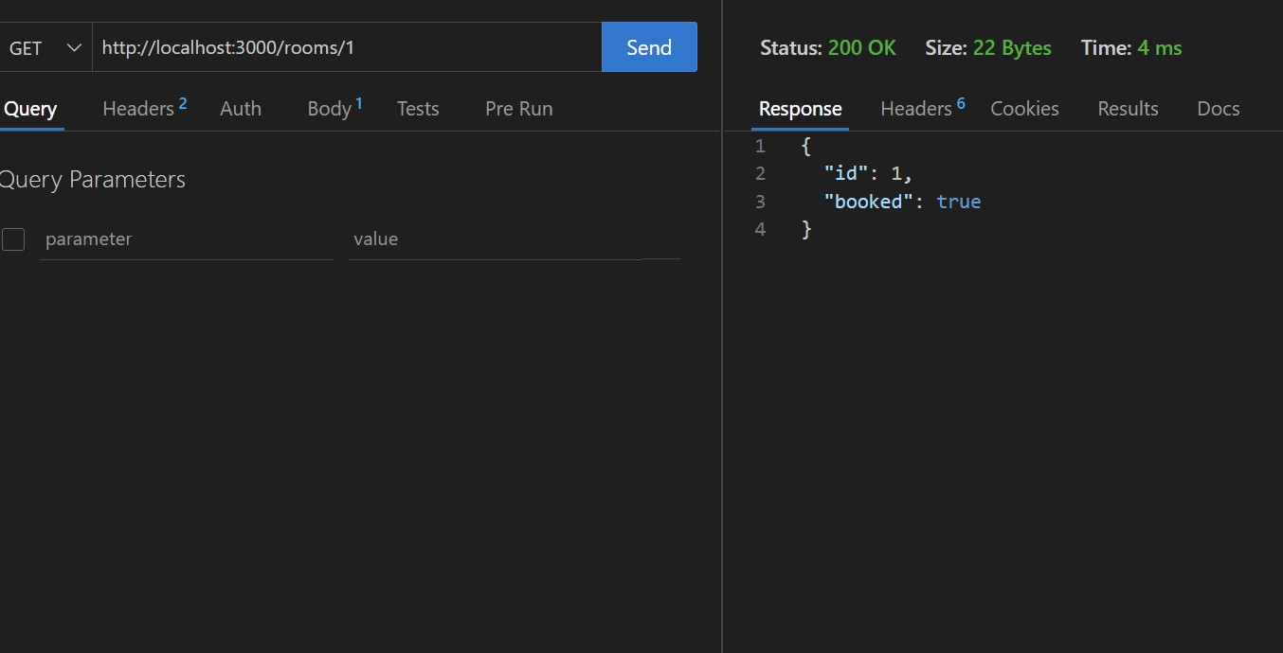
- DELETE/rooms/{id}→Cancelbooking
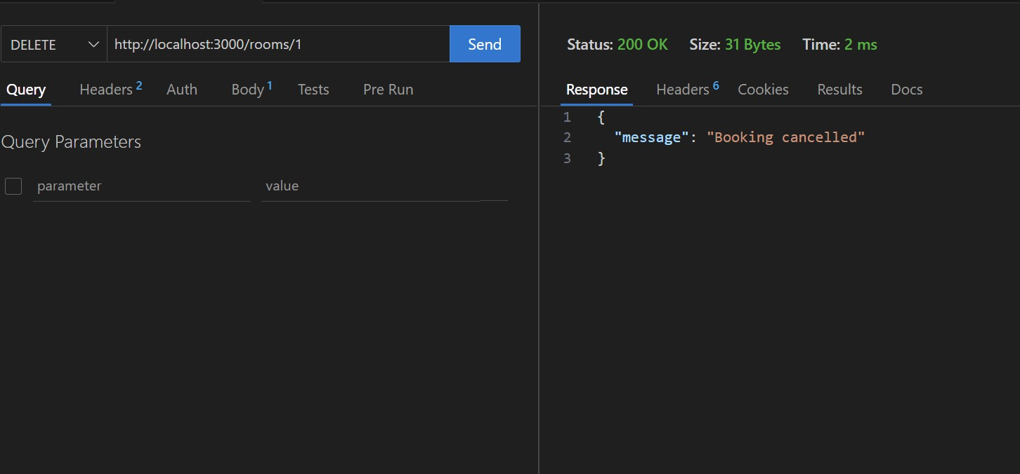
Task4–OnlineVotingAPI

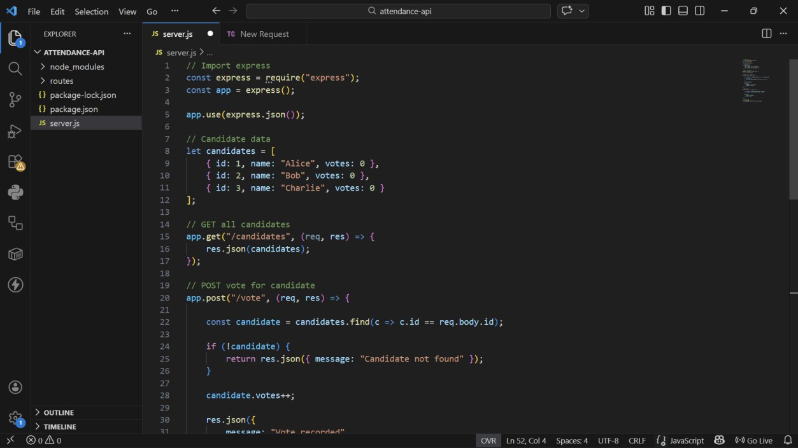
- GET/candidates→Listcandidates
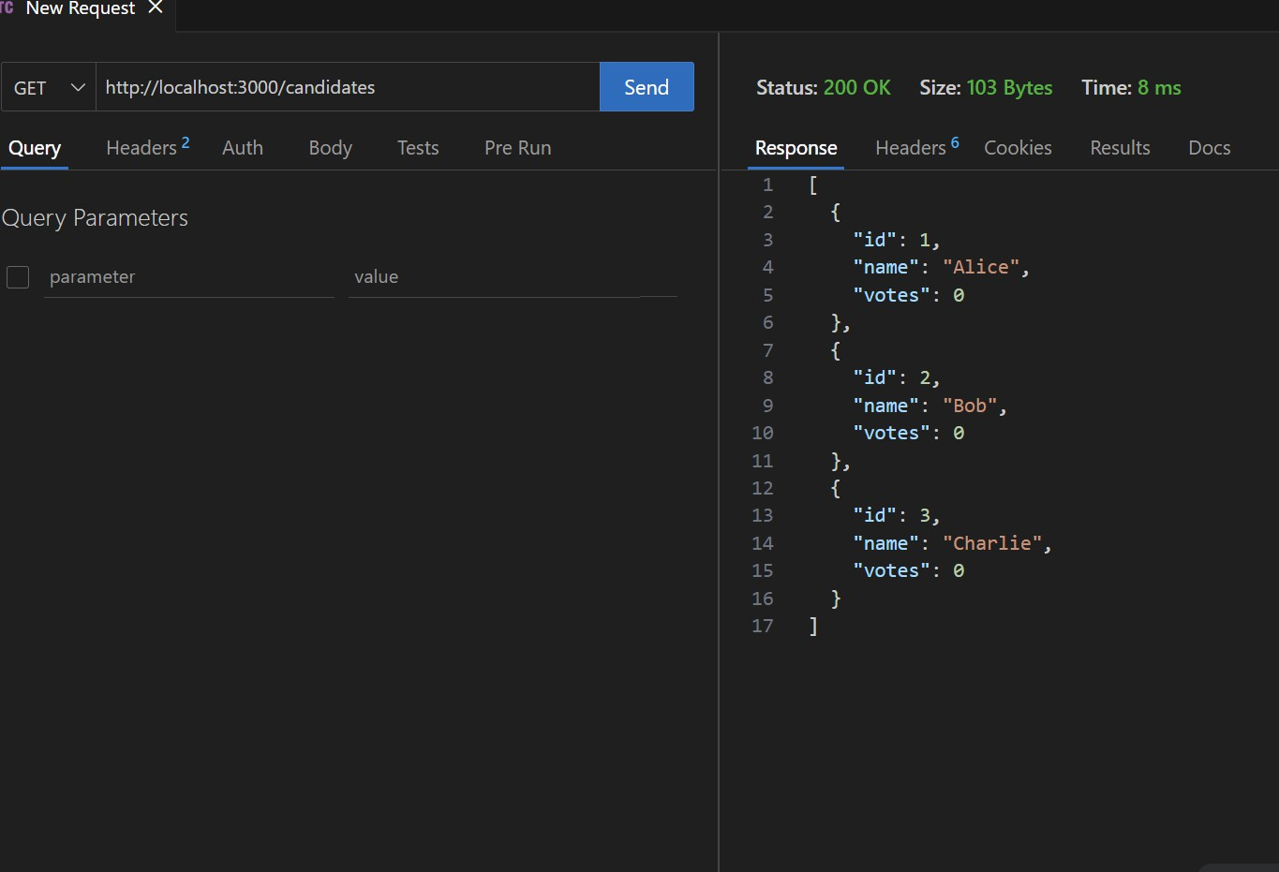
- POST/vote→Castavote

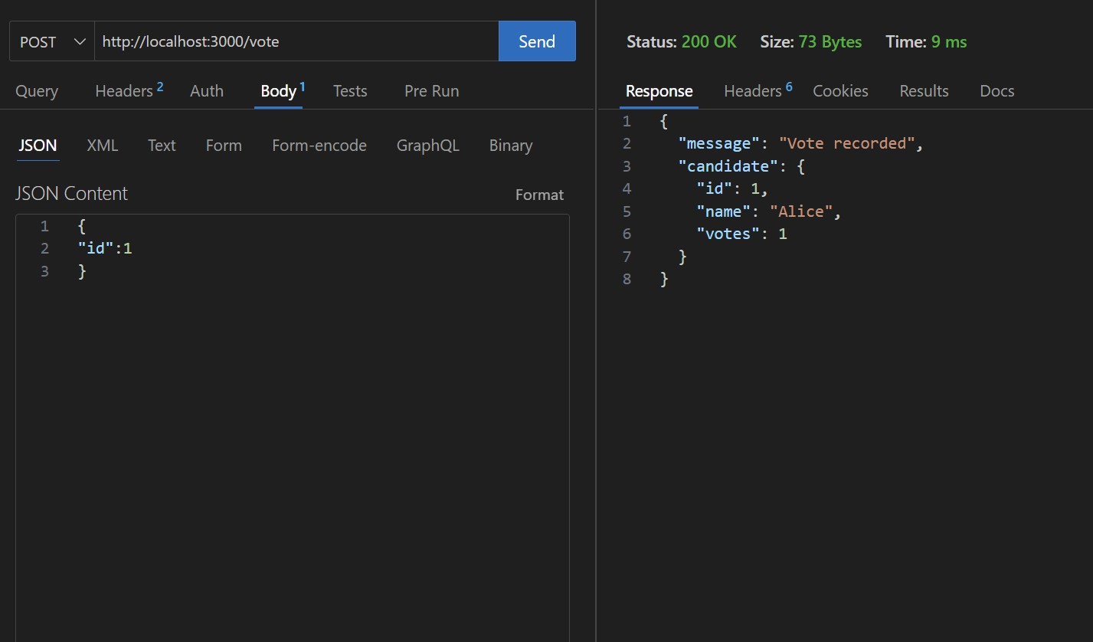
- GET/results→Viewvoting results
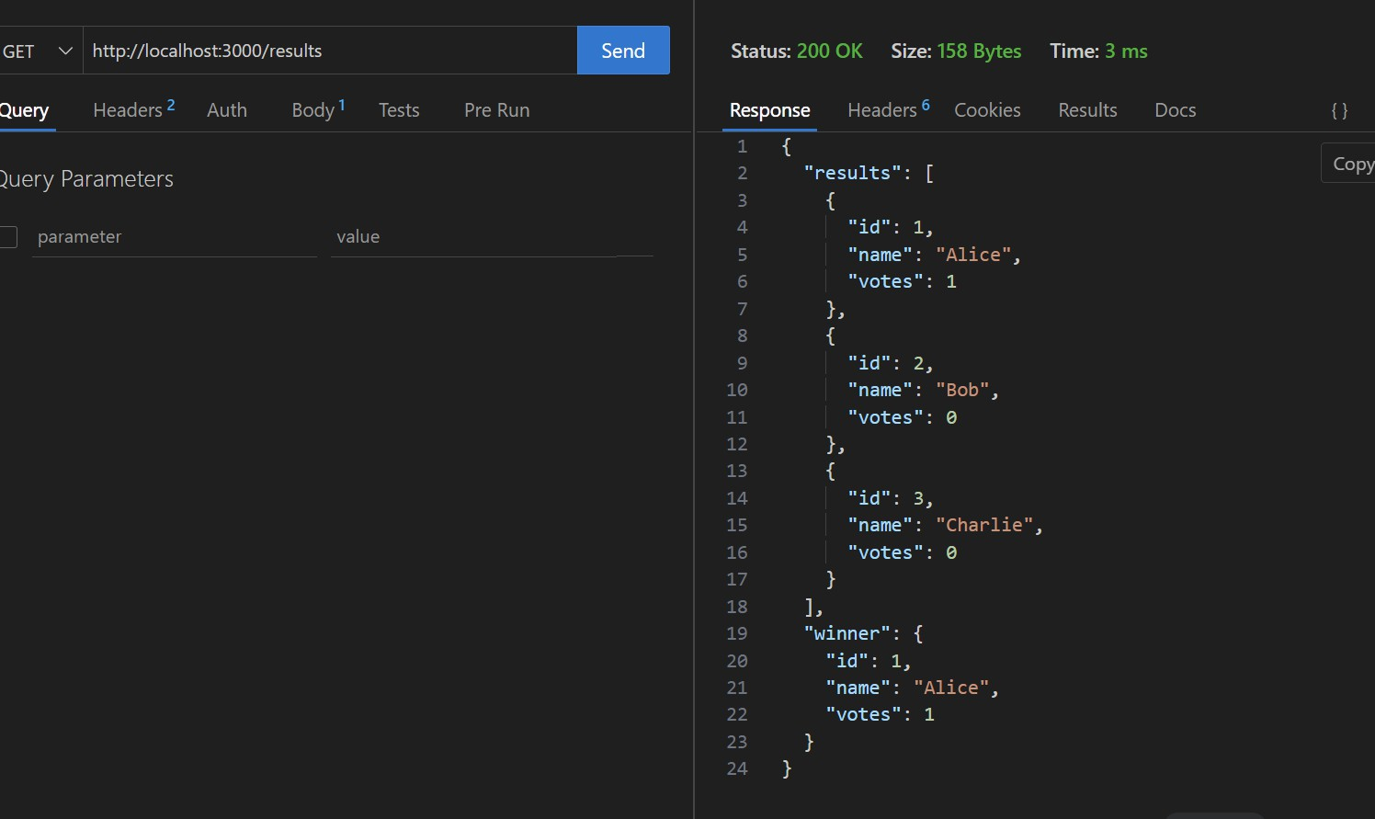

Task5–TeacherManagementAPI

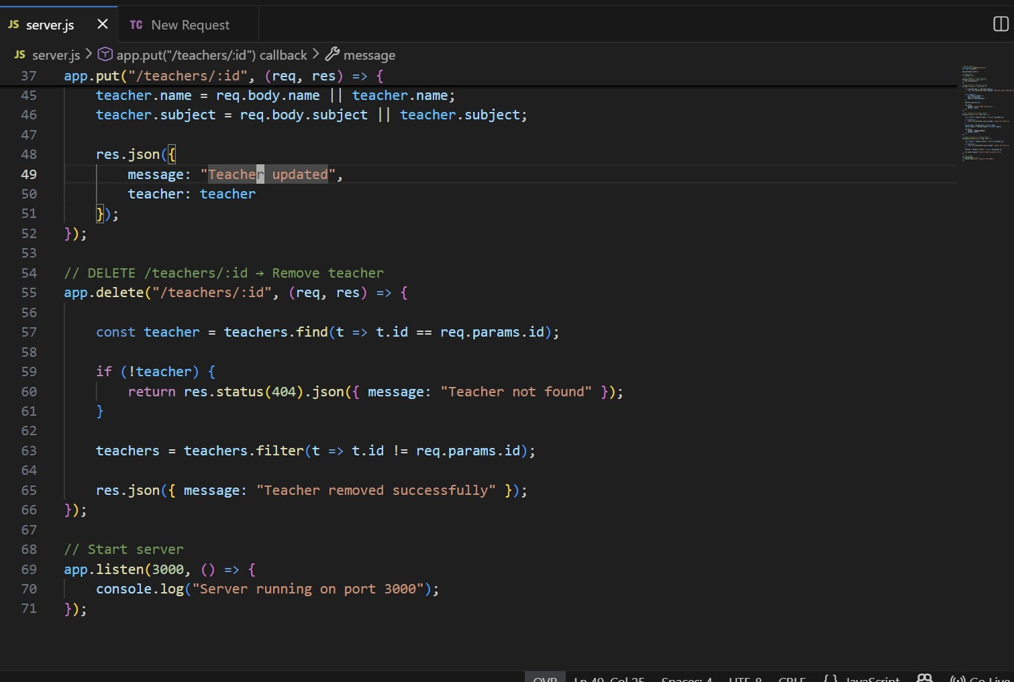
- GET/teachers→Listallteachers
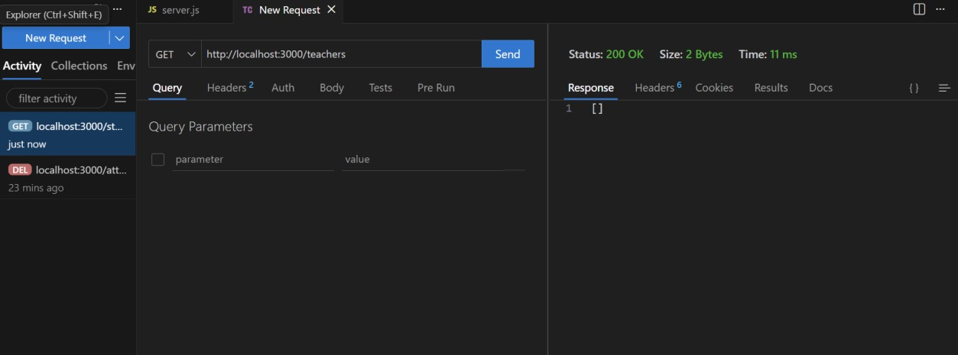
- POST/teachers→Addanewteacher

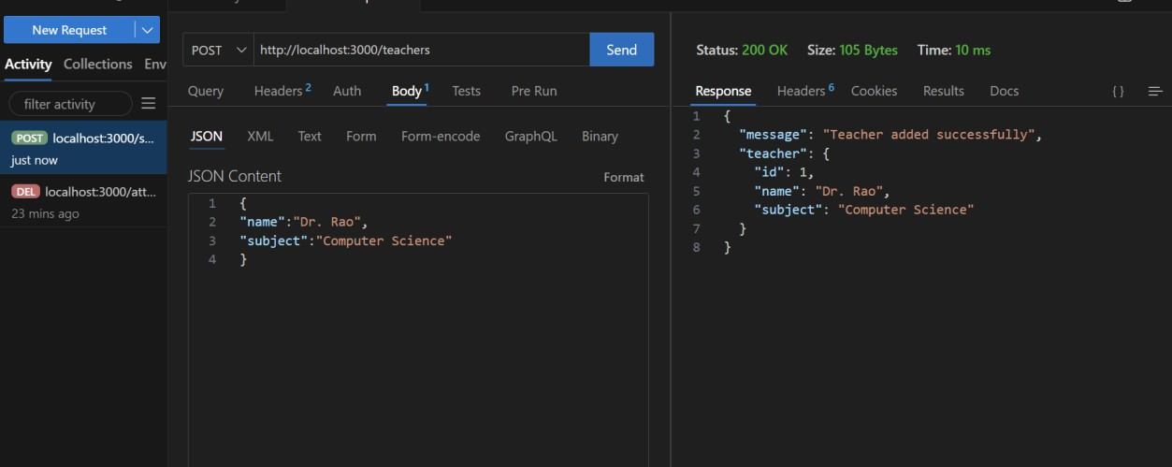
- PUT/teachers/{id}→Updateteacherdetails
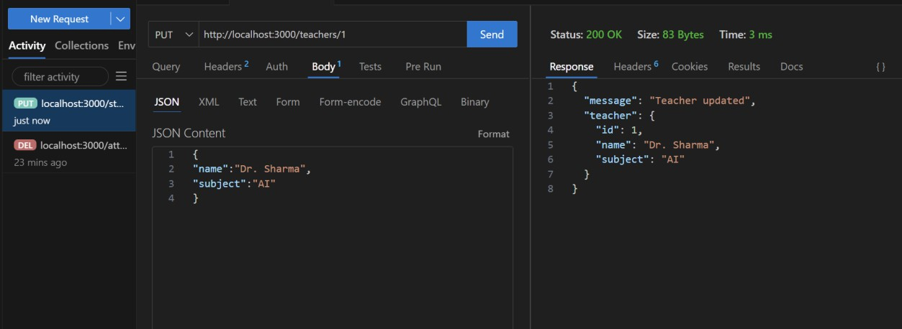
- DELETE/teachers/{id}→Removeateacher
