SchoolofComputerScienceandArtificial Intelligence

LabAssignment#20.2

Program :B.Tech(CSE) Specialization :AIML
Course Title :AIAssistedCoding Course Code : 23CS002PC304
Semester : VI AcademicSession:2025-2026
Name of Student :lasya priya
Enrollment No. : 2303A52102
Batch No. : 34
Date :11/04/26

Task1–PasswordSecurityEnhancementPrompt:
Code:
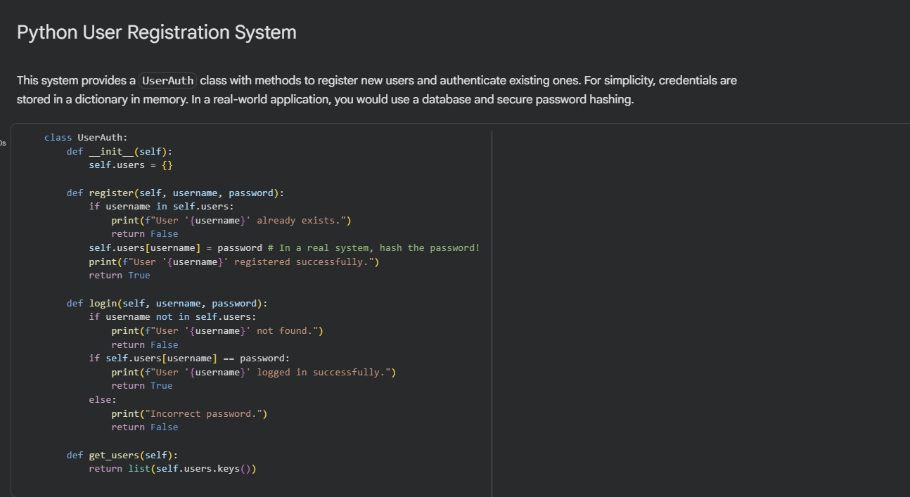

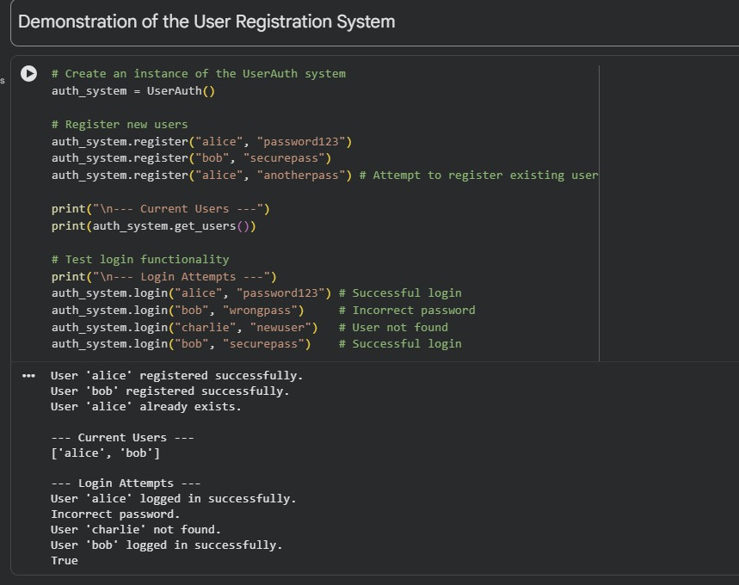
Task2–SecureAPIKeyManagementPrompt:
Code:
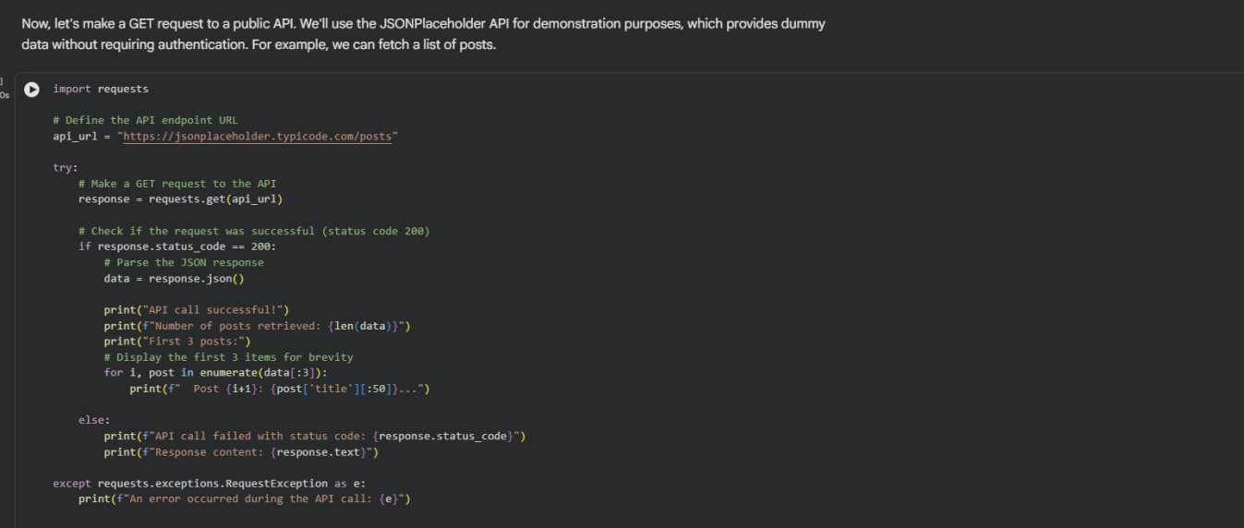

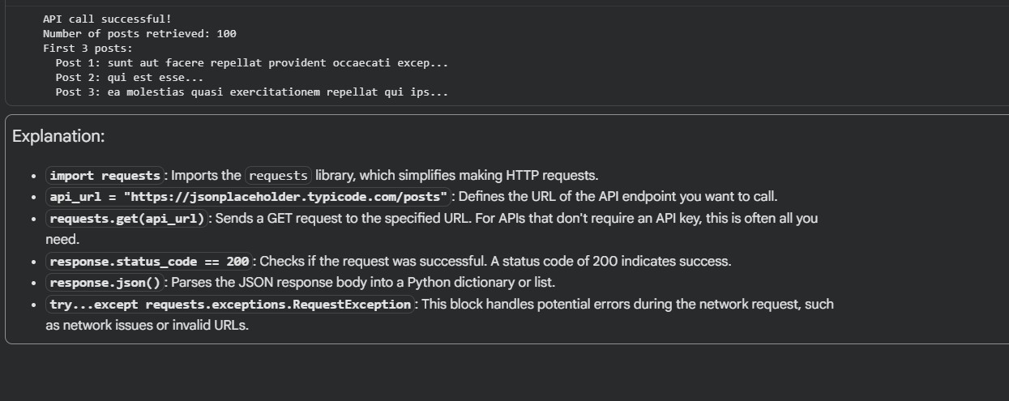
Task3–WeakEncryptionDetectionPrompt:
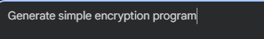
Code:

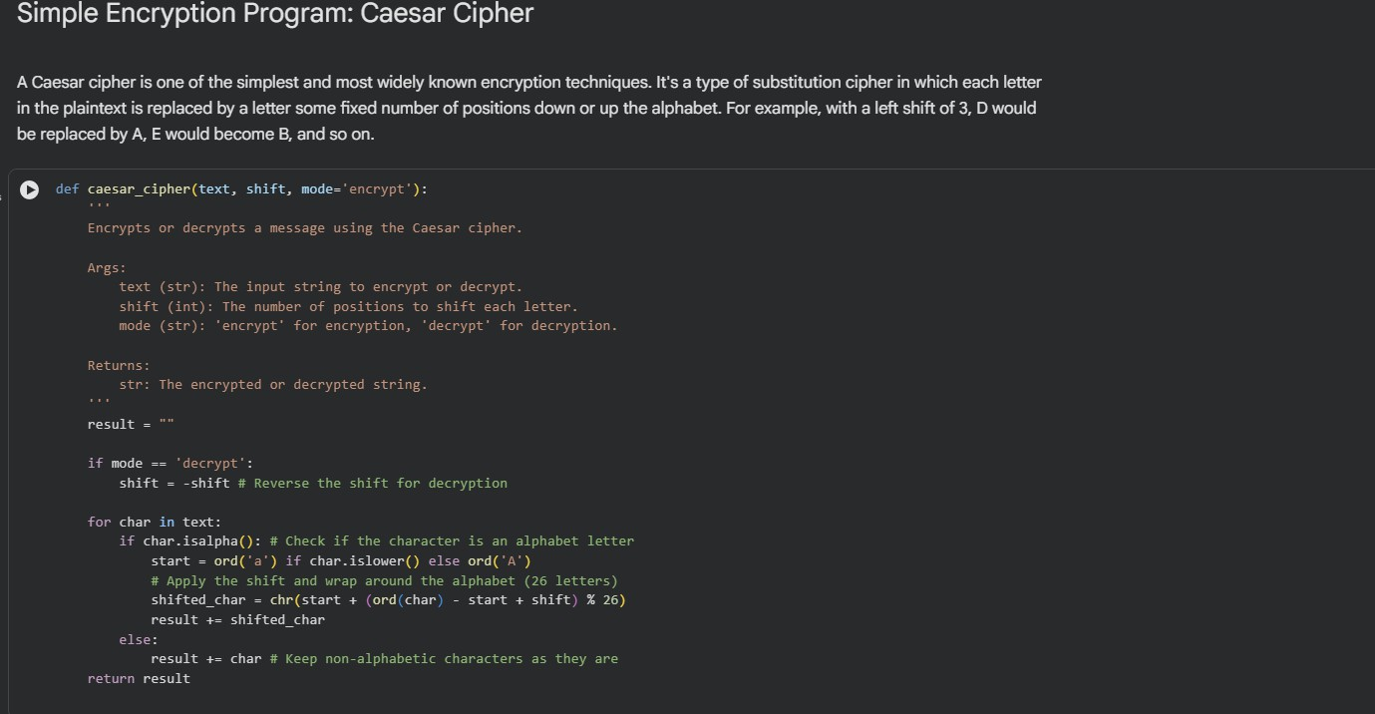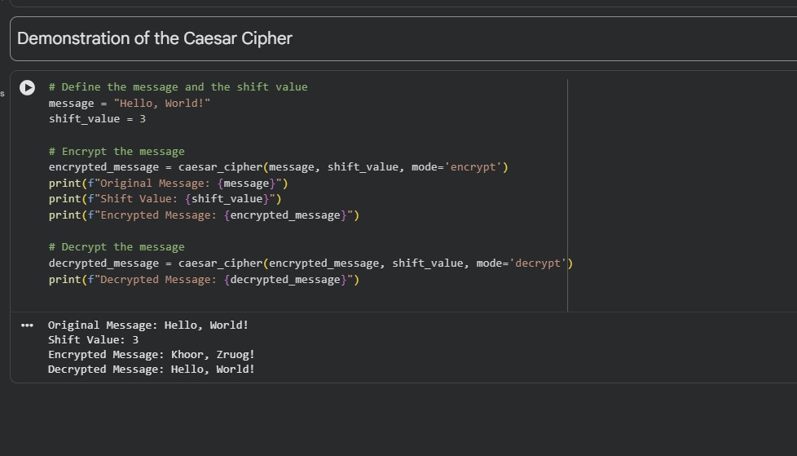
Task4–SecurityReviewof WebServicePrompt:
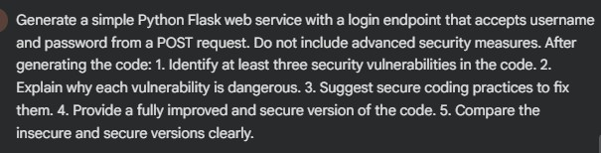

Code:
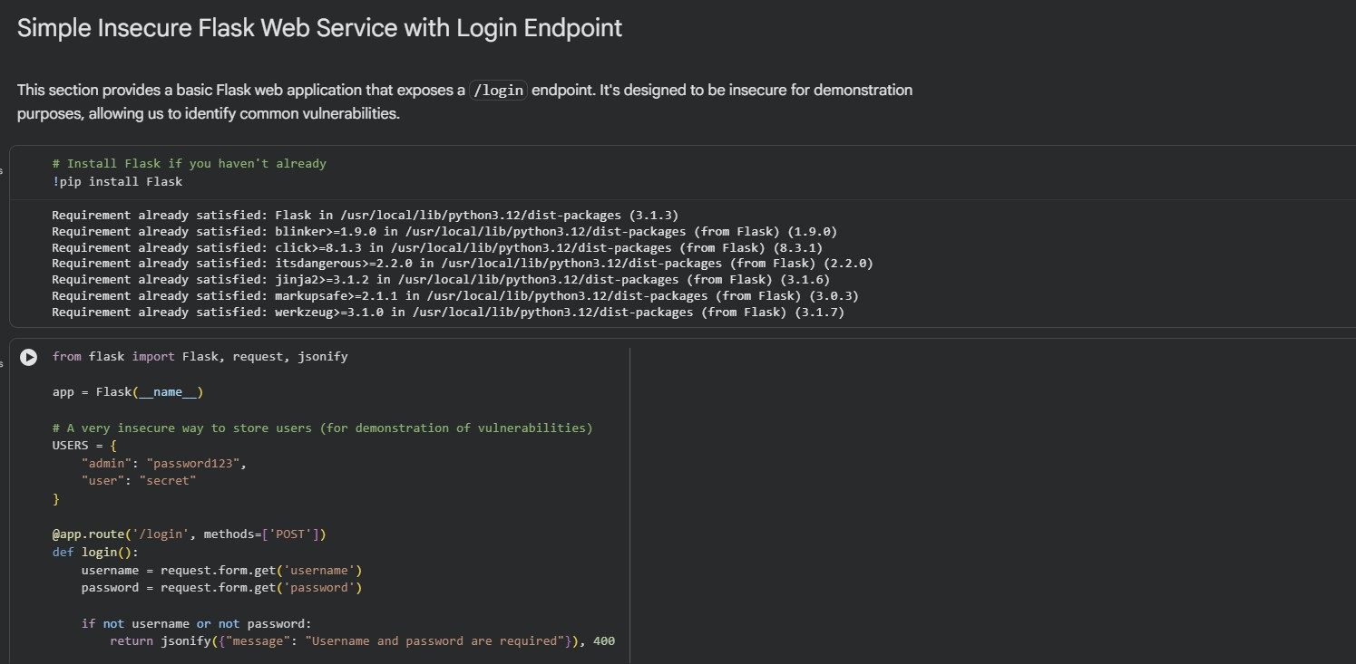
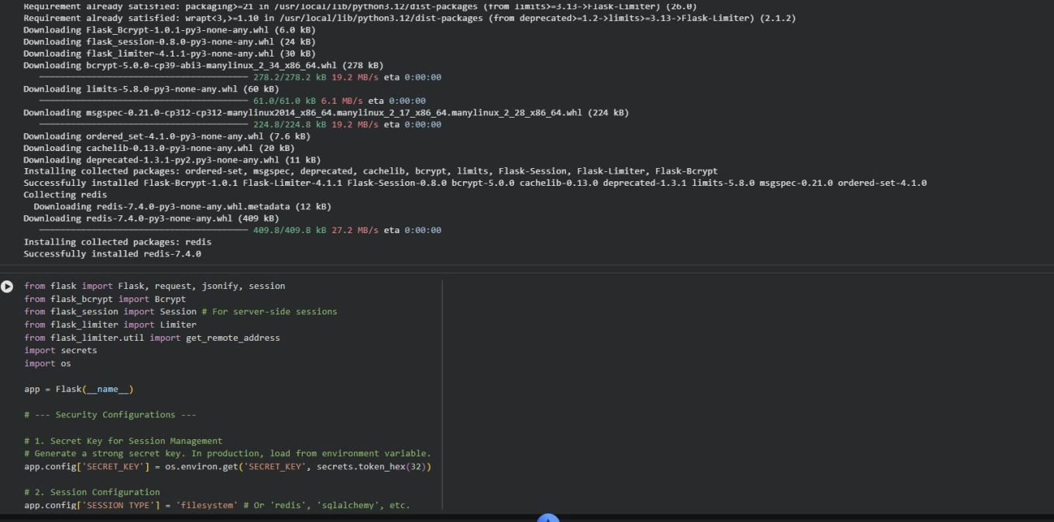

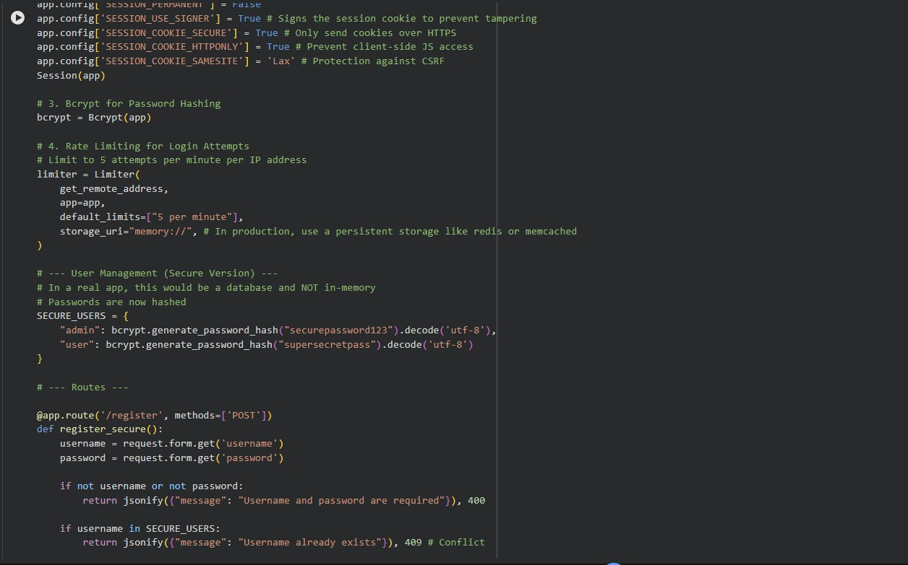
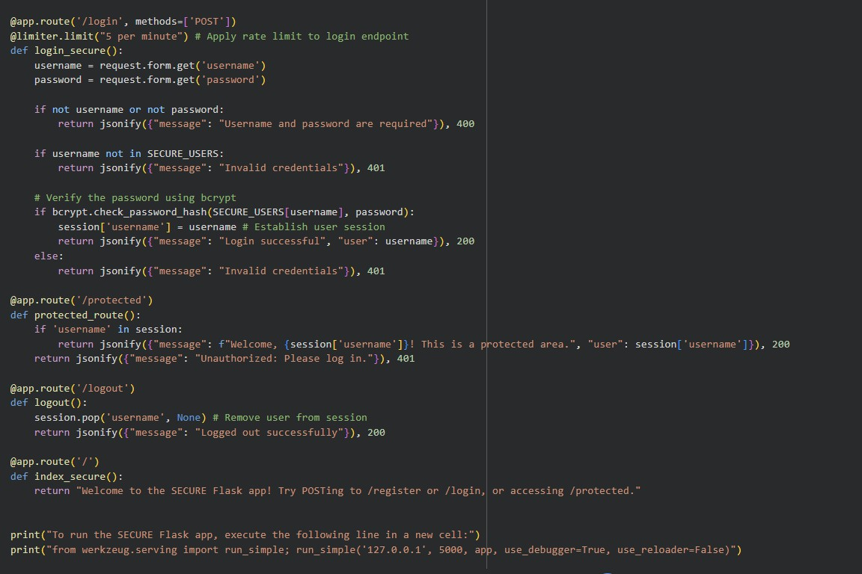

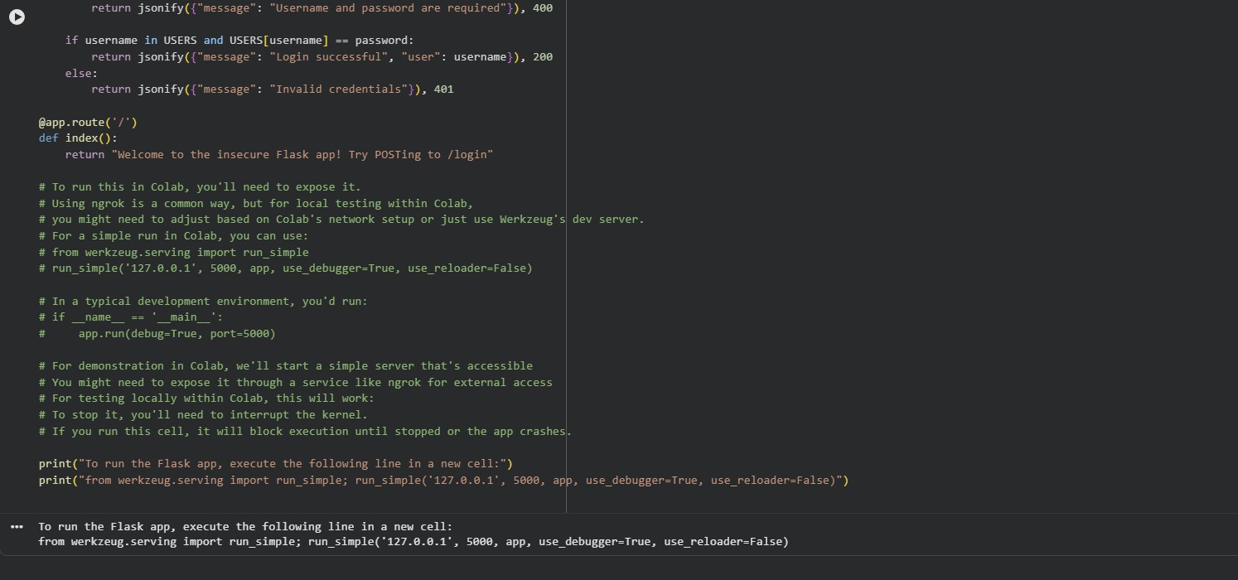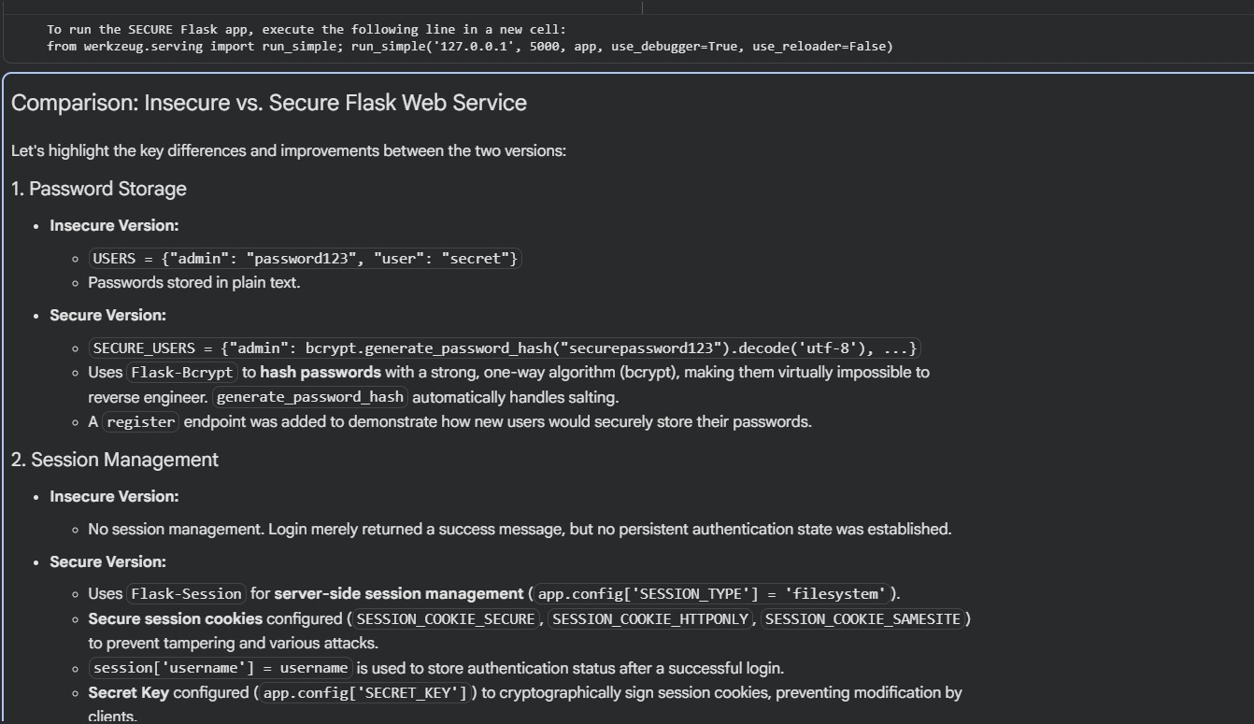

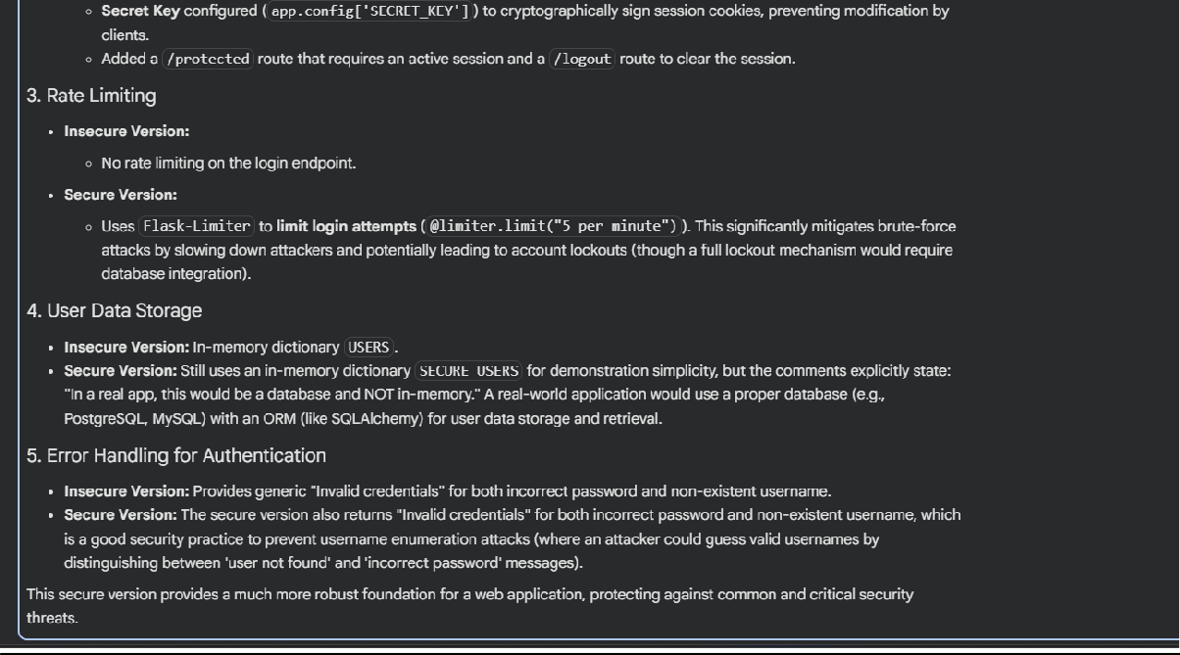
Task5–ExceptionHandlingImprovementPrompt:
Code:
