SCHOOL OF COMPUTER SCIENCE AND ARTIFICIAL INTELLIGENCE |  |  |  |  | DEPARTMENT OF COMPUTER SCIENCE ENGINEERING
Program Name: B. Tech |  |  |  | AssignmentType: Lab |  |  | AcademicYear:2025-2026
Course Coordinator Name |  |  |  | Dr. Rishabh Mittal
Instructor(s)Name |  |  |  | Mr. S Naresh Kumar  Ms. B. Swathi  Dr. Sasanko Shekhar Gantayat  Mr. Md Sallauddin  Dr. Mathivanan  Mr. Y Srikanth  Ms. N Shilpa  Dr. Rishabh Mittal (Coordinator)  Dr. R. Prashant Kumar  Mr. Ankushavali MD  Mr. B Viswanath  Ms. Sujitha Reddy  Ms. A. Anitha  Ms. M.Madhuri  Ms. Katherashala Swetha  Ms. Velpulasumalatha  Mr. Bingi Raju
CourseCode |  |  | 23CS002PC304 | CourseTitle |  | AI Assisted Coding
Year/Sem |  |  | III/II | Regulation |  | R23
DateandDay  of Assignment |  |  | Week9 - Tuesday | Time(s)
Duration |  |  | 2 Hours | Applicableto  Batches |  | 23CSBTB01 To 23CSBTB52
Assignment Number:17.2(Presentassignmentnumber)/24(Totalnumberofassignments)
 | Q.No. | Question |  |  |  |  |  | Expected Time  to complete
 | 1 | Lab 17 – AI for Data Processing: Data Cleaning and Preprocessing Scripts  Lab Objectives:  - Learn how to clean raw datasets using AI-assisted Python scripting.  - Apply preprocessing techniques such as handling missing values, encoding categorical data, and normalization.  - Automate repetitive data-cleaning tasks with AI-generated code.  Understand how preprocessing impacts model performance.  Task Description – 1(Student Academic Data Cleaning)  - Task:  Use AI assistance to generate a Python script that cleans and prepares a student academic dataset for analysis.  Instructions:  - Handle missing values in marks, attendance, and department.  - Remove duplicate student records based on student ID.  - Standardize text fields such as department names.  - Encode categorical variables like gender and department.  Sample Code:  import pandas as pd  data = pd.read_csv("students.csv")  print(data.head())  Expected Output:  - A cleaned and encoded Pandas DataFrame suitable for academic performance analysis.  Task Description – 2 (Financial Transaction Data Preprocessing)  - Task:  Preprocess financial transaction data using AI-generated Python code.  Instructions:  - Convert transaction date columns to datetime format.  - Create derived features such as transaction month and year.  - Normalize the transaction amount column.  - Identify and handle extreme transaction values.  Sample Code:  import pandas as pd  from sklearn.preprocessing import MinMaxScaler  transactions = pd.read_csv("transactions.csv")  print(transactions.info())  Expected Output:  - A transformed dataset with normalized values and newly generated time-based features.  Task 3 – (Environmental Sensor Data Preparation)  - Task:  Clean and preprocess environmental sensor data using AI-assisted scripts.  Instructions:  - Handle missing values in temperature, humidity, and air_quality_index.  - Scale numerical features using standard scaling.  - Encode categorical fields such as sensor_status.  - Split the dataset into training and testing subsets.  Sample Code:  import pandas as pd  from sklearn.model_selection import train_test_split  data = pd.read_csv("sensor_data.csv")  Expected Output:  - A fully preprocessed dataset ready for predictive modeling tasks.  Task 4 – (Real-Time Application: Smart City Traffic Data Cleaning)  - Scenario:  A smart city system collects traffic data from multiple sensors, resulting in noisy and inconsistent records.  Requirements:  - Standardize road and location names.  - Fill missing traffic density values using appropriate statistical methods.  - Remove duplicate sensor readings.  - Normalize speed and vehicle count metrics.  - Generate a brief summary comparing dataset quality before and after cleaning  Sample Code:  import pandas as pd  traffic = pd.read_csv("traffic_data.csv")  print(traffic.describe())  Expected Output:  - A cleaned and normalized traffic dataset with an accompanying data-quality improvement summary.  Task 5 – (Social Media Text Data Cleaning and Feature Extraction)  - Task:  Use AI-assisted Python scripting to clean and preprocess social media text data for sentiment analysis.  Instructions:  - Remove duplicate posts and null text entries.  - Clean text by removing URLs, special characters, and extra spaces.  - Convert text to lowercase and perform basic tokenization.  - Remove stopwords and perform stemming or lemmatization.  - Generate basic text features such as word count and sentiment score.  Sample Code:  import pandas as pd  import re  posts = pd.read_csv("social_media_posts.csv")  print(posts.head())  Expected Output:  A cleaned text dataset with extracted features suitable for sentiment analysis models.  Note: Report should be submitted a word document for all tasks in a single document with prompts, comments & code explanation, and output and if required, screenshots. |  |  |  |  |  | Week9 - Tuesday
Task 1: (Student Academic Data Cleaning)
Prompt:
Generate a Python script to clean and preprocess a student academic dataset by handling missing values, removing duplicates, standardizing text, and encoding categorical variables. Ensure the dataset is transformed into a structured format suitable for academic analysis.

Code:

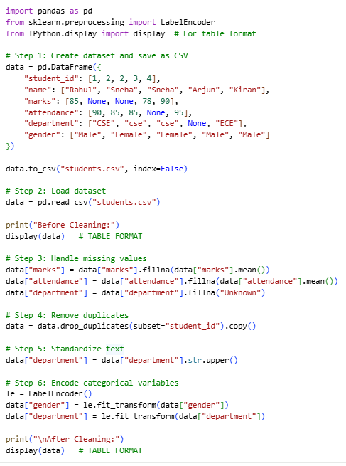

Sample Input/Output:
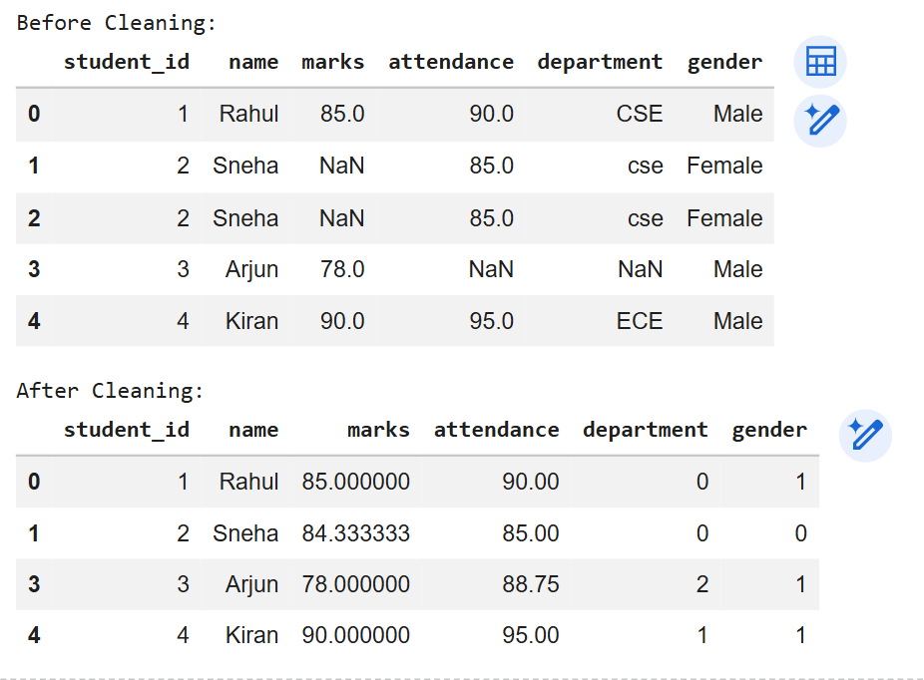

Code Explanation:

- This task demonstrates preprocessing of a student academic dataset using Python.
- A sample dataset is first created and saved as a CSV file to simulate real-world data.
- Missing values in marks and attendance are replaced using mean values.
- Duplicate records are removed based on student ID to ensure data consistency.
- Department names are standardized to maintain uniform formatting.
- Categorical variables like gender and department are encoded numerically.
- The cleaned dataset becomes structured and ready for analysis or modeling.
- Proper preprocessing improves data quality and ensures reliable results.

Task 2: (Financial Transaction Data Preprocessing)
Prompt:
Generate a Python script to preprocess a financial transaction dataset by handling date formats, creating new features, and normalizing numerical values. Ensure the processed dataset is suitable for further financial analysis and machine learning applications.

Code:
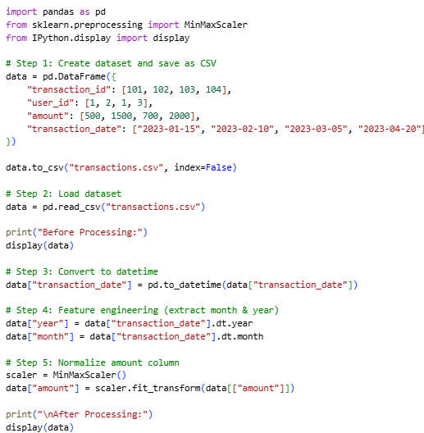

Sample Input/Output:
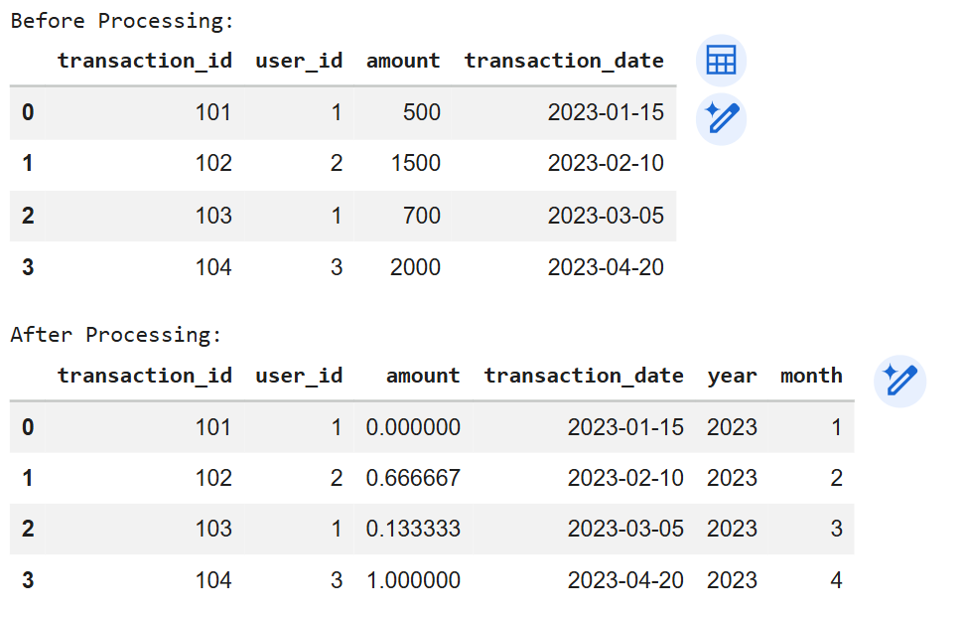

Code Explanation:

- This task focuses on preprocessing financial transaction data for analysis.
- The dataset is created and stored as a CSV file to simulate real-world input.
- The transaction_date column is converted into datetime format for time-based operations.
- New features such as year and month are extracted from the date column.
- Feature engineering helps in analyzing transaction trends over time.
- MinMaxScaler is used to normalize the transaction amount values between 0 and 1.
- The processed dataset becomes suitable for machine learning models.
- This improves data consistency and enables efficient financial analysis.

Task 3: (Environmental Sensor Data Preparation)
Prompt:
Generate a Python script to preprocess environmental sensor data by handling missing values, removing outliers, and normalizing numerical features. Ensure the dataset is cleaned and structured for environmental monitoring and analysis.

Code:
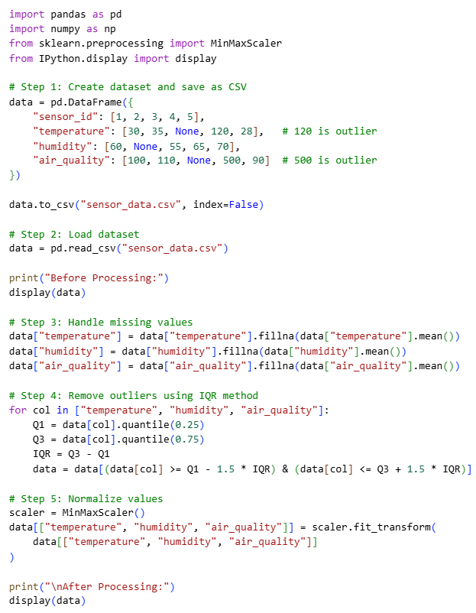

Sample Input/Output:
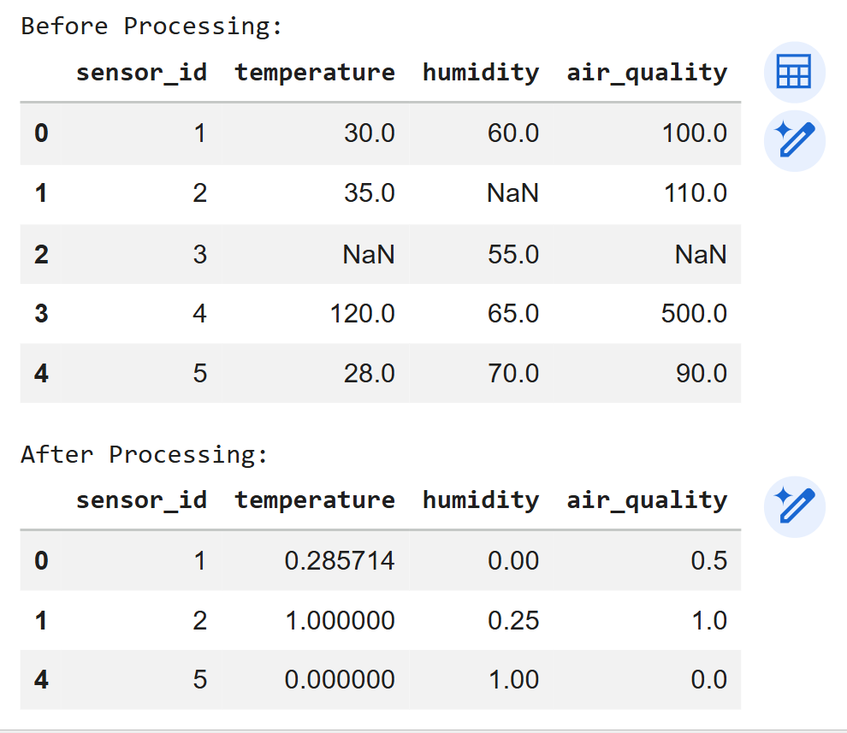

Code Explanation:

- This task focuses on preprocessing environmental sensor data for analysis.
- Missing values in temperature, humidity, and air quality are replaced using mean values.
- Outliers are detected and removed using the Interquartile Range (IQR) method.
- Removing outliers improves data quality and prevents incorrect analysis.
- MinMaxScaler is used to normalize sensor readings between 0 and 1.
- Normalization ensures uniform scale across all features.
- The cleaned dataset becomes suitable for environmental monitoring systems.
- This process enhances accuracy and reliability of sensor-based predictions.

Task 4: (Real-Time Application: Smart City Traffic Data Cleaning)
Prompt:
Generate a Python script to clean and preprocess smart city traffic data by standardizing location names, handling missing values, removing duplicates, and normalizing traffic metrics. Also generate a summary comparing dataset quality before and after cleaning.

Code:
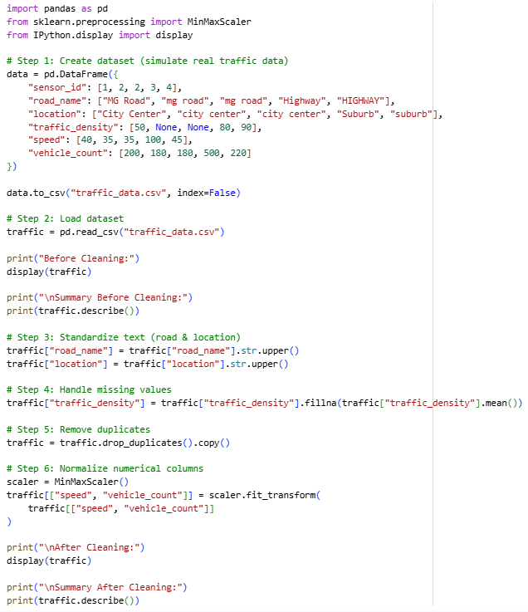

Sample Input/Output:
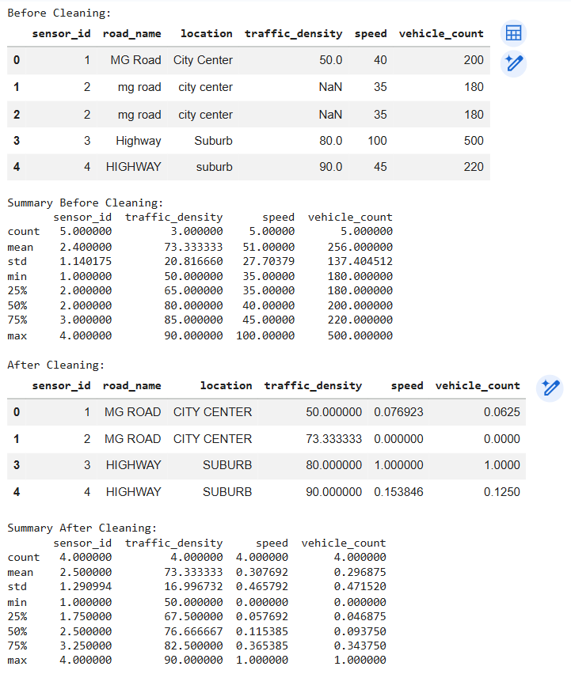

Code Explanation:

- This task demonstrates real-time traffic data preprocessing in a smart city system.
- Text standardization ensures consistency in road and location names.
- Missing traffic density values are replaced using mean values.
- Duplicate sensor records are removed to avoid redundant data.
- Numerical features like speed and vehicle count are normalized using MinMaxScaler.
- Dataset summaries before and after cleaning highlight improvements in data quality.
- Cleaned data becomes suitable for traffic analysis and prediction systems.
- This process enhances accuracy and reliability of smart city applications.

Task 5: (Social Media Text Data Cleaning and Feature Extraction)
Prompt:
Generate a Python script to clean and preprocess social media text data by removing noise, handling duplicates, and performing NLP techniques. Extract useful features such as word count and sentiment score for analysis.

Code:
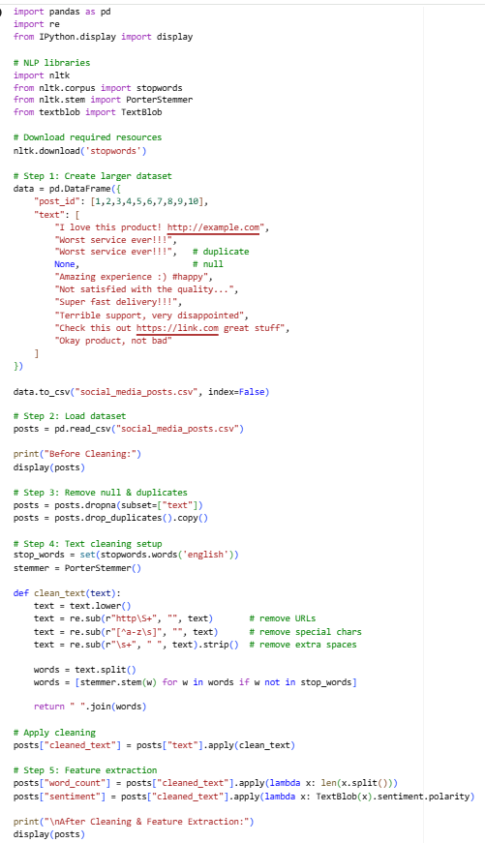

Sample Input/Output:
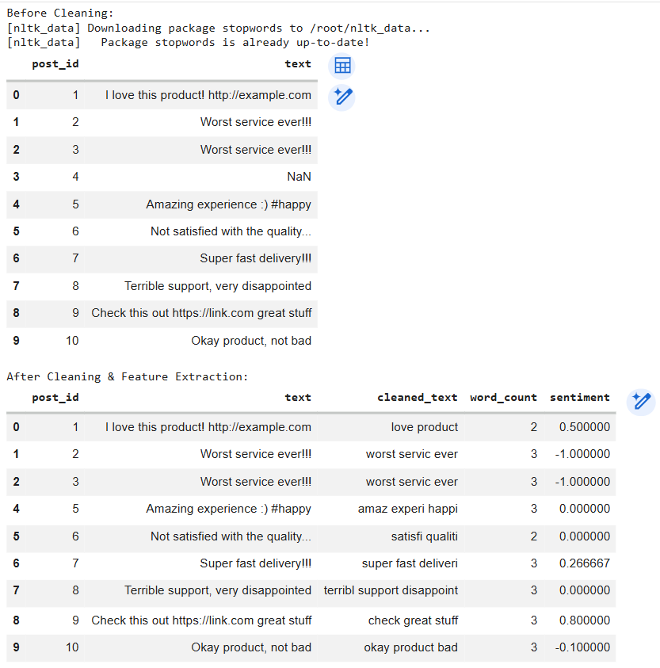

Code Explanation:

- This task focuses on preprocessing social media text data for sentiment analysis.
- Null and duplicate posts are removed to ensure data quality.
- Regular expressions are used to remove URLs and unwanted characters.
- Text is converted to lowercase and tokenized into words.
- Stopwords are removed and stemming is applied to reduce words to root form.
- Word count feature is extracted to measure text length.
- Sentiment polarity is calculated using TextBlob for analysis.
- The processed dataset becomes suitable for NLP and machine learning models.

