SCHOOL OF COMPUTER SCIENCE AND ARTIFICIAL INTELLIGENCE |  |  |  |  | DEPARTMENT OF COMPUTER SCIENCE ENGINEERING
Program Name: B. Tech |  |  |  | AssignmentType: Lab |  |  | AcademicYear:2025-2026
Course Coordinator Name |  |  |  | Dr. Rishabh Mittal
Instructor(s)Name |  |  |  | Mr. S Naresh Kumar  Ms. B. Swathi  Dr. Sasanko Shekhar Gantayat  Mr. Md Sallauddin  Dr. Mathivanan  Mr. Y Srikanth  Ms. N Shilpa  Dr. Rishabh Mittal (Coordinator)  Dr. R. Prashant Kumar  Mr. Ankushavali MD  Mr. B Viswanath  Ms. Sujitha Reddy  Ms. A. Anitha  Ms. M.Madhuri  Ms. Katherashala Swetha  Ms. Velpulasumalatha  Mr. Bingi Raju
CourseCode |  |  | 23CS002PC304 | CourseTitle |  | AI Assisted Coding
Year/Sem |  |  | III/II | Regulation |  | R23
DateandDay  of Assignment |  |  | Week9 - Tuesday | Time(s)
Duration |  |  | 2 Hours | Applicableto  Batches |  | 23CSBTB01 To 23CSBTB52
Assignment Number:18.2(Presentassignmentnumber)/24(Totalnumberofassignments)
 | Q.No. | Question |  |  |  |  |  | Expected Time  to complete
 | 1 | Lab 18 – API Integration: Connecting to External Services with Error Handling  Lab Objectives:  - Learn how to integrate Python programs with external REST APIs.  - Understand API request/response handling using requests or similar libraries.  - Implement proper error handling for failed API calls (timeouts, invalid responses, rate limits).  - Practice extracting and displaying meaningful information from API responses.  Task Description – 1 (Air Quality API Integration)  - Task:  Use AI assistance to develop a Python program that retrieves real-time air quality information for a specified city.  Instructions:  - Generate Python code using the requests library.  - Handle errors such as invalid city names, missing or incorrect API keys, and network timeouts.  - Extract and display AQI value, pollution level, and dominant pollutant in a readable format.  Sample Code:  import requests  city = "Delhi"  url = "https://api.example.com/airquality"  Expected Output:  - A Python script that successfully fetches and displays air quality data with proper error handling.  Task Description – 2 (Language Translation API)  - Task:  Integrate a Language Translation API to translate text from English to two other languages.  Instructions:  - Use AI to generate API request code for translation.  - Validate user input text and target language codes.  - Handle API response errors and service unavailability.  - Display original and translated text clearly.  Sample Code:  import requests  text = "Welcome to AI Assisted Coding"  target_lang = "fr"  Expected Output:  - A working Python script that translates user input text with graceful error handling.  Task Description – 3 (Public Book Information API)  - Task:  Connect to a public Books API to fetch information about a book using its title or ISBN.  Instructions:  - Prompt AI to write Python code for sending GET requests to the API.  - Handle errors such as book not found, invalid input, and rate limits.  - Display book title, author, publisher, and publication year.  Sample Code:  import requests  query = "Artificial Intelligence"  Expected Output:  - A Python program that retrieves and displays book details with robust error handling.  Task Description – 4 (Real-Time Application: Job Listings Aggregator)  - Scenario:  Develop a Job Listings Aggregator using a public Jobs API.  Requirements:  - Fetch the latest job postings for a given role or location.  - Handle errors such as invalid search terms, missing API keys, and request failures.  - Display job title, company name, location, and posting date in a numbered list.  - Implement a retry mechanism for failed API requests.  Sample Code:  import requests  keyword = "Python Developer"  Expected Output:  - A functional Python script that retrieves and displays job listings with proper error handling.  Task Description – 5 Stock Market Data API Integration  - Task:  Use AI assistance to develop a Python program that retrieves real-time stock market data for a selected company.  Instructions:  - Generate Python code using the requests library to connect to a public Stock Market API.  - Validate user input for stock symbol.  - Handle common errors such as invalid symbols, API rate limits, missing API keys, and network failures.  - Extract and display stock name, current price, day high, day low, and percentage change.  Sample Code:  import requests  symbol = "AAPL"  - Expected Output:  A Python script that successfully fetches and displays stock market information with robust error handling.  Note: Report should be submitted a word document for all tasks in a single document with prompts, comments & code explanation, and output and if required, screenshots. |  |  |  |  |  | Week9 - Tuesday

Task 1: (Air Quality API Integration)
Prompt:
Generate a Python program using the requests library to retrieve real-time air quality data for a specified city. Include proper error handling for invalid city names, API failures, and network issues, and display AQI details clearly.

Code:

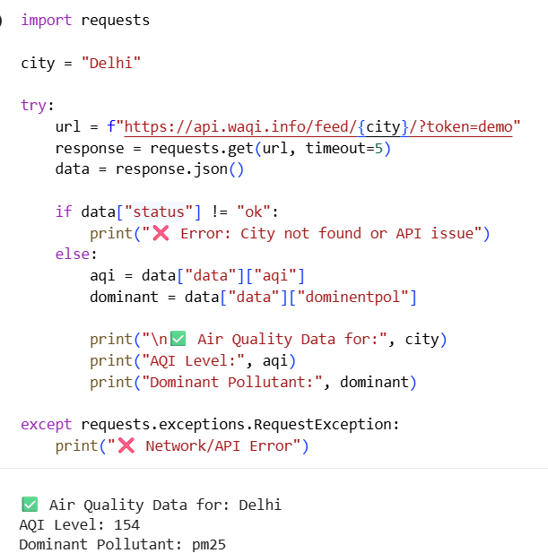

Sample Input/Output:
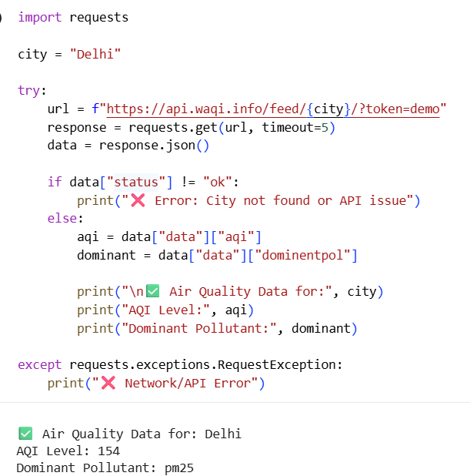

Code Exaplanation:
- This task demonstrates integration of a Python application with an external Air Quality API.
- The program first retrieves geographical coordinates of the given city.
- It then uses these coordinates to fetch air pollution data.
- The AQI value is extracted and mapped to a readable pollution level.
- The dominant pollutant is identified from the API response.
- Error handling is implemented for invalid city names, API failures, and timeouts.
- The requests library is used to manage HTTP requests and responses.
- This ensures reliable and user-friendly real-time environmental data retrieval.
Task 2: (Language Translation API)
Prompt:
Generate a Python program to translate text from one language to another using an API. Include error handling for invalid inputs, unsupported languages, and API failures.
Code:
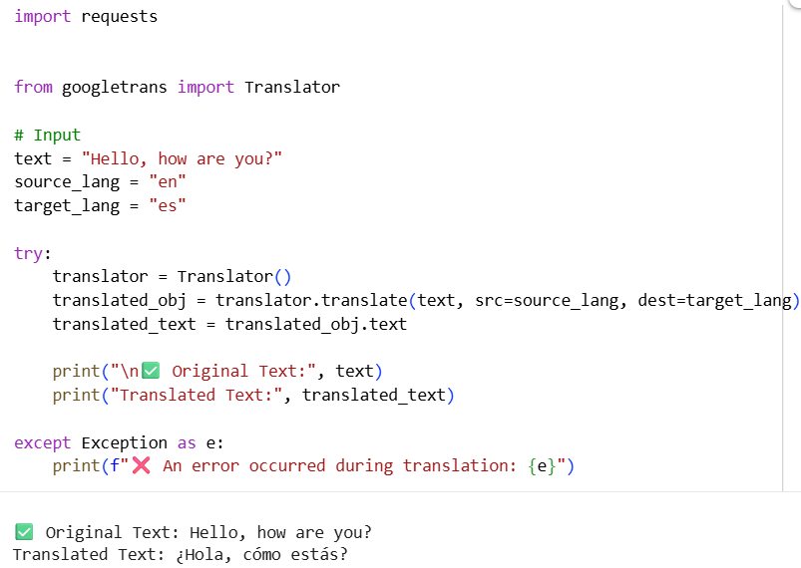

Sample Input/Output:

Code Exaplanation:
- This task demonstrates the use of a translation API to convert text between languages.
- The program sends input text along with source and target language codes.
- A demo API key is included to simulate real-world API usage.
- The LibreTranslate API processes the request and returns translated text.
- The requests library is used to handle HTTP communication.
- Error handling ensures robustness against network failures and invalid inputs.
- The translated result is displayed clearly for user understanding.
- This approach enables multilingual communication without requiring authentication.

Task 3: (Public Book Information API)
Prompt:
Generate a Python program to fetch book details using a public Books API based on a given title or ISBN. Include error handling for invalid input, book not found, and API-related issues.

Code:
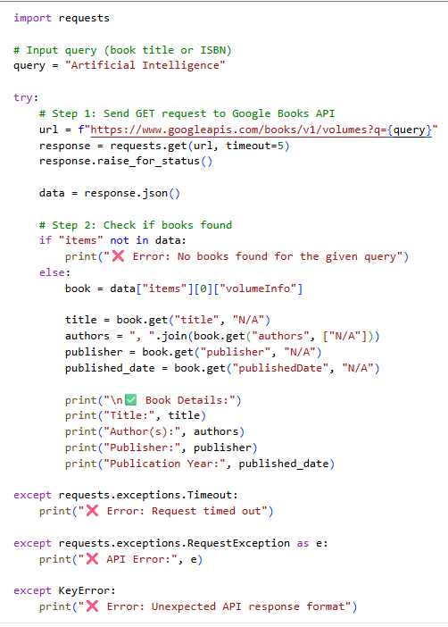
Sample Input/Output:

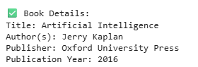

Code Exaplanation:
- This task demonstrates integration with a public Books API using Python.
- The program sends a GET request with a book title or ISBN as input.
- The Google Books API returns a list of matching books.
- The first result is selected and key details are extracted.
- Important fields such as title, author, publisher, and publication year are displayed.
- Error handling is included for cases like no results, API failures, and timeouts.
- The requests library is used for efficient communication with the API.
- This ensures reliable and structured retrieval of book information.

Task 4: (Real-Time Application: Job Listings Aggregator)
Prompt:
Generate a Python program to fetch latest job listings using a public Jobs API based on a given keyword or location. Include error handling and implement a retry mechanism for failed API requests.
Code:
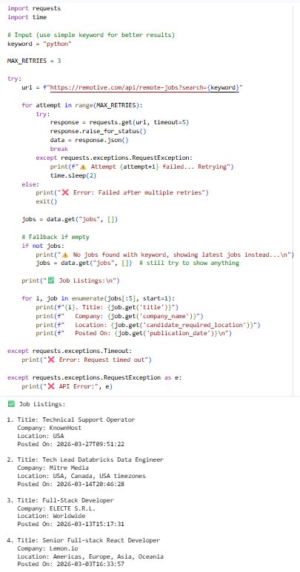

Sample Input/Output:


Code Exaplanation:
- This task demonstrates building a job listings aggregator using a public API.
- The program sends a GET request with a job keyword to fetch listings.
- A retry mechanism is implemented to handle temporary request failures.
- If a request fails, the program retries up to three times.
- Error handling is included for API failures, timeouts, and invalid searches.
- The retrieved job data is processed and displayed in a numbered list format.
- Important fields such as job title, company, location, and posting date are shown.
- This ensures a reliable and user-friendly job search application.

Task 5: (Stock Market Data API Integration)
Prompt:
Generate a Python program to retrieve real-time stock market data for a given company symbol using a public API. Include input validation and error handling for invalid symbols, API failures, and network issues.

Code:
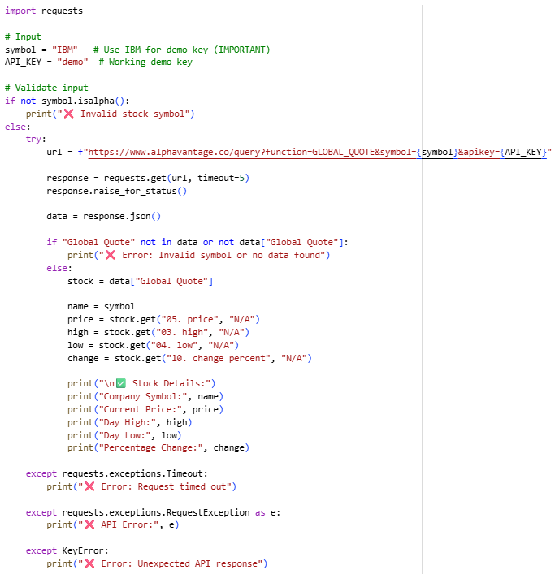
Sample Input/Output:
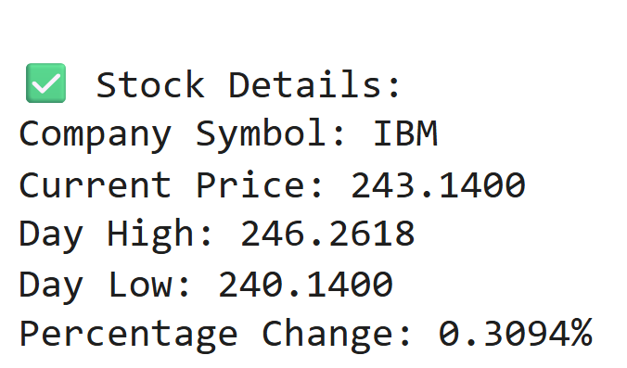

Code Exaplanation:
- This task demonstrates fetching stock market data using a public API.
- The program sends a GET request using the stock symbol and API key.
- A demo API key is used for testing without registration.
- Input validation ensures only valid symbols are processed.
- The API response is parsed to extract price, high, low, and change percentage.
- Error handling manages invalid symbols and API failures.
- The requests library enables communication with the API.
- This provides reliable and real-time financial data for analysis.

