Name:T.Ramyasri
H.no:2303A52136
Batch-41

 1. Stack Implementation Using Python List
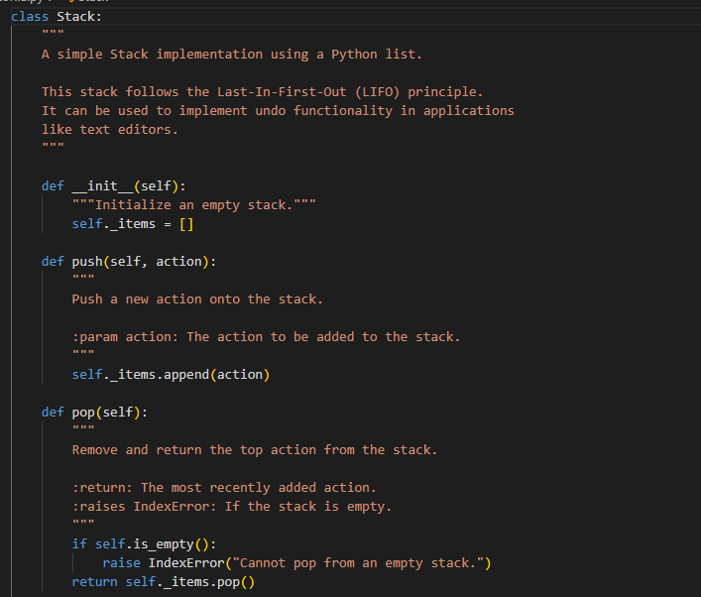
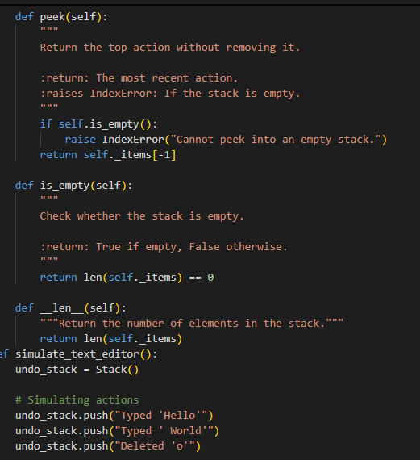
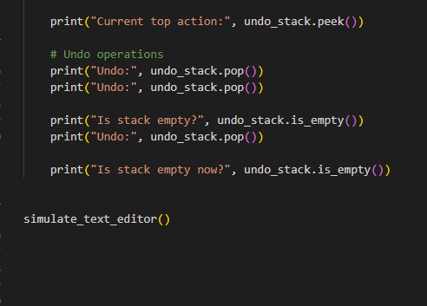
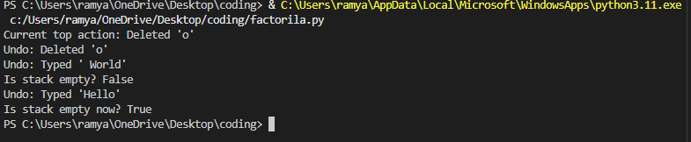
2. Alternative Implementation Using collections.deque
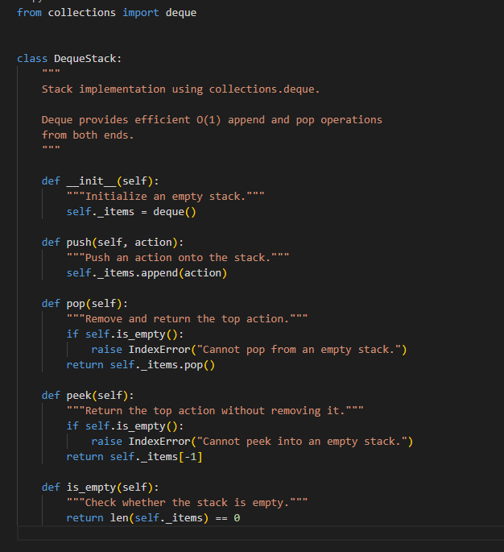
Comparison: List-Based vs Deque-Based Stack
Feature | List-Based Stack | Deque-Based Stack
Implementation | Simple, built-in list | Requires collections module
Push (append) | O(1) | O(1)
Pop (end) | O(1) | O(1)
Memory Efficiency | Slightly less optimized | More memory-efficient
Recommended For | Most simple stack use cases | High-performance or heavy operations
JUSTIFICATION:
A stack is ideal for undo functionality because it follows the Last-In-First-Out (LIFO) principle. The most recent action performed by the user must be undone first, which matches how a stack removes elements — the last item pushed is the first item popped.
Using a Python list is simple and efficient for stack operations (append() and pop() are O(1)). Alternatively, collections.deque provides similar O(1) performance and is slightly more optimized for heavy usage.
TASK-2:QUEUE FOR CUSTOMER SERVICE REQUESTS
Why a Queue is Suitable
A queue follows the First-In-First-Out (FIFO) principle.
In a customer support system:
- The first customer request received should be handled first.
- New requests go to the end of the line.
This ensures fairness and ordered processing.
List-Based Queue Implementation
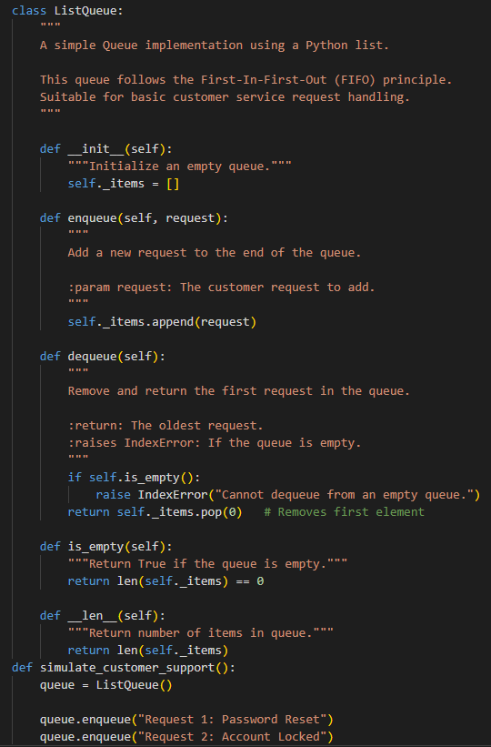
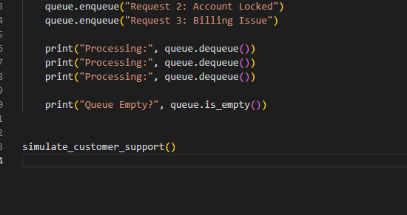
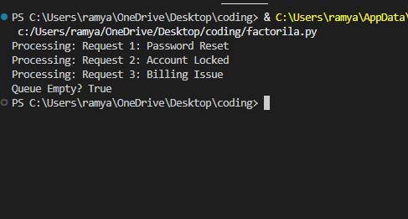
Performance Review of List-Based Queue
Problem:
pop(0) has O(n) time complexity.
Why?
Because removing the first element shifts all remaining elements one position to the left.
If there are 10,000 requests:
- Every dequeue operation shifts 9,999 elements.
- This becomes slow in large systems.
Real-World Impact:
In a real customer service system:
- High traffic = thousands of requests
- Frequent dequeue operations
- Performance degradation over time
Optimized Queue Using collections.deque
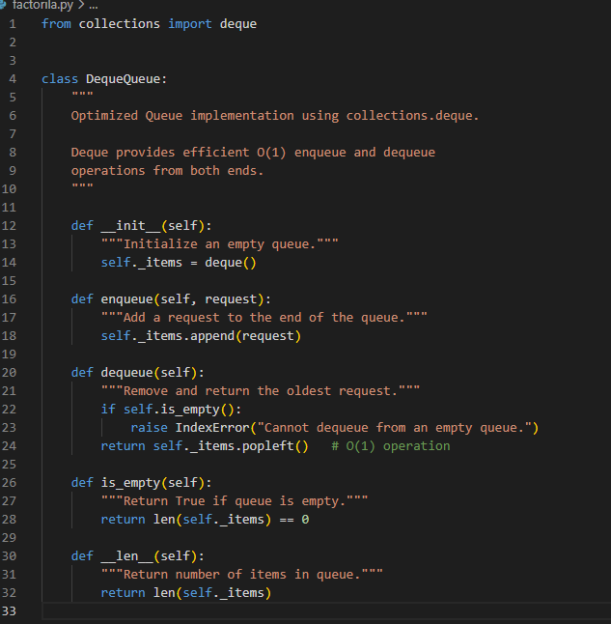

Performance Comparison
Operation | List-Based Queue | Deque-Based Queue
Enqueue | O(1) | O(1)
Dequeue | O(n) | O(1)
Memory Efficiency | Moderate | Optimized
Suitable For | Small systems | Large-scale systems

Why deque Performs Better
collections.deque is implemented as a doubly linked list (not a dynamic array like list).
This means:
- No shifting of elements
- append() → O(1)
- popleft() → O(1)
- Efficient for both stack and queue operations

A queue is appropriate for customer service requests because it follows the First-In-First-Out (FIFO) principle. The first request received should be handled first to ensure fairness and proper order of service.
A list-based queue works for small systems, but pop(0) takes O(n) time because all remaining elements must shift after removal. In high-traffic systems, this causes performance slowdowns.

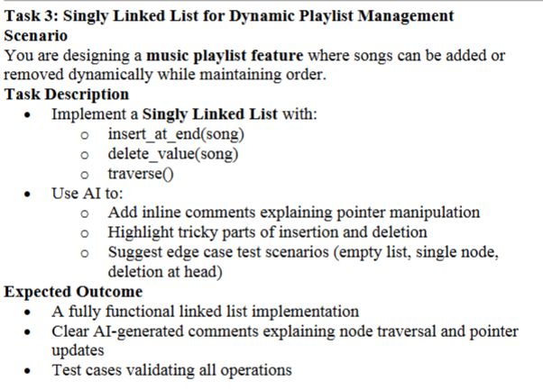
🎵 Why Singly Linked List for Playlist?
A Singly Linked List is suitable because:
- Songs can be added dynamically without resizing (like arrays).
- Deletions are efficient when the node is known.
- Order of songs is maintained.
- Memory is allocated dynamically.
Unlike lists, linked lists do not require shifting elements during deletion.
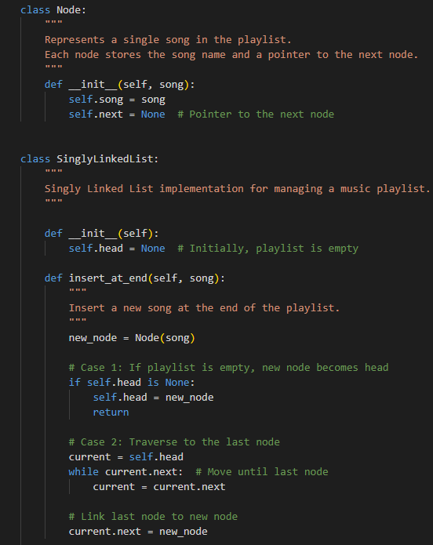
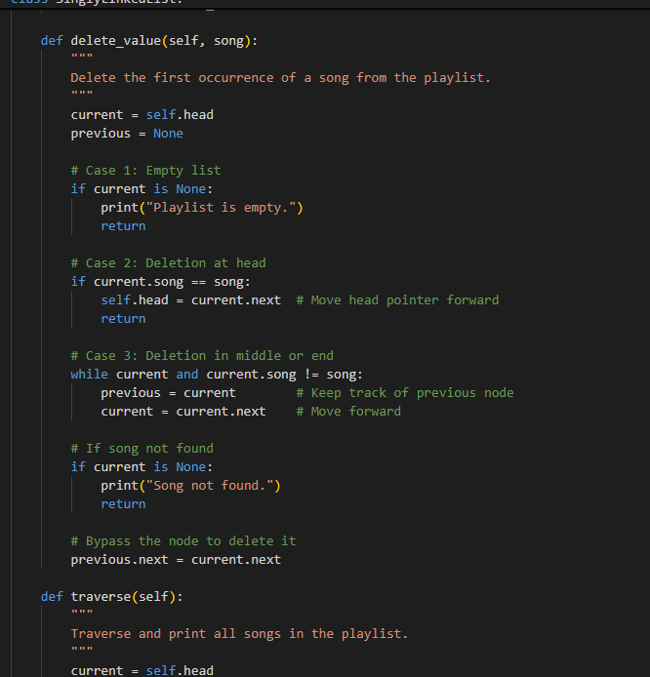
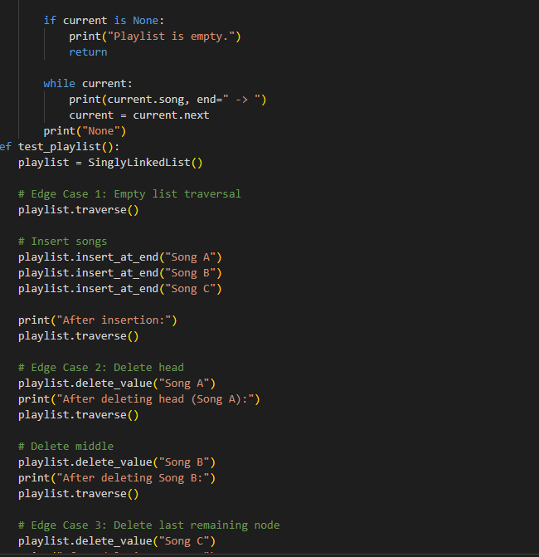
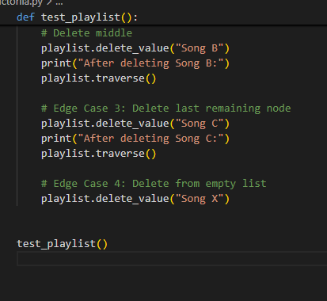
Output:
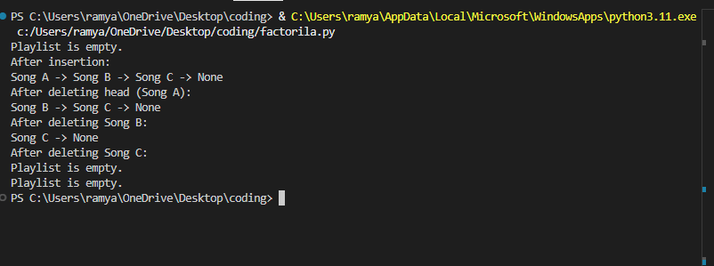
JUSTIFICATION:
A Singly Linked List is suitable for dynamic playlist management because songs can be added or removed without shifting other elements, unlike arrays or lists. Each song (node) points to the next, making insertion at the end and deletion efficient through pointer updates.
Task 4: Binary Search Tree for Fast Record Lookup
Why Use a BST for Student Records?
A Binary Search Tree (BST) allows fast searching based on roll numbers because:
- Left subtree contains values smaller than the node.
- Right subtree contains values greater than the node.
- This ordered structure reduces search space at every step.
Instead of checking every record (like linear search), BST eliminates half the remaining records at each comparison (in ideal cases).
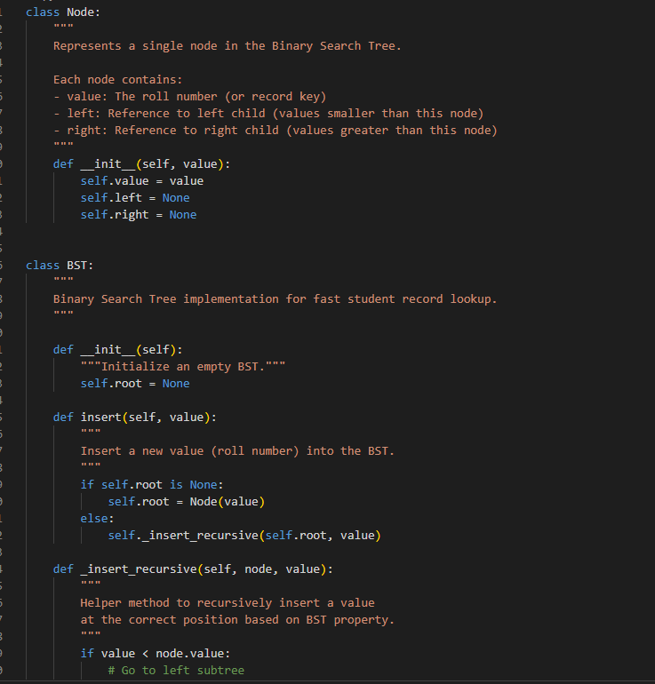
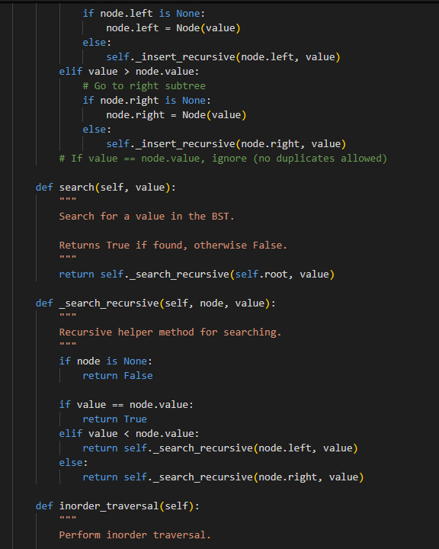
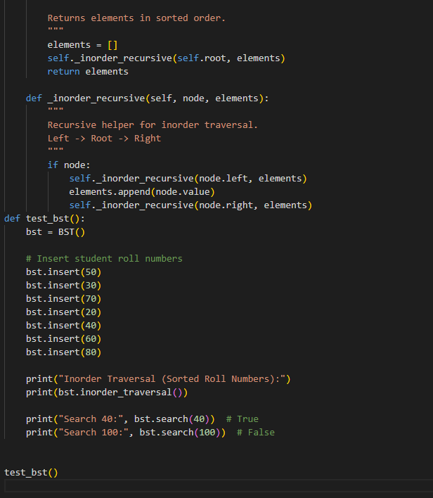
Output:
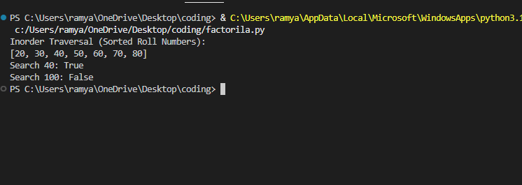
Why BST Improves Search Efficiency
🔹 Linear Search (List)
- Checks every element one by one.
- Time Complexity: O(n)
If there are 10,000 student records, worst case → 10,000 comparisons.
Binary Search Tree
Because of ordering:
- Compare with root.
- If smaller → go left.
- If larger → go right.
- Each step eliminates half the tree (in balanced case).
Performance Analysis
Case | Time Complexity
Best Case (Balanced Tree) | O(log n)
Average Case | O(log n)
Worst Case (Skewed Tree) | O(n)
✅ Best Case (Balanced)
If tree is balanced:
- Height ≈ log₂(n)
- Very fast lookup.
Example:
10,000 records → ~14 comparisons only.
❌ Worst Case (Skewed Tree)
If values inserted in sorted order:
- Tree becomes like a linked list.
- Search becomes O(n).
Justification:
A Binary Search Tree (BST) is suitable for student record lookup because it stores roll numbers in a sorted hierarchical structure. This allows the system to eliminate half of the remaining records at each comparison, making search operations faster than linear search.
Task 5: Graph Traversal for Social Network Connections
Why Use a Graph?
A social network naturally forms a graph:
- Each user → Vertex (Node)
- Each friendship → Edge (Connection)
We use an adjacency list representation because:
- Efficient for sparse graphs (like social networks)
- Easy to store and traverse connections
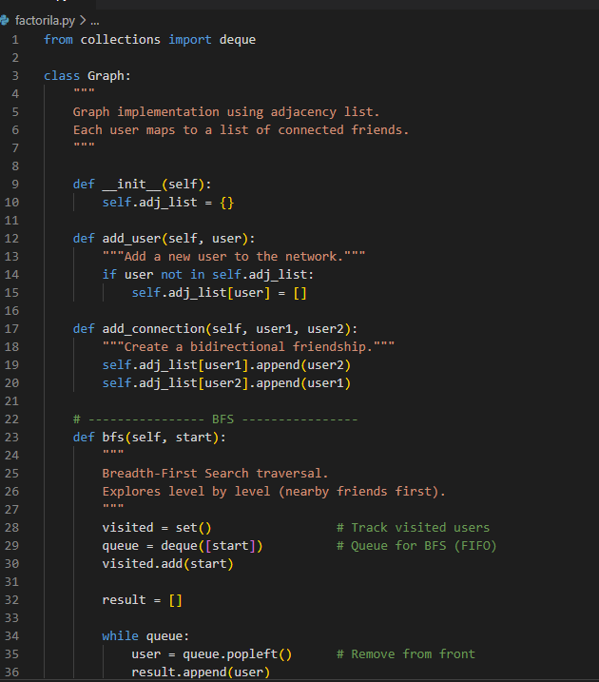
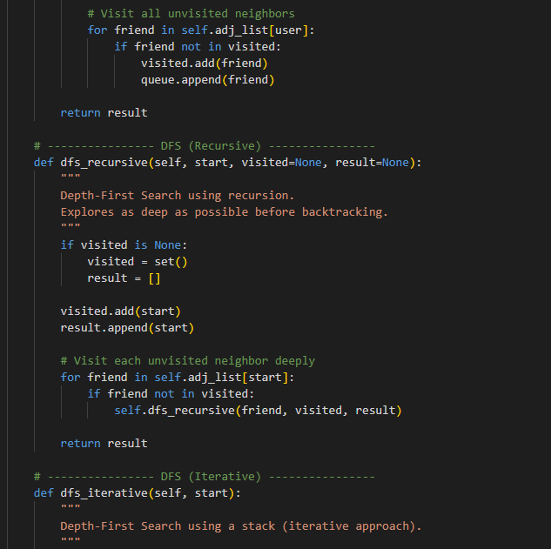
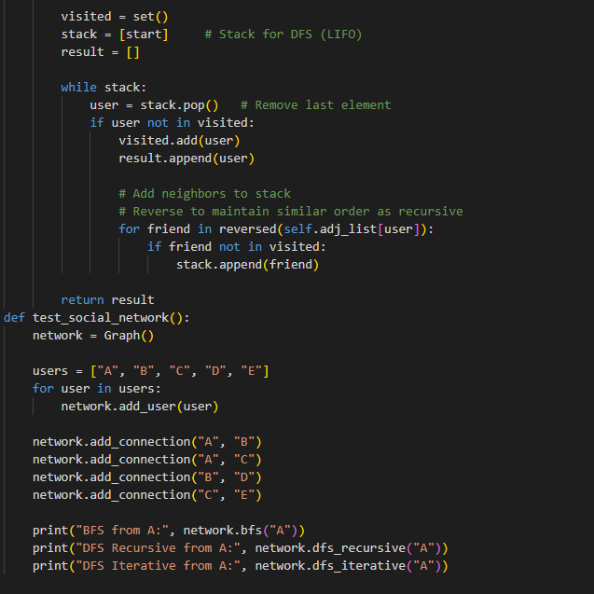
Output:
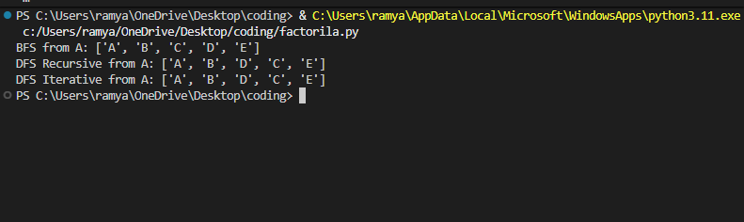
Traversal Logic Explained
🔹 BFS (Breadth-First Search)
- Uses a queue (FIFO).
- Visits:
  - First → direct friends
  - Then → friends of friends
- Explores level by level.
🔹 DFS (Depth-First Search)
- Uses a stack (LIFO) or recursion.
- Goes deep along one path before backtracking.
- Explores branch fully before moving to next.
- Recursive vs Iterative DFS
- Feature | Recursive DFS | Iterative DFS
- Uses | System call stack | Explicit stack
- Code Simplicity | Cleaner and shorter | More control
- Risk | Stack overflow (deep graph) | Safer for large graphs
- Memory Control | Less direct control | Full control
Practical Use Cases
✅ When to Use BFS
- Finding shortest path in unweighted graph
- Finding nearby friends (1st, 2nd level connections)
- Social network friend suggestions
✅ When to Use DFS
- Exploring all possible connection paths
- Detecting cycles
- Finding connected components
- Path existence checking
Justification:
A graph is suitable for modeling a social network because users can be represented as nodes and friendships as edges. This structure naturally represents connections between people.
BFS is useful for finding nearby connections (like mutual friends or shortest path), while DFS is useful for exploring deep connection paths and checking overall connectivity. Together, they help efficiently analyze relationships within the network.

