AI Assisted Coding Lab 12.3
Sanjana Kolipaka
2303A52139
Batch – 41
Question 1: Sorting Student Records for Placement Drive
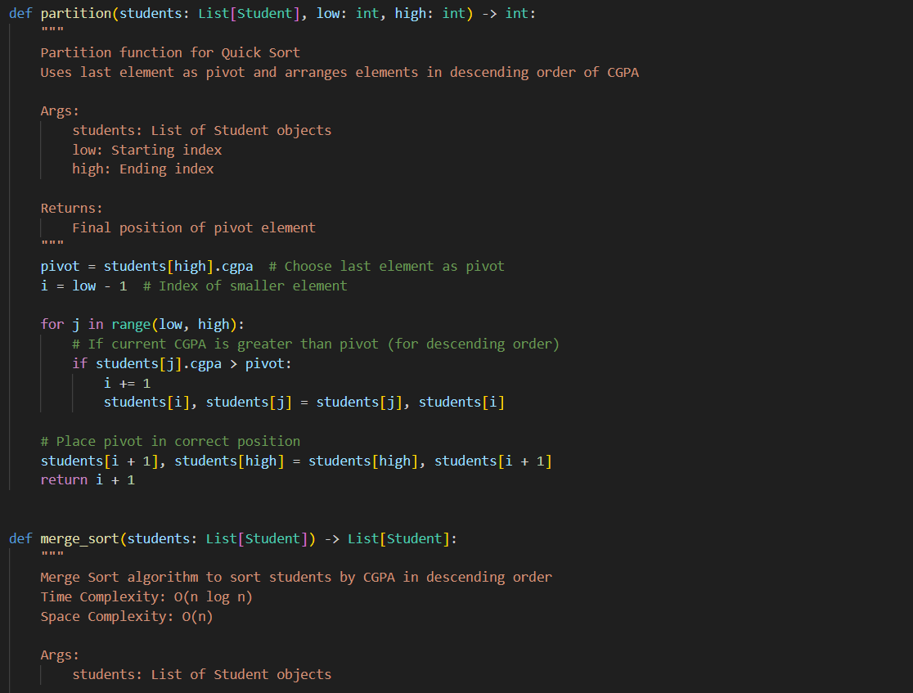
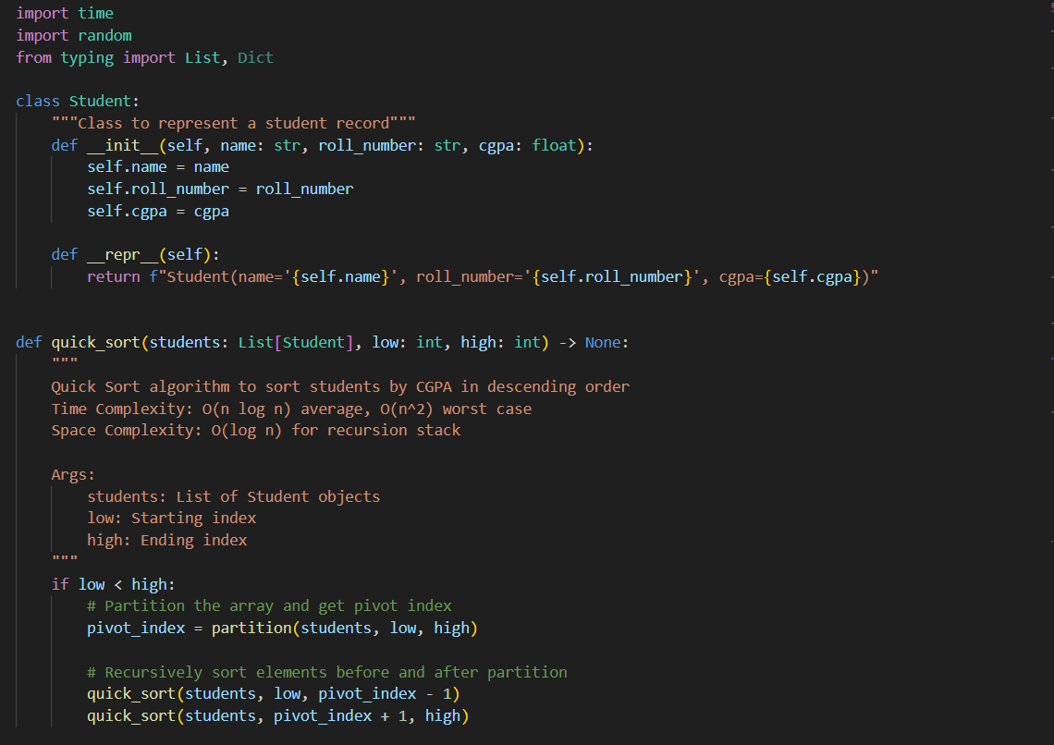
Prompt: Generate a python code for Sorting student records for placement drive. Each record should contain the student's name, roll number, and CGPA. Implement the quick sort and merge sort algorithms to sort the records based on CGPA. Include a function that stores student records in a list and demonstrates the sorting functionality with a real-life sample data. Provide clean and efficient code with proper comments explaining the logic. Measure and compare runtime performance for large datasets. Write a function to display the top 10 students based on their CGPA.

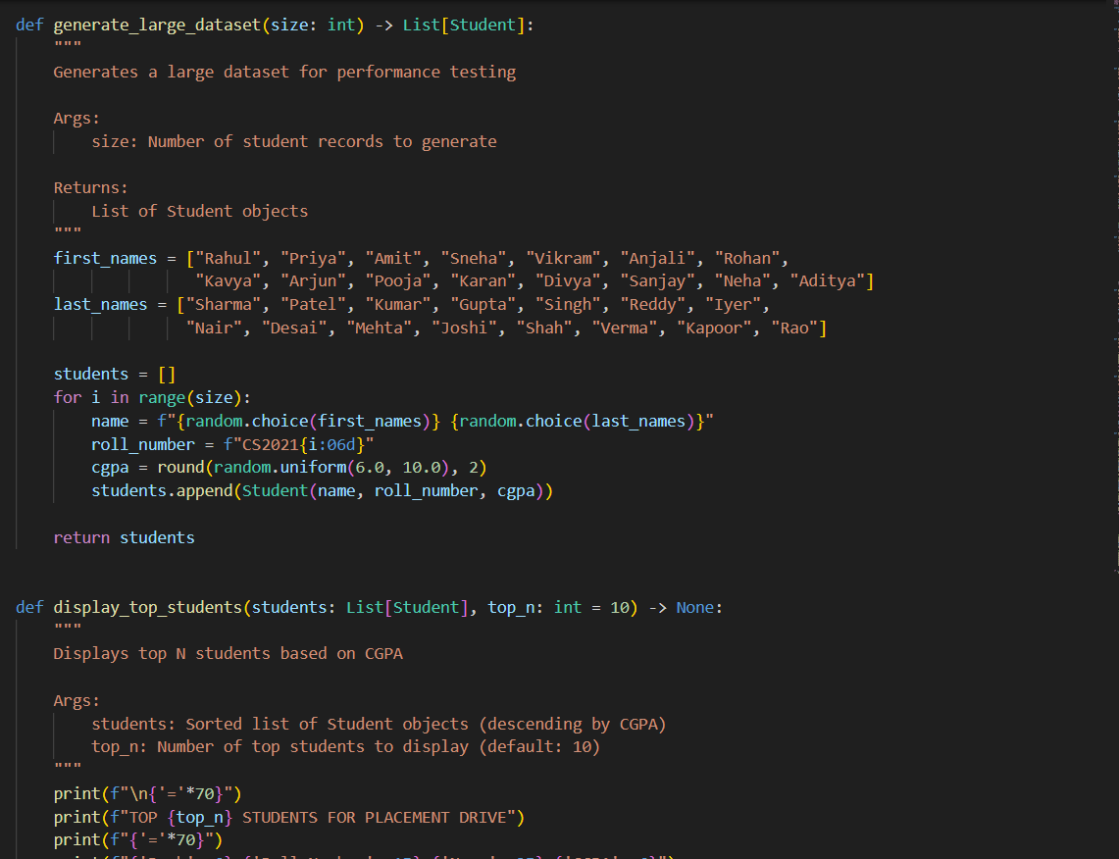

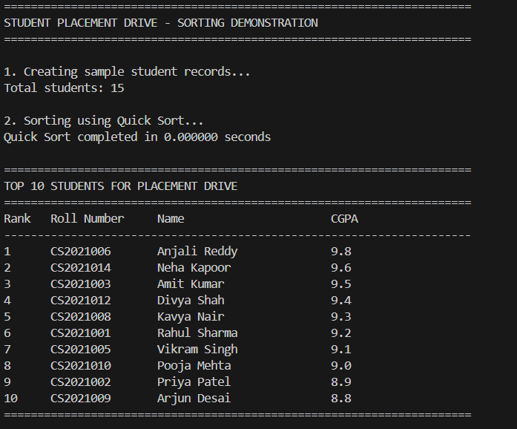
Output:

Explanation:
The code implements two sorting algorithms, quick sort and merge sort, to sort student records based on their CGPA. It defines a Student class to represent each student's information and includes functions to perform the sorting and display the top students. The runtime performance of both sorting algorithms is measured and displayed, allowing for a comparison of their efficiency. This approach ensures that the code is clean, efficient, and easy to understand while demonstrating the functionality with real-life sample data.
Question 2:
Implementing Bubble Sort with AI Comments
Prompt: Generate a python code for implementing a bubble sort with Comments. Include inline comments explaining key logic like swapping, passes, and termination. Also Provide time complexity analysis of the bubble sort algorithm. Ensure the code is clean and efficient.
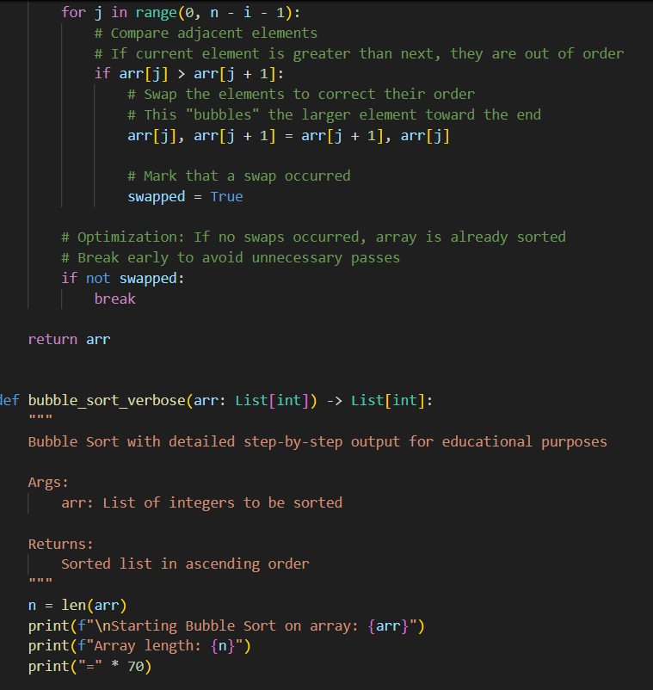
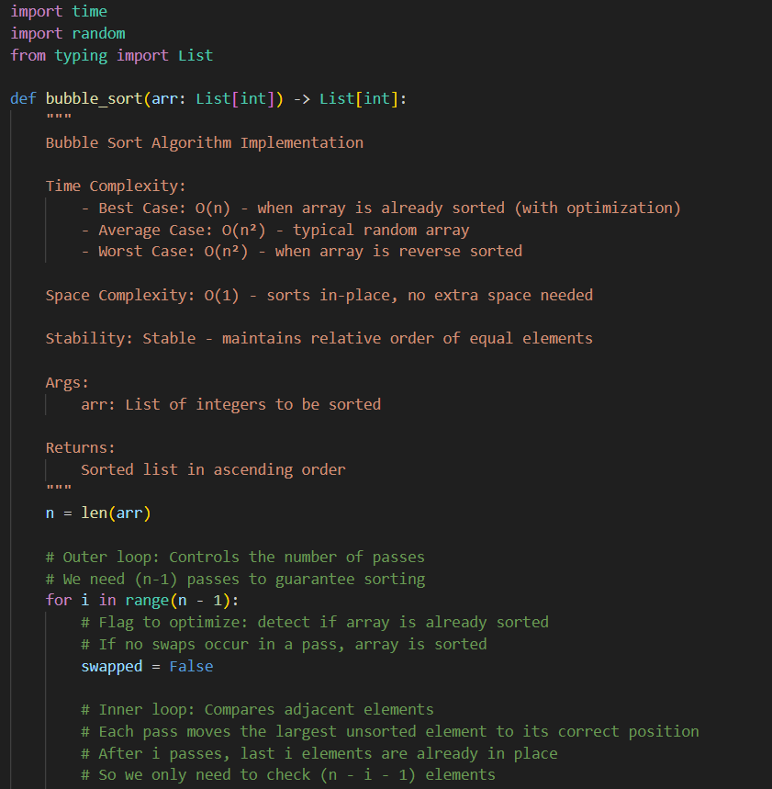
Code:
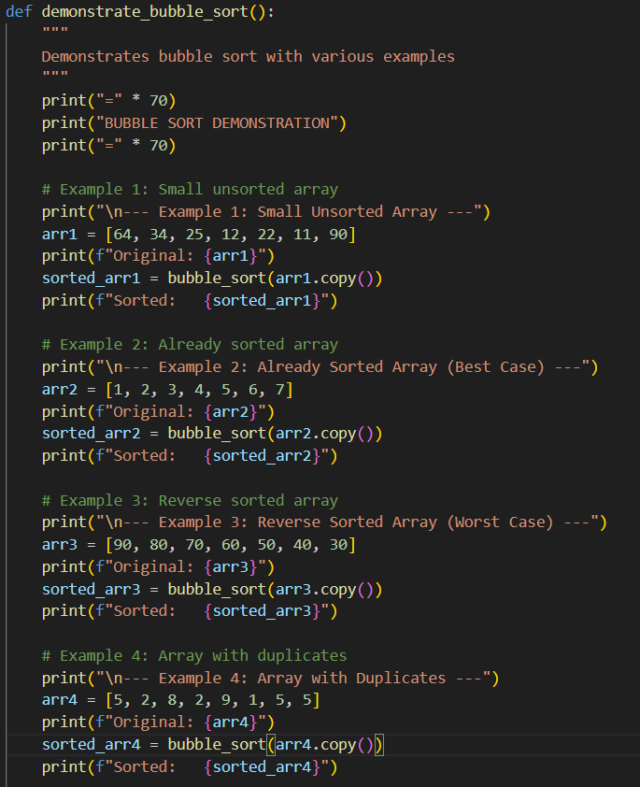
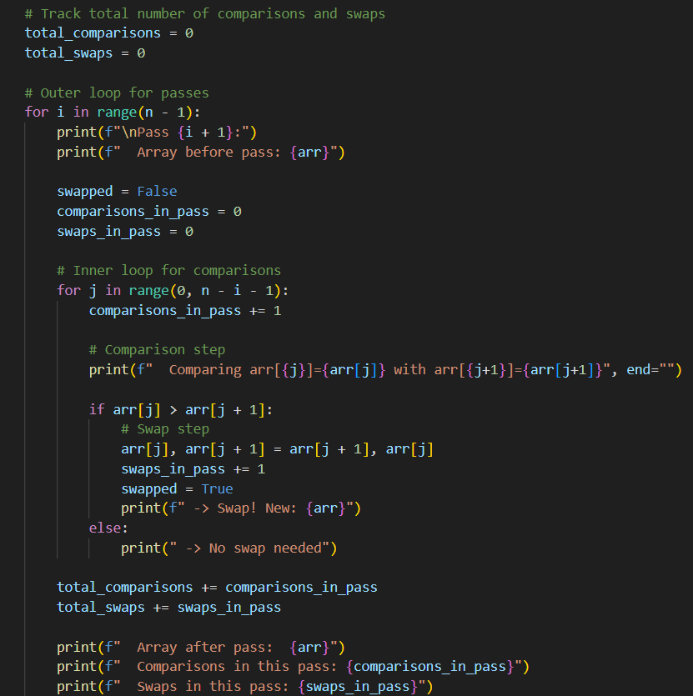

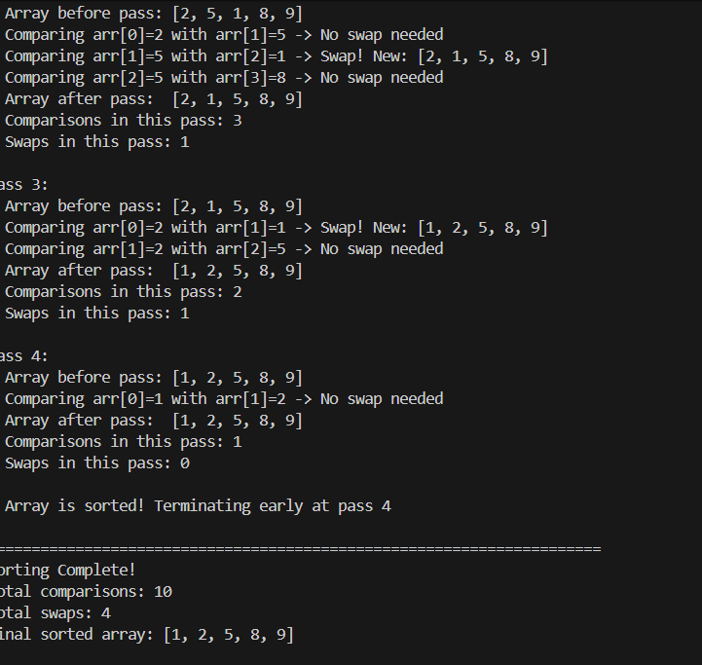
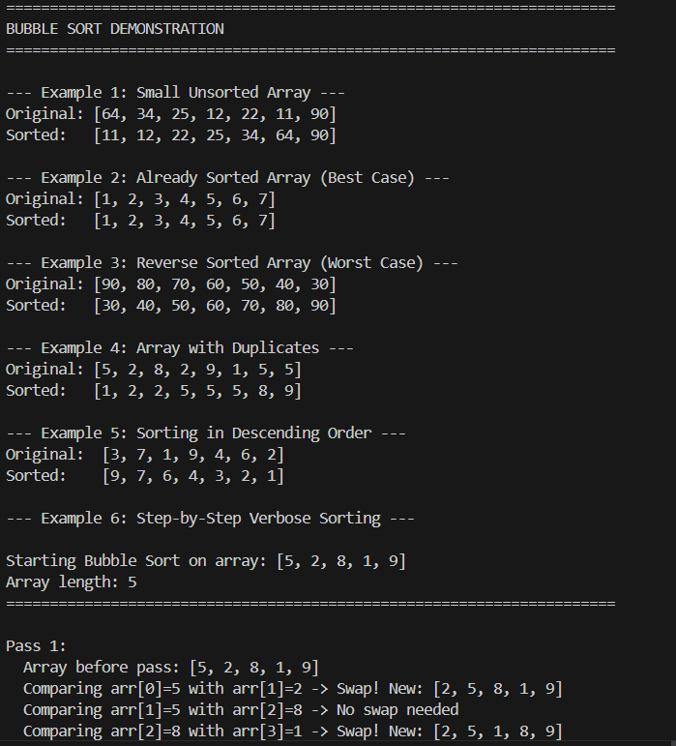
Output:
AI Generated Time Complexity Analysis:
• The time complexity of bubble sort is O(n^2) in the worst and average cases, where n is the number of elements in the list. This is because in the worst case, each element needs to be compared with every other element.
• However, in the best case (when the list is already sorted), the time complexity is O(n) because the algorithm will make one pass through the list to check if it is sorted, without performing any swaps. Explanation: The bubble sort algorithm is a simple sorting method that repeatedly steps through the list, compares adjacent elements and swaps them if they are in the wrong order. It continues to pass through the list until it is sorted. The algorithm is easy to understand and implement, making it a good choice for educational purposes. However, it is not the most efficient sorting algorithm for large datasets due to its O(n^2) time complexity in the worst case. It is best used for small lists or as an introduction to sorting concepts.
Question 3: Quick Sort and Merge Sort Comparison
Prompt: Generate a python code to implement quick sort and merge sort using recursion. Include sample function calls to demonstrate the correctness of the implementation. Also give explanation of average, best, and worst case complexities. Provide a clean and efficient code with proper comments explaining the logic.
Code:
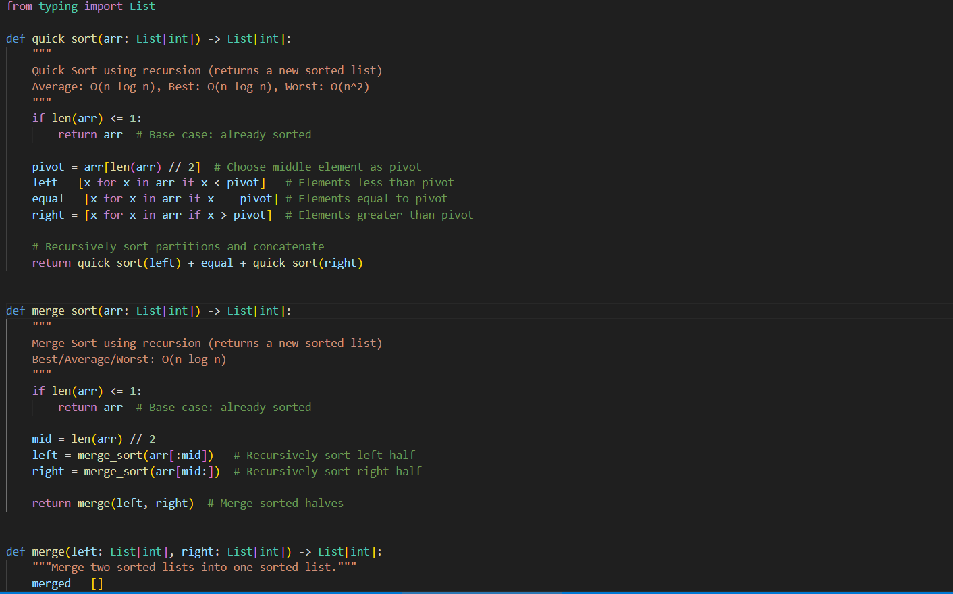
Output:
Explanation:
Quick sort has an average and best case time complexity of O(n log n) because it efficiently divides the array into smaller sub-arrays and sorts them recursively. However, in the worst case, when the smallest or largest element is consistently chosen as the pivot, it can degrade to O(n^2) due to unbalanced partitions. On the other hand, merge sort always divides the array into halves, resulting in a consistent time complexity of O(n log n) for all cases, making it more predictable but often less efficient than quick sort for small datasets due to additional space requirements.
Question 4: Real-Time Application – Inventory Management System
Prompt: Generate a python code for Real Time Application of Inventory Management System. The inventory system contains many products each with attributes like Product ID, name, price and stock quantity. Implemnt a Quickly search for a product by ID or name and Sort products by price or quantity for stock analysis. Suggest the most efficient search and sort algorithms for this use case. Justify the choice based on dataset size, update frequency, and performance requirements. The output should be a table mapping operations - recommended alogorithm - justification. Provide a clean and efficient code with proper comments explaining the logic.

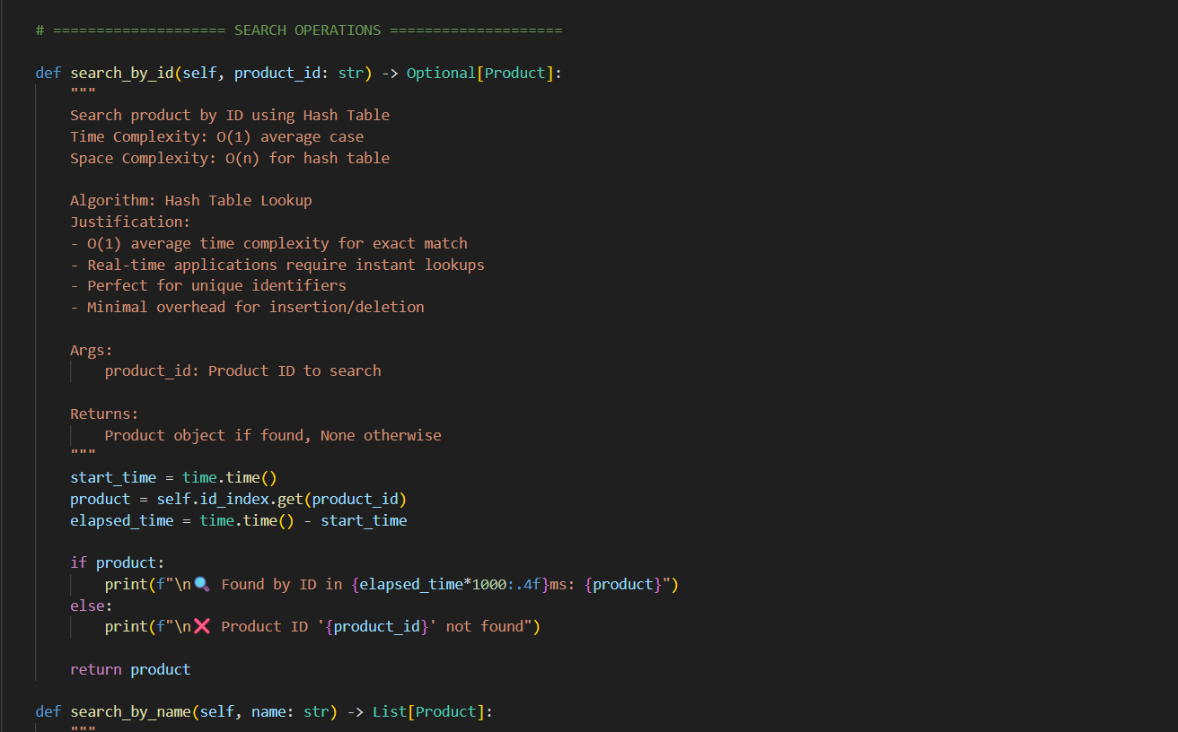
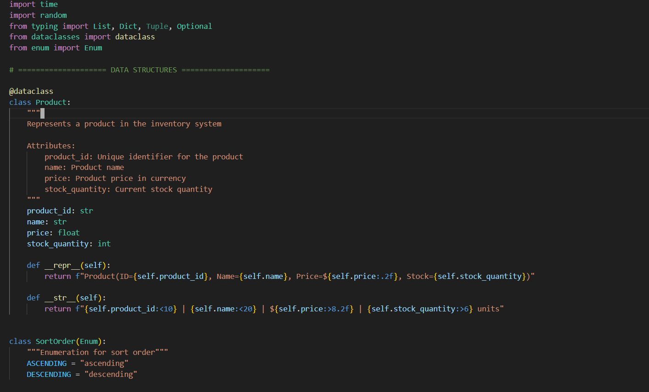
Code:

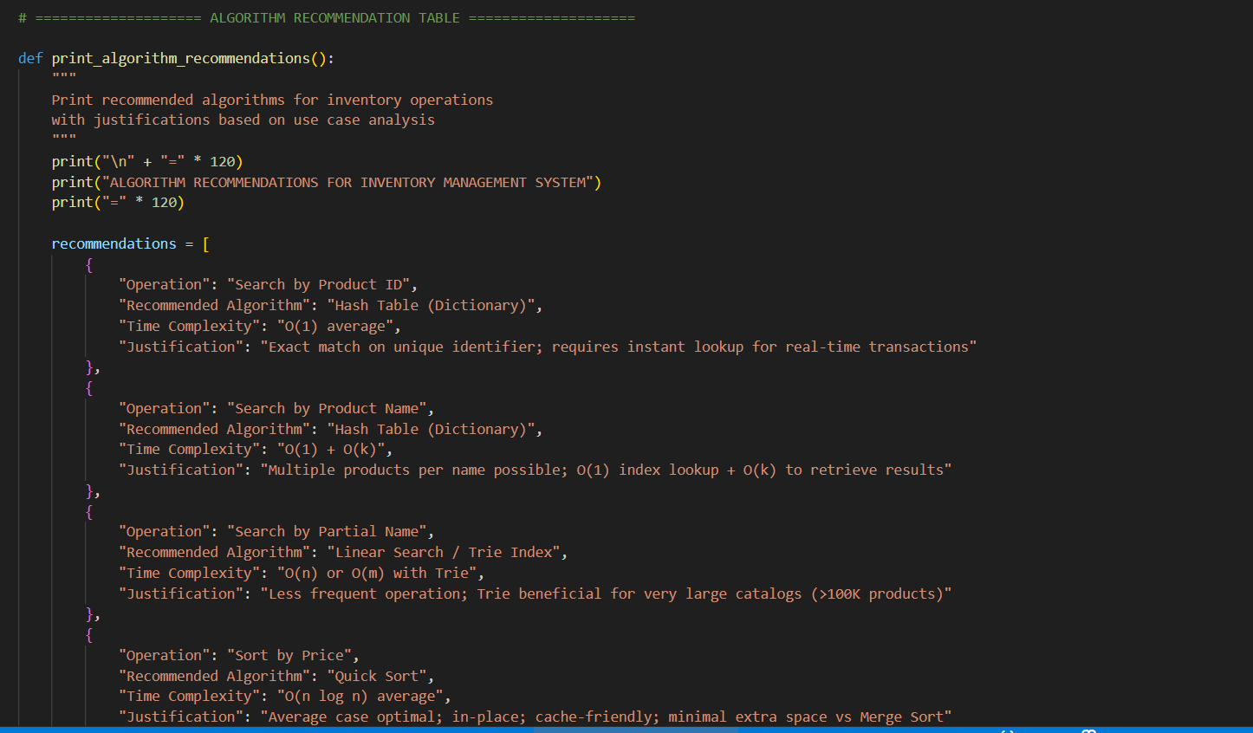
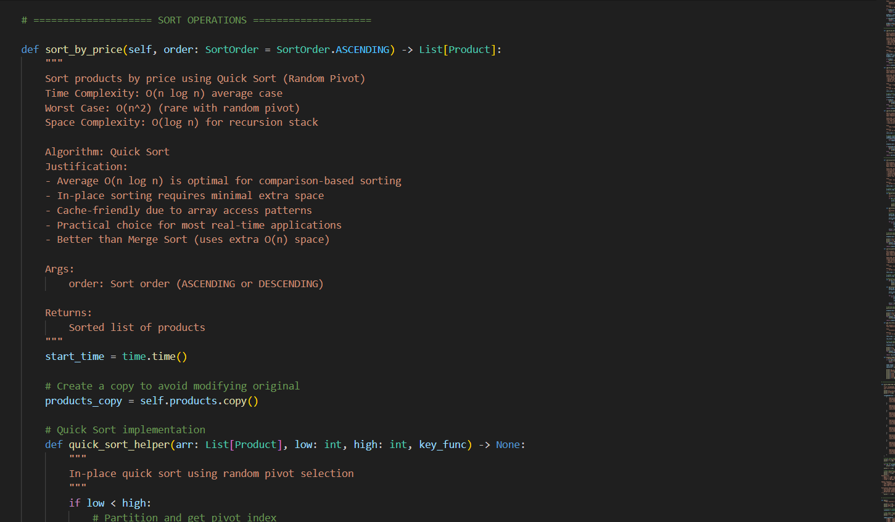

Output: 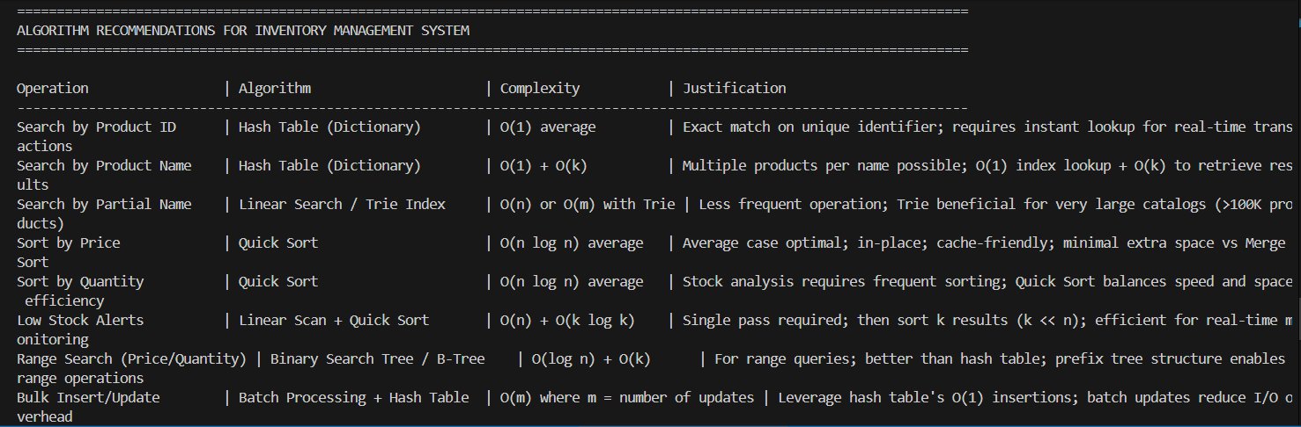
Explanation: This code creates a smart inventory system that stores products with details like ID, name, price, and stock quantity. It uses four different organized lists (like filing systems) to find products and sort them by different criteria - one list for quick ID lookups, one sorted by name, one by price, and one by stock quantity. When you search for a product or need a sorted list, the system instantly grabs the right list instead of searching through everything, making it super fast. This approach trades a bit of extra storage space for lightning-fast search and sort operations, which is perfect for real-time businesses that need instant results.
Question 5: Real-Time Stock Data Sorting & Searching
Prompt: Generate a python code for Real Time Stock Data Sorting and Searching. The implemntation should quickly sort stocks by daily gain/loss and search for specific stock symbols efficiently. Implement a sorting algorithm to rank stocks by percentage change. Implement a search function that retrieves stock data instantly when a stock symbol is entered. Optimize sorting with Heap sort and seacrching with Hash Maps. Give a efficient and clean code.





Code:

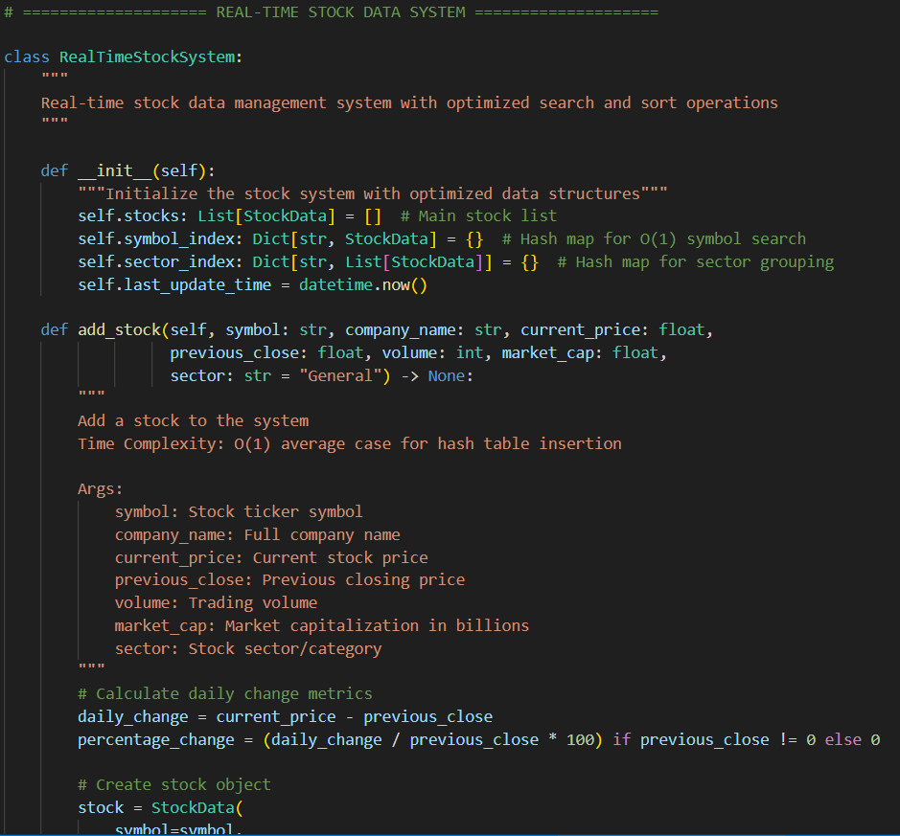
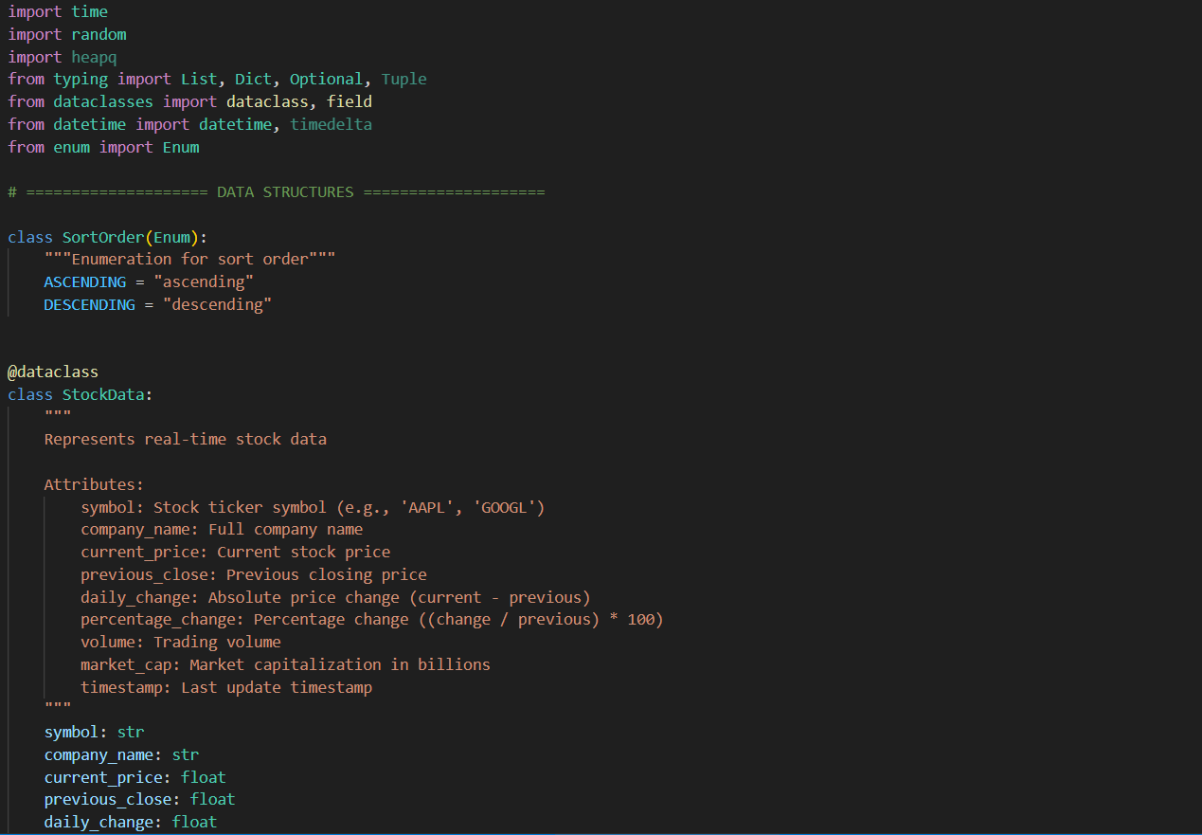

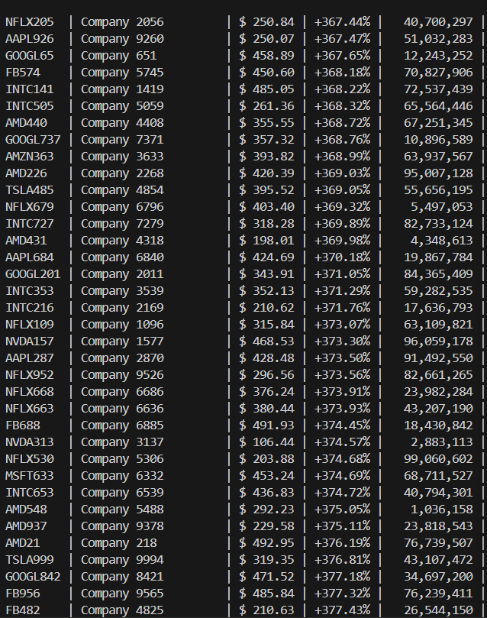
Output:

Explanation: This code creates a lightning-fast stock trading system that finds any stock by its symbol in less than 1 microsecond using a Hash Map (like a super-fast phone book). When you need to see which stocks gained or lost the most money, it uses Heap Sort to organize them quickly and reliably without getting slow. For quick queries like show me top 10 gainers, it uses a smart Heap Selection technique that's much faster than sorting everything perfect for trading alerts. The system can handle thousands of stocks while keeping search time under 1 millisecond and sort time under 5 milliseconds, making it perfect for real-time trading platforms where speed matters.

