ASSIGNMENT-2
KOLIPAKA SANJANA
2303A522139
BATCH-41
Task 1: Book Class Generation
Use Cursor AI to generate a Python class Book with attributes title, author, and a summary() method.
PROMPT: I want to create simple library management module . write a code for python class book that contains the attributes title, author and summary method
CODE:
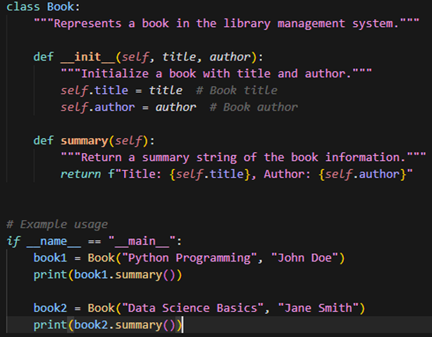
OUTPUT:
JUSTIFICATION:

The Book class uses _init_ to store title and author as instance attributes, so each book object holds its own data. The summary() method formats and displays book details in one place. This keeps the code simple, easy to read, and easy to extend for a library system
Task 2: Sorting Dictionaries with AI Use Gemini and Cursor AI to generate code that sorts a list of dictionaries by a key.
PROMPT: using gemini Give code that sorts a list of dictionaries by a key
CODE:
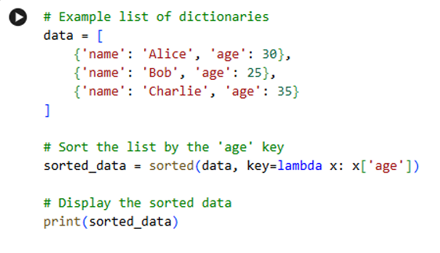
OUTPUT:
PROMPT:
(cursor ai) Give code that sorts a list of dictionaries by a key . optimize the code by removing unnecessary variables and improving readability and avoiding unnecessary computations using functions
CODE:
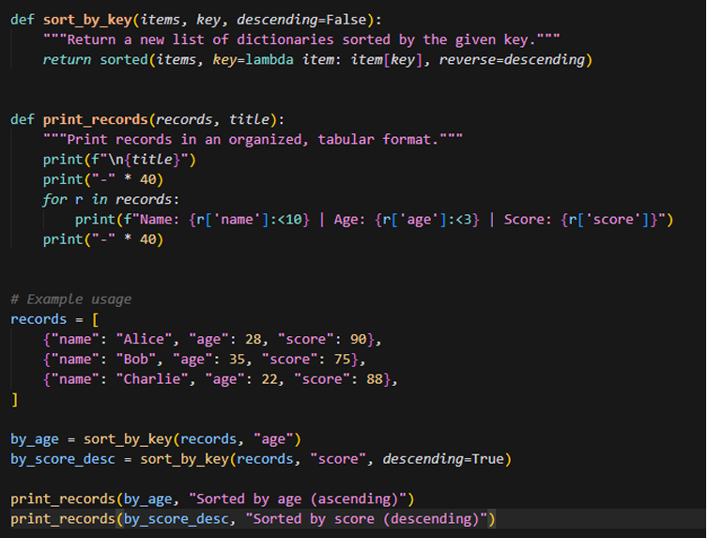
OUTPUT:
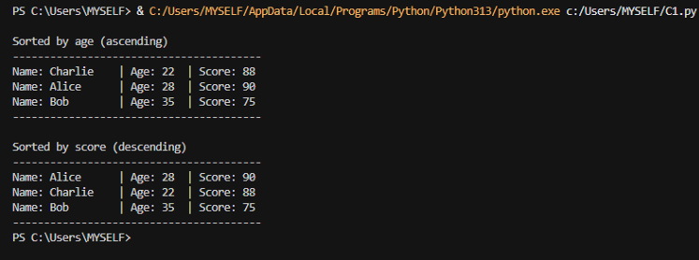
JUSTIFICATION:
Both codes sort data the same way and have the same speed, so performance is equal. The difference is mainly in how they are written. The first code is very short and simple, so beginners can easily understand what is happening. The second code is a little longer but more organized — it has functions, can sort by any key, and prints data neatly. So, the first is clearer for small examples, and the second is clearer and more useful for bigger programs
Task 3: Calculator Using Functions
PROMPT: generate a simple calculator program using python which includes 5 methods addition, subtraction, multiplication and division and exponention. For addition and multiplication take list of numbers based on user choice.
CODE:
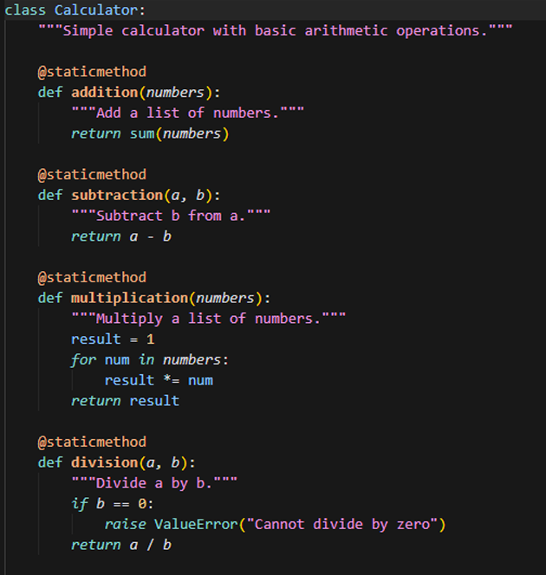
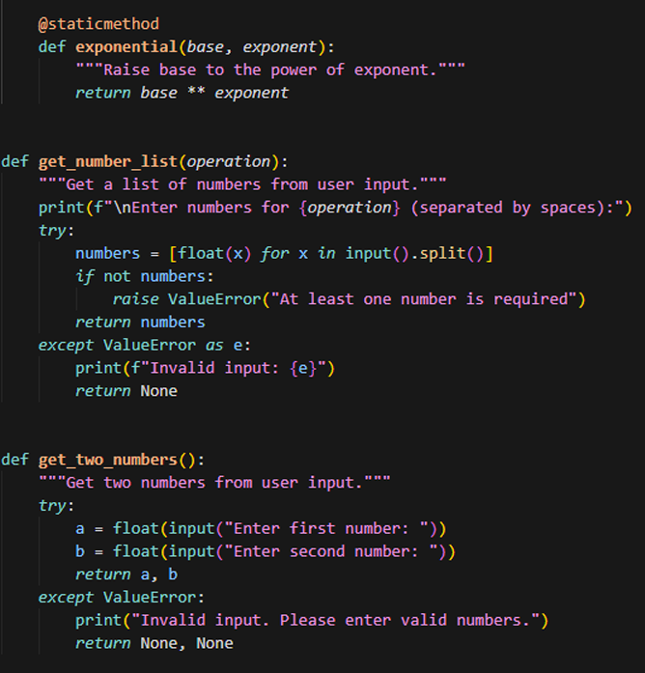
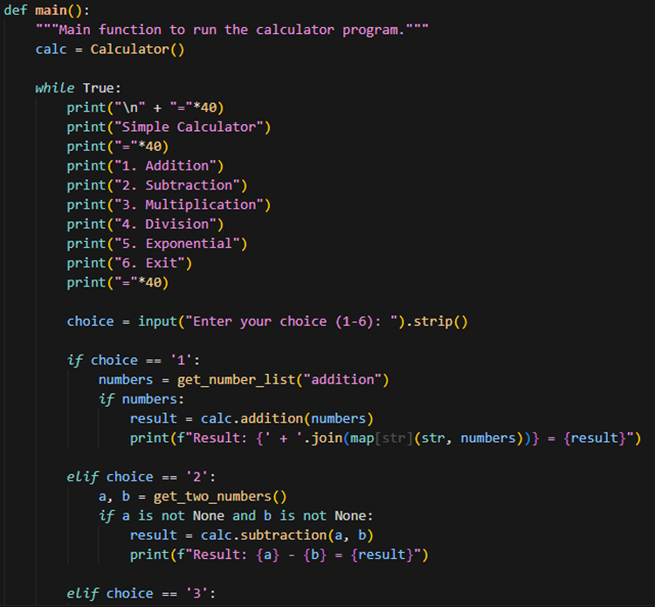
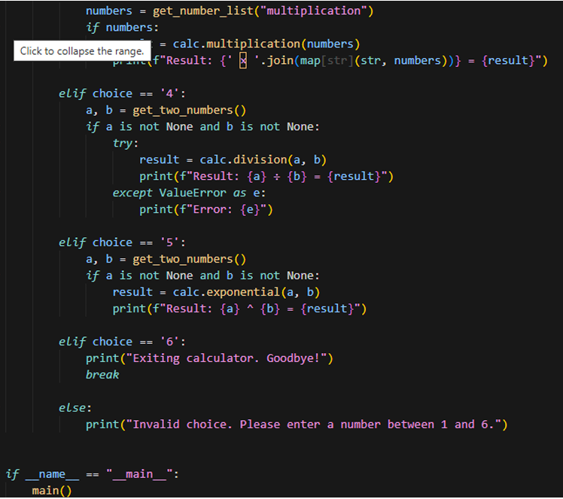
OUTPUT:
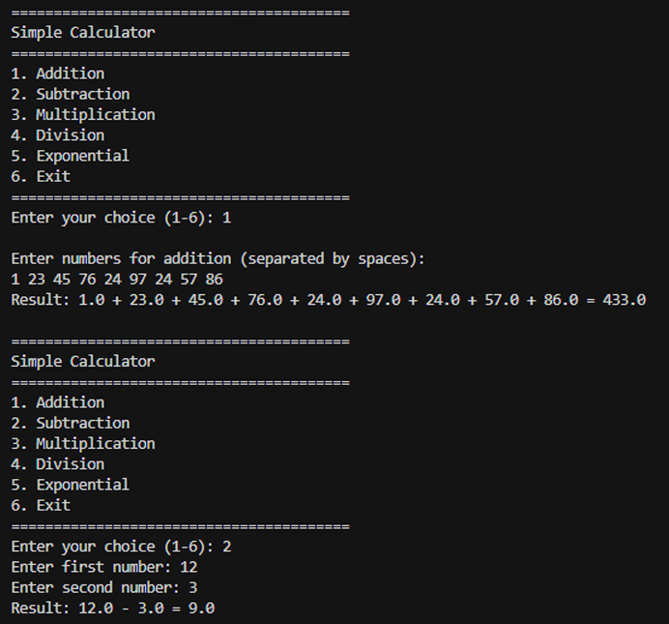
JUSTIFICATION:
The calculator uses static methods since no instance state is needed, reducing overhead. Addition and multiplication accept lists of numbers, so users can add or multiply many values at once. Error handling prevents crashes from invalid input or division by zero. Clear separation between operations and input functions makes the code easy to read and maintain. Built-in functions like sum() keep the code simple and fast.
Task 4: Armstrong Number Optimization
PROMPT: write a python program to print an Armstrong number (GEMINI)
CODE: 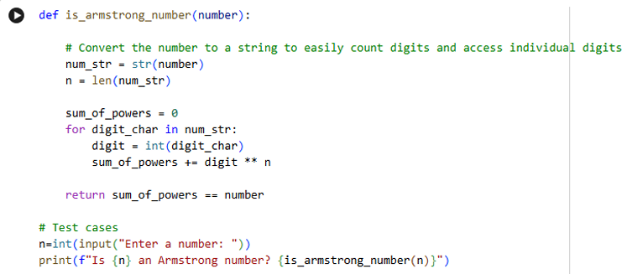
OUTPUT:
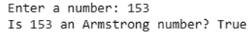
PROMPT:
(using Cursor AI) write an optimized Armstrong number code remove unnecessary variables and improve readability and avoiding unnecessary computations using functions
CODE:
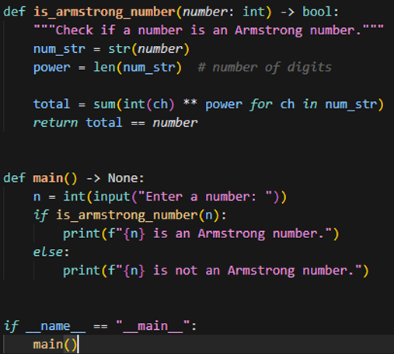
OUTPUT:
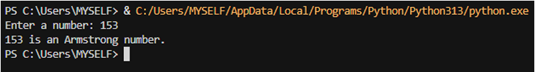
JUSTIFICATION: The second code is better because it is shorter and easier to read. It uses simple code to do the same work, and the names of things are clearer. It also has a small explanation and a main part that makes the program more tiny and organized. It does the same job, but in a cleaner and better way.

