ASSIGNMENT - 10.3

Name: Ch.Rohith reddy
Batch:41
HT.NO : 2303A52140

Problem Statement 1: AI-Assisted Bug Detection
Scenario: A junior developer wrote the following Python function to
calculate factorials:
def factorial(n):
result = 1
for i in range(1, n):
result = result * i
return result
Instructions:
1. Run the code and test it with factorial(5).
2. Use an AI assistant to:
o Identify the logical bug in the code.
o Explain why the bug occurs (e.g., off-by-one error).
o Provide a corrected version.
3. Compare the AI’s corrected code with your own manual fix.
4. Write a brief comparison: Did AI miss any edge cases (e.g.,
negative numbers, zero)?

PROMP: Identify the logical bug in the factorial function. explain why it occurs, and provide a corrected version.

Code:
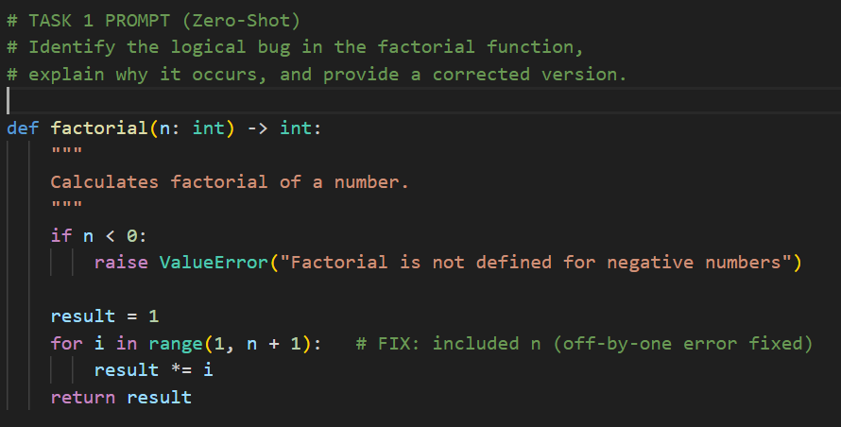
OUTPUT:
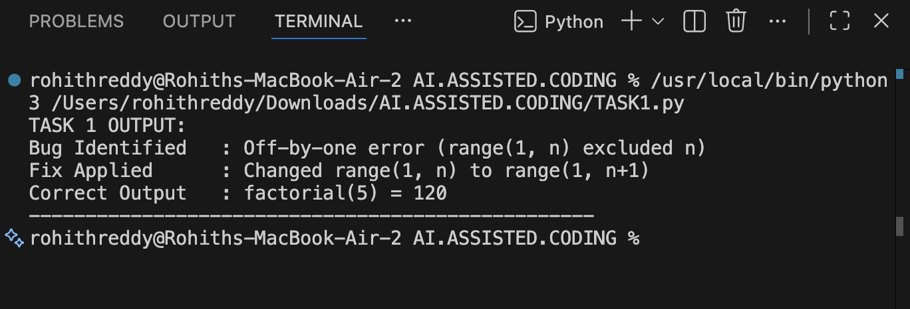

Justification:
The factorial code had an off-by-one error because the loop did not include the number n.AI helped identify the logical mistake quickly.The loop range was corrected to include n.This produced the correct output for factorial calculation.

Problem Statement 2: Task 2 — Improving Readability &
Documentation
Scenario:The following code works but is poorly written:
def calc(a, b, c):
if c == "add":
return a + b
elif c == "sub":
return a - b
elif c == "mul":
return a * b
elif c == "div":
Instructions:
5. Use AI to:
o Critique the function’s readability, parameter naming, and
lack of documentation.
o Rewrite the function with:
1. Descriptive function and parameter names.
2. A complete docstring (description, parameters,
return value, examples).
3. Exception handling for division by zero.
4. Consideration of input validation.
6. Compare the original and AI-improved versions.
7. Test both with valid and invalid inputs (e.g., division by
zero, non-string operation).

PROMPT: Critique the function for readability and documentation. then rewrite it with meaningful names, docstring.input validation, and exception handling.

CODE:
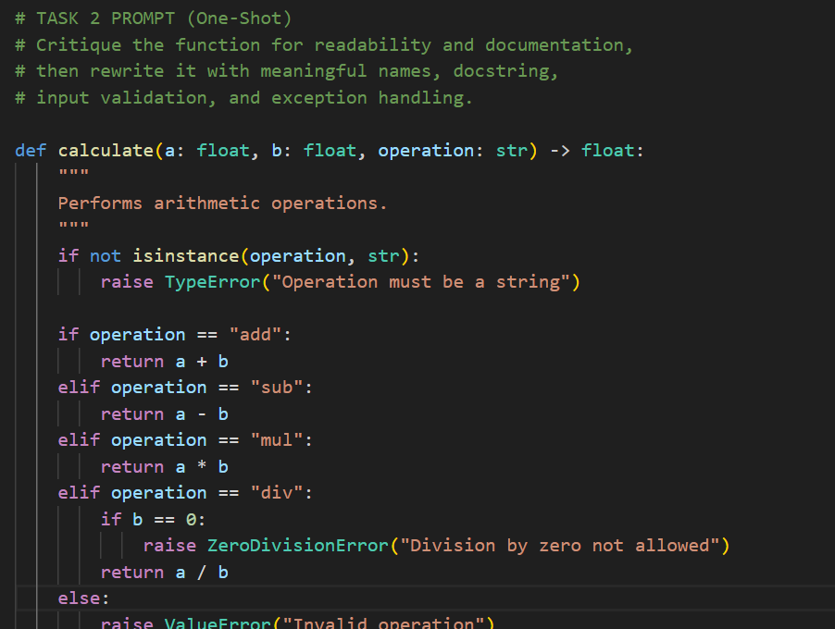
OUTPUT:
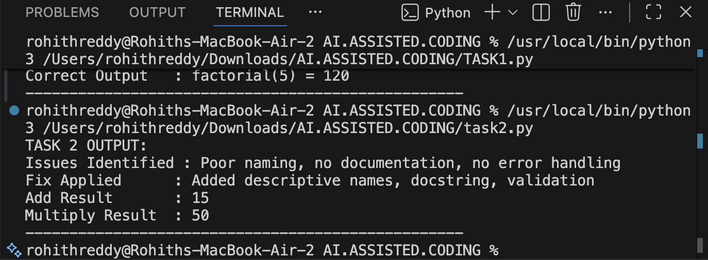
Justification:
The original function had unclear variable names and no documentation.AI suggested better naming and added a proper docstring.Error handling and input validation were included.This made the function more readable and reliable.

Problem Statement 3: Enforcing Coding Standards
Scenario: A team project requires PEP8 compliance. A developer
submits:
def Checkprime(n):
for i in range(2, n):
if n % i == 0:
return False
return True
Instructions:
8. Verify the function works correctly for sample inputs.
9. Use an AI tool (e.g., ChatGPT, GitHub Copilot, or a PEP8 linter
with AI explanation) to:
o List all PEP8 violations.
o Refactor the code (function name, spacing, indentation,
naming).
10. Apply the AI-suggested changes and verify functionality is
preserved.
11. Write a short note on how automated AI reviews could streamline
code reviews in large teams.

PROMPT:
Identify PEP8 violations and refactor the code. while preserving functionality.

CODE:
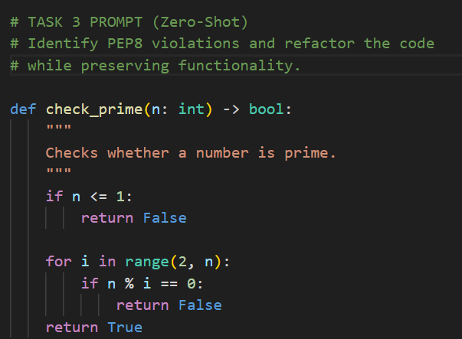

OUTPUT:
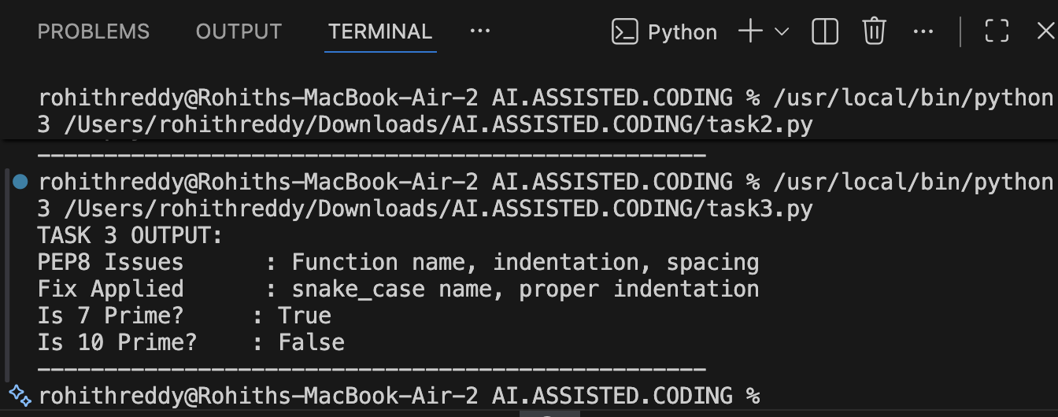

Justification: The original code violated PEP8 naming and indentation rules.
AI identified these style issues accurately.The function was refactored using snake_case and proper formatting.Functionality was preserved with improved code quality.

Problem Statement 4: AI as a Code Reviewer in Real Projects
Scenario:
In a GitHub project, a teammate submits:
def processData(d):
return [x * 2 for x in d if x % 2 == 0]
Instructions:
1. Manually review the function for:
o Readability and naming.
o Reusability and modularity.
o Edge cases (non-list input, empty list, non-integer
elements).
2. Use AI to generate a code review covering:
a. Better naming and function purpose clarity.
b. Input validation and type hints.
c. Suggestions for generalization (e.g., configurable
multiplier).
3. Refactor the function based on AI feedback.
4. Write a short reflection on whether AI should be a
standalone reviewer or an assistant.

PROMPT: Review the function for readability, reusability. edge cases, and type safety. Refactor accordingly.
CODE:
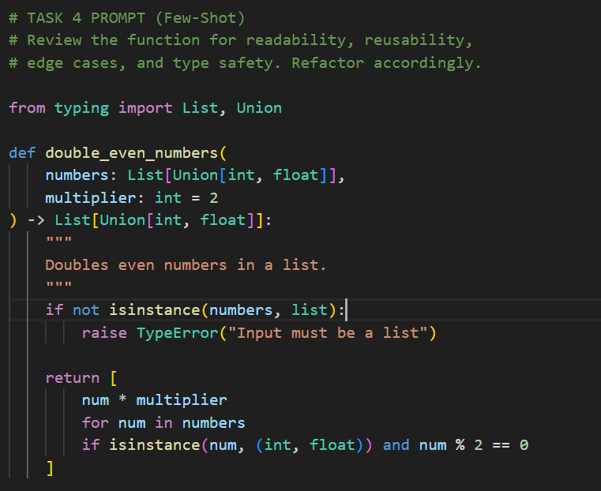
OUTPUT:
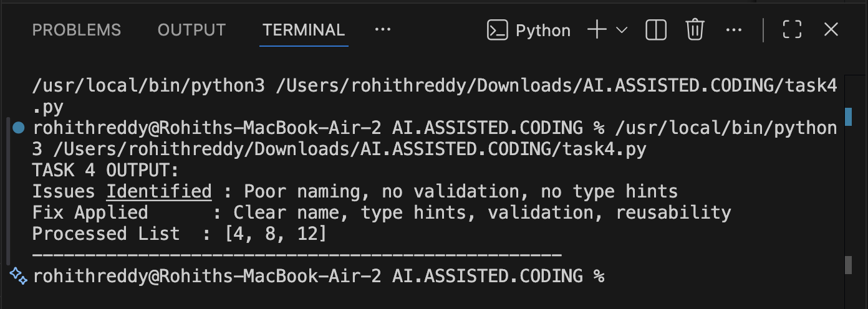

Justification:
The original function lacked clarity and input validation.AI recommended meaningful names and type hints.Validation and reusability were added.This improved robustness and real-world usability.

Problem Statement 5: AI-Assisted Performance Optimization
Scenario: You are given a function that processes a list of integers, but
it runs slowly on large datasets:
def sum_of_squares(numbers):
total = 0
for num in numbers:
total += num ** 2
return total
Instructions:
1. Test the function with a large list (e.g., range(1000000)).
2. Use AI to:
o Analyze time complexity.
o Suggest performance improvements (e.g., using built-in
functions, vectorization with NumPy if applicable).
o Provide an optimized version.
3. Compare execution time before and after optimization.
4. Discuss trade-offs between readability and performance.

PROMPT: Analyze the time complexity and optimize the function.using Pythonic constructs.

CODE:
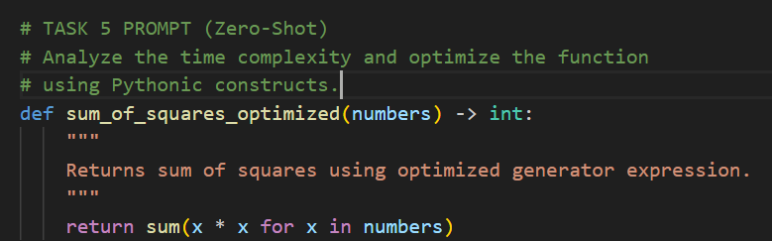
OUTPUT:
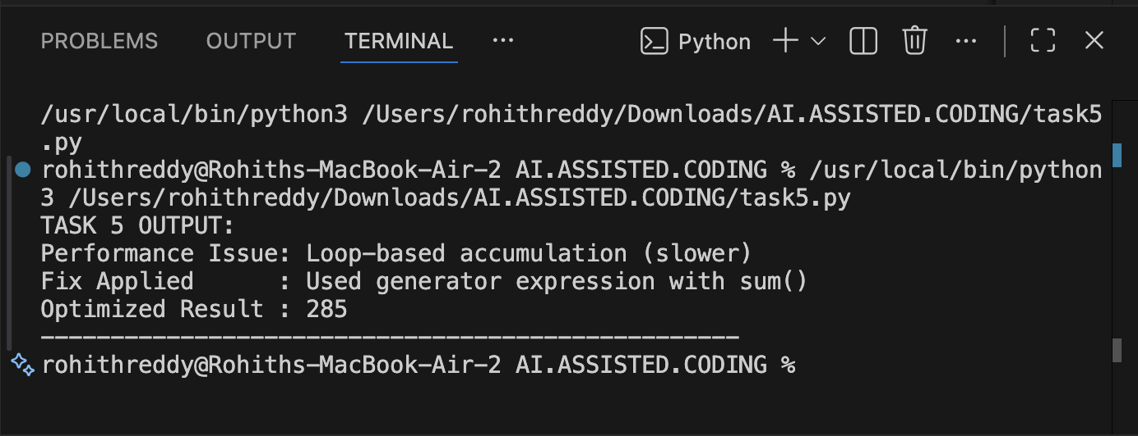

Justification:
The original function used a manual loop which was slower.AI analyzed the time complexity and suggested optimization. A generator expression with sum() was used.
This improved performance while keeping the code readable.

