Name: B.Pooja
Hall Ticket: 2303A52141
Batch: 41
Task 1: Student Performance Evaluation System
Prompt:
Create a Python class named Student with attributes name, roll_number, and marks, then use comments or partial method names to let GitHub Copilot generate a method to display student details and another method that uses an if-else condition to check whether the student’s marks are above the class average and return a performance message, using proper self attributes and clear, readable code

Code:
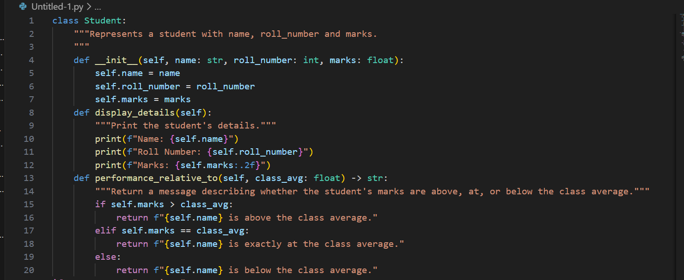
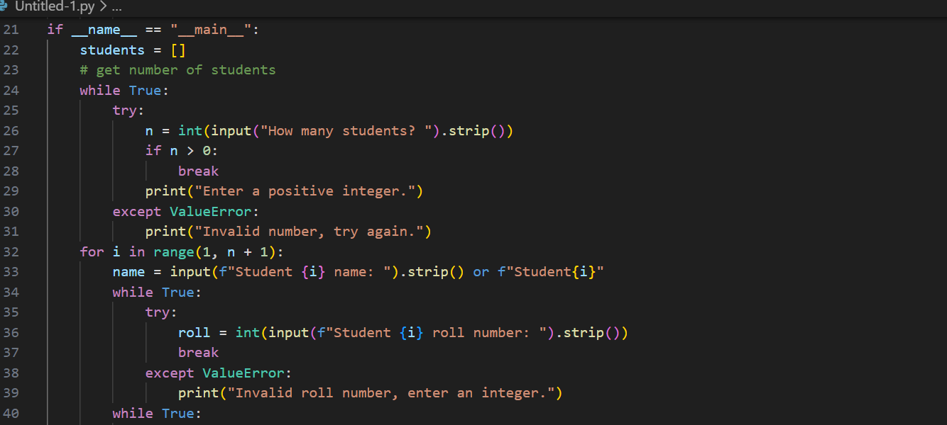
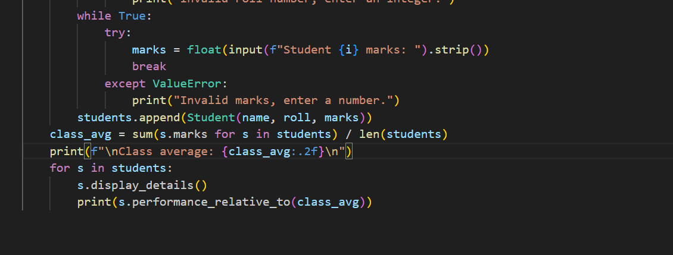

Output:

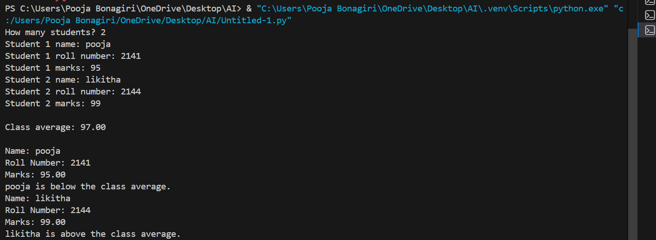

Explanation:
The generated code defines a Student class with essential attributes such as name, roll number, and marks, ensuring proper data encapsulation using self. It includes a method to display student details in a clear and readable format, demonstrating how class data can be accessed and presented. Another method uses an if-else conditional statement to compare the student’s marks with the class average and determine performance status. Overall, the output shows correct use of object-oriented concepts, conditional logic, and produces meaningful results for evaluating student performance.
Task 2: Data Processing in a Monitoring System
Prompt:

Identify even sensor readings from a list, calculate the square of each even number, and print the result in a readable format inside a for loop.

Code:
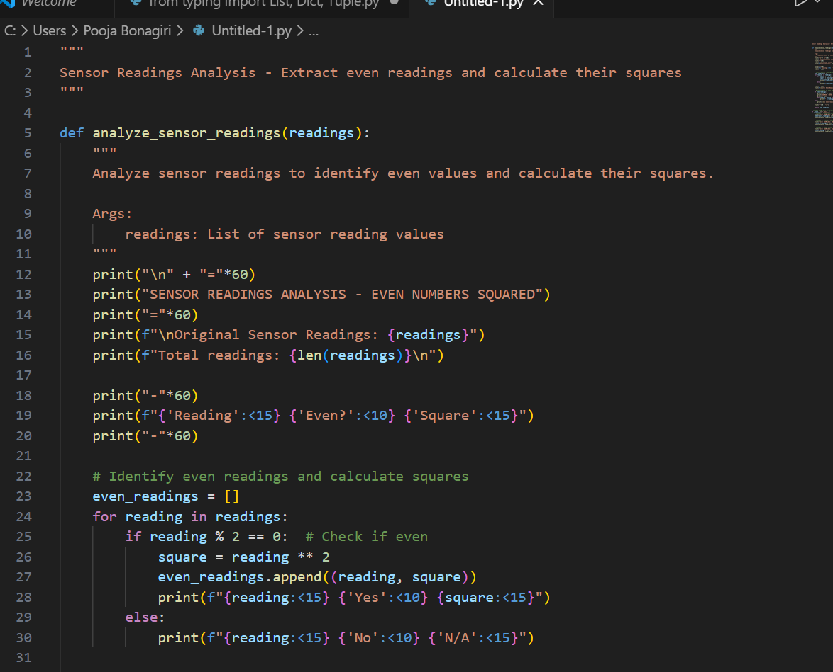
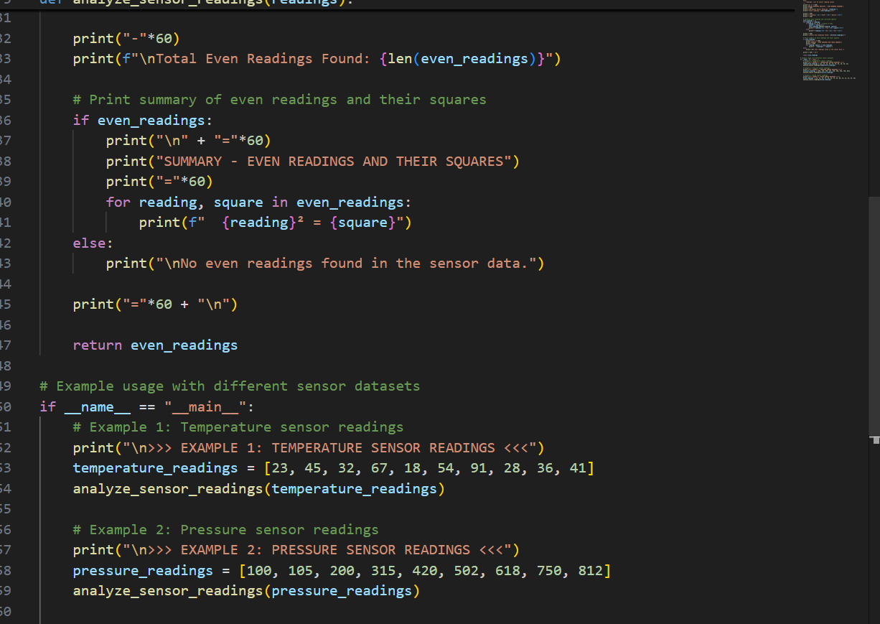
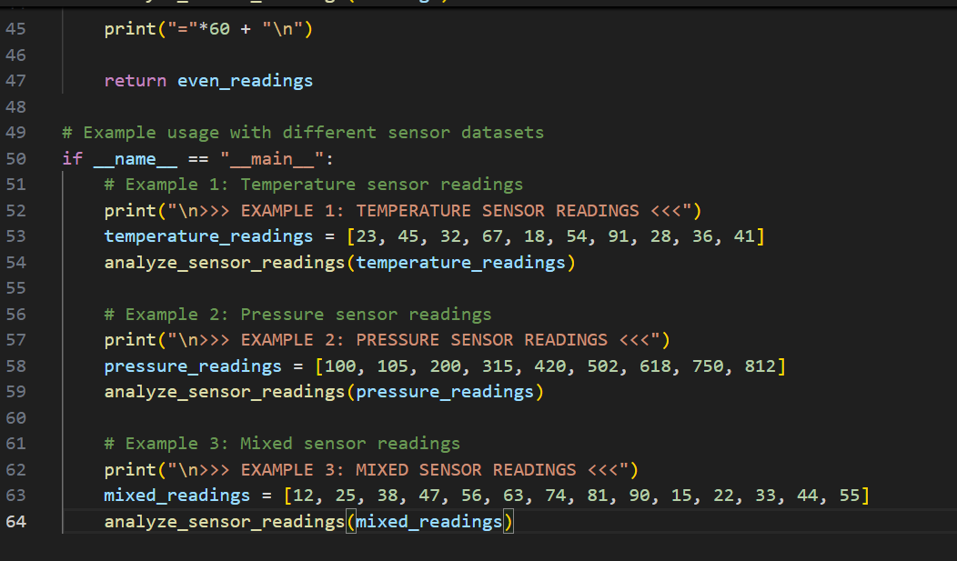
Output:
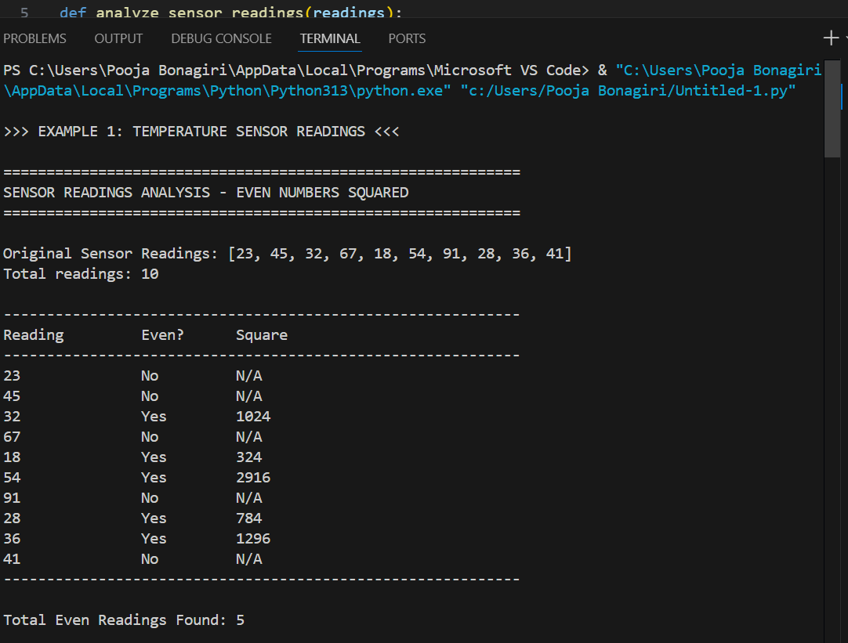
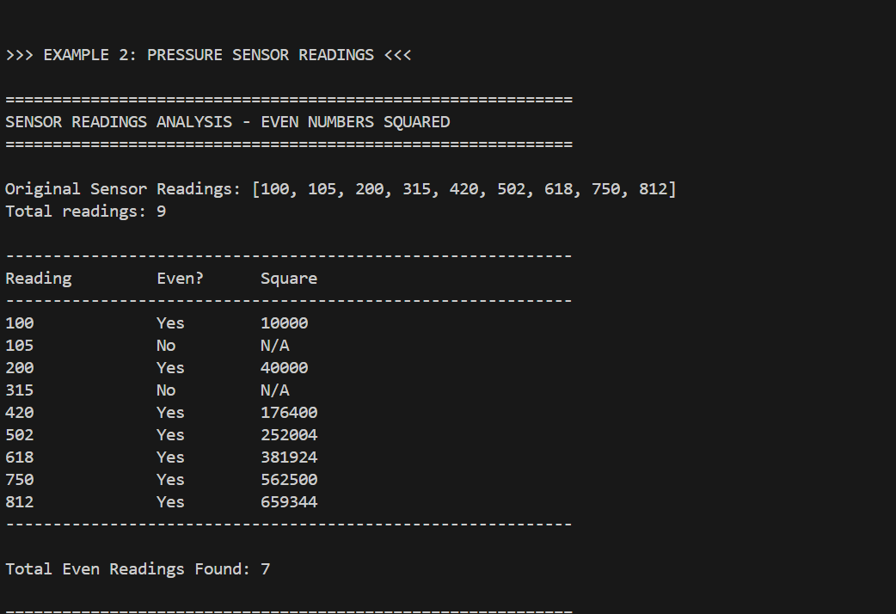

O

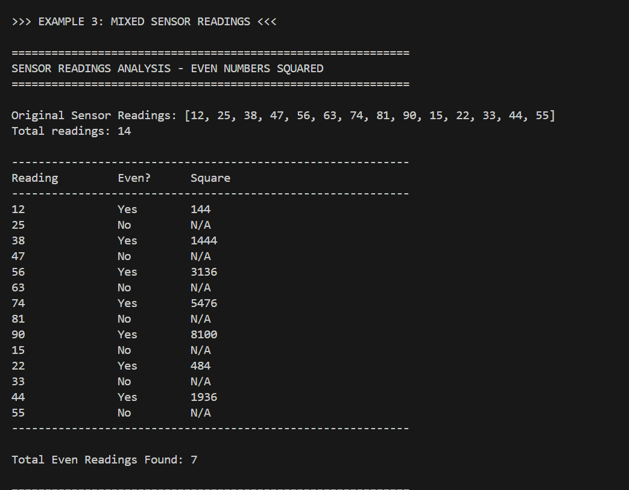
Explanation:
This program is used to analyze sensor readings by checking each value in a list and identifying which readings are even numbers. It starts by displaying the original sensor data and the total number of readings. Then, it goes through each reading one by one; if a reading is even, the program calculates its square and displays it, and if the reading is odd, it marks it as not even and does not calculate a square. All even readings along with their squared values are stored for later use. After processing all the readings, the program prints a summary showing how many even readings were found and lists each even number with its square. The same function is reused for different sensor datasets like temperature, pressure, and mixed readings, showing that the code is reusable, clear, and easy to understand.

Task 3: Banking Transaction Simulation
Prompt:
Create a Python class named BankAccount for a simple banking transaction system. First, define the class with an __init__ method that initializes the attributes account_holder and balance. Then, using method names and short comments, let GitHub Copilot generate a deposit method to add money to the balance and a withdraw method that subtracts money only if sufficient balance is available, using if-else conditions, proper self attributes, and clear, user-friendly messages for invalid withdrawal attempts.
Code:

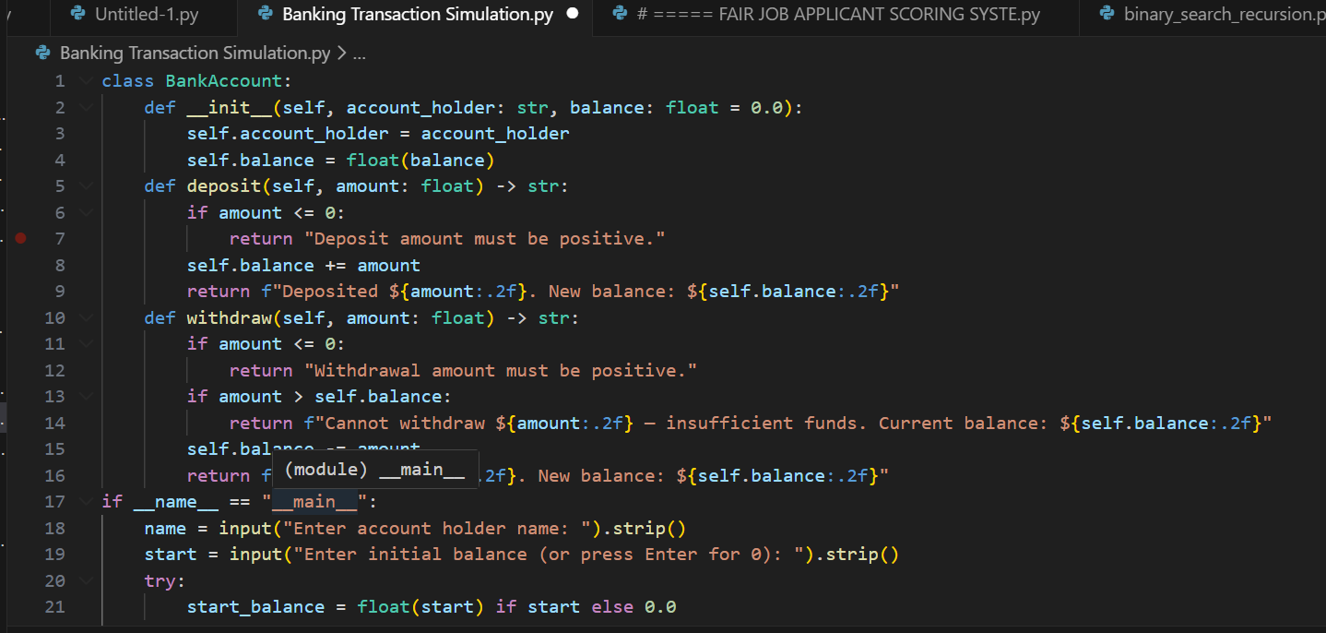
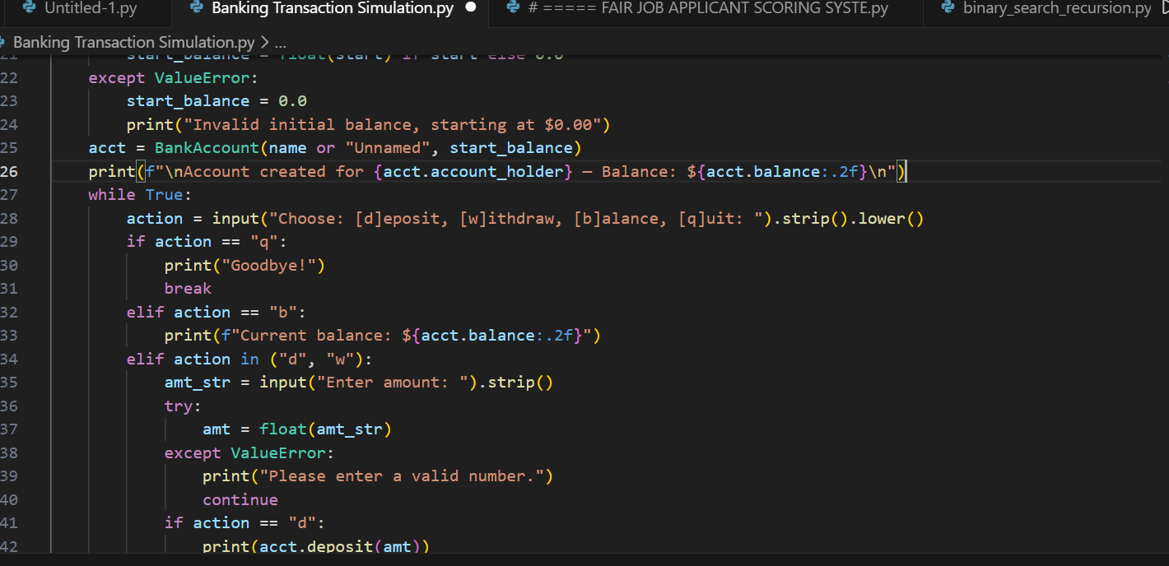
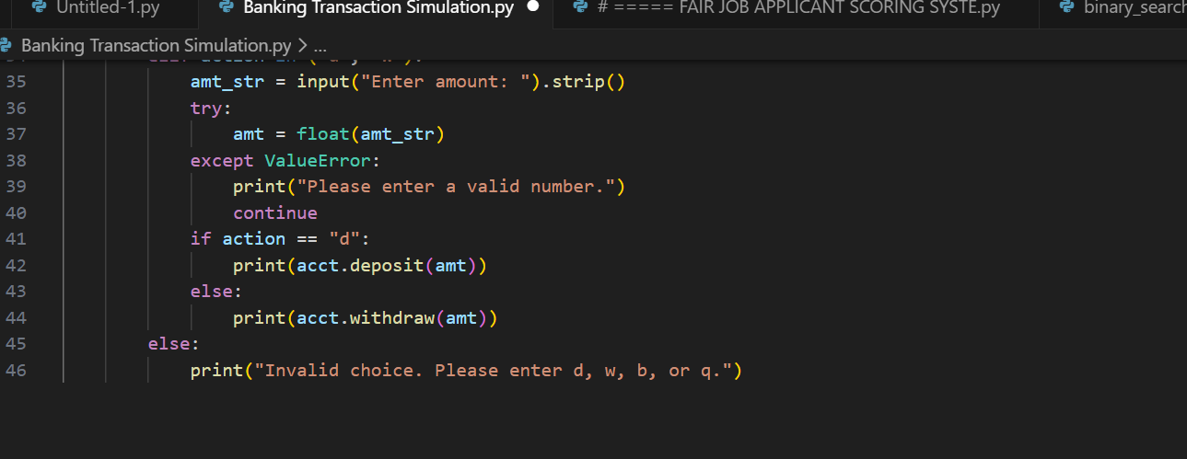

Output:

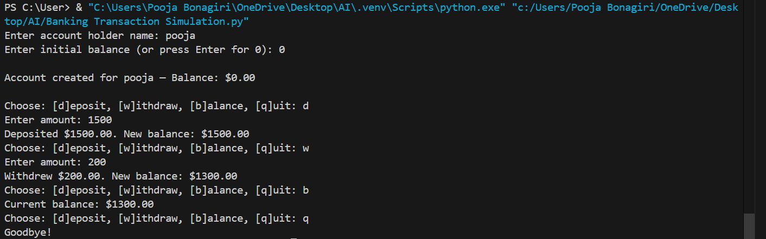

Explanation:

The generated code represents a simple banking system using a BankAccount class that stores the account holder’s name and current balance. The deposit method increases the balance when a valid amount is added, while the withdrawal method uses if-else conditions to check whether sufficient funds are available before allowing the transaction. If the balance is too low, the code prevents the withdrawal and displays a clear, user-friendly message. Overall, the output demonstrates correct use of class attributes with self, conditional logic, and safe handling of basic banking transactions.
Task 4: Student Scholarship Eligibility Check
Prompt:
Create a Python program to check student scholarship eligibility. First, define a list of dictionaries where each dictionary contains a student’s name and score. After initializing the list, write comments to guide GitHub Copilot to generate a while loop that iterates through the list using an index, checks if a student’s score is greater than 75, and prints the names of eligible students in a clean and readable format.

Code:

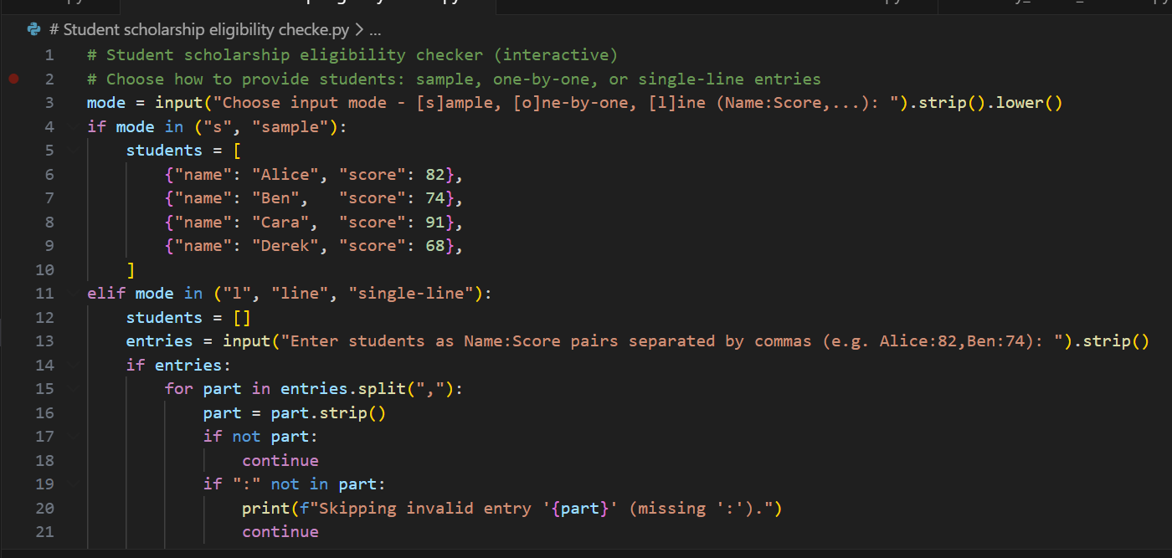
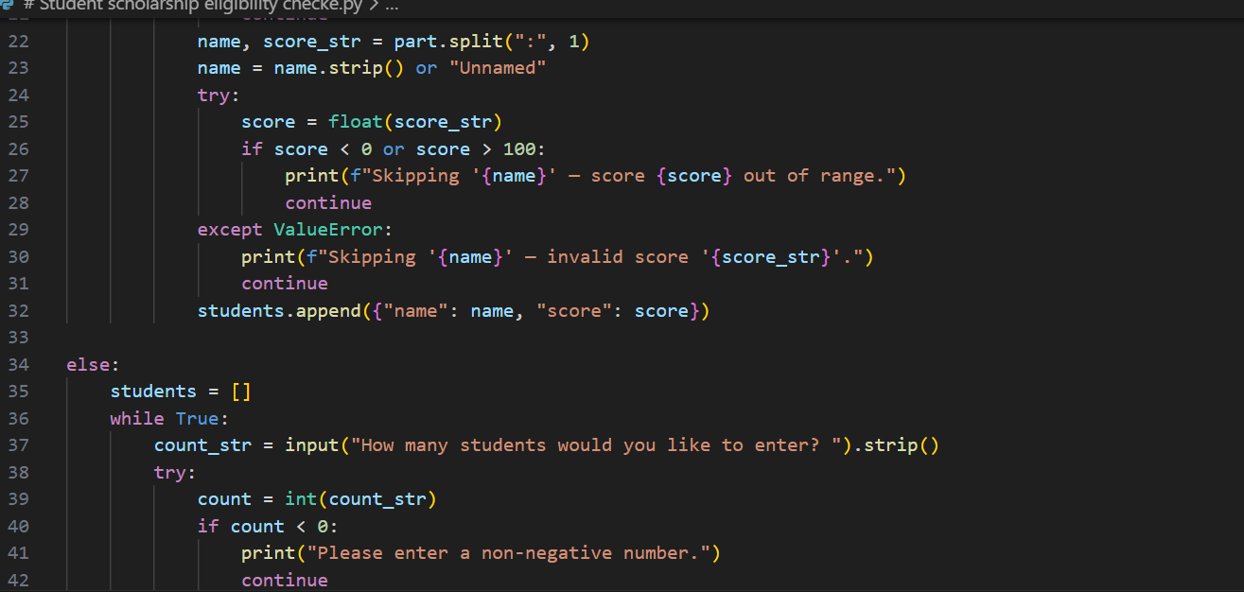

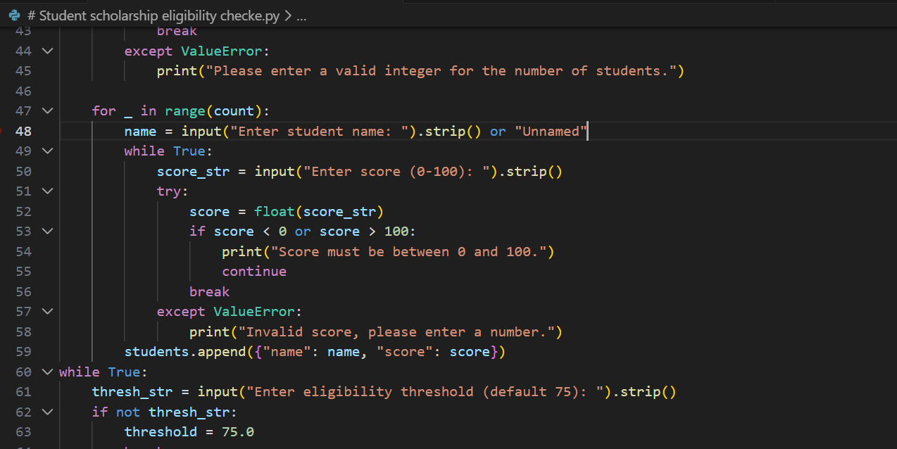

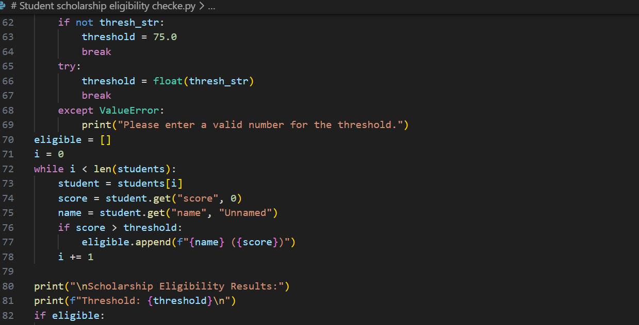
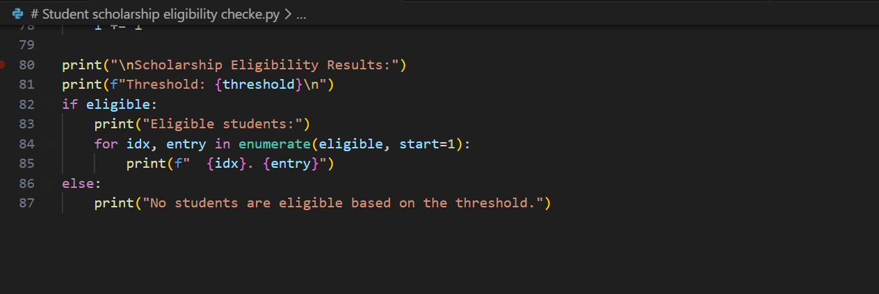
Output:

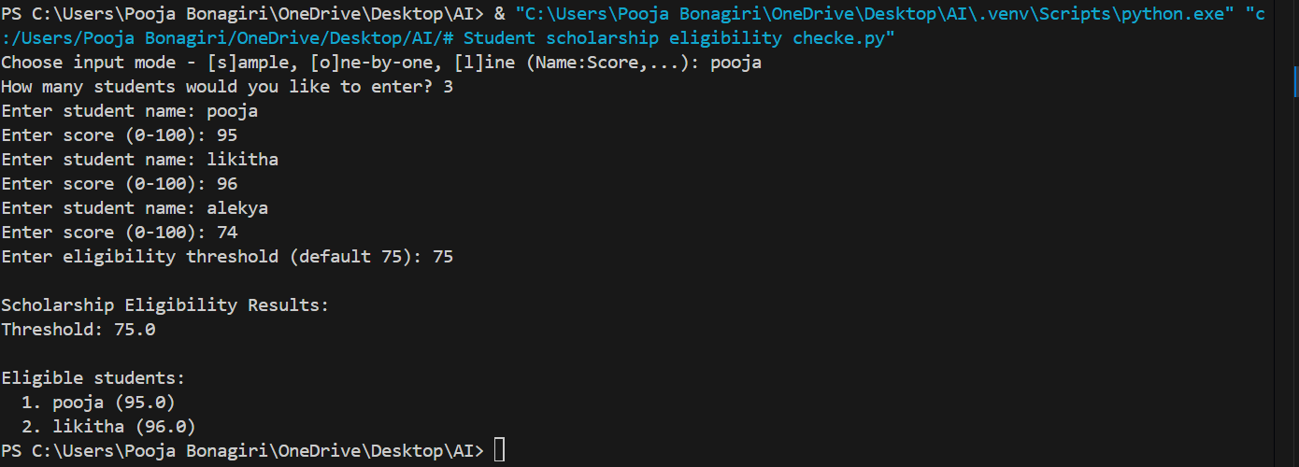

Explanation:
The generated code stores student details in a list of dictionaries, making the data easy to manage and access. A while loop is used to iterate through the list by maintaining an index, demonstrating correct loop control and condition checking. Inside the loop, an if statement checks whether a student’s score is above 75, and eligible students’ names are printed. The output clearly lists students who qualify for the merit-based scholarship, showing proper use of loops, conditions, and structured data.

Task 5: Online Shopping Cart Module
Prompt:
Create a Python class named ShoppingCart for a simple online shopping system. Start by initializing an empty list to store cart items, where each item contains a name, price, and quantity. Then, using clear method names and meaningful comments, guide GitHub Copilot to generate methods to add items to the cart, remove items from the cart, calculate the total bill using a loop, and apply a conditional discount when the total amount exceeds a specified limit. Ensure the code uses proper self attributes, loops, and if-else conditions, and include a small example to demonstrate adding items, removing items, and displaying the final bill.
Code:
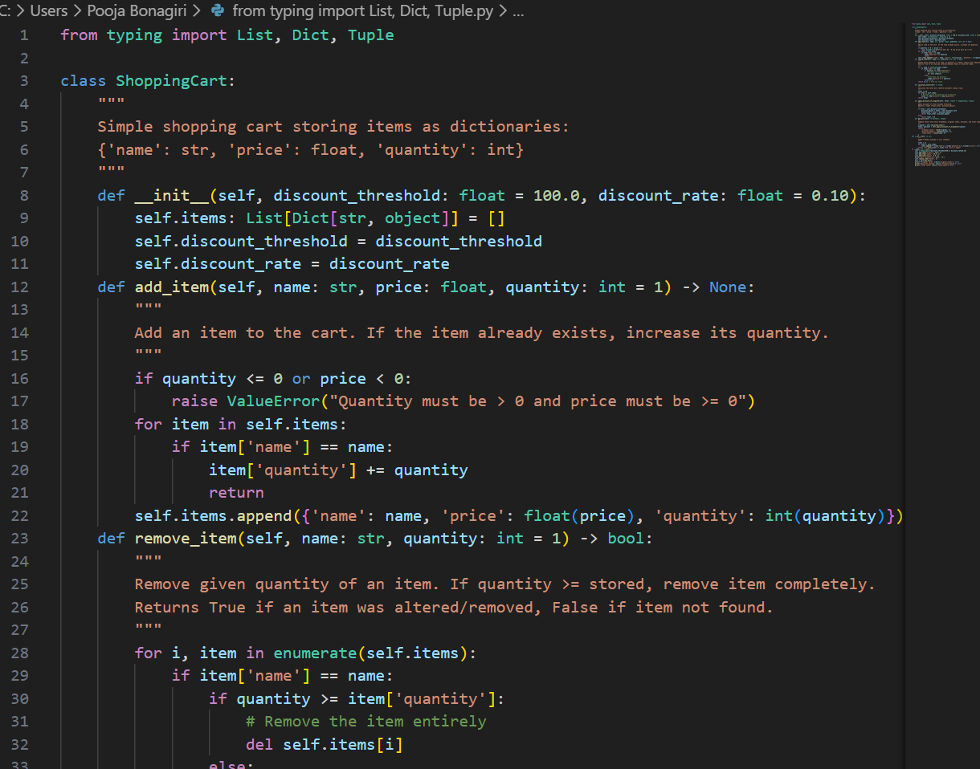
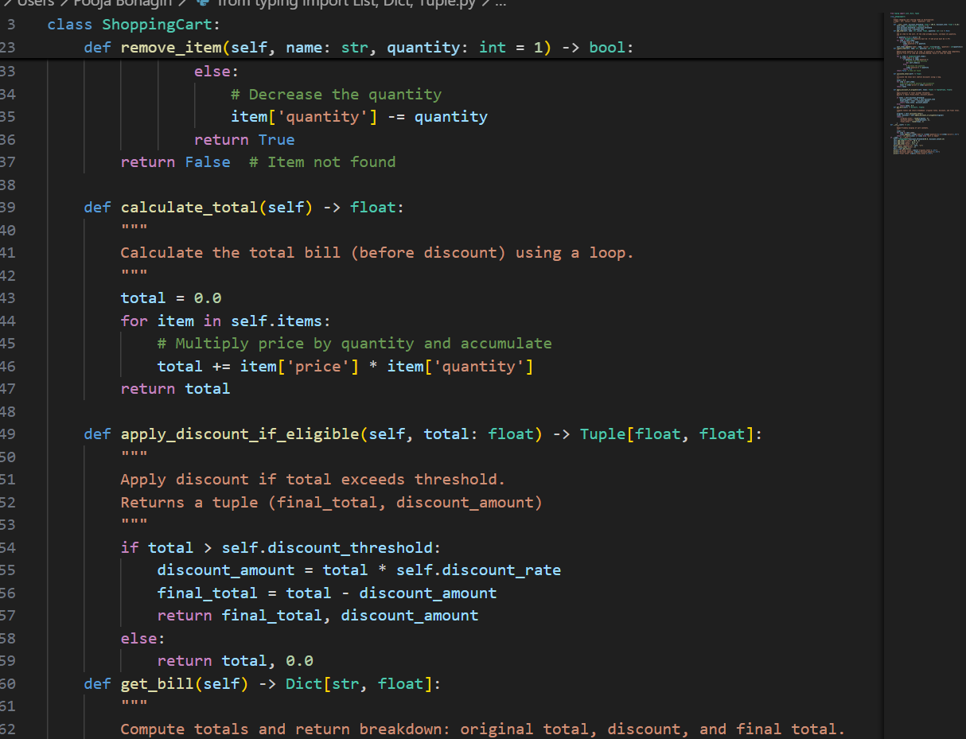
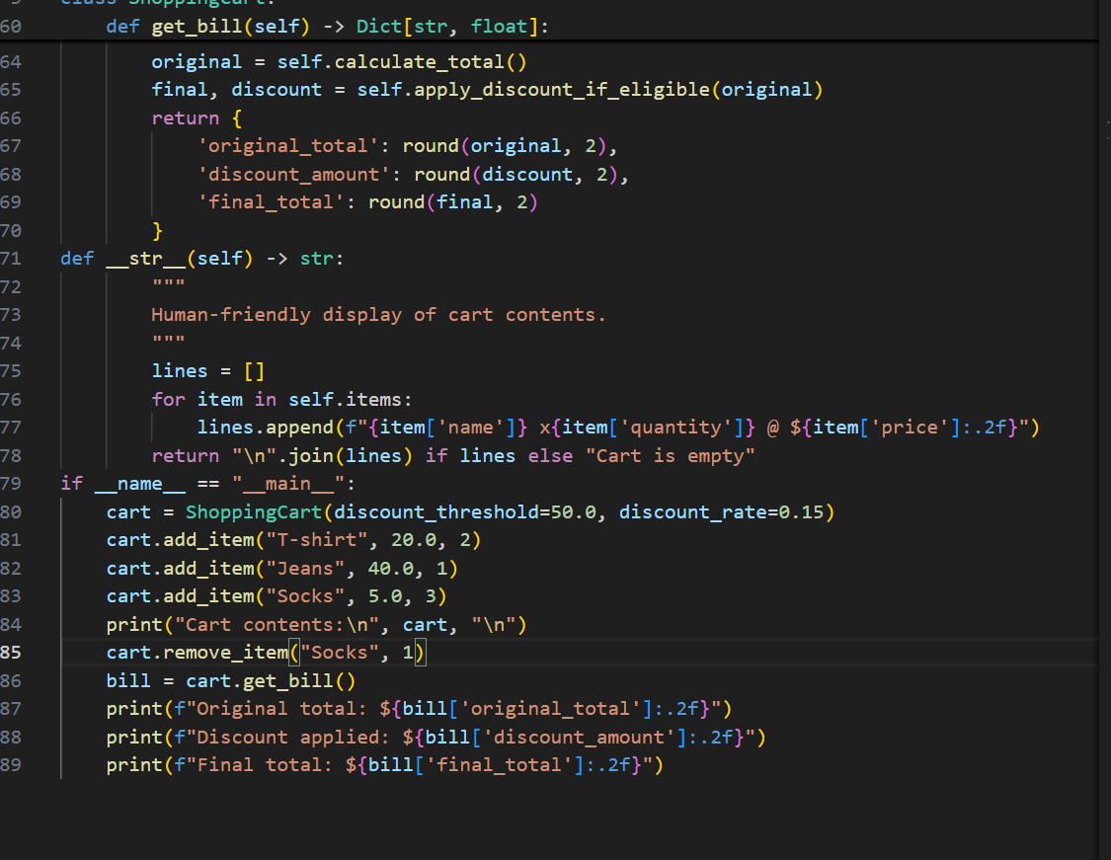
Output:
Explanation:
The generated ShoppingCart class simulates a basic e-commerce cart system by maintaining a list of items with their names, prices, and quantities. Methods for adding and removing items allow dynamic cart management, while a loop is used to calculate the total bill based on item prices and quantities. Conditional statements are applied to offer discounts when the total amount exceeds a predefined threshold, demonstrating decision-making logic. The sample input and output clearly show how items are managed in the cart and how the final payable amount is calculated, highlighting correct use of object-oriented concepts, loops, and conditional logic.

