Name: B.Pooja
Hall Ticket2303A52141
Batch: 41

Task 1: Fixing Syntax Errors
Prompt:
Analyze the following Python code and identify any syntax errors present in it.Correct the function definition so that it follows proper Python syntax.Explain the cause of the syntax error in simple terms.Finally, provide the corrected code along with its correct output.
Given Code:
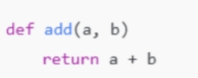
Corrected code:
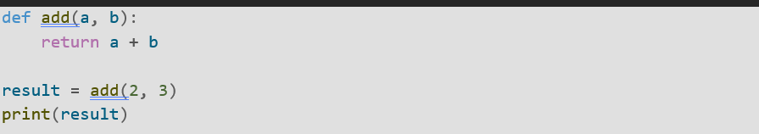
Explanation:
The syntax error occurs because Python function definitions must end with a colon (:).In the original code, the colon after def add(a, b) is missing.Adding the colon fixes the syntax error and allows the function to run correctly.
Task 2: Debugging Logic Errors in Loops
Prompt:
Examine the given code that contains a loop-related error.Identify the issue in the loop where the counter is not updating correctly, causing an infinite loop.Modify the loop by fixing the increment or decrement logic so it terminates properly.Explain the reason for the infinite iteration and describe how the corrected logic changes the loop’s behavior.

Given Code:
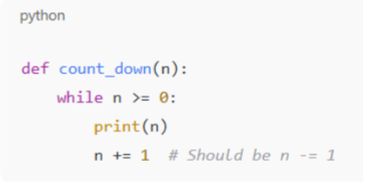
Corrected code:
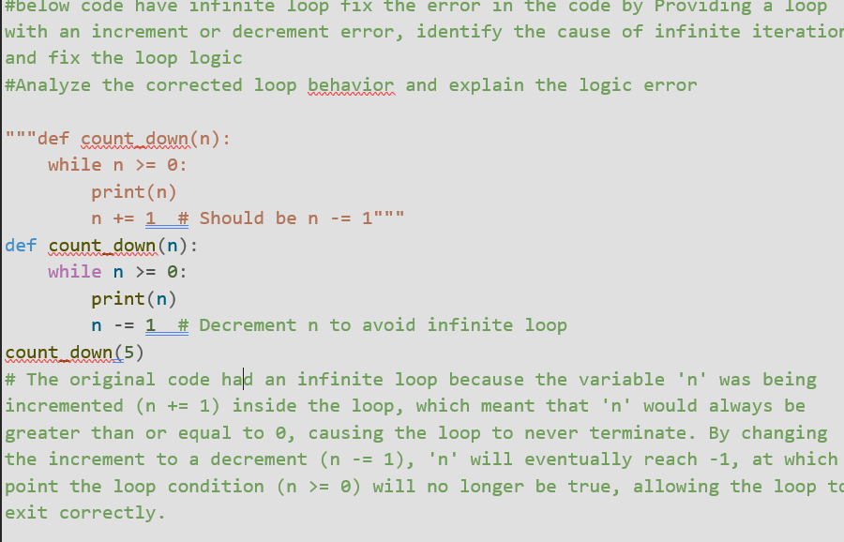
Explanation:
The loop runs infinitely because the loop control variable is not updated correctly inside the loop.Since the increment or decrement statement is missing or incorrect, the loop condition never becomes false.
As a result, the loop continues to execute without stopping.By correcting the increment or decrement logic, the loop variable changes on each iteration.This ensures that the loop eventually meets the stopping condition and terminates as expected.

Task 3: Handling Runtime Errors (Division by Zero)
Prompt:
Review the given Python program and identify the runtime error that occurs during execution.The function performs a division operation without checking the divisor value.Modify the code by adding appropriate try–except blocks to safely handle a division by zero scenario.Explain the error-handling approach used and describe how it prevents the runtime error.
Given Code:
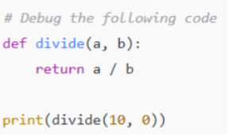
Corrected code:

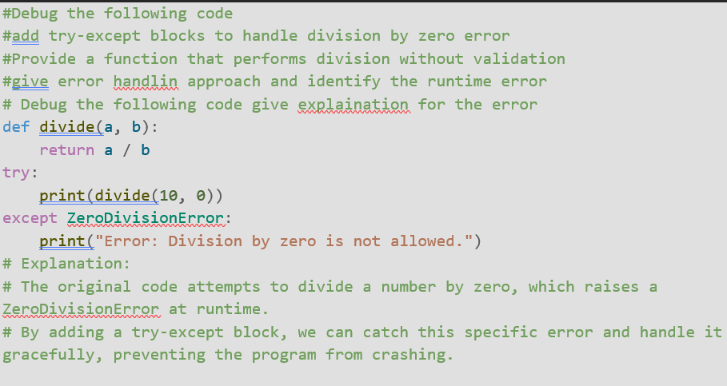
Explanation:
The runtime error occurs when the program attempts to divide a number by zero, which is not allowed in Python.This causes a ZeroDivisionError during program execution.By using a try-except block, the risky division operation is placed inside the try section.If division by zero occurs, the except block catches the error and displays a meaningful message instead of crashing the program.
This error-handling approach makes the program more reliable and prevents unexpected termination.
Task 4: Debugging Class Definition Errors
Prompt:
The class definition contains an error because the self parameter is missing in the __init__() method.In Python, self is required to refer to the current object of the class.
Without self, the instance variables cannot be accessed or stored correctly.
Given code:
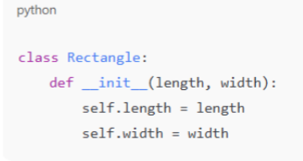
Corrected code:
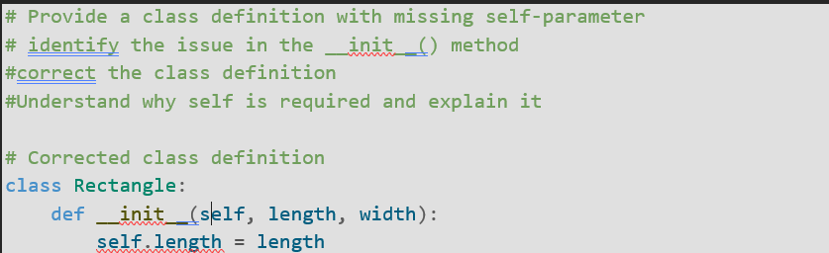
Explanation:
n Python, self refers to the current object of a class.It is required in the __init__() method to store and access instance variables.When an object is created, Python automatically passes the object reference as self.If self is missing, the class cannot correctly assign values to its variables.Therefore, using self is necessary for proper object initialization and functionality.

Task 5: Resolving Index Errors in Lists
Prompt:
The error occurs because the program requests a list position that does not exist.To prevent this, bounds checking ensures the index is within the list’s valid size before accessing it.Alternatively, exception handling captures the error if it occurs and allows the program to continue safely.Both approaches avoid program crashes and improve reliability.
Given code:
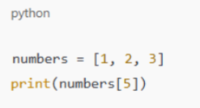
Corrected code:
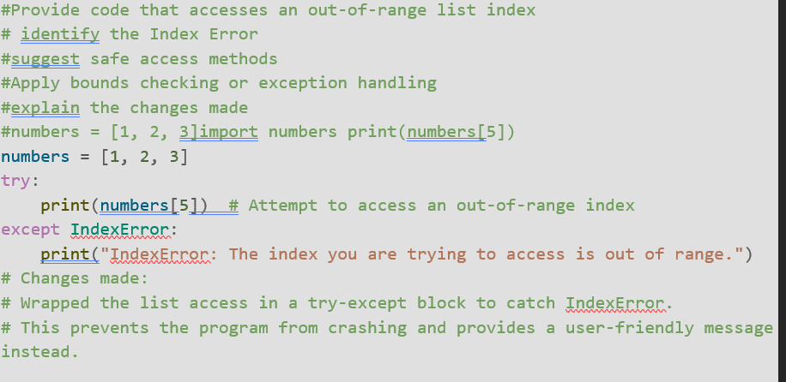
Explanation:
The list contains only three elements, but the program attempts to read an element beyond its valid range.Since that index does not exist, Python throws an IndexError.The code places the unsafe operation inside a try block to monitor for errors.When the invalid access occurs, the except block catches the error and prevents the program from terminating abruptly.As a result, the program continues running and displays a clear message instead of failing.

