Name: B.pooja
Hall Ticket: 2303A52141
Batch: 41
Task 1 Stack Implementa on for Undo Opera ons (LIFO)
Prompt:
Write a Python code to implement a Stack class for undo operations using push, pop, peek, and is_empty methods, following the LIFO (Last In, First Out) principle.
The stack ensures that the most recent action is undone first, making it suitable for implementing undo functionality.
Code:
class Stack:
"""Implements a Last-In-First-Out (LIFO) stack data structure."""
def __init__(self):
"""Initializes an empty stack.""" self._items = []
def push(self, action):
"""Adds an item (action) to the top of the stack.

Args: action: The item to be added to the stack.
""" self._items.append(action)
def pop(self):
"""Removes and returns the item from the top of the stack.

Raises:
IndexError: If the stack is empty.

Returns: The item removed from the top of the stack.
""" if self.is_empty():
raise IndexError("Cannot pop from an empty stack") return self._items.pop()
def peek(self):
"""Returns the item at the top of the stack without removing it.
Raises:
IndexError: If the stack is empty.

Returns:
The item at the top of the stack.
""" if self.is_empty():
raise IndexError("Cannot peek into an empty stack") return self._items[-1]

def is_empty(self):
"""Checks if the stack is empty.

Returns:
True if the stack is empty, False otherwise.
"""
return len(self._items) == 0
def size(self):
"""Returns the number of items in the stack.

Returns:
The number of items in the stack.
"""
return len(self._items)
def __str__(self):
"""Returns a string representation of the stack.""" return str(self._items)

def main_stack_interaction():
undo_stack = Stack() print("--- Interactive Stack Operations (List-based) ---")
while True:
print("\nCurrent Stack: ", undo_stack) print("1. Push (add action)") print("2. Pop (undo last action)") print("3. Peek (view last action)") print("4. Check if Empty") print("5. Exit")
choice = input("Enter your choice (1-5): ")
if choice == '1':
action = input("Enter action to push: ") undo_stack.push(action) print(f"'{action}' pushed to stack.") elif choice == '2': try:
action = undo_stack.pop() print(f"'{action}' popped (undone).") except IndexError as e: print(f"Error: {e}") elif choice == '3': try:
action = undo_stack.peek() print(f"Top action: '{action}'.") except IndexError as e: print(f"Error: {e}") elif choice == '4': if undo_stack.is_empty(): print("Stack is empty.")
else:
print("Stack is not empty.") elif choice == '5':
print("Exiting interactive stack operations.") break else:
print("Invalid choice. Please enter a number between 1 and 5.")
# Run the interactive session main_stack_interaction()

Output:
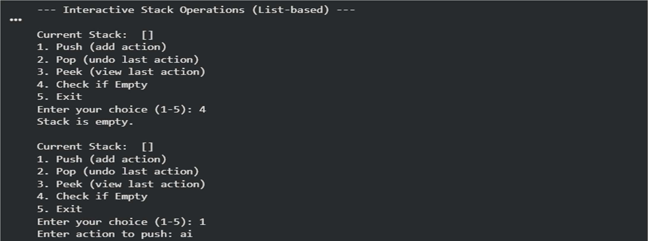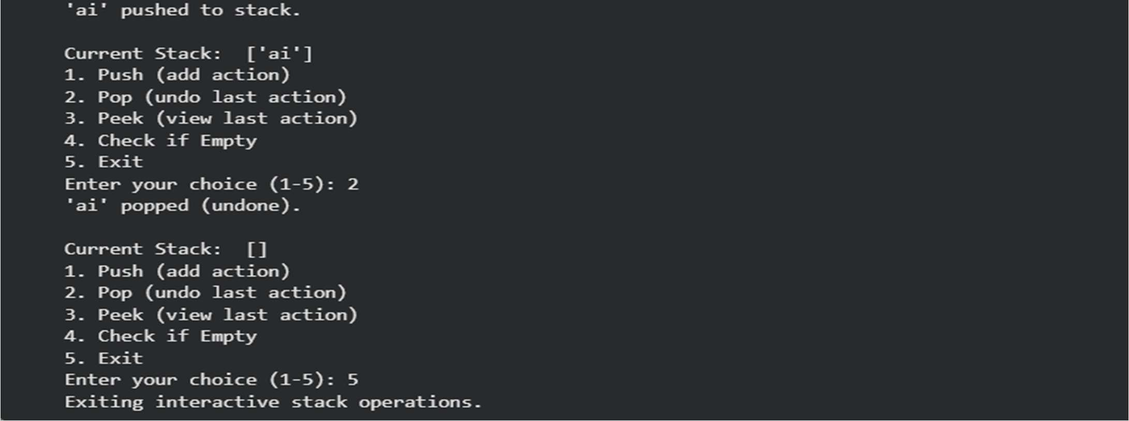
Explanation:
A stack is ideal for implementing undo operations because it follows the Last-In-First-Out (LIFO) principle, where the most recent action performed is the first one to be undone. In Python, a list can be easily used to implement a stack, while collections.deque is slightly more efficient when there are frequent push and pop operations.
Task 2 Queue for Customer Service Requests (FIFO)
Prompt:
Write a Python Queue class (FIFO) using a list with enqueue, dequeue, and is_empty methods, and briefly analyze its performance. Then implement an optimized version using collections.deque and compare their time complexity and real-world efficiency in a short paragraph.
Code:
class ListQueue:
"""Implements a First-In-First-Out (FIFO) queue data structure using a Python list."""
def __init__(self):
"""Initializes an empty queue.""" self._items = []
def enqueue(self, request):
"""Adds a request to the rear of the queue.

Args: request: The item to be added to the queue.
""" self._items.append(request)
def dequeue(self):
"""Removes and returns the request from the front of the queue.
Raises:
IndexError: If the queue is empty.

Returns:
The item removed from the front of the queue.
""" if self.is_empty():
raise IndexError("Cannot dequeue from an empty queue") return self._items.pop(0) # Removing from the beginning of the list
def is_empty(self):
"""Checks if the queue is empty.

Returns:
True if the queue is empty, False otherwise.
"""
return len(self._items) == 0
def size(self):
"""Returns the number of items in the queue.

Returns:
The number of items in the queue.
""" return len(self._items)
def __str__(self):
"""Returns a string representation of the queue.""" return str(self._items)

def main_list_queue_interaction(): service_queue = ListQueue()
print("--- Interactive List-based Queue Operations ---")
while True:
print("\nCurrent Queue: ", service_queue) print("1. Enqueue (add request)") print("2. Dequeue (handle next request)") print("3. Check if Empty") print("4. Exit")
choice = input("Enter your choice (1-4): ")
if choice == '1':
request = input("Enter request to enqueue: ") service_queue.enqueue(request) print(f"'{request}' enqueued.") elif choice == '2':
try:
request = service_queue.dequeue() print(f"Handling: '{request}'.") except IndexError as e: print(f"Error: {e}") elif choice == '3':
if service_queue.is_empty(): print("Queue is empty.") else:
print("Queue is not empty.") elif choice == '4':
print("Exiting interactive queue operations.") break else:
print("Invalid choice. Please enter a number between 1 and 4.")
# Run the interactive session for ListQueue main_list_queue_interaction()

Output:
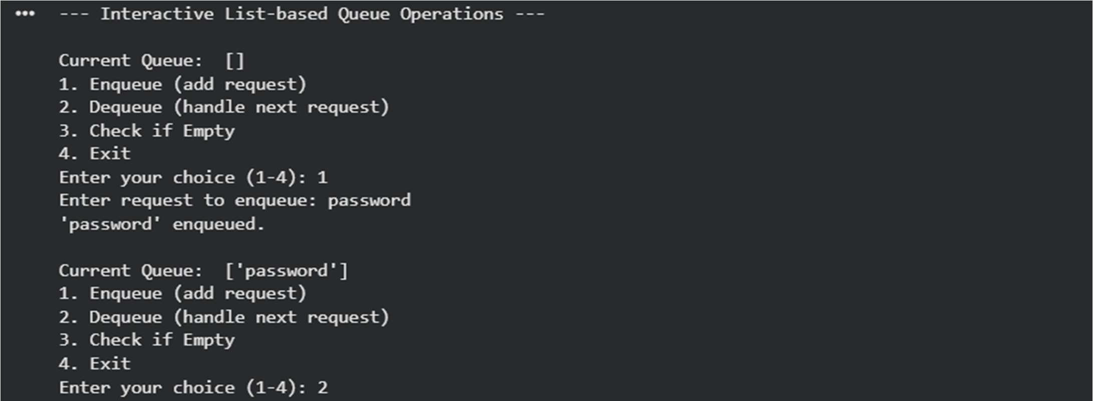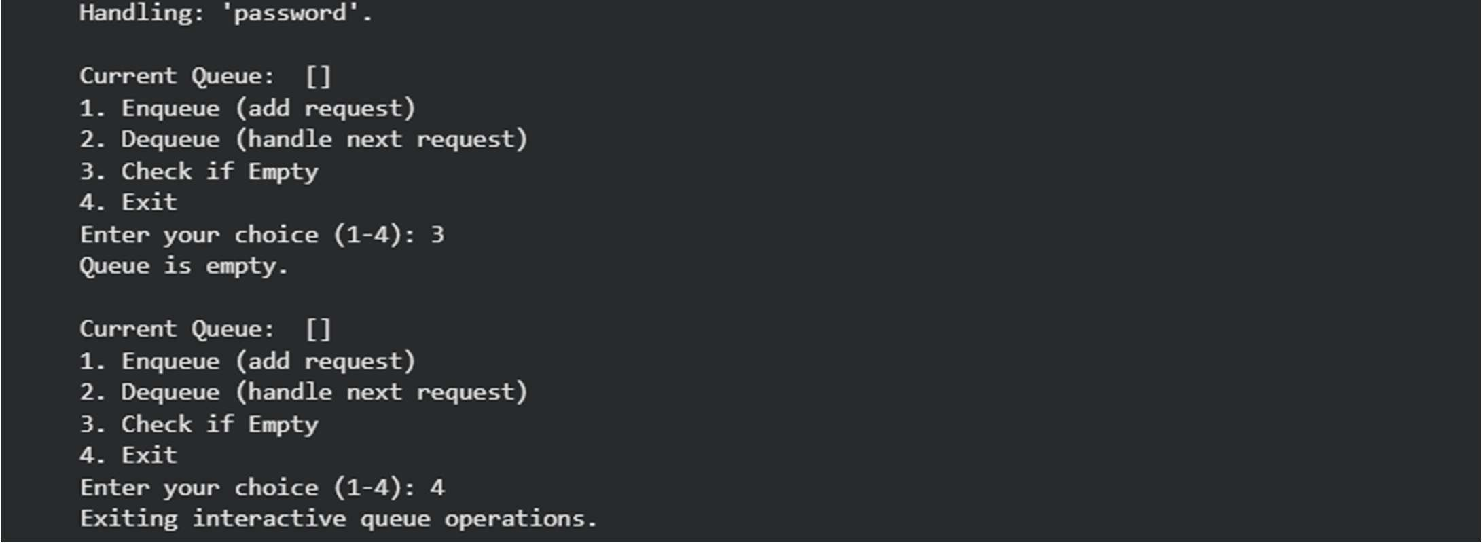
Explanation:
A queue follows the First-In-First-Out (FIFO) principle, so the earliest request is processed first.Using a list makes dequeue O(n) due to element shifting, while collections.deque provides O(1) enqueue and dequeue, making it more efficient for real-world systems.
Task 3: Singly Linked List for Dynamic Playlist Management
Prompt:
Write a Python program to implement a Singly Linked List for playlist management with methods insert_at_end, delete_value, and traverse. Include inline comments explaining pointer manipulation, clearly highlight tricky parts in insertion and deletion, add edge case tests (empty list, single node, deleting head), and provide a very short paragraph explaining how the code works.
Code:
class Node:
"""Represents a node in a singly linked list."""
def __init__(self, data):
"""Initializes a new node.

Args: data: The data to be stored in the node (e.g., song name).
""" self.data = data self.next = None # Pointer to the next node, initially None

class SinglyLinkedList:
"""Manages a singly linked list for dynamic playlist management."""
def __init__(self):
"""Initializes an empty singly linked list."""
self.head = None # The head points to the first node, initially None
def insert_at_end(self, song):
"""Inserts a new song (node) at the end of the linked list.
Args: song: The song data to be inserted.
"""
new_node = Node(song) if self.head is None:
# If the list is empty, the new node becomes the head.
self.head = new_node return

# Traverse to the last node current = self.head while current.next:
current = current.next

# Link the last node's 'next' pointer to the new node current.next = new_node
def delete_value(self, song):
"""Deletes the first occurrence of a node with the given song value.
Args: song: The song data to be deleted.
"""
current = self.head

# Case 1: If the head itself holds the song to be deleted if current and current.data == song:
self.head = current.next # Move head to the next node current = None # Dereference the old head node print(f"Deleted '{song}' (head).") return
prev = None
# Search for the song to be deleted, keep track of the previous node while current and current.data != song:
prev = current current = current.next

# Case 2: If song was not present in linked list if current is None:
print(f"'{song}' not found in playlist.") return

# Case 3: If song is found (not head) # Unlink the node from the linked list if prev:
prev.next = current.next else:
# This case should ideally be handled by Case 1, but as a safeguard.
self.head = current.next

current = None # Dereference the node print(f"Deleted '{song}'.")
def traverse(self):
"""Traverses the linked list and prints all song names.""" songs = [] current = self.head if not current:
print("Playlist is empty.") return while current:
songs.append(current.data)
current = current.next # Move to the next node using its 'next' pointer print("Current Playlist: ", " -> ".join(songs))
def __str__(self):
"""Returns a string representation of the playlist.""" songs = [] current = self.head while current:
songs.append(str(current.data)) current = current.next
return " -> ".join(songs) if songs else "Empty Playlist"
# --- Test Cases for Singly Linked List Playlist --- print("\n--- Playlist Management Test Cases ---") playlist = SinglyLinkedList()

# Edge Case: Empty list traversal and deletion print("\nTesting with empty playlist:") playlist.traverse() playlist.delete_value("Nonexistent Song")

# Insert songs at the end print("\nInserting songs:") playlist.insert_at_end("Song A") playlist.insert_at_end("Song B") playlist.insert_at_end("Song C") playlist.traverse()

# Delete a song from the middle print("\nDeleting 'Song B' (middle):") playlist.delete_value("Song B") playlist.traverse()

# Insert another song print("\nInserting 'Song D':") playlist.insert_at_end("Song D") playlist.traverse()

# Edge Case: Delete a song at the head print("\nDeleting 'Song A' (head):") playlist.delete_value("Song A") playlist.traverse()

# Edge Case: Delete the only remaining song (single node list) print("\nDeleting 'Song C' (single node list):") playlist.delete_value("Song C") playlist.traverse()

# List should now be 'Song D'
print("\nDeleting 'Song D' (last remaining):") playlist.delete_value("Song D") playlist.traverse()

# Attempt to delete from an empty list again print("\nAttempting to delete from an empty list:") playlist.delete_value("Any Song") playlist.traverse()

# Test inserting into an empty list after deletions print("\nInserting into an empty list after deletions:") playlist.insert_at_end("New Song 1") playlist.traverse() playlist.insert_at_end("New Song 2") playlist.traverse()

# Delete a non-existent song print("\nDeleting non-existent song:") playlist.delete_value("Nonexistent Song 2") playlist.traverse()

Output:
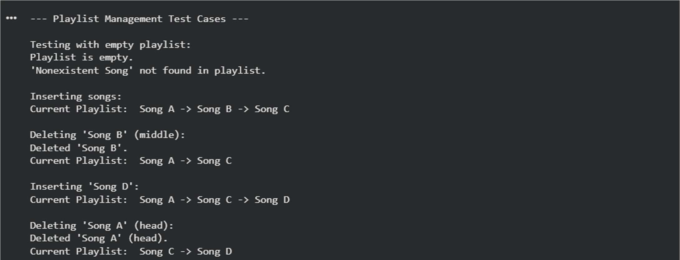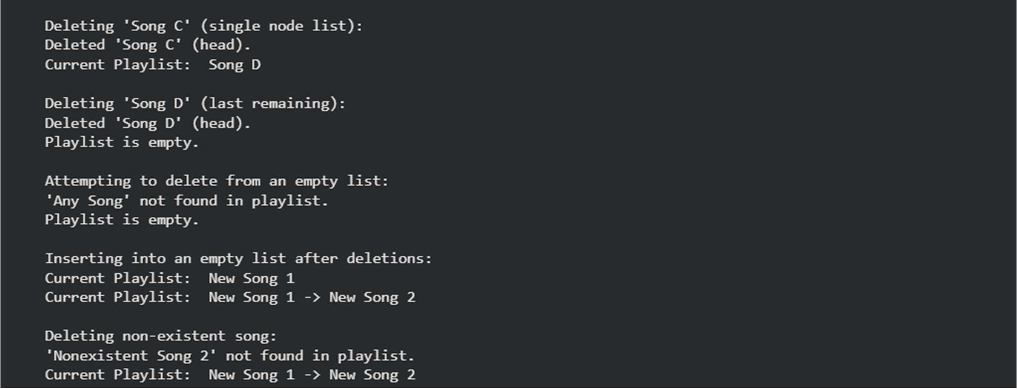
Explanation:
A singly linked list stores each song in a node, where each node contains the song data and a pointer to the next node. Insertion at the end requires traversing to the last node and updating its next pointer to the new node. Deletion is tricky because the previous node’s pointer must be updated correctly, especially when deleting the head node or when the list contains only one node.
Task 4: Binary Search Tree for Fast Record Lookup
Prompt:
Complete a partially written Python Binary Search Tree by implementing the insert, search, and inorder_traversal methods with proper docstrings. Then add a very short paragraph explaining how a BST improves search efficiency compared to linear search, including best-case and worst-case time complexity.
Code:
class Node:
"""Represents a node in a Binary Search Tree (BST)."""
def __init__(self, key):
"""Initializes a new node with a given key.

Args:
key: The value (e.g., roll number) to be stored in the node.

""" self.key = key
self.left = None # Pointer to the left child node self.right = None # Pointer to the right child node
class BinarySearchTree:
"""Implements a Binary Search Tree for efficient record lookup."""
def __init__(self):
"""Initializes an empty Binary Search Tree.""" self.root = None # The root of the BST, initially None
def insert(self, key):
"""Inserts a new key into the BST.

Args: key: The value to be inserted.
"""
self.root = self._insert_recursive(self.root, key)
def _insert_recursive(self, node, key):
"""Helper function to recursively insert a key into the BST.
Args:
node: The current node being examined.
key: The value to be inserted.

Returns:
The node after insertion.
""" if node is None:
return Node(key) # If current position is empty, create new node
if key < node.key:
node.left = self._insert_recursive(node.left, key) elif key > node.key:
node.right = self._insert_recursive(node.right, key)
# If key is equal to node.key, we don't insert duplicates in this implementation return node
def search(self, key):
"""Searches for a key in the BST.

Args:
key: The value to search for.

Returns:
True if the key is found, False otherwise.
"""
return self._search_recursive(self.root, key)
def _search_recursive(self, node, key):
"""Helper function to recursively search for a key in the BST.

Args:
node: The current node being examined.
key: The value to search for.

Returns:
True if the key is found, False otherwise.
""" if node is None:
return False # Key not found
if node.key == key:
return True # Key found elif key < node.key: return self._search_recursive(node.left, key) else: # key > node.key
return self._search_recursive(node.right, key)
def inorder_traversal(self):
"""Performs an in-order traversal of the BST and prints the keys. In-order traversal visits nodes in ascending order of their keys.
""" result = [] self._inorder_recursive(self.root, result) print("In-order Traversal (Sorted Roll Numbers):", result)
def _inorder_recursive(self, node, result):
"""Helper function for recursive in-order traversal.

Args:
node: The current node being visited. result: A list to store the keys in order.
""" if node:
self._inorder_recursive(node.left, result) result.append(node.key)
self._inorder_recursive(node.right, result)
# --- Test Cases for Binary Search Tree --- print("--- Binary Search Tree for Student Records ---") bst = BinarySearchTree()

# Insert student roll numbers
print("\nInserting roll numbers: 50, 30, 70, 20, 40, 60, 80, 55") bst.insert(50) bst.insert(30) bst.insert(70) bst.insert(20) bst.insert(40) bst.insert(60) bst.insert(80) bst.insert(55)

# Perform in-order traversal (should print sorted roll numbers) bst.inorder_traversal()

# Search for existing roll numbers
print("\nSearching for roll number 40:", bst.search(40)) # Expected: True print("Searching for roll number 80:", bst.search(80)) # Expected: True print("Searching for roll number 50:", bst.search(50)) # Expected: True
# Search for non-existing roll numbers print("Searching for roll number 25:", bst.search(25)) # Expected: False print("Searching for roll number 90:", bst.search(90)) # Expected: False
# Test with an empty BST print("\nTesting with an empty BST:") empty_bst = BinarySearchTree() print("Searching for 100 in empty BST:", empty_bst.search(100)) # Expected: False empty_bst.inorder_traversal() # Expected: Empty list output
# Test inserting duplicate (should not be added in this implementation) print("\nInserting 50 again:") bst.insert(50) bst.inorder_traversal() # Should remain the same

Output:
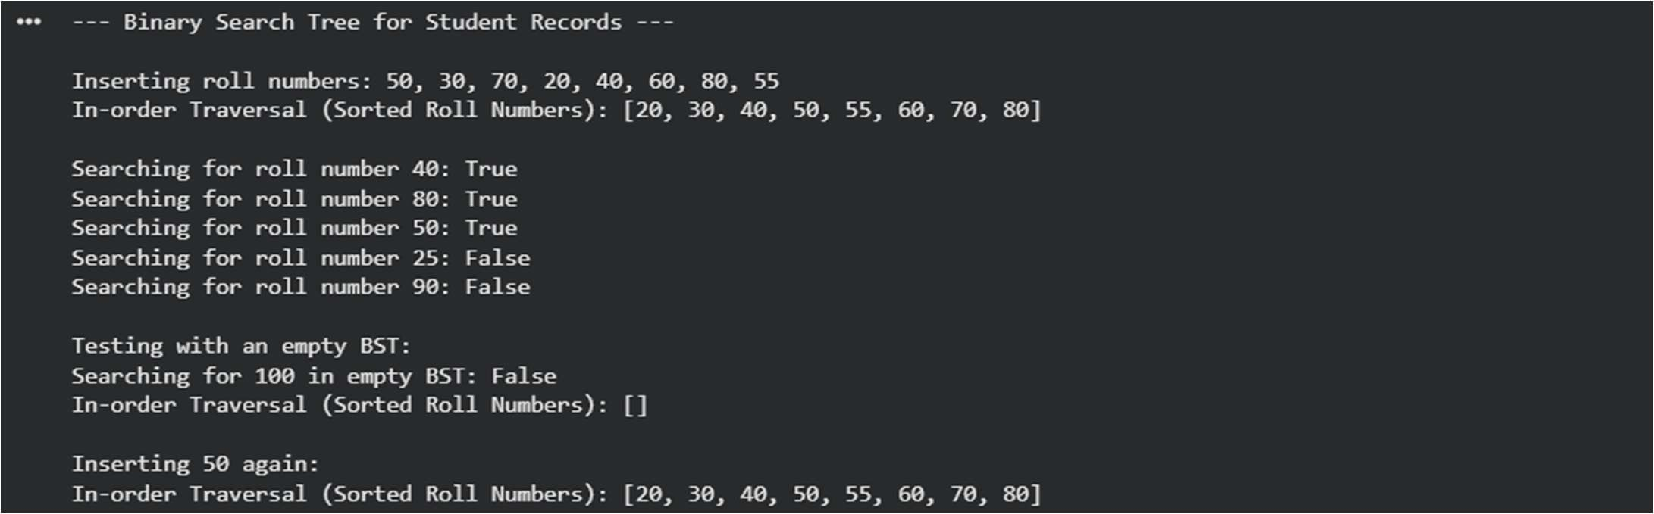
Explanation:
A Binary Search Tree (BST) stores smaller values on the left subtree and larger values on the right subtree, which enables faster searching than linear search. In the best case (when the tree is balanced), search operations take O(log n) time, but in the worst case (when the tree becomes skewed), the time complexity degrades to O(n), similar to linear search.
Task 5: Graph Traversal for Social Network Connections
Prompt:
Create a Python graph using an adjacency list and implement BFS and DFS. Add inline comments explaining traversal steps, compare recursive vs itera ve DFS briefly, and give a very short paragraph explaining BFS vs DFS use cases.
Code:
from collections import deque
class Graph:
"""Represents a social network using an adjacency list."""

def __init__(self):
"""Initializes an empty graph."""
self.graph = {} # Adjacency list: {node: [neighbor1, neighbor2, ...]}
def add_edge(self, u, v):
"""Adds an edge between two users (nodes) u and v.

Since it's a social network (undirected), add edges in both directions.
Args:
u: The first user (node). v: The second user (node).
""" if u not in self.graph: self.graph[u] = [] if v not in self.graph: self.graph[v] = [] self.graph[u].append(v) self.graph[v].append(u)
def bfs(self, start_node):
"""Performs a Breadth-First Search (BFS) starting from a given node.
Finds all reachable nodes level by level.

Args:
start_node: The node to start the traversal from.

Returns:
A list of nodes visited in BFS order.
""" visited = set() # Keep track of visited nodes to avoid cycles and reprocessing queue = deque() # Use a deque for efficient O(1) appends and pops from left bfs_order = [] # Store the order of nodes visited
if start_node not in self.graph:
print(f"Node {start_node} not in graph.") return []

# Start BFS queue.append(start_node) visited.add(start_node)
while queue:
current_node = queue.popleft() # Dequeue the first node bfs_order.append(current_node) # Add to the traversal order
# Explore all unvisited neighbors of the current node for neighbor in self.graph[current_node]: if neighbor not in visited:
visited.add(neighbor) # Mark as visited queue.append(neighbor) # Enqueue for future exploration

return bfs_order
def dfs_recursive(self, start_node):
"""Performs a Depth-First Search (DFS) recursively starting from a given node.
Explores as far as possible along each branch before backtracking.
Args:
start_node: The node to start the traversal from.

Returns:
A list of nodes visited in DFS order.
"""
visited = set() # Keep track of visited nodes dfs_order = [] # Store the order of nodes visited
if start_node not in self.graph:
print(f"Node {start_node} not in graph.") return []
def _dfs_util(node):
visited.add(node) # Mark the current node as visited dfs_order.append(node) # Add to traversal order
# Recursively visit all unvisited neighbors if node in self.graph: for neighbor in self.graph[node]: if neighbor not in visited:
_dfs_util(neighbor)

_dfs_util(start_node) return dfs_order
def dfs_iterative(self, start_node):
"""Performs a Depth-First Search (DFS) iteratively using a stack.
Args:
start_node: The node to start the traversal from.

Returns:
A list of nodes visited in DFS order.
""" visited = set() # Keep track of visited nodes stack = [] # Use a list as a stack (LIFO) dfs_order = [] # Store the order of nodes visited
if start_node not in self.graph:
print(f"Node {start_node} not in graph.") return []

# Push the start node onto the stack and mark as visited initially (or when popped) stack.append(start_node)

visited.add(start_node) # Mark as visited when pushing to avoid re-adding to stack
while stack:
current_node = stack.pop() # Pop the top node from the stack dfs_order.append(current_node) # Add to traversal order
# Explore neighbors. Push unvisited neighbors onto stack. # Pushing in reverse order ensures correct traversal order if processing top of stack.
# For example, if neighbors are [B, C], pushing C then B means B is processed first.
# To ensure consistent order with recursive DFS, process neighbors in sorted/reverse sorted order.
if current_node in self.graph:
# Sort neighbors to ensure consistent output for testing, otherwise order might vary
# depending on adjacency list order. We iterate in reverse to simulate pushing B then C
# such that C is processed first (as it's popped last from the stack). for neighbor in sorted(self.graph[current_node], reverse=True):
if neighbor not in visited:
visited.add(neighbor) # Mark as visited stack.append(neighbor) # Push onto stack return dfs_order
# --- Test Cases for Graph Traversal ---
print("--- Social Network Connections (Graph Traversal) ---") network = Graph()

# Add users and their connections network.add_edge("Alice", "Bob") network.add_edge("Alice", "Carol") network.add_edge("Bob", "David") network.add_edge("Carol", "Eve") network.add_edge("David", "Frank") network.add_edge("Eve", "Grace") network.add_edge("Frank", "Heidi") network.add_edge("Grace", "Ivan") network.add_edge("Heidi", "Ivan")
print("\nBFS from Alice (nearby connections):") print(network.bfs("Alice"))
# Expected: ['Alice', 'Bob', 'Carol', 'David', 'Eve', 'Frank', 'Grace', 'Heidi',
'Ivan'] print("\nRecursive DFS from Alice (deep connection paths):") print(network.dfs_recursive("Alice"))
# Expected (order can vary slightly based on adjacency list order, but path is deep):
# E.g., ['Alice', 'Bob', 'David', 'Frank', 'Heidi', 'Ivan', 'Grace', 'Eve', 'Carol']
print("\nIterative DFS from Alice (deep connection paths):") print(network.dfs_iterative("Alice"))
# Expected: ['Alice', 'Carol', 'Eve', 'Grace', 'Ivan', 'Heidi', 'Frank', 'David', 'Bob']
# (Order might be different from recursive due to explicit stack manipulation vs. call stack)
print("\nBFS from a node not in graph:") print(network.bfs("Zoe")) # Expected: Node Zoe not in graph. []

print("\nDFS from a node not in graph:") print(network.dfs_recursive("Zoe")) # Expected: Node Zoe not in graph. []

Output:
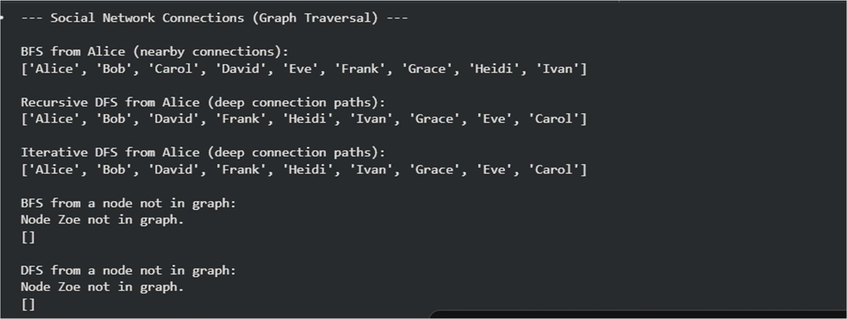
Explanation:
A graph represents user connections using an adjacency list, where each user maintains a list of connected users. Breadth-First Search (BFS) explores nodes level by level, making it ideal for finding nearby connections, while Depth-First Search (DFS) explores one path deeply before backtracking, which helps in tracing complete connection chains. Recursive DFS relies on the call stack, whereas iterative DFS uses an explicit stack data structure.

