Name:B.Pooja
Hall Ticket:2303A52141
Batch:41
Task 1: Hospital Management Database
Prompt: Transform the given Python Student class into an equivalent C++ program. Include a main() function and ensure it generates the same output as the Python version.
Code:
// Python Code (for reference)
/* class Student: def __init__(self, name, age, marks):
self.name = name self.age = age self.marks = marks
def display(self):
print("Name:", self.name) print("Age:", self.age) print("Marks:", self.marks)
s1 = Student("Likki", 20, 85) s1.display()
*/

// Convert the above Python Student class into equivalent C++ code
#include <iostream> #include <string> using namespace std;
class Student { private:
string name; int age; int marks;
public:
Student(string n, int a, int m) { name = n; age = a; marks = m;
}
void display() { cout << "Name: " << name << endl; cout << "Age: " << age << endl; cout << "Marks: " << marks << endl; }
};
int main() {
Student s1("Likki", 20, 85); s1.display(); return 0;
}

Output:
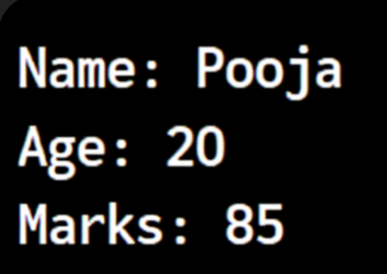
Explanation:
The Python class is adapted into C++ by declaring attributes as private data members and initializing them through a constructor. Member functions are used to print the details, and the main() function creates an object and invokes the display method.
Task 2:Java to Python Function on Conversion
Prompt:
Rewrite the provided Java isPrime() method into a Python function, following proper Python syntax and testing it with multiple values.
Code:
# Java Code
''' public class PrimeCheck { public static boolean isPrime(int n) { if (n <= 1) return false; for (int i = 2; i <= n / 2; i++) { if (n % i == 0) return false;
} return true;
}
public static void main(String[] args) {
System.out.println(isPrime(7));
System.out.println(isPrime(10));
} }
*/'''
#Convert the above Java isPrime() method into equivalent Python function. Ensure Pythonic syntax and test with multiple inputs. def is_prime(n): if n <= 1:
return False for i in range(2, n // 2 + 1):
if n % i == 0: return False return True
# Testing the function with multiple inputs print(is_prime(7)) # True print(is_prime(10)) # False print(is_prime(2)) # True print(is_prime(15)) # False print(is_prime(1)) # False print(is_prime(0)) # False print(is_prime(-5)) # False

Output:
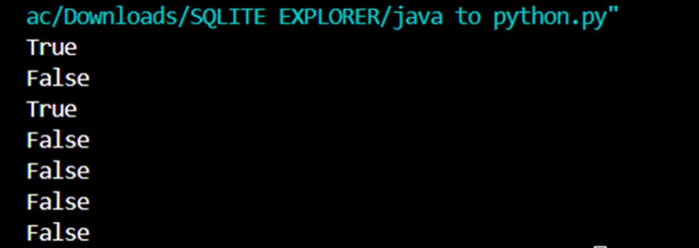
Explanation:
The Java method is rewritten in Python by eliminating strict data types and applying Python’s indentation-based structure. The core logic remains unchanged, using a loop to verify divisibility and returning True or False.
Task 3 :Pseudocode to python implementa on
Prompt:
Convert the given pseudocode into a Python implementation of Bubble Sort, ensuring the logic is correct and testing it with sample data.
Code:
# Pseudocode
"""
START
Input list of numbers FOR i from 0 to n-1
FOR j from 0 to n-i-2
IF list[j] > list[j+1]
SWAP list[j] and list[j+1]
END FOR
Output sorted list
END
"""

#Convert the above pseudocode into equivalent Python code using bubble sort.Ensure correct logic and test with sample inputs.
def bubble_sort(arr):
n = len(arr)
# Traverse through all elements in the list for i in range(n):
# Last i elements are already in place, no need to check them for j in range(0, n-i-1):
# Swap if the element found is greater than the next element if arr[j] > arr[j+1]:
arr[j], arr[j+1] = arr[j+1], arr[j] return arr
# Test the bubble_sort function with sample inputs if __name__ == "__main__":
sample_input = [64, 34, 25, 12, 22, 11, 90] sorted_list = bubble_sort(sample_input) print("Sorted list is:", sorted_list)
# Output should be: Sorted list is: [11, 12, 22, 25, 34, 64, 90]

Output:
Explanation:
The pseudocode is implemented in Python using nested loops and element swapping. Bubble Sort works by repeatedly comparing adjacent elements and arranging them in order step by step.

Task 4:Op mize Queries
Prompt:
Translate the provided SQL query into equivalent Pandas code in Python.
Code:
# SQL Query (for reference)
"""
SELECT name, salary
FROM employees
WHERE salary > 50000;
"""

# Convert the above SQL query into equivalent Pandas code import pandas as pd
# Assuming we have a DataFrame 'employees' with columns 'name' and 'salary'
# Example DataFrame creation (for demonstration purposes) data = {
'name': ['Alice', 'Bob', 'Charlie', 'David'],
'salary': [60000, 45000, 70000, 30000]
} employees = pd.DataFrame(data)

# Equivalent Pandas code result = employees[employees['salary'] > 50000][['name', 'salary']] print(result)
Output:
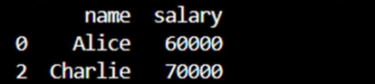
Explanation:
The SQL query is represented in Pandas by applying filters on rows and selecting necessary columns. Boolean indexing is used to mimic the WHERE clause and column selection in SQL.
Task 5:Real time application on:algrthm transla on Across Languages
Prompt:
Convert the given Python linear search algorithm into an equivalent C program, ensuring proper use of arrays, loops, and function structure.
Code:
# Python Code
def linear_search(arr, key): for i in range(len(arr)): if arr[i] == key:
return i return -1
# Test arr = [10, 20, 30, 40, 50] key = 30
result = linear_search(arr, key)
if result != -1:
print("Element found at index:", result) else:
print("Element not found")

Converted C Code:
#Convert the above Python linear search algorithm into equivalent C code. Ensure proper handling of arrays, loops, and function structure.
#include <stdio.h> int linear_search(int arr[], int size, int key) {
for (int i = 0; i < size; i++) { if (arr[i] == key) {
return i; // Return the index of the found element } } return -1; // Return -1 if the element is not found
}
int main() { int arr[] = {10, 20, 30, 40, 50}; int key = 30;
int size = sizeof(arr) / sizeof(arr[0]);
int result = linear_search(arr, size, key);

if (result != -1) { printf("Element found at index: %d\n", result);
} else { printf("Element not found\n");
}
return 0;
}

Output:
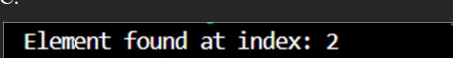
Explanation:
. The Python linear search is rewritten in C by defining explicit data types, using loops and arrays. Unlike Python, C requires manual array size handling and uses printf for displaying results.

