Name: B.Pooja
Hall Ticket: 2303A52141
Batch: 41
Task 1: Movie Database API Integration
Prompt:
Create a Python program using requests to get movie details from the OMDb API by title, with proper error handling for invalid names, API issues, timeouts, and empty results.
Code:
import requests
def fetch_movie_details(movie_title, api_key):
url = f"http://www.omdbapi.com/?t={movie_title}&apikey={api_key}"

try:
response = requests.get(url, timeout=10)
response.raise_for_status() # Raise an error for HTTP errors
except requests.RequestException as e:
print(f"Error fetching movie details: {e}")
return None
data = response.json()

if data.get("Response") == "False":
print(f"Movie not found: {movie_title}")
return None
return data
# Example usage
api_key = "a28f0b2c"
movie_title = input("Enter the movie title: ")
movie_details = fetch_movie_details(movie_title, api_key)
if movie_details:
print(f"Title: {movie_details.get('Title')}")
print(f"Year: {movie_details.get('Year')}")
print(f"Genre: {movie_details.get('Genre')}")
print(f"Director: {movie_details.get('Director')}")
print(f"Plot: {movie_details.get('Plot')}")

Output:
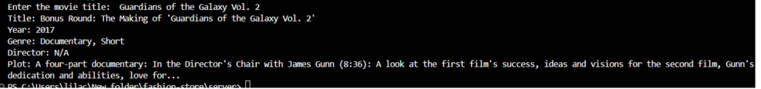
Explanation:
This program retrieves movie data using requests and prevents crashes by handling errors like wrong input, API failures, and network problems.
Task 2: Public Transport Schedule API
Prompt:
Build a Python script using requests to fetch transport arrival times by stop ID, including retries and handling errors like invalid input and server issues, showing the next 3 arrivals.

Code: import requests
import time
# Real working API (London Transport)
BASE_URL = "https://api.tfl.gov.uk/StopPoint/"
def fetch_arrival_times(stop_id):
url = f"{BASE_URL}{stop_id}/Arrivals"
retries = 2 # minimum 1 retry
for attempt in range(retries + 1):
try:
response = requests.get(url, timeout=5)
response.raise_for_status()
data = response.json()
# Handle empty response
if not data:
print("❌ No arrivals found. Check Stop ID.")
return None
# Sort by arrival time
data.sort(key=lambda x: x.get("timeToStation", 0))
# Extract next 3 arrivals
arrivals = []
for item in data[:3]:
arrivals.append({
"line": item.get("lineName", "N/A"),
"destination": item.get("destinationName", "N/A"),
"time": item.get("timeToStation", 0) // 60
})
return arrivals
except requests.exceptions.Timeout:
print("⚠ Request timed out. Retrying...")
except requests.exceptions.ConnectionError:
print("❌ Server unavailable / Network issue.")
return None
except requests.exceptions.HTTPError:
if response.status_code == 404:
print("❌ Invalid Stop ID.")
else:
print("❌ HTTP error occurred.")
return None
except Exception as err:
print(f"❌ Unexpected error: {err}")
return None
time.sleep(2)
print("❌ Failed after retry attempts.")
return None
# -------- MAIN --------
if __name__ == "__main__":
stop_id = input("Enter Stop ID: ").strip()
# Better validation (not just digits)
if not stop_id:
print("❌ Stop ID cannot be empty.")
else:
arrivals = fetch_arrival_times(stop_id)
if arrivals:
print("\n🚌 Next 3 Arrivals")
print("-" * 30)
for i, a in enumerate(arrivals, 1):
print(f"{i}. Line {a['line']} → {a['destination']} in {a['time']} min")
else:
print("⚠ Could not retrieve arrival data.”)

Output:
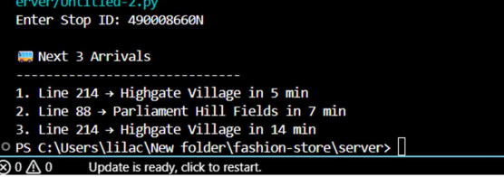
Explanation:
This script gets arrival data from an API, sorts it, and shows the next three timings while managing errors and retrying on failures.
Task 3: Stock Market Data API
Prompt:
Write a Python script using requests to get stock details from an API using a symbol, with validation, safe JSON parsing, and handling API limits and errors
Code:
import requests
API_KEY = "ZKU956STHE1S2YKU"
symbol = input("Enter stock symbol: ").upper()
url =
f"https://www.alphavantage.co/query?function=GLOBAL_QUOTE&symbol={symbol}&apikey={API_KEY}
"
try:
response = requests.get(url, timeout=5)
data = response.json()
if "Global Quote" not in data or not data["Global Quote"]:
print(" Invalid stock symbol or no data.")
elif "Note" in data:
print(" API rate limit exceeded. Try later.")
else:
quote = data["Global Quote"]
print("\n Stock Details")
print(f"Symbol : {quote.get('01. symbol')}")
print(f"Price : {quote.get('05. price')}")
print(f"High : {quote.get('03. high')}")
print(f"Low : {quote.get('04. low')}")
except Exception as e:
print(" Error:", e)

Output:
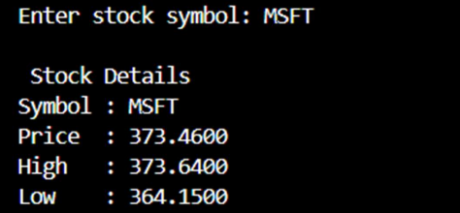
Explanation:
The script fetches stock data based on user input and displays price details while managing invalid symbols, rate limits, and network issues.

Task 4: GeolocaƟon API (IP Address Lookup)
Prompt:
Develop a Python script to fetch IP geolocation details (country, city, ISP) with
Code:
port re
def is_valid_ip(ip):
# Simple IPv4 validation
pattern = r"^(?:[0-9]{1,3}\.){3}[0-9]{1,3}$"
return re.match(pattern, ip)
def get_location(ip):
url = f"http://ip-api.com/json/{ip}"
try:
response = requests.get(url, timeout=5)
response.raise_for_status()
try:
data = response.json()
except ValueError:
print(" Error: Invalid JSON response.")
return
# API failure
if data.get("status") != "success":
print(" Error: Invalid IP or API failed.")
return
print("\n Geolocation Details")
print("-" * 30)
print(f"Country : {data.get('country')}")
print(f"City : {data.get('city')}")
print(f"ISP : {data.get('isp')}")
except requests.exceptions.Timeout:
print(" Error: Request timed out.")
except requests.exceptions.ConnectionError:
print(" Error: Network problem.")
except requests.exceptions.HTTPError:
print(" Error: HTTP issue.")
except Exception as e:
print(f" Unexpected error: {e}")
# -------- MAIN --------
if __name__ == "__main__":
ip = input("Enter IP address: ").strip()
if not ip:
print(" Error: IP cannot be empty.")
elif not is_valid_ip(ip):
print(" Error: Invalid IP format.")
else:
get_location(ip)

Output:
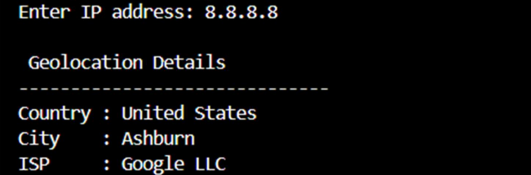
Explanation:
This script checks IP format and retrieves location data while safely handling API and parsing errors.

Task 5: Real-Time ApplicaƟon: Payment Gateway SimulaƟon API
Prompt:
Create a Python script to simulate payments using POST requests, with input validation, error handling, and logging failed transactions.

Code:
import requests
import json
from datetime import datetime
# -------- VALIDATION --------
def validate_input(amount, currency, method):
if amount <= 0:
return "Amount must be greater than 0"
if currency not in ["USD", "INR", "EUR"]:
return "Unsupported currency"
if method not in ["card", "upi", "netbanking"]:
return "Invalid payment method"
return None
# -------- LOGGING --------
def log_failure(data, error):
with open("failed_transactions.log", "a") as file:
file.write(f"{datetime.now()} | Data: {data} | Error: {error}\n")
# -------- PAYMENT FUNCTION --------
def process_payment(amount, currency, method):
url = "https://httpbin.org/post"
payload = {
"amount": amount,
"currency": currency,
"method": method
}
error = validate_input(amount, currency, method)
if error:
print(f" Validation Error: {error}")
log_failure(payload, error)
return
try:
response = requests.post(url, json=payload, timeout=5)
# Handle HTTP errors manually
if response.status_code == 400:
raise Exception("Bad Request (400)")
elif response.status_code == 401:
raise Exception("Unauthorized (401)")
elif response.status_code == 500:
raise Exception("Server Error (500)")
data = response.json()
print("\n Payment Successful")
print("-" * 30)
print(f"Amount : {amount}")
print(f"Currency : {currency}")
print(f"Method : {method}")
print(f"Status : SUCCESS")
except requests.exceptions.Timeout:
print(" Error: Request timed out.")
log_failure(payload, "Timeout")
except requests.exceptions.ConnectionError:
print(" Error: Network issue.")
log_failure(payload, "Connection Error")
except Exception as e:
print(f" Payment Failed: {e}")
log_failure(payload, str(e))
# -------- MAIN --------
if __name__ == "__main__":
try:
amount = float(input("Enter amount: "))
currency = input("Enter currency (USD/INR/EUR): ").upper()
method = input("Enter payment method (card/upi/netbanking): ").lower()
process_payment(amount, currency, method)
except ValueError:
print(" Invalid input. Amount must be a number.")

Output:
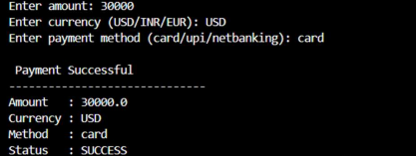
Explanation:
The script processes payments via API, validates data, manages errors, and records failed transactions for tracking.

