Name: K.Likitha
Hall Ticket: 2303A52144 Batch: 41
Task 1: Book Class Generation
Prompt:
Create a Python class named Book with attributes title and author, and a method summary() to display book details.
Write a main program to create a Book object and print the output of the summary() method.

Code:
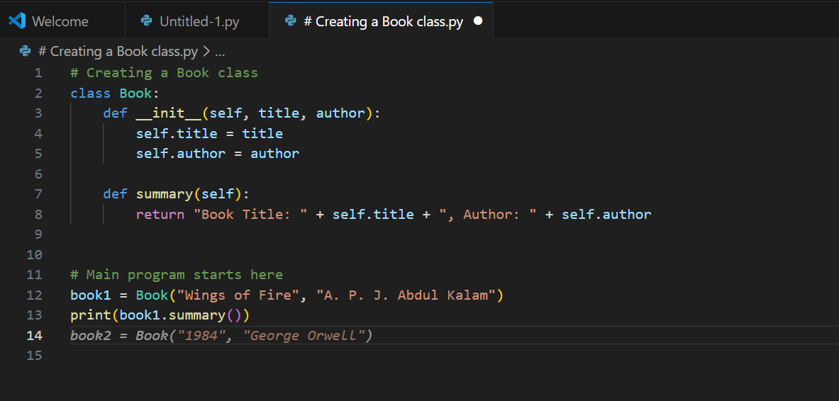
Output:
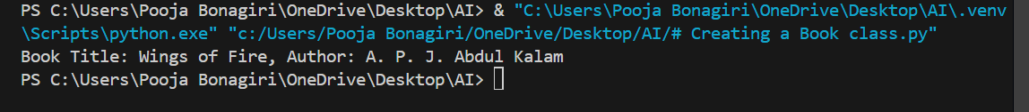

Explanation:
This program defines a Book class with attributes for the book’s title and author. The summary() method returns a short description of the book using these attributes. In the main part of the program, a Book object is created and the summary is printed, showing how the class works.

Task 2: Sorting Dictionaries with AI
Prompt:
Write a Python program that stores user details as a list of dictionaries and sorts them based on the age field.
Include sample user data, apply sorting logic, and display the sorted result.
Briefly explain how the sorting process works in simple terms.

Code:

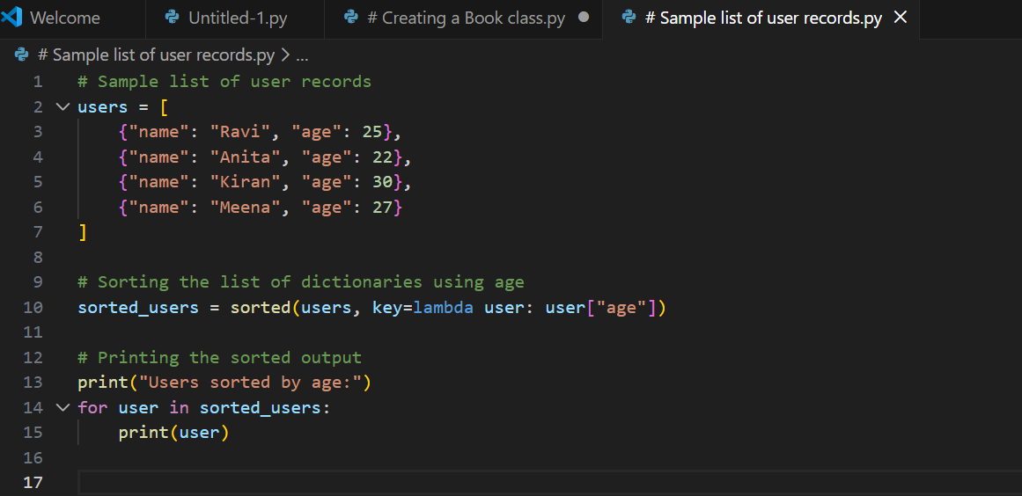

Output:

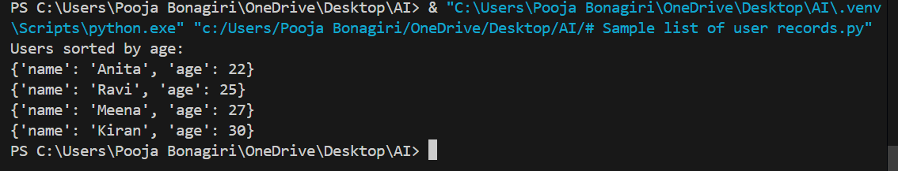
Explanations:

Comparison: Gemini Output vs Cursor AI Output (Sorting Dictionaries by Age) Gemini AI Output – Explanation
The Gemini AI output demonstrates a basic and clear approach to sorting a list of dictionaries by the age key. It first prints the original records and then displays the sorted records in ascending order of age. The code is concise and easy to understand, making it suitable for beginners. However, the output format is simple and mainly focuses on showing the sorted dictionaries without additional formatting.

Cursor AI Output – Explanation
The Cursor AI output provides a more detailed and structured solution. It prints the original list of users in a well- formatted manner and then shows the sorted results in both ascending and descending order. The output is more readable due to clear labels, separators, and aligned fields such as name, age, and city. This makes the program more user-friendly and suitable for real-world use.

Overall Comparison
Both Gemini AI and Cursor AI correctly sort the user records by age and have similar performance since they use Python’s built-in sorting methods. Gemini AI focuses on simplicity and minimal code, while Cursor AI emphasizes clarity, better output formatting, and additional functionality. Cursor AI’s output is more polished, whereas Gemini AI’s output is easier for quick understanding and learning.
Task 3: Calculator Using Functions
Prompt:
Create a Python calculator program in a single code block using functions.
The program should show a menu with options for Addition, Subtraction, Multiplication, Division, and Square Root numbered from 1 to 5.All values must be taken from the user using input(). Based on the selected option, the program should perform the chosen operation on the entered numbers and display the result
final result. If the user selects option 5, the program should ask for a single number, calculate its square root using a function, and print the result. The program should be simple, clear, and beginner-friendly.
Code:
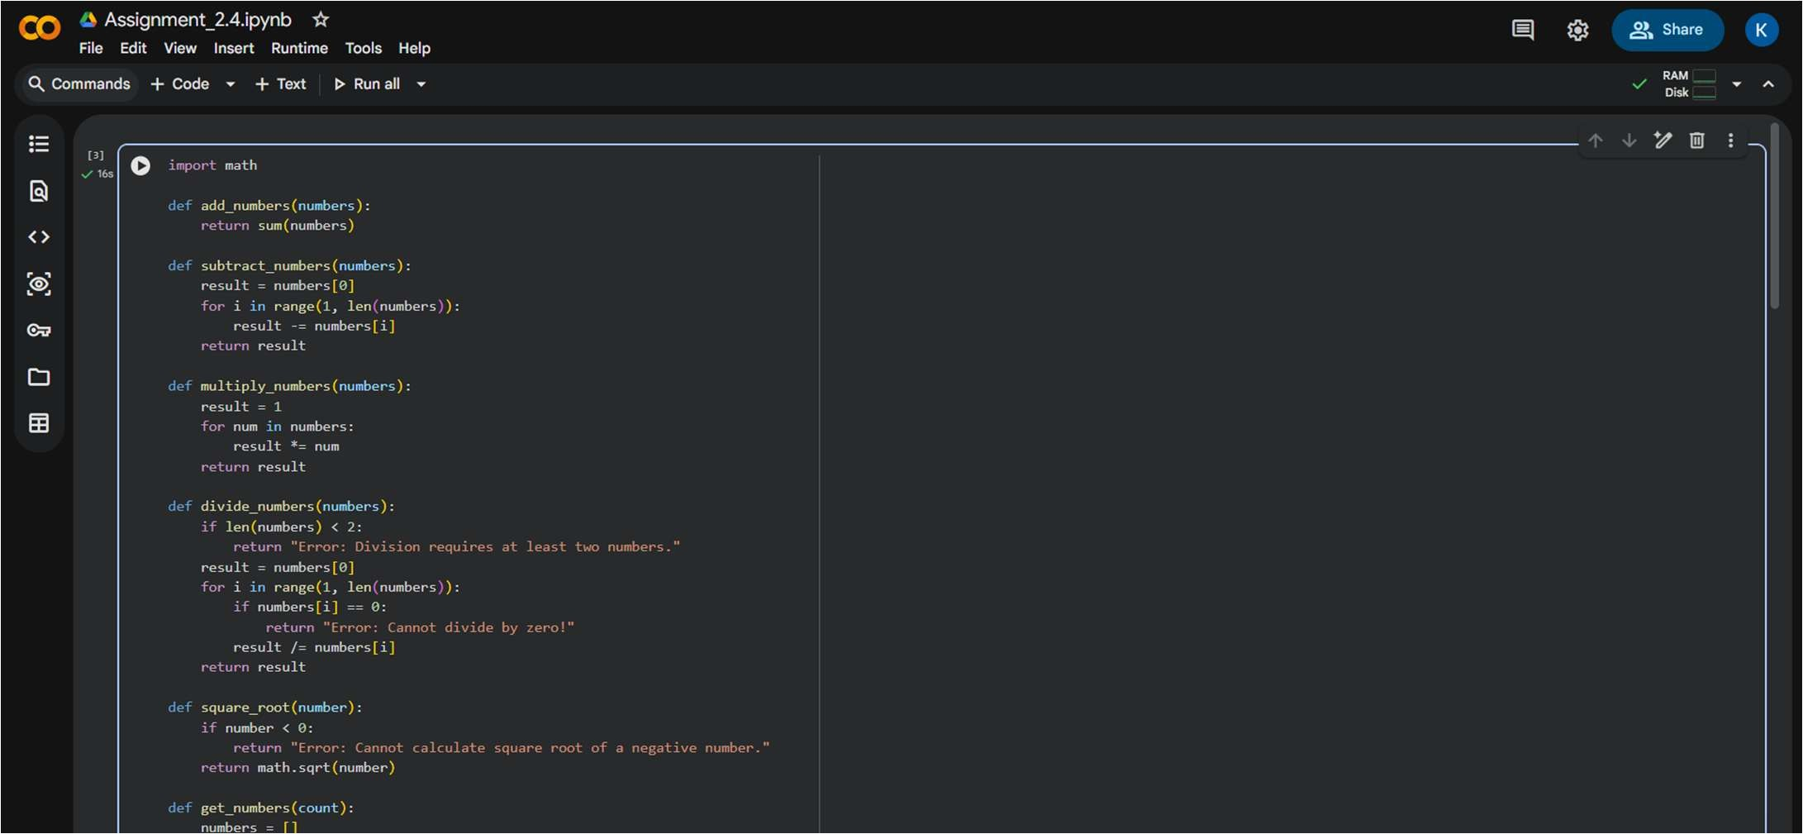
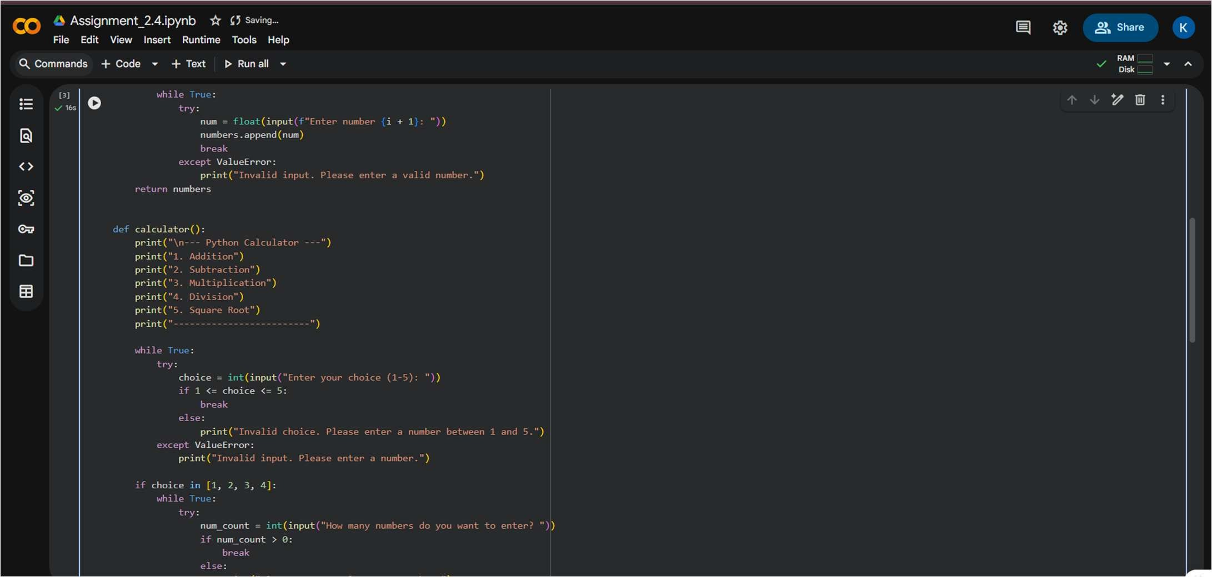

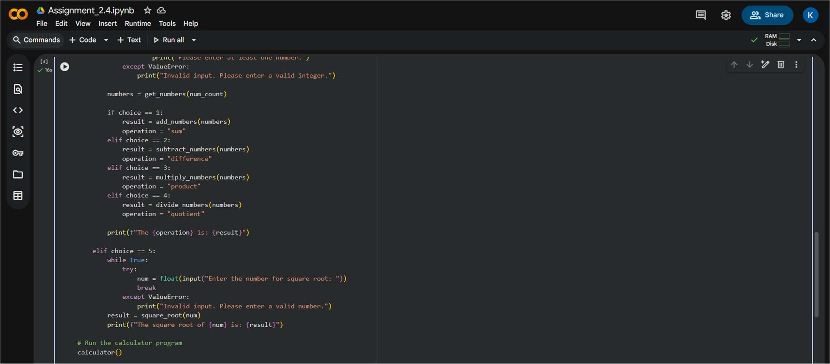
Output:
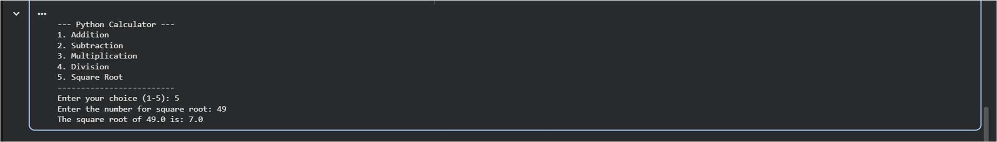

Task 4: Armstrong Number Optimization
Gemini Prompt:
Create a Python program to check whether a given number is an Armstrong number. The program should take the number from the user using input()

Gemini Code:
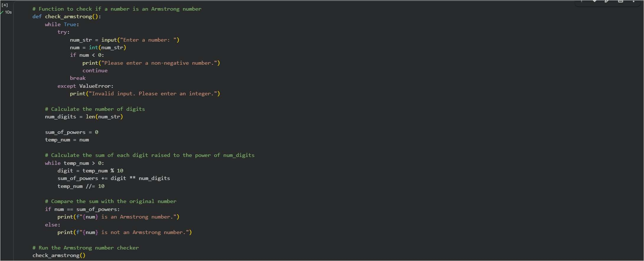

Gemini Output:
Cursor AI Prompt:
mprove the given Python program that checks an Armstrong number by enhancing its efficiency and readability.
Avoid repeated calculations, store the digit count once, and use a cleaner loop structure.
The program should still take input using input() and produce the same correct output.
Cursor AI: Code
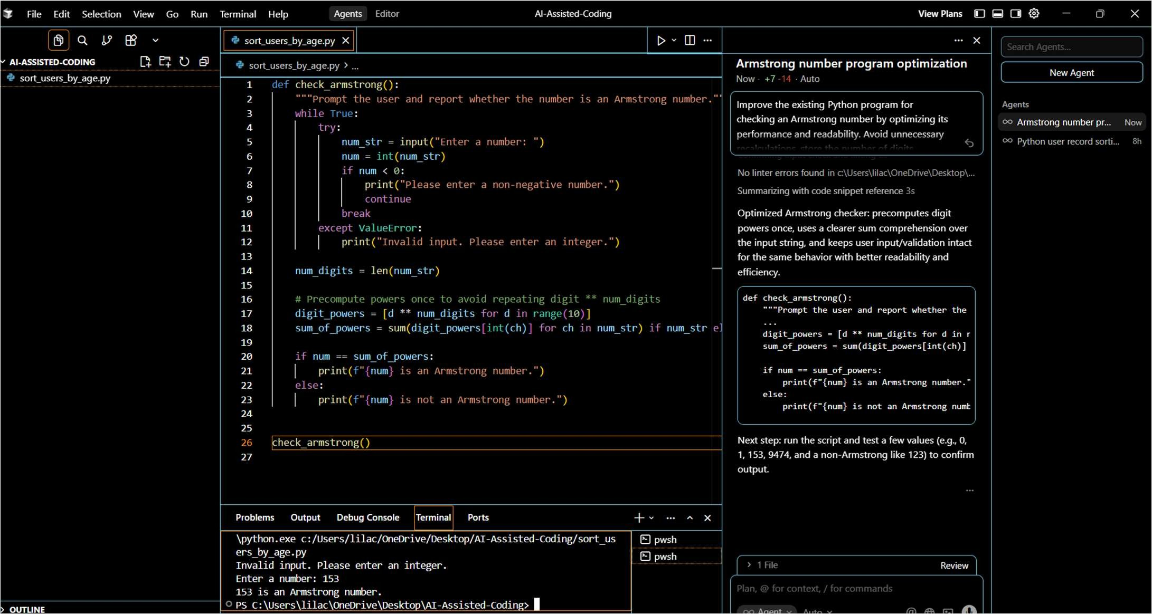

Cursor AI Output:
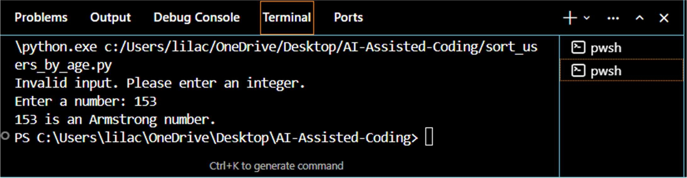
Explanations:
The Armstrong number program generated using Google Gemini was basic and functional but lacked efficiency and strong input validation. Cursor AI optimized the program by reducing redundant calculations, handling invalid and

negative inputs effectively, and improving overall code structure. The optimized version is more efficient, readable, and robust while maintaining the same correct output.

