Name: B.Pooja
Hall Ticket: 2303A521441

Batch: 41
Task 1: AI-Generated Logic Without Modularization (Fibonacci Sequence Without Functions)
Prompt:
Write a simple python code for printing fibonacci series up to n terms without using functions. Code:
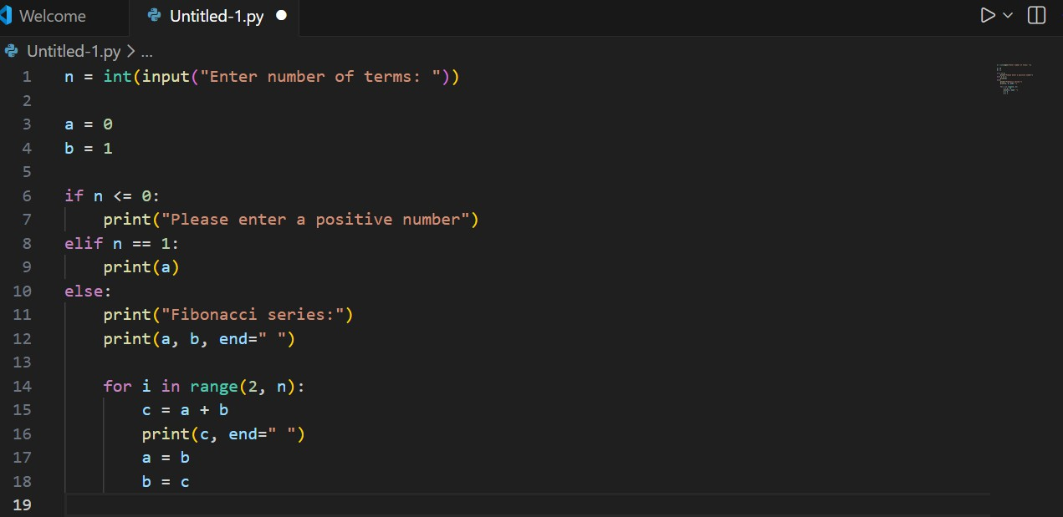
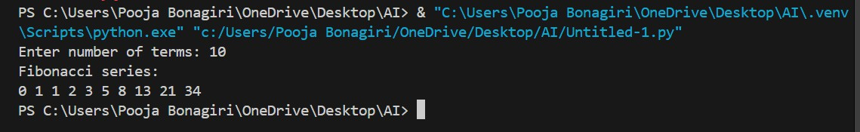
Output:

Explanation:
In this task, the Fibonacci series is generated up to n terms directly in the main program without using functions. The program takes user input and displays the sequence using a single loop
Task 2: AI Code Optimization & Cleanup (Improving Efficiency)
Prompt:
Optimize version of Fibonacci series up to n terms without using functions Code:

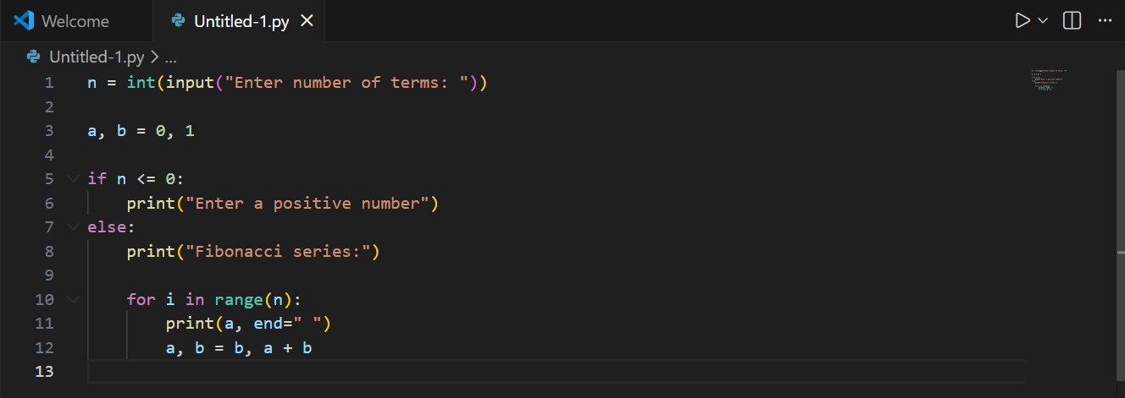

Ouput:
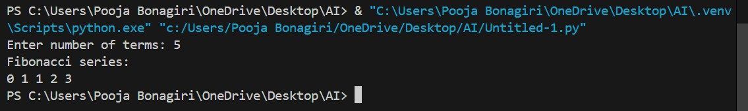

Explanations:
Through this task, the earlier code was optimized to improve efficiency while maintaining simplicity. Optimization reduces time and memory usage, making programs faster and more resource-efficient.
Task 3: Modular Design Using AI Assistance (Fibonacci Using Functions)
Prompt:
Optimize version of Fibonacci series up to n terms with using functions Code:
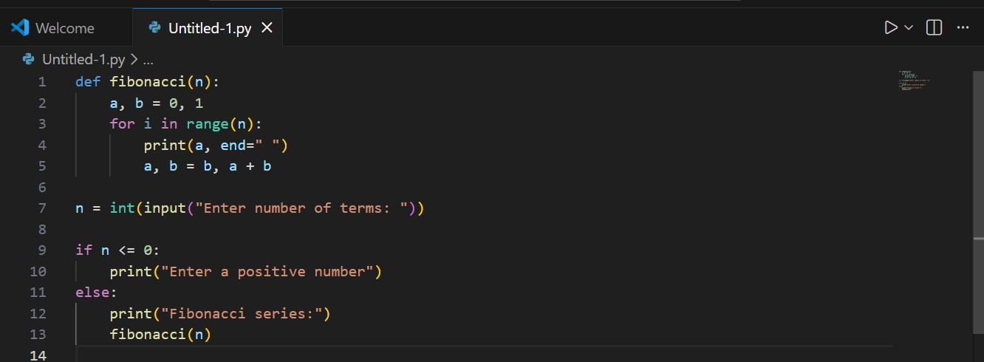

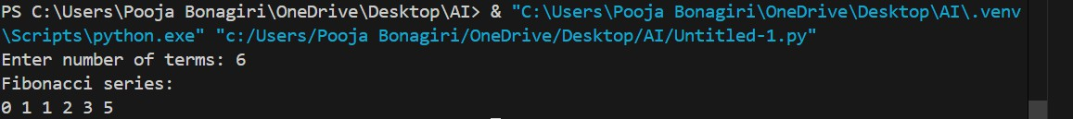
Explanation:
n this task, the Fibonacci series is implemented using a user-defined function, making the code modular and reusable. Modularization improves code organization, readability, debugging, and suitability for large programs.
Task 4: Comparative Analysis – Procedural vs Modular Fibonacci Code
Prompt:
Procedural: Write a code for printing fibonacci series up to n terms without using functions Modular: Optimized version of Fibonacci series up to n terms using functions
Code:
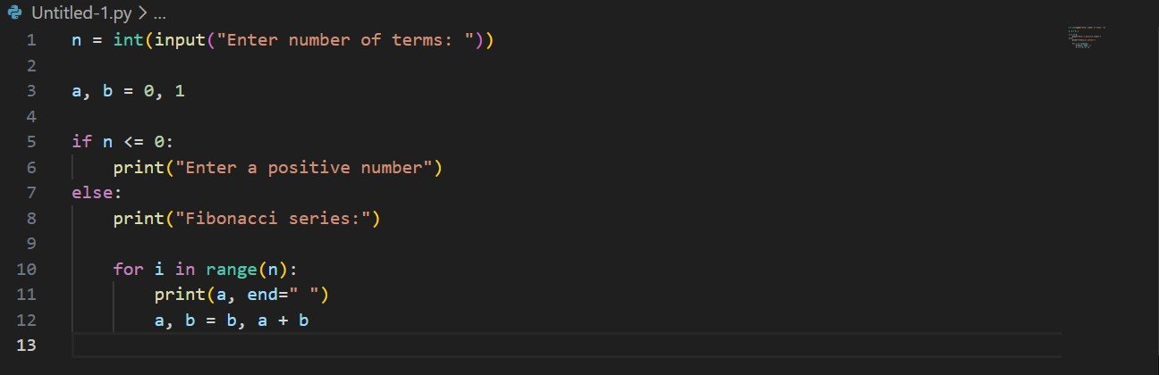
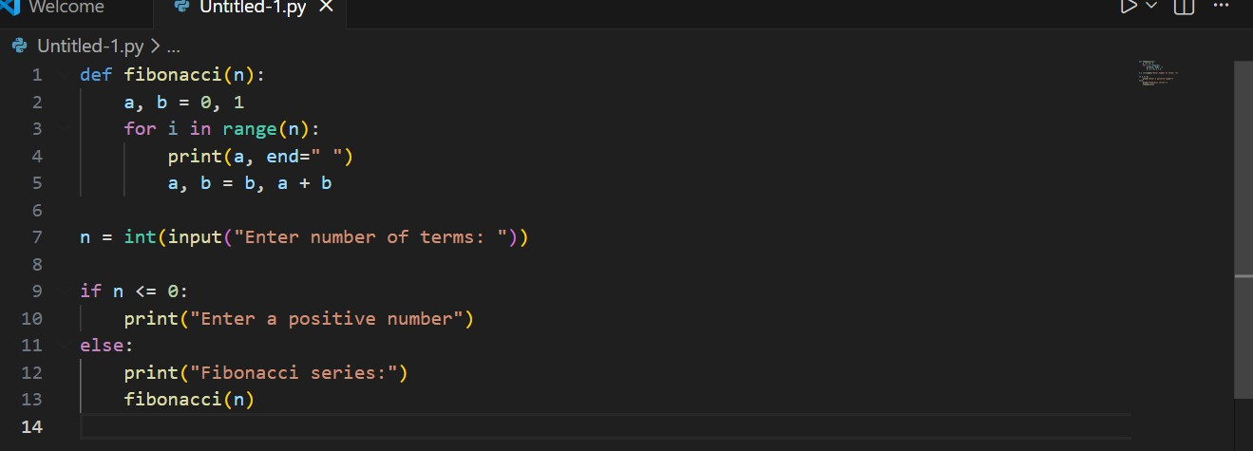
Code:

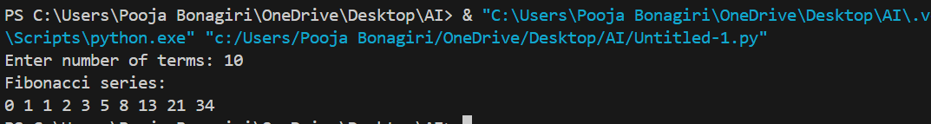
Output:
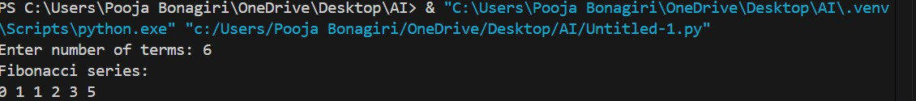
Explanations:
Through this task, we were able to understand the difference between the procedural approach (without using functions) and the modular approach (using functions). The main advantages of using functions include code reusability, easier debugging, better code clarity, and suitability for large systems. From this analysis, it can be concluded that the modular approach is cleaner and more effective.
Task 5: AI-Generated Iterative vs Recursive Fibonacci Approaches (Different Algorithmic Approaches for Fibonacci Series)
Prompt:
Iterative approach: write a code fibonacci series up to n terms using iterative approach Recursive approach : write a code fibonacci series up to n terms using recursive approach Code:
Iterative approach:
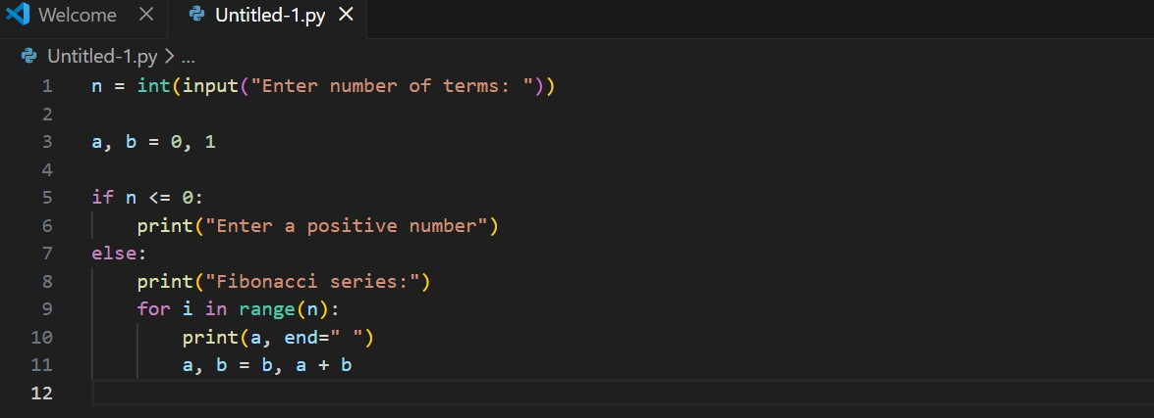

Recursive Approach:

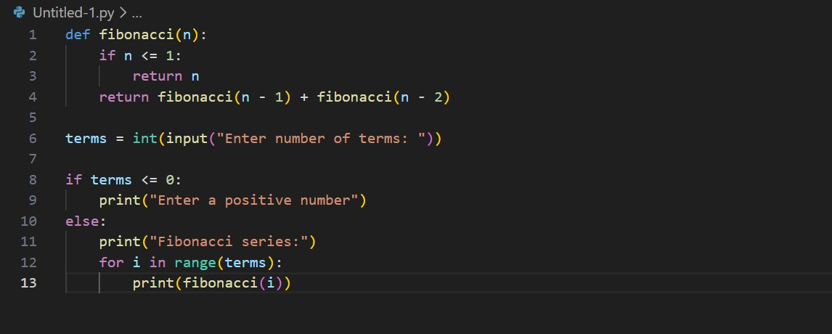
Output:
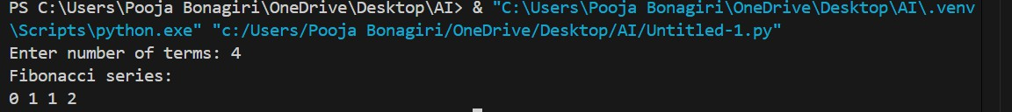
Iterative approach:
Recursive Approach:
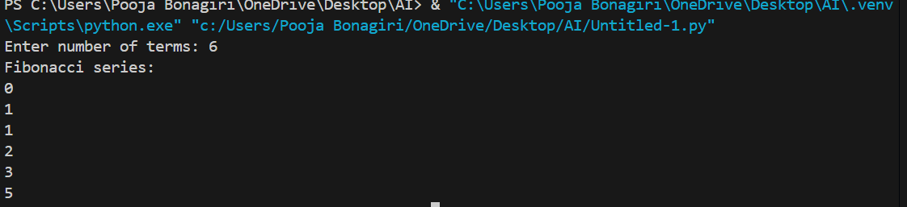
Explanation:
Generating Fibonacci numbers using an iterative loop is more efficient because it executes faster, consumes less memory, and can handle large inputs easily. Recursive approaches are slower, require more memory, and may not work well for large values, so iterative methods are preferred in practical applications.

