Name: B.Pooja
Hall Ticket: 2303A52141
Batch: 41
Task 1: Email Validation using TDD
Prompt:
Create a Python email validation system that checks if an email contains @ and ., does not allow multiple @ symbols, and does not start or end with special characters. Also include an interactive program that asks the user to enter an email, validates it using is_valid_email(email), and displays whether it is valid or invalid, with an option to continue
Code:
def is_valid_email(email):
"""
Validate an email address according to specified requirements.

Requirements:
- Must contain @ and . characters
- Must not start or end with special characters
- Should not allow multiple @ symbols

Args:
email (str): Email address to validate

Returns:
bool: True if email is valid, False otherwise
"""
# Check if email is empty or None
if not email or not isinstance(email, str):
return False

# Remove leading/trailing whitespace for validation
email = email.strip()

# Check if email is empty after stripping
if not email:
return False

# Check for spaces (not allowed in email addresses)
if ' ' in email:
return False

# Requirement 1: Must contain @ symbol
if '@' not in email:
return False

# Requirement 2: Must contain . (dot) character
if '.' not in email:
return False

# Requirement 3: Should not allow multiple @ symbols
if email.count('@') != 1:
return False

# Split email into local part (before @) and domain part (after @)
parts = email.split('@')
if len(parts) != 2:
return False

local_part = parts[0]
domain_part = parts[1]

# Check if local part or domain part is empty
if not local_part or not domain_part:
return False

# Requirement 4: Must not start with special characters
# Special characters that shouldn't be at the start: . _ - + @
if local_part[0] in ['.', '_', '-', '+', '@']:
return False

# Requirement 5: Must not end with special characters
# Check local part doesn't end with special characters
if local_part[-1] in ['.', '_', '-', '+']:
return False

# Check domain part doesn't end with special characters
if domain_part[-1] in ['.', '_', '-', '+']:
return False

# Check for consecutive dots (invalid)
if '..' in local_part or '..' in domain_part:
return False

# Check that domain part contains at least one dot (for TLD)
if '.' not in domain_part:
return False

# Check that domain part doesn't start with dot
if domain_part[0] == '.':
return False

# All requirements passed
return True

def get_user_email():
"""
Interactive function to get email input from user and validate it.

Returns:
tuple: (email, is_valid) - The email entered and validation result
"""
email = input("Enter an email address to validate: ").strip()
is_valid = is_valid_email(email)
return email, is_valid

def main():
"""Main function for interactive email validation."""
print("=" * 60)
print("Email Validation System")
print("=" * 60)
print("\nRequirements:")
print("- Must contain @ and . characters")
print("- Must not start or end with special characters")
print("- Should not allow multiple @ symbols")
print("-" * 60)

while True:
print()
email, is_valid = get_user_email()

if is_valid:
print(f"✓ '{email}' is a VALID email address.")
else:
print(f"✗ '{email}' is an INVALID email address.")

# Ask if user wants to continue
print()
continue_choice = input("Do you want to validate another email? (yes/no): ").strip().lower()
if continue_choice not in ['yes', 'y']:
print("\nThank you for using Email Validation System!")
break

if __name__ == '__main__':
main()

Output:
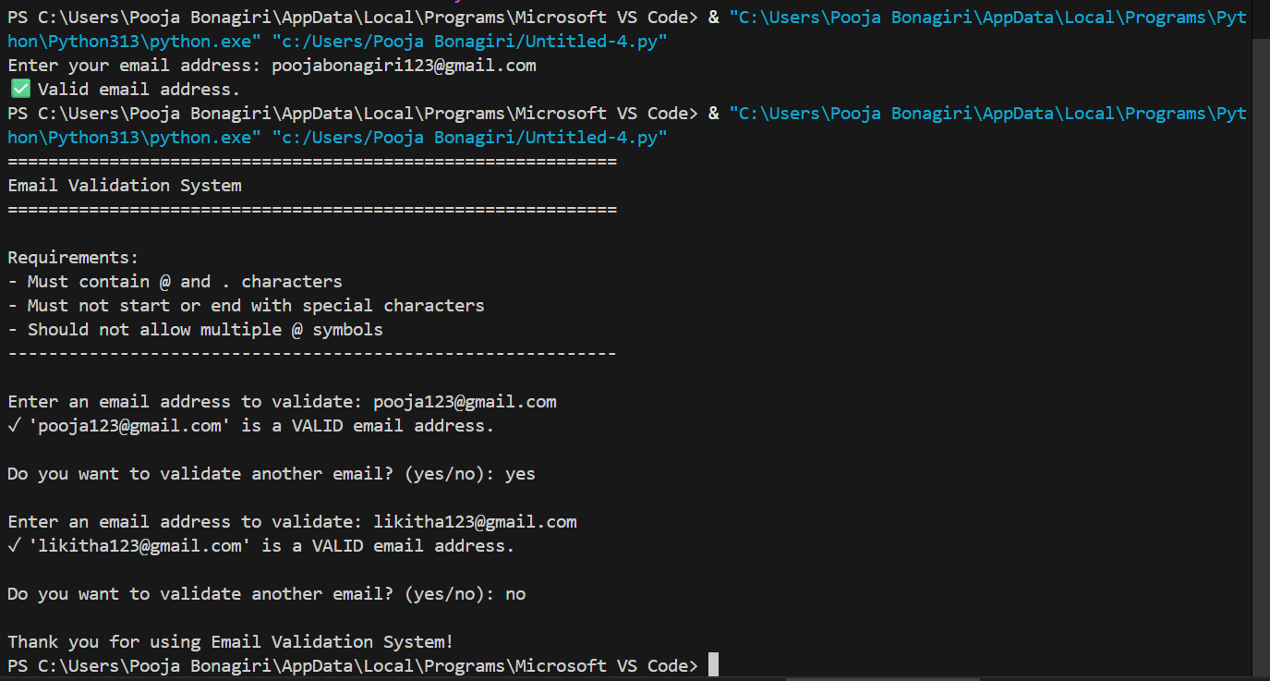
Explanation:
This program checks whether an email address is valid based on simple rules like having exactly one @, containing a dot in the domain, and not starting or ending with special characters. It also includes an interactive feature where the user can enter an email, see if it’s valid or not, and choose to check another one.

Task 2: Grade Assignment using Loops
Prompt:
Create a Python assign_grade(score) function that returns A–F grades, handles invalid inputs, and passes all unittest test cases including boundaries and edge cases.
Code:
def assign_grade(score):
"""
Assign a grade based on the score.

90-100 -> A
80-89 -> B
70-79 -> C
60-69 -> D
Below 60 -> F
"""
if not isinstance(score, (int, float)):
raise TypeError("Score must be a number.")
if score < 0 or score > 100:
raise ValueError("Score must be between 0 and 100.")

if 90 <= score <= 100:
return 'A'
elif 80 <= score <= 89:
return 'B'
elif 70 <= score <= 79:
return 'C'
elif 60 <= score <= 69:
return 'D'
else:
return 'F'

def main():
print("=== Interactive Grade Assignment ===")
print("Enter your scores to get grades. Type 'exit' to quit.")

while True:
user_input = input("\nEnter score: ").strip()

if user_input.lower() in ['exit', 'quit']:
print("Exiting the grading system. Goodbye!")
break

try:
# Convert input to float to handle decimal scores
score = float(user_input)
grade = assign_grade(score)
print(f"Score: {score} → Grade: {grade}")
except ValueError as ve:
print(f"Invalid input: {ve}")
except TypeError as te:
print(f"Invalid input: {te}")

if __name__ == "__main__":
main()

Output:

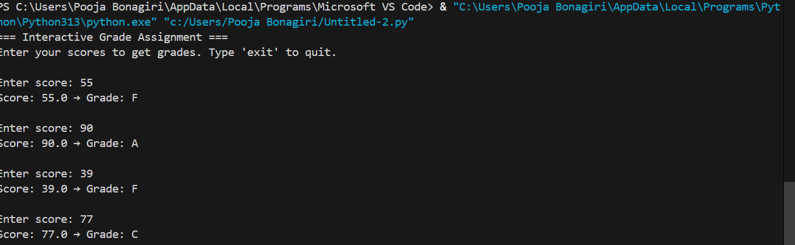
Explanation:
This task is about creating an automated grading system using a test-driven approach. The goal is to write tests first for all grade ranges (A–F), including boundary values like 60, 70, 80, 90, and invalid inputs like -5, 105, or "eighty." Then, you implement the assign_grade(score) function so it passes all tests, correctly assigns grades, and handles errors gracefully.
Task 3: Sentence Palindrome Checker
Prompt:
Create a Python function `is_sentence_palindrome(sentence)` that checks if a sentence is a palindrome. Ignore case, spaces, and punctuation. Also, generate unittest test cases covering palindromic and non-palindromic sentences.
Code:
# palindrome_checker.py

import unittest
import string

def is_sentence_palindrome(sentence: str) -> bool:
"""
Check if a sentence is a palindrome.
Ignores case, spaces, and punctuation.

Args:
sentence (str): The sentence to check.

Returns:
bool: True if palindrome, False otherwise.
"""
if not isinstance(sentence, str):
raise TypeError("Input must be a string")

# Remove punctuation and spaces, convert to lowercase
cleaned = ''.join(c.lower() for c in sentence if c.isalnum())

# Check palindrome
return cleaned == cleaned[::-1]

# ==============================
# Unit Tests
# ==============================
class TestSentencePalindrome(unittest.TestCase):
"""Unit tests for is_sentence_palindrome function."""

def test_simple_palindrome(self):
self.assertTrue(is_sentence_palindrome("madam"))

def test_sentence_palindrome(self):
self.assertTrue(is_sentence_palindrome("A man a plan a canal Panama"))

def test_sentence_with_punctuation(self):
self.assertTrue(is_sentence_palindrome("No 'x' in Nixon!"))

def test_non_palindrome_sentence(self):
self.assertFalse(is_sentence_palindrome("This is not a palindrome"))

def test_empty_string(self):
self.assertTrue(is_sentence_palindrome(""))

def test_single_character(self):
self.assertTrue(is_sentence_palindrome("x"))

def test_numeric_palindrome(self):
self.assertTrue(is_sentence_palindrome("12321"))

def test_numeric_non_palindrome(self):
self.assertFalse(is_sentence_palindrome("12345"))

def test_invalid_input(self):
with self.assertRaises(TypeError):
is_sentence_palindrome(12345)
with self.assertRaises(TypeError):
is_sentence_palindrome(None)

if __name__ == "__main__":
# Run tests with detailed output
unittest.main(verbosity=2)

Output:
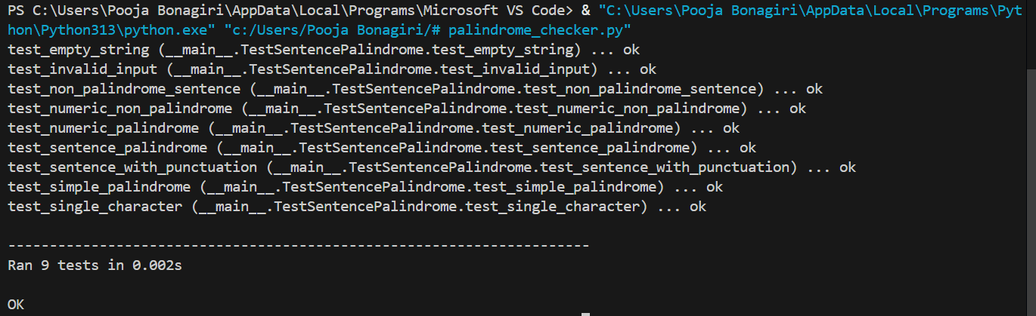
Explanation:
The is_sentence_palindrome function checks if a sentence reads the same forwards and backwards, ignoring spaces, punctuation, and case. It first cleans the sentence by keeping only letters and numbers in lowercase, then compares it with its reverse. The unit tests cover normal palindromes, sentences with punctuation, numbers, non-palindromes, empty strings, single characters, and invalid inputs to ensure the function works correctly.

Task 4: ShoppingCart Class
Prompt:
Write a Python class ShoppingCart with methods add_item(name, price), remove_item(name), and total_cost(). Include validation for empty cart and correct total cost calculation. Also, create unit tests to verify adding, removing, and total cost.
Code:
# shopping_cart_input.py

class ShoppingCart:
"""Simple interactive shopping cart."""

def __init__(self):
self.items = {}

def add_item(self, name, price):
if name in self.items:
self.items[name] += price
else:
self.items[name] = price

def remove_item(self, name):
if name in self.items:
del self.items[name]

def total_cost(self):
return sum(self.items.values())

def main():
cart = ShoppingCart()
while True:
print("\nOptions: add, remove, total, show, quit")
choice = input("Enter option: ").strip().lower()

if choice == "add":
name = input("Item name: ").strip()
try:
price = float(input("Item price: "))
cart.add_item(name, price)
print(f"{name} added with price {price}.")
except ValueError:
print("Invalid price! Please enter a number.")

elif choice == "remove":
name = input("Item name to remove: ").strip()
cart.remove_item(name)
print(f"{name} removed if it existed.")

elif choice == "total":
print(f"Total cost: {cart.total_cost()}")

elif choice == "show":
print("Cart items:", cart.items)

elif choice == "quit":
print("Exiting. Final total:", cart.total_cost())
break

else:
print("Invalid option! Try again.")

if __name__ == "__main__":
main()

Output:
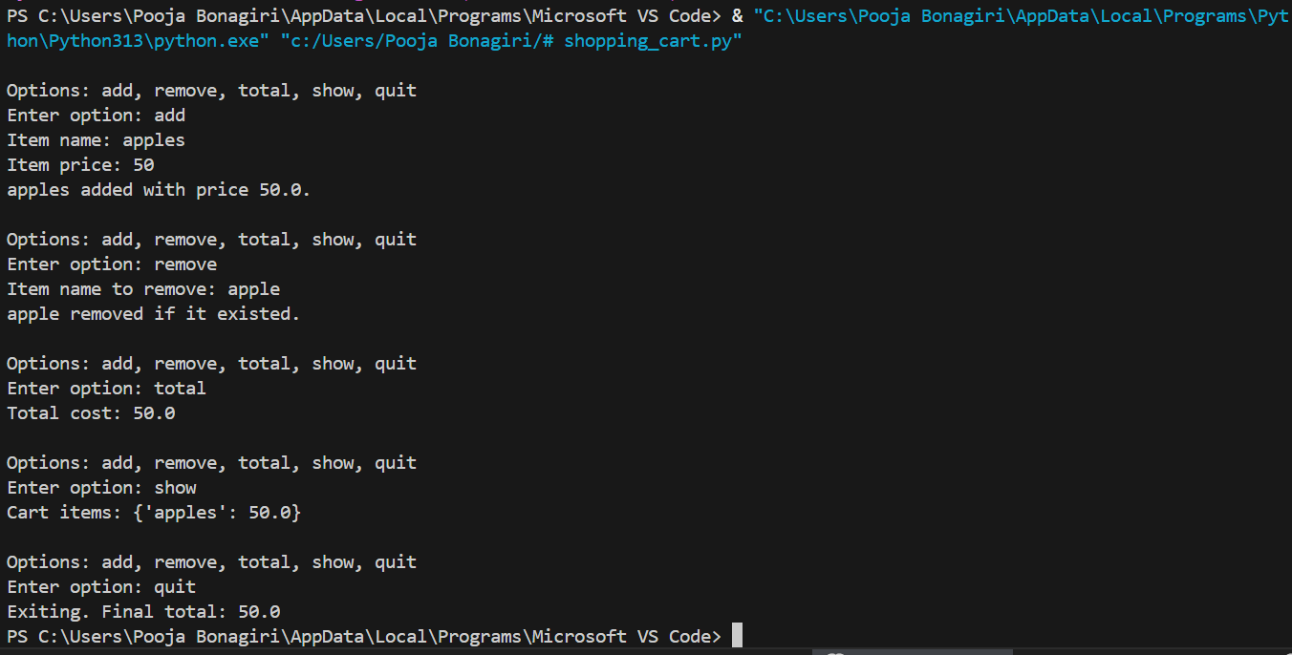

Explanation:
The ShoppingCart program lets users manage a simple e-commerce cart interactively. It uses a ShoppingCart class that stores items and their prices in a dictionary and provides methods to add items, remove items, and calculate the total cost. The main() function runs a loop where the user can input commands to add or remove products, view the current total, or exit the program. The program validates inputs, updates the cart in real time, and continues running until the user chooses to quit, ensuring an easy and dynamic shopping experience.
Task 5: Date Format Conversion
Prompt:
Write a Python function convert_date_format(date_str) that converts a date from YYYY-MM-DD format to DD-MM-YYYY. Include input validation and test cases.
Code:
def convert_date_format(date_str):
"""
Convert a date string from 'YYYY-MM-DD' to 'DD-MM-YYYY'.

Args:
date_str (str): Date in 'YYYY-MM-DD' format.

Returns:
str: Date in 'DD-MM-YYYY' format.

Raises:
ValueError: If the input is not in the correct format.
"""
# Validate input type
if not isinstance(date_str, str):
raise TypeError("Input must be a string in 'YYYY-MM-DD' format")

# Split the date
parts = date_str.split('-')

# Check for correct format
if len(parts) != 3:
raise ValueError("Date must be in 'YYYY-MM-DD' format")

year, month, day = parts

# Basic validation
if len(year) != 4 or len(month) != 2 or len(day) != 2:
raise ValueError("Date must be in 'YYYY-MM-DD' format")

return f"{day}-{month}-{year}"

# --- Interactive Loop ---
while True:
user_input = input("Enter date in YYYY-MM-DD format (or type 'exit' to quit): ").strip()
if user_input.lower() == 'exit':
print("Exiting program.")
break
try:
converted_date = convert_date_format(user_input)
print(f"Converted Date: {converted_date}")
except (ValueError, TypeError) as e:
print(f"Error: {e}")
quit

Output:
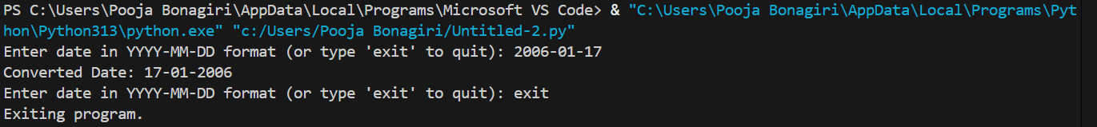

Explanation:
This program converts dates from YYYY-MM-DD to DD-MM-YYYY format. It defines a function convert_date_format that checks if the input is a string and properly formatted, then rearranges the year, month, and day. The program runs in a loop, asking the user for input repeatedly until they type exit, If the input is valid, it prints the converted date; if not, it shows a clear error message. This way, the program handles both correct and incorrect inputs interactively.

