Name:B.Pooja
Hall Ticket:2303A52141
Batch - 41

Task 1 Employee Dataset Cleaning
Prompt:
Clean an employee dataset by handling missing values (salary → median, designation → mode, experience → mean), removing duplicate employee IDs, standardizing job titles to lowercase, and encoding categorical features for analysis.
Code :
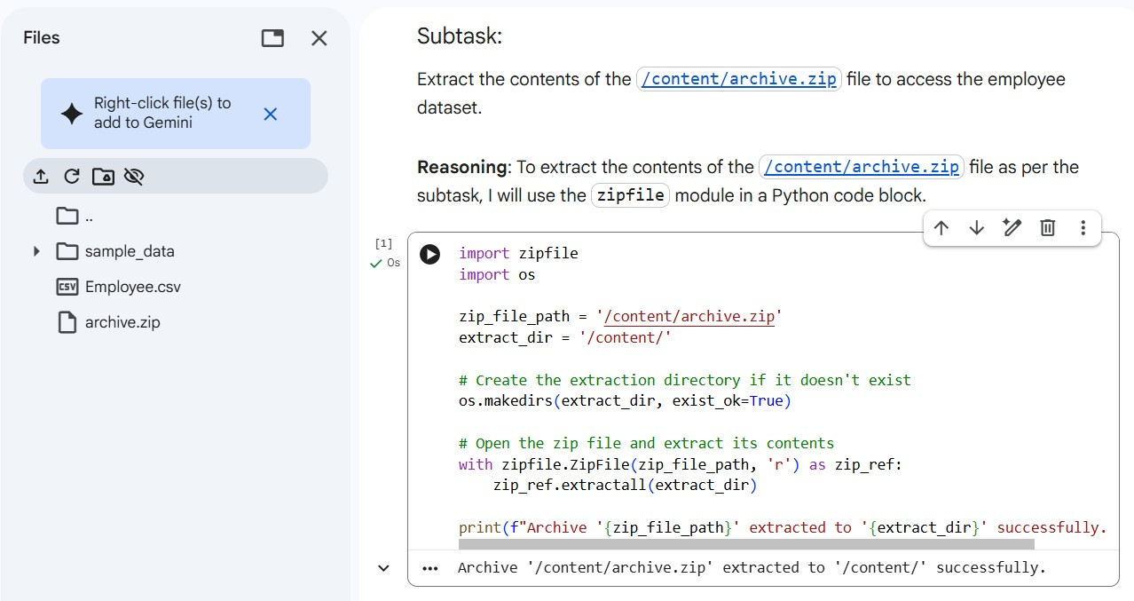

Load Employee Dataset
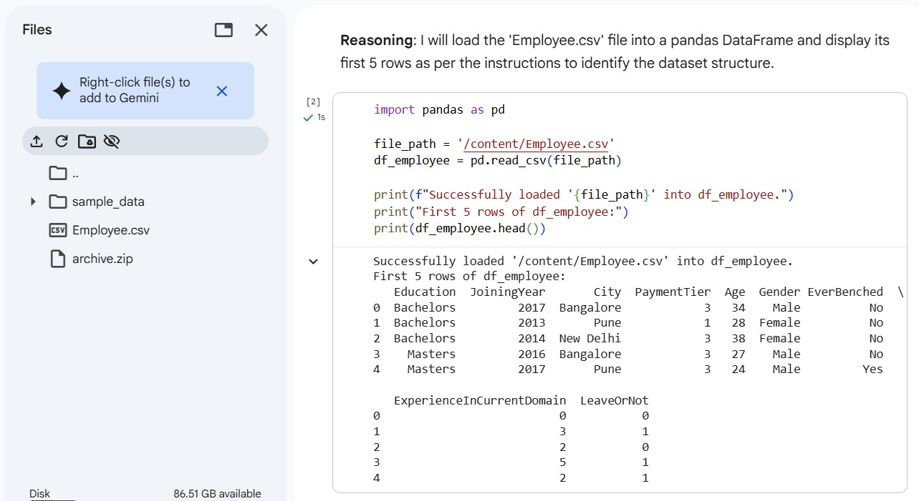
Handle Missing Values
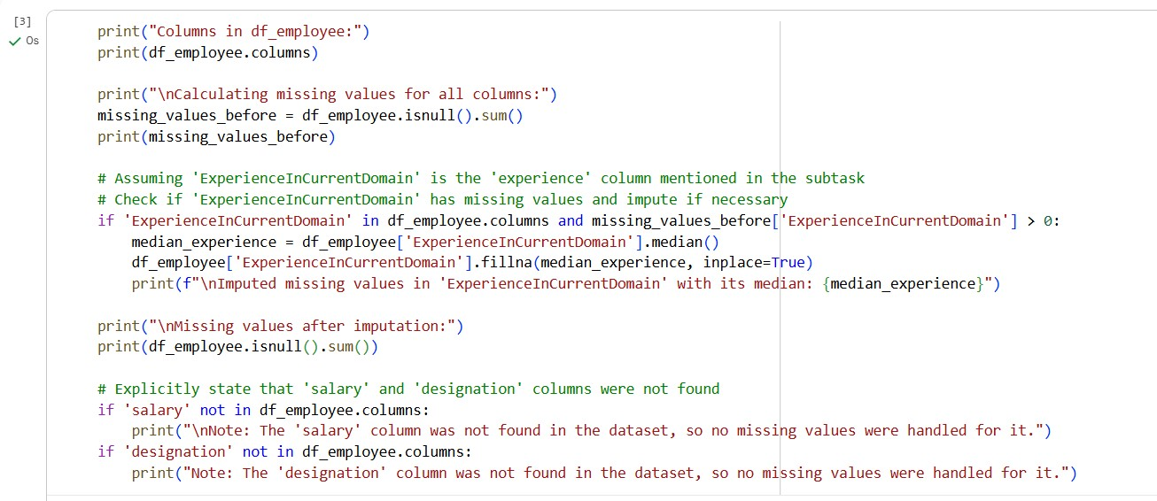

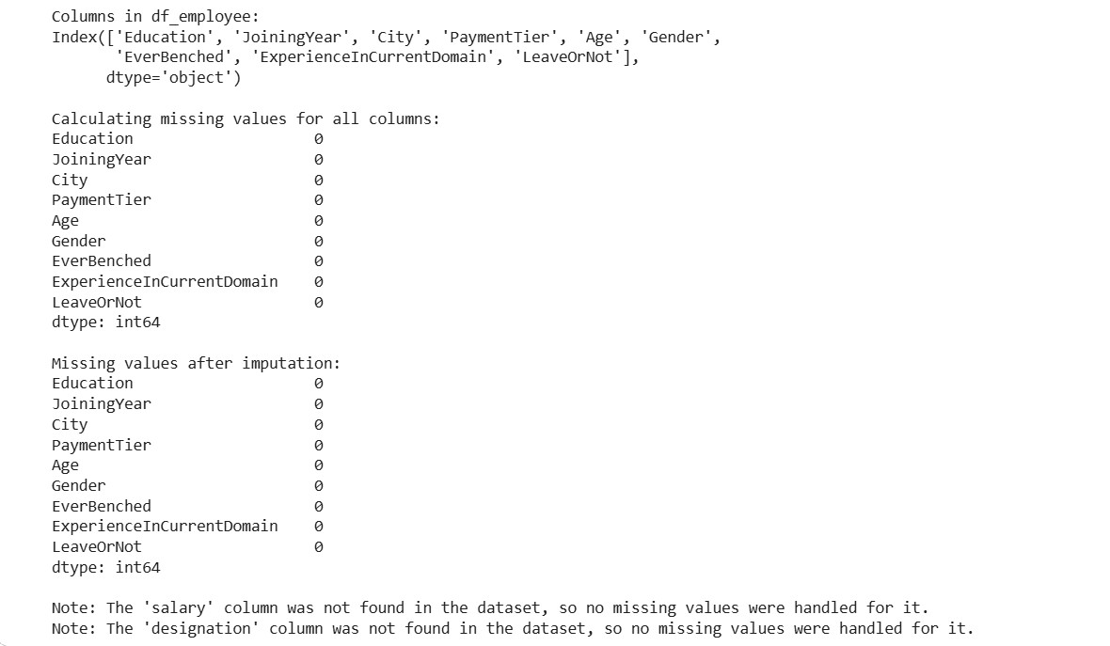

Remove Duplicate Employee IDs
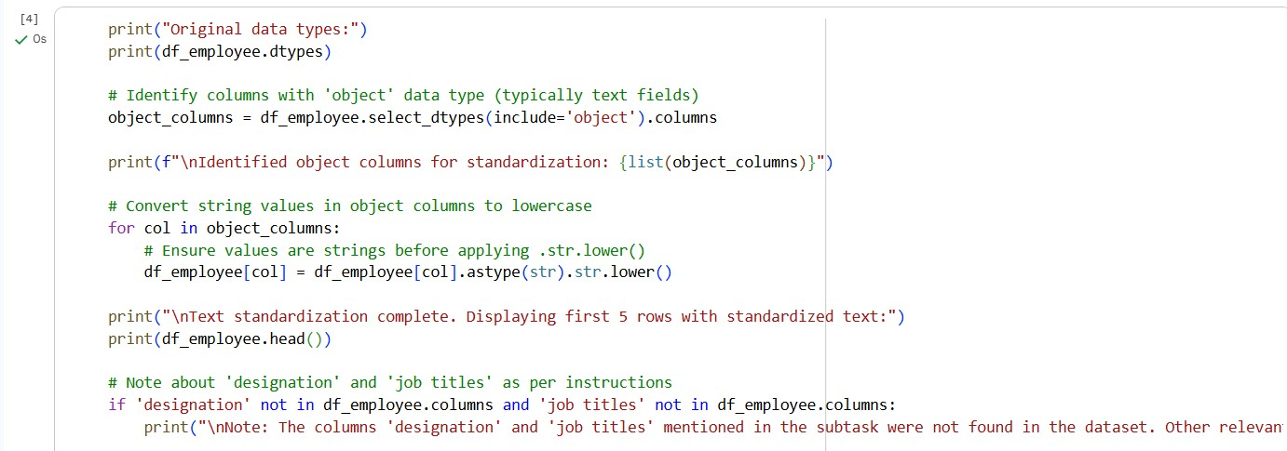

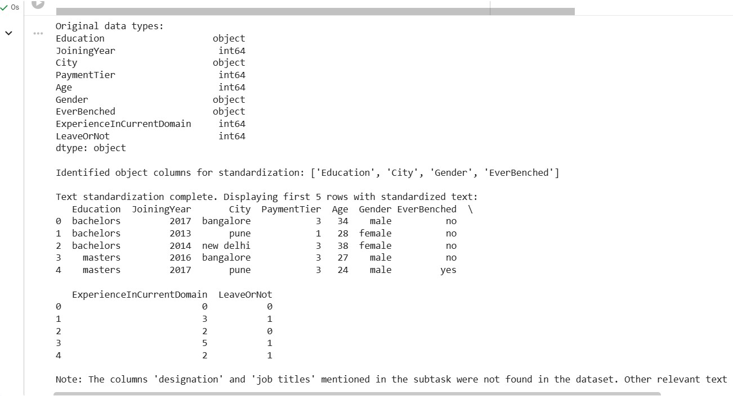

Encode Categorical Features
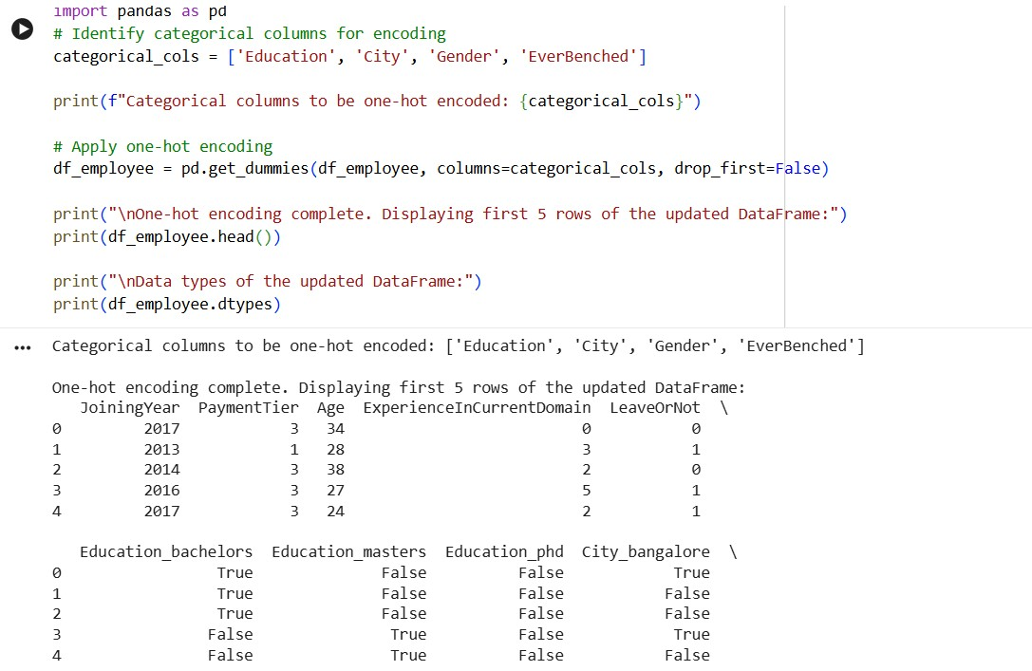

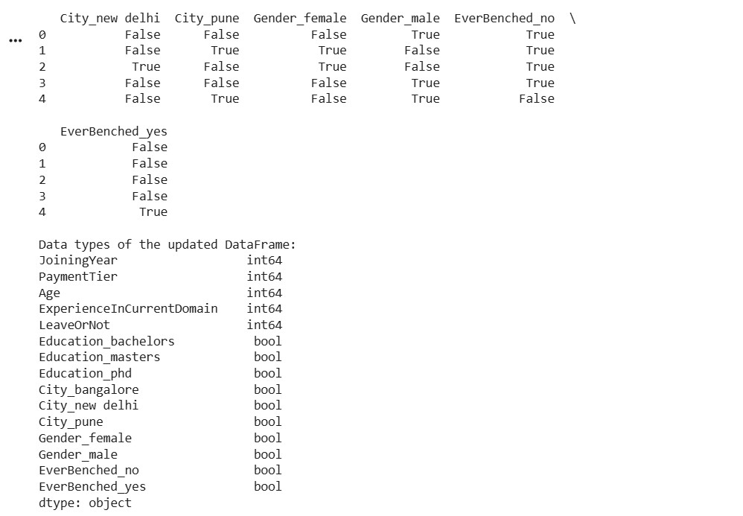

Identify Invalid Employee Information
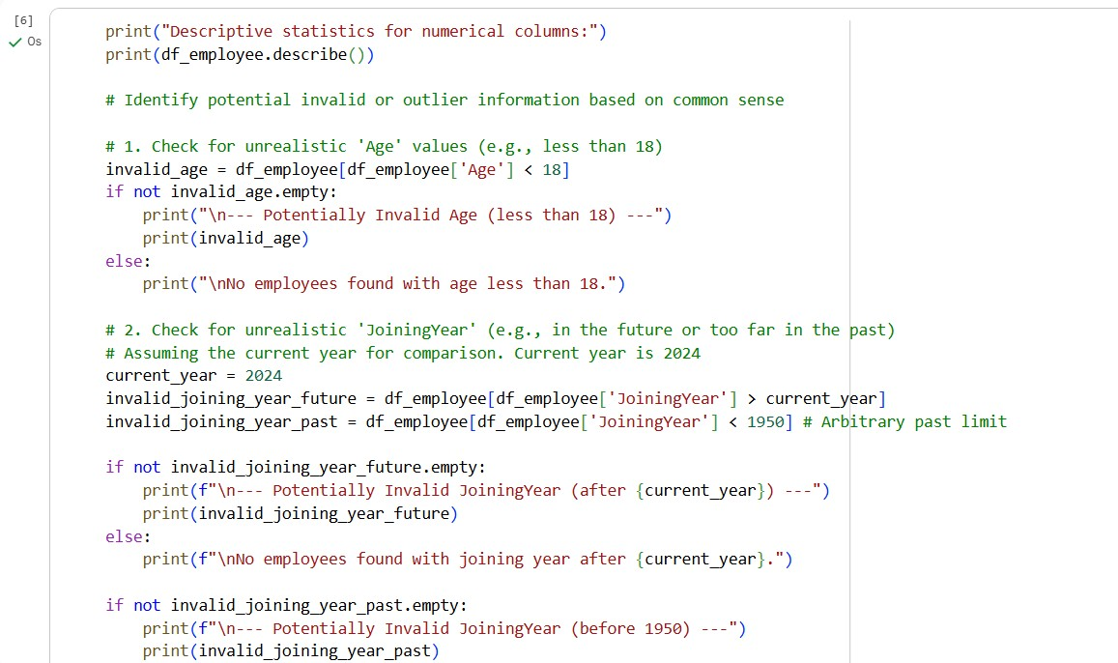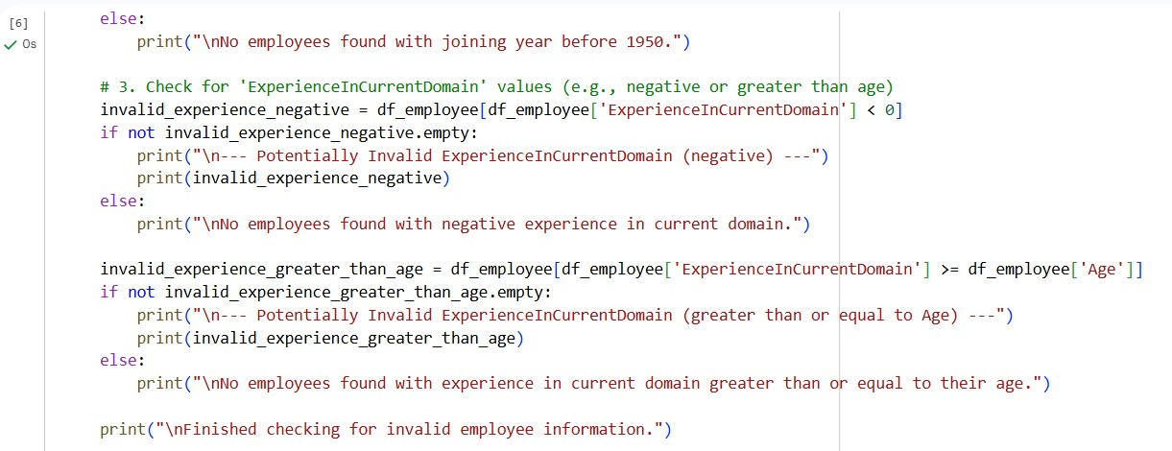

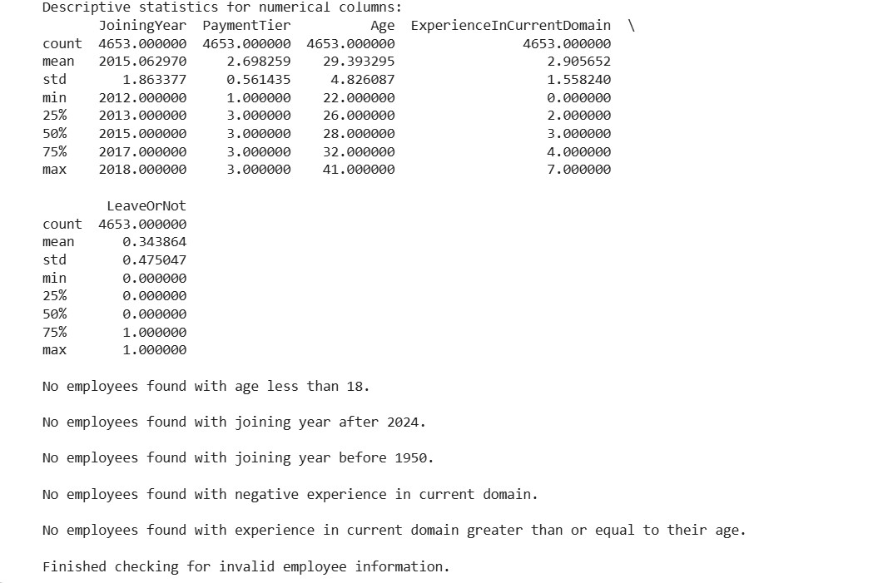

Display Cleaned Dataset Information
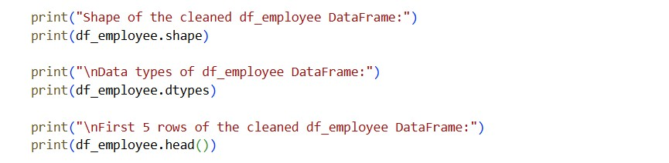

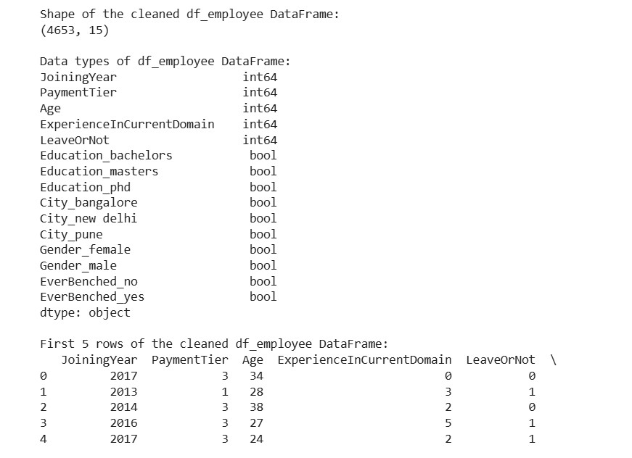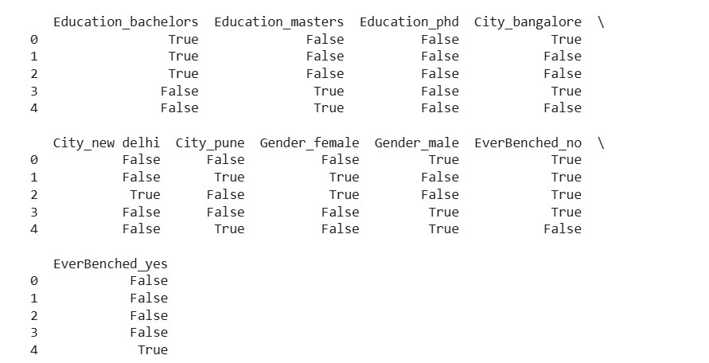

Explanation:
Missing values are handled using suitable statistical methods to maintain data quality. Salary is filled with the median since it avoids the effect of extreme values. Designation is replaced with the most frequent value to keep category consistency, while experience uses the average to maintain numerical balance. Duplicate employee IDs are removed to ensure accurate records. Text standardization converts job titles into lowercase to avoid inconsistencies. Finally, categorical features are encoded into numerical form so that machine learning models can process the data effectively.

Task 2 – Student Performance Data Preprocessing
Prompt:
Preprocess a student performance dataset.

Code :
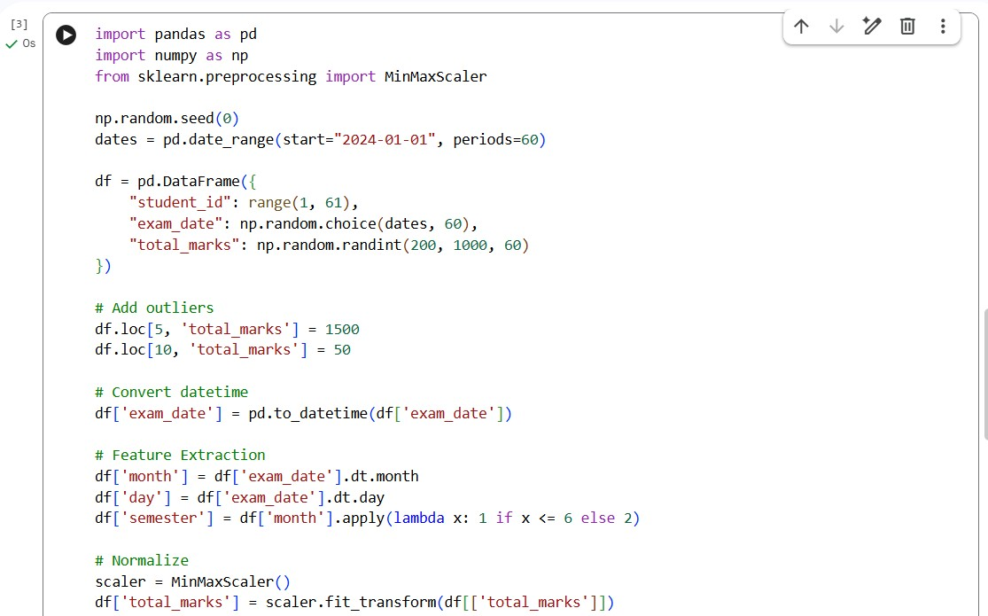
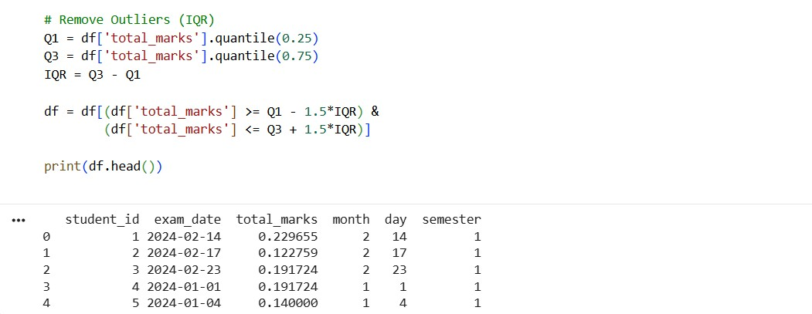

Explanation:
Datetime conversion allows better time-based analysis of the data. Feature extraction helps in identifying important patterns such as semester trends. Min-max scaling normalizes the data into a 0–1 range for better model performance. Removing outliers improves the overall accuracy and reliability of the model.

Task 3 – Student Health Data Preparation
Prompt:
Prepare a student health dataset for machine learning.
Code and output:
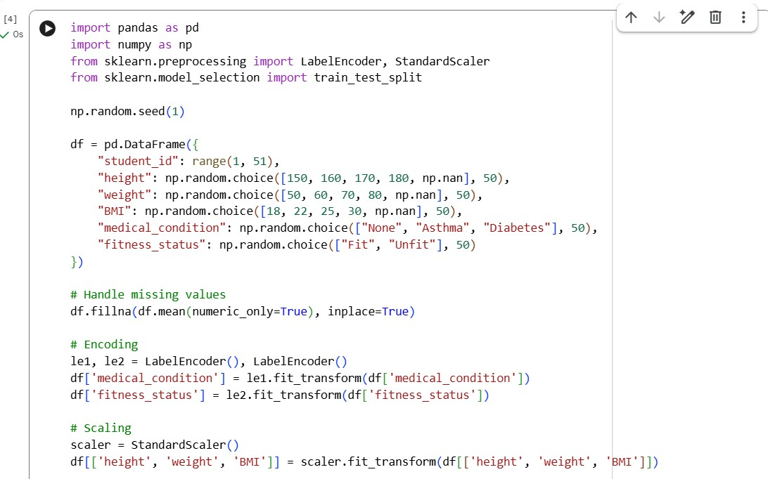
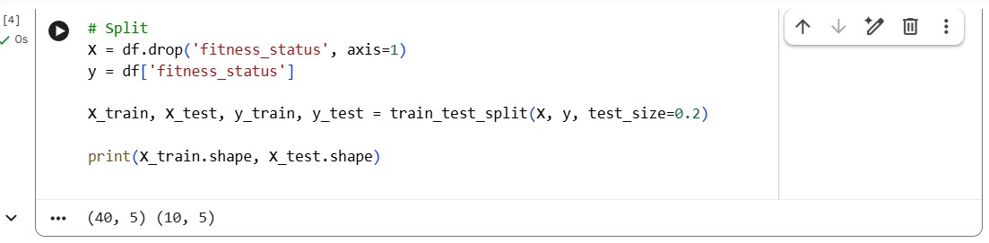

Explanation:
Mean imputation is used to fill missing values without reducing the dataset size. Encoding converts categorical variables into numerical form so that machine learning models can process them. Standard scaling ensures that all features are on a similar scale, improving model efficiency. The train-test split is applied to evaluate the performance of the model on unseen data.

Task 4: Real-Time Application: Ride-Sharing Data Cleaning
Prompt:
Clean a ride-sharing dataset.

Code:
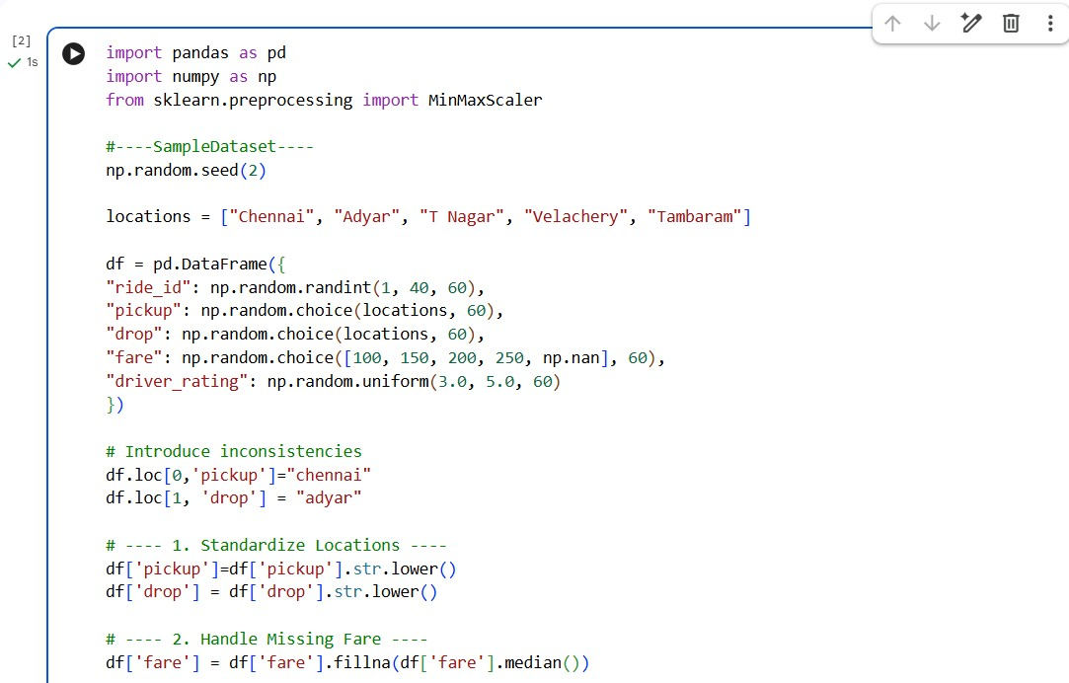
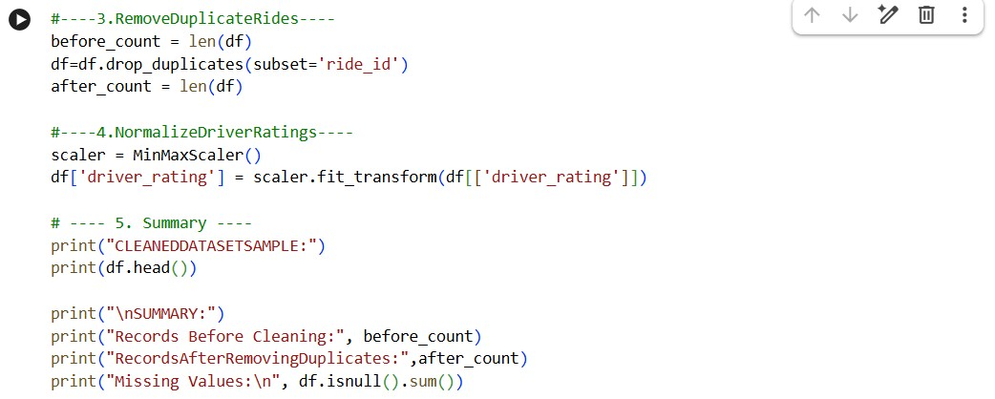

Output:
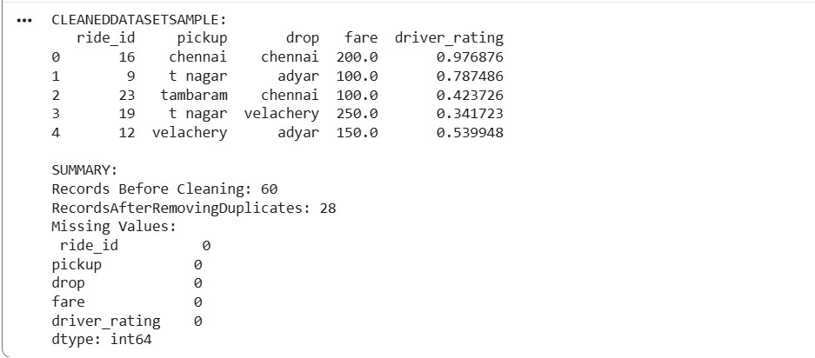
Explanation:
Standardizing location names helps avoid duplicate and inconsistent entries in the dataset. Using the median for fare minimizes the effect of extreme values. Removing duplicates ensures the data remains accurate and reliable. Normalization makes it easier to compare ratings fairly. Finally, a summary step is used to confirm that the data cleaning process has been successfully completed.

