Name: B.Pooja
Hall Ticket: 2303A52141
Batch: 41
Task 1: AI-Assisted Bug Detection
Prompt:
identify the the logical bug in the code of given code
Code:
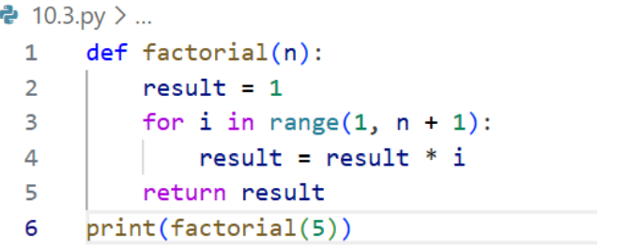

Output:
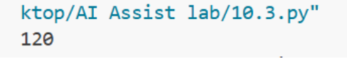

Explanation:
The bug was in the for loop because it ran only up to n-1, giving a wrong result. The AI fixed it by changing the range to n+1. My manual fix and the AI’s fix are similar. However, the AI did not handle negative numbers, where factorial is undefined.

Task 2: Improving Readability &Documentation
Prompt:
Rewrite the function with clear, descriptive names and add a complete docstring including description, parameters, return value, examples, and handling for division by zero with input validation.
Scenario Code:
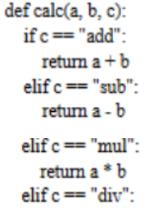

AI Corrected Code:
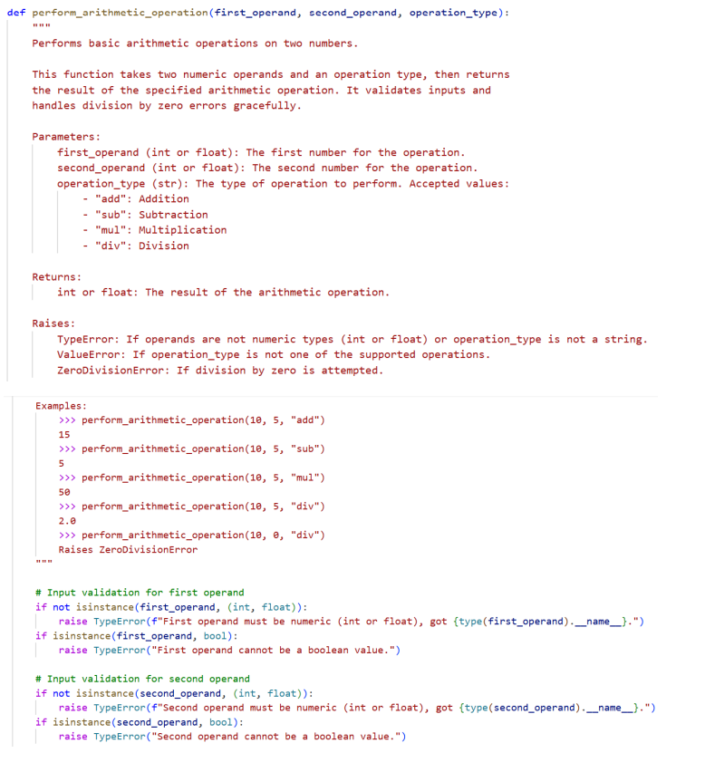
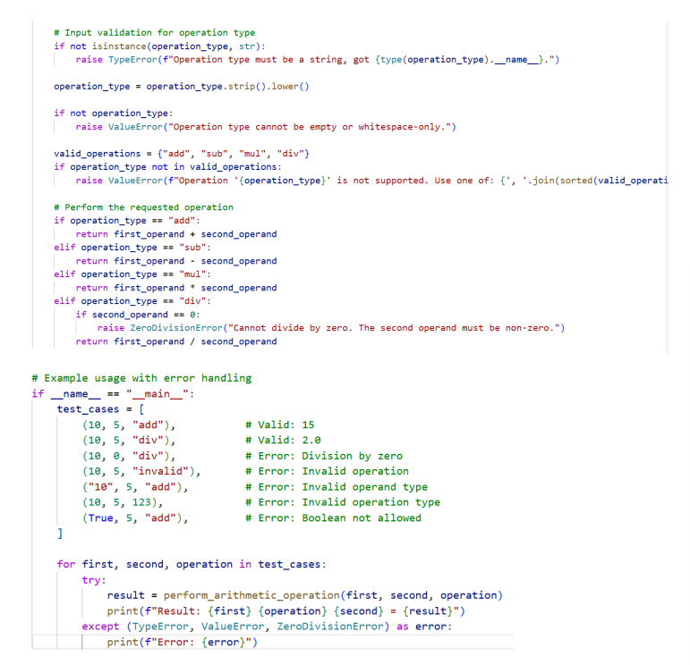
Output:
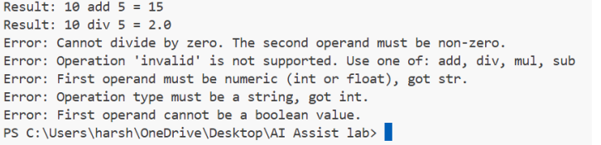

Explanation:
In this task, the AI improved the code by adding clear documentation, proper docstrings, exception handling, and input validation.Compared to the original version, the AI-enhanced code is more structured and easier to understand. It works correctly for both valid and invalid inputs.
Task 3: Enforcing Coding Standards
Prompt:
Identify all PEP 8 style violations in the given code and rewrite the code after correcting those issues.
Code:
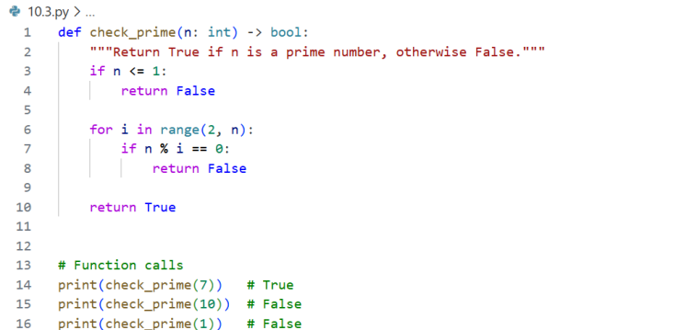

Output:

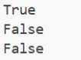
Explanation:
PEP 8 Violations:
- The function name does not follow snake_case convention → Checkprime should be check_prime.
- A blank line is missing before the function definition.
- The function does not include a docstring.
- The edge case where n <= 1 is not properly handled.
Automated AI-based code reviews help teams by quickly identifying style issues, logical errors, and potential performance problems. They ensure consistent adherence to standards like PEP 8 and reduce the manual effort required from reviewers. This enables developers to concentrate more on system design and core functionality rather than formatting issues, leading to faster reviews, cleaner code, and better teamwork.
Task 4: AI as a Code Reviewer in Real Projects
Prompt:
Refactor and enhance the code in the file by using clearer, more descriptive names and provide suggestions to make the code more generalized and reusable.
Code:
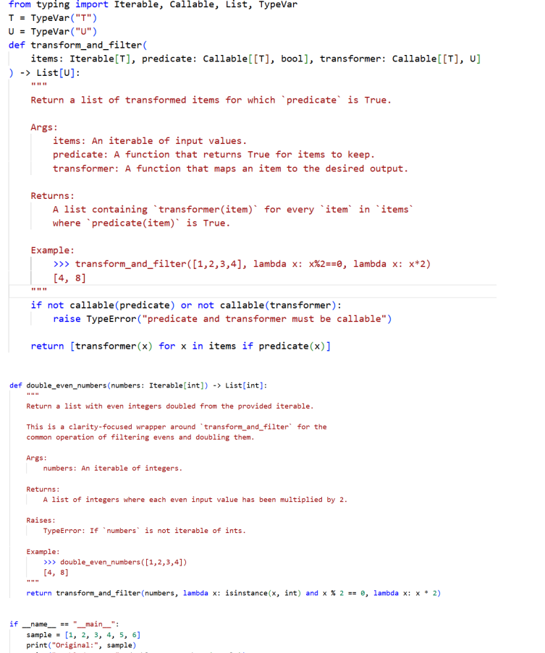

Output:
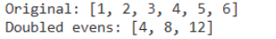
Explanation:
To make the code more general, we can add a max_items parameter to handle large data, use yield instead of returning a list to improve memory efficiency, and create common helper functions like is_even. We can also support async functions for IO-related tasks. AI should support human reviewers by quickly finding errors, while humans focus on logic and design decisions.
Task 5: AI-Assisted Performance Optimization
Prompt:
Analyze the given code, give time complexity, and then optimize the code and check for input range 1000000.
Code:

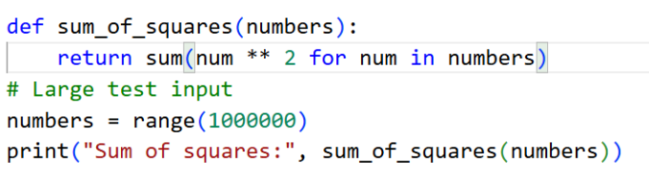

Output:

Explanation:
Both the original and optimized code have the same time complexity of O(n) because the loop runs up to n to get the result. The optimization only uses built-in functions to make the solution simpler and cleaner.Readable code is easier for people to understand, maintain, and debug. Very optimized code may run faster, but it can become difficult to read. So, it is better to keep the code simple and optimize only when performance is really required.

