Name: B.Pooja
Hall Ticket:2303A52141
Batch:41
Task 1: Responsive Homepage Layout for a Startup Website
Prompt:
Create a responsive homepage layout using HTML, CSS, and JavaScript with a header, navigation bar (Home, About, Services, Contact), main content area, and footer, with a clean modern design.add clickable dropdown menus for Home, About, Services, and Contact that show more options without reloading the page and ensure the layout works on mobile, tablet, and desktop using media queries.
Code:
<!DOCTYPE html>
<html lang="en">
<head>
<meta charset="UTF-8">
<meta name="viewport" content="width=device-width, initial-scale=1.0">
<title>Startup Website</title>
<style>
/* Basic reset */
*{
margin:0;
padding:0;
box-sizing:border-box;
font-family: Arial, sans-serif;
}
/* Header */
header{
background:#4CAF50;
color:white;
text-align:center;
padding:20px;
}
/* Navigation bar */
nav{
background:#333;
}
.menu{
list-style:none;
display:flex;
justify-content:center;
}
.menu li{
position:relative;
}
.menu a{
display:block;
padding:15px 20px;
color:white;
text-decoration:none;
}
.menu a:hover{
background:#555;
}
/* Dropdown menu */
.submenu{
display:none;
position:absolute;
background:#444;
top:50px;
list-style:none;
min-width:150px;
}
.submenu li{
padding:10px;
color:white;
cursor:pointer;
}
.submenu li:hover{
background:#666;
}
/* Main content */
main{
padding:40px;
}
.content-box{
background:#f4f4f4;
padding:30px;
border-radius:5px;
}

/* Button */
button{
margin-top:20px;
padding:10px 20px;
background:#4CAF50;
color:white;
border:none;
cursor:pointer;
}
button:hover{
background:#45a049;
}
/* Footer */
footer{
background:#333;
color:white;
text-align:center;
padding:15px;
margin-top:40px;
}
/* Responsive design */
@media(max-width:768px){
.menu{
flex-direction:column;
align-items:center;
}
.submenu{
position:static;
}
}
</style>
</head>
<body>
<header>
<h1>Welcome to Our Website</h1>
</header>
<nav>
<ul class="menu">
<li>
<a href="#" onclick="toggleMenu('homeMenu')">Home</a>
<ul id="homeMenu" class="submenu">
<li onclick="showMessage('Home Overview')">Overview</li>
<li onclick="showMessage('Latest News')">Latest News</li>
<li onclick="showMessage('Updates')">Updates</li>
</ul>
</li>
<li>
<a href="#" onclick="toggleMenu('aboutMenu')">About</a>
<ul id="aboutMenu" class="submenu">
<li onclick="showMessage('Our Team')">Our Team</li>
<li onclick="showMessage('Company History')">History</li>
<li onclick="showMessage('Mission & Vision')">Mission</li>
</ul>
</li>
<li>
<a href="#" onclick="toggleMenu('servicesMenu')">Services</a>
<ul id="servicesMenu" class="submenu">
<li onclick="showMessage('Web Development Service')">Web Development</li>
<li onclick="showMessage('Mobile App Development')">App Development</li>
<li onclick="showMessage('Business Consulting')">Consulting</li>
</ul>
</li>
<li>
<a href="#" onclick="toggleMenu('contactMenu')">Contact</a>
<ul id="contactMenu" class="submenu">
<li onclick="showMessage('Email: contact@startup.com')">Email</li>
<li onclick="showMessage('Phone: +91 9876543210')">Phone</li>
<li onclick="showMessage('Location: India')">Location</li>
</ul>
</li>
</ul>
</nav>
<main>
<div class="content-box">
<h2>Main Content Area</h2>
<p>This is the main content area of the homepage. Here you can add information about your website, services, or any other relevant content.</p>
<button onclick="ctaAction()">Click Here</button>
</div>
</main>
<footer>
<p>© 2026 Startup Website | All Rights Reserved</p>
</footer>
<script>
// Function to open and close dropdown menus
function toggleMenu(menuId){
let menu = document.getElementById(menuId);
if(menu.style.display === "block"){
menu.style.display = "none";
}
else{
menu.style.display = "block";
}
}
// Function to show alert when submenu is clicked
function showMessage(text){
alert("You clicked: " + text);
}
// Call-to-action button function
function ctaAction(){
alert("Thank you for clicking the Call-to-Action button!");
}
</script>
</body>
</html>

Output:
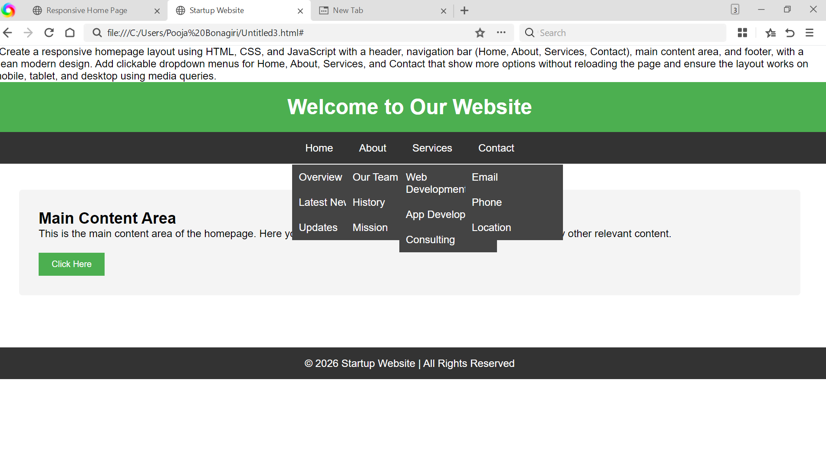
Link:
file:///C:/Users/Pooja%20Bonagiri/Untitled3.html#
Explanation:
The code creates a responsive website homepage using HTML, CSS, and JavaScript. HTML builds the structure with a header, navigation menu, main content, and footer. CSS is used to style the page and make it responsive for mobile, tablet, and desktop screens. JavaScript adds interactivity by opening dropdown menus and showing alert messages when users click the menu items or the button without reloading the page.
Task 2: Interactive Call-to-Action Button
Prompt:
Create a responsive homepage layout using HTML, CSS, and JavaScript with a header, navigation bar (Home, About, Services, Contact), main content area, and footer, with a clean modern design.Add clickable dropdown menus for Home, About, Services, and Contact that show more options without reloading the page and ensure the layout works on mobile, tablet, and desktop using media queries.
Code:
<!DOCTYPE html>
<html>
<head>
<title>Call To Action Button</title>
<style>
/* Page style */
body{
font-family: Arial;
text-align:center;
margin-top:100px;
}
/* Button style */
button{
background-color:blue;
color:white;
padding:12px 25px;
border:none;
font-size:18px;
cursor:pointer;
border-radius:5px;
}
/* Message style */
#message{
margin-top:20px;
font-size:20px;
color:green;
}
</style>
</head>
<body>
<h2>Welcome to Our Website</h2>
<p>Click the button to see the message</p>
<!-- Call to action button -->
<button onclick="showMessage()">Click Here</button>

<!-- Message will appear here -->
<p id="message"></p>

<script>
/*
This function runs when the button is clicked.
It displays a message on the page without refreshing it.
*/
function showMessage(){
document.getElementById("message").innerHTML="Thank you for clicking the button!";
}
</script>
</body>
</html>

Output:
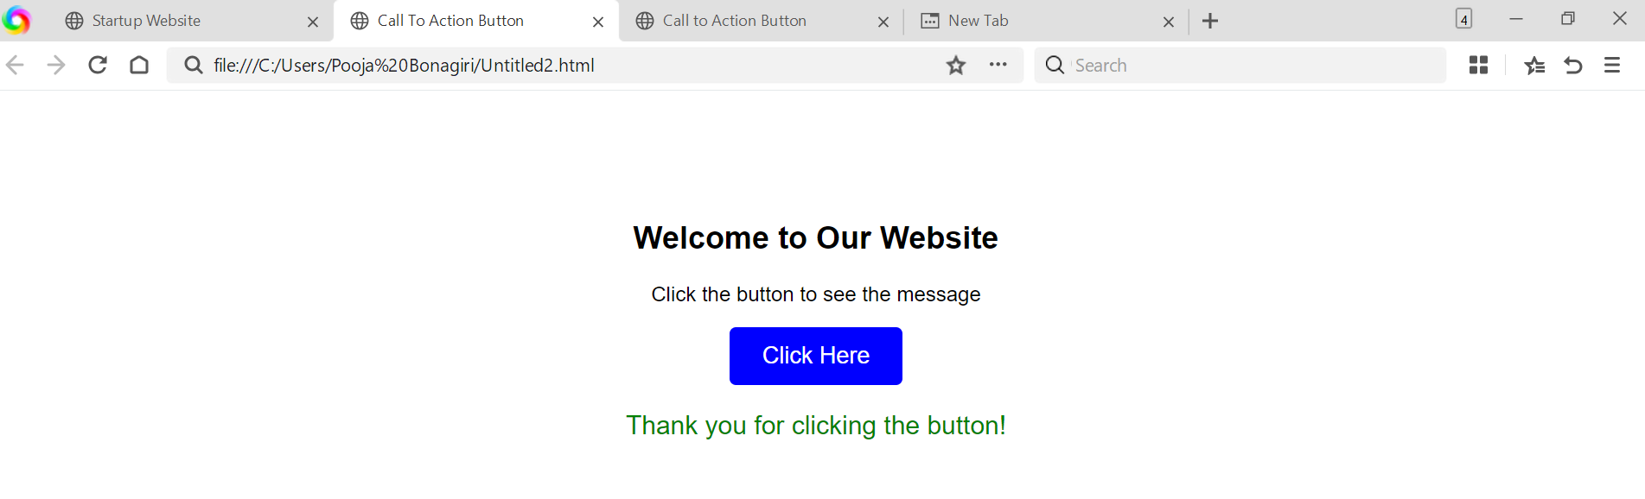
Link:
file:///C:/Users/Pooja%20Bonagiri/Untitled2.html
Explanation:
This code creates a simple web page with a call-to-action button using HTML, CSS, and JavaScript. HTML builds the page structure and button, while CSS styles the page and button appearance. When the user clicks the button, the JavaScript function displays a message on the page without reloading it.

Task 3: Contact Form with Client-Side Validation
Prompt:
Create a contact form using HTML, CSS, and JavaScript with fields for Name, Email, and Message, and add client-side validation to prevent empty inputs and check valid email format, showing error or success messages without reloading the page.
Code:
<!DOCTYPE html>
<html>
<head>
<title>Contact Form</title>
<style>
body{
font-family: Arial;
background:#f4f4f4;
text-align:center;
margin-top:40px;
}
form{
background:white;
width:350px;
margin:auto;
padding:20px;
border-radius:5px;
box-shadow:0px 0px 5px gray;
}
input, textarea{
width:90%;
padding:10px;
margin:8px;
}

button{
padding:10px 20px;
margin:10px;
background:green;
color:white;
border:none;
cursor:pointer;
}
button:hover{
background:darkgreen;
}
.error{
color:red;
font-size:13px;
}
.success{
color:green;
font-size:15px;
}
</style>
</head>
<body>
<h2>Contact Us</h2>
<form onsubmit="return validateForm()">
<input type="text" id="name" placeholder="Enter your name">
<br>
<span id="nameError" class="error"></span>
<input type="text" id="email" placeholder="Enter your email">
<br>
<span id="emailError" class="error"></span>
<input type="text" id="phone" placeholder="Enter your phone number">
<br>
<span id="phoneError" class="error"></span>
<input type="text" id="subject" placeholder="Enter subject">
<br>
<textarea id="message" placeholder="Enter your message"></textarea>
<br>
<span id="messageError" class="error"></span>
<button type="submit">Submit</button>
<button type="reset">Clear</button>
</form>
<p id="successMessage" class="success"></p>
<h3>Our Contact Details</h3>
<p>Email: support@company.com</p>
<p>Phone: +91 9876543210</p>
<p>Location: India</p>
<script>
/* This function validates the form fields */
function validateForm(){
let name=document.getElementById("name").value;
let email=document.getElementById("email").value;
let phone=document.getElementById("phone").value;
let message=document.getElementById("message").value;
let emailPattern=/^[^ ]+@[^ ]+\.[a-z]{2,3}$/;
let valid=true;
/* clear old messages */
document.getElementById("nameError").innerHTML="";
document.getElementById("emailError").innerHTML="";
document.getElementById("phoneError").innerHTML="";
document.getElementById("messageError").innerHTML="";
document.getElementById("successMessage").innerHTML="";
/* name validation */
if(name===""){
document.getElementById("nameError").innerHTML="Name is required";
valid=false;
}
/* email validation */
if(email===""){
document.getElementById("emailError").innerHTML="Email is required";
valid=false;
}
else if(!email.match(emailPattern)){
document.getElementById("emailError").innerHTML="Enter valid email";
valid=false;
}
/* phone validation */
if(phone===""){
document.getElementById("phoneError").innerHTML="Phone number is required";
valid=false;
}
/* message validation */
if(message===""){
document.getElementById("messageError").innerHTML="Message is required";
valid=false;
}
/* success message */
if(valid){
document.getElementById("successMessage").innerHTML="Form submitted successfully!";
}
return false;
}
</script>
</body>
</html>

Output:
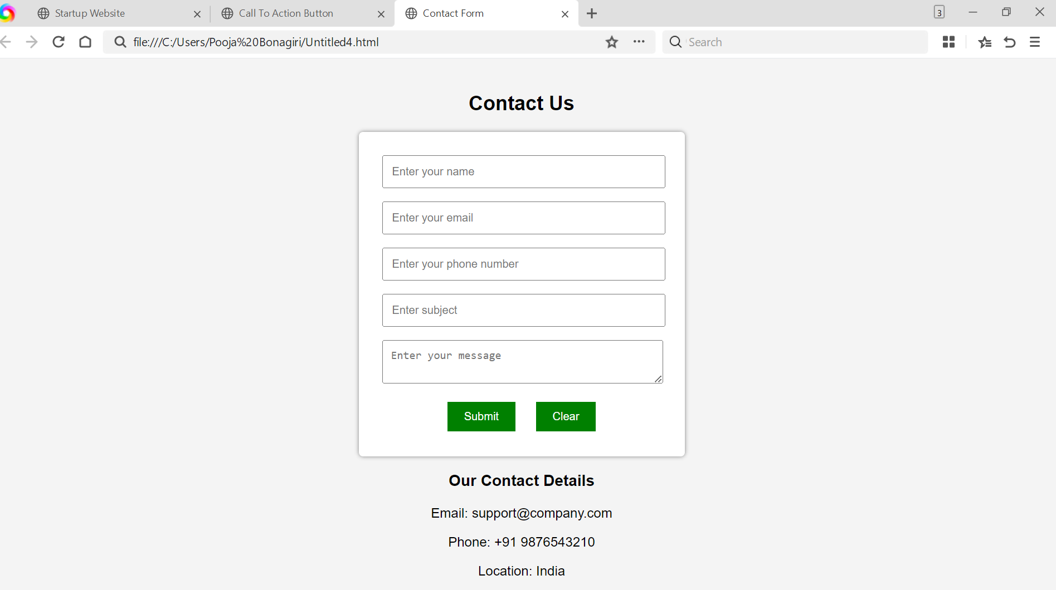
Link:
file:///C:/Users/Pooja%20Bonagiri/Untitled4.html

Explanation:
This code creates a contact form using HTML, CSS, and JavaScript. The form collects user details like name, email, phone, subject, and message. JavaScript validates the inputs, shows error messages for invalid fields, and displays a success message when the form is correctly filled, without reloading the page.
Task 4: Dynamic List Management for a Product Page
Prompt:
Create a web page using HTML and JavaScript with a product list where clicking an add Item button adds a new item and a "Remove Item" button removes the last item dynamically without reloading the page.
Code:
<!DOCTYPE html>
<html>
<head>
<title>Product List</title>

<style>

body{
font-family: Arial;
text-align:center;
margin-top:50px;
}

button{
padding:10px 20px;
margin:10px;
background:green;
color:white;
border:none;
cursor:pointer;
}

li{
margin:5px;
}

</style>

</head>

<body>

<h2>Product List</h2>

<ul id="productList">
<li>Product 1</li>
<li>Product 2</li>
</ul>

<button onclick="addItem()">Add Item</button>
<button onclick="removeItem()">Remove Item</button>

<script>

/* Function to add a new item to the list */

function addItem(){

let list=document.getElementById("productList");

let newItem=document.createElement("li");

newItem.innerHTML="New Product";

list.appendChild(newItem);

}

/* Function to remove the last item from the list */

function removeItem(){

let list=document.getElementById("productList");

if(list.lastElementChild){
list.removeChild(list.lastElementChild);
}

}

</script>

</body>
</html>
Output:
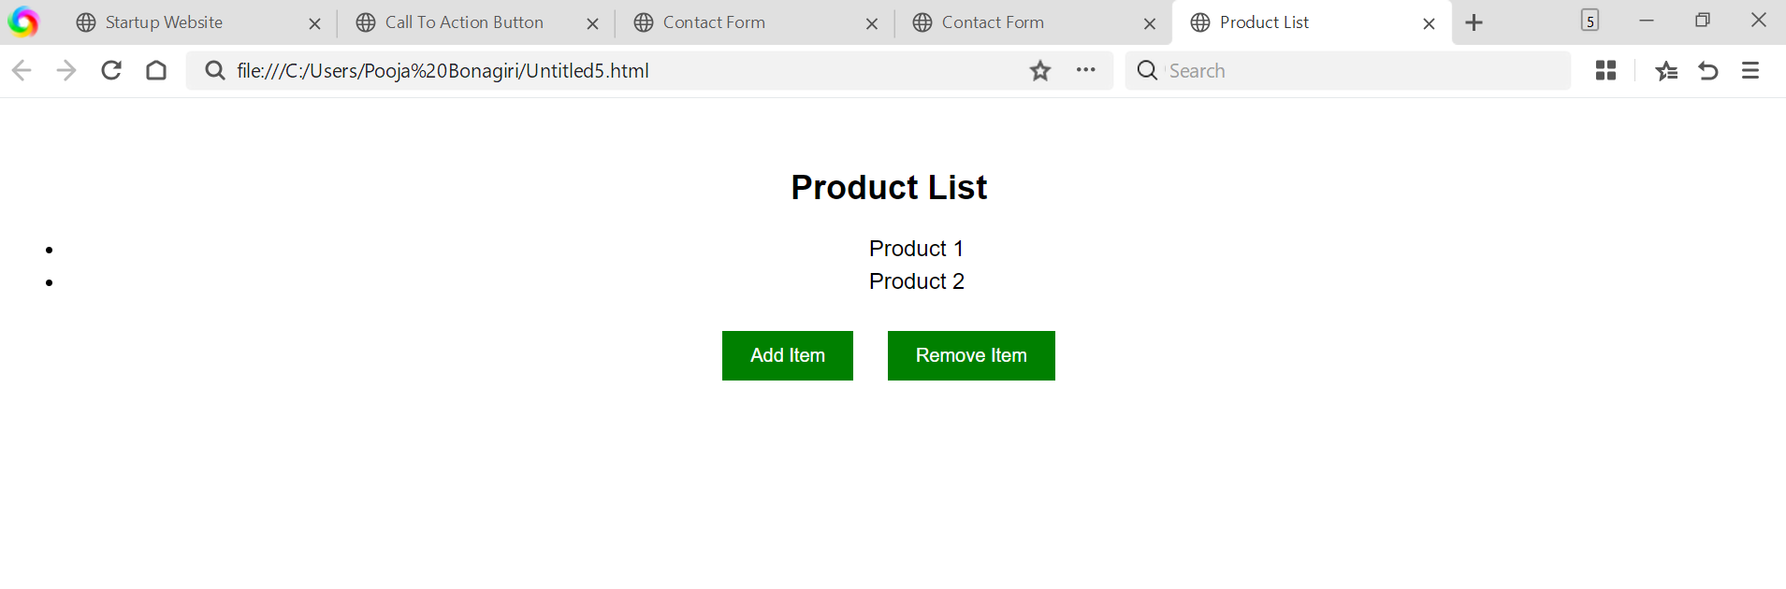
Link:
file:///C:/Users/Pooja%20Bonagiri/Untitled5.html
Explanation:
This code creates a product list using HTML and uses JavaScript to update the list dynamically. When the user clicks Add Item, a new product is added to the list, and when Remove Item is clicked, the last product is removed without reloading the page.
Task 5: Modal Popup for User Notifications
Prompt:
Create a web page using HTML, CSS, and JavaScript with a modal popup that opens when clicking an Open Modal button and closes when clicking a close button or the overlay without reloading the page.
Code:
<!DOCTYPE html>
<html>
<head>
<title>User Notification</title>

<style>

body{
font-family: Arial;
text-align:center;
margin:0;
background:#f4f4f4;
}

/* Header */
header{
background:#333;
color:white;
padding:15px;
}

/* Content */
.container{
padding:40px;
}

/* Button */
button{
padding:10px 20px;
background:green;
color:white;
border:none;
cursor:pointer;
font-size:16px;
}

/* Modal background */
.modal{
display:none;
position:fixed;
top:0;
left:0;
width:100%;
height:100%;
background:rgba(0,0,0,0.6);
}

/* Modal box */
.modal-content{
background:white;
width:320px;
margin:15% auto;
padding:20px;
border-radius:5px;
text-align:center;
}

/* Close button */
.close{
float:right;
font-size:20px;
cursor:pointer;
}

/* Footer */
footer{
background:#333;
color:white;
padding:10px;
margin-top:40px;
}

</style>

</head>

<body>

<header>
<h2>Website Notification System</h2>
</header>

<div class="container">

<h2>User Notification</h2>

<p>This page shows how a modal popup works for website announcements.</p>

<button onclick="openModal()">Open Modal</button>

</div>

<!-- Modal -->
<div id="myModal" class="modal" onclick="closeModal()">

<div class="modal-content" onclick="event.stopPropagation()">

<span class="close" onclick="closeModal()">&times;</span>

<h3>Announcement</h3>

<p>Welcome to our website! Check out the latest updates and offers.</p>

<button onclick="closeModal()">Close</button>

</div>

</div>

<footer>
<p>© 2026 My Website | Notifications Demo</p>
</footer>

<script>

/* Function to open modal */
function openModal(){
document.getElementById("myModal").style.display="block";
}

/* Function to close modal */
function closeModal(){
document.getElementById("myModal").style.display="none";
}

</script>

</body>
</html>

Output:
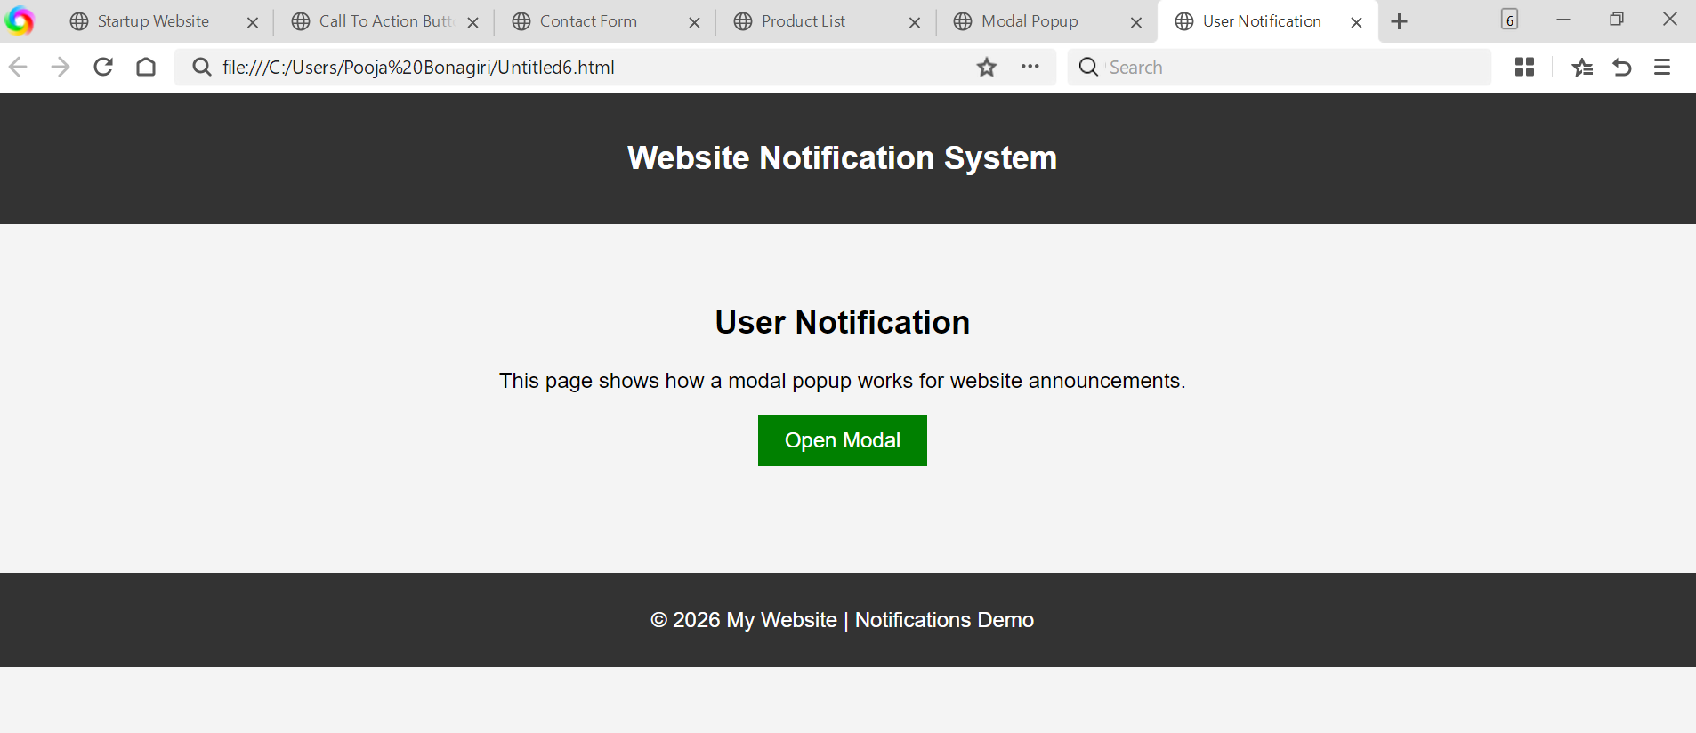
Link:
file:///C:/Users/Pooja%20Bonagiri/Untitled6.html
Explanation:
This code creates a modal popup notification using HTML, CSS, and JavaScript. When the user clicks the Open Modal button, a popup appears with a semi-transparent background overlay. The popup can be closed by clicking the close button or the background, without reloading the page.

