Name: B.Pooja
Hall Ticket: 2303A52141
Batch: 41
Task 1: Hospital Management Database
Prompt:
Design a normalized Hospital Management System database in SQLite with three tables: Doctors, Patients, and Appointments, including primary keys, foreign keys, and constraints like NOT NULL and UNIQUE. Write SQL join queries to list appointments for a specific doctor, retrieve a patient’s full history, and count distinct patients treated by each doctor. Also include sample INSERT statements and basic SELECT queries to test and verify the data.
Code:
-- SQLite
-- DROP old tables (important if you ran before)
DROP TABLE IF EXISTS Appointments;
DROP TABLE IF EXISTS Doctors;
DROP TABLE IF EXISTS Patients;

-- Create Doctors table CREATE TABLE Doctors (
doctor_id INTEGER PRIMARY KEY AUTOINCREMENT, first_name TEXT NOT NULL, last_name TEXT NOT NULL, specialty TEXT NOT NULL,
UNIQUE (first_name, last_name)
);

-- Create Patients table CREATE TABLE Patients ( patient_id INTEGER PRIMARY KEY AUTOINCREMENT, first_name TEXT NOT NULL, last_name TEXT NOT NULL, date_of_birth TEXT NOT NULL,
UNIQUE (first_name, last_name, date_of_birth)
);

-- Create Appointments table CREATE TABLE Appointments ( appointment_id INTEGER PRIMARY KEY AUTOINCREMENT, doctor_id INTEGER NOT NULL, patient_id INTEGER NOT NULL, appointment_date TEXT NOT NULL,
FOREIGN KEY (doctor_id) REFERENCES Doctors(doctor_id),
FOREIGN KEY (patient_id) REFERENCES Patients(patient_id)
);

-- Insert data
INSERT INTO Doctors (first_name, last_name, specialty) VALUES
('John', 'Doe', 'Cardiology'),
('Jane', 'Smith', 'Neurology');

INSERT INTO Patients (first_name, last_name, date_of_birth) VALUES
('Alice', 'Johnson', '1980-05-15'),
('Bob', 'Brown', '1990-08-22');

INSERT INTO Appointments (doctor_id, patient_id, appointment_date) VALUES
(1, 1, '2024-07-01'),
(1, 2, '2024-07-02'),
(2, 1, '2024-07-03');

-- TEST OUTPUT (IMPORTANT)
SELECT * FROM Doctors;
SELECT * FROM Patients;
SELECT * FROM Appointments;

-- Required Queries
SELECT a.appointment_id, d.first_name, d.last_name, p.first_name, p.last_name, a.appointment_date
FROM Appointments a
JOIN Doctors d ON a.doctor_id = d.doctor_id
JOIN Patients p ON a.patient_id = p.patient_id
WHERE a.doctor_id = 1;

SELECT a.appointment_id, d.first_name, d.last_name, a.appointment_date FROM Appointments a
JOIN Doctors d ON a.doctor_id = d.doctor_id
WHERE a.patient_id = 1;

SELECT d.doctor_id, d.first_name, d.last_name, COUNT(DISTINCT a.patient_id) FROM Doctors d
LEFT JOIN Appointments a ON d.doctor_id = a.doctor_id
GROUP BY d.doctor_id;
CREATE TABLE test123 (id INTEGER);
SELECT name FROM sqlite_master;

Output:
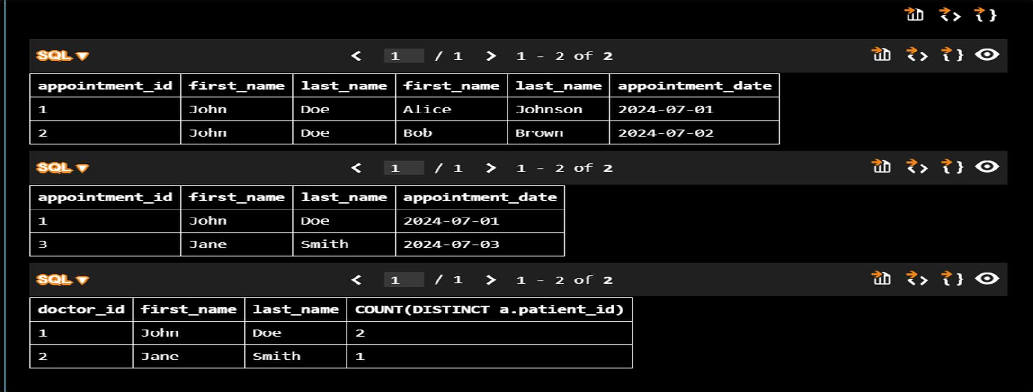
Explanation:
The system uses three interconnected tables, with the Appointments table acting as a link between Doctors and Patients through foreign keys to maintain proper normalization. SQL joins help merge data from these tables to easily access appointment records, patient histories, and summary counts.
Task 2: Real-Time Applica on: Online Shopping Database
Prompt:
Create a complete SQL solution for an E-commerce (Online Shopping) system by designing a normalized database with four tables: Users, Products, Orders, and OrderDetails. Define primary keys, foreign keys, suitable data types, and constraints like NOT NULL and UNIQUE, ensuring compatibility with SQLite and maintaining at least Third Normal Form (3NF). Establish proper relationships between the tables. Then, write SQL join queries to fetch all orders for a specific user using user_id, identify the most purchased product based on total quantity sold, and calculate total revenue for a selected month. Include sample INSERT statements for testing, along with SELECT queries to verify the data, and briefly suggest improvements for normalization and query optimization.
Code:
-- SQLite
-- SQLite E-commerce Database (FINAL CLEAN)

PRAGMA foreign_keys = ON;

-- RESET (important to avoid duplicate/exists errors)
DROP TABLE IF EXISTS OrderDetails;
DROP TABLE IF EXISTS Orders;
DROP TABLE IF EXISTS Products;
DROP TABLE IF EXISTS Users;

-- Create Users table CREATE TABLE Users ( user_id INTEGER PRIMARY KEY AUTOINCREMENT, username TEXT NOT NULL UNIQUE, email TEXT NOT NULL UNIQUE, password TEXT NOT NULL,
created_at DATETIME DEFAULT CURRENT_TIMESTAMP
);

-- Create Products table CREATE TABLE Products (
product_id INTEGER PRIMARY KEY AUTOINCREMENT, product_name TEXT NOT NULL, price REAL NOT NULL, stock INTEGER NOT NULL, created_at DATETIME DEFAULT CURRENT_TIMESTAMP
);

-- Create Orders table CREATE TABLE Orders (
order_id INTEGER PRIMARY KEY AUTOINCREMENT, user_id INTEGER NOT NULL,
order_date DATETIME DEFAULT CURRENT_TIMESTAMP, FOREIGN KEY (user_id) REFERENCES Users(user_id)
);

-- Create OrderDetails table CREATE TABLE OrderDetails ( order_detail_id INTEGER PRIMARY KEY AUTOINCREMENT, order_id INTEGER NOT NULL, product_id INTEGER NOT NULL, quantity INTEGER NOT NULL, price REAL NOT NULL,
FOREIGN KEY (order_id) REFERENCES Orders(order_id),
FOREIGN KEY (product_id) REFERENCES Products(product_id)
);

-- Insert data
INSERT INTO Users (username, email, password) VALUES
('john_doe', 'john@example.com', 'password123');

INSERT INTO Products (product_name, price, stock) VALUES
('Laptop', 999.99, 10),
('Mouse', 29.99, 50);

INSERT INTO Orders (user_id) VALUES (1);

INSERT INTO OrderDetails (order_id, product_id, quantity, price) VALUES
(1, 1, 1, 999.99),
(1, 2, 2, 29.99);

-- TEST OUTPUT (you MUST see data)
SELECT * FROM Users;
SELECT * FROM Products;
SELECT * FROM Orders;
SELECT * FROM OrderDetails;

-- 1. Retrieve all orders by a user
SELECT o.order_id, o.order_date, od.product_id, od.quantity, od.price FROM Orders o
JOIN OrderDetails od ON o.order_id = od.order_id
WHERE o.user_id = 1;

-- 2. Most purchased product
SELECT p.product_name, SUM(od.quantity) AS total_quantity_sold
FROM Products p
JOIN OrderDetails od ON p.product_id = od.product_id
GROUP BY p.product_id
ORDER BY total_quantity_sold DESC
LIMIT 1;

-- 3. Total revenue in a given month
SELECT SUM(od.quantity * od.price) AS total_revenue FROM Orders o
JOIN OrderDetails od ON o.order_id = od.order_id
WHERE strftime('%Y-%m', o.order_date) = '2024-01';

Output:
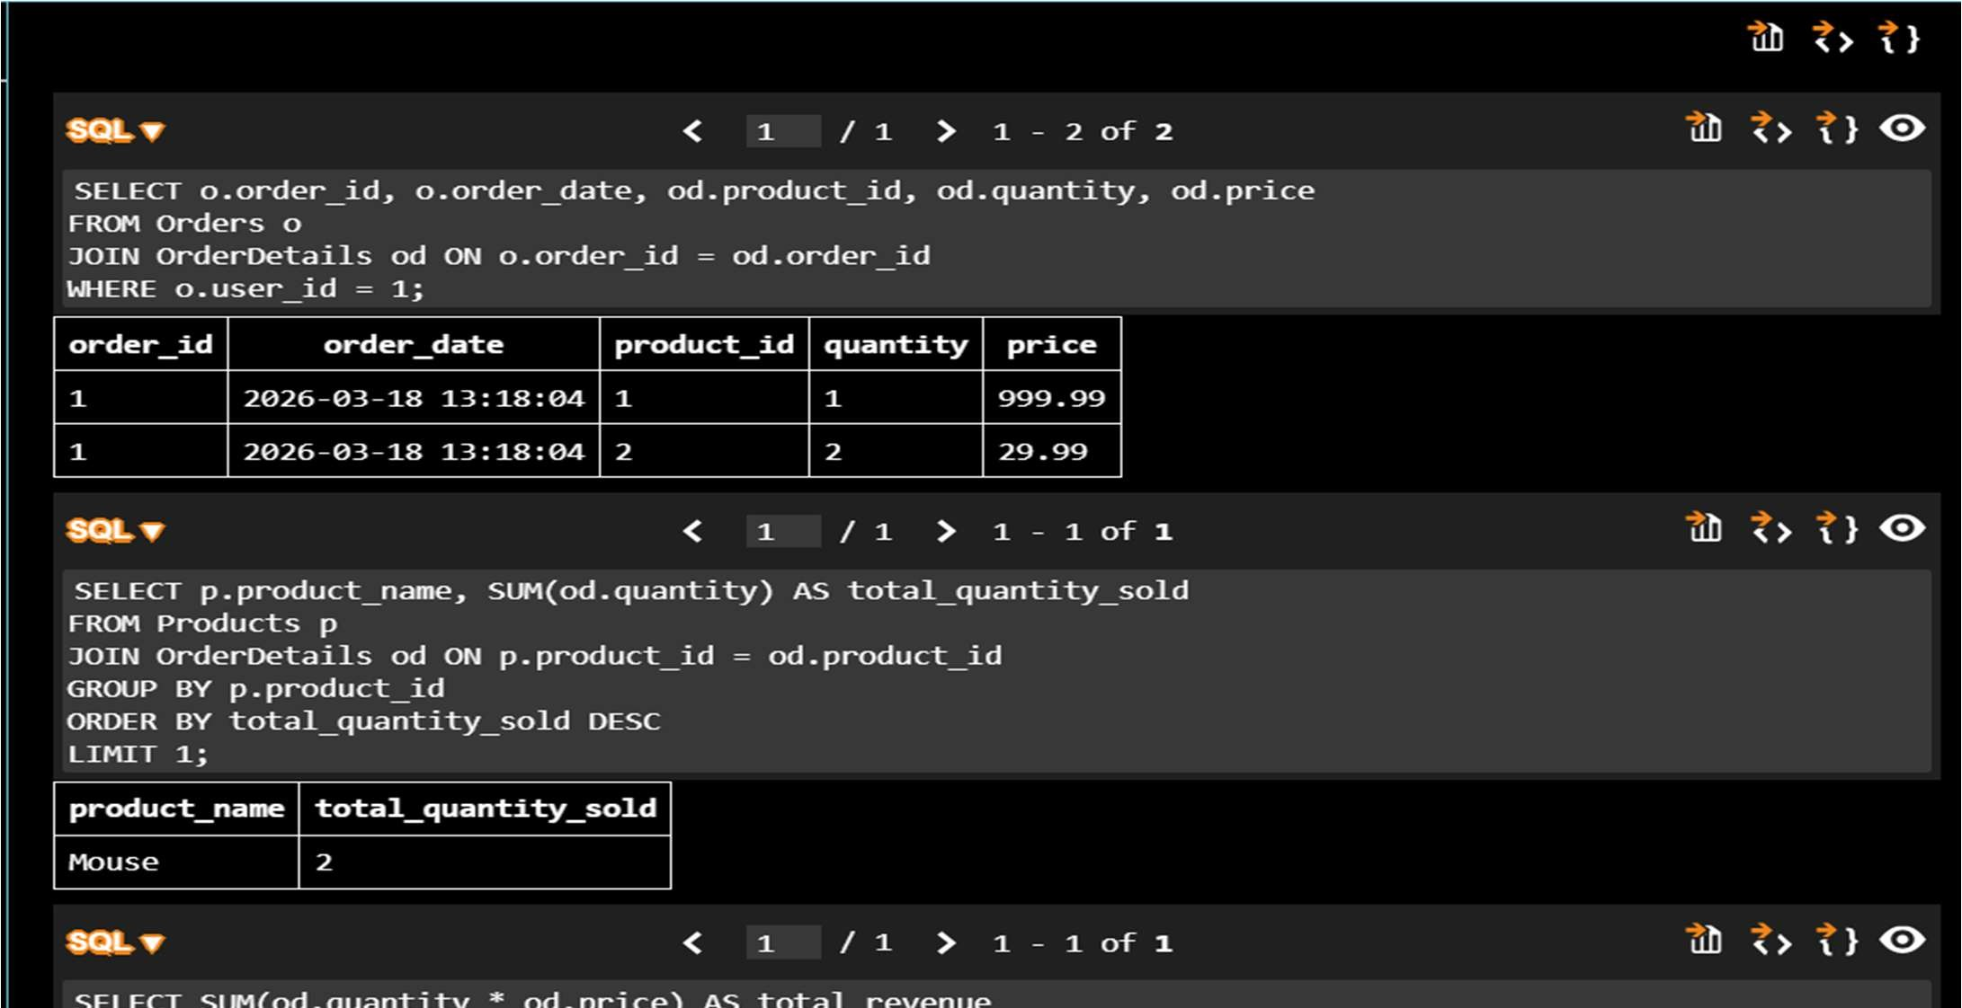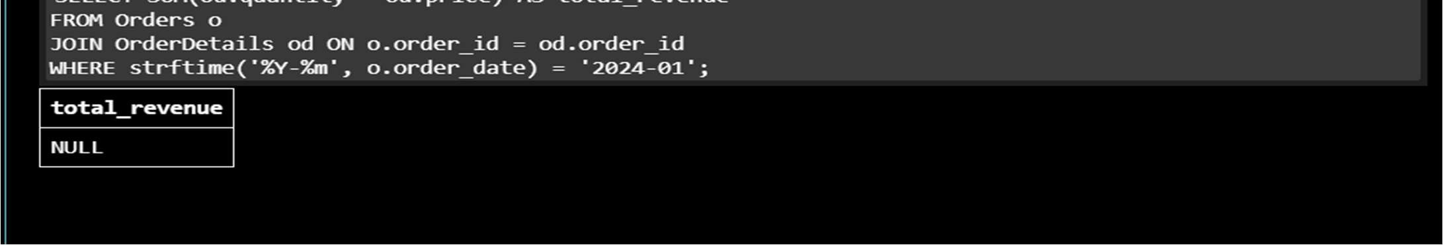
Explanation:
The system is built using multiple related tables, where the OrderDetails table serves as a link between Orders and Products to maintain normalization and reduce redundancy. SQL joins and aggregate functions are applied to effectively analyze customer orders, identify best-selling products, and compute monthly revenue.
Task 3: Library Database
Prompt:
Create a complete SQL solution for a Library Management System by designing a normalized database with three tables: Books, Members, and Loans. Define primary keys, foreign keys, suitable data types, and constraints like NOT NULL and UNIQUE, ensuring SQLite compatibility and maintaining Third Normal Form (3NF). Establish proper relationships between the tables. Then, write SQL join queries to list all currently issued books (not returned), identify overdue books (loaned for more than 30 days), and count the number of books borrowed by each member. Also, suggest an indexing strategy to improve performance and include sample INSERT statements for testing, ensuring the solution is clear, well-structured, and error-free.
Code:
-- SQLite
--Generate a complete SQL solution for a Library Management System by creating a normalized database schema with three tables: Books, Members, and Loans. Include primary keys, foreign keys, appropriate data types, and constraints such as NOT NULL and UNIQUE, ensuring compatibility with SQLite. Establish proper relationships between tables and maintain at least Third Normal Form (3NF). Then write SQL queries using joins to retrieve all books currently issued (not yet returned), find overdue books where the loan date is more than 30 days from the current date, and count the number of books loaned by each

member. Also suggest an indexing strategy to improve query performance. Include sample INSERT statements for testing and ensure the output is clean, well-structured, and fully executable without errors.
-- Create the Books table
CREATE TABLE Books (
BookID INTEGER PRIMARY KEY AUTOINCREMENT,
Title TEXT NOT NULL,
Author TEXT NOT NULL,
PublishedYear INTEGER NOT NULL,
UNIQUE(Title, Author)
);
-- Create the Members table
CREATE TABLE Members (
MemberID INTEGER PRIMARY KEY AUTOINCREMENT,
FirstName TEXT NOT NULL,
LastName TEXT NOT NULL,
Email TEXT NOT NULL UNIQUE
);
-- Create the Loans table
CREATE TABLE Loans (
LoanID INTEGER PRIMARY KEY AUTOINCREMENT,
BookID INTEGER NOT NULL,
MemberID INTEGER NOT NULL,
LoanDate DATE NOT NULL,
ReturnDate DATE,
FOREIGN KEY (BookID) REFERENCES Books(BookID),
FOREIGN KEY (MemberID) REFERENCES Members(MemberID)
);
-- Sample INSERT statements for testing
INSERT INTO Books (Title, Author, PublishedYear) VALUES ('The Great Gatsby', 'F. Scott Fitzgerald', 1925);
INSERT INTO Books (Title, Author, PublishedYear) VALUES ('To Kill a Mockingbird', 'Harper Lee', 1960);
INSERT INTO Books (Title, Author, PublishedYear) VALUES ('1984', 'George Orwell', 1949);
INSERT INTO Members (FirstName, LastName, Email) VALUES ('John', 'Doe',
'john.doe@example.com');
INSERT INTO Members (FirstName, LastName, Email) VALUES ('Jane', 'Smith',
'jane.smith@example.com');
INSERT INTO Loans (BookID, MemberID, LoanDate) VALUES (1, 1, '2024-05-01');
INSERT INTO Loans (BookID, MemberID, LoanDate) VALUES (2, 2, '2024-05-15');
-- Query to retrieve all books currently issued (not yet returned)
SELECT b.Title, b.Author, m.FirstName, m.LastName, l.LoanDate FROM Loans l
JOIN Books b ON l.BookID = b.BookID
JOIN Members m ON l.MemberID = m.MemberID
WHERE l.ReturnDate IS NULL;
-- Query to find overdue books where the loan date is more than 30 days from the current date
SELECT b.Title, b.Author, m.FirstName, m.LastName, l.LoanDate
FROM Loans l
JOIN Books b ON l.BookID = b.BookID
JOIN Members m ON l.MemberID = m.MemberID
WHERE l.ReturnDate IS NULL AND julianday('now') - julianday(l.LoanDate) > 30;
-- Query to count the number of books loaned by each member
SELECT m.FirstName, m.LastName, COUNT(l.LoanID) AS BooksLoaned
FROM Members m
LEFT JOIN Loans l ON m.MemberID = l.MemberID
GROUP BY m.MemberID;
-- Indexing strategy to improve query performance
CREATE INDEX idx_loans_bookid ON Loans(BookID);
CREATE INDEX idx_loans_memberid ON Loans(MemberID);
CREATE INDEX idx_loans_loan_date ON Loans(LoanDate);
CREATE INDEX idx_books_title_author ON Books(Title, Author);
CREATE INDEX idx_members_email ON Members(Email);

Output:
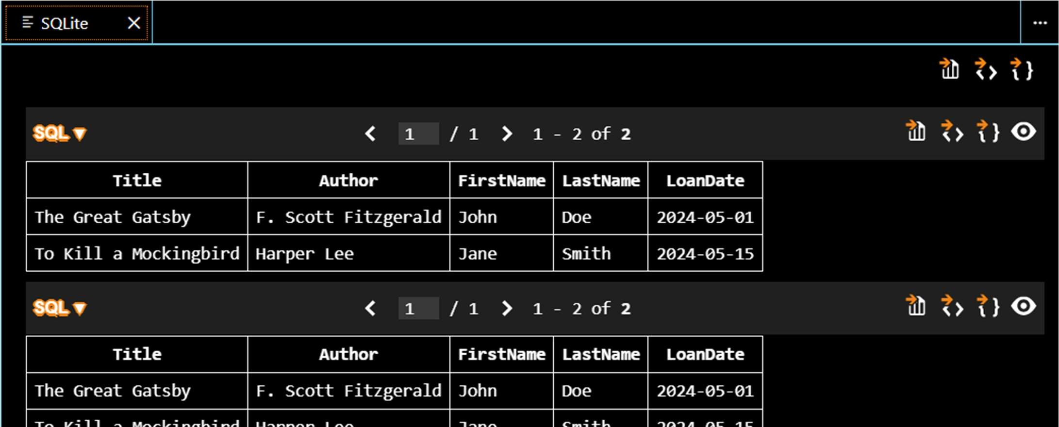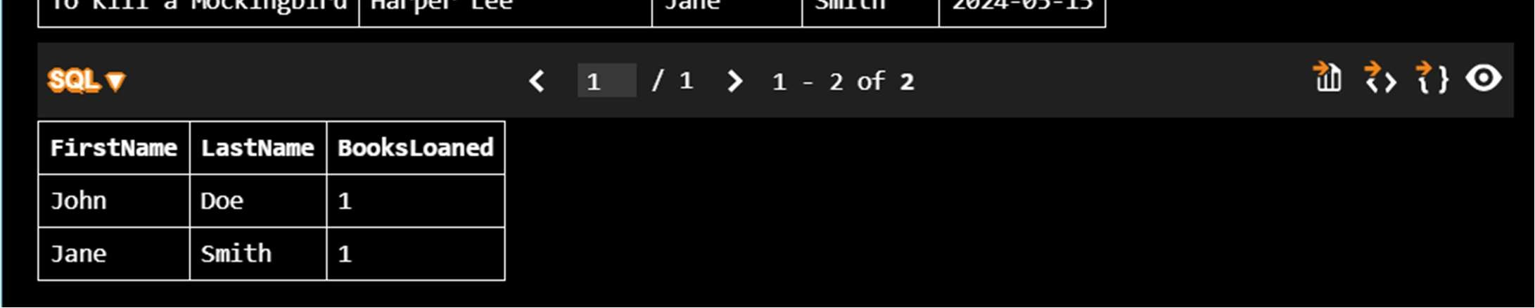
Explanation:
The system is designed with three connected tables, where Loans links Books and Members to ensure proper normalization and reduce redundancy. SQL joins and conditions are used to efficiently track issued books, identify overdue items, and measure borrowing activity..
Task 4: Op mize Queries
Prompt:
Analyze and improve SQL query performance using an example. Begin with an original query that uses a subquery to find books written by UK authors, then rewrite it using joins for better efficiency. Ensure both queries produce the same results. Briefly explain how the optimized version enhances performance in terms of execution time and scalability. Also, suggest further improvements like adding indexes on columns such as author_id and country, and avoiding unnecessary subqueries. Include both queries and a simple validation step to confirm correctness, keeping the solution clear, concise, and compatible with SQLite.
Code:
-- SQLite
-- Analyze and optimize SQL queries for better performance using a given example

PRAGMA foreign_keys = ON;

-- Create Authors table CREATE TABLE Authors ( id INTEGER PRIMARY KEY AUTOINCREMENT, name TEXT NOT NULL, country TEXT NOT NULL
);

-- Create Books table CREATE TABLE Books ( book_id INTEGER PRIMARY KEY AUTOINCREMENT, title TEXT NOT NULL, author_id INTEGER,
FOREIGN KEY (author_id) REFERENCES Authors(id)
);

-- Insert sample data
INSERT INTO Authors (name, country) VALUES
('Author A', 'UK'),
('Author B', 'USA'),
('Author C', 'UK');

INSERT INTO Books (title, author_id) VALUES
('Book 1', 1),
('Book 2', 2),
('Book 3', 3);

-- Original Query using subquery
SELECT title
FROM Books
WHERE author_id IN (
SELECT id
FROM Authors
WHERE country = 'UK'
);

-- Optimized Query using JOIN
SELECT b.title
FROM Books b
JOIN Authors a ON b.author_id = a.id
WHERE a.country = 'UK';

-- Validation query (should return empty if both are same)
SELECT title
FROM Books
WHERE author_id IN (
SELECT id FROM Authors WHERE country = 'UK' )
EXCEPT

SELECT b.title
FROM Books b
JOIN Authors a ON b.author_id = a.id
WHERE a.country = 'UK';

-- Indexing for optimization
CREATE INDEX idx_books_author_id ON Books(author_id); CREATE INDEX idx_authors_country ON Authors(country);

-- Explanation:
-- The original query uses a subquery which may scan data multiple times.
-- The optimized query uses JOIN, allowing faster execution and better use of indexes.

Output:
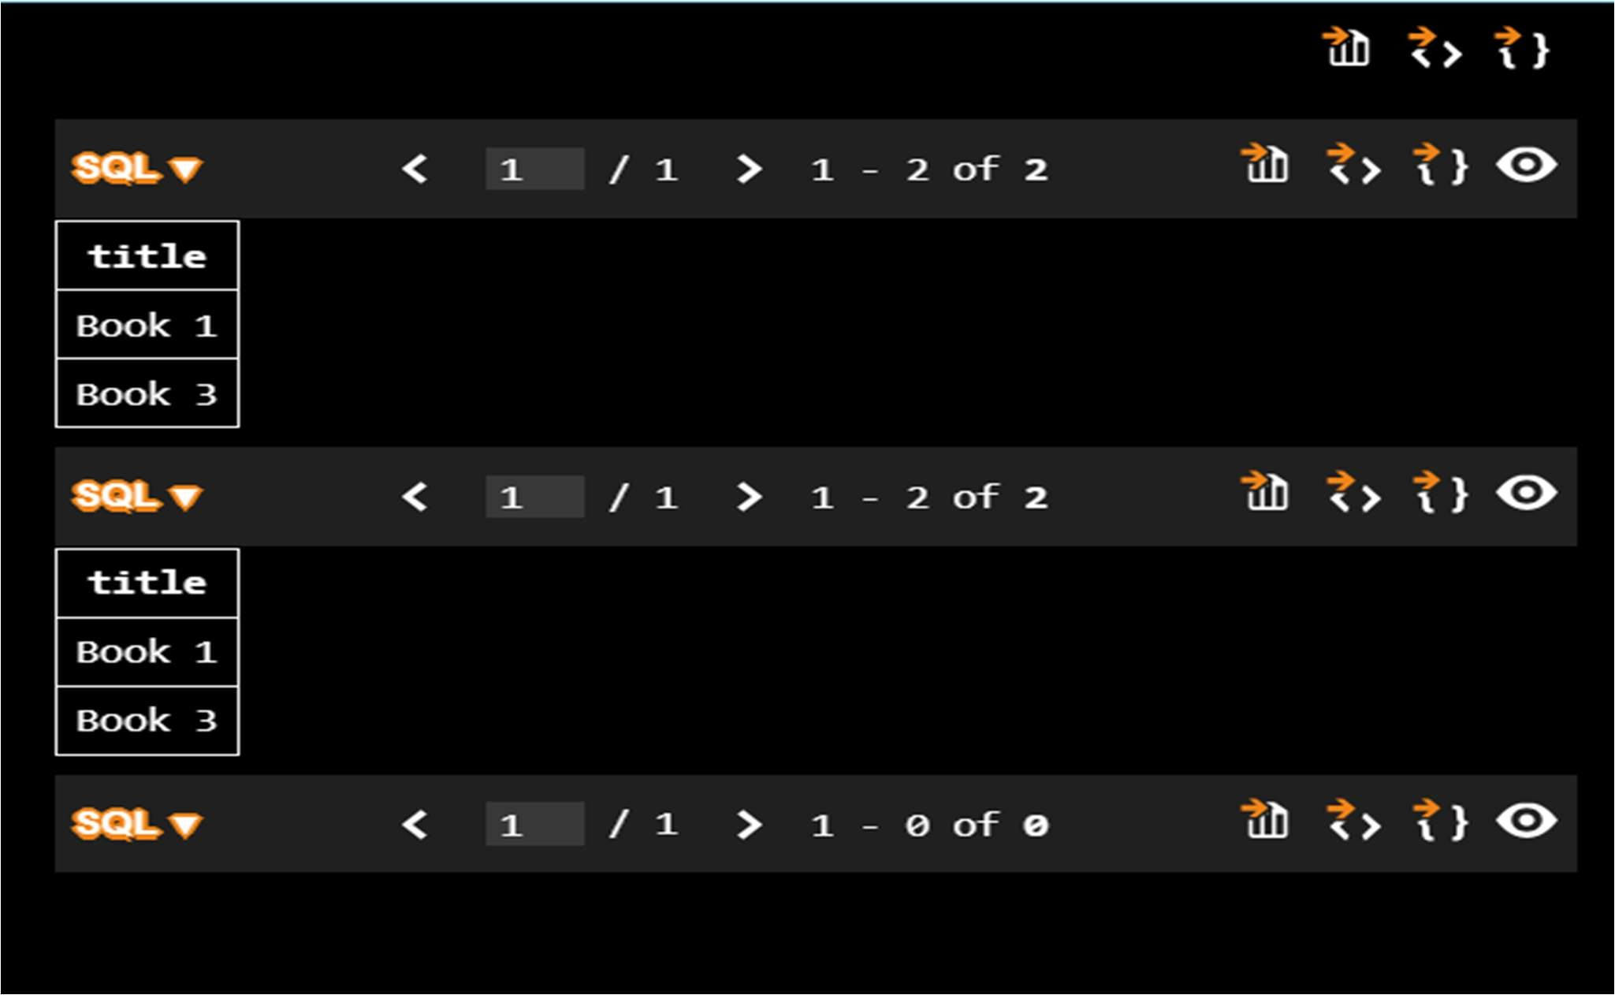
Explanation:
The initial query relies on a subquery, which may become inefficient with large datasets. The optimized version uses joins instead, resulting in faster execution. Adding indexes and minimizing nested queries further enhances performance without affecting the output.
Task 5: University Course Registration
Prompt:
Develop a complete SQL solution for a University Course Registration System by creating a normalized schema with four tables: Students, Courses, Faculty, and Registrations. Define primary keys, foreign keys, appropriate data types, and constraints like NOT NULL and UNIQUE, ensuring compatibility with SQLite and maintaining Third Normal Form (3NF). Set up relationships so that a student can enroll in multiple courses, and each course is assigned to one faculty member. Then, write SQL join queries to display students enrolled in a specific course using course_id, identify faculty handling more than two courses, and find courses with the highest number of registrations. Include sample INSERT statements for testing and ensure the solution is clear, structured, and executable without errors
-- SQLite
--Generate a complete SQL solution for a University Course Registration System by creating a normalized database schema with four tables: Students, Courses, Faculty, and
Registrations. Include primary keys, foreign keys, appropriate data types, and constraints such as NOT NULL and UNIQUE, ensuring compatibility with SQLite. Define relationships such that each student can register for multiple courses and each course is taught by one faculty member. Maintain at least Third Normal Form (3NF). Then write SQL queries using joins to list all students enrolled in a specific course using course_id, find faculty members teaching more than 2 courses, and retrieve courses with the highest number of registrations. Include sample INSERT statements for testing and ensure the output is clean, well-structured, and fully executable without errors.
-- Create the Students table CREATE TABLE Students ( student_id INTEGER PRIMARY KEY AUTOINCREMENT, first_name TEXT NOT NULL, last_name TEXT NOT NULL, email TEXT NOT NULL UNIQUE
);
-- Create the Faculty table CREATE TABLE Faculty ( faculty_id INTEGER PRIMARY KEY AUTOINCREMENT, first_name TEXT NOT NULL, last_name TEXT NOT NULL, email TEXT NOT NULL UNIQUE
);
-- Create the Courses table CREATE TABLE Courses ( course_id INTEGER PRIMARY KEY AUTOINCREMENT, course_name TEXT NOT NULL, faculty_id INTEGER NOT NULL,
FOREIGN KEY (faculty_id) REFERENCES Faculty(faculty_id) );
-- Create the Registrations table CREATE TABLE Registrations ( registration_id INTEGER PRIMARY KEY AUTOINCREMENT, student_id INTEGER NOT NULL, course_id INTEGER NOT NULL,
FOREIGN KEY (student_id) REFERENCES Students(student_id),
FOREIGN KEY (course_id) REFERENCES Courses(course_id),
UNIQUE(student_id, course_id)
);
-- Sample INSERT statements for testing
INSERT INTO Faculty (first_name, last_name, email) VALUES ('John', 'Doe',
'john.doe@university.edu');
INSERT INTO Students (first_name, last_name, email) VALUES ('Alice', 'Smith',
'alice.smith@university.edu');
INSERT INTO Courses (course_name, faculty_id) VALUES ('Introduction to Computer Science', 1);
INSERT INTO Registrations (student_id, course_id) VALUES (1, 1);
-- Query to list all students enrolled in a specific course using course_id
SELECT s.first_name, s.last_name, s.email
FROM Students s
JOIN Registrations r ON s.student_id = r.student_id
WHERE r.course_id = 1;
-- Query to find faculty members teaching more than 2 courses
SELECT f.first_name, f.last_name, COUNT(c.course_id) AS course_count
FROM Faculty f
JOIN Courses c ON f.faculty_id = c.faculty_id
GROUP BY f.faculty_id
HAVING course_count > 2;
-- Query to retrieve courses with the highest number of registrations
SELECT c.course_name, COUNT(r.registration_id) AS registration_count FROM Courses c
JOIN Registrations r ON c.course_id = r.course_id
GROUP BY c.course_id
ORDER BY registration_count DESC
LIMIT 1;

Output:
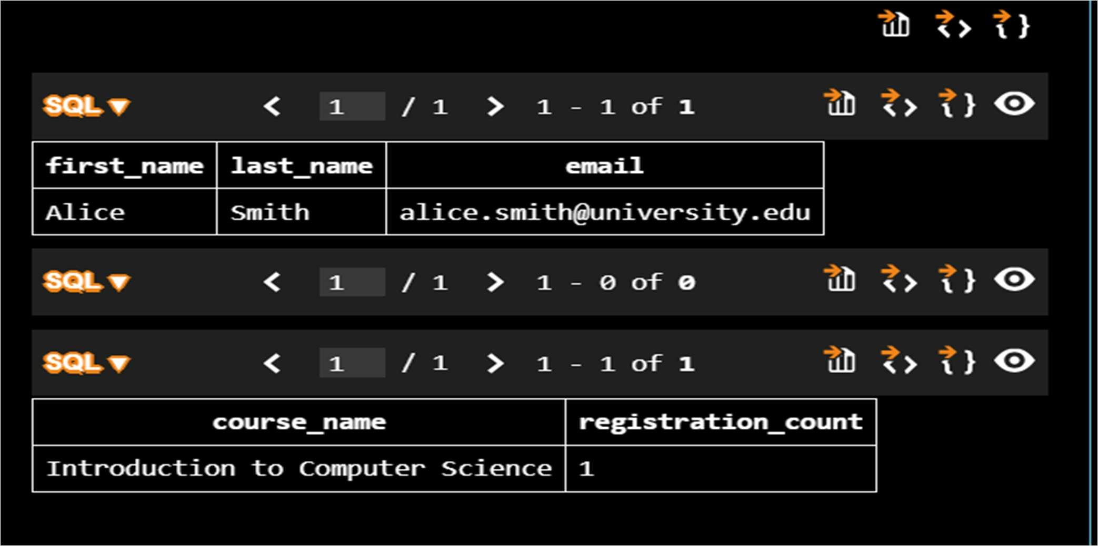
Explanation:
The system is designed using four related tables: Students, Courses, Faculty, and Registrations. The Registrations table connects students and courses, allowing each student to enroll in multiple courses, while each course is handled by one faculty member. SQL joins are used to easily find students in a course, identify faculty teaching many courses, and determine which courses have the highest registrations

