Name: B.pooja
Hall Ticket: 2303A52141
Batch: 41
Task 1: Sorting Student Records for Placement Drive
Prompt:
Write a Python program to store student records (Name, Roll Number, CGPA) and sort them in descending order using Quick Sort and Merge Sort.
Measure and compare their runtime performance for large datasets and display the top 10 students based on CGPA
Code:
# students_sort.py
import random
import time
import argparse
from dataclasses import dataclass
from typing import List
@dataclass
class Student:
name: str
roll: int
cgpa: float
def generate_students(n: int, seed: int = 0) -> List[Student]:
random.seed(seed)
students = []
for i in range(1, n + 1):
name = f"Student{i}"
roll = i
cgpa = round(random.uniform(0.0, 10.0), 4)
students.append(Student(name, roll, cgpa))
random.shuffle(students)
return students
def quick_sort(arr: List[Student], low: int, high: int):
if low < high:
p = _partition(arr, low, high)
quick_sort(arr, low, p - 1)
quick_sort(arr, p + 1, high)
def _partition(arr: List[Student], low: int, high: int) -> int:
pivot_index = random.randint(low, high)
arr[pivot_index], arr[high] = arr[high], arr[pivot_index]
pivot = arr[high].cgpa
i = low
for j in range(low, high):
if arr[j].cgpa > pivot: # greater -> come earlier (descending)
arr[i], arr[j] = arr[j], arr[i]
i += 1
arr[i], arr[high] = arr[high], arr[i]
return i
def merge_sort(arr: List[Student]) -> List[Student]:
n = len(arr)
if n <= 1:
return arr[:]
mid = n // 2
left = merge_sort(arr[:mid])
right = merge_sort(arr[mid:])
return _merge(left, right)
def _merge(left: List[Student], right: List[Student]) -> List[Student]:
i = j = 0
merged = []
while i < len(left) and j < len(right):
if left[i].cgpa >= right[j].cgpa:
merged.append(left[i]); i += 1
else:
merged.append(right[j]); j += 1
if i < len(left):
merged.extend(left[i:])
if j < len(right):
merged.extend(right[j:])
return merged
def top_k_print(arr: List[Student], k: int = 10):
print(f"Top {k} students by CGPA:")
for idx, s in enumerate(arr[:k], 1):
print(f"{idx:2}. {s.name:12} Roll:{s.roll:6} CGPA:{s.cgpa:.4f}")
def measure_and_compare(n: int, seed: int = 0):
base = generate_students(n, seed)
# Quick Sort (in-place)
arr_qs = base.copy()
start = time.perf_counter()
quick_sort(arr_qs, 0, len(arr_qs) - 1)
qs_time = time.perf_counter() - start
arr_ms_input = base.copy()
start = time.perf_counter()
arr_ms = merge_sort(arr_ms_input)
ms_time = time.perf_counter() - start
print(f"\nDataset size: {n}")
print(f"Quick Sort time : {qs_time:.6f} sec")
print(f"Merge Sort time : {ms_time:.6f} sec")
faster = "Quick Sort" if qs_time < ms_time else "Merge Sort"
print(f"Faster: {faster}\n")
top_k_print(arr_ms if ms_time <= qs_time else arr_qs, 10)
if __name__ == "__main__":
parser = argparse.ArgumentParser(description="Sort student records and compare Quick Sort vs Merge Sort")
parser.add_argument("-n", "--num", type=int, default=100000, help="number of student records to generate (default: 100000)")
parser.add_argument("-s", "--seed", type=int, default=0, help="random seed (default: 0)")
args = parser.parse_args()
measure_and_compare(args.num, args.seed)

Output:
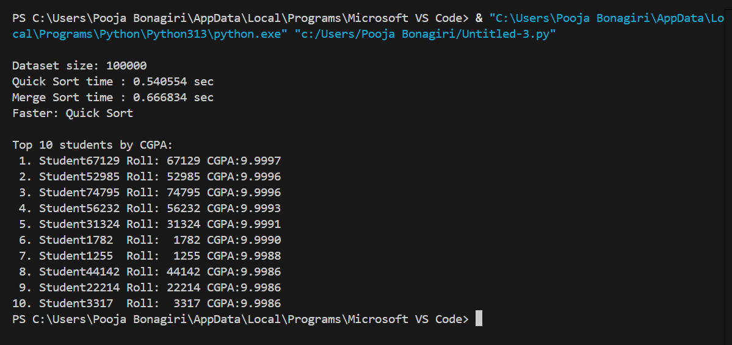
Explanation:
This task involves creating a Python program to manage and sort student records for a placement drive based on CGPA in descending order. Quick Sort and Merge Sort are implemented to compare their runtime performance on large datasets, and the program displays the top 10 students with the highest CGPA to help shortlist candidates efficiently.

Task 2: Implementing Bubble Sort with AI Comments
Prompt:
Write a Python program to implement Bubble Sort and add AI-generated inline comments explaining swapping, passes, and termination logic. Also include a brief time complexity analysis.
Code:
import random
from typing import List
def bubble_sort(arr: List[int]) -> None:
"""
Bubble Sort (in-place, ascending).
Inline comments explain swapping, passes, and termination logic.
"""
n = len(arr)
for i in range(n):
swapped = False .
for j in range(0, n - i - 1):
if arr[j] > arr[j + 1]:
arr[j], arr[j + 1] = arr[j + 1], arr[j]
swapped = True
if not swapped:
break

if __name__ == "__main__":
data = [random.randint(0, 100) for _ in range(20)]
print("Before:", data)
bubble_sort(data)
print("After: ", data)

Output:
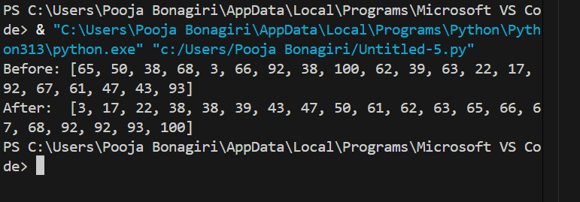

Explanation:
Bubble Sort repeatedly compares and swaps adjacent elements, moving the largest values to the end after each pass.
Its time complexity is O(n²) in average and worst cases, and O(n) in the best case if the list is already sorted.
Task 3: Quick Sort and Merge Sort Comparison
Prompt:
Write a Python code to implement recursive Quick Sort and Merge Sort, add proper docstrings, and compare their performance on random, sorted, and reverse-sorted lists with time complexity analysis.
Code:
# quick_merge_compare.py
"""
Recursive Quick Sort and Merge Sort implementations with timing comparisons
on random, sorted, and reverse-sorted lists.

Usage
python quick_merge_compare.py # runs default tests
python quick_merge_compare.py --n 20000 # change input size
"""
from typing import List
import random
import time
import argparse
import sys
def quick_sort(arr: List[int], low: int, high: int) -> None:
"""
In-place recursive Quick Sort (descending or ascending controlled by comparator).
This implementation sorts arr in ascending order.
Args:
arr: list of integers to sort in-place.
low: starting index of the segment to sort.
high: ending index of the segment to sort.
Notes:
- Uses a random pivot to reduce chance of worst-case behavior on already-sorted input.
- Recursive; Python recursion depth may be reached for very large inputs.
"""
if low < high:
p = _partition(arr, low, high)
quick_sort(arr, low, p - 1)
quick_sort(arr, p + 1, high)
def _partition(arr: List[int], low: int, high: int) -> int:
"""
Lomuto-style partition with a random pivot.
Places pivot into its final position and returns its index.
Elements <= pivot are moved to the left, > pivot to the right.
"""
pivot_idx = random.randint(low, high)
arr[pivot_idx], arr[high] = arr[high], arr[pivot_idx]
pivot = arr[high]
i = low
for j in range(low, high):
if arr[j] <= pivot:
arr[i], arr[j] = arr[j], arr[i]
i += 1
arr[i], arr[high] = arr[high], arr[i]
return i
def merge_sort(arr: List[int]) -> List[int]:
"""
Recursive Merge Sort (returns a new sorted list).
Args:
arr: list of integers
Returns:
New list containing sorted elements in ascending order.

Notes:
- Stable and guarantees O(n log n) time.
- Uses O(n) extra memory.
"""
n = len(arr)
if n <= 1:
return arr[:]
mid = n // 2
left = merge_sort(arr[:mid])
right = merge_sort(arr[mid:])
return _merge(left, right)
def _merge(left: List[int], right: List[int]) -> List[int]:
i = j = 0
merged: List[int] = []
while i < len(left) and j < len(right):
if left[i] <= right[j]:
merged.append(left[i]); i += 1
else:
merged.append(right[j]); j += 1
if i < len(left):
merged.extend(left[i:])
if j < len(right):
merged.extend(right[j:])
return merged
def generate_random(n: int, seed: int = 0) -> List[int]:
random.seed(seed)
return [random.randint(0, n * 10) for _ in range(n)]
def generate_sorted(n: int) -> List[int]:
return list(range(n))
def generate_reverse_sorted(n: int) -> List[int]:
return list(range(n, 0, -1))
def time_function(func, *args, repeats: int = 3):
"""Return average elapsed time over `repeats` runs."""
times = []
for _ in range(repeats):
start = time.perf_counter()
result = func(*args)
elapsed = time.perf_counter() - start
times.append(elapsed)
if isinstance(result, list):
del result
return sum(times) / len(times)
def run_bench(n: int, seed: int = 0):
scenarios = {
"Random": generate_random(n, seed),
"Sorted": generate_sorted(n),
"Reverse-sorted": generate_reverse_sorted(n),
}
print(f"Input size: {n}\n")
for name, base in scenarios.items():
print(f"Scenario: {name}")
arr_qs = base.copy()
try:
qs_time = time_function(lambda a: quick_sort(a, 0, len(a) - 1), arr_qs)
except RecursionError:
qs_time = float('inf')
print(" Quick Sort: RecursionError (increase recursionlimit or use iterative/built-in sort)")
else:
assert arr_qs == sorted(base)
print(f" Quick Sort time : {qs_time:.6f} s")
try:
ms_time = time_function(merge_sort, base)
except RecursionError:
ms_time = float('inf')
print(" Merge Sort: RecursionError (increase recursionlimit)")
else:
assert merge_sort(base) == sorted(base)
print(f" Merge Sort time : {ms_time:.6f} s")
faster = "Quick Sort" if qs_time < ms_time else "Merge Sort"
print(f" Faster: {faster}\n")
if __name__ == "__main__":
parser = argparse.ArgumentParser(description="Compare recursive Quick Sort and Merge Sort")
parser.add_argument("--n", type=int, default=20000, help="number of elements (default: 20000)")
parser.add_argument("--seed", type=int, default=0, help="random seed")
parser.add_argument("--recurse", type=int, default=2000, help="set recursionlimit (optional)")
args = parser.parse_args()
if args.recurse:
try:
sys.setrecursionlimit(args.recurse)
except Exception:
pass
run_bench(args.n, args.seed)
Output: 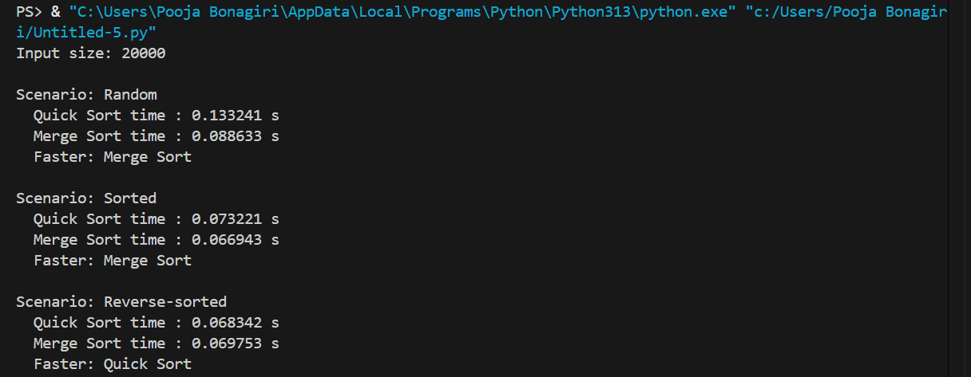

Explanation:
This task implements recursive Quick Sort and Merge Sort and compares their behavior on different input types. It analyzes best, average, and worst-case time complexities to understand their performance differences.
Task 4 (Real-Time Application – Inventory Management System)
Prompt:
Write a Python program for an Inventory Management System that implements efficient search (by ID/name) and sorting (by price/quantity) algorithms, and justify the chosen algorithms based on performance requirements.
Code:
# Inventory Management System with efficient search and sorting
from dataclasses import dataclass, field
from typing import List, Dict, Callable, Optional, Tuple
import bisect

@dataclass
class Item:
"""Represents an inventory item."""
id: str
name: str
price: float
quantity: int

class Inventory:
"""
Inventory supports:
- O(1) lookup by ID using a hash map
- Exact-name lookup using a dict (name -> list[Item])
- Prefix-name search using a sorted list + bisect (O(log n + k))
- Sorting by arbitrary key using merge sort (stable O(n log n))
"""
def __init__(self):
self._items: List[Item] = []
self._id_map: Dict[str, Item] = {}
self._name_map: Dict[str, List[Item]] = {}
# For prefix search: list of (name_lower, Item) sorted by name_lower
self._name_index: List[Tuple[str, Item]] = []
self._name_index_needs_rebuild = False

def add_item(self, item: Item) -> None:
"""Add item; replaces item with same ID."""
existing = self._id_map.get(item.id)
if existing:
self.remove_item_by_id(item.id)
self._items.append(item)
self._id_map[item.id] = item
key = item.name.lower()
self._name_map.setdefault(key, []).append(item)
self._name_index_needs_rebuild = True

def remove_item_by_id(self, id: str) -> bool:
"""Remove item by ID. Returns True if removed."""
item = self._id_map.pop(id, None)
if not item:
return False
try:
self._items.remove(item)
except ValueError:
pass
key = item.name.lower()
lst = self._name_map.get(key)
if lst:
try:
lst.remove(item)
if not lst:
del self._name_map[key]
except ValueError:
pass
self._name_index_needs_rebuild = True
return True

def update_item(self, id: str, *, name: Optional[str]=None,
price: Optional[float]=None, quantity: Optional[int]=None) -> bool:
"""Update fields of an item by ID."""
item = self._id_map.get(id)
if not item:
return False
if name is not None:
# update name maps
old_key = item.name.lower()
self._name_map[old_key].remove(item)
if not self._name_map[old_key]:
del self._name_map[old_key]
item.name = name
new_key = name.lower()
self._name_map.setdefault(new_key, []).append(item)
self._name_index_needs_rebuild = True
if price is not None:
item.price = price
if quantity is not None:
item.quantity = quantity
return True

# --- Search APIs ---

def search_by_id(self, id: str) -> Optional[Item]:
"""O(1) exact lookup by ID using a hash map."""
return self._id_map.get(id)

def search_by_name_exact(self, name: str) -> List[Item]:
"""Exact-case-insensitive name match (fast: O(1) average)."""
return list(self._name_map.get(name.lower(), []))

def _rebuild_name_index(self) -> None:
"""Rebuild sorted name index for prefix searches. O(n log n)."""
self._name_index = sorted(((item.name.lower(), item) for item in self._items), key=lambda x: x[0])
self._name_index_needs_rebuild = False

def search_by_name_prefix(self, prefix: str) -> List[Item]:
"""
Prefix search: returns items whose name starts with prefix (case-insensitive).
Uses a sorted index and bisect to find range: O(log n + k).
"""
if self._name_index_needs_rebuild:
self._rebuild_name_index()
lo_key = prefix.lower()
# Compute upper bound by incrementing last char trick
hi_key = lo_key[:-1] + chr(ord(lo_key[-1]) + 1) if lo_key else chr(0x10FFFF)
names = [nm for nm, _ in self._name_index] # transient list for bisect
lo = bisect.bisect_left(names, lo_key)
hi = bisect.bisect_left(names, hi_key)
return [self._name_index[i][1] for i in range(lo, hi) if self._name_index[i][0].startswith(lo_key)]
def sort_by_price(self, descending: bool = False) -> List[Item]:
"""Return a new list sorted by price using stable merge sort (O(n log n))."""
return merge_sort(self._items, key=lambda it: it.price, reverse=descending)

def sort_by_quantity(self, descending: bool = False) -> List[Item]:
"""Return a new list sorted by quantity using stable merge sort (O(n log n))."""
return merge_sort(self._items, key=lambda it: it.quantity, reverse=descending)
def merge_sort(arr: List[Item], *, key: Callable[[Item], object]=lambda x: x, reverse: bool=False) -> List[Item]:
"""
Stable merge sort that returns a new sorted list.
- key: function to extract comparison key
- reverse: if True, sort descending
Time: O(n log n), Space: O(n)
"""
n = len(arr)
if n <= 1:
return arr[:]
mid = n // 2
left = merge_sort(arr[:mid], key=key, reverse=reverse)
right = merge_sort(arr[mid:], key=key, reverse=reverse)
return _merge(left, right, key, reverse)
def _merge(left: List[Item], right: List[Item], key: Callable[[Item], object], reverse: bool) -> List[Item]:
i = j = 0
merged: List[Item] = []
while i < len(left) and j < len(right):
a = key(left[i])
b = key(right[j])
if (a <= b) ^ reverse:
merged.append(left[i]); i += 1
else:
merged.append(right[j]); j += 1
if i < len(left):
merged.extend(left[i:])
if j < len(right):
merged.extend(right[j:])
return merged
def _demo():
inv = Inventory()
inv.add_item(Item("id1", "Apple", 0.99, 120))
inv.add_item(Item("id2", "Banana", 0.59, 200))
inv.add_item(Item("id3", "Apricot", 1.79, 30))
print("Search by ID id2:", inv.search_by_id("id2"))
print("Exact name 'apple':", inv.search_by_name_exact("apple"))
print("Prefix 'ap':", [i.name for i in inv.search_by_name_prefix("ap")])
print("Sorted by price desc:", [(i.name, i.price) for i in inv.sort_by_price(descending=True)])
if __name__ == "__main__":
_demo()

Output: 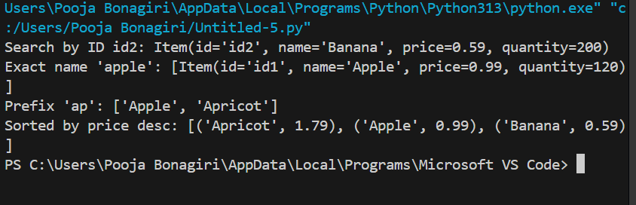
Explanation:
This task focuses on selecting efficient algorithms for real-time inventory management. It evaluates search and sorting techniques based on performance requirements and dataset size, then implements and justifies the chosen solutions in Python.
Task 5: Real-Time Stock Data Sorting & Searching
Prompt:
Write a Python program to simulate stock data (Symbol, Opening Price, Closing Price), sort stocks by percentage change using Heap Sort, implement fast search using a Hash Map, and compare performance with built-in sorted() and dictionary lookups.
Code: import random
import string
import time
import heapq

# -----------------------------
# Generate Simulated Stock Data
# -----------------------------

def generate_stock_data(n):
"""
Generate n simulated stock records.
Each record contains:
Symbol, Opening Price, Closing Price
"""
stocks = []
for _ in range(n):
symbol = ''.join(random.choices(string.ascii_uppercase, k=4))
opening = round(random.uniform(100, 1000), 2)
closing = round(random.uniform(100, 1000), 2)
stocks.append({
"symbol": symbol,
"opening": opening,
"closing": closing
})
return stocks

# -----------------------------------------
# Calculate Percentage Change
# -----------------------------------------

def calculate_percentage_change(stock):
"""
Calculate percentage change for a stock.
"""
return ((stock["closing"] - stock["opening"]) / stock["opening"]) * 100

# -----------------------------------------
# Heap Sort Based on Percentage Change
# -----------------------------------------

def heap_sort_stocks(stocks):
"""
Sort stocks by percentage change using Heap Sort.
"""
heap = []

for stock in stocks:
percent_change = calculate_percentage_change(stock)
heapq.heappush(heap, (percent_change, stock))

sorted_stocks = []
while heap:
sorted_stocks.append(heapq.heappop(heap)[1])

return sorted_stocks

# -----------------------------------------
# Hash Map for Fast Search
# -----------------------------------------

def create_stock_map(stocks):
"""
Create a dictionary (Hash Map) for fast stock lookup by symbol.
"""
return {stock["symbol"]: stock for stock in stocks}

def search_stock(stock_map, symbol):
"""
Search stock instantly using dictionary lookup.
"""
return stock_map.get(symbol, "Stock not found")

# -----------------------------------------
# Performance Comparison
# -----------------------------------------

def compare_performance(stocks):
"""
Compare Heap Sort with built-in sorted()
"""
# Heap Sort timing
start = time.time()
heap_sorted = heap_sort_stocks(stocks)
heap_time = time.time() - start

# Built-in sorted timing
start = time.time()
builtin_sorted = sorted(
stocks,
key=lambda x: calculate_percentage_change(x)
)
builtin_time = time.time() - start

print("\nPerformance Comparison:")
print(f"Heap Sort Time: {heap_time:.6f} seconds")
print(f"Built-in sorted() Time: {builtin_time:.6f} seconds")

return heap_sorted

# -----------------------------------------
# Main Execution
# -----------------------------------------

if __name__ == "__main__":
n = 1000 # Number of simulated stocks
stocks = generate_stock_data(n)

# Compare Sorting Performance
sorted_stocks = compare_performance(stocks)

# Create Hash Map for fast searching
stock_map = create_stock_map(stocks)

# Example Search
sample_symbol = stocks[0]["symbol"]
print(f"\nSearching for stock: {sample_symbol}")
print(search_stock(stock_map, sample_symbol))

Output: 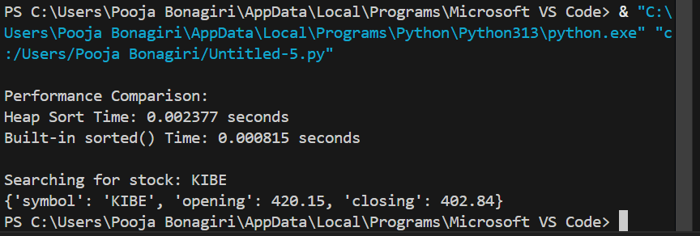

Explanation:
This task builds a real-time stock analysis tool that ranks stocks by daily gain/loss and retrieves stock data instantly. It compares custom algorithms with Python’s built-in functions to evaluate performance and efficiency trade-offs.

