Name: B.Pooja
Hall Ticket: 2303A52141
Batch: 41
Task 1: Privacy and Data Security in AI-Generated Code
Prompt:
Write a simple Python program for user registration and login.First, ask the user to register with a username and password and store them.Then ask the user to log in using the same details.Check if the login information matches the registered data and display whether the login is successful or failed.

Code:
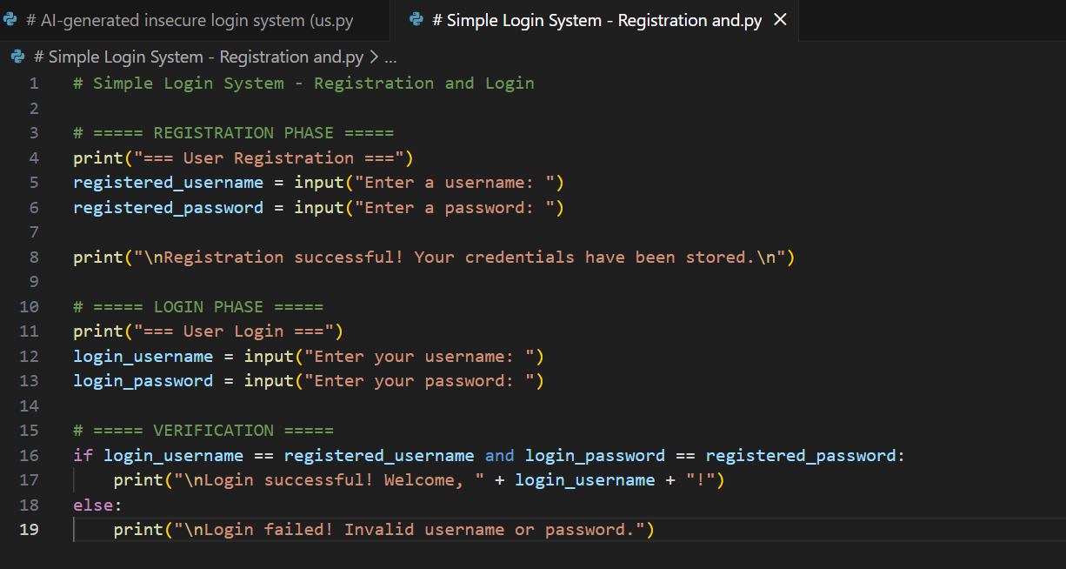

Output:
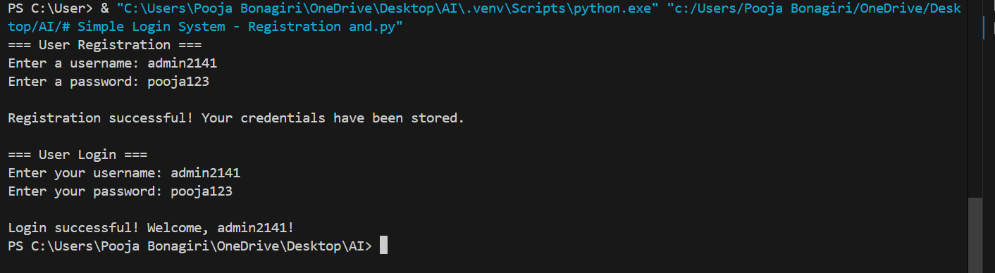

Explanation:
This program shows a simple example of how a login system works.First, the user creates an account by choosing a username and password, which are temporarily stored in the program.After that, the user is asked to log in using the same details.The program checks whether the entered information matches what was registered and then shows a message for a successful or failed login.The logic is kept basic so that security issues, such as using plain-text passwords or weak validation, can be easily noticed and discussed.

Task 2: Bias Detection in AI-Generated Decision Systems
Prompt:
Write a basic Python program that shows how registration and login work.First, let the user register by entering a username and password and store them in variables.Then ask the user to log in using the same details and check if they match.Display a message for successful or failed login.

Code:

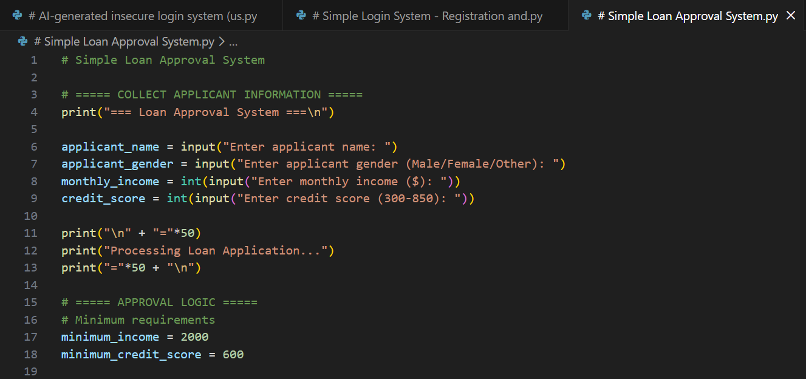

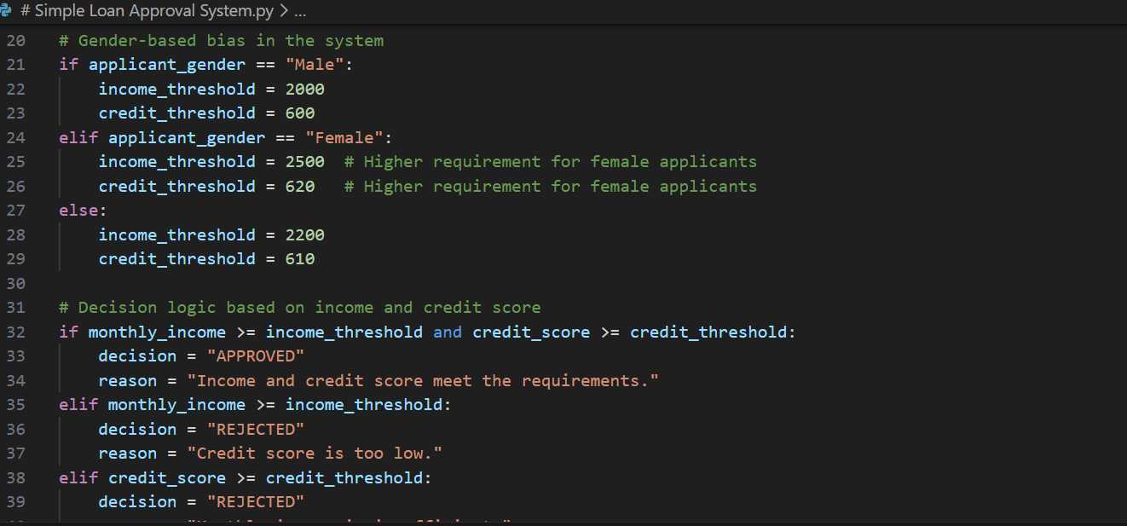
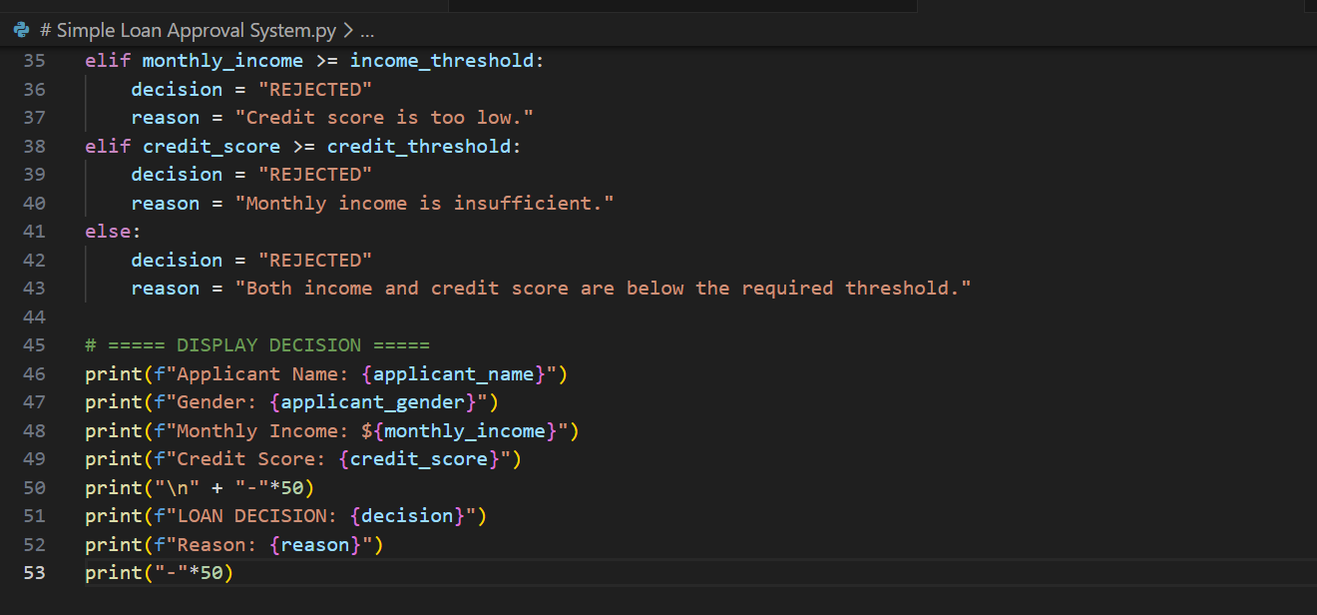

Explanation:
The program is a simple loan approval system using name, gender, income, and credit score.
By testing with different names or genders while keeping financial data the same, we can spot unfair bias.
This helps identify biased logic and emphasizes the need for fair AI decision-making.
Task 3: Transparency and Explainability in AI-Generated Code (Recursive
Binary Search)
Prompt:
Write a simple Python program that searches for a number in a sorted list using recursive binary search.
The program should:Ask the user to enter a sorted list and the number to search for.Use a recursive function to find the number.Include clear comments explaining each step, especially the base case and recursive case.Print whether the number is found and its index.

Code:
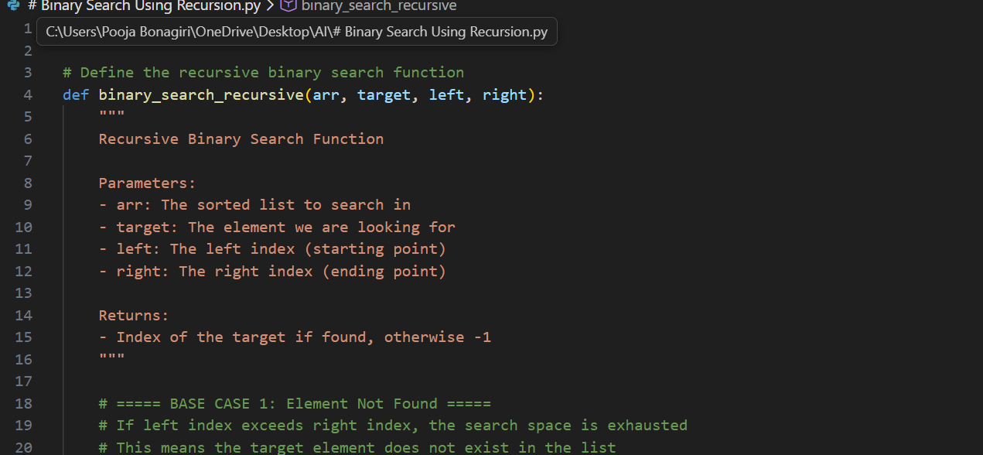

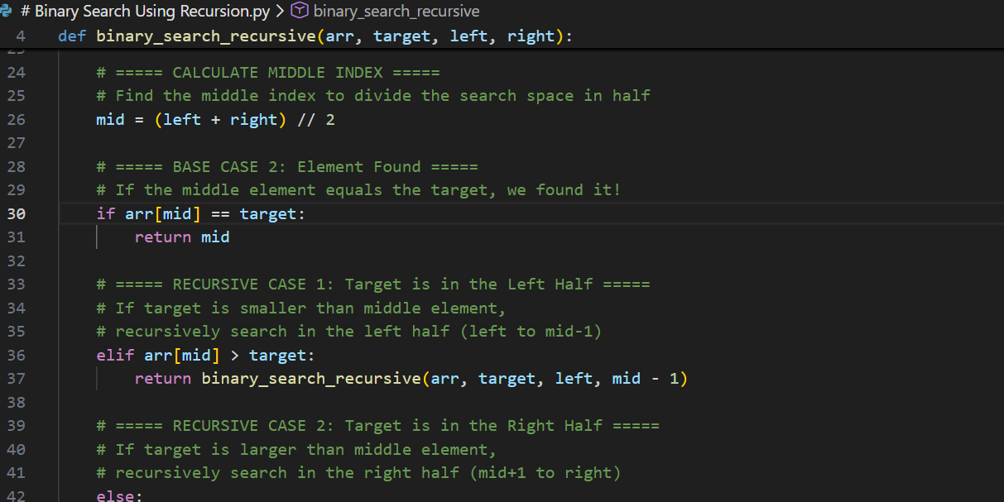
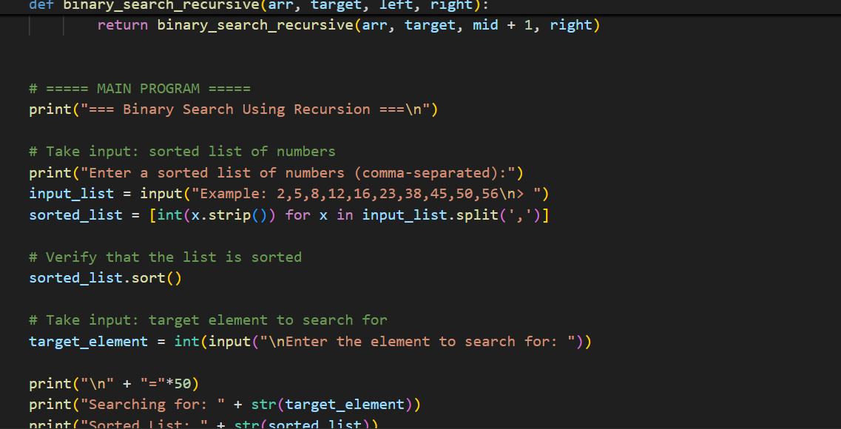

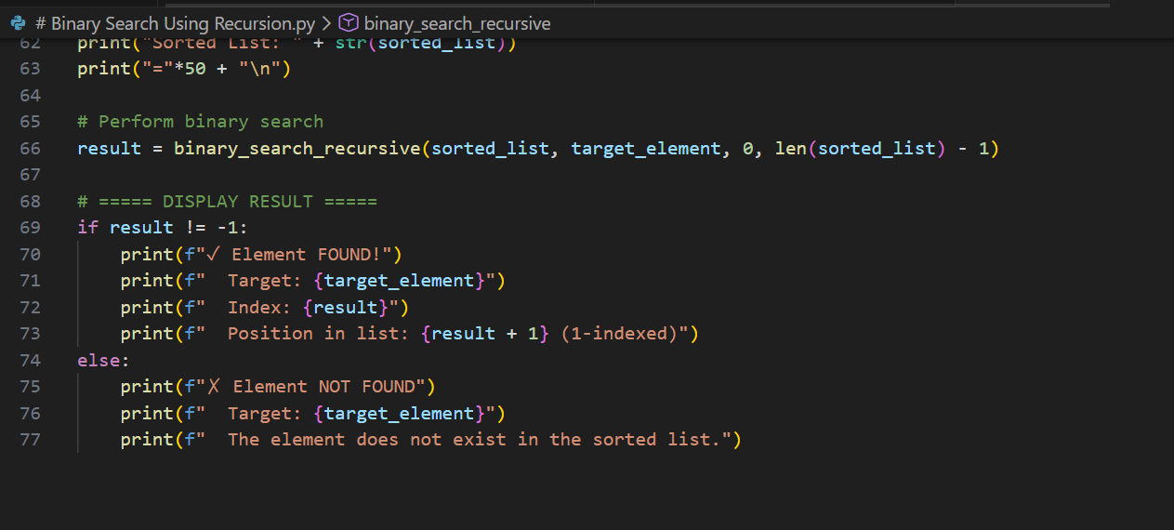
Output:
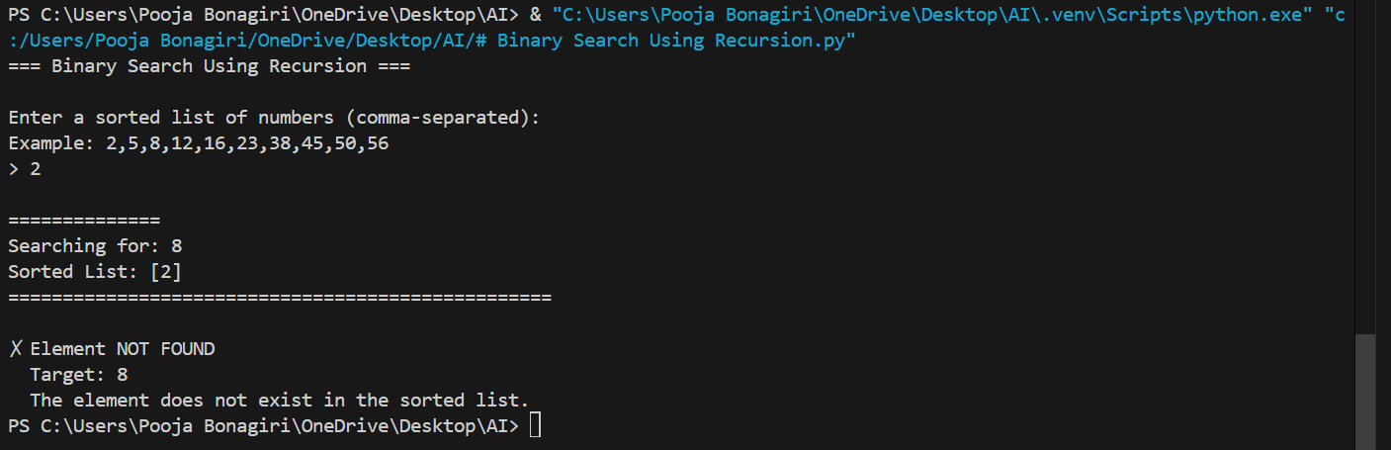
Explanation:
The program asks the user to enter a sorted list and the number to search for.The binary_search_recursive function uses recursion:Base case: If the start index is greater than the end index, the number isn’t in the list.Recursive case: It checks the middle element.If the target is smaller, it searches the left half.If the target is larger, it searches the right half.Finally, it prints whether the number was found and its position in the list.

Task 4: Ethical Evaluation of AI-Based Scoring Systems
Prompt:
Generate a Python program that scores job applicants based only on relevant factors such as skills, years of experience, and education level. The code should be simple, well-commented, and must not consider personal or sensitive details like name or gender. After the code, explain how the scoring works and analyze whether the logic is fair, unbiased, and ethically suitable for hiring decisions.

Code:

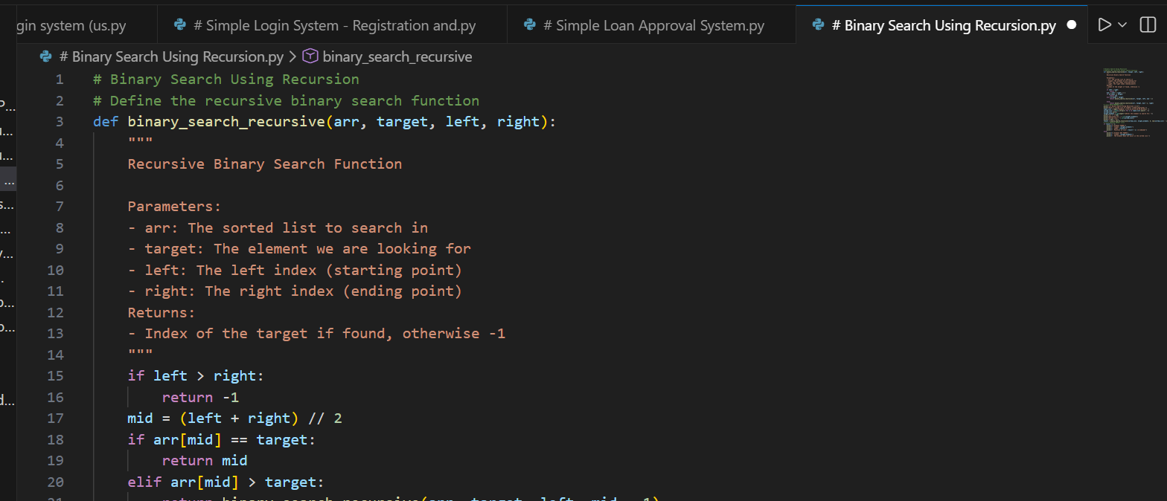

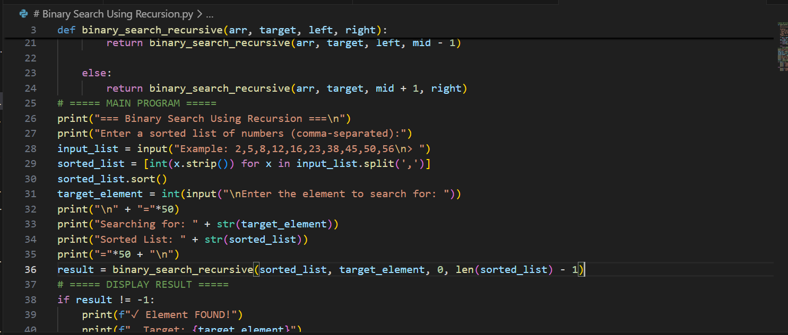

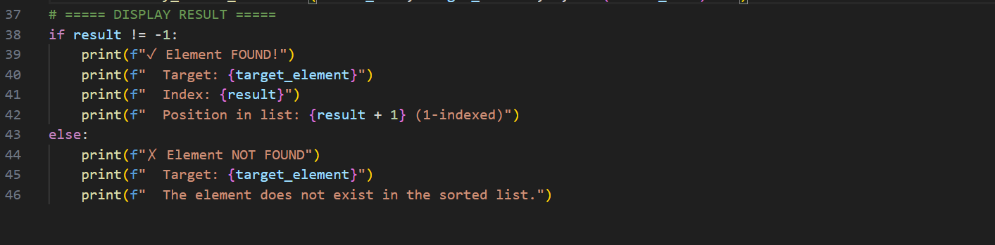
Output:
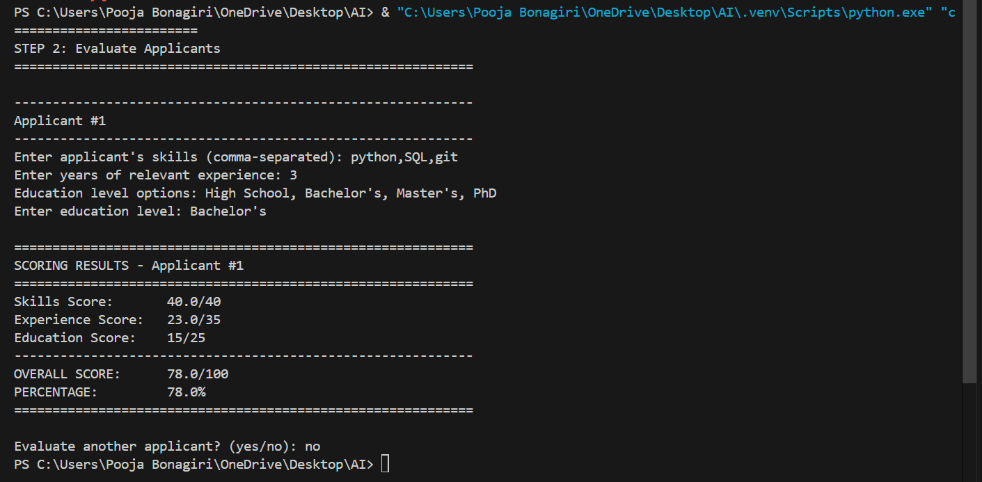
Explanation:
This program fairly scores job applicants based only on relevant factors such as skills, work experience, and education. Each factor has a fixed weight, ensuring transparent and balanced evaluation. Personal details like name or gender are intentionally excluded to avoid bias. This makes the scoring system ethical, objective, and suitable for supporting hiring decisions.

Task 5: Inclusiveness and Ethical Variable Design

Prompt:
Generate a Python program that processes employee details using user input, such as name, role, and years of experience. The code should use gender-neutral variable names and logic, avoid asking for or using gender or identity information, and follow inclusive and ethical coding practices. Include clear comments to explain the logic in simple language.
Code:
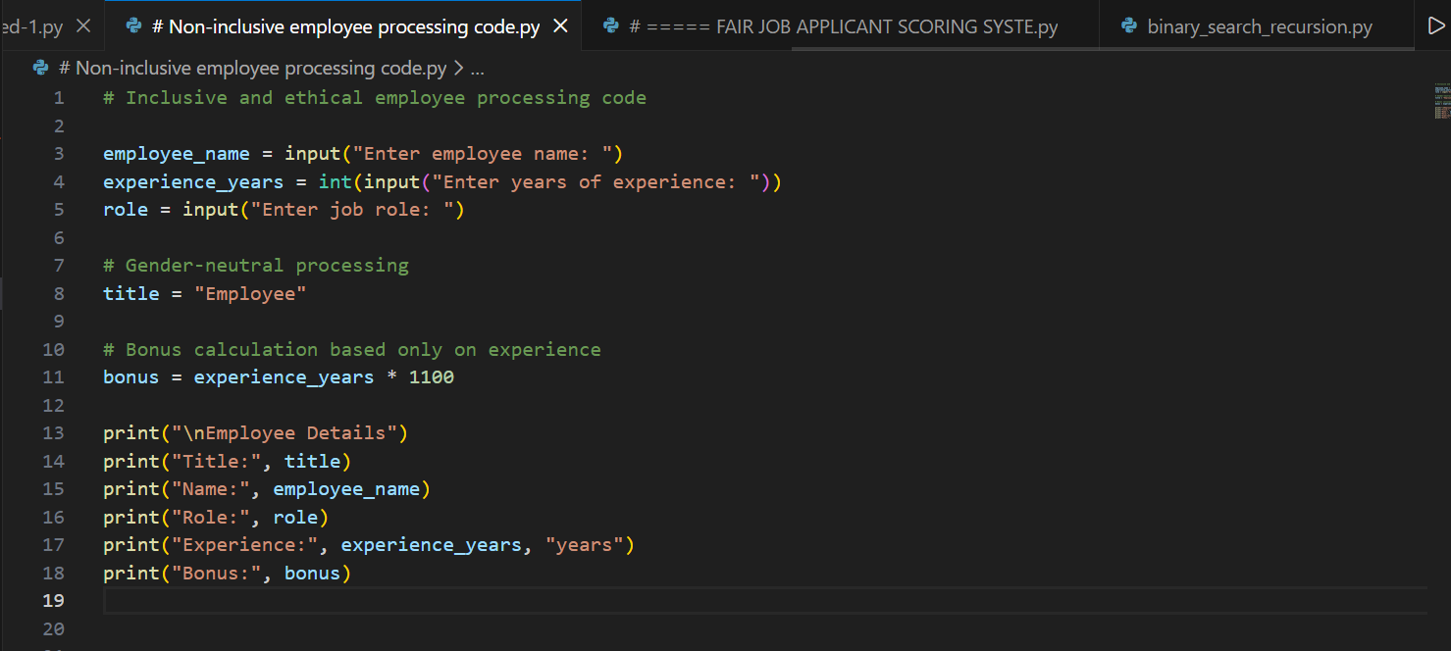

Output:
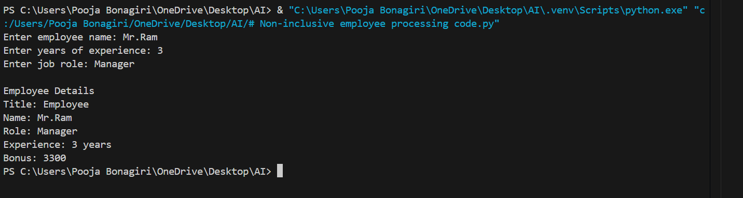
Explanation:
This revised code processes employee details using only job-related information such as name, role, and experience. It avoids gender-specific variables, titles, and conditions to prevent bias or assumptions. By using neutral naming and experience-based logic, the program follows inclusive and ethical coding practices.

