Name: B.Pooja
Hall Ticket: 2303A52141
Batch: 41
Task 1: Refactoring Data Transformation Logic
Prompt:
Write a Python program to refactor the given loop-based code into a more Pythonic version using list comprehension.The program should double each element in the list and produce the same output
Code:
values = [2, 4, 6, 8, 10]
doubled = []
for v in values:
doubled.append(v * 2)
print(doubled)
#Refactor this loop into a more Python-style solution using list comprehension or a helper function.
doubled = [v * 2 for v in values]
print(doubled)
#Refactor this loop into a more Python-style solution using a helper function.
def double(v):
return v * 2
doubled = list(map(double, values))
print(doubled)
#Refactor this loop into a more Python-style solution using a helper function.
def double(v):
return v * 2
doubled = list(map(double, values))
print(doubled)

Output:
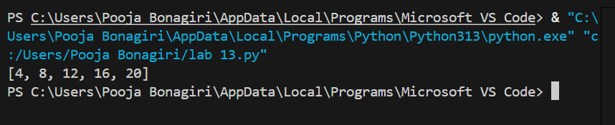
Explanation:
The original code uses a long for-loop.List comprehension makes it shorter, cleaner, and easier to read while keeping the same output.
Task 2: Improving Text Processing Code Readability
Prompt:
Refactor the given loop-based Python code into a Pythonic version using list comprehension.
Ensure the output remains [4, 8, 12, 16, 20].
Code:
words = ["Refactoring", "with", "AI", "improves","quality"]
message = ""
for w in words:
message += w + " "
print(message.strip())
#Rewrite this string-building loop in a more readable and efficient Python way, keeping the final output unchanged
message = " ".join(words)
print(message)

Output:
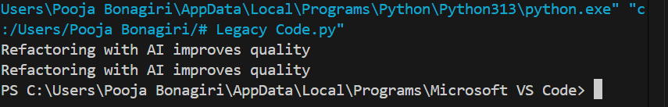
Explanation:
The original code builds the sentence using repeated string concatenation inside a loop, which is less efficient and harder to read. Using " ".join(words) is more Pythonic, cleaner, and faster because it combines all words into a single string in one step while keeping the same output.
Task 3: Safer Access to Configuration Data
Prompt:
Code:
# Legacy Code
config = {"host": "localhost", "port": 8080}

if "timeout" in config:
print(config["timeout"])
else:
print("Default timeout used")

# Refactored Code using safer dictionary access
config = {"host": "localhost", "port": 8080}

print(config.get("timeout", "Default timeout used"))

Output:
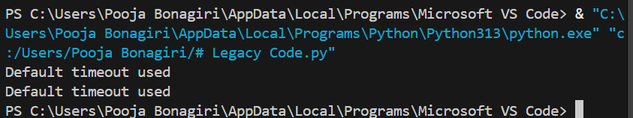
Explanation:
The original code manually checks if the key exists before accessing it.
Using dict.get() is safer and shorter because it automatically returns a default value if the key is
Task 4: Refactoring Conditional Logic for Scalability
Prompt:
Refactor the multiple if–elif conditional statements into a cleaner and more scalable approach using a mapping technique (like a dictionary).Ensure the functionality and output remain the same.
Code:

action = "divide"
x, y = 10, 2

if action == "add":
result = x + y
elif action == "subtract":
result = x - y
elif action == "multiply":
result = x * y
elif action == "divide":
result = x / y
else:
result = None

print("Using if-elif:", result)

action = "divide"
x, y = 10, 2

operations = {
"add": lambda a, b: a + b,
"subtract": lambda a, b: a - b,
"multiply": lambda a, b: a * b,
"divide": lambda a, b: a / b
}

result = operations.get(action, lambda a, b: None)(x, y)

print("Using dictionary mapping:", result)
Output:
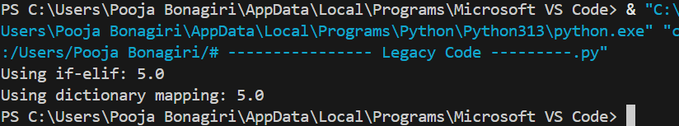
Explanation:
Using multiple if–elif conditions is harder to scale when more operations are added.
A dictionary mapping actions to functions makes the code cleaner, easier to maintain, and more scalable.
Task 5: Simplifying Search Logic in Collections
Prompt:
Refactor the manual loop used for searching an item in a list into a more concise and Pythonic approach.Ensure the output remains "Item Available" if the item exists
Code:
inventory = ["pen", "notebook", "eraser", "marker"]
found = False
for item in inventory:
if item == "eraser":
found = True
break
print("Item Available" if found else "Item Not Available")
#Refactor this manual loop-based search into a more concise and readable Python approach, while preserving the same output behavior.
if "eraser" in inventory:
print("Item Available")
else:
print("Item Not Available")

Output:
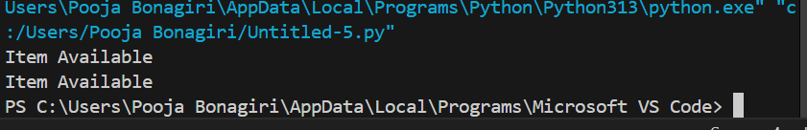
Explanation:
AI recognizes that manually looping to search an item is unnecessary and suggests using Python’s built-in in operator to make the code shorter and easier to read while keeping the same result.

