Name:M.Shiva Teja
Hall Ticket:2303a52145
Batch No:41
Task 1: Refactoring Data Transformation Logic
Prompt:
Write a Python program that converts a traditional loop-based implementation into a more Pythonic version using list comprehension.The program should double each element in a list and generate the same output as the original loop-based code.
Code:
values = [2, 4, 6, 8, 10]
doubled = []
for v in values:
doubled.append(v * 2)
print(doubled)
#Refactor this loop into a more Python-style solution using list comprehension or a helper function.
doubled = [v * 2 for v in values]
print(doubled)
#Refactor this loop into a more Python-style solution using a helper function.
def double(v):
return v * 2
doubled = list(map(double, values))
print(doubled)
#Refactor this loop into a more Python-style solution using a helper function.
def double(v):
return v * 2
doubled = list(map(double, values))
print(doubled)
Output:
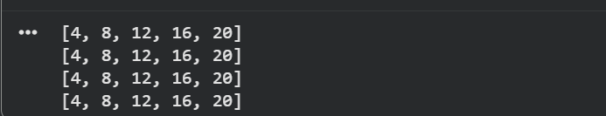

Explanation:
The original program uses a lengthy for loop to process the list.
By applying list comprehension, the code becomes shorter, more readable, and more elegant while still producing the same output.

Task 2: Improving Text Processing Code Readability
Prompt:
Refactor the provided loop-based Python code using list comprehension to make it more concise and readable
Code:
words = ["Refactoring", "with", "AI", "improves","quality"]
message = ""
for w in words:
message += w + " "
print(message.strip())
#Rewrite this string-building loop in a more readable and efficient Python way, keeping the final output unchanged
message = " ".join(words)
print(message)

Output:
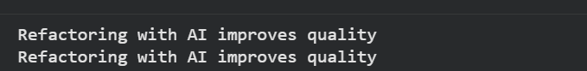

Explanation:
The original implementation constructs a sentence using repeated string concatenation inside a loop, which reduces readability and efficiency.Using " ".join(words) is a more Pythonic and efficient approach because it combines all words into a single string in one step while maintaining the same output

Task 3: Safer Access to Configuration Data
Prompt:
Modify the legacy Python code to use safer and more efficient dictionary access methods (such as .get() instead of direct key access)
Code:
# Legacy Code
config = {"host": "localhost", "port": 8080}

if "timeout" in config:
print(config["timeout"])
else:
print("Default timeout used")

# Refactored Code using safer dictionary access
config = {"host": "localhost", "port": 8080}

print(config.get("timeout", "Default timeout used"))

Output:
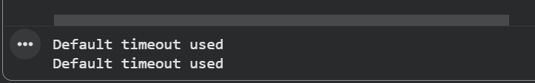
Explanation:
The original code explicitly checks whether a key exists in a dictionary before accessing it.
Using the dict.get() method makes the code safer and more concise, as it automatically returns a default value when the key is missing, preventing potential errors
Task 4: Refactoring Conditional Logic for Scalability
Prompt:
Refactor the existing multiple if–elif conditional statements into a cleaner, more scalable structure using a mapping technique (such as a dictionary-based approach).
Ensure that the program’s functionality and output remain unchanged
Code:

action = "divide"
x, y = 10, 2

if action == "add":
result = x + y
elif action == "subtract":
result = x - y
elif action == "multiply":
result = x * y
elif action == "divide":
result = x / y
else:
result = None

print("Using if-elif:", result)

action = "divide"
x, y = 10, 2

operations = {
"add": lambda a, b: a + b,
"subtract": lambda a, b: a - b,
"multiply": lambda a, b: a * b,
"divide": lambda a, b: a / b
}

result = operations.get(action, lambda a, b: None)(x, y)

print("Using dictionary mapping:", result)

Output:
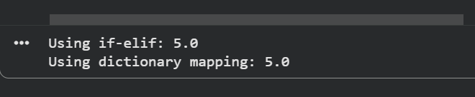
Explanation:
Using multiple if–elif statements becomes difficult to manage and extend as the number of conditions increases.
Replacing them with a dictionary that maps actions to functions results in cleaner, more maintainable, and scalable code while preserving the same functionality.

Task 5: Simplifying Search Logic in Collections
Prompt:
Rewrite the manual loop used to search for an item in a list by replacing it with a more concise and Pythonic approach.
Code:
inventory = ["pen", "notebook", "eraser", "marker"]
found = False
for item in inventory:
if item == "eraser":
found = True
break
print("Item Available" if found else "Item Not Available")
#Refactor this manual loop-based search into a more concise and readable Python approach, while preserving the same output behavior.
if "eraser" in inventory:
print("Item Available")
else:
print("Item Not Available")

Output:
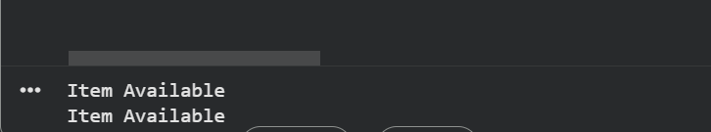

Explanation:
Instead of manually iterating through a list to search for an item, Python’s built-in in operator provides a simpler and more readable solution.
This approach shortens the code and improves clarity while ensuring the output remains the same.

