AI ASSISTANT CODING
ASSIGNMENT-19.2

Name: A.Sathwik
Enrollment no: 2303A52158
Batch: 34
Semester: VI
Branch: CSE(AIML)

Lab 19 – Code Translation: Converting Between Programming Languages
Task 1 – Python to Java Conversion
Task:
Convert a Python program that performs file handling operations into an equivalent Java program using AI assistance.
Instructions:
• Prompt AI to translate a Python script that reads from and writes to a file into Java.
• Ensure proper handling of file streams, exceptions, and input/output formatting.
• Verify that the Java program produces the same file content and console output as the Python version.
• Test both implementations with sample input files.
Expected Output:
A correctly translated and executable Java program that performs the same file handling operations as the original Python script.

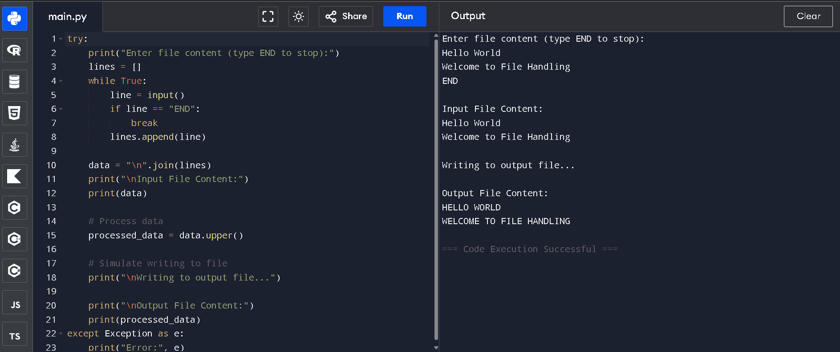
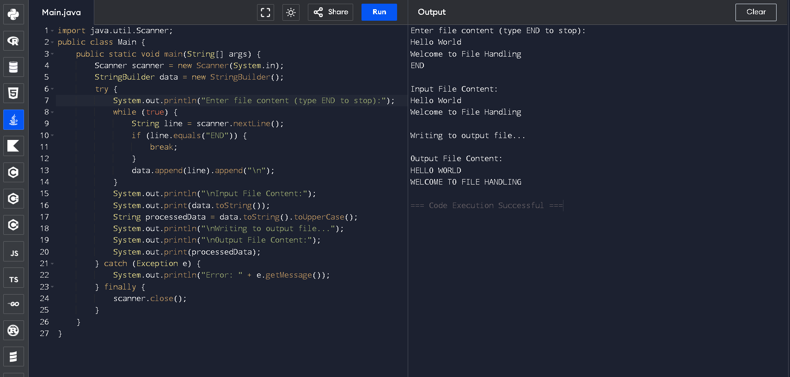

Task 2 – C++ to Python Function Conversion
Task:
Translate a C++ program that implements a sorting algorithm into Python using AI assistance.
Instructions:
• Provide AI with a C++ implementation of a sorting technique (e.g., Bubble Sort or Selection Sort).
• Ask AI to generate an equivalent Python implementation.
• Ensure logical correctness and validate results using multiple test cases.
• Confirm that the Python version maintains the same sorting behavior.
Expected Output:
A correct and executable Python program equivalent to the given C++ sorting implementation.

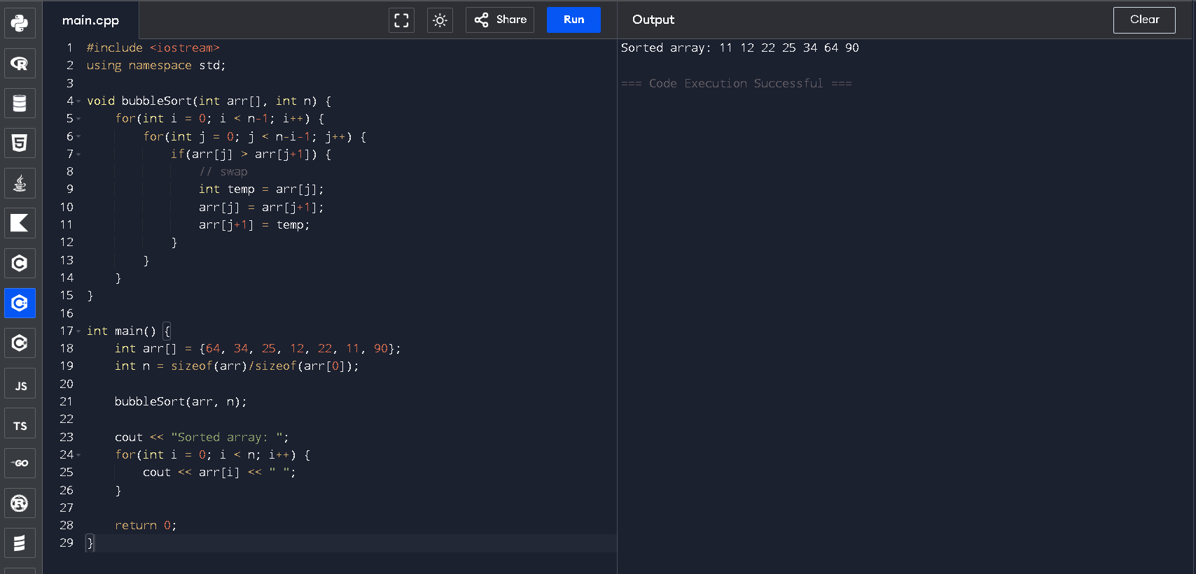
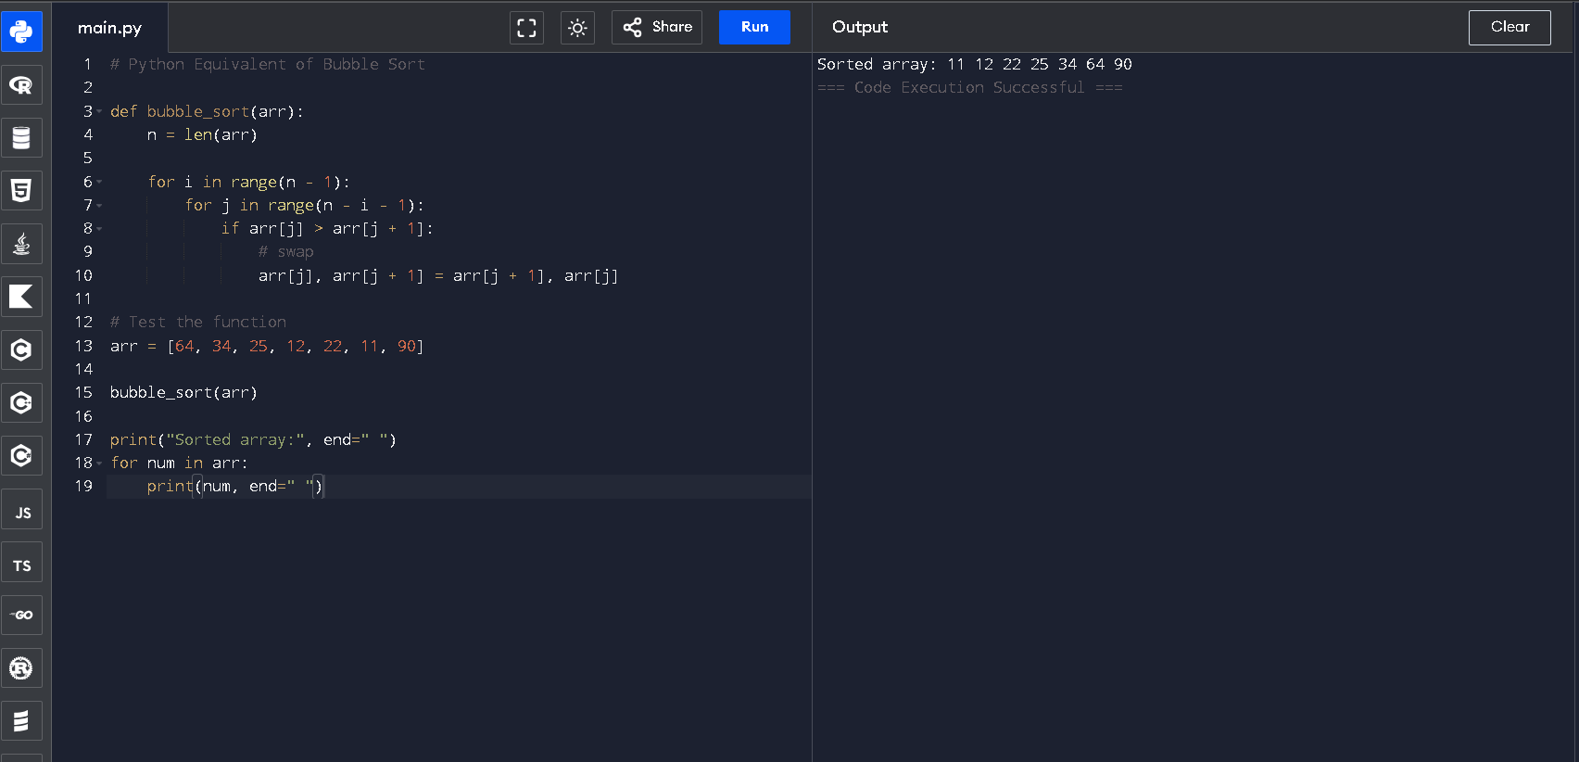

Task 3 – SQL to Pandas Query
Task:
Convert a SQL query involving GROUP BY and aggregate functions into an equivalent Pandas Data Frame operation.

Instructions:
• Provide AI with a SQL query that calculates aggregate values (e.g., total sales per department).
• Prompt AI to generate equivalent Pandas code using groupby() and aggregation functions.
• Test the generated code using a sample dataset.
• Verify that both SQL and Pandas outputs match.
Expected Output:
An accurate Pandas Data Frame operation that produces results equivalent to the given SQL query with aggregation.
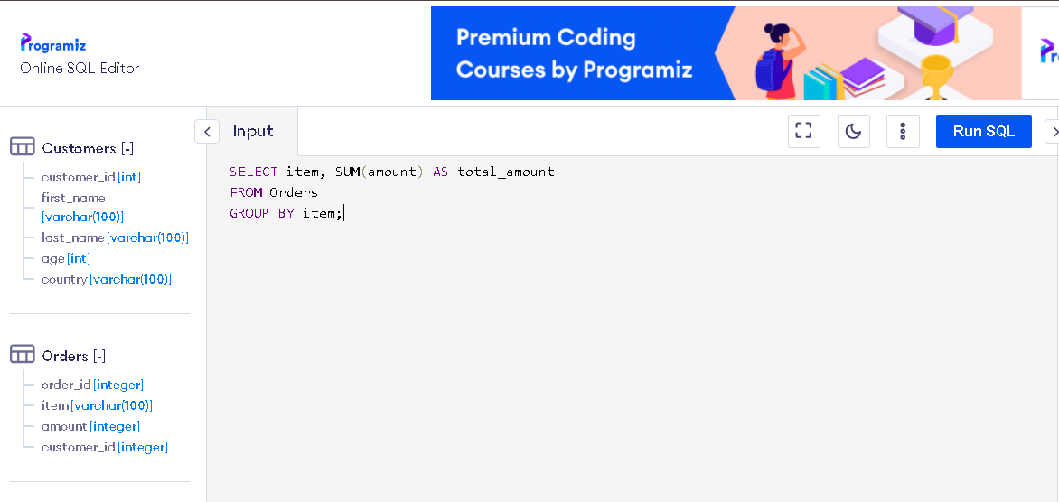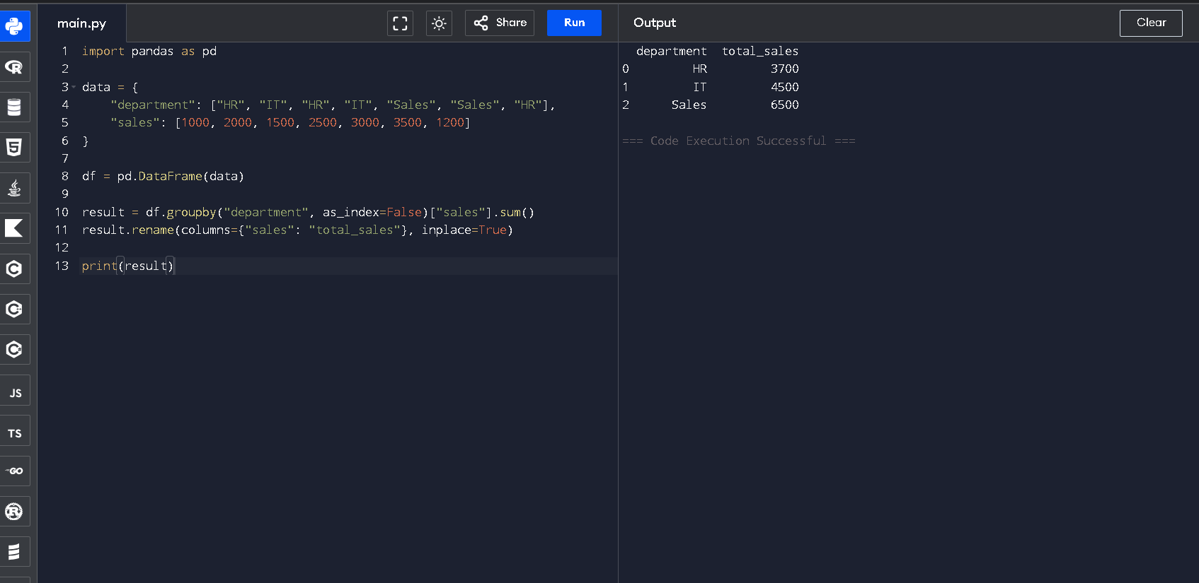
Task 4 – Real-Time Application: Multi-Language Snippet Converter
Scenario:
Students will select a practical real-world application requiring the same logic in two different programming languages.
Example:
• Converting a REST API implementation from Python (Flask) to Java (Spring Boot).
• Translating a data processing script from Python to C++ for performance optimization.
Instructions:
• Provide AI with source code in one programming language.
• Prompt AI to convert the code into another chosen language.
• Execute and test both versions to ensure identical functionality.
• Document differences observed in syntax, libraries, and execution behavior.
Expected Output:
Functionally equivalent and executable code snippets implemented in two different programming languages, along with documented observations.

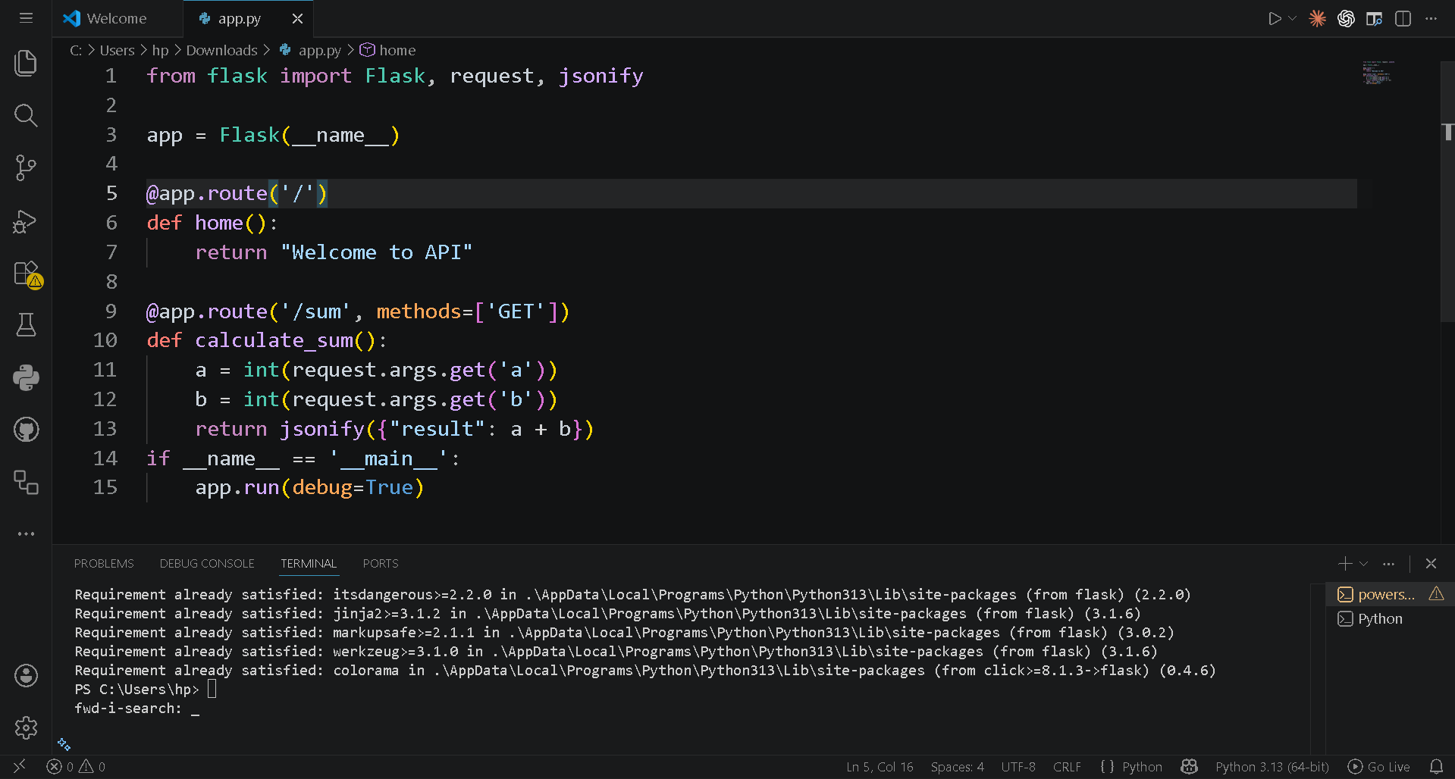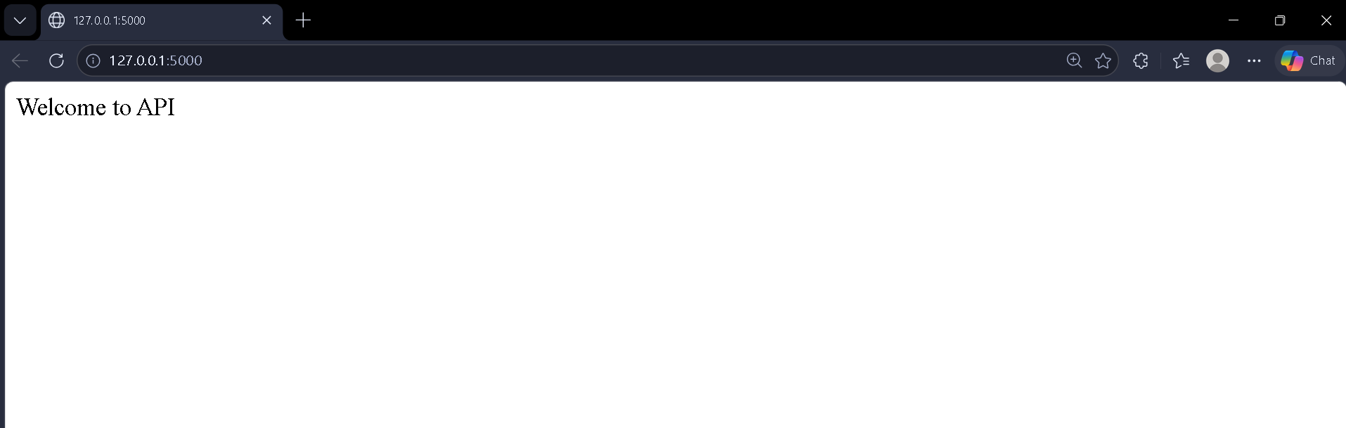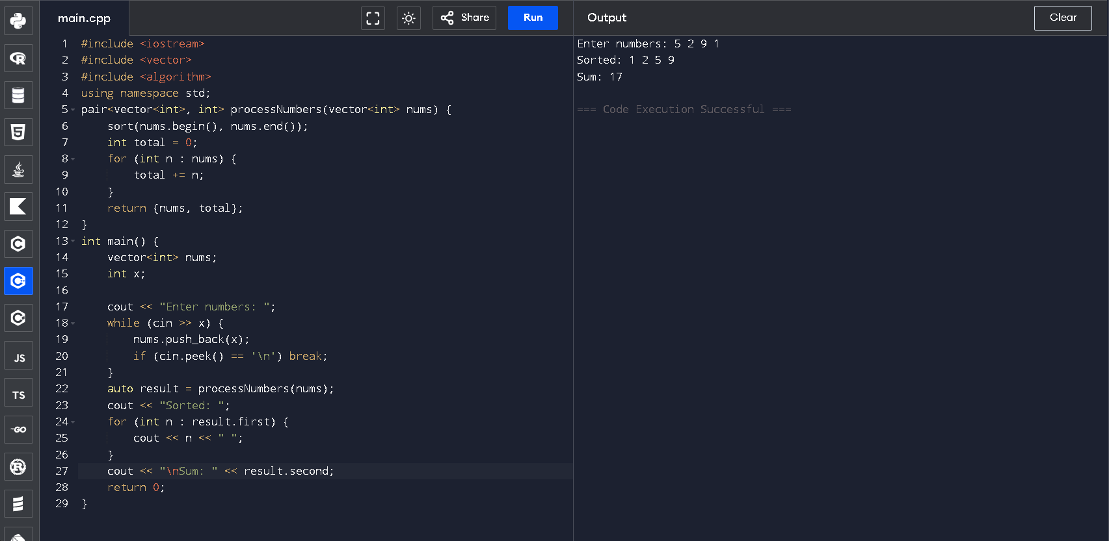

Task -5: (Basic Function Translation (Python to C++)
Translate a simple Python function that checks whether a number is even or odd into C++ using AI assistance.
Instructions:
• Provide AI with a basic Python function that determines if a number is even or odd.
• Prompt AI to generate equivalent C++ code.
• Ensure correct syntax, input handling, and output formatting.
• Compile and run the C++ program to verify it produces the same result as the Python version.
• Test with at least three different input values.
Expected Output:
A simple and executable C++ program equivalent to the given Python function, correctly identifying whether a number is even or odd for all test cases.

