AI ASSISTANT CODING
ASSIGNMENT-18.2

Name: A.Sathwik
Enrollment no: 2303A52158
Batch: 34
Semester: VI
Branch: CSE(AIML)

Lab 18 – API Integration: Connecting to External Services with Error Handling
Task Description – 1 (Air Quality API Integration)
• Task:
Use AI assistance to develop a Python program that retrieves real-time air quality information for a specified city.
Instructions:
• Generate Python code using the requests library.
• Handle errors such as invalid city names, missing or incorrect API keys, and network timeouts.
• Extract and display AQI value, pollution level, and dominant pollutant in a readable format.
Sample Code:
import requests
city = "Delhi"
url = "https://api.example.com/airquality"
Expected Output:
• A Python script that successfully fetches and displays air quality data with proper error handling.
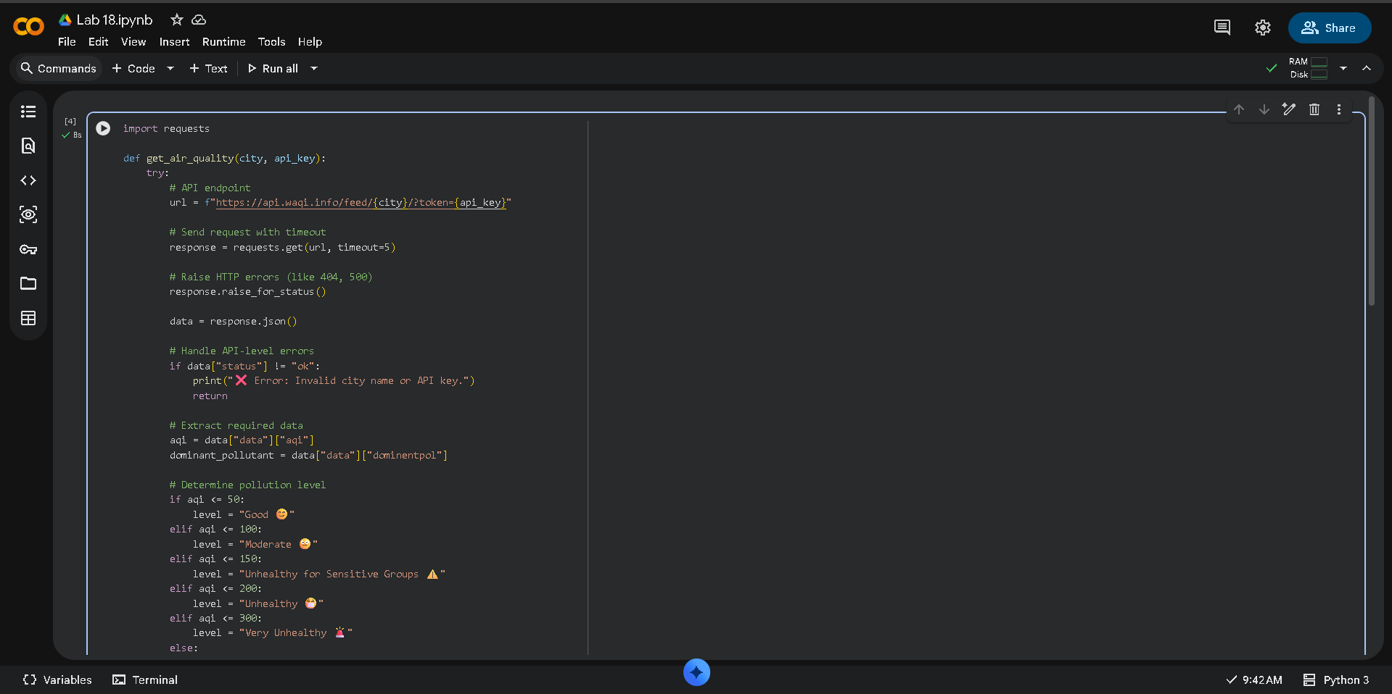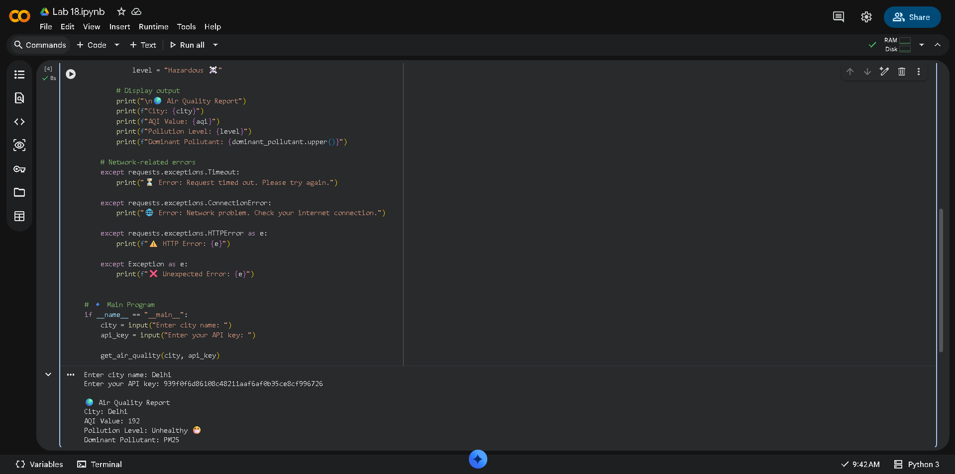

Task Description – 2 (Language Translation API)
• Task:
Integrate a Language Translation API to translate text from English to two other languages.
Instructions:
• Use AI to generate API request code for translation.
• Validate user input text and target language codes.
• Handle API response errors and service unavailability.
• Display original and translated text clearly.
Sample Code:
import requests
text = "Welcome to AI Assisted Coding"
target_lang = "fr"
Expected Output:
• A working Python script that translates user input text with graceful error handling.
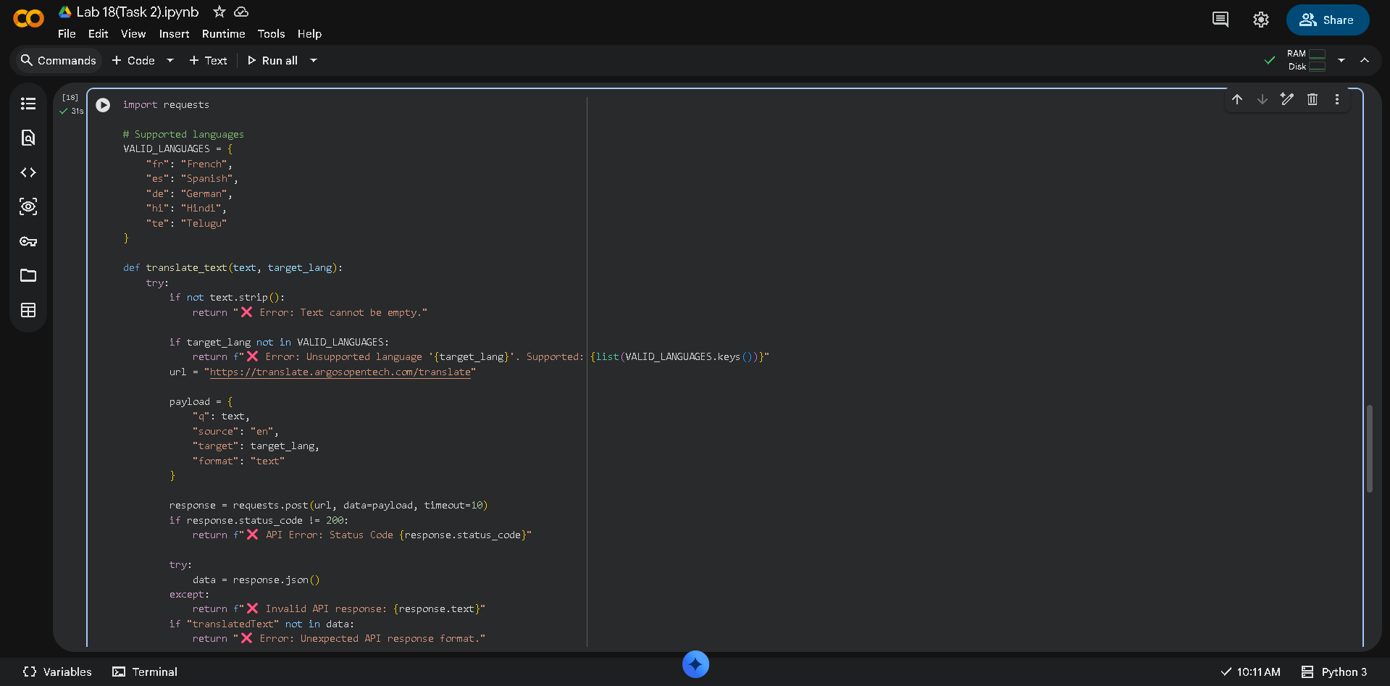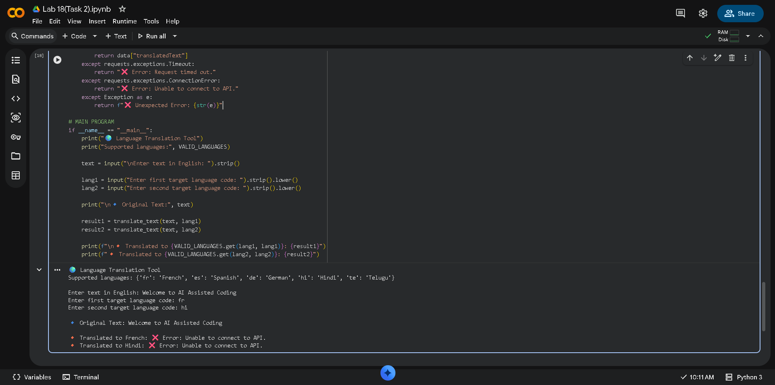

Task Description – 3 (Public Book Information API)
• Task:
Connect to a public Books API to fetch information about a book using its title or ISBN.
Instructions:
• Prompt AI to write Python code for sending GET requests to the API.
• Handle errors such as book not found, invalid input, and rate limits.
• Display book title, author, publisher, and publication year.
Sample Code:
import requests
query = "Artificial Intelligence"
Expected Output:
• A Python program that retrieves and displays book details with robust error handling.
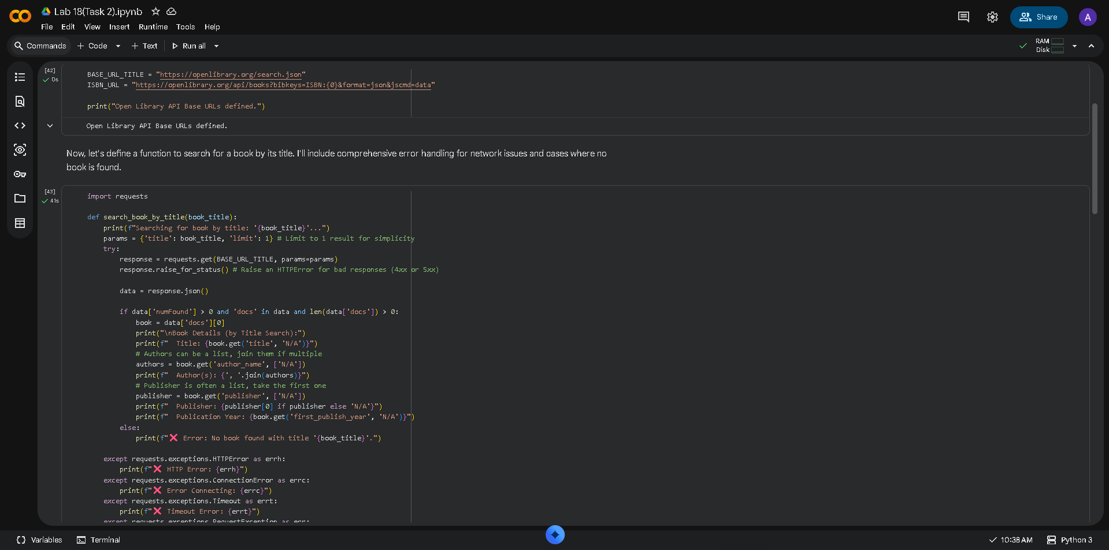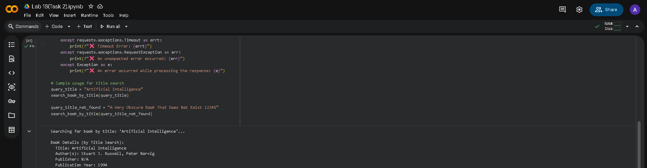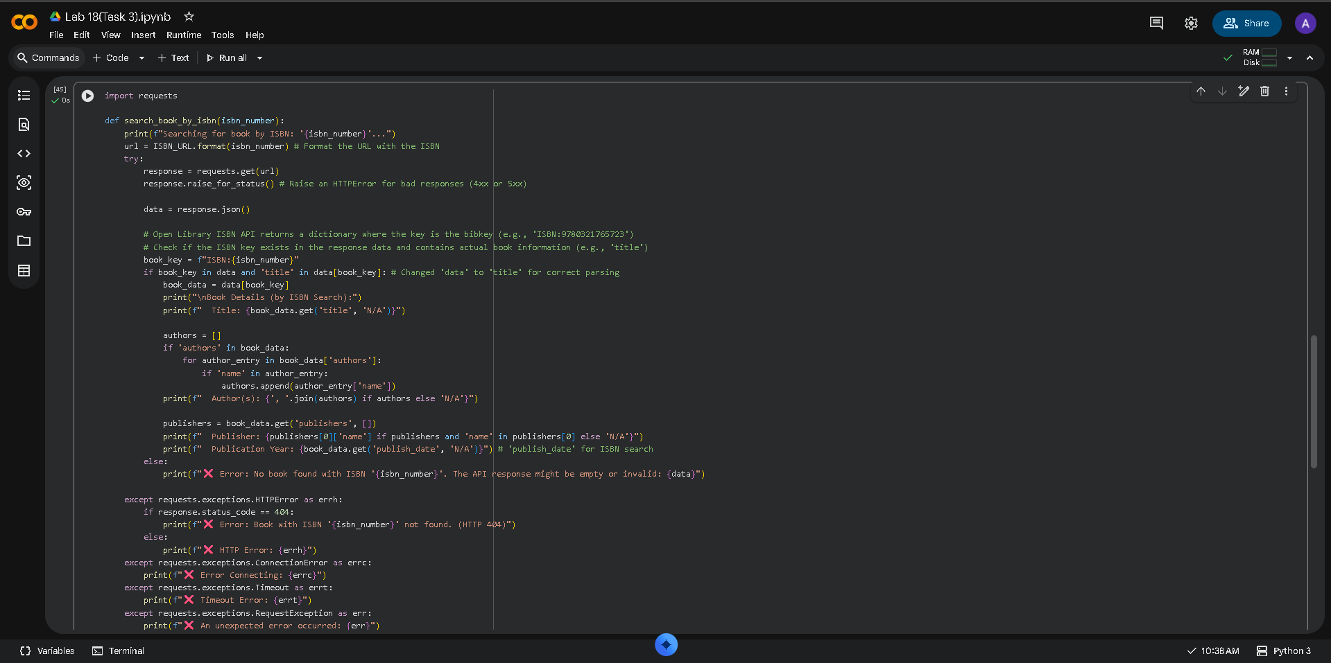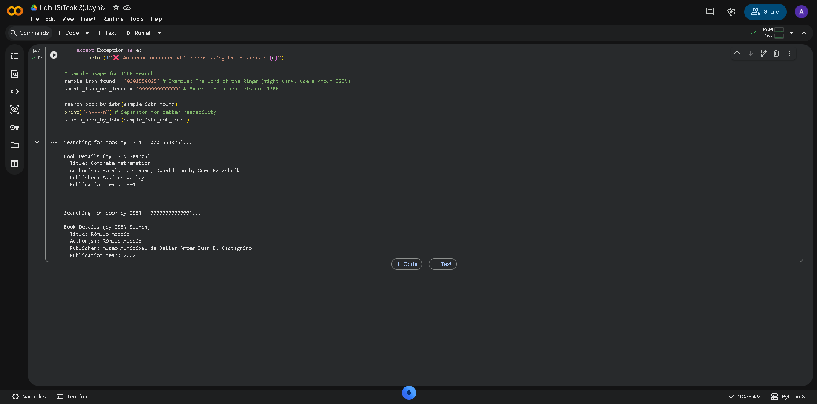

Task Description – 4 (Real-Time Application: Job Listings Aggregator)
• Scenario:
Develop a Job Listings Aggregator using a public Jobs API.
Requirements:
• Fetch the latest job postings for a given role or location.
• Handle errors such as invalid search terms, missing API keys, and request failures.
• Display job title, company name, location, and posting date in a numbered list.
• Implement a retry mechanism for failed API requests.
Sample Code:
import requests
keyword = "Python Developer"
Expected Output:
• A functional Python script that retrieves and displays job listings with proper error handling.
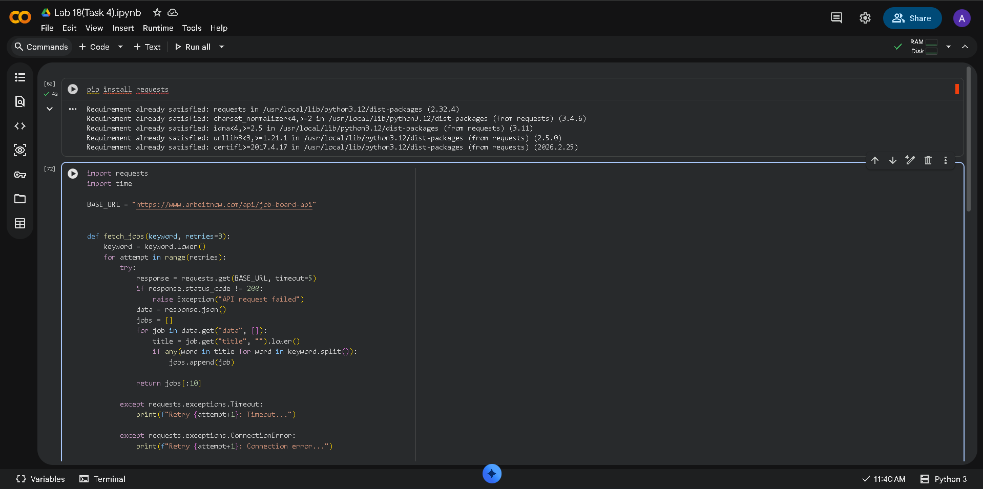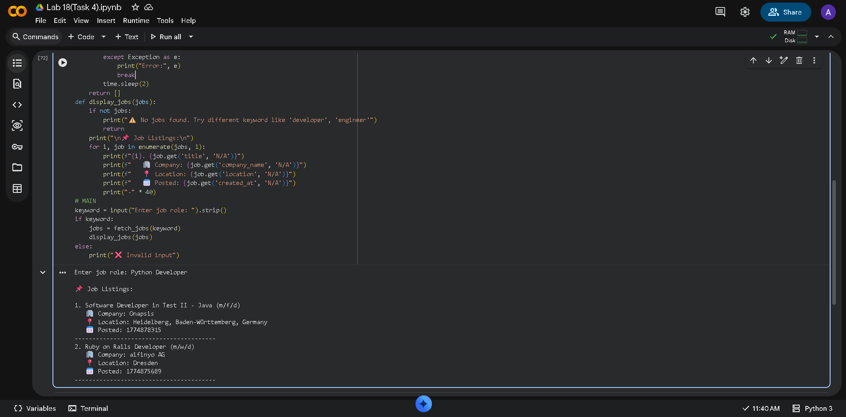

Task Description – 5 Stock Market Data API Integration
• Task:
Use AI assistance to develop a Python program that retrieves real-time stock market data for a selected company.
Instructions:
• Generate Python code using the requests library to connect to a public Stock Market API.
• Validate user input for stock symbol.
• Handle common errors such as invalid symbols, API rate limits, missing API keys, and network failures.
• Extract and display stock name, current price, day high, day low, and percentage change.
Sample Code:
import requests
symbol = "AAPL"
• Expected Output:
A Python script that successfully fetches and displays stock market information with robust error handling.
