AI ASSISTANT CODING
ASSIGNMENT-8.2

Name: A.Sathwik
Enrollment no: 2303A52158
Batch: 34
Semester: VI
Branch: CSE(AIML)

Lab 8: Test-Driven Development with AI – Generating and Working with Test Cases
Task Description
Task 1 – Test-Driven Development for Even/Odd Number Validator
• Use AI tools to first generate test cases for a function is_even(n)
and then implement the function so that it satisfies all generated
tests.
Requirements:
• Input must be an integer
• Handle zero, negative numbers, and large integers
Example Test Scenarios:
is_even(2) → True
is_even(7) → False
is_even(0) → True
is_even(-4) → True
is_even(9) → False

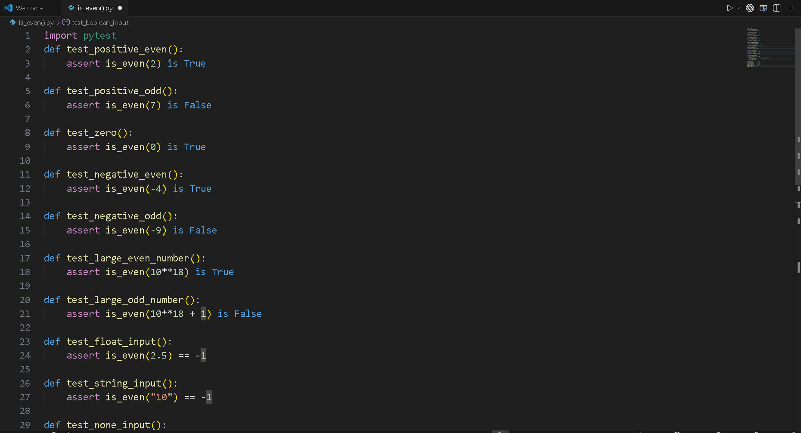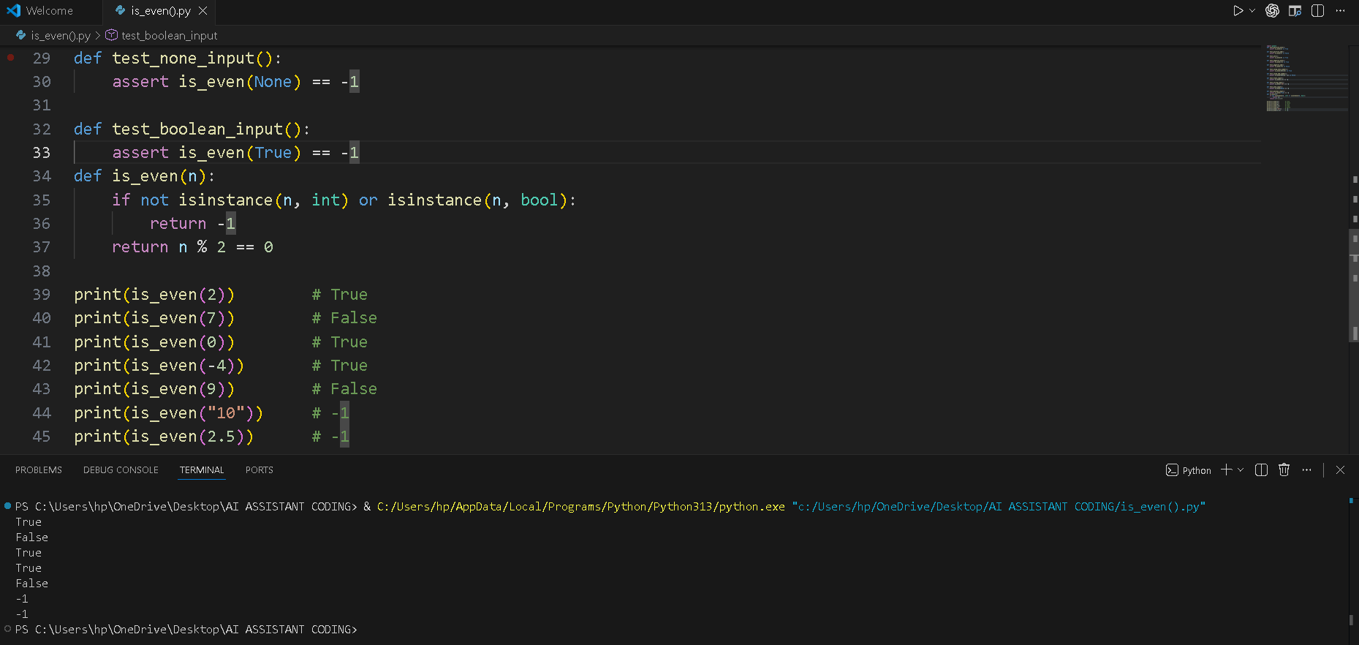
Task 2 – Test-Driven Development for String Case Converter
• Ask AI to generate test cases for two functions:
• to_uppercase(text)
• to_lowercase(text)
Requirements:
• Handle empty strings
• Handle mixed-case input
• Handle invalid inputs such as numbers or None
Example Test Scenarios:
to_uppercase("ai coding") → "AI CODING"
to_lowercase("TEST") → "test"
to_uppercase("") → ""
to_lowercase(None) → Error or safe handling
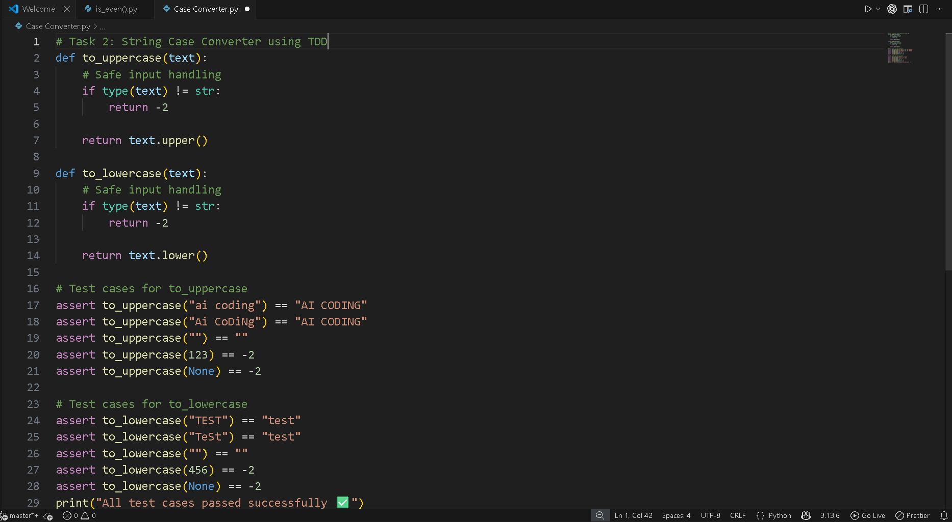
Task 3 – Test-Driven Development for List Sum Calculator
• Use AI to generate test cases for a function sum_list(numbers) that calculates the sum of list elements.
Requirements:
• Handle empty lists
• Handle negative numbers
• Ignore or safely handle non-numeric values
Example Test Scenarios:
sum_list([1, 2, 3]) → 6
sum_list([]) → 0
sum_list([-1, 5, -4]) → 0
sum_list([2, "a", 3]) → 5

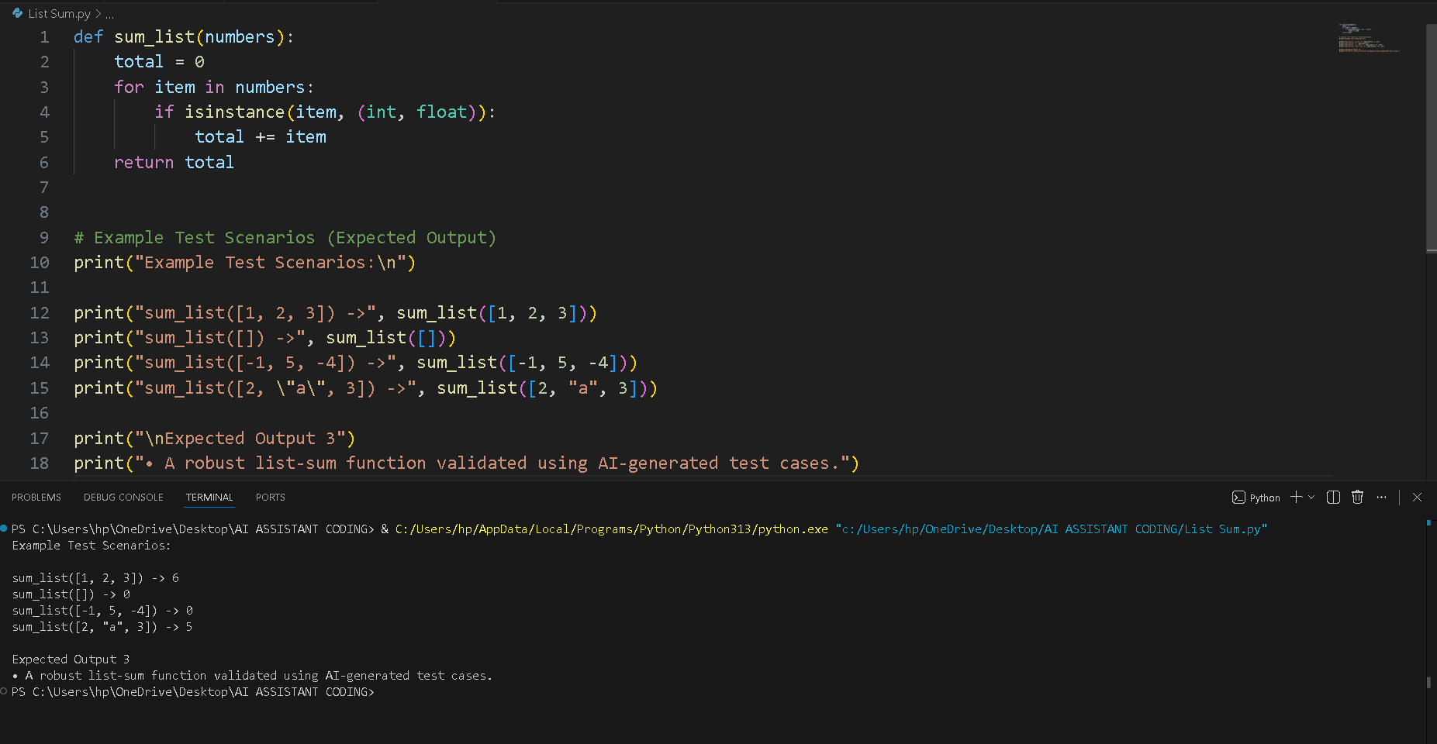
Task 4 – Test Cases for Student Result Class
• Generate test cases for a StudentResult class with the following methods:
• add_marks(mark)
• calculate_average()
• get_result()
Requirements:
• Marks must be between 0 and 100
• Average ≥ 40 → Pass, otherwise Fail
Example Test Scenarios:
Marks: [60, 70, 80] → Average: 70 → Result: Pass
Marks: [30, 35, 40] → Average: 35 → Result: Fail
Marks: [-10] → Error
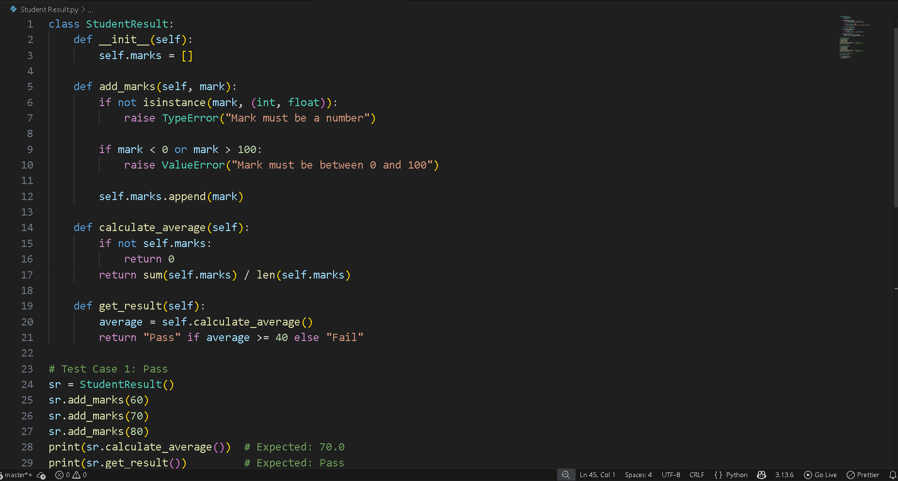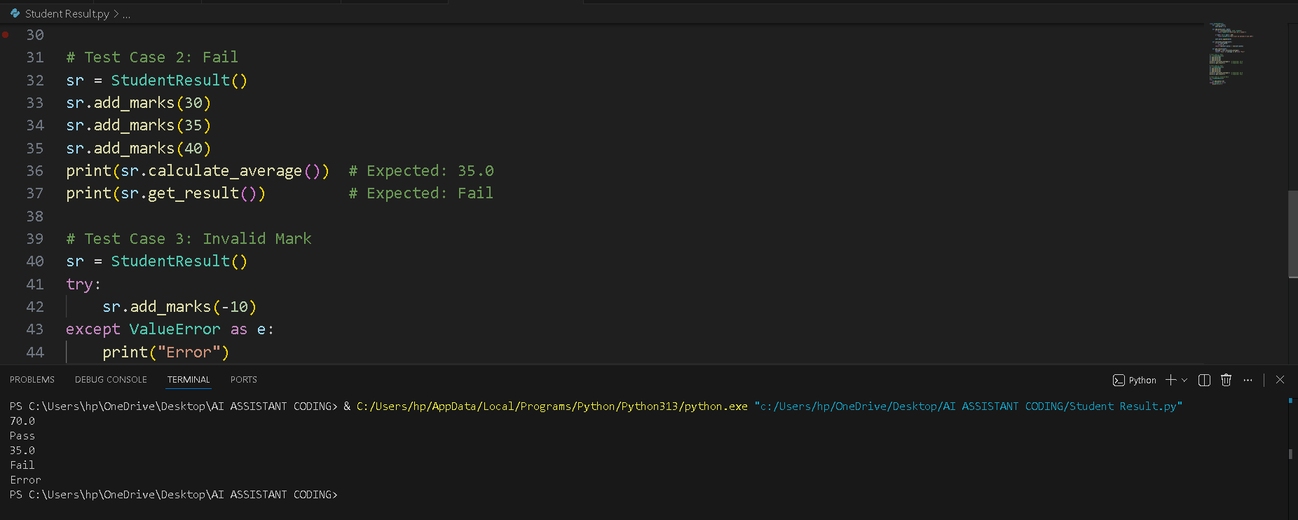
Task 5 – Test-Driven Development for Username Validator
Requirements:
• Minimum length: 5 characters
• No spaces allowed
• Only alphanumeric characters
Example Test Scenarios:
is_valid_username("user01") → True
is_valid_username("ai") → False
is_valid_username("user name") → False
is_valid_username("user@123") → False

