AI ASSIST CODING ASSIGNMENT-15.5
Program Name: B. Tech
Assignment Type: Lab
Academic Year: 2025-2026
Course Code: 23CS002PC304
Course Title: AI Assisted Coding
Student Name: A.sathwik
Roll No: 2303A52158
batch: 34
Assignment Number: 15.5 / 24

Lab 15 – Backend API Development: Creating RESTful Services with AI

Lab Objectives
• Understand the fundamentals of RESTful API design.
• Use AI‑assisted coding tools to generate backend services.
• Implement CRUD (Create, Read, Update, Delete) operations.
• Document endpoints with comments and auto‑generated documentation.

Task 1 – Student Attendance API

Prompt Used
Generate a RESTful API for student attendance tracking with CRUD operations using JSON based request and response.

Required Endpoints
GET /attendance → View attendance records
POST /attendance → Mark attendance
PUT /attendance/{id} → Update attendance record
DELETE /attendance/{id} → Remove attendance entry

Code Implementation
from flask import Flask, request, jsonify
app = Flask(__name__)
attendance = []
@app.route('/attendance', methods=['GET'])
def get_attendance():
return jsonify(attendance)
@app.route('/attendance', methods=['POST'])
def mark_attendance():
data = request.json
attendance.append(data)
return jsonify({"message": "Attendance added"})
@app.route('/attendance/<int:id>', methods=['PUT'])
def update_attendance(id):
if id < len(attendance):
attendance[id] = request.json
return jsonify({"message": "Attendance updated"})
return jsonify({"error": "Record not found"})
@app.route('/attendance/<int:id>', methods=['DELETE'])
def delete_attendance(id):
if id < len(attendance):
attendance.pop(id)
return jsonify({"message": "Attendance deleted"})
return jsonify({"error": "Record not found"})
if __name__ == '__main__':
app.run(debug=True)

Output
API successfully performs attendance operations.

Screenshot of Execution – Task 1
👉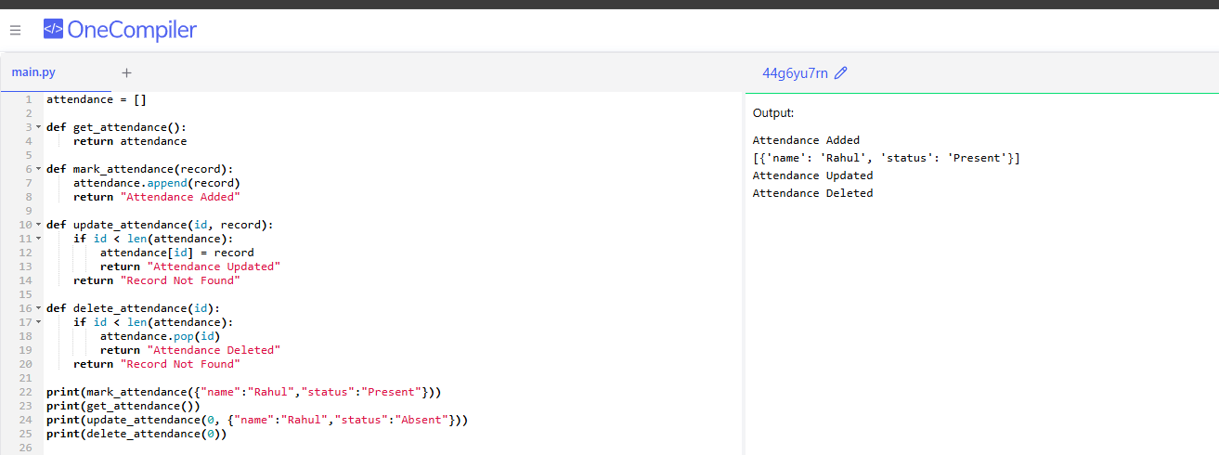

Task 2 – Inventory Management API

Prompt Used
Generate a REST API for warehouse inventory management including validation for stock values.

Required Endpoints
GET /inventory → List all items
POST /inventory → Add new item
PUT /inventory/{id} → Update stock quantity
DELETE /inventory/{id} → Remove an item

Code Implementation
from flask import Flask, request, jsonify
app = Flask(__name__)
inventory = []
@app.route('/inventory', methods=['GET'])
def list_items():
return jsonify(inventory)
@app.route('/inventory', methods=['POST'])
def add_item():
item = request.json
if item.get("stock",0) < 0:
return jsonify({"error":"Invalid stock value"})
inventory.append(item)
return jsonify({"message":"Item added"})
@app.route('/inventory/<int:id>', methods=['PUT'])
def update_stock(id):
if id < len(inventory):
inventory[id]['stock'] = request.json.get('stock', inventory[id]['stock'])
return jsonify({"message":"Stock updated"})
return jsonify({"error":"Item not found"})
@app.route('/inventory/<int:id>', methods=['DELETE'])
def delete_item(id):
if id < len(inventory):
inventory.pop(id)
return jsonify({"message":"Item removed"})
return jsonify({"error":"Item not found"})
if __name__ == '__main__':
app.run(debug=True)

Output
API manages inventory stock levels successfully.

Screenshot of Execution – Task 2
👉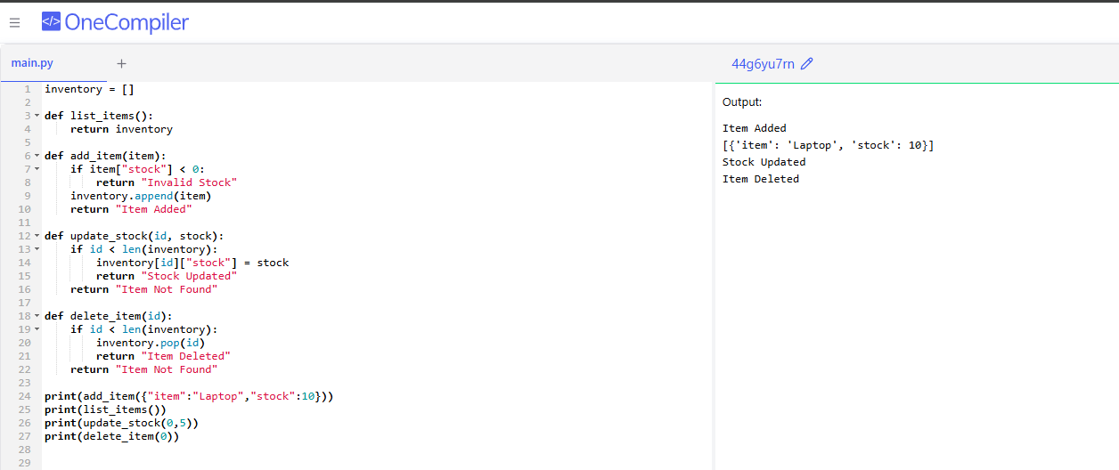

Task 3 – Hotel Room Booking API

Prompt Used
Generate a RESTful API for hotel room booking with error handling for unavailable rooms.

Required Endpoints
GET /rooms → View available rooms
POST /rooms/book → Book a room
GET /rooms/{id} → View booking details
DELETE /rooms/{id} → Cancel booking

Code Implementation
from flask import Flask, request, jsonify
app = Flask(__name__)
rooms = {1:"available",2:"available",3:"available"}
@app.route('/rooms', methods=['GET'])
def view_rooms():
return jsonify(rooms)
@app.route('/rooms/book', methods=['POST'])
def book_room():
room_id = request.json.get('room')
if rooms.get(room_id) == "available":
rooms[room_id] = "booked"
return jsonify({"message":"Room booked"})
return jsonify({"error":"Room unavailable"})
@app.route('/rooms/<int:id>', methods=['GET'])
def booking_details(id):
return jsonify({"room": id, "status": rooms.get(id)})
@app.route('/rooms/<int:id>', methods=['DELETE'])
def cancel_booking(id):
if rooms.get(id) == "booked":
rooms[id] = "available"
return jsonify({"message":"Booking cancelled"})
return jsonify({"error":"No booking"})
if __name__ == '__main__':
app.run(debug=True)

Output
API simulates hotel room booking successfully.

Screenshot of Execution – Task 3
👉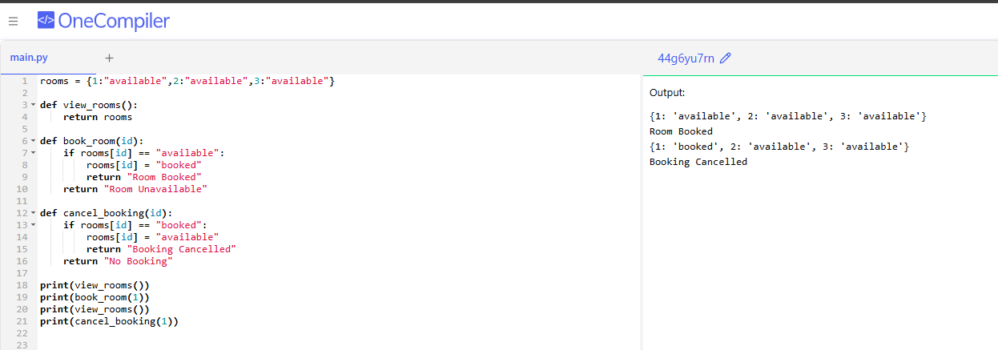

Task 4 – Online Voting API

Prompt Used
Generate a RESTful API for an online voting system ensuring one vote per user.

Required Endpoints
GET /candidates → List candidates
POST /vote → Cast a vote
GET /results → View voting results

Code Implementation
from flask import Flask, request, jsonify
app = Flask(__name__)
candidates = {"A":0,"B":0,"C":0}
voted_users = set()
@app.route('/candidates', methods=['GET'])
def list_candidates():
return jsonify(candidates)
@app.route('/vote', methods=['POST'])
def vote():
user = request.json.get('user')
candidate = request.json.get('candidate')
if user in voted_users:
return jsonify({"error":"User already voted"})
if candidate in candidates:
candidates[candidate] += 1
voted_users.add(user)
return jsonify({"message":"Vote counted"})
return jsonify({"error":"Invalid candidate"})
@app.route('/results', methods=['GET'])
def results():
return jsonify(candidates)
if __name__ == '__main__':
app.run(debug=True)

Output
API simulates voting and displays results correctly.

Screenshot of Execution – Task 4
👉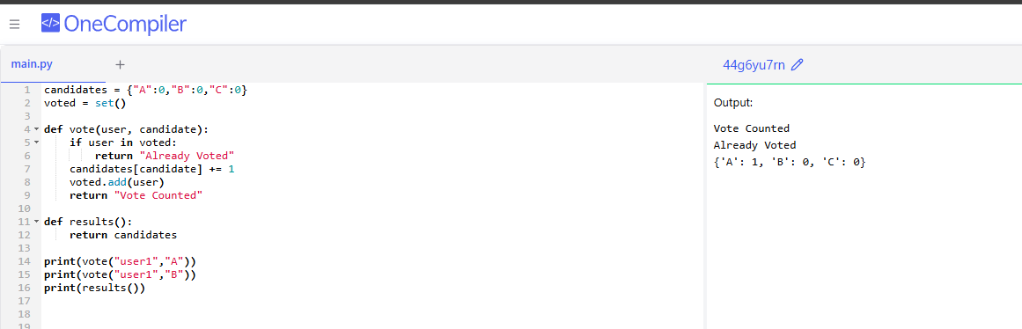

Task 5 – Teacher Management API

Prompt Used
Generate a RESTful API for managing teacher records with proper error handling.

Required Endpoints
GET /teachers → List all teachers
POST /teachers → Add a new teacher
PUT /teachers/{id} → Update teacher details
DELETE /teachers/{id} → Remove a teacher

Code Implementation
from flask import Flask, request, jsonify
app = Flask(__name__)
teachers = []
@app.route('/teachers', methods=['GET'])
def get_teachers():
return jsonify(teachers)
@app.route('/teachers', methods=['POST'])
def add_teacher():
teachers.append(request.json)
return jsonify({"message":"Teacher added"})
@app.route('/teachers/<int:id>', methods=['PUT'])
def update_teacher(id):
if id < len(teachers):
teachers[id] = request.json
return jsonify({"message":"Teacher updated"})
return jsonify({"error":"Teacher not found"})
@app.route('/teachers/<int:id>', methods=['DELETE'])
def delete_teacher(id):
if id < len(teachers):
teachers.pop(id)
return jsonify({"message":"Teacher deleted"})
return jsonify({"error":"Teacher not found"})
if __name__ == '__main__':
app.run(debug=True)

Output
API performs CRUD operations for teacher records successfully.

Screenshot of Execution – Task 5
👉
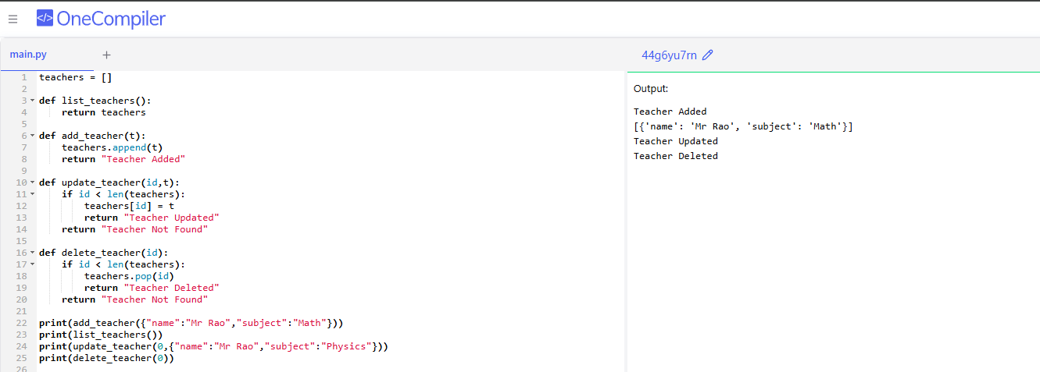

Conclusion
This lab demonstrated how AI‑assisted coding tools can be used to design RESTful APIs and implement CRUD operations for different real‑world scenarios such as attendance tracking, inventory management, hotel booking, online voting, and teacher management systems.

