AI ASSISTANT CODING
ASSIGNMENT-10.2

Name: A.Sathwik
Enrollment no: 2303A52158
Batch: 34
Semester: VI
Branch: CSE(AIML)

Lab 10 – Code Review and Quality: Using AI to Improve Code Quality and Readability

Task Description -1(Error Detection and Correction)
Task:
Use AI to analyze a Python script and correct all syntax and logical errors.
Sample Input Code:
def calculate_total(nums)
sum = 0
for n in nums
sum += n
return total
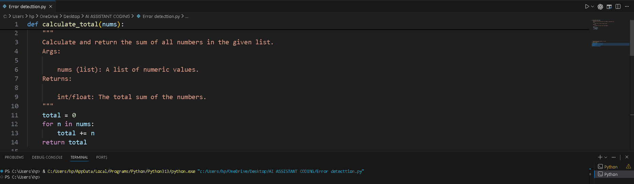
Corrected Code
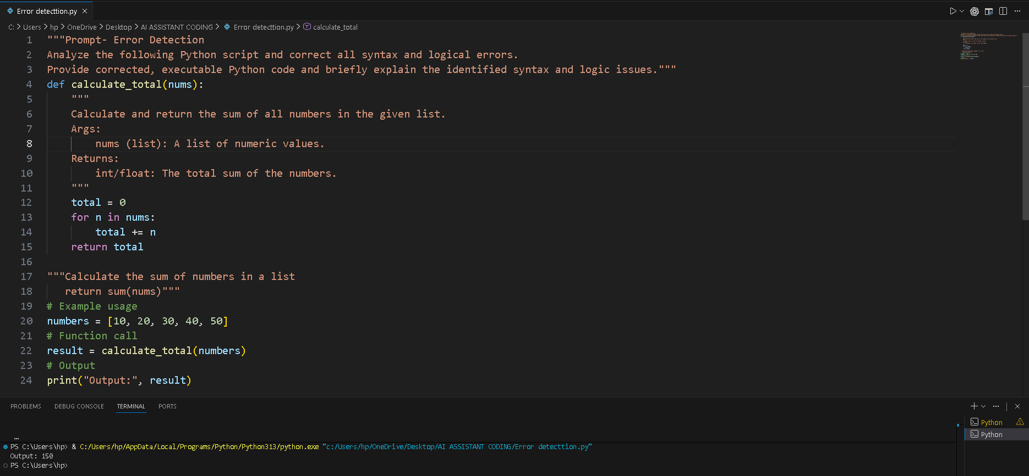

EXPLANATION:
1 Added missing colon (:) after the function definition.
2 Added missing colon (:) after the for loop statement.
3 Corrected indentation inside the function block.
4 Fixed variable mismatch (sum initialized but total returned).
5 Replaced sum with total to avoid overriding Python’s built-in sum() function.

Task Description -2(Code Style Standardization)
Use AI to refactor Python code to comply with standard coding style
guidelines.
Sample Input Code:
def findSum(a,b):return a+b
print(findSum(5,10))

PROMPT WITH CODE:
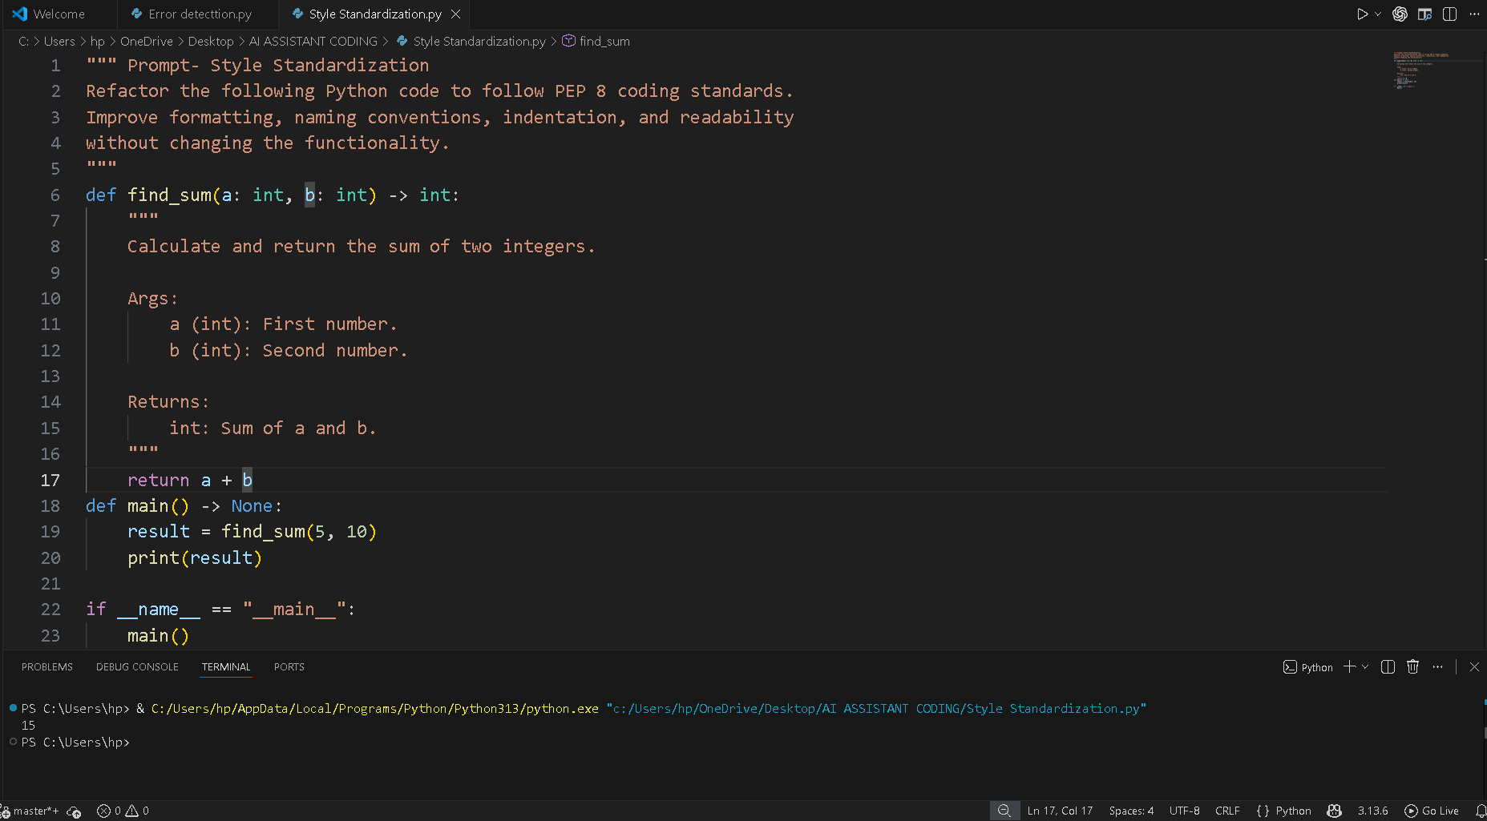

Task Description -3(Code Clarity Improvement)
Use AI to improve code readability without changing its functionality.
Sample Input Code:
def f(x,y):
return x-y*2
print(f(10,3))

PROMPT WITH CODE:
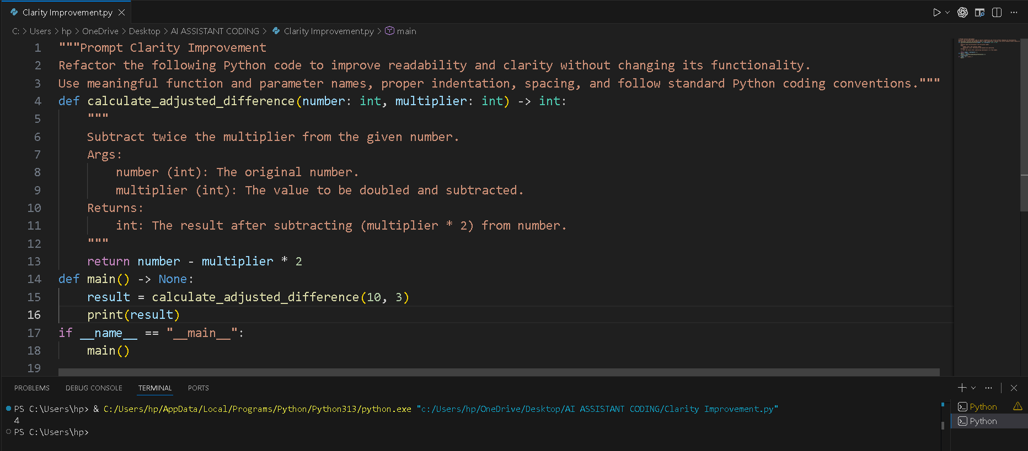

Task Description -4(Structural Refactoring)
Use AI to refactor repetitive code into reusable functions.
Sample Input Code:
print("Hello Ram")
print("Hello Sita")
print("Hello Ravi")

PROMPT WITH CODE:
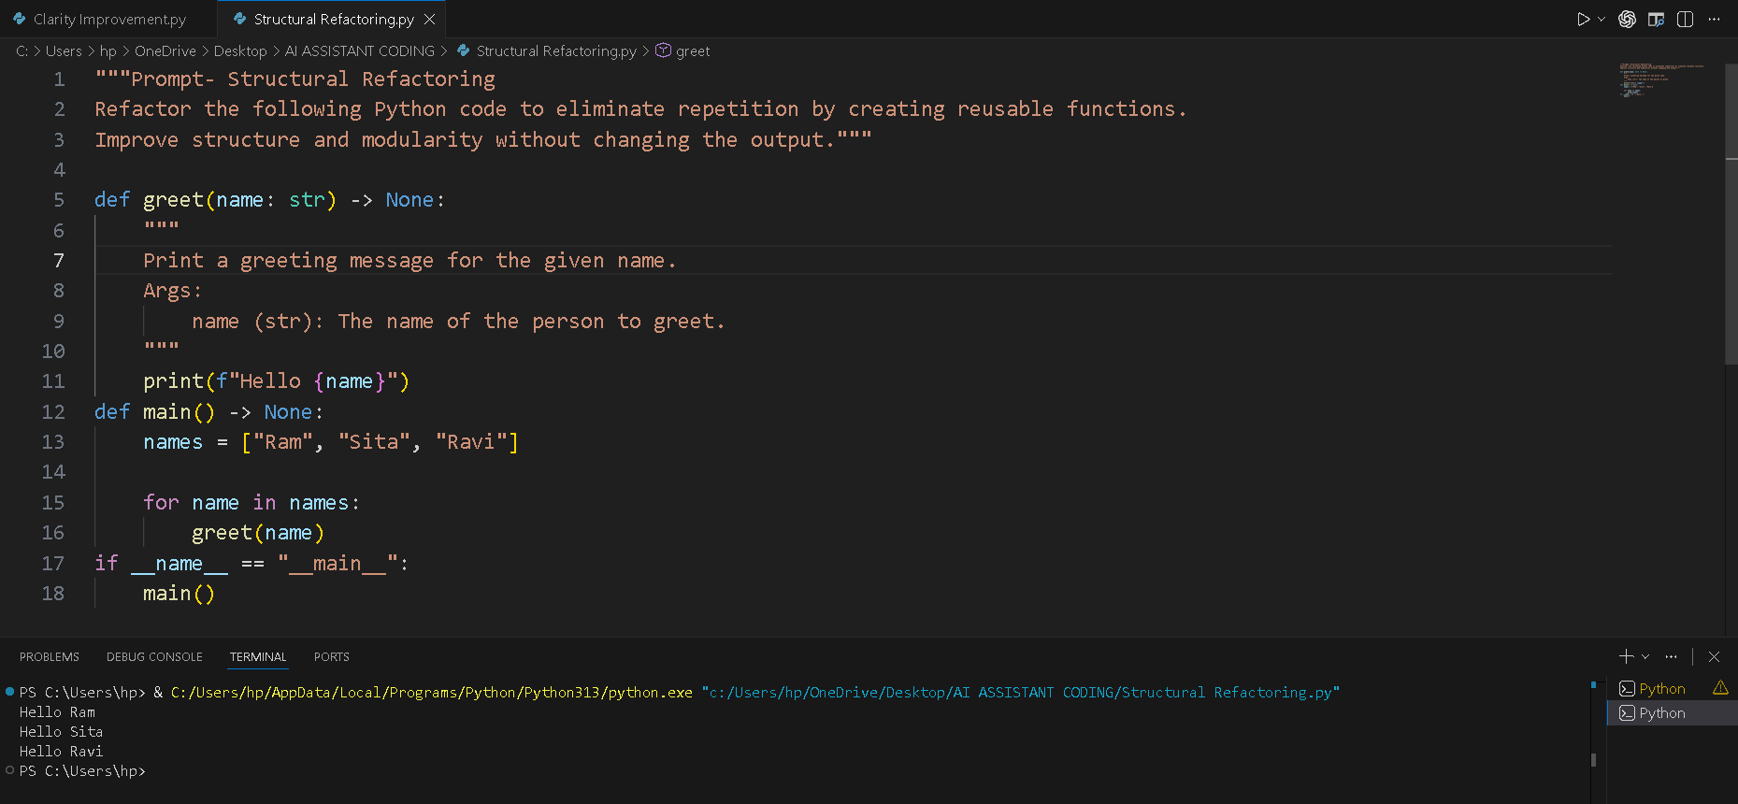

Task Description -5(Efficiency Enhancement)
Use AI to optimize Python code for better performance.
Sample Input Code:
numbers = [ ]
for i in range(1, 500000):
numbers.append(i * i)
print(len(numbers))

PROMPT WITH CODE:
