AI ASSISTANT CODING
ASSIGNMENT-12.2

Name: A.Sathwik
Enrollment no: 2303A52158
Batch: 34
Semester: VI
Branch: CSE(AIML)

Lab 12: Algorithms with AI Assistance – Sorting, Searching, and
Optimizing Algorithms

Task Description -1 (Data Structures – Stack Implementation with AI Assistance)
➢ Task: Use AI assistance to generate a Python program that
implements a Stack data structure.
Instructions:
Prompt AI to create a Stack class with the following methods:
➢ push(element)
➢ pop()
➢ peek()
➢ is_empty()
➢ Ensure proper error handling for stack underflow.
➢ Ask AI to include clear docstrings for each method

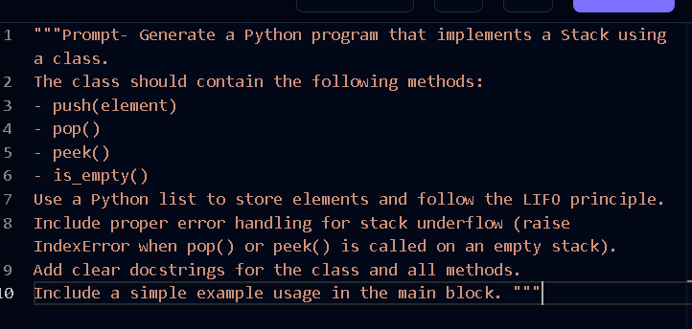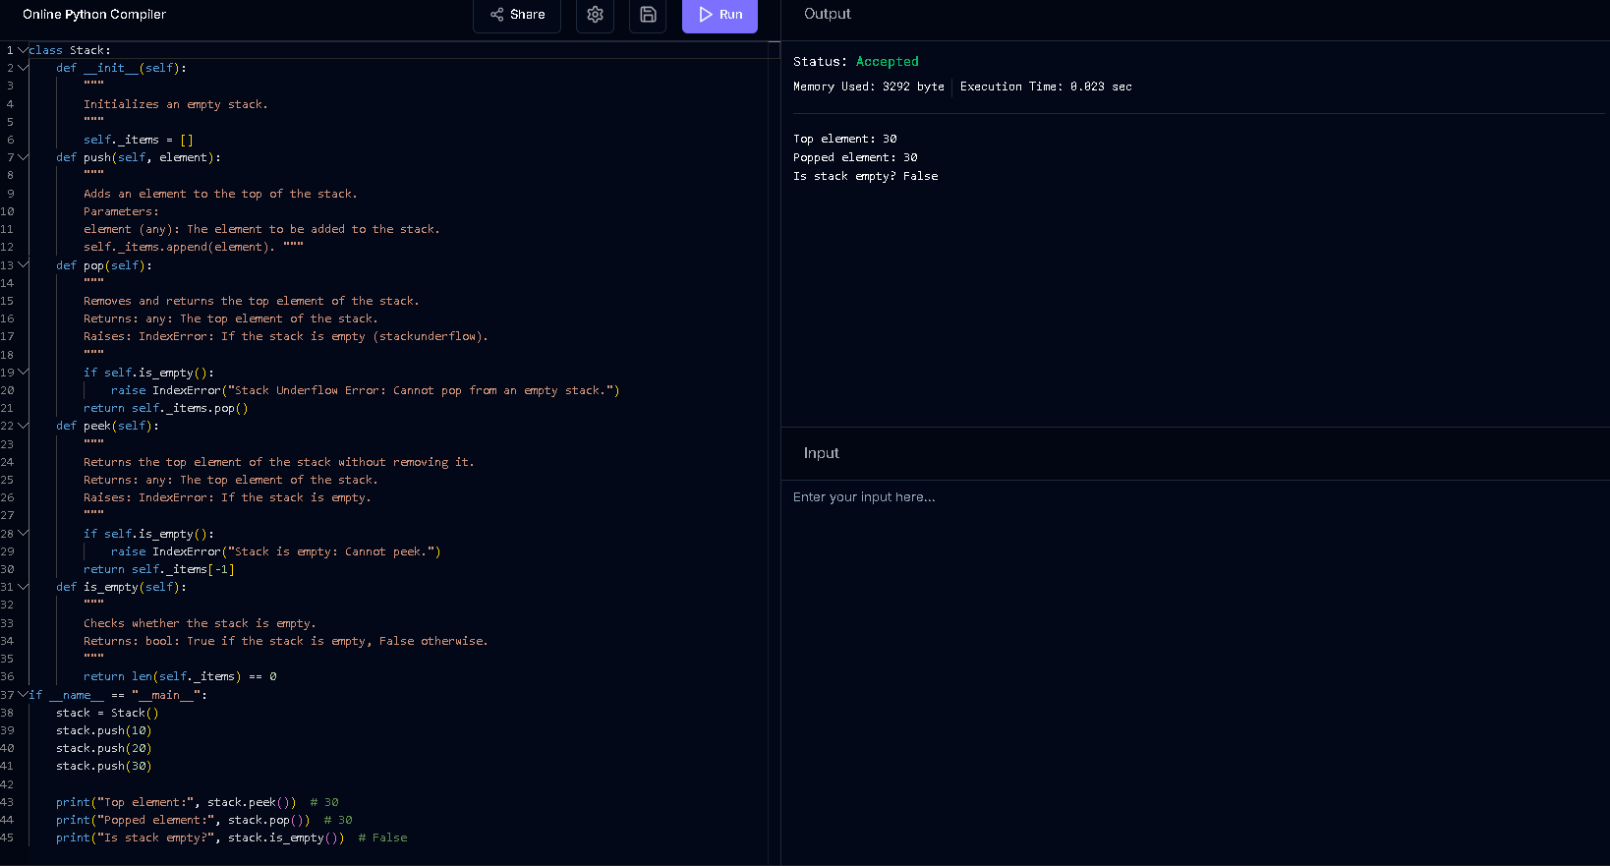
Task Description -2 (Algorithms – Linear vs Binary Search Analysis)
➢ Task: Use AI to implement and compare Linear Search and Binary Search algorithms in Python.
Instructions:
➢ Prompt AI to generate:
➢ linear_search(arr, target)
➢ binary_search(arr, target)
➢ Include docstrings explaining:
➢ Working principle. Test both algorithms using different input sizes.
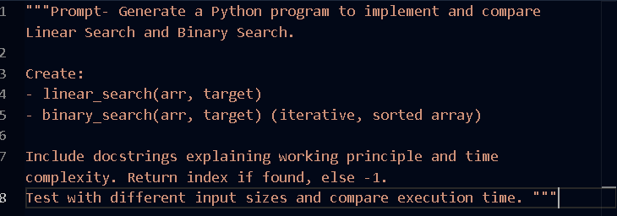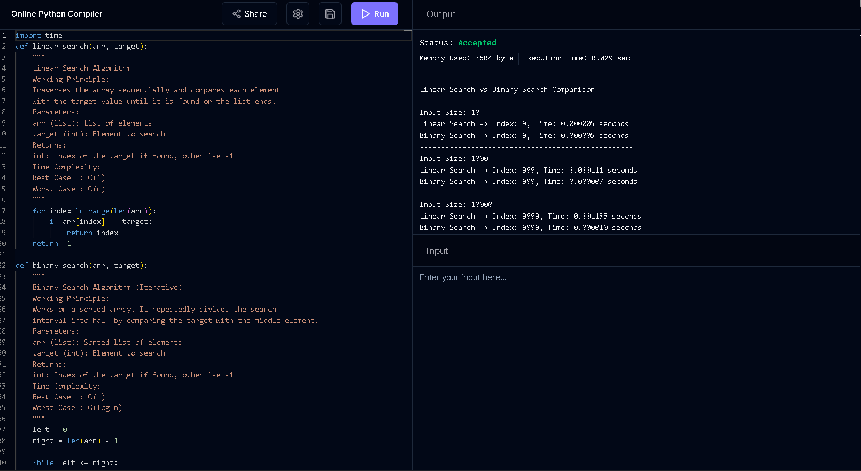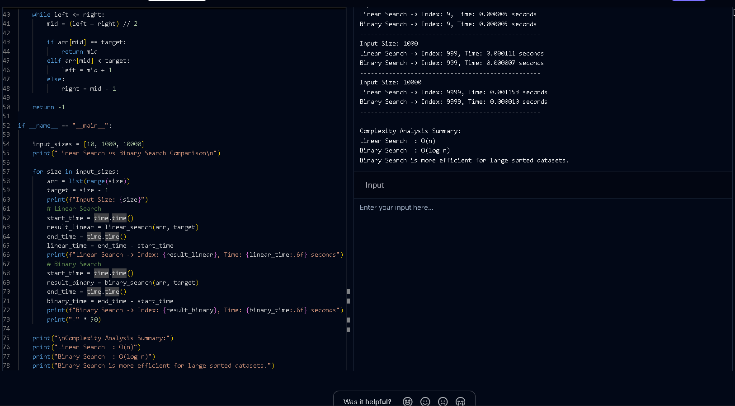

Task Description -3 (Test Driven Development – Simple Calculator Function)
➢ Task:
Apply Test Driven Development (TDD) using AI assistance to develop a calculator function.
Instructions:
➢ Prompt AI to first generate unit test cases for addition and subtraction.
➢ Run the tests and observe failures.
➢ Ask AI to implement the calculator functions to pass all tests.
➢ Re-run the tests to confirm success.
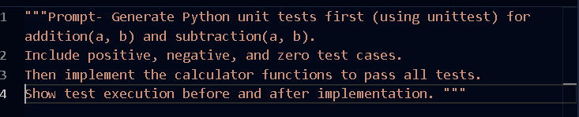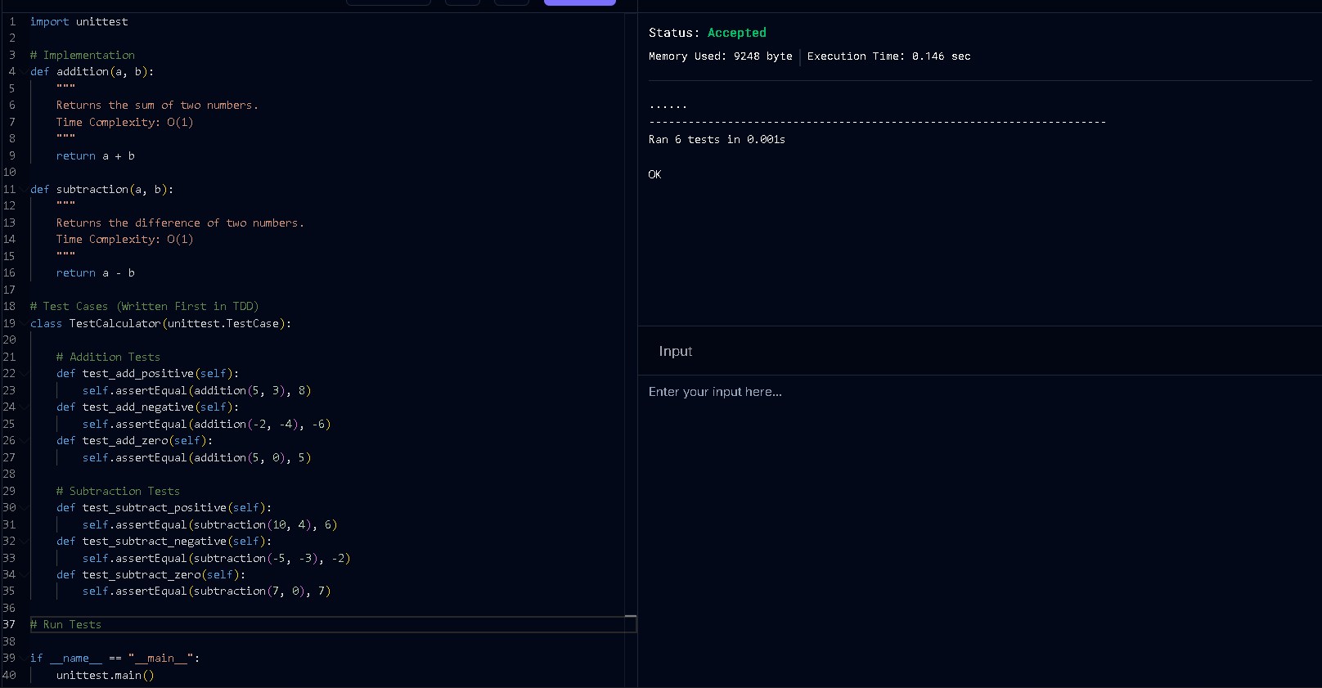

Task Description -4 (Data Structures – Queue Implementation with AI Assistance)
Task: Use AI assistance to generate a Python program that implements a Queue data structure.
Instructions:
➢ Prompt AI to create a Queue class with the following methods:
• enqueue(element)
• dequeue()
• front()
• is_empty()
➢ Handle queue overflow and underflow conditions.
➢ Include appropriate docstrings for all methods.

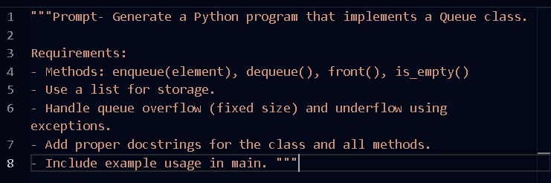
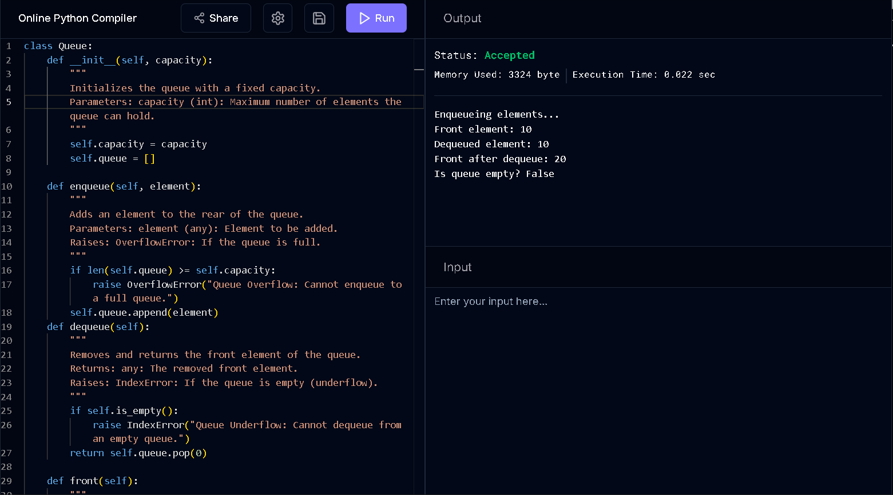

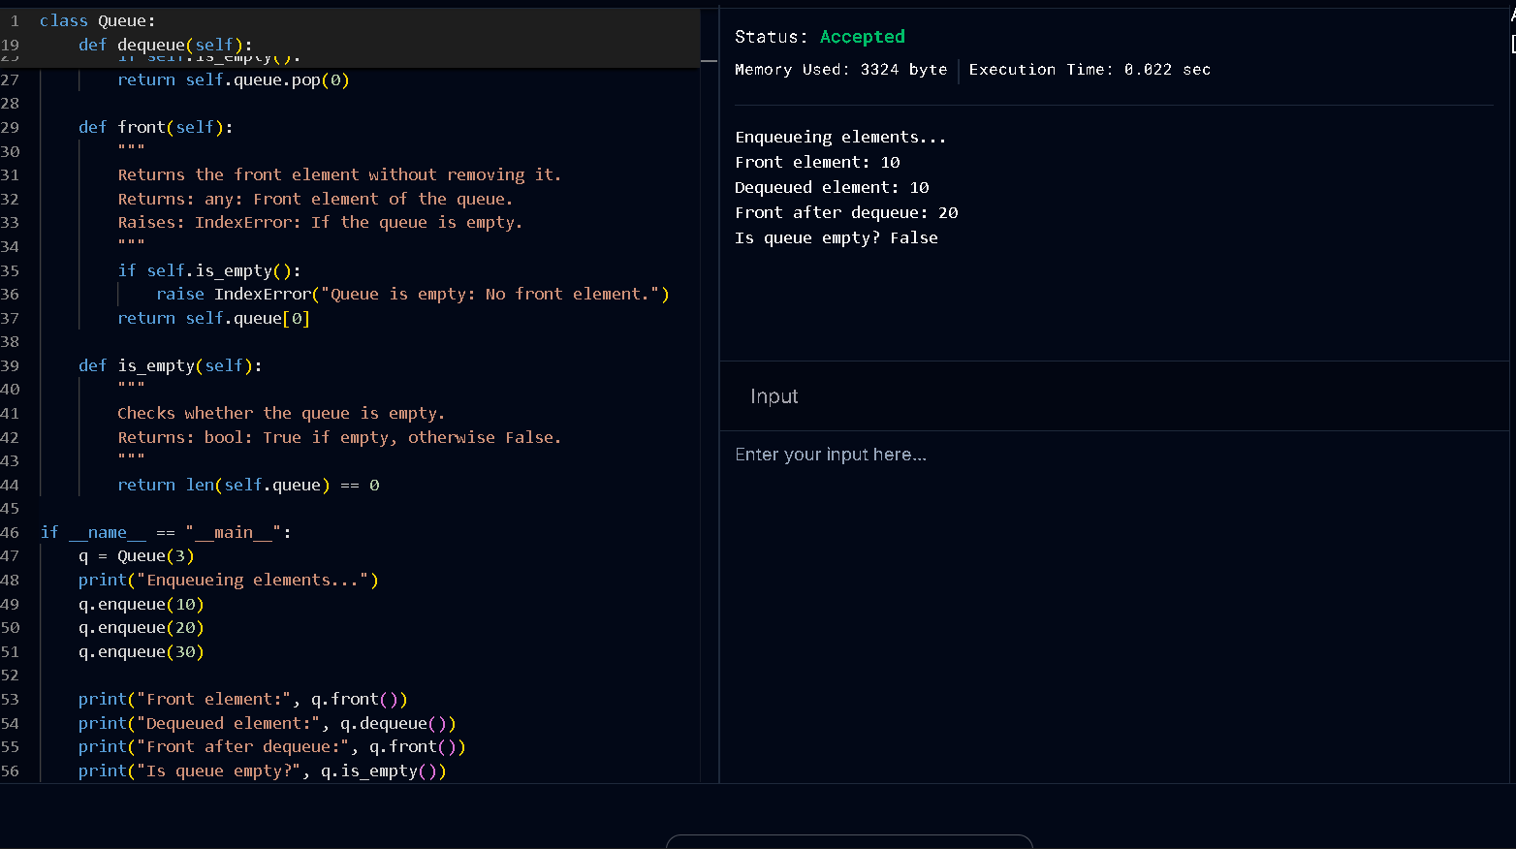

Task Description -5 (Algorithms – Bubble Sort vs Selection Sort)
➢ Task:
Use AI to implement Bubble Sort and Selection Sort algorithms and compare their behavior.
Instructions:
➢ Prompt AI to generate:
• bubble_sort(arr)
• selection_sort(arr)
➢ Include comments explaining each step.
➢ Add docstrings mentioning time and space complexity.

