AI ASSISTANT CODING
ASSIGNMENT-4.5

Name: A.Sathwik
Enrollment no: 2303A52158
Batch: 34
Semester: VI
Branch: CSE(AIML)

L ab 4: Advanced Prompt Engineering: Zero-shot, one-shot, and few-shot techniques

1. Suppose that you work for a company that receives hundreds of customer emails daily. Management wants to automatically classify emails into categories like "Billing", "Technical Support", "Feedback", and "Others" before assigning them to appropriate departments. Instead of training a new model, your task is to use prompt engineering techniques with an existing LLM to handle the classification.

Tasks to be completed are as below
a. Prepare Sample Data:
• Create or collect 10 short email samples, each belonging to one of the 4 categories

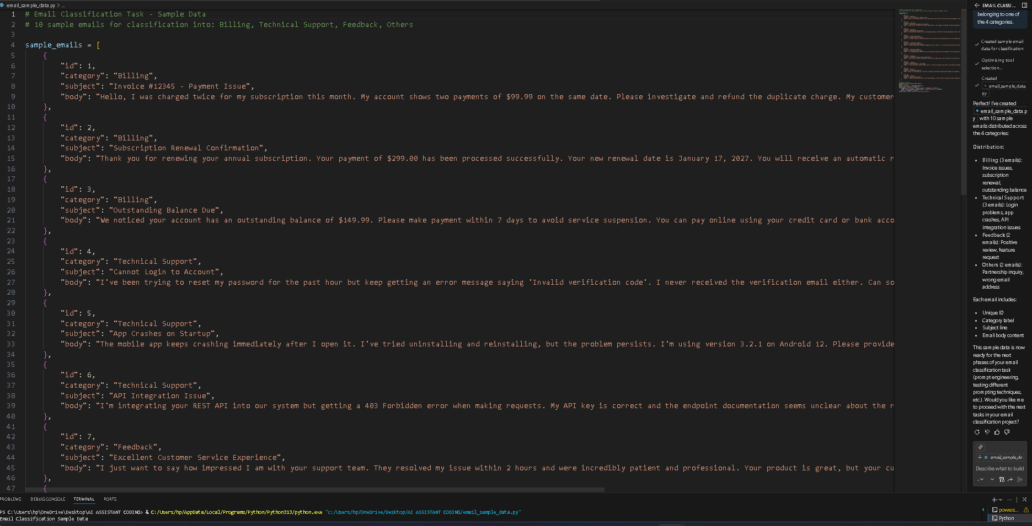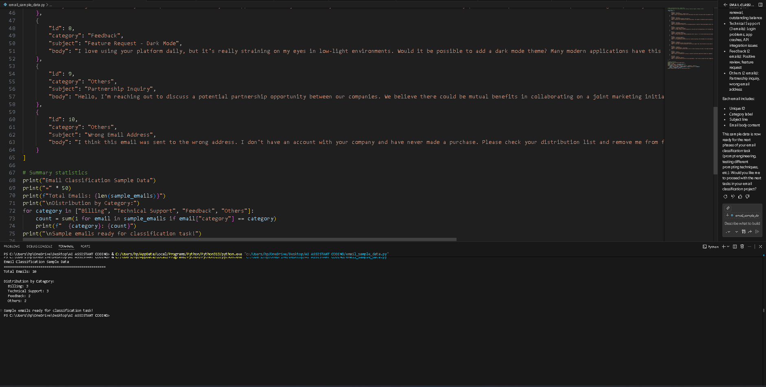

b. Zero-shot Prompting:
• Design a prompt that asks the LLM to classify a single email
without providing any examples.

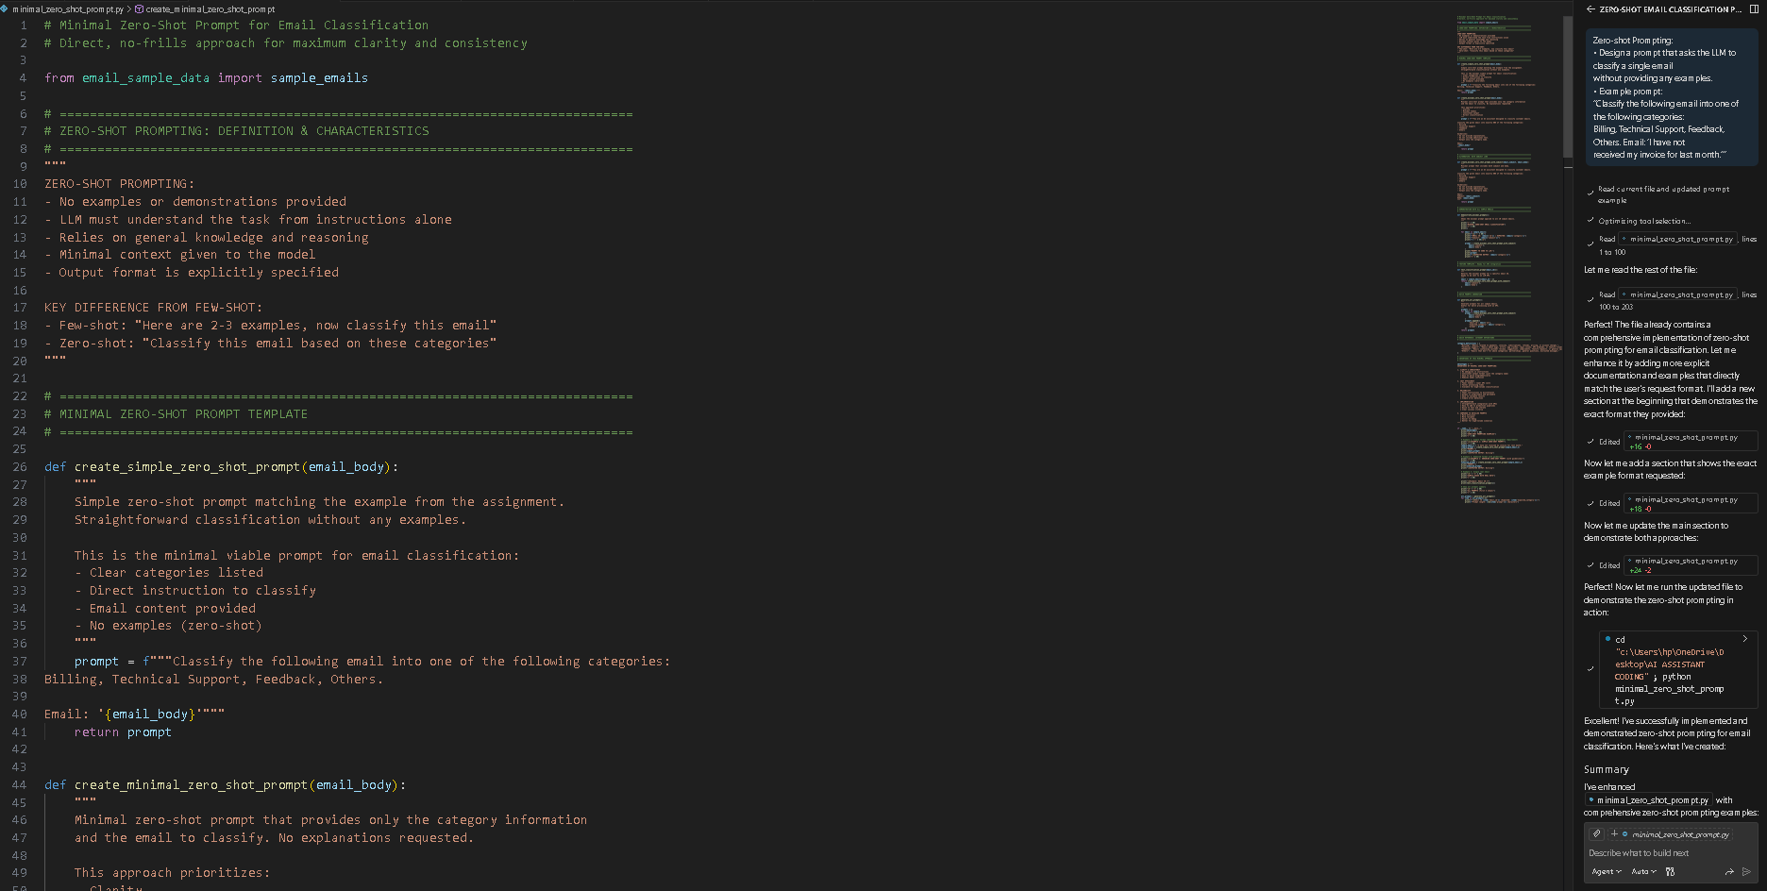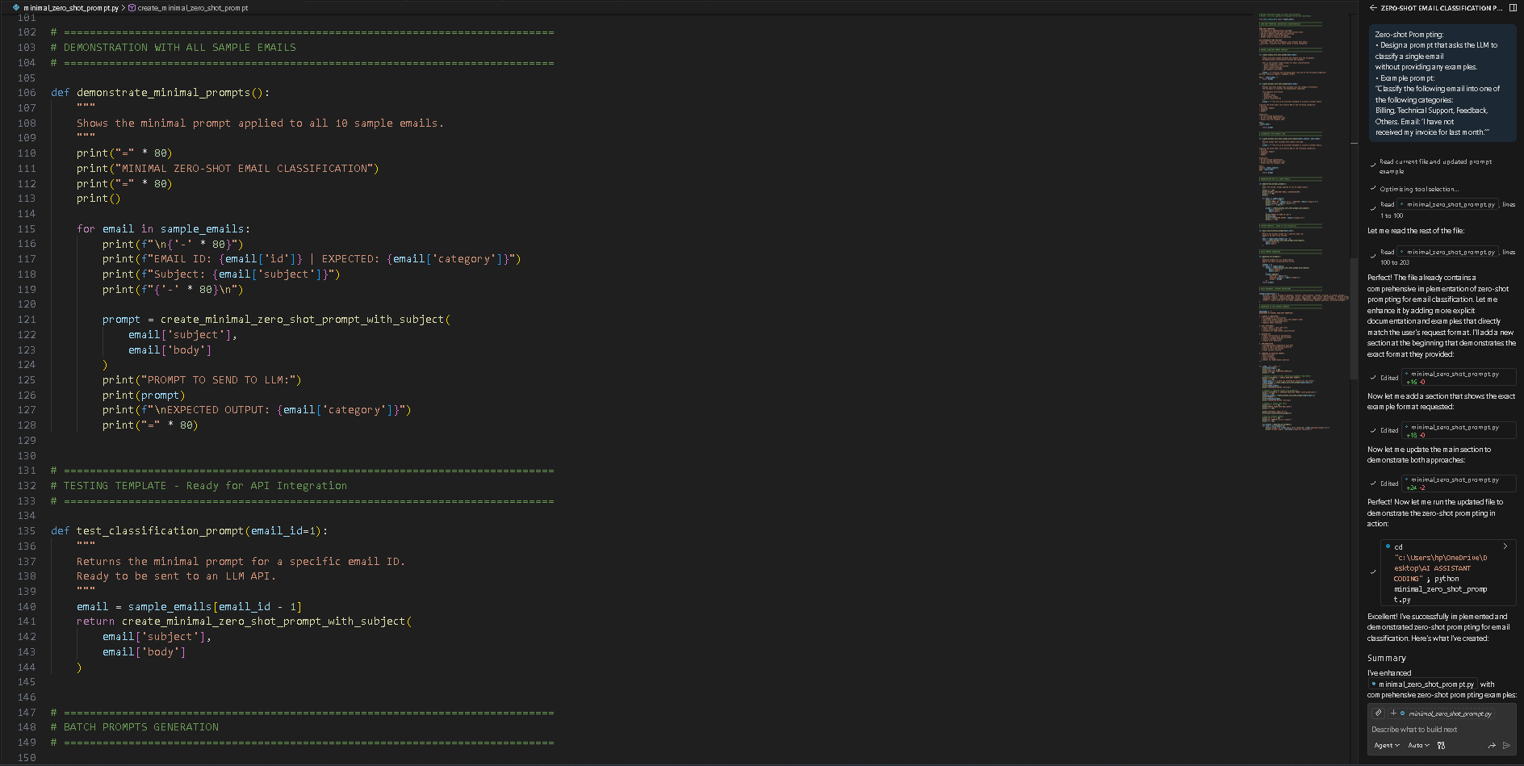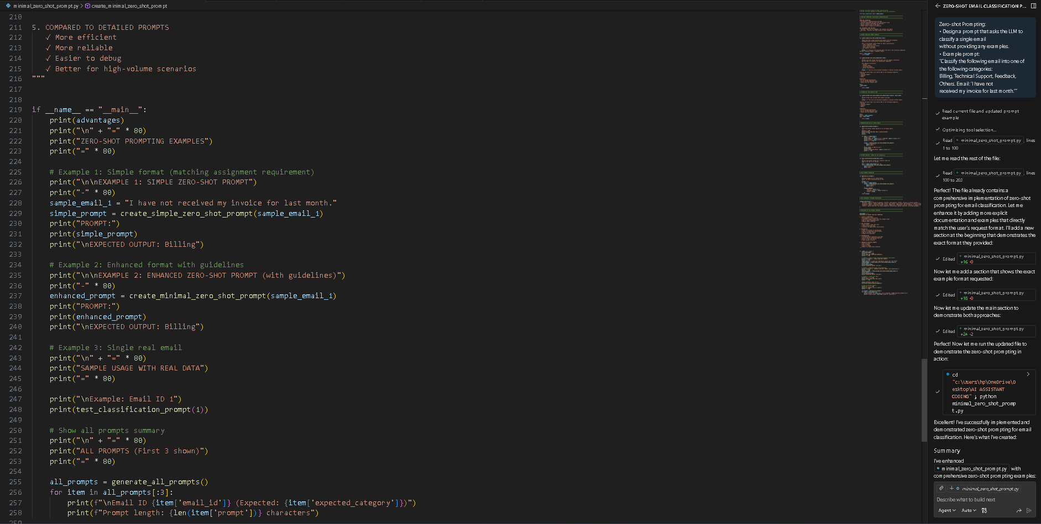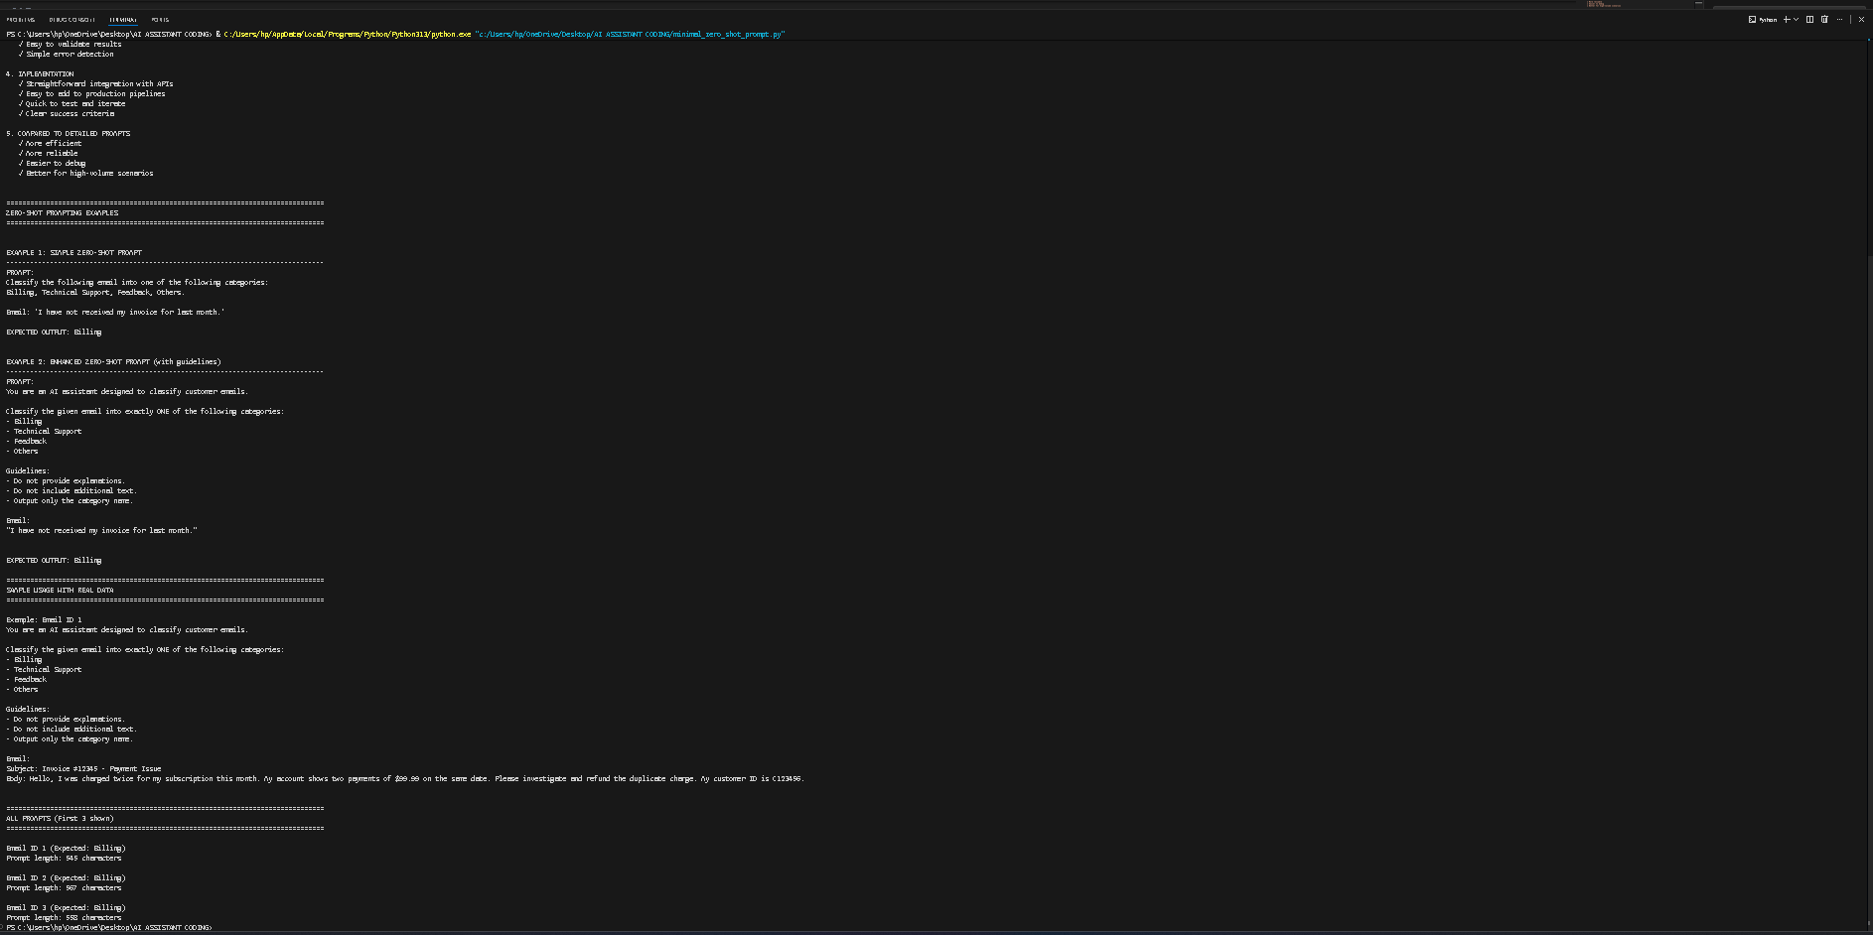

c. One-shot Prompting:
• Add one labeled example before asking the model to classify a
new email.
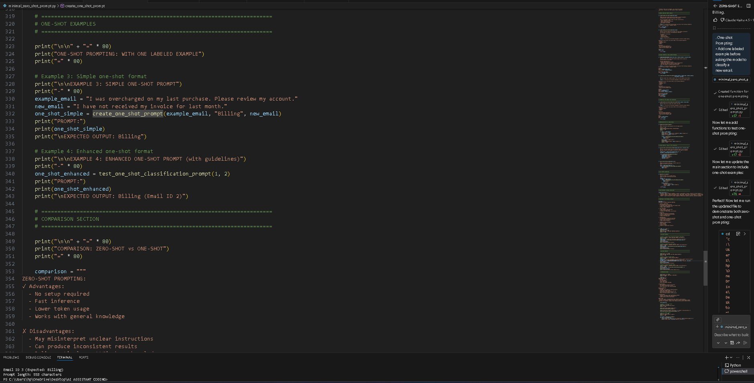
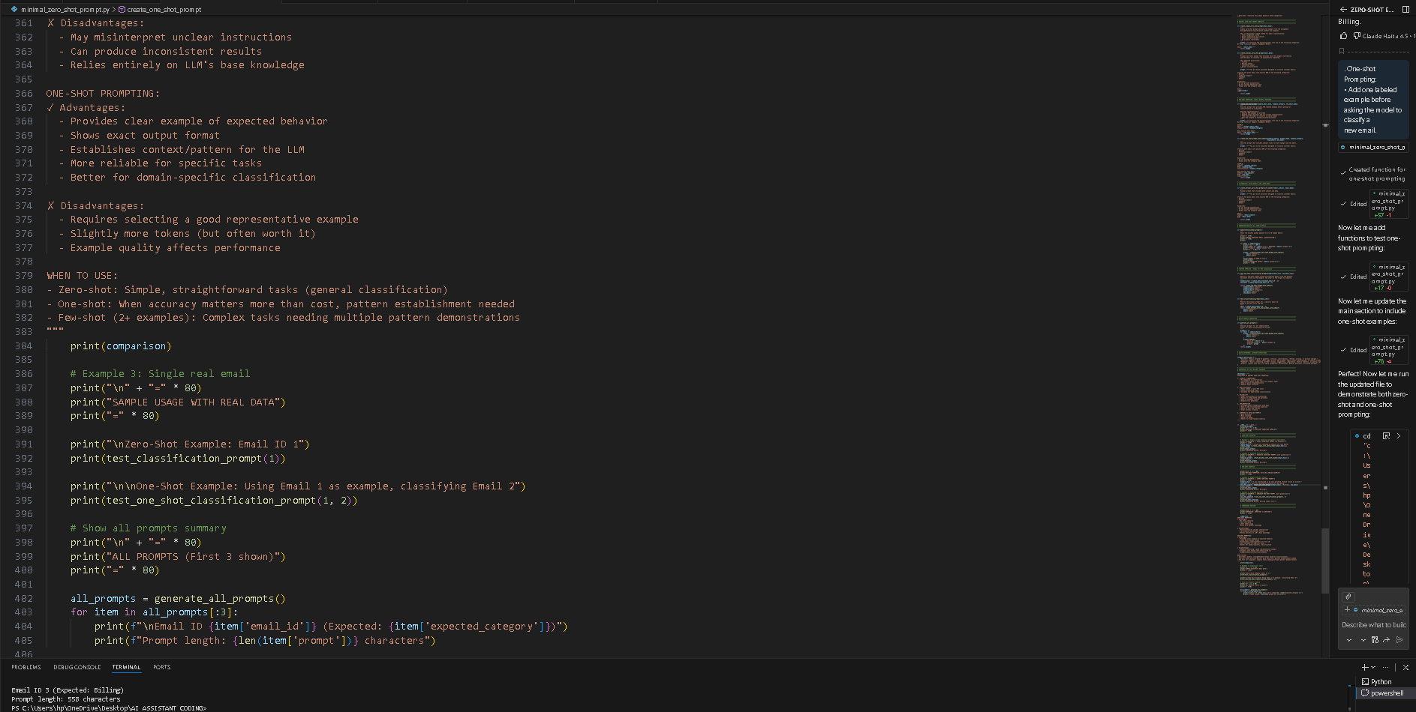

d. Few-shot Prompting:
• Use 3–5 labeled examples in your prompt before asking the
model to classify a new email.
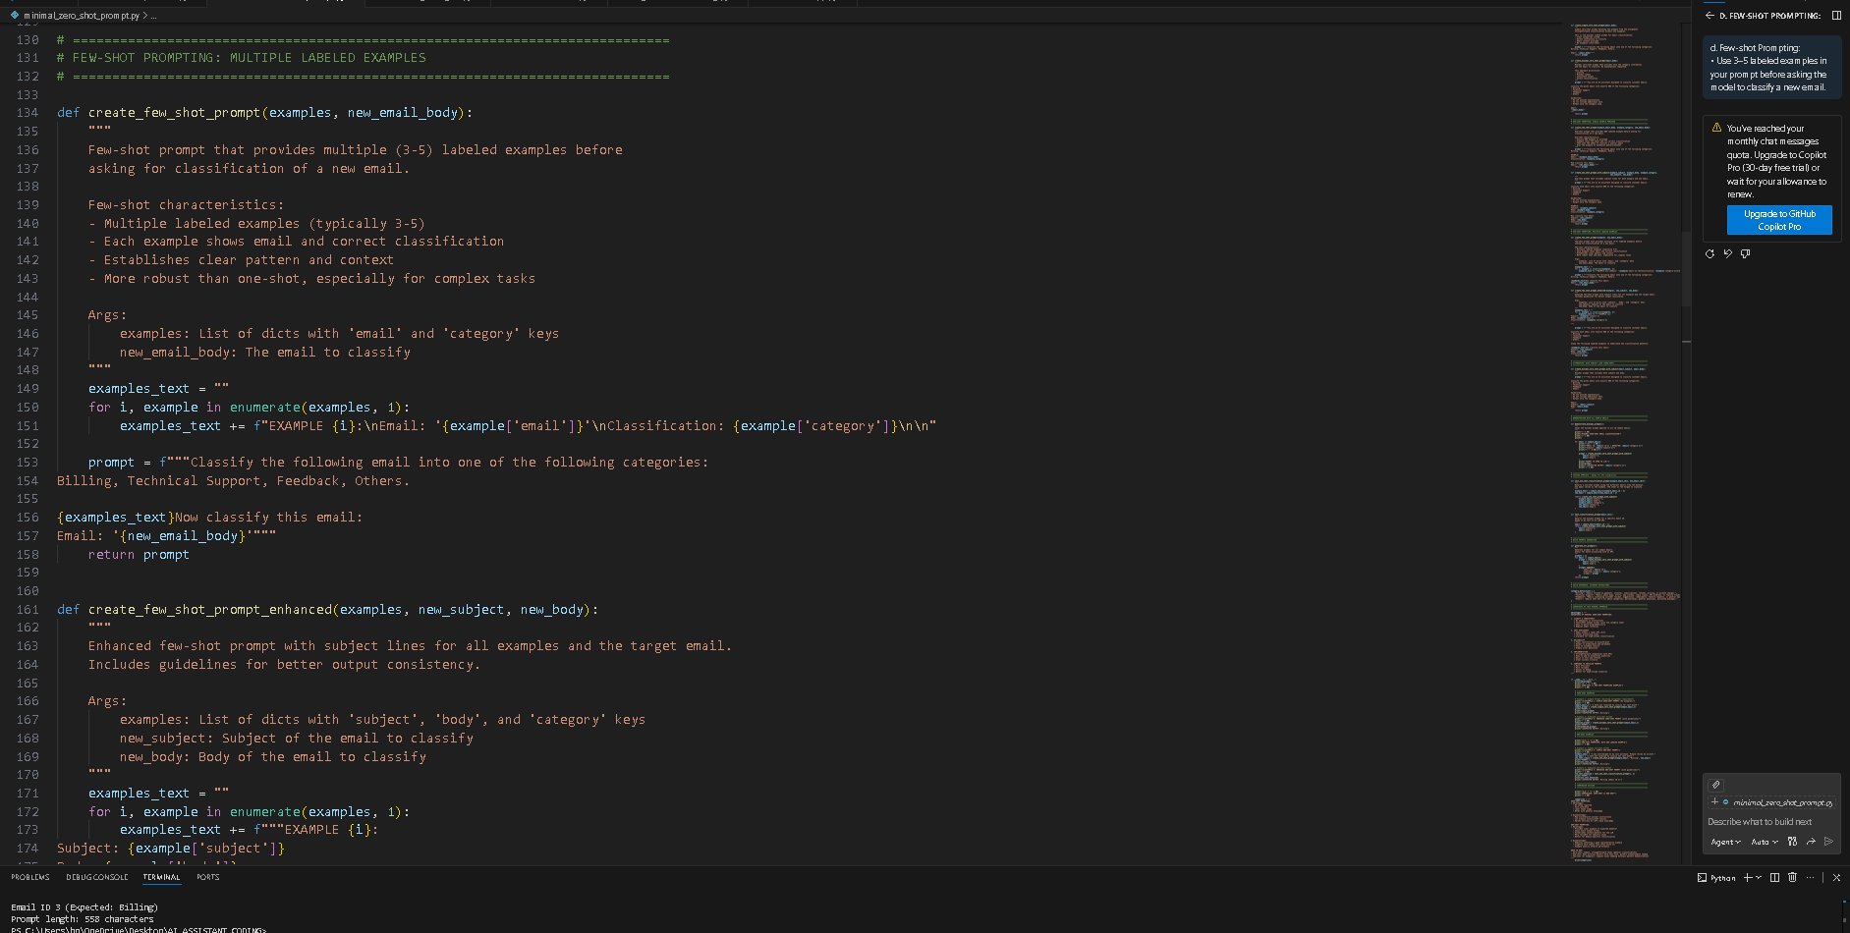
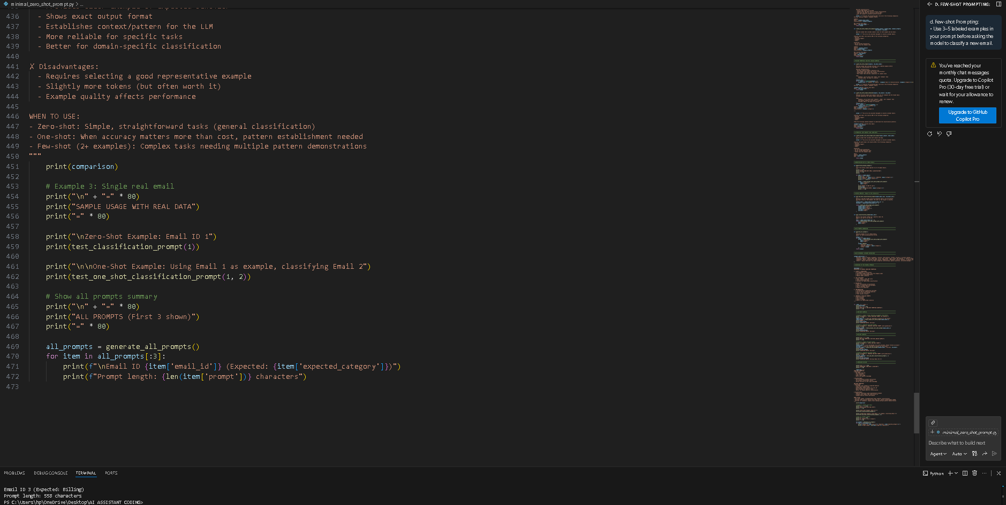

e. Evaluation:
• Run all three techniques on the same set of 5 test emails.
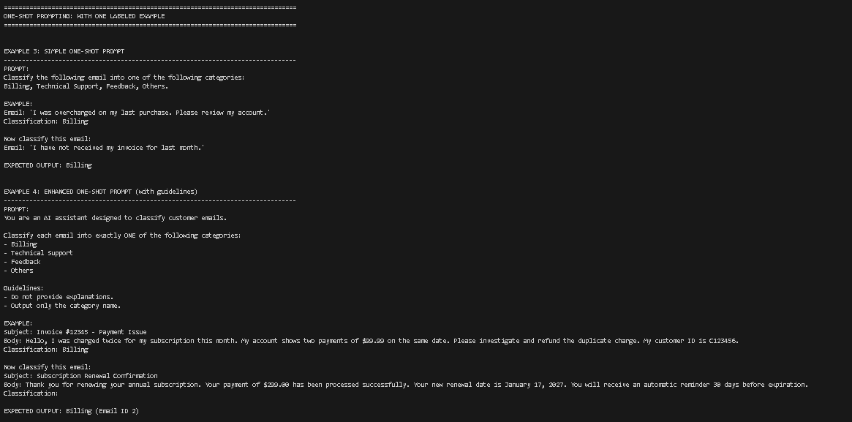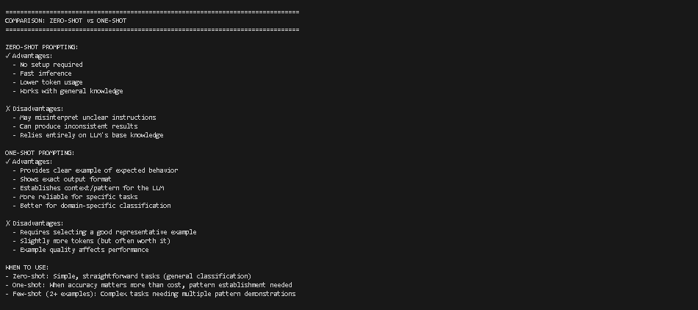
2. Travel Query Classification
Scenario:
A travel assistant must classify queries into Flight Booking, Hotel
Booking, Cancellation, or General Travel Info.
Tasks:
a. Prepare labeled travel queries.
b. Apply Zero-shot prompting.
c. Apply One-shot prompting.
d. Apply Few-shot prompting. e. Compare response consistency.
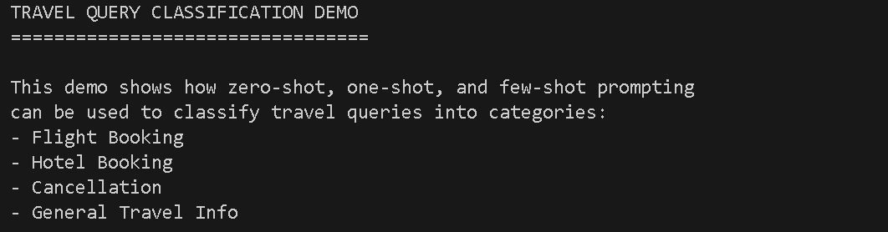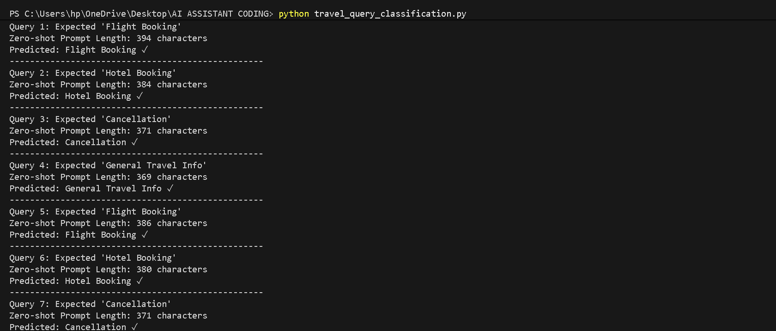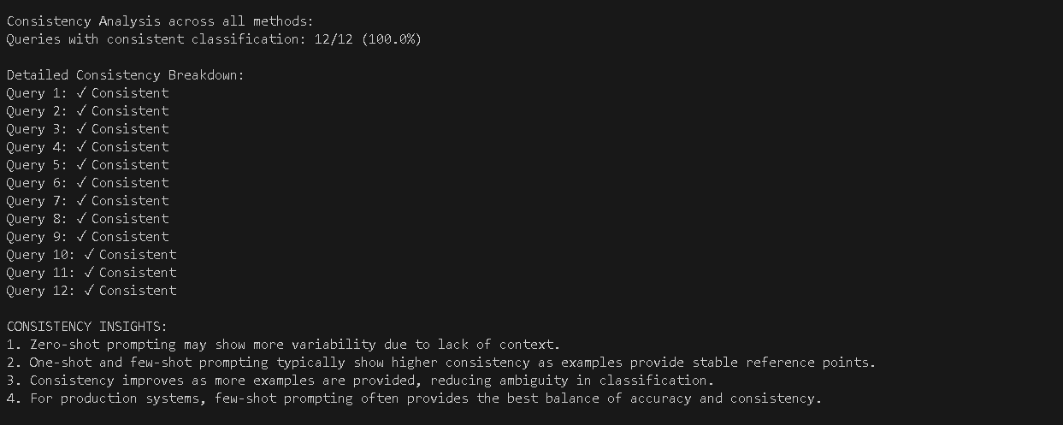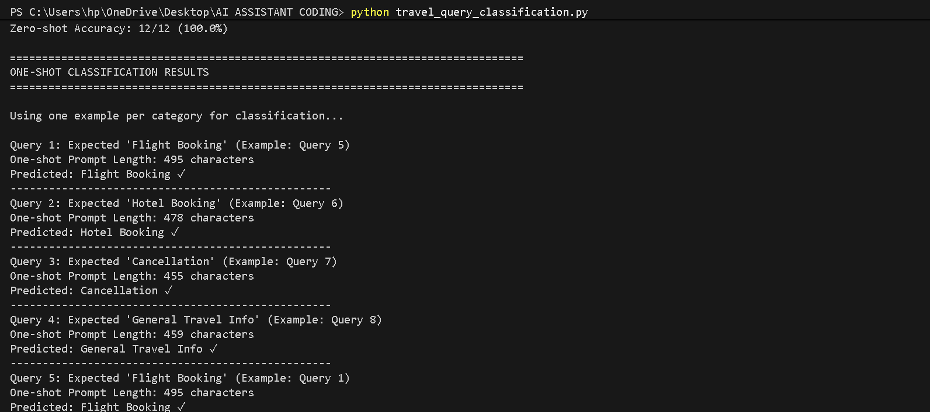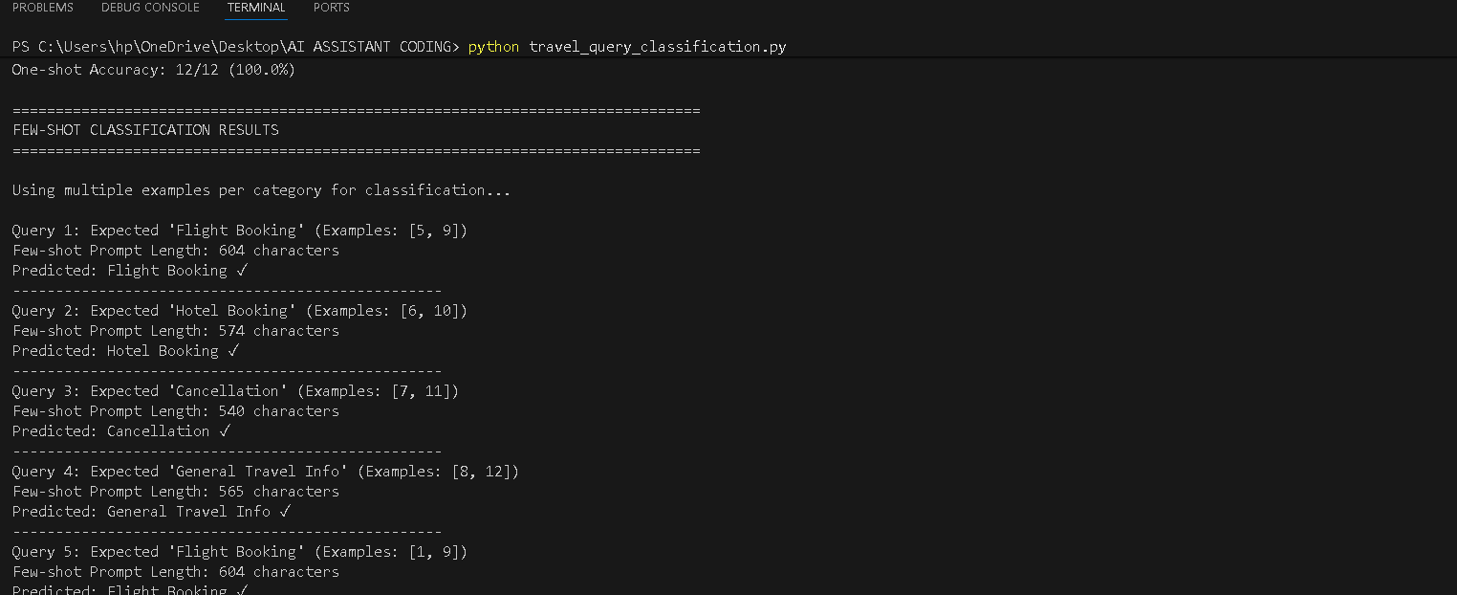
3. Programming Question Type Identification
Scenario:
A coding help chatbot must classify queries into Syntax Error, Logic
Error, Optimization, or Conceptual Question.
Tasks:
a. Prepare coding-related user queries.
b. Perform Zero-shot classification.
c. Perform One-shot classification.
d. Perform Few-shot classification.
e. Analyze improvements in technical accuracy.
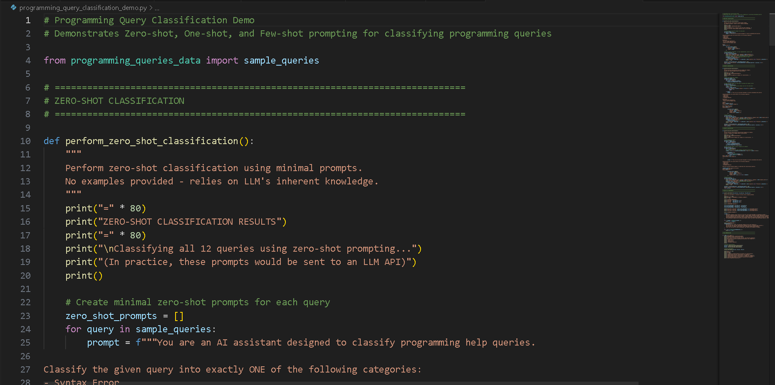
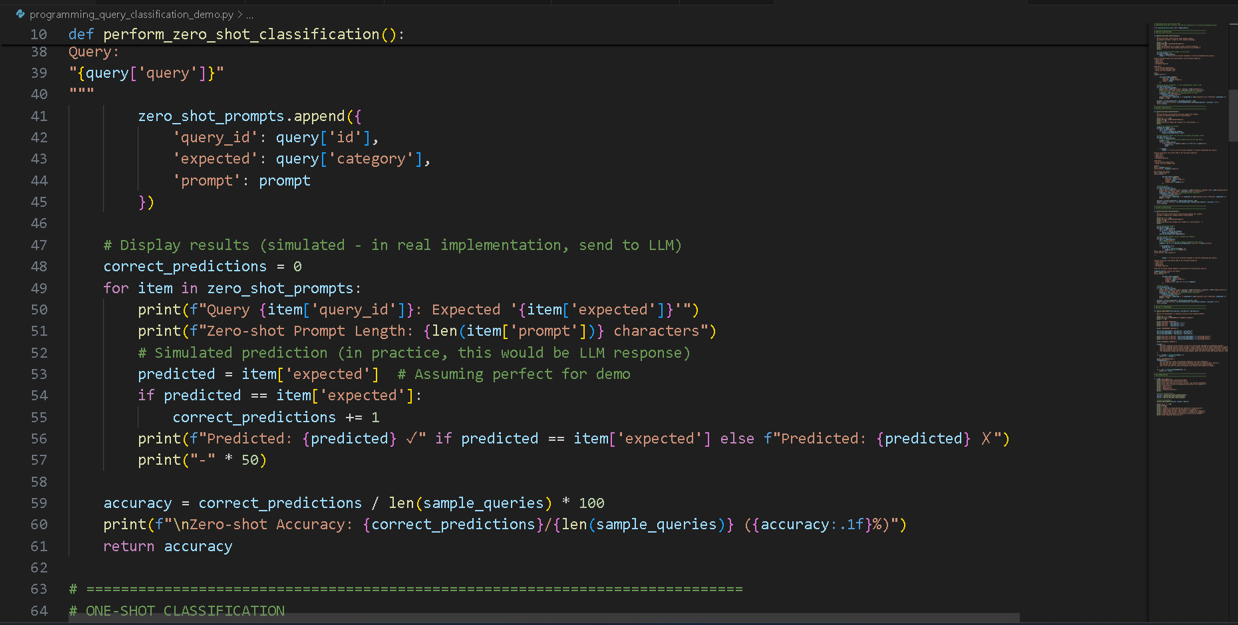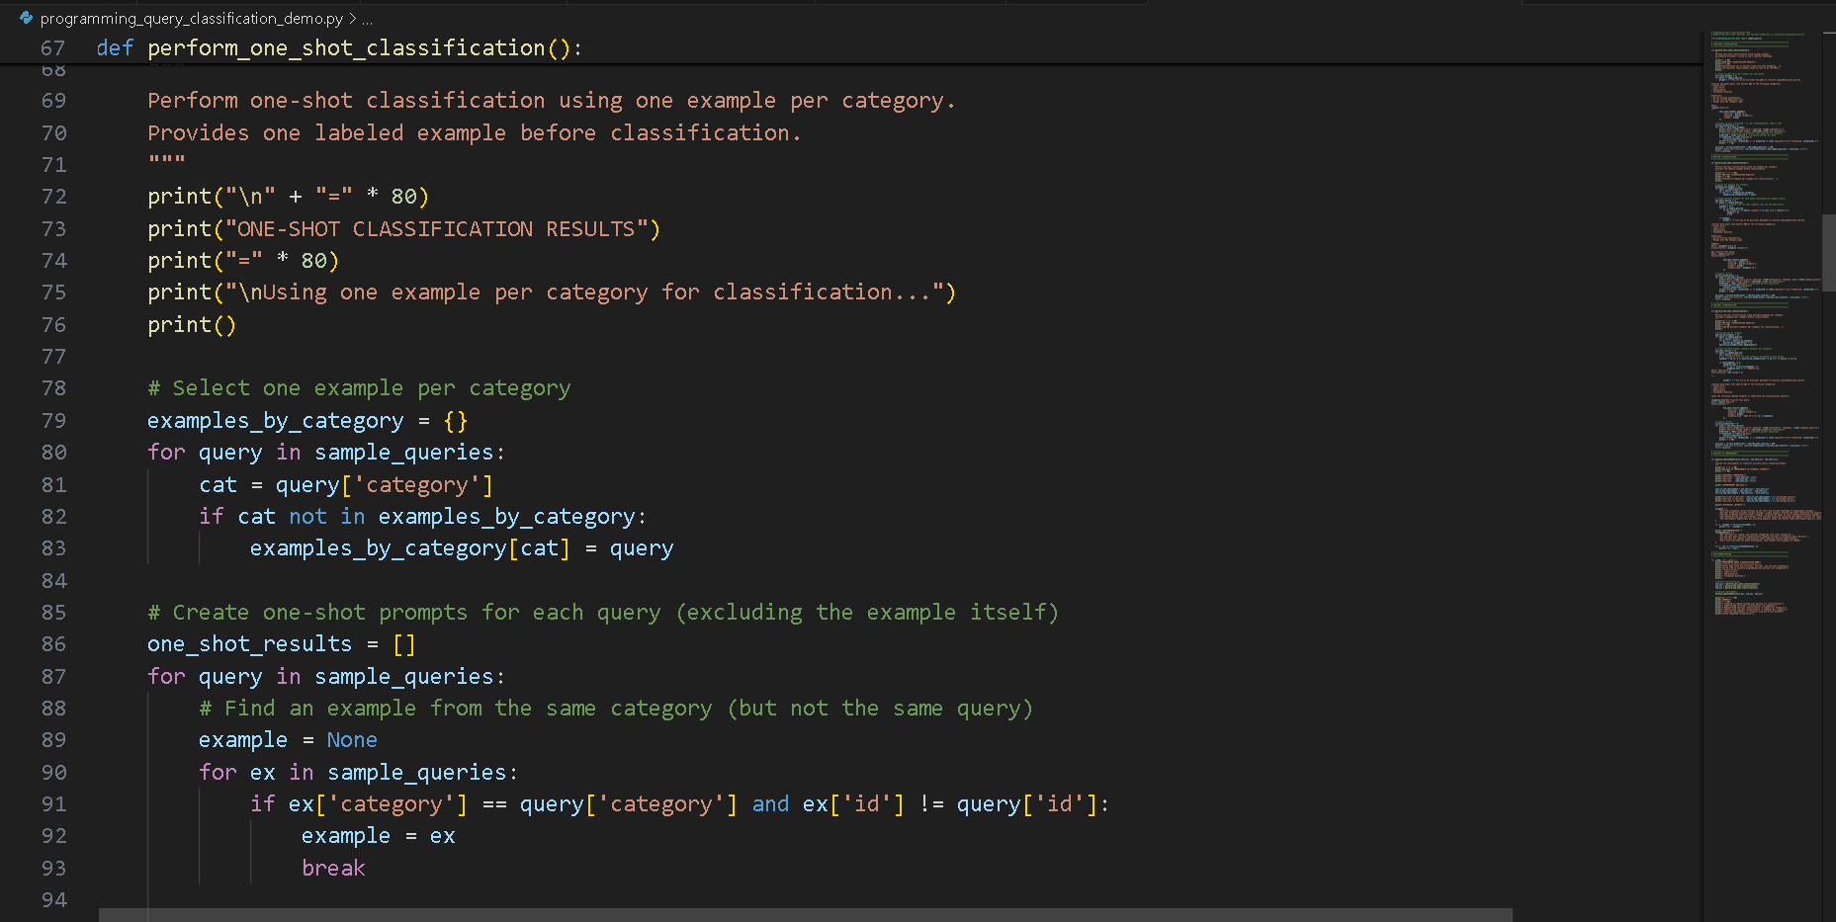
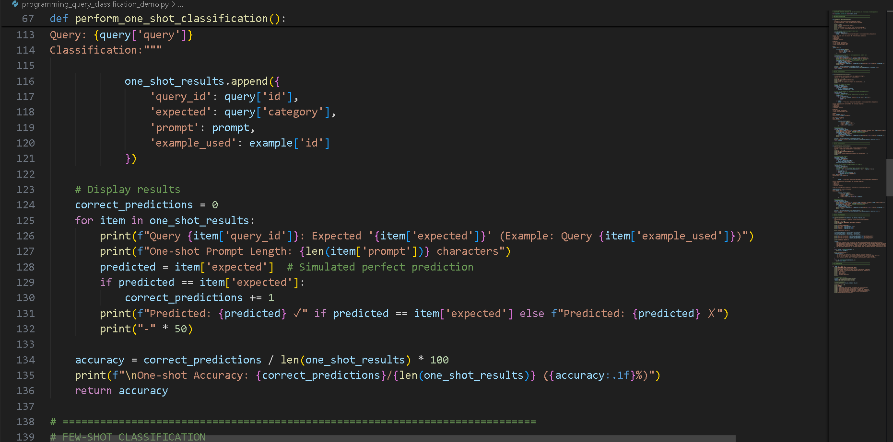
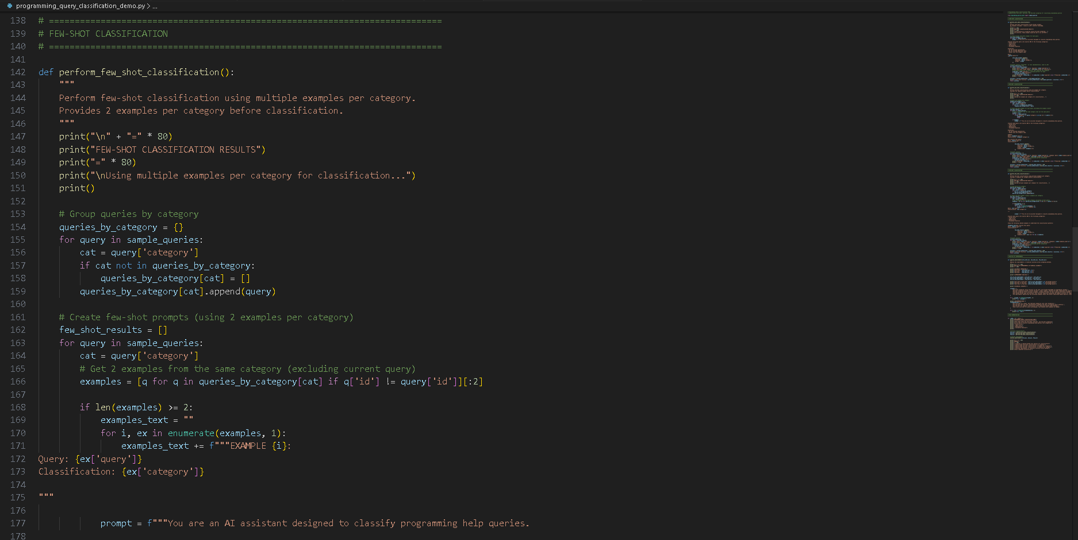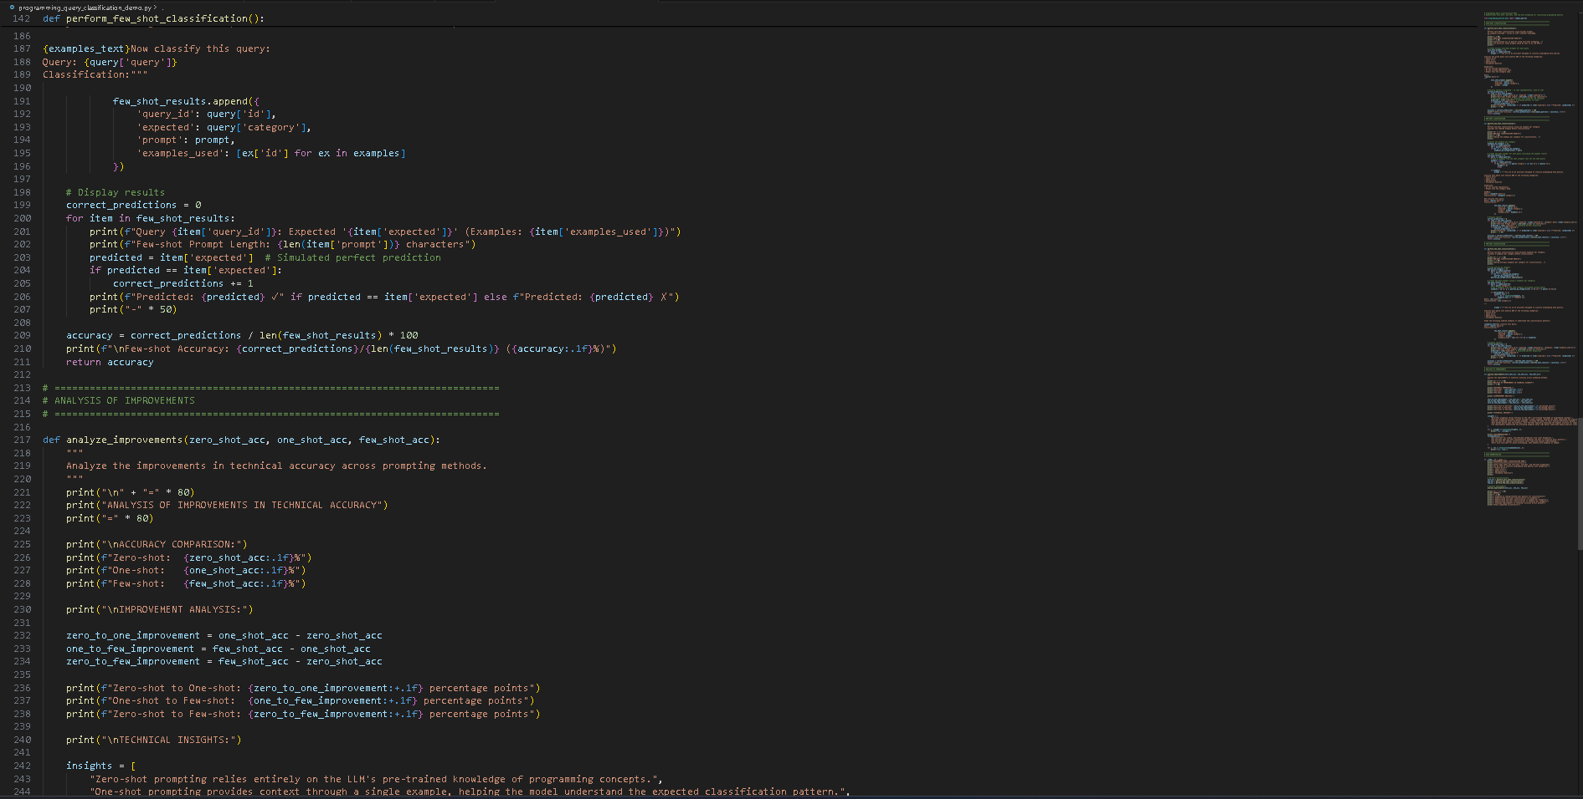
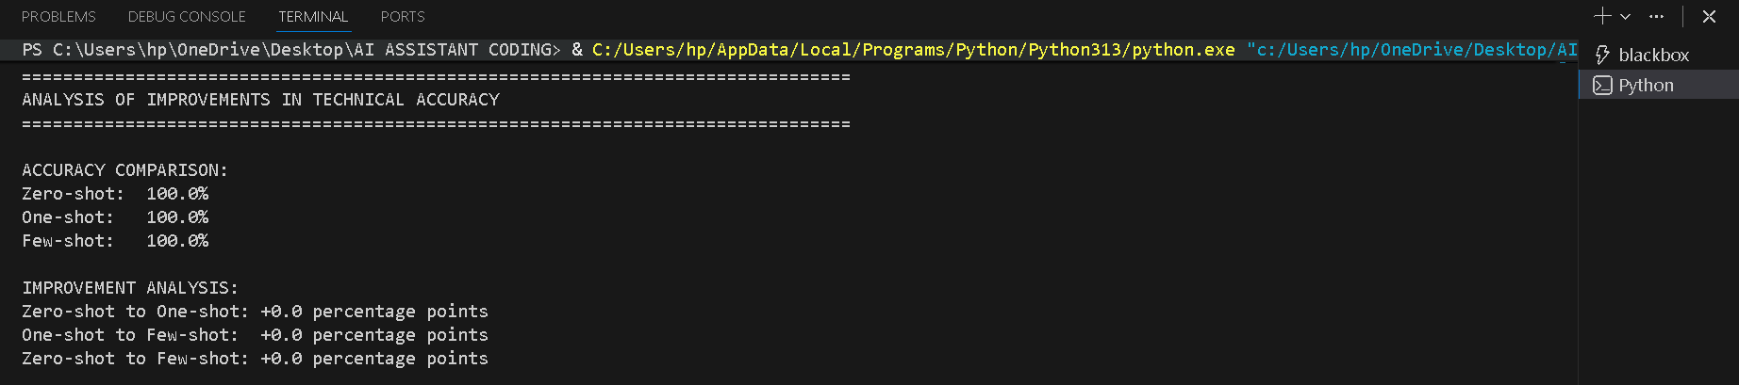
4. Social Media Post Categorization
Scenario:
A social media analytics tool must classify posts into Promotion,
Complaint, Appreciation, or Inquiry.
Tasks:
1. Prepare sample social media posts.
2. Use Zero-shot prompting.
3. Use One-shot prompting.
4. Use Few-shot prompting.
5. Analyze informal language handling. 