AI ASSISTANT CODING
ASSIGNMENT-4.2

Name: A.Sathwik
Enrollment no: 2303A52158
Batch: 34
Semester: VI
Branch: CSE(AIML)

Lab 4: Advanced Prompt Engineering – Zero-shot, One-shot, and Few-shot Techniques
Task Description-1
• Zero-shot: Prompt AI with only the instruction. Write a Python function to determine whether a given number is prime
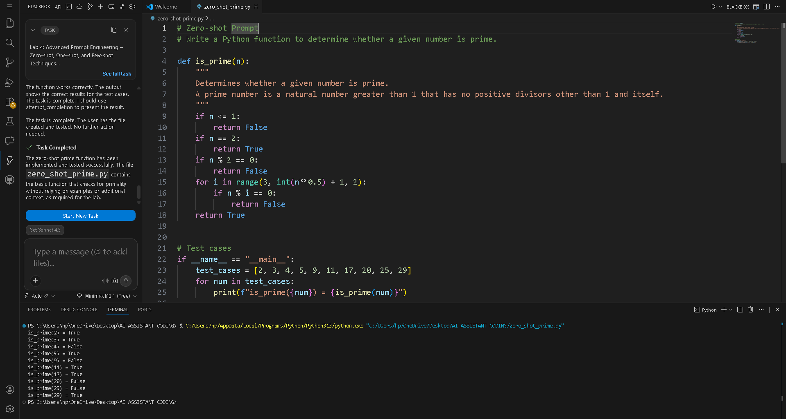

Task Description-2
• One-shot: Provide one example: Input: [1, 2, 3, 4], Output: 10 to help AI generate a function that calculates the sum of elements in a list.
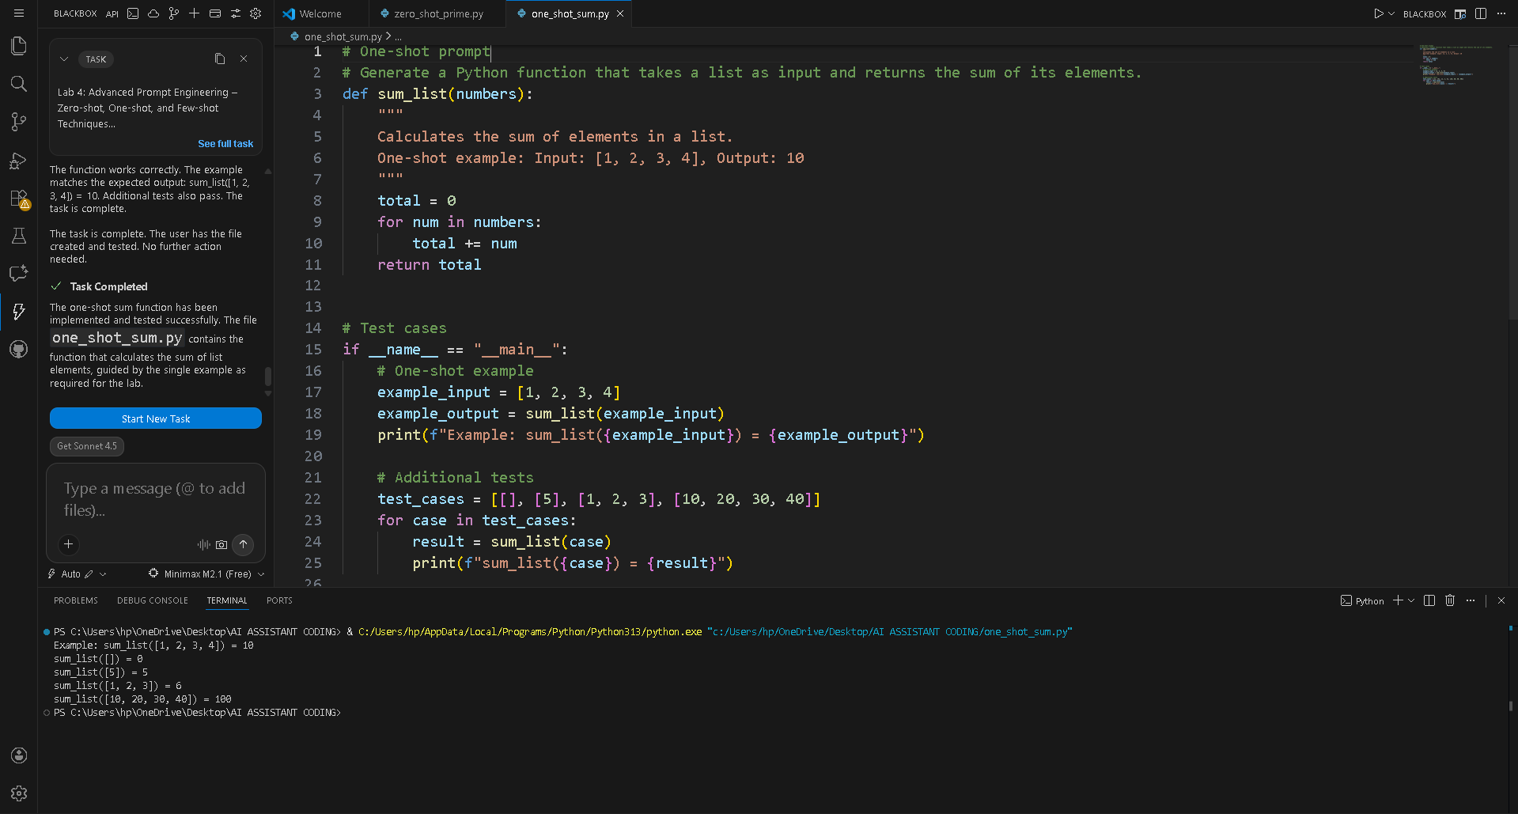

Task Description-3
• Few-shot: Give 2–3 examples to create a function that extracts digits from an alphanumeric string.
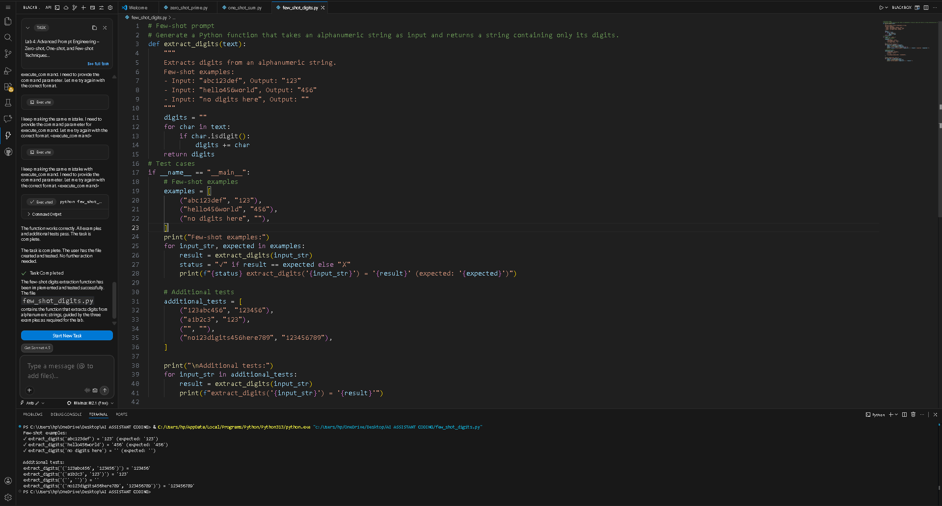
Task Description-4
• Compare zero-shot vs few-shot prompting for generating a function that counts the number of vowels in a string.
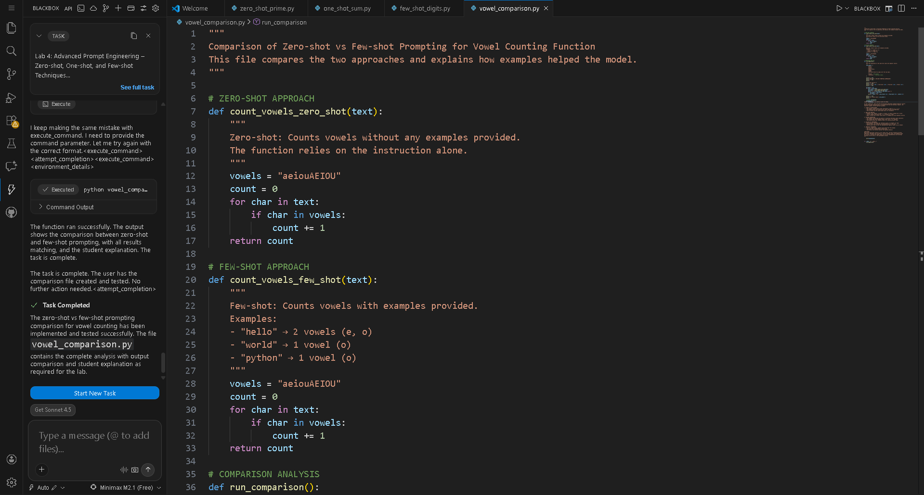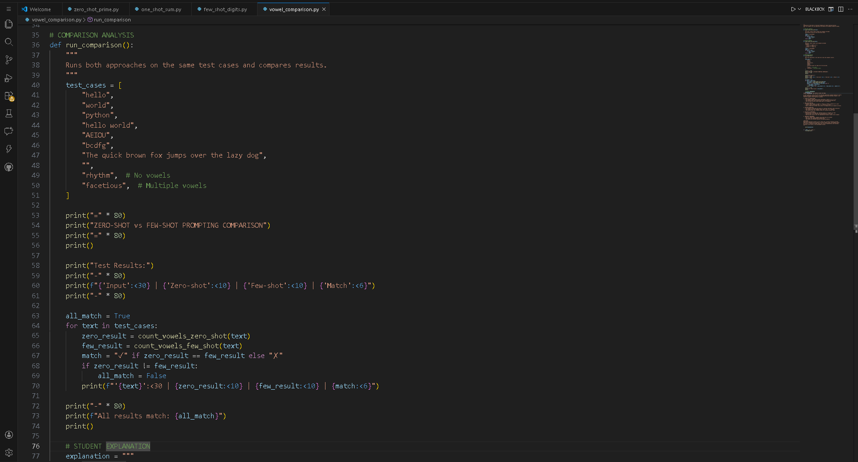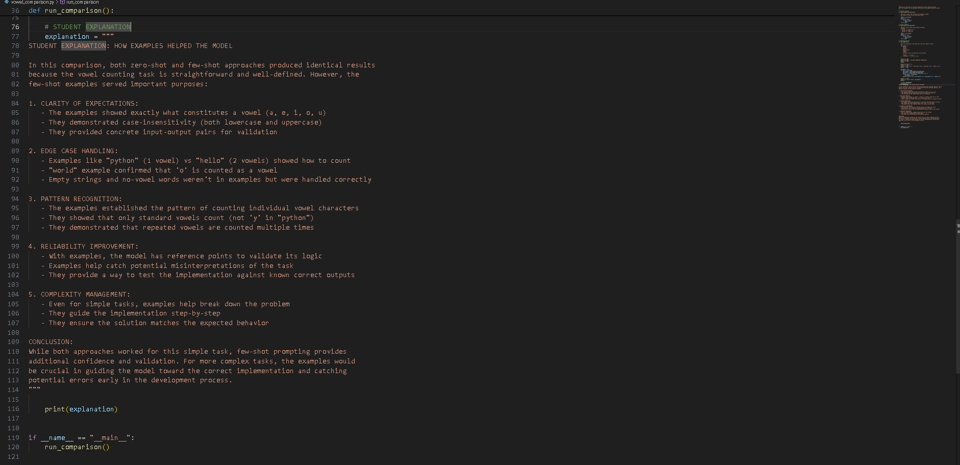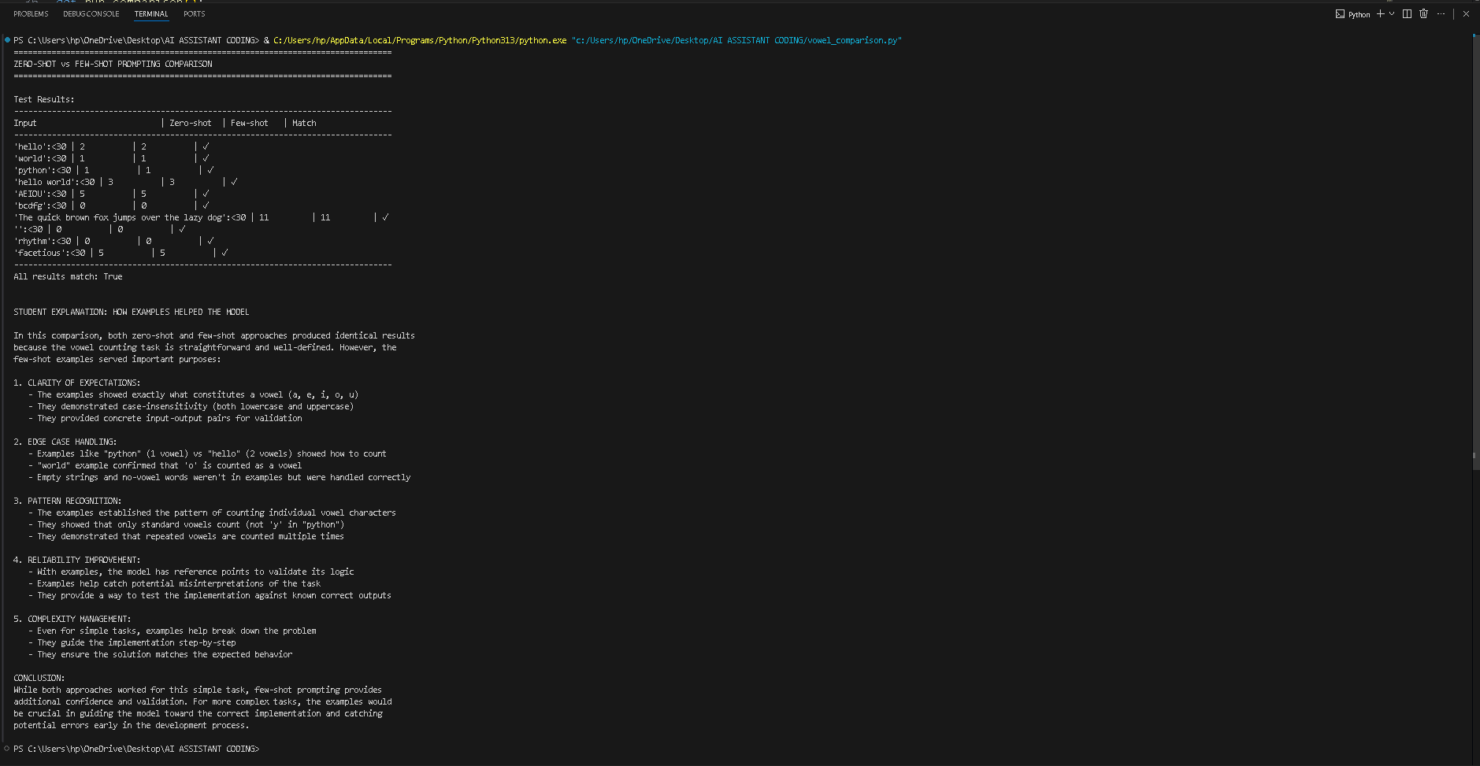
Task Description-5
• Use few-shot prompting with 3 sample inputs to generate a function that determines the minimum of three numbers without using the built-in min() function. 