AI ASSISTANT CODING
ASSIGNMENT-6.5

Name: A.Sathwik
Enrollment no: 2303A52158
Batch: 34
Semester: VI
Branch: CSE(AIML)

Experiment 6: AI-Based Code Completion: Working with suggestions for classes, loops, conditionals

Task Description #1 (AI-Based Code Completion for Conditional Eligibility Check)
Task: Use an AI tool to generate eligibility logic.
Prompt: “Generate Python code to check voting eligibility based on age and citizenship.”
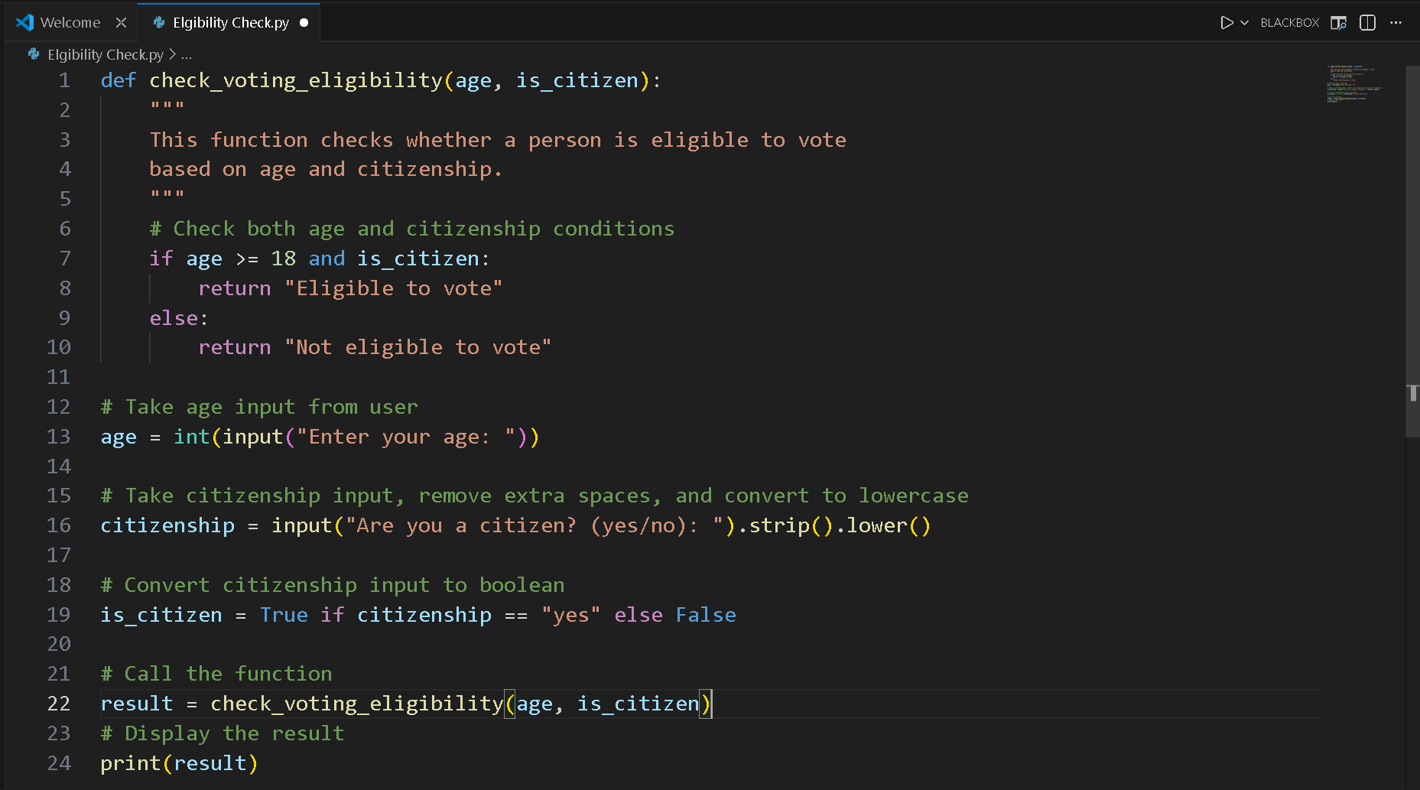
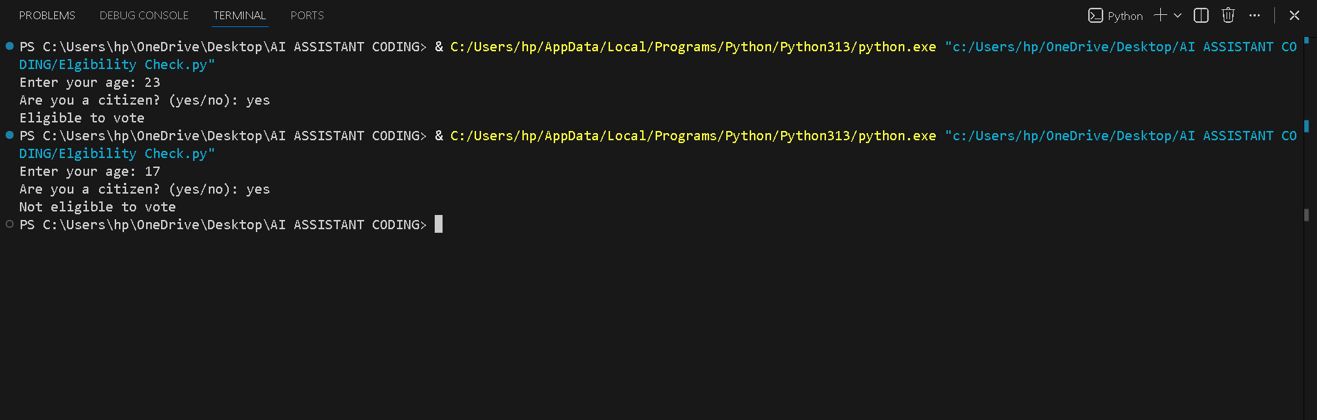
Condition 1: Age Check (age >= 18)
- The person must be 18 years or older to vote.
- If age is less than 18, the person is not eligible, even if they are a citizen.
Condition 2: Citizenship Check (is_citizen)
- The person must be a citizen to vote.
- The user enters "yes" or "no", which is converted into a Boolean value:
  - "yes" → True
  - "no" → False
Decision Outcome
- If both conditions are true → "Eligible to vote"
- If any condition is false → "Not eligible to vote"

Task Description #2(AI-Based Code Completion for Loop-Based String Processing)
Task: Use an AI tool to process strings using loops.
Prompt:
“Generate Python code to count vowels and consonants in a string
using a loop.”
Expected Output:
• AI-generated string processing logic.
• Correct counts.
• Output verification.
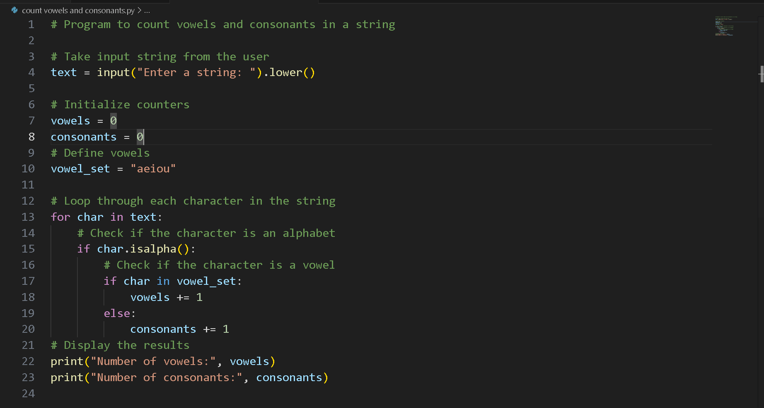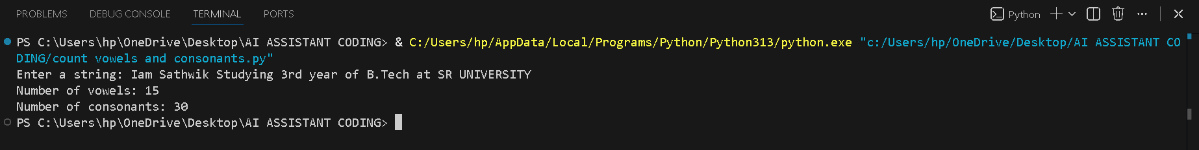

Task Description #3 (AI-Assisted Code Completion Reflection Task)
Task: Use an AI tool to generate a complete program using classes, loops, and conditionals.
Prompt:
“Generate a Python program for a library management system
using classes, loops, and conditional statements.”

1) Review of AI suggestions quality.
The AI suggestions are accurate and reliable. The generated code effectively uses classes, loops, and conditional statements to build a functional library management system. The logic is clear, well-structured, and easy to understand, making the solution suitable for beginners and academic use.

2) Short reflection on AI-assisted coding experience.
AI-assisted coding helped in developing the program efficiently by providing a clear structure and correct logic. It reduced the time required to write code and minimized errors during implementation. Reviewing the AI-generated solution improved understanding of object-oriented concepts, loops, and conditional statements, making the overall coding experience easier and more effective.
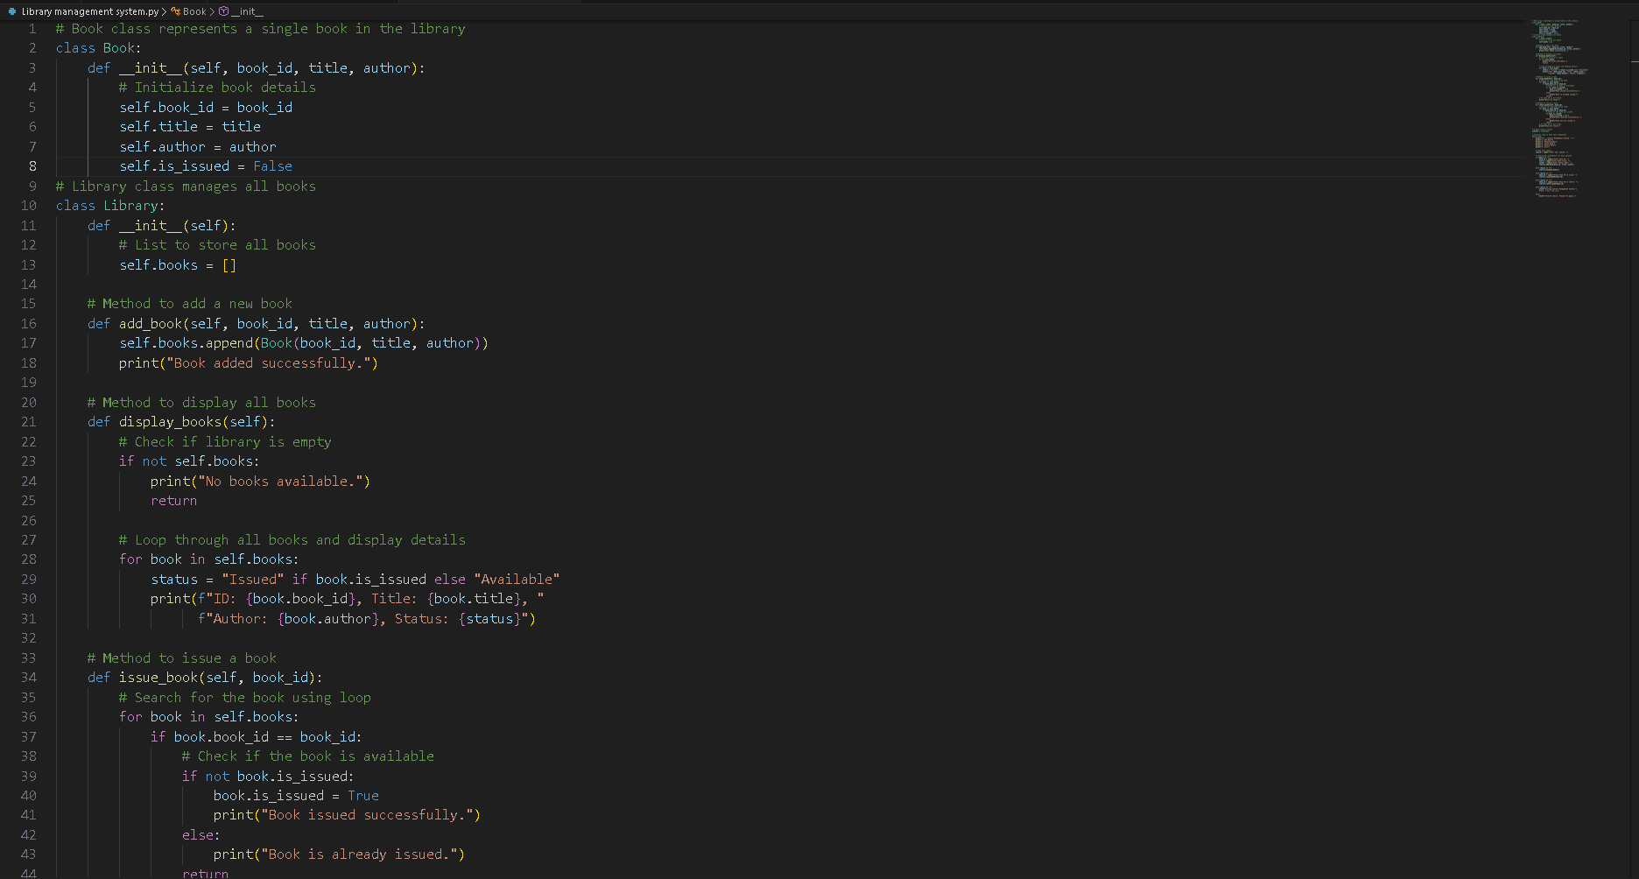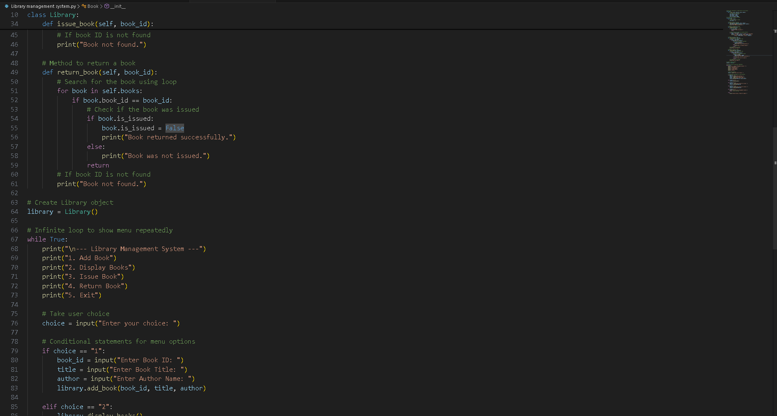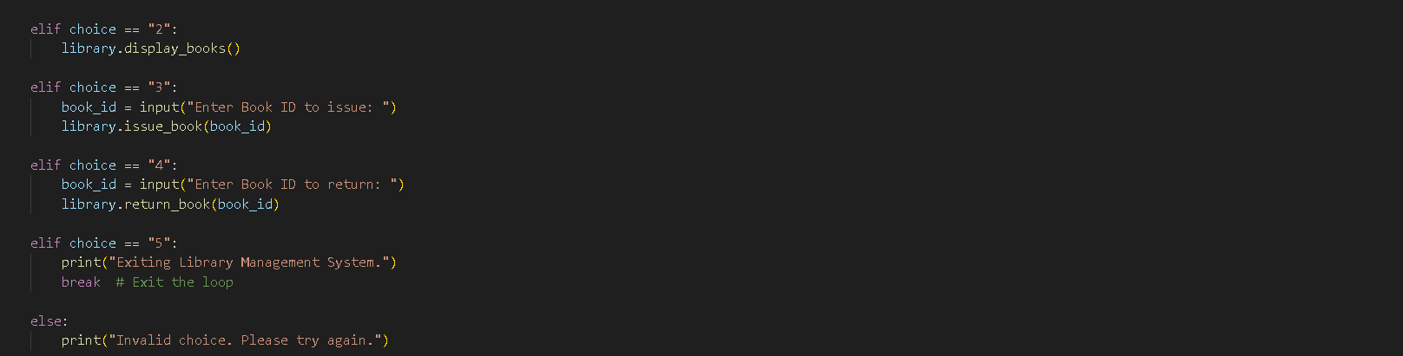
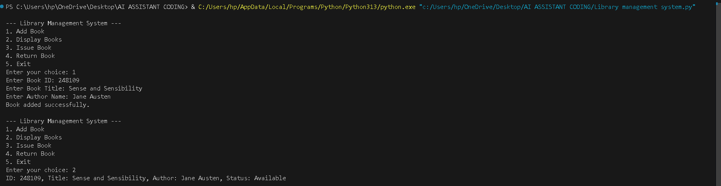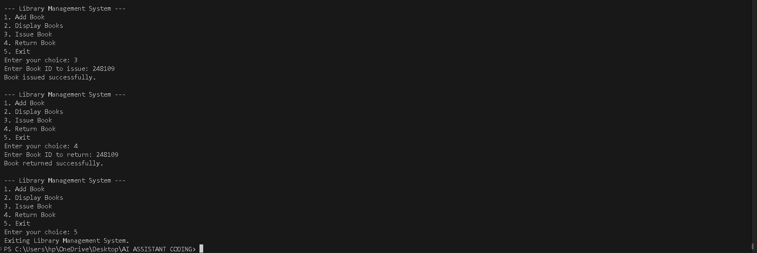

Task Description #4 (AI-Assisted Code Completion for Class- Based Attendance System)
Task: Use an AI tool to generate an attendance management class.
Prompt: “Generate a Python class to mark and display student
attendance using loops.”

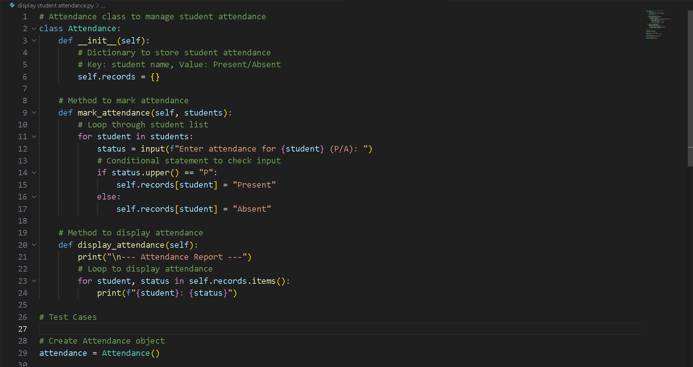
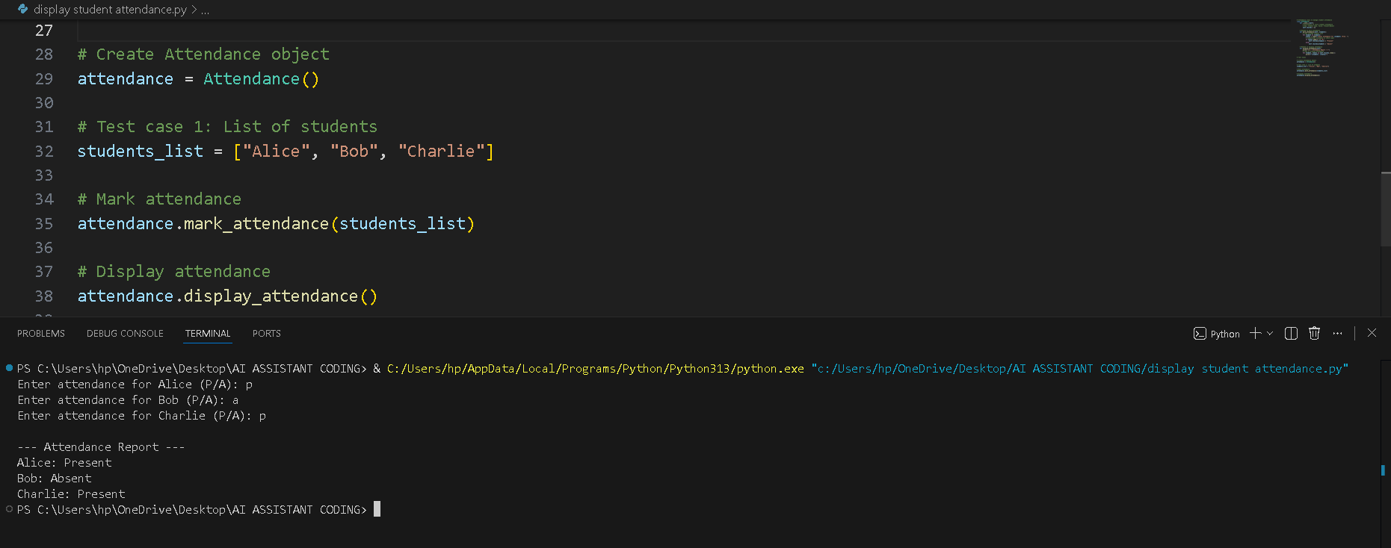

Task Description #5 (AI-Based Code Completion for Conditional Menu Navigation)
Task: Use an AI tool to complete a navigation menu.
Prompt: “Generate a Python program using loops and conditionals
to simulate an ATM menu.”
Expected Output:
• AI-generated menu logic.
• Correct option handling.
• Output verification.

