AI ASSISTANT CODING
ASSIGNMENT-17.2

Name: A.Sathwik
Enrollment no: 2303A52158
Batch: 34
Semester: VI
Branch: CSE(AIML)

Lab 17 – AI for Data Processing: Data Cleaning and Preprocessing Scripts
Task Description – 1(Student Academic Data Cleaning)
• Task: Use AI assistance to generate a Python script that cleans and prepares a student academic dataset for analysis.
Instructions:
• Handle missing values in marks, attendance, and department.
• Remove duplicate student records based on student ID.
• Standardize text fields such as department names.
• Encode categorical variables like gender and department.
Sample Code:
import pandas as pd
data = pd.read_csv("students.csv")
print(data.head())
Expected Output:
• A cleaned and encoded Pandas DataFrame suitable for academic
performance analysis.
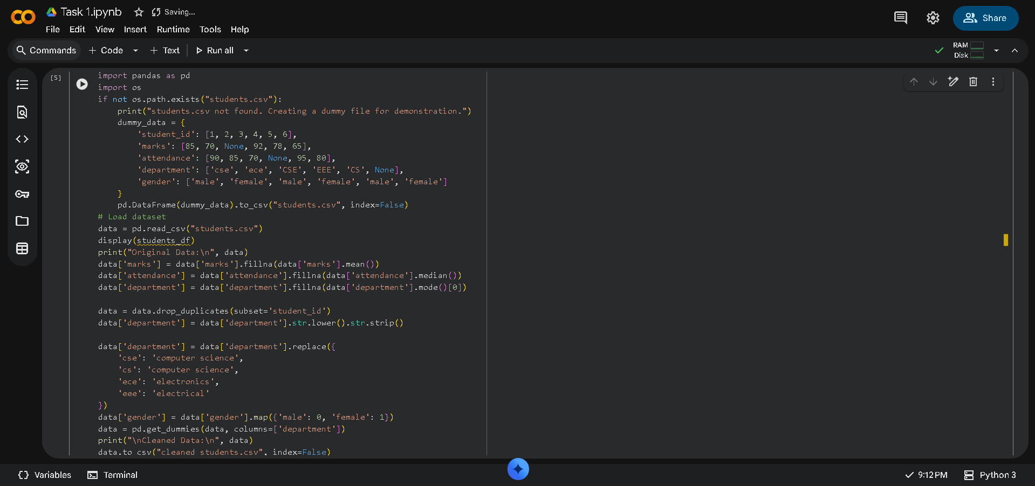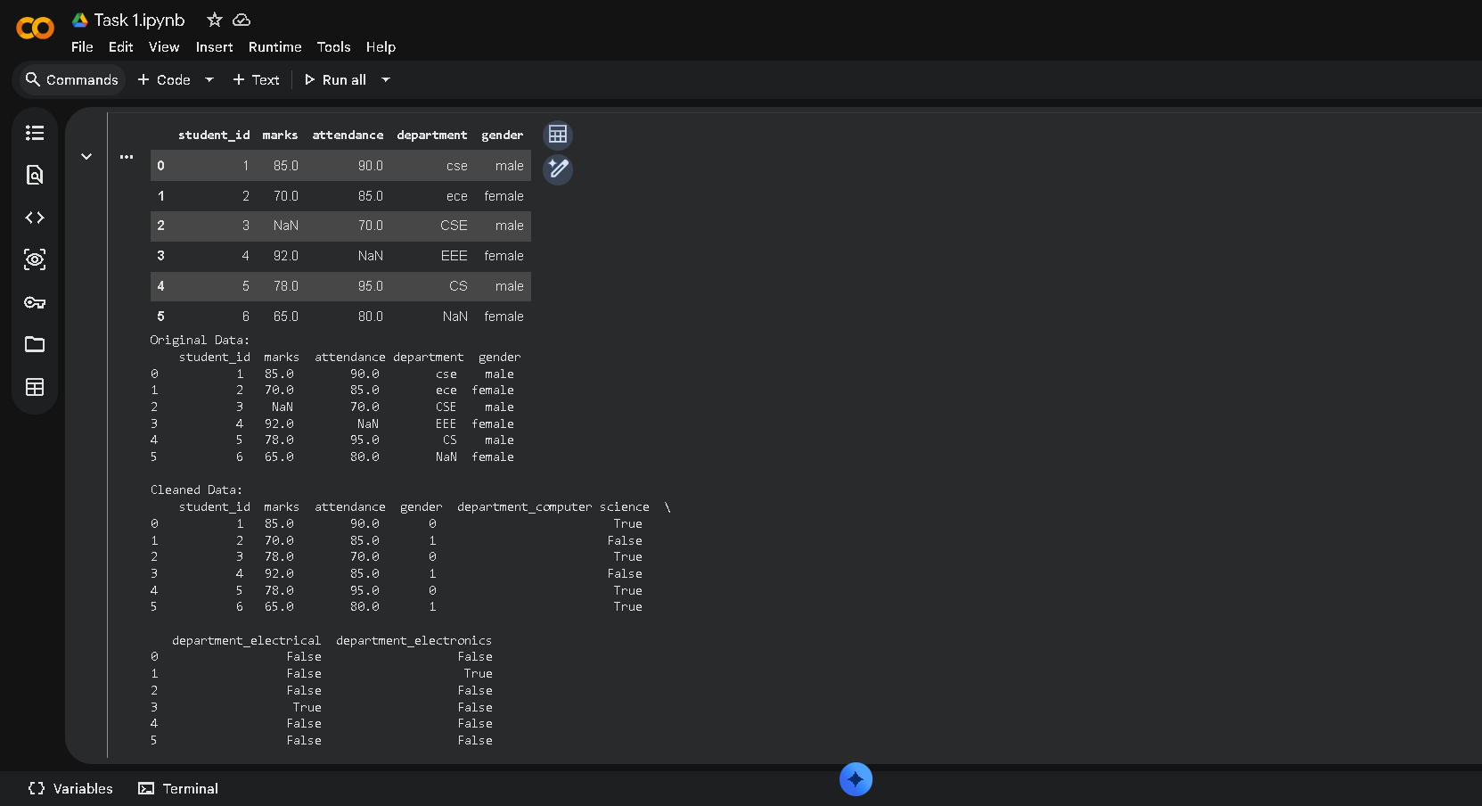

Task Description – 2 (Financial Transaction Data Preprocessing)
• Task: Preprocess financial transaction data using AI-generated Python code.
Instructions:
• Convert transaction date columns to datetime format.
• Create derived features such as transaction month and year.
• Normalize the transaction amount column.
• Identify and handle extreme transaction values.
Sample Code:
import pandas as pd
from sklearn.preprocessing import MinMaxScaler
transactions = pd.read_csv("transactions.csv")
print(transactions.info())
Expected Output:
• A transformed dataset with normalized values and newly generated time based features.
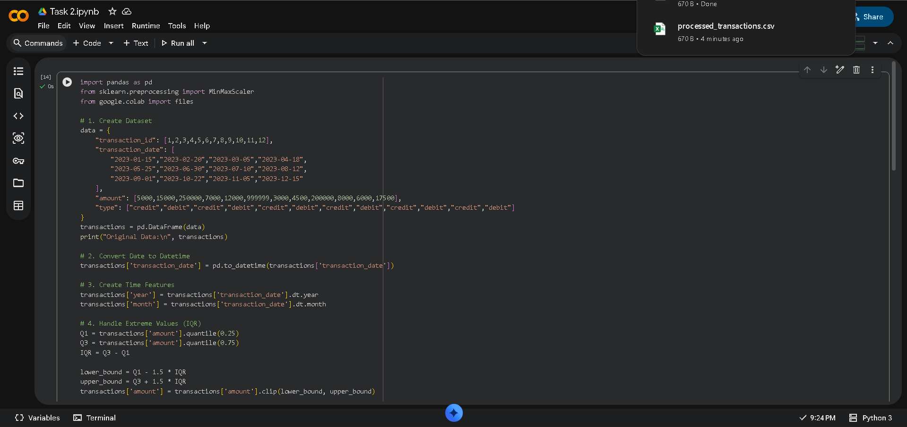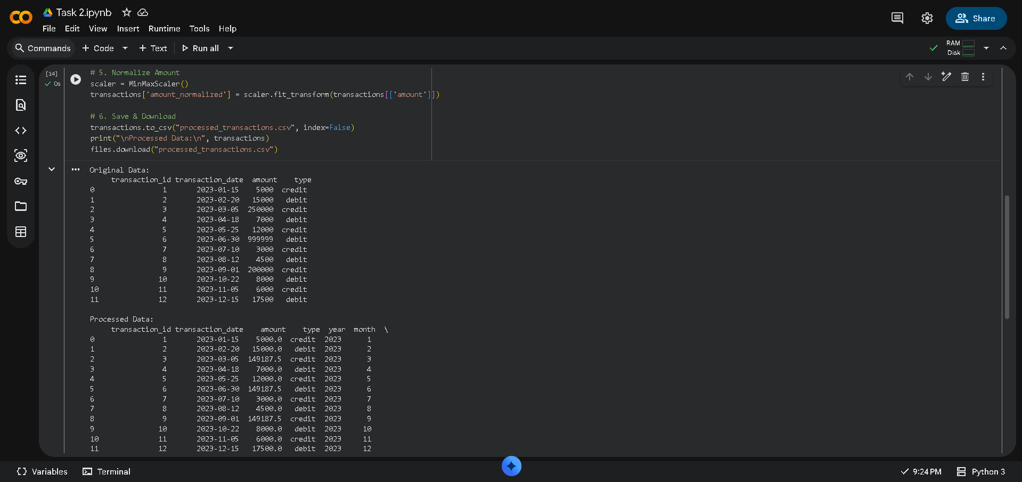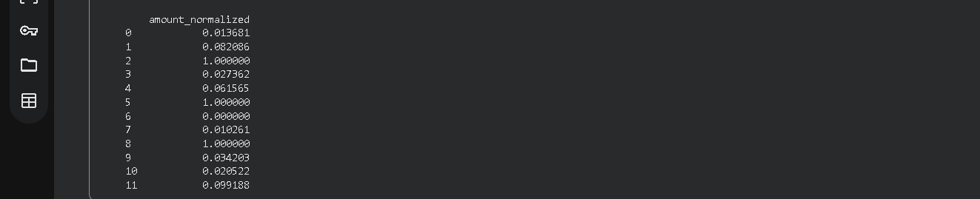
Task 3 – (Environmental Sensor Data Preparation)
• Task: Clean and preprocess environmental sensor data using AI-assisted scripts.
Instructions:
• Handle missing values in temperature, humidity, and air_quality_index.
• Scale numerical features using standard scaling.
• Encode categorical fields such as sensor_status.
• Split the dataset into training and testing subsets.
Sample Code:
import pandas as pd
from sklearn.model_selection import train_test_split
data = pd.read_csv("sensor_data.csv")
Expected Output:
• A fully preprocessed dataset ready for predictive modeling tasks.

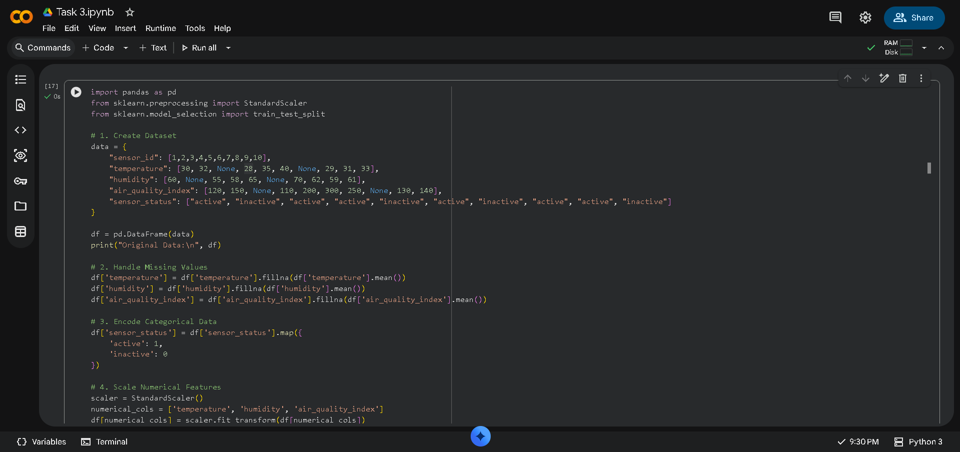
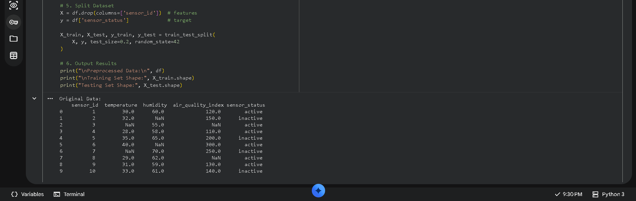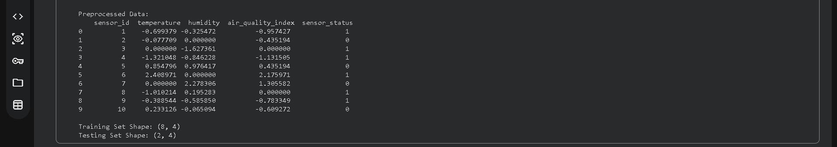

Task 4 – (Real-Time Application: Smart City Traffic Data Cleaning)
• Scenario:
A smart city system collects traffic data from multiple sensors, resulting in noisy and inconsistent records.
Requirements:
• Standardize road and location names.
• Fill missing traffic density values using appropriate statistical methods.
• Remove duplicate sensor readings.
• Normalize speed and vehicle count metrics.
• Generate a brief summary comparing dataset quality before and after cleaning
Sample Code:
import pandas as pd
traffic = pd.read_csv("traffic_data.csv")
print(traffic.describe())
Expected Output:
• A cleaned and normalized traffic dataset with an accompanying
data-quality improvement summary.
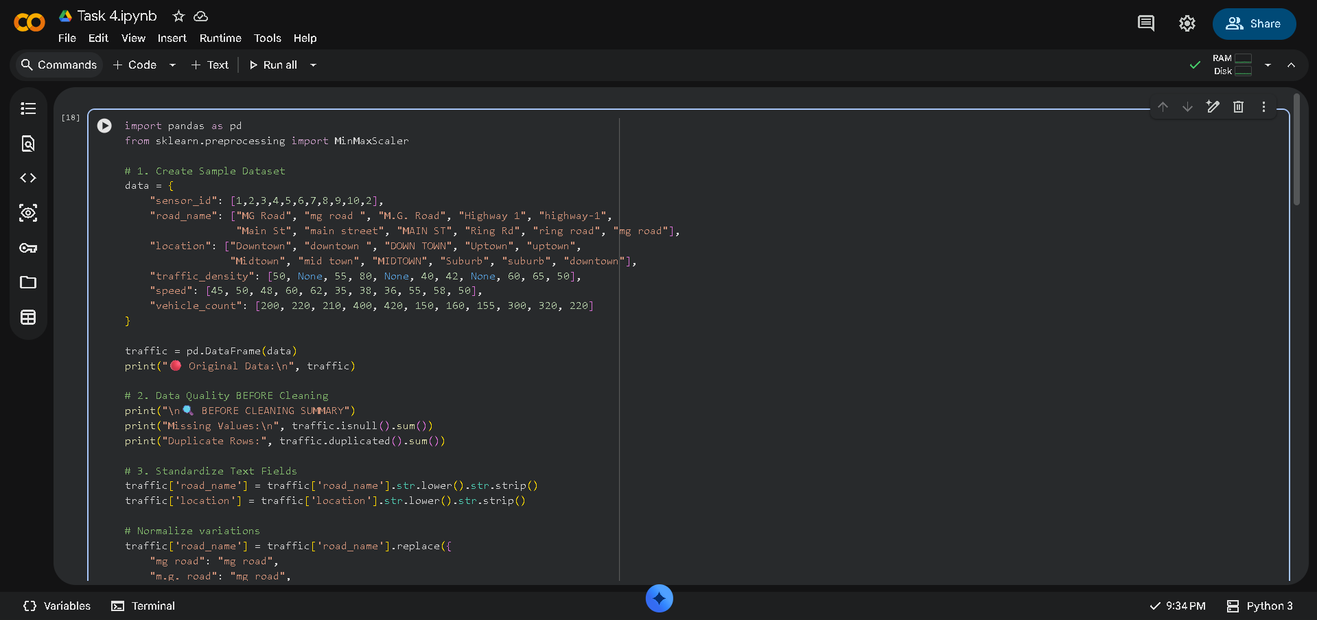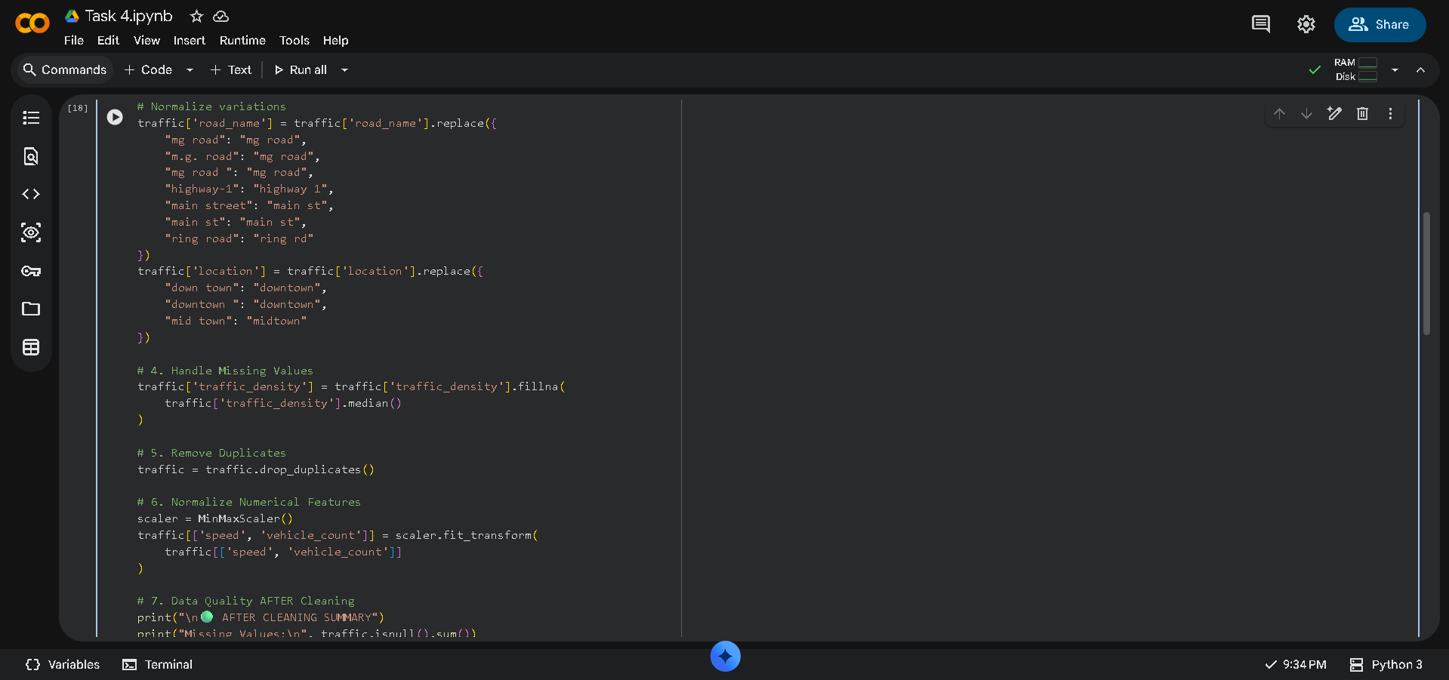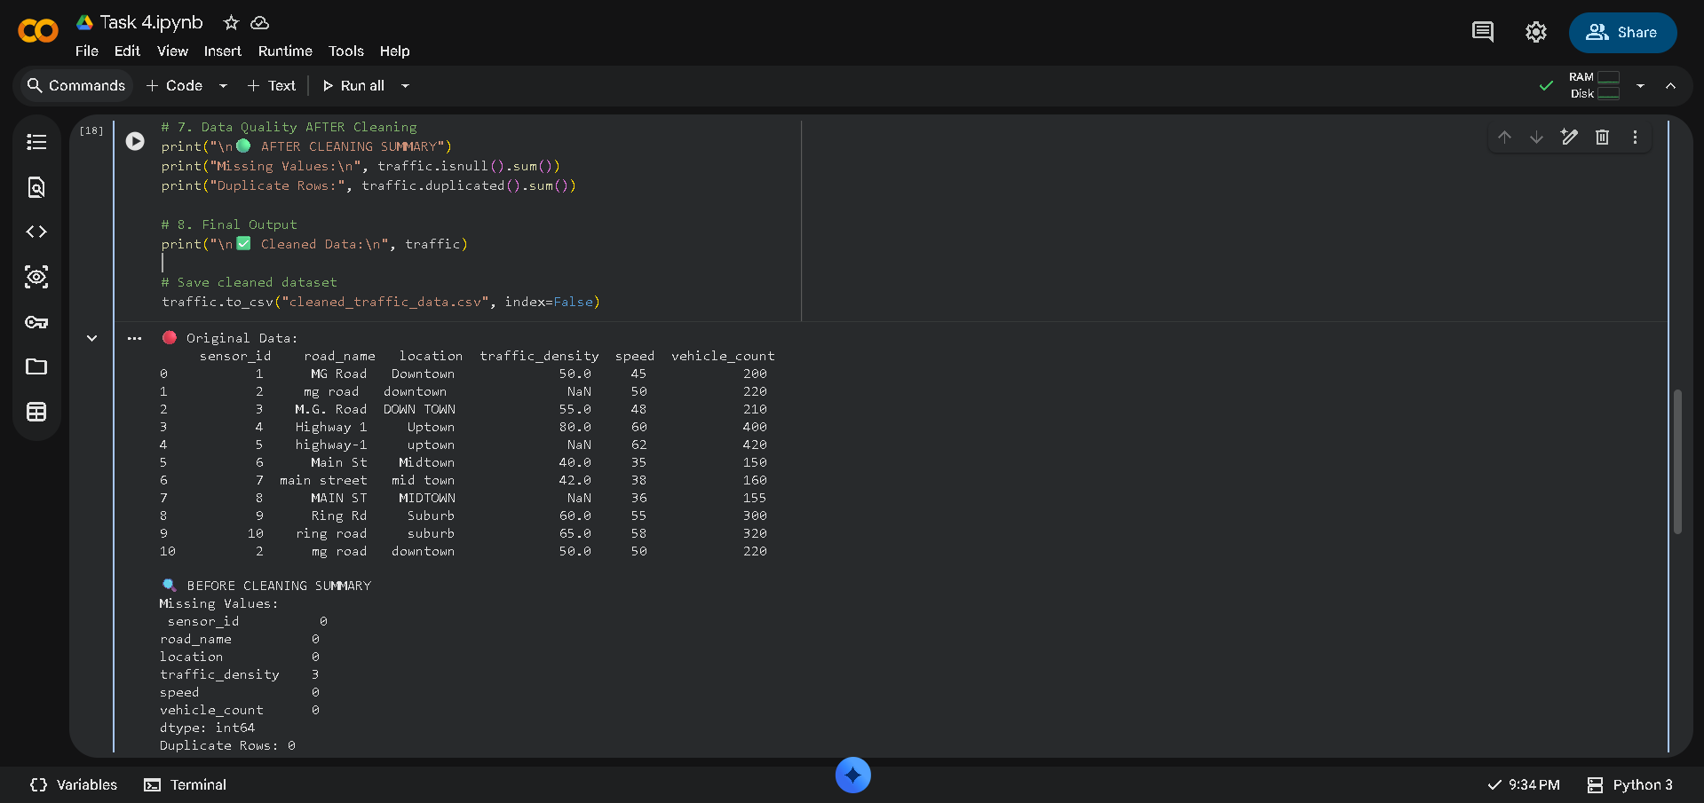
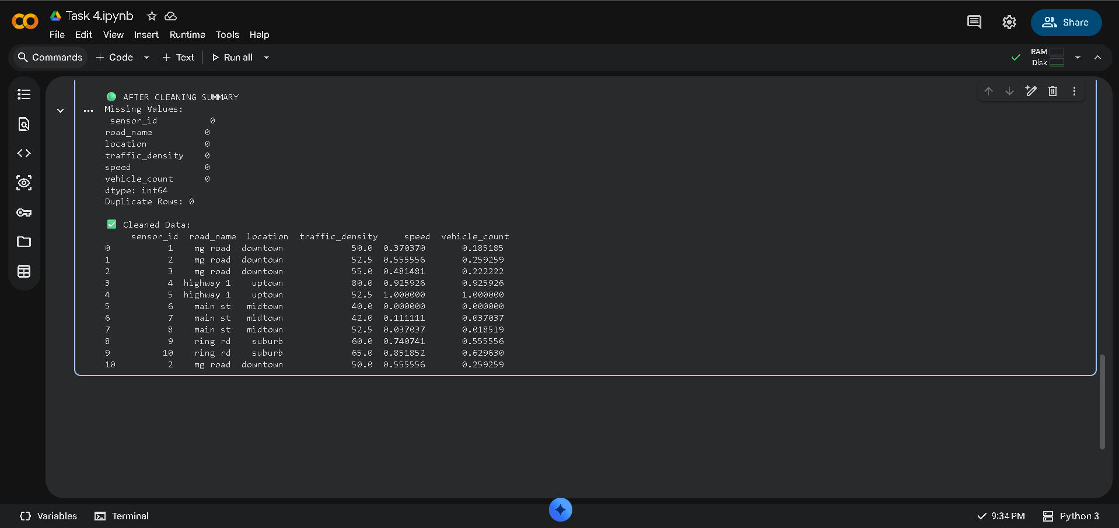

Task 5 – (Social Media Text Data Cleaning and Feature Extraction)
• Task:
Use AI-assisted Python scripting to clean and preprocess social media text data for sentiment analysis.
Instructions:
• Remove duplicate posts and null text entries.
• Clean text by removing URLs, special characters, and extra spaces.
• Convert text to lowercase and perform basic tokenization.
• Remove stopwords and perform stemming or lemmatization. Generate basic text features such as word count and sentiment score.
Sample Code:
import pandas as pd
import re
posts = pd.read_csv("social_media_posts.csv")
print(posts.head())
Expected Output:
A cleaned text dataset with extracted features suitable for sentiment analysis models.
