AI ASSISTANT CODING
ASSIGNMENT-19.4

Name: A.Sathwik
Enrollment no: 2303A52158
Batch: 34
Semester: VI
Branch: CSE(AIML)

Lab 19: Assignment – Code Translation: Converting Between Programming Languages
Task 1 – JavaScript to Python (Array Processing Logic)
Scenario
A frontend application written in JavaScript processes user scores. The
backend team wants the same logic implemented in Python for analytics
processing.
Task
Translate a JavaScript function that:
• Takes an array of numbers
• Filters values greater than 50
• Returns the average of filtered values
Instructions
• Prompt AI to convert JavaScript array methods (filter, reduce) into equivalent Python logic.
• Ensure list comprehension or Pythonic style is used.
• Compare outputs of both implementations with sample input.
• Document differences in handling arrays between JS and Python.
Expected Output
• Equivalent Python function.
• Same output for identical inputs.
• Clean and Pythonic implementation.

Prompt:

Convert the given JavaScript function into Python.
Requirements:
- Input: array of numbers
- Filter values > 50
- Return average (0 if none)
- Use list comprehension and Python built-ins (sum, len)
Also:
- Show both JS and Python code
- Test with sample input
- Ensure outputs match
- Briefly compare JS (filter, reduce) vs Python
JavaScript:
function averageAbove50(arr) {
const filtered = arr.filter(num => num > 50);
if (filtered.length === 0) return 0;
const sum = filtered.reduce((acc, num) => acc + num, 0);
return sum / filtered.length;
}
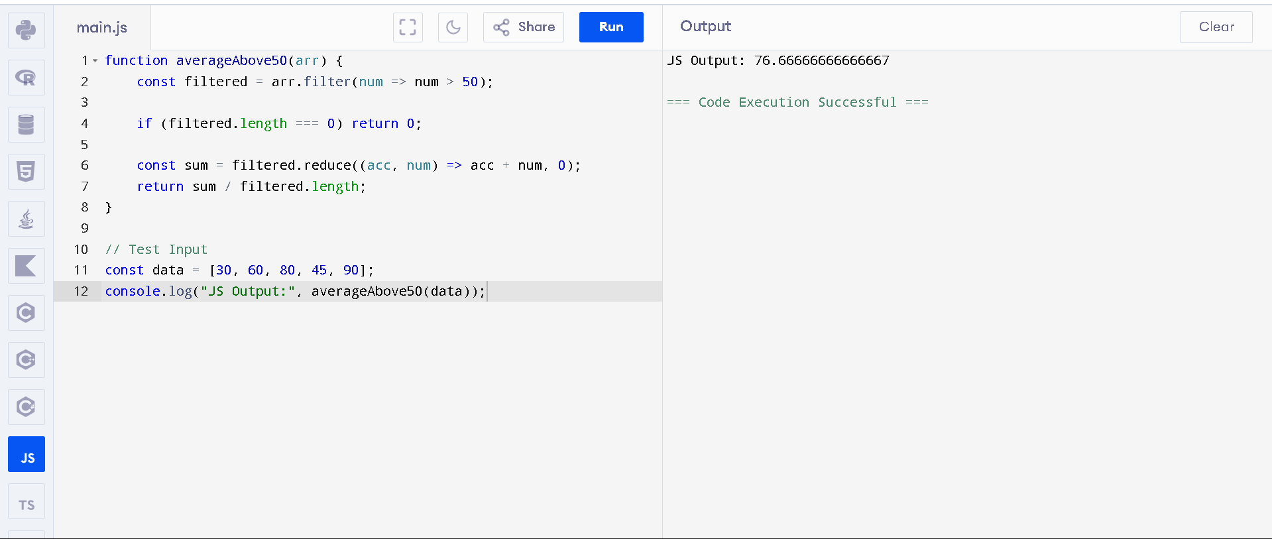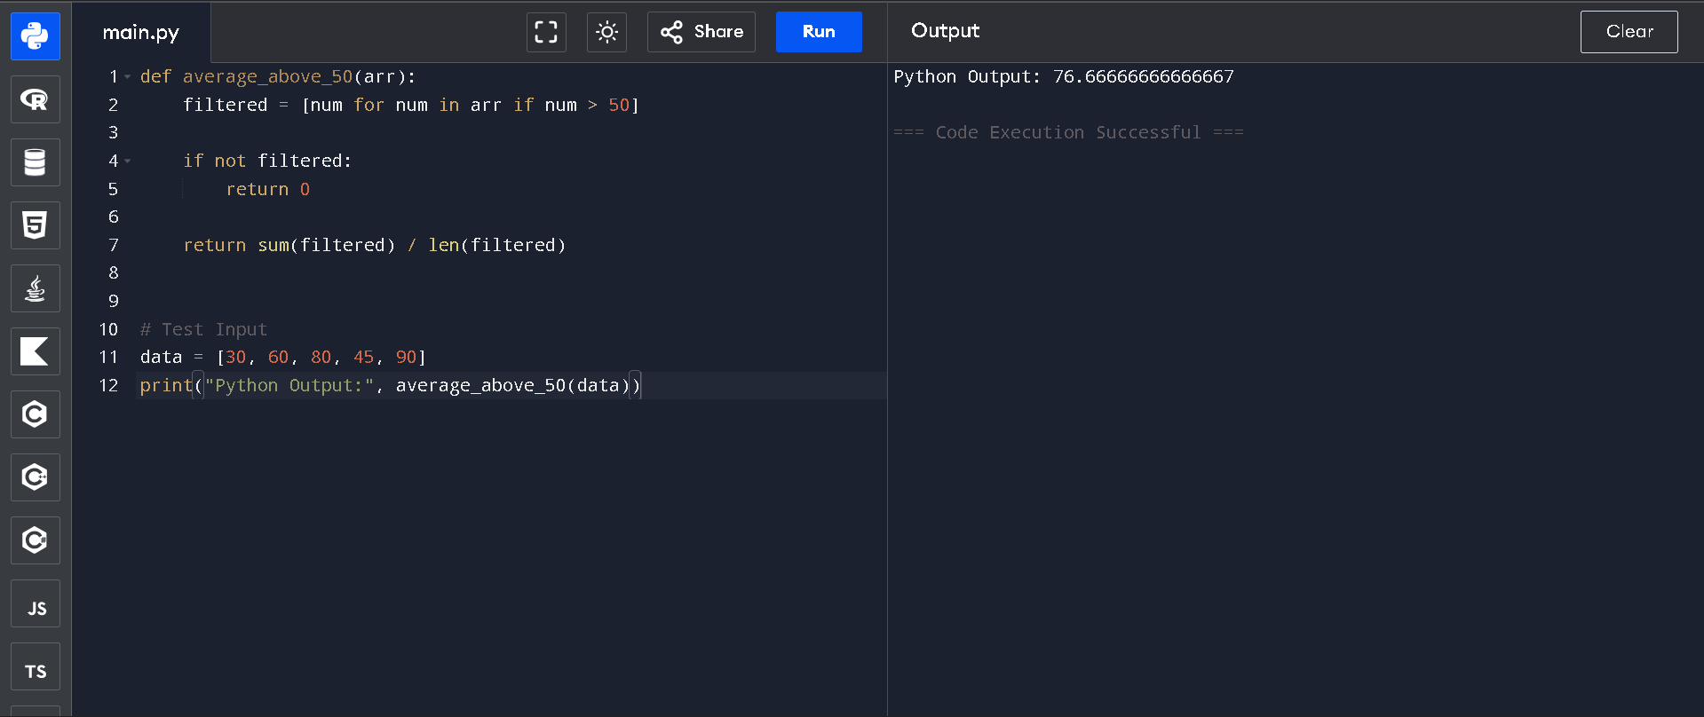

Task 2 – Python OOP to C++ Class Translation
Scenario
A data modeling module is written in Python using OOP. The system is being migrated to a high-performance C++ environment.
Task
Translate a Python class that:
• Contains private attributes
Uses getter/setter methods
• Includes a method that calculates a derived value
Instructions
• Convert the Python class into a C++ class.
• Ensure:
o Proper access modifiers
o Constructor handling
o Correct data types
• Compile and test the C++ version.
• Compare how encapsulation differs between Python and C++.
Expected Output
• Fully working C++ class equivalent to Python version.
• Proper use of access specifiers (private, public).

Prompt:

Convert the following Python OOP class into an equivalent C++ class.
Requirements:
- Use private attributes
- Implement getter and setter methods
- Include a method that calculates a derived value
- Apply proper access specifiers (private, public)
- Add a constructor with correct data types
- Ensure the C++ code is complete and compilable
Also:
- Show both Python and C++ code
- Provide sample input/output
- Briefly compare encapsulation in Python vs C++

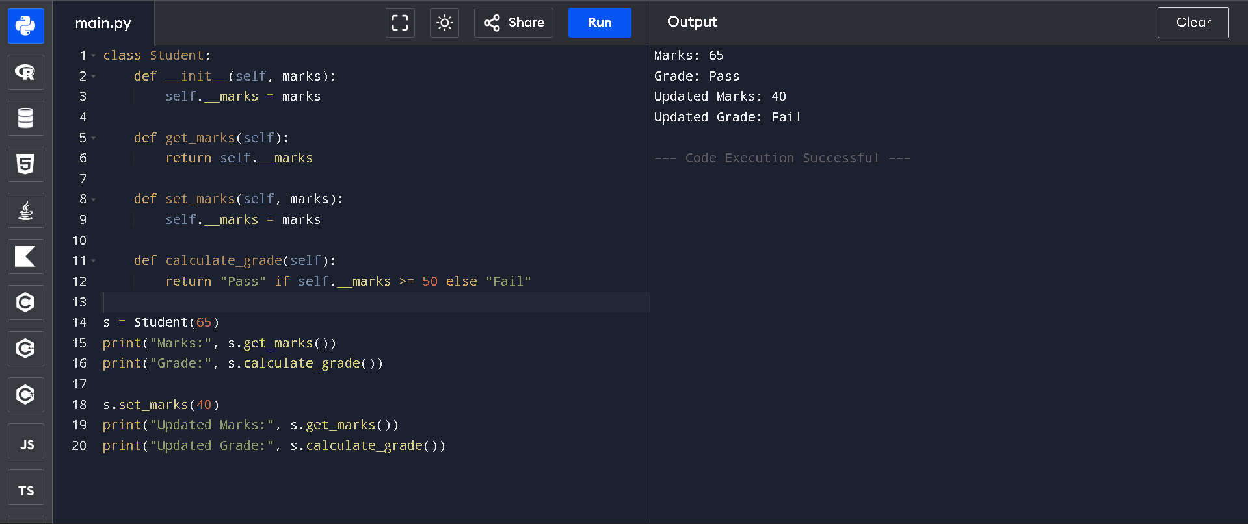
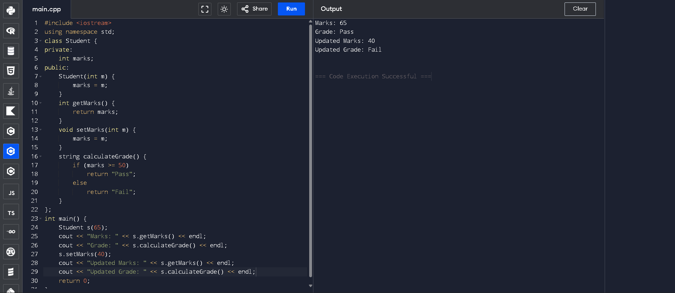

Task 3 – REST API Call Translation: Python to JavaScript
Scenario
A backend developer wrote an API request using Python requests. The frontend team needs the same functionality in JavaScript (Fetch API).
Task
Translate Python API request code into JavaScript.
Instructions
• Convert:
o GET request logic
o JSON parsing
o Error handling (try-except → try-catch)
• Ensure proper async/await usage in JavaScript.
• Compare differences in error handling mechanisms.
Expected Output
• Equivalent JavaScript code using Fetch API.
• Proper async handling.
• Similar output structure.

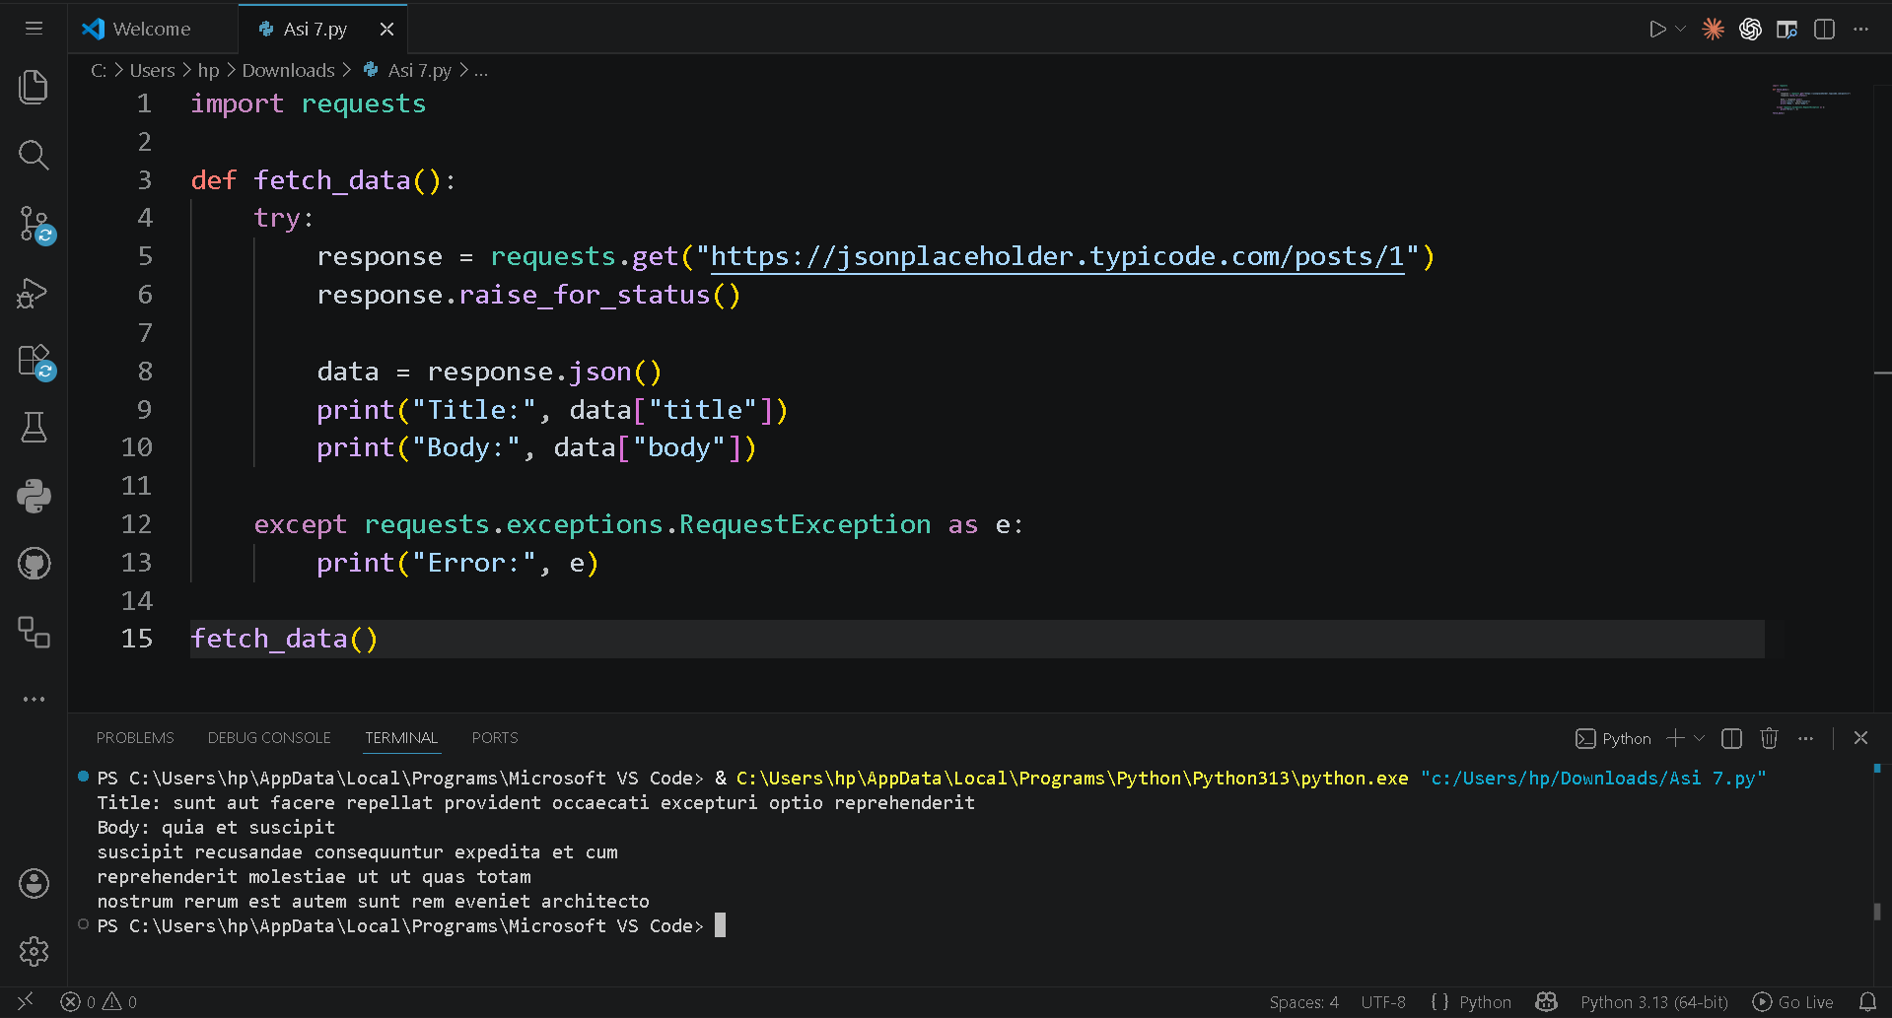
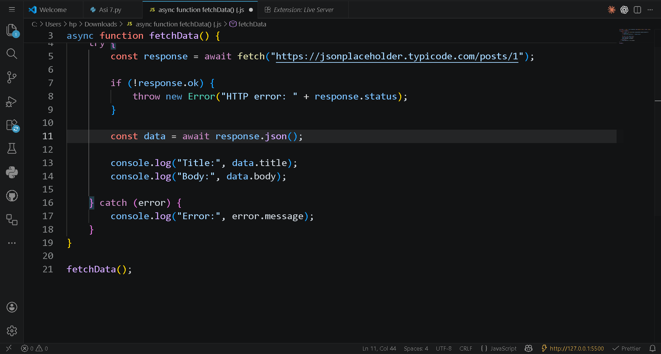
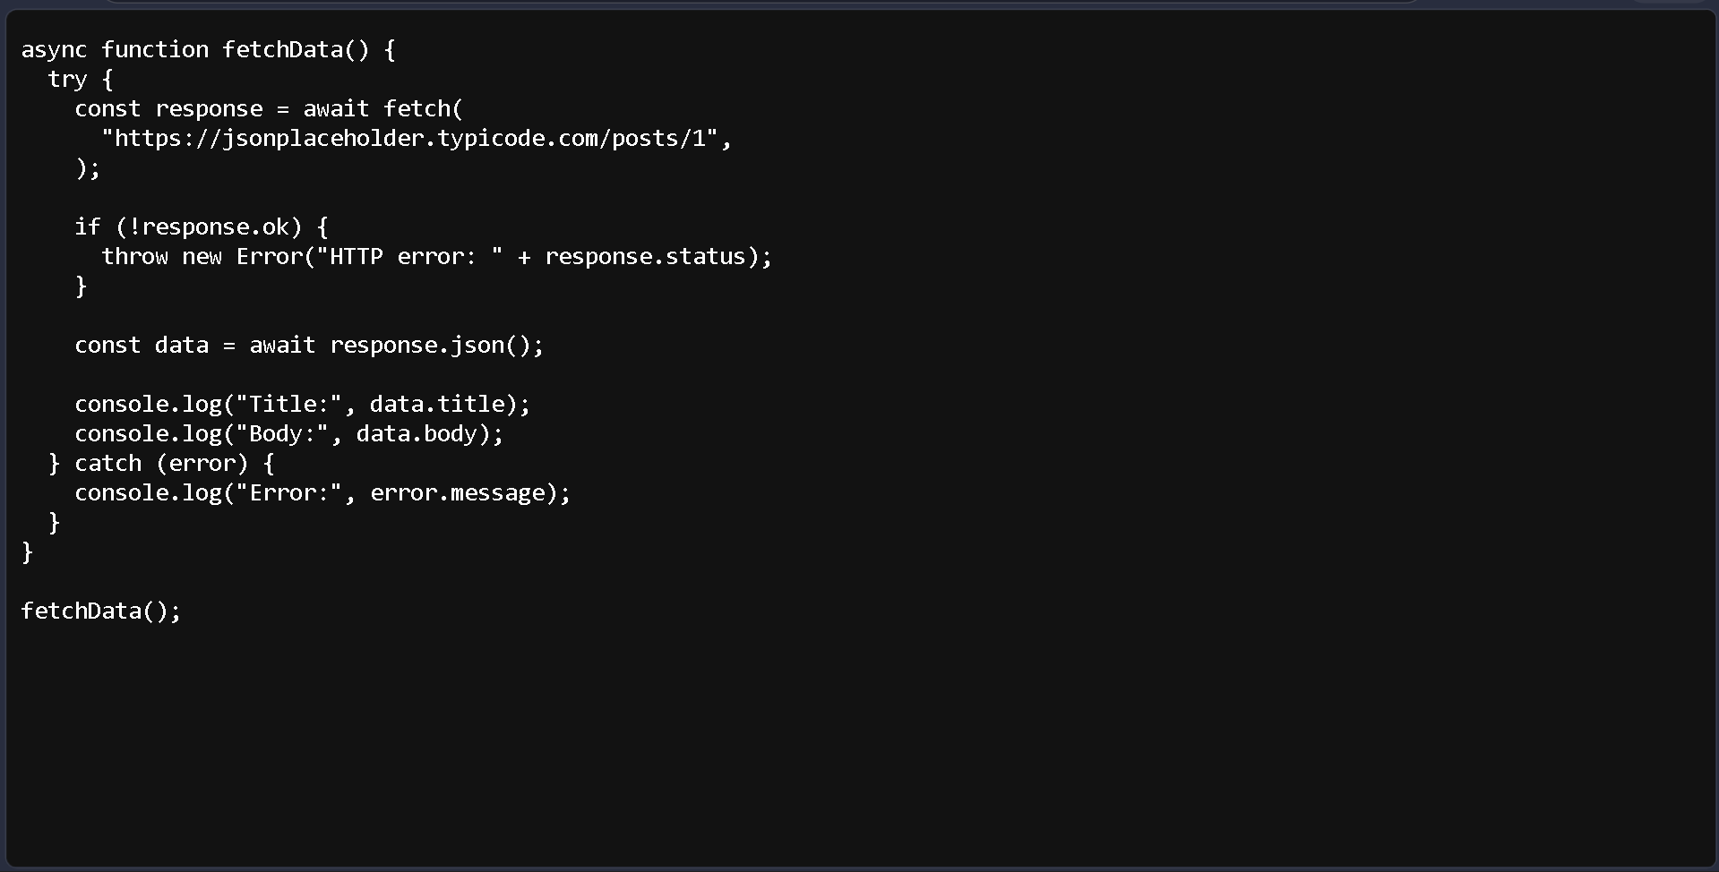

Task 4 – SQL Aggregation to MongoDB Query Translation
Scenario
A company is migrating from relational databases (SQL) to MongoDB
(NoSQL).
Task
Translate an SQL aggregation query into a MongoDB aggregation pipeline.
Example Logic:
• Group records by category
• Calculate average price
• Filter groups where average price > threshold
Instructions
• Provide SQL query to AI.
• Generate equivalent MongoDB query.
• Explain differences between relational and document-based querying.
• Validate results conceptually.
Expected Output
• Working MongoDB aggregation query.
• Clear understanding of grouping and aggregation differences.
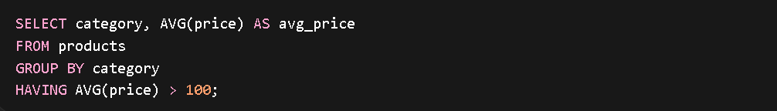
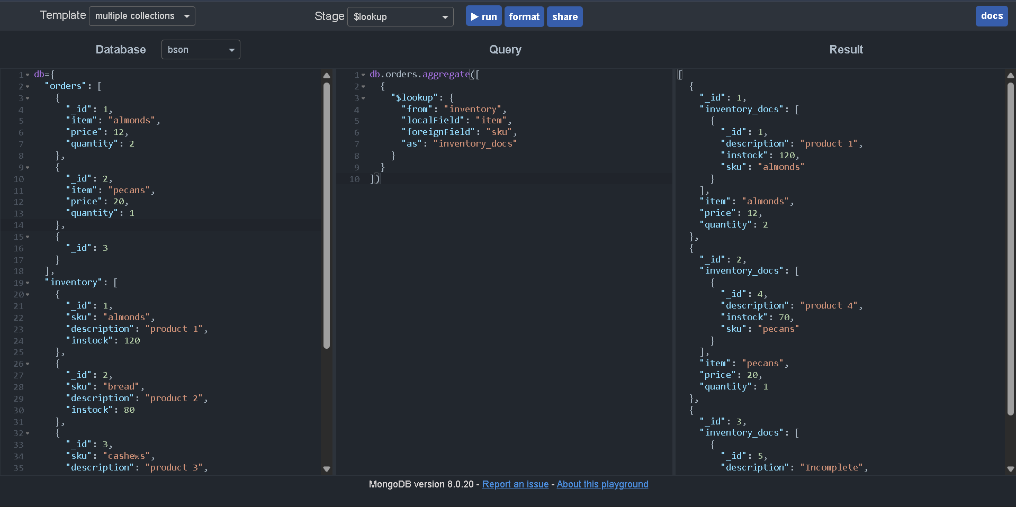

Task 5 – Real-Time Application: Algorithm Translation Across Three Languages
Scenario
A tech company maintains codebases in multiple languages (Python, Java, and
Go). A common algorithm must be implemented consistently across systems.
Task
Choose an algorithm (e.g., binary search, palindrome check, prime number
checker) and translate it across:
• Python
• Java
• One additional language (Go / C# / JavaScript)
Instructions
• Ensure logic remains identical across languages.
• Handle:
o Data types
o Loop differences
o Input/output handling
• Test each version with same input values.
• Briefly document translation challenges.
Expected Output
• Three equivalent working implementations.
• Clear logical consistency.
• Understanding of syntactic vs structural differences


