AI ASSISTANT CODING
ASSIGNMENT-7.2

Name: A.Sathwik
Enrollment no: 2303A52158
Batch: 34
Semester: VI
Branch: CSE(AIML)

Lab 7: Error Debugging with AI: Systematic approaches to finding and fixing bugs
Task Description
Task 1 – Runtime Error Due to Invalid Input Type
• A Python program accepts user input and performs arithmetic operations. However, the program throws a runtime error because the input is treated as a string instead of a numeric type.

Example (Buggy Code):
num = input("Enter a number: ")
result = num + 10
print(result)

• Task:
Use AI tools to identify the cause of the runtime error and modify the program so it executes correctly.

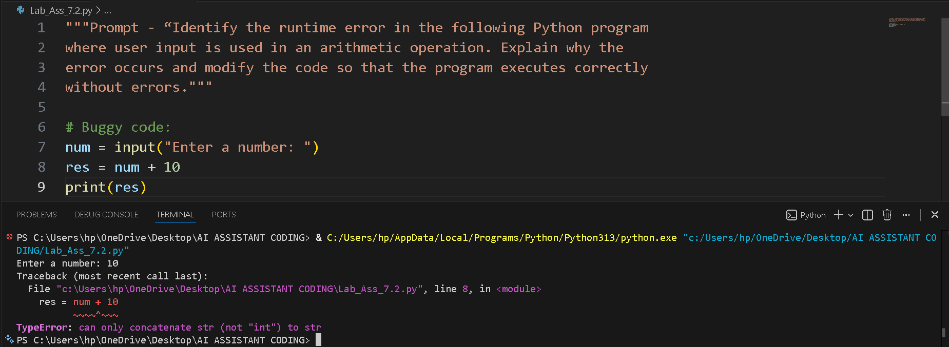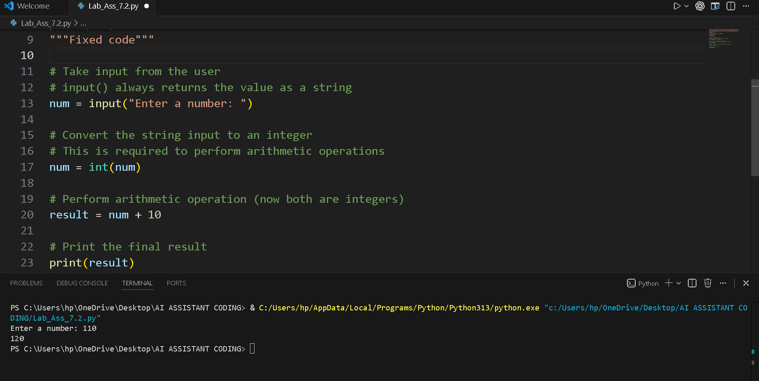
Task Description:
Task 2 – Incorrect Function Return Value
A function is designed to calculate the square of a number, but it does not return the computed result properly.

Example (Buggy Code):
def square(n):
result = n * n

Task:
Use AI assistance to analyze the function and ensure the correct value is returned

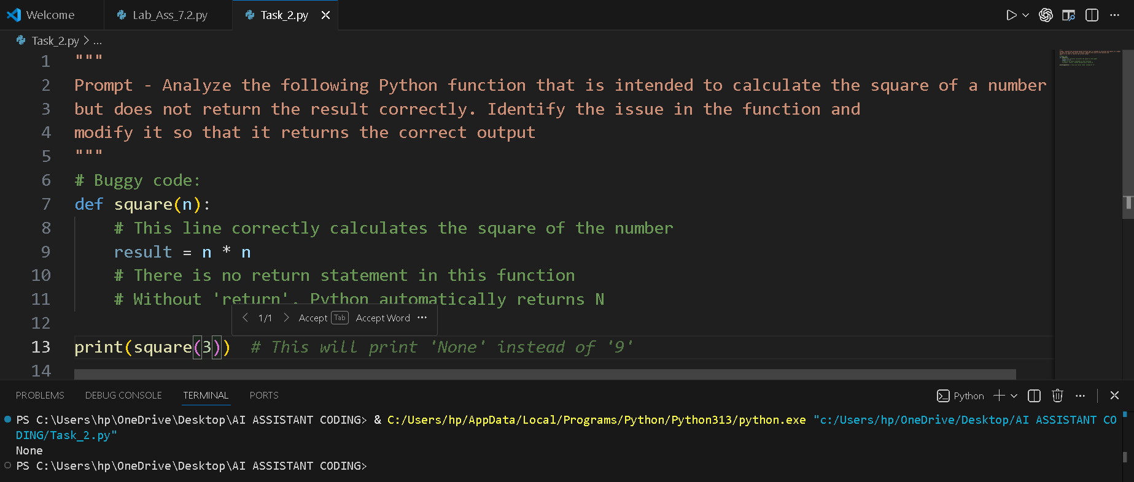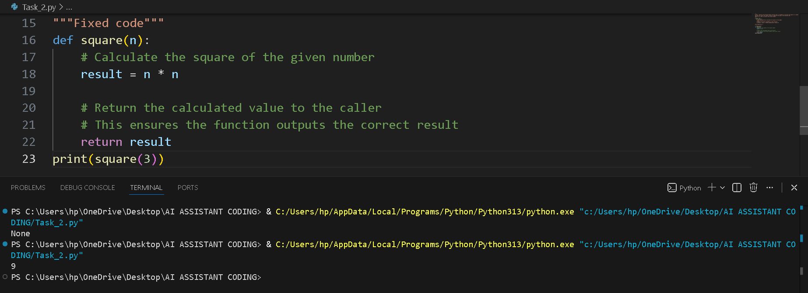
Task Description
Task 3 – Index Error in List Traversal
A Python program iterates over a list using incorrect index limits, causing an IndexError.

Example (Buggy Code):
numbers = [10, 20, 30]
for i in range(0, len(numbers)+1):
print(numbers[i])

Task:
Use AI to identify the incorrect loop boundary and correct the iteration
logic.
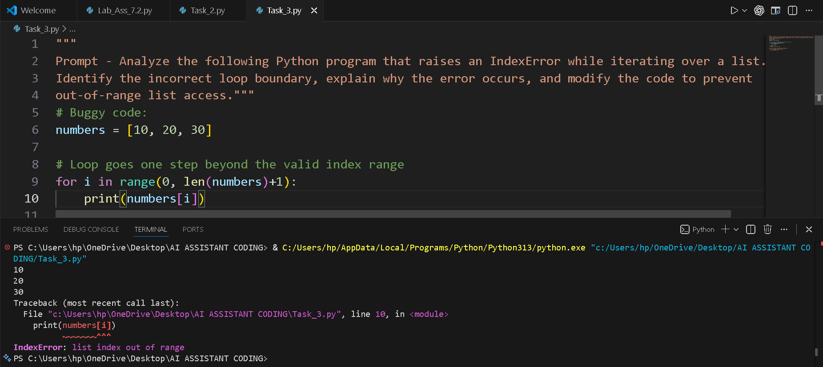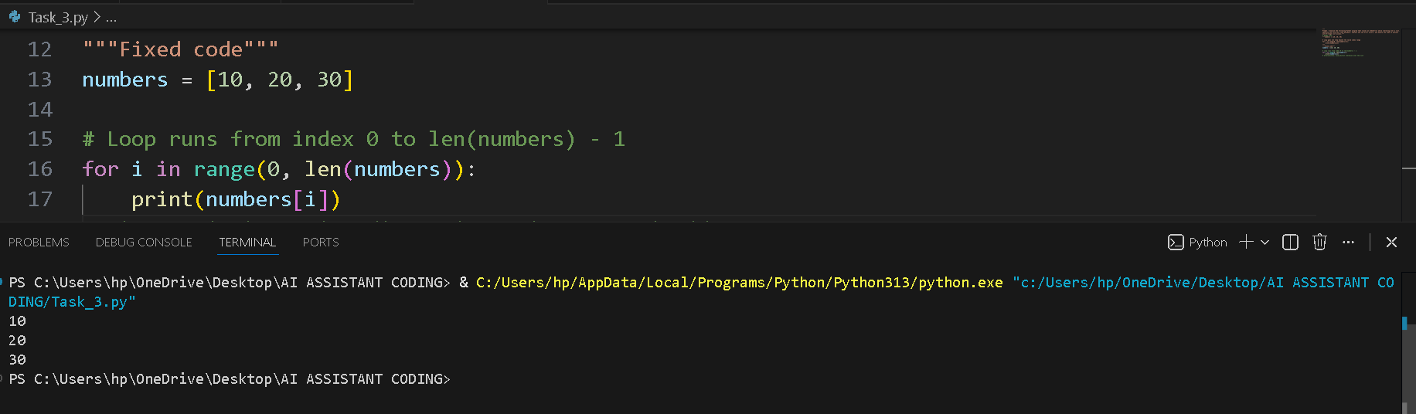
Task Description
Task 4 – Uninitialized Variable Usage
A program uses a variable in a calculation before assigning it any value.

Example (Buggy Code):
if True:
pass
print(total)

Task:
Use AI tools to detect the uninitialized variable and correct the program.

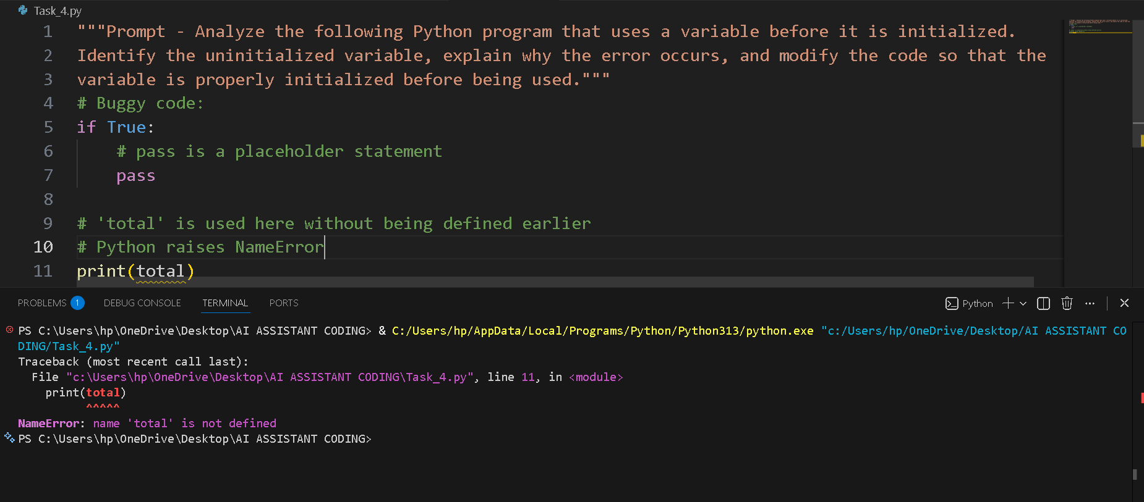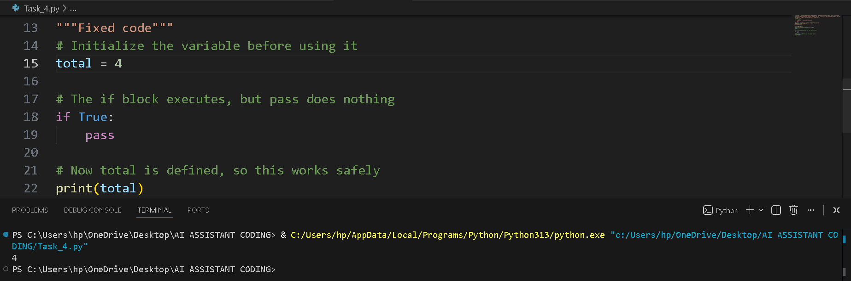
Task Description
Task 5 – Logical Error in Student Grading System
A grading program assigns incorrect grades due to improper conditional logic.

Example (Buggy Code):
marks = 85
if marks >= 90:
grade = "A"
elif marks >= 80:
grade = "C"
else:
grade = "B"
print(grade)
Task:
Use AI to analyze the grading conditions and correct the logical flow.
