SCHOOL OF COMPUTER SCIENCE AND ARTIFICIAL INTELLIGENCE |  |  |  |  | DEPARTMENT OF COMPUTER SCIENCE ENGINEERING
Program Name: B. Tech |  |  |  | Assignment Type: Lab |  |  | Academic Year:2025-2026
Course Coordinator Name |  |  |  | Dr. Rishabh Mittal
Instructor(s)Name |  |  |  | Mr. S Naresh Kumar  Ms. B. Swathi  Dr. Sasanko Shekhar Gantayat  Mr. Md Sallauddin  Dr. Mathivanan  Mr. Y Srikanth  Ms. N Shilpa  Dr. Rishabh Mittal (Coordinator)  Dr. R. Prashant Kumar  Mr. Ankushavali MD  Mr. B Viswanath  Ms. Sujitha Reddy  Ms. A. Anitha  Ms. M.Madhuri  Ms. Katherashala Swetha  Ms. Velpulasumalatha  Mr. Bingi Raju
CourseCode |  |  | 23CS002PC304 | CourseTitle |  | AI Assisted Coding
Year/Sem |  |  | III/II | Regulation |  | R23
DateandDay  of Assignment |  |  | Week10 - Tuesday | Time(s)
Duration |  |  | 2 Hours | Applicableto  Batches |  | 23CSBTB01 To 23CSBTB52
Assignment Number: 19.2(Present assignment number)/24(Total number of assignments)
 | Q.No. | Question |  |  |  |  |  | Expected Time  to complete
 | 1 | Lab 19 – Code Translation: Converting Between Programming Languages  Lab Objectives:  - Understand how AI tools can assist in translating code between different programming languages.  - Learn to verify correctness and functionality after translation.  - Explore syntactic and semantic differences between languages (e.g., Python, Java, C++).  - Practice debugging and optimizing AI-translated code.  Task 1 – Python to Java Conversion  Task:  Convert a Python program that performs file handling operations into an equivalent Java program using AI assistance.  Instructions:  - Prompt AI to translate a Python script that reads from and writes to a file into Java.  - Ensure proper handling of file streams, exceptions, and input/output formatting.  - Verify that the Java program produces the same file content and console output as the Python version.  - Test both implementations with sample input files.  Expected Output:  A correctly translated and executable Java program that performs the same file handling operations as the original Python script.  Task 2 – C++ to Python Function Conversion  Task:  Translate a C++ program that implements a sorting algorithm into Python using AI assistance.  Instructions:  - Provide AI with a C++ implementation of a sorting technique (e.g., Bubble Sort or Selection Sort).  - Ask AI to generate an equivalent Python implementation.  - Ensure logical correctness and validate results using multiple test cases.  - Confirm that the Python version maintains the same sorting behavior.  Expected Output:  A correct and executable Python program equivalent to the given C++ sorting implementation.  Task 3 – SQL to Pandas Query  Task:  Convert a SQL query involving GROUP BY and aggregate functions into an equivalent Pandas Data Frame operation.  Instructions:  - Provide AI with a SQL query that calculates aggregate values (e.g., total sales per department).  - Prompt AI to generate equivalent Pandas code using groupby() and aggregation functions.  - Test the generated code using a sample dataset.  - Verify that both SQL and Pandas outputs match.  Expected Output:  An accurate Pandas Data Frame operation that produces results equivalent to the given SQL query with aggregation.  Task 4 – Real-Time Application: Multi-Language Snippet Converter  Scenario:  Students will select a practical real-world application requiring the same logic in two different programming languages.  Example:  Converting a REST API implementation from Python (Flask) to Java (Spring Boot).  Translating a data processing script from Python to C++ for performance optimization.  Instructions:  - Provide AI with source code in one programming language.  - Prompt AI to convert the code into another chosen language.  - Execute and test both versions to ensure identical functionality.  - Document differences observed in syntax, libraries, and execution behavior.  Expected Output:  Functionally equivalent and executable code snippets implemented in two different programming languages, along with documented observations.  Task -5: (Basic Function Translation (Python to C++)  Translate a simple Python function that checks whether a number is even or odd into C++ using AI assistance.  Instructions:  Provide AI with a basic Python function that determines if a number is even or odd.  Prompt AI to generate equivalent C++ code.  Ensure correct syntax, input handling, and output formatting.  Compile and run the C++ program to verify it produces the same result as the Python version.  Test with at least three different input values.  Expected Output:  A simple and executable C++ program equivalent to the given Python function, correctly identifying whether a number is even or odd for all test cases.  Bottom of Form  Note: Report should be submitted a word document for all tasks in a single document with prompts, comments & code explanation, and output and if required, screenshots. |  |  |  |  |  | Week10 - Tuesday

Task 1: Python to Java Conversion
Prompt:
Convert a Python program that performs file handling operations (reading and writing) into an equivalent Java program. Ensure proper file streams, exception handling, and identical input/output behavior.

Code:
Python Code (Original):
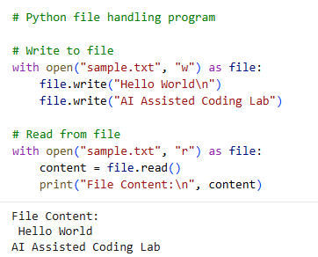

Java Code (Converted):
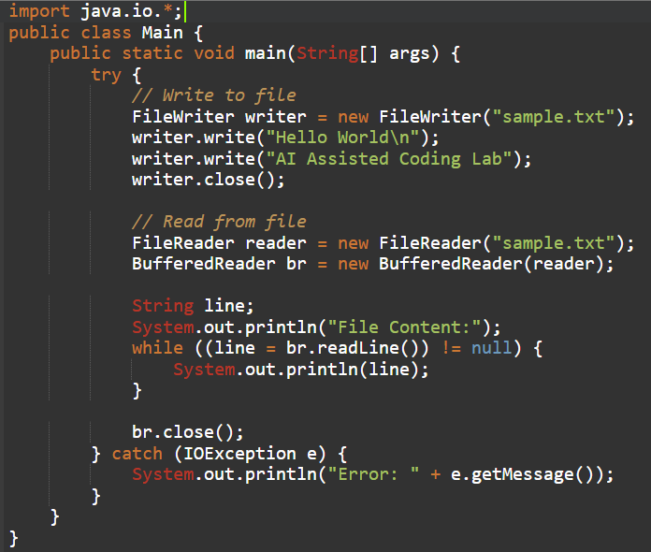

Sample Input/Output:
Python:
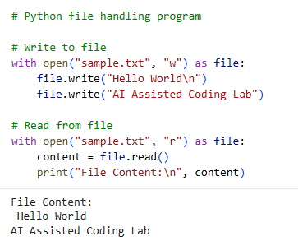

Java:
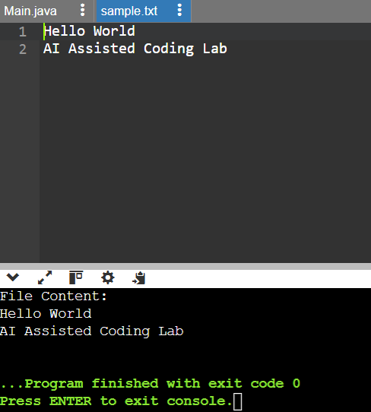

Code Explanation:
- This task demonstrates translation of file handling code from Python to Java.
- The Python program uses open() with read and write modes.
- It writes data to a file and then reads and prints the content.
- The Java version uses FileWriter and BufferedReader for file operations.
- Exception handling is implemented using try-catch blocks in Java.
- Both programs perform identical operations and produce the same output.
- The translation highlights differences in syntax and file handling mechanisms.
- This ensures functional equivalence between both programming languages.

Task 2: C++ to Python Function Conversion
Prompt:
Convert a C++ program implementing a sorting algorithm (Bubble Sort) into an equivalent Python program. Ensure the Python version maintains the same logic and produces identical sorted output for multiple test cases.

Code:
C++ Code (Original – Bubble Sort):
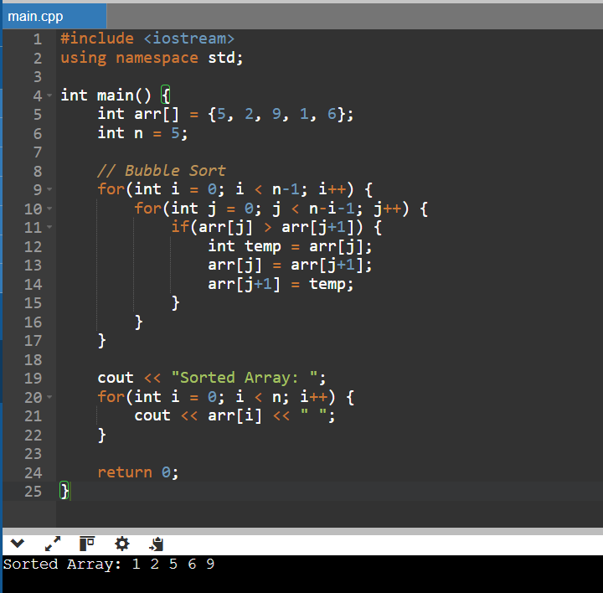

Python Code (Converted):
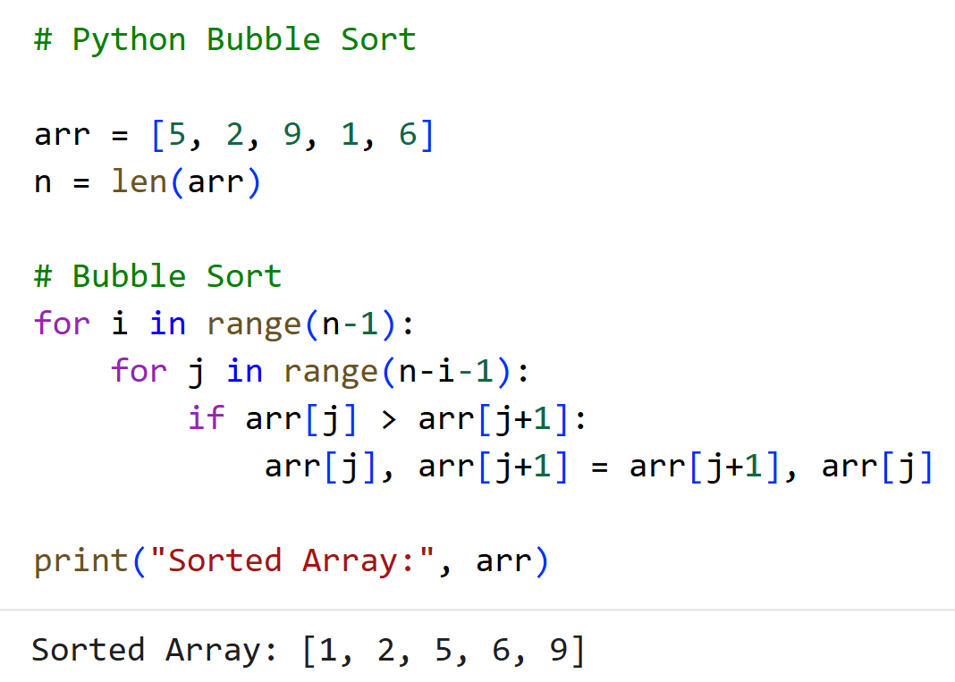

Sample Input/Output:
C++ Code (Original – Bubble Sort):
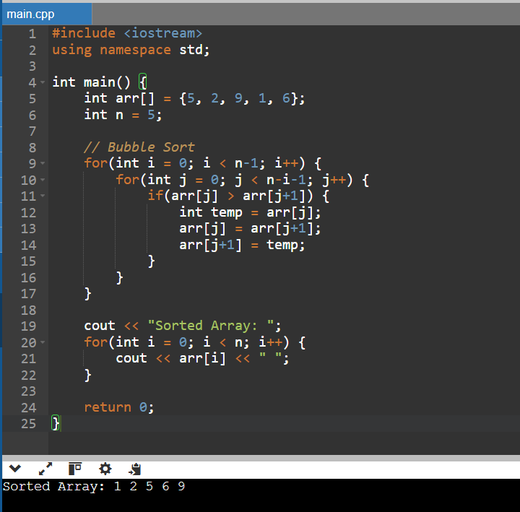

Python Code (Converted):
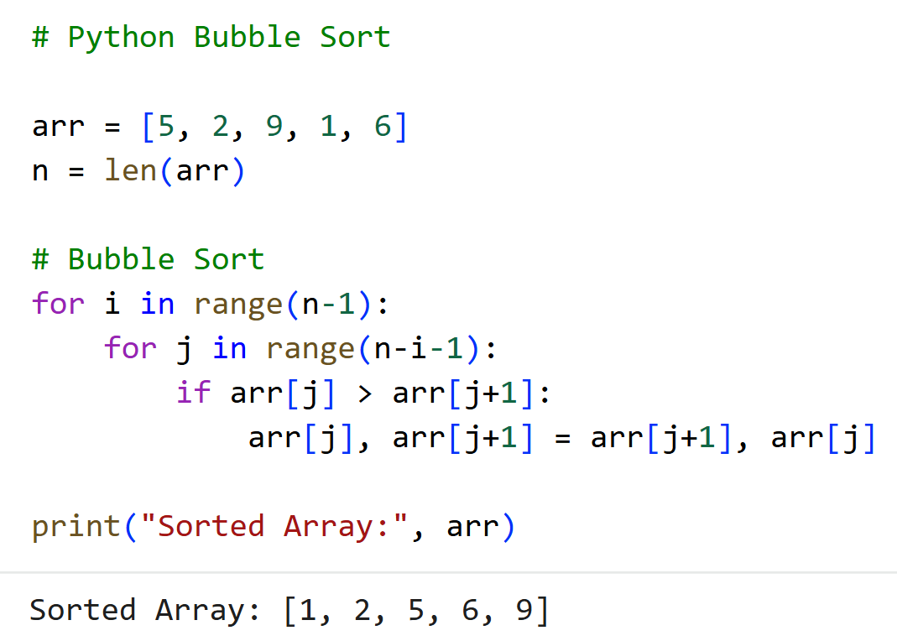

Code Explanation:
- This task demonstrates translation of a sorting algorithm from C++ to Python.
- The C++ program uses Bubble Sort to arrange elements in ascending order.
- Nested loops compare adjacent elements and swap them if needed.
- The Python version maintains the same logic using for loops.
- Python simplifies swapping using tuple unpacking.
- Multiple test cases are used to verify correctness.
- Both implementations produce identical sorted results.
- This confirms logical equivalence between C++ and Python versions.

Task 3: SQL to Pandas Query
Prompt:
Convert a SQL query using GROUP BY and aggregate functions into an equivalent Pandas DataFrame operation.
Ensure the Pandas output matches the SQL query results using a sample dataset.
Code:
SQL Query (Original)
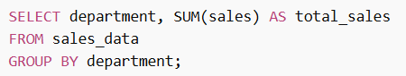

Python Code (Pandas Equivalent)
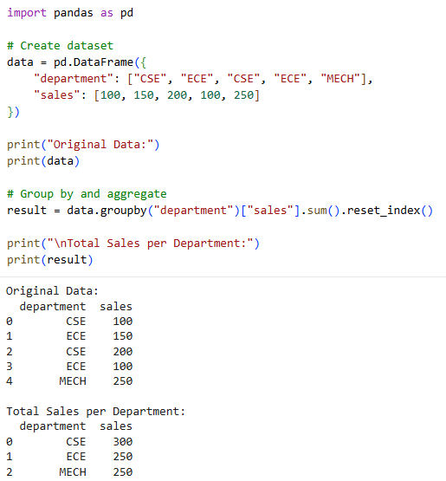

Sample Input/Output:
SQL Query:
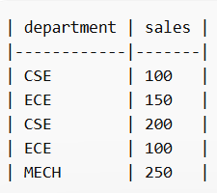

Python Code (Pandas Equivalent)
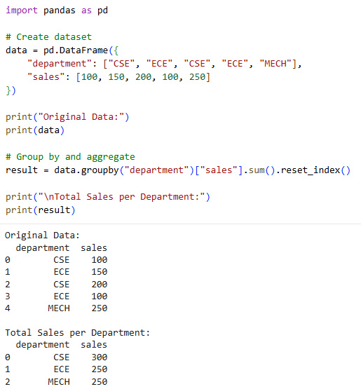
Code Explanation:
- This task demonstrates converting SQL aggregation queries into Pandas operations.
- The SQL query groups data by department and calculates total sales.
- The Pandas version uses groupby() to achieve the same functionality.
- The sum() function aggregates sales values for each department.
- The dataset is created manually to simulate database records.
- The result is reset using reset_index() for proper table format.
- Both SQL and Pandas outputs produce identical results.
- This confirms correct translation between SQL and Python data processing.

Task 4: Real-Time Application: Multi-Language Snippet Converter
Prompt:
Convert a Python program that processes a list of numbers (finding sum and average) into an equivalent C++ program. Ensure both implementations produce identical outputs and analyze differences in syntax and execution.
Code:
Python Code (Source)
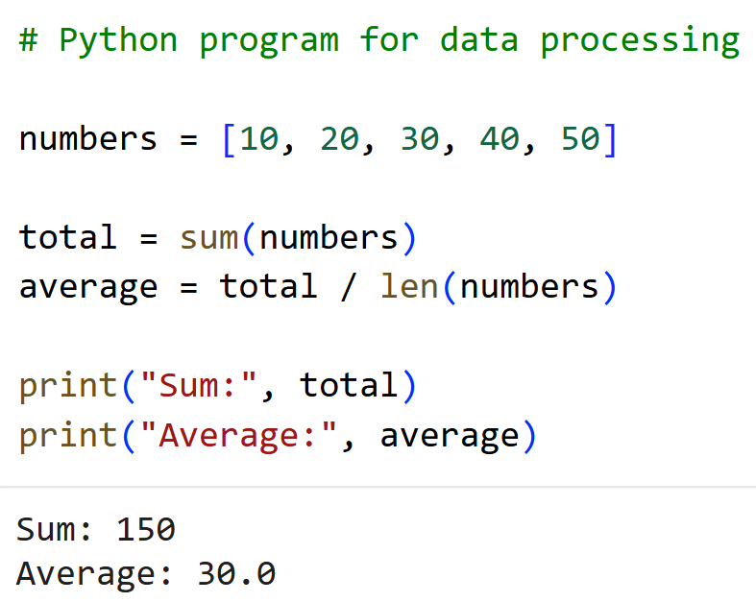

C++ Code (Converted)
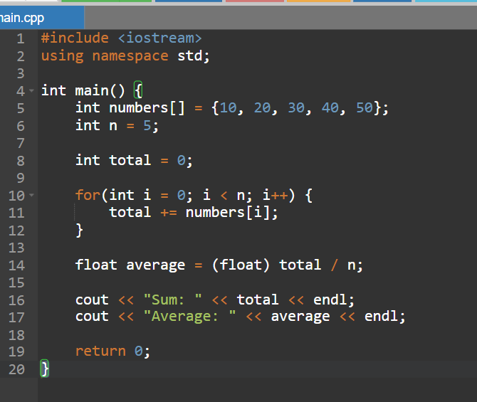
Sample Input/Output:
Python Code (Source)
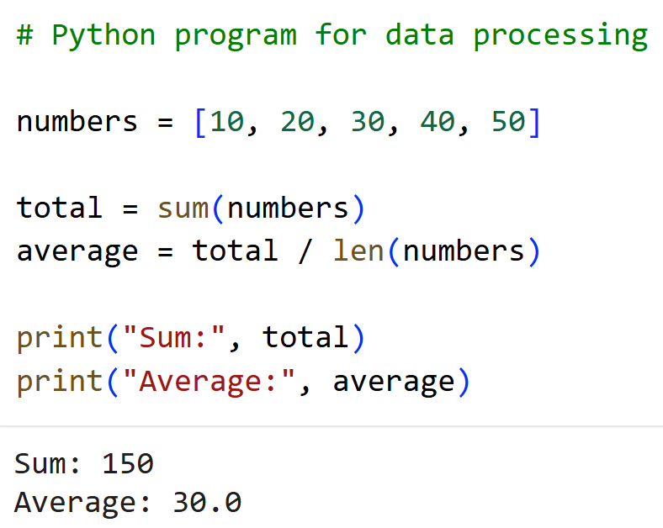

C++ Code (Converted)
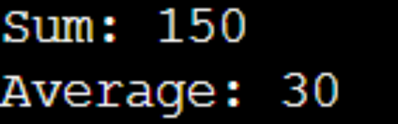

Code Explanation:
- This task demonstrates converting a real-world data processing program between languages.
- The Python program calculates sum and average using built-in functions.
- The C++ version uses loops to perform the same calculations manually.
- Both implementations process the same dataset and produce identical results.
- Python offers simpler syntax and built-in utilities like sum().
- C++ requires explicit loops and type casting for calculations.
- Execution behavior differs as Python is interpreted and C++ is compiled.
- This highlights differences in syntax, libraries, and performance.

Task 5: (Basic Function Translation (Python to C++)
Prompt:
Convert a Python function that checks whether a number is even or odd into an equivalent C++ program. Ensure proper input handling, syntax correctness, and identical output behavior for multiple test cases.
Code:
Python Code (Original)
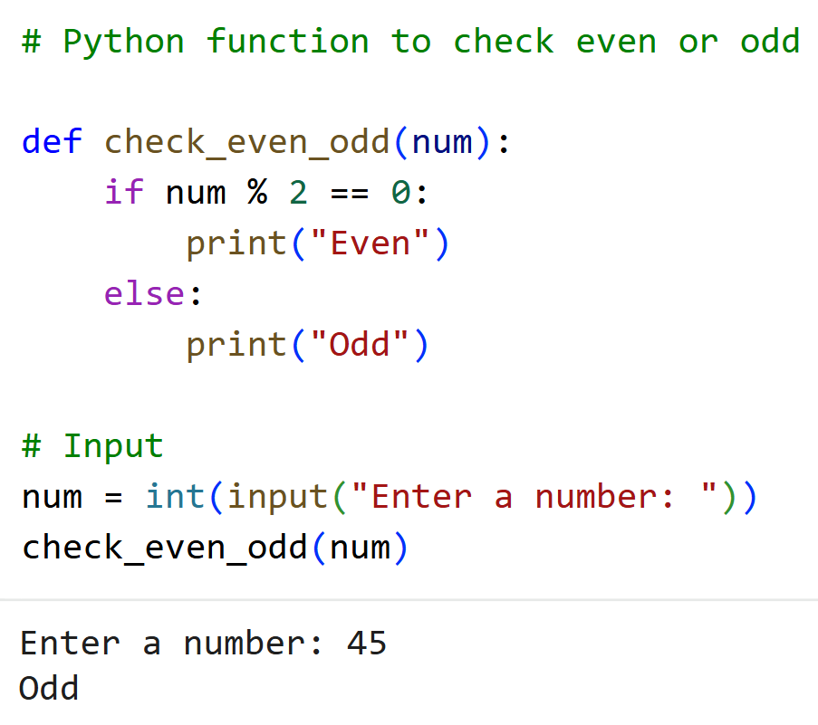

C++ Code (Converted)
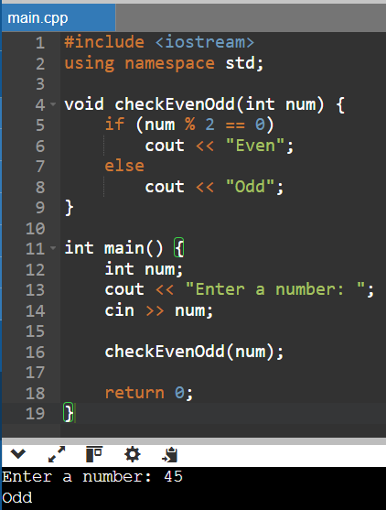

Sample Input/Output:
Python Code (Original)
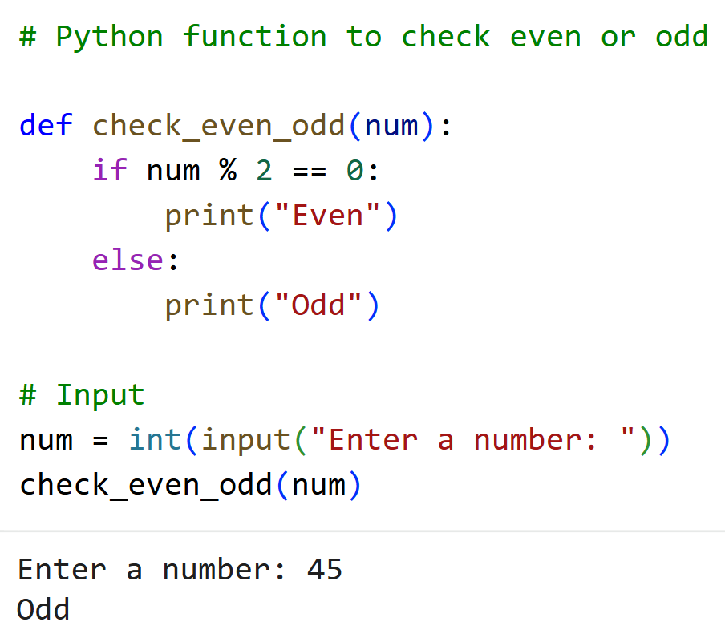

C++ Code (Converted)
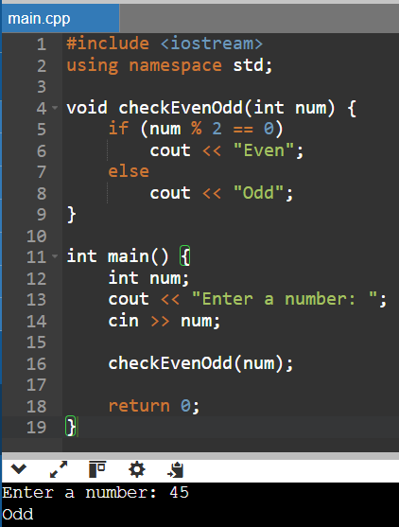

Code Explanation:
- This task demonstrates basic function translation from Python to C++.
- The Python function checks whether a number is even or odd using modulus.
- The same logic is implemented in C++ using a function.
- Input is taken using input() in Python and cin in C++.
- Output is displayed using print() in Python and cout in C++.
- Both programs produce identical results for the same inputs.
- Multiple test cases confirm correctness and consistency.
- This ensures logical equivalence across both languages.

