SCHOOL OF COMPUTER SCIENCE AND ARTIFICIAL INTELLIGENCE |  |  |  |  | DEPARTMENT OF COMPUTER SCIENCE ENGINEERING
Program Name: B. Tech |  |  |  | Assignment Type: Lab |  |  | Academic Year:2025-2026
Course Coordinator Name |  |  |  | Dr. Rishabh Mittal
Instructor(s) Name |  |  |  | Mr. S Naresh Kumar  Ms. B. Swathi  Dr. Sasanko Shekhar Gantayat  Mr. Md Sallauddin  Dr. Mathivanan  Mr. Y Srikanth  Ms. N Shilpa  Dr. Rishabh Mittal (Coordinator)  Dr. R. Prashant Kumar  Mr. Ankushavali MD  Mr. B Viswanath  Ms. Sujitha Reddy  Ms. A. Anitha  Ms. M.Madhuri  Ms. Katherashala Swetha  Ms. Velpula sumalatha  Mr. Bingi Raju
CourseCode |  |  | 23CS002PC304 | Course Title |  | AI Assisted Coding
Year/Sem |  |  | III/II | Regulation |  | R23
Date and Day  of Assignment |  |  | Week11 –Friday | Time(s) |  | 23CSBTB01 To 23CSBTB52
Duration |  |  | 2 Hours | Applicable to  Batches |  | All batches
Assignment Number: 21.5(Present assignment number)/24(Total number of assignments)
 | Q.No. | Question |  |  |  |  |  | Expected Time  to complete
 | 1 | Lab 21 – Collaborative AI Coding: Pair Programming and Version Control Integration  Lab Objectives:  - Learn to use AI as a pair programmer for writing, reviewing, and optimizing code.  - Understand how to integrate AI-generated code into version control systems (Git).  - Practice collaborative workflows such as commit messages, branching, and merging.  Task A – AI-Based Initial Program Development  • Use AI to generate a basic program (e.g., Student Grade Calculator).  • Ask AI to enhance it with validation and additional features.  • Compare both versions.  Task B – AI-Assisted Application Improvement  • Generate a simple program (e.g., Library Management).  • Use AI to add new functionalities.  • Analyze improvements in structure and performance.  Task C – Git Workflow Practice  • Initialize a Git repository.  • Create a new branch and add AI-generated changes.  • Commit and merge changes into the main branch.  Task D – Branching and Merging with AI Support  • Develop a program in the main branch.  • Create a feature branch and modify using AI.  • Merge and verify output.  Task E – AI for Commit Message Writing  • Perform multiple code changes.  • Use AI to generate commit messages.  • Compare with manually written messages.  Task F – Pair Programming with AI Assistance  • Student A develops initial code.  • Student B uses AI to enhance and optimize.  • Integrate changes using Git.  Task G – Collaborative Development using Branches  • Divide work between two students.  • Use AI for feature implementation.  • Merge contributions into a single project.  Task H – AI-Supported Team Coding Workflow  • Simulate a team coding environment.  • Use AI for suggestions and improvements.  • Manage integration using Git branching and merging. |  |  |  |  |  | Week11 –Friday

Task A: AI-Based Initial Program Development
Prompt:
Generate a basic Python program for a Student Grade Calculator that takes marks as input and calculates the grade. Enhance the program by adding input validation and additional features like average calculation and grade classification.

Code:
Initial Code (Basic Version)
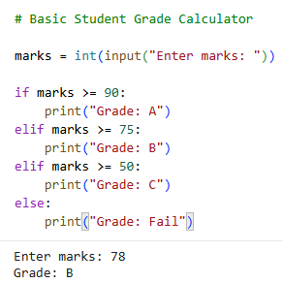

Enhanced Code (Improved Version):
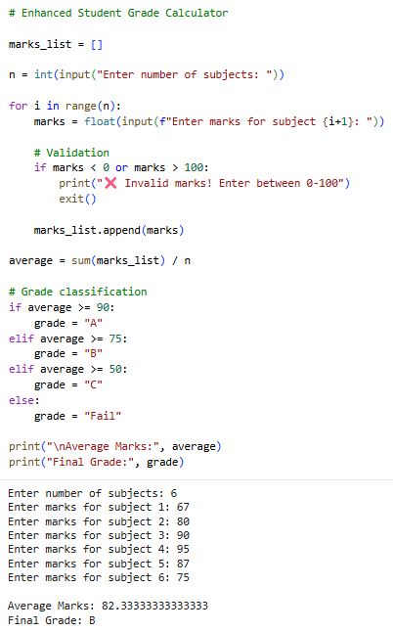

Sample Input/Output:
Initial Code (Basic Version)


Enhanced Code (Improved Version)


Code Explanation:

- This task demonstrates AI-assisted program development and enhancement.
- The initial version calculates grade based on a single input mark.
- It lacks validation and does not handle multiple subjects.
- The enhanced version allows multiple inputs for different subjects.
- Input validation ensures marks are within valid range (0–100).
- The program calculates average marks for accurate grading.
- Additional features improve usability and correctness.
- This shows how AI can refine and optimize code effectively.

Task B: AI-Assisted Application Improvement
Prompt:
Generate a basic Python program for a Library Management System with simple book storage functionality. Enhance the program by adding features like search, issue, return, and improved structure.

Code:
Initial Code (Basic Version)
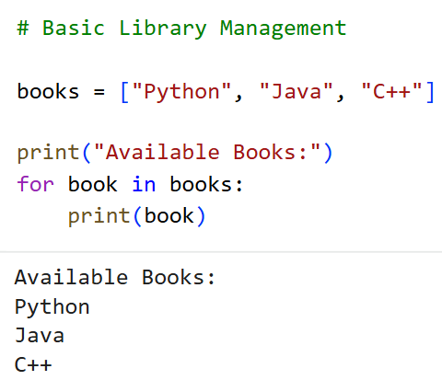

Enhanced Code (Improved Version)
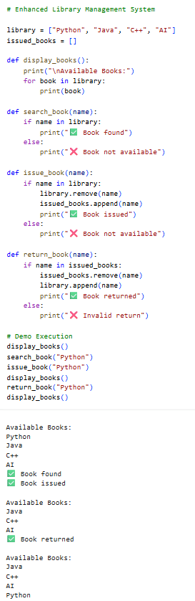

Sample Input/Output:
Initial Code (Basic Version)


Enhanced Code (Improved Version)


Code Explanation:
- This task demonstrates improving an AI-generated application.
- The basic version only displays available books.
- It lacks functionality for real-world usage.
- The enhanced version introduces multiple features like search, issue, and return.
- Functions are used to improve modularity and readability.
- Book availability is dynamically updated during operations.
- Error handling ensures proper responses for invalid actions.
- This shows how AI can enhance both structure and functionality.

Task C : Git Workflow Practice
Prompt:
Demonstrate how to initialize a Git repository, create a new branch, and add AI-generated changes. Perform commit and merge operations to integrate changes into the main branch.

CodeSample Input/Output:
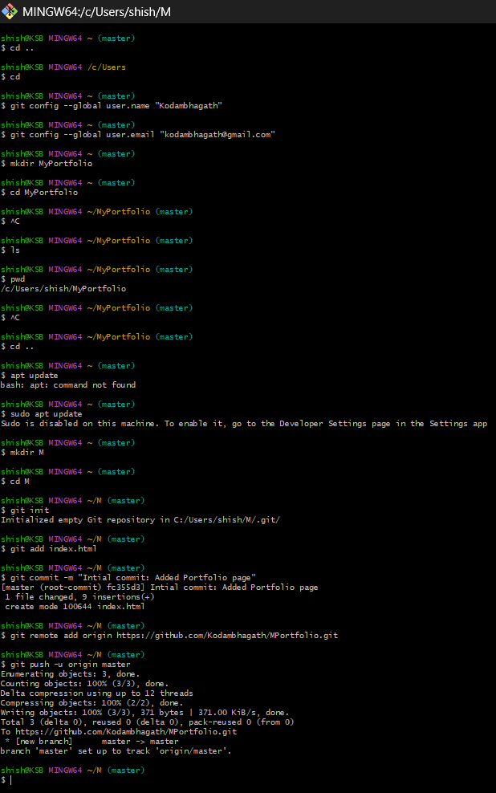







Code Explanation:
- This task demonstrates integration of AI-generated code with Git version control.
- The repository is initialized using git init.
- Initial code is added and committed to the main branch.
- A new branch is created to work on AI-generated improvements.
- Changes are committed separately in the feature branch.
- The main branch is then updated by merging the feature branch.
- This ensures safe and organized code development.
- Git helps track changes and supports collaborative workflows.

Task D: Branching and Merging with AI Support
Prompt:
Demonstrate branching and merging in Git by developing a program in the main branch and enhancing it in a feature branch using AI. Merge the changes back into the main branch and verify the final output.

Code:

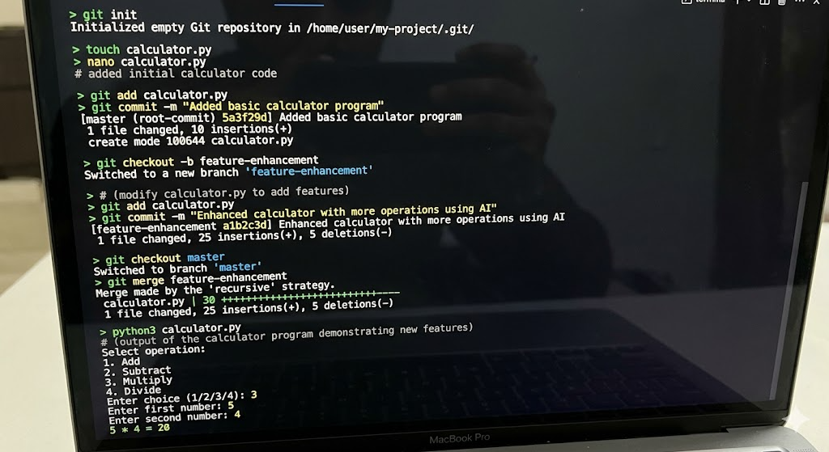









Sample Input/Output:
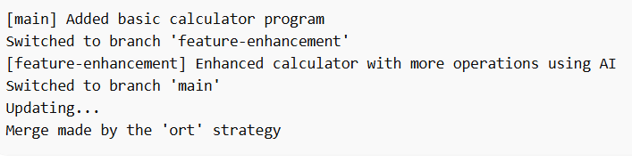

Code Explanation:
- This task demonstrates branching and merging with AI-assisted development.
- The main branch contains the initial version of the program.
- A feature branch is created to add enhancements using AI.
- Changes are committed separately in the feature branch.
- The main branch remains stable during development.
- After completion, changes are merged back into the main branch.
- The final program is tested to verify correct functionality.
- This workflow supports safe and efficient collaborative development.

Task E: AI for Commit Message Writing
Prompt:
Generate meaningful Git commit messages for multiple code changes using AI and compare them with manually written messages. Ensure the messages clearly describe the changes and follow best practices.

Code:

# Manual commit message
git commit -m "Updated code"

# AI-generated commit message
git commit -m "Added input validation and improved calculator functionality"

Sample Input/Output:
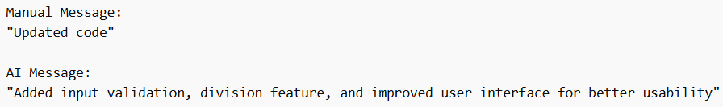

Code Explanation:
- This task focuses on improving commit message quality using AI.
- Manual commit messages are often short and unclear.
- Poor messages make it difficult to track changes in a project.
- AI-generated messages are more descriptive and structured.
- They clearly explain what changes were made and why.
- This improves collaboration and version tracking.
- Better commit messages help in debugging and maintenance.
- AI assists developers in following best practices.

Task F: Pair Programming with AI Assistance
Prompt:
Simulate pair programming where one developer writes initial code and another uses AI to enhance and optimize it. Integrate both contributions using Git and verify the final improved program.
Code:
Initial Code (Student A)
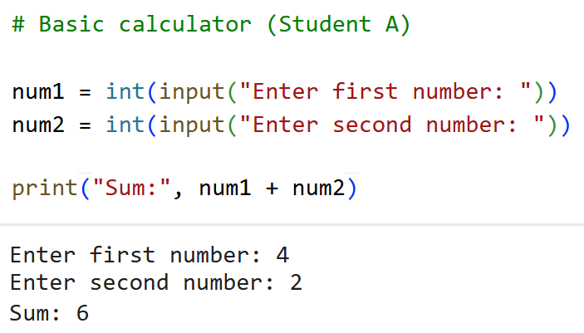

Enhanced Code (Student B using AI):
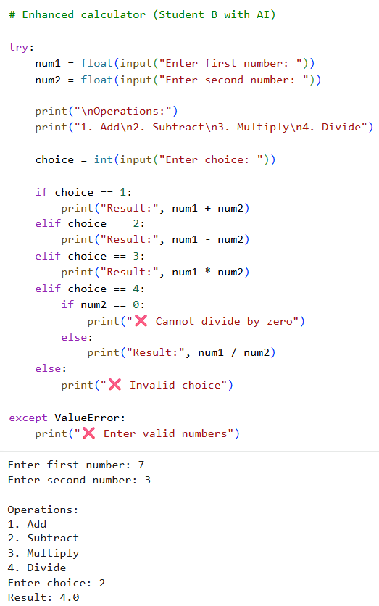
Sample Input/Output:
Initial Code (Student A)


Enhanced Code (Student B using AI)


Code Explanation:

- This task demonstrates pair programming with AI assistance.
- Student A develops a basic calculator with limited functionality.
- Student B uses AI to enhance the program with more features.
- Additional operations like subtraction, multiplication, and division are added.
- Exception handling improves reliability and prevents crashes.
- User interaction is enhanced with a menu-driven approach.
- Both contributions are integrated using Git workflow.
- This shows how AI supports collaborative development effectively.

Task G: Collaborative Development using Branches
Prompt:
Simulate collaborative development where two developers work on different features using Git branches and AI assistance. Merge both contributions into a single project and verify the final integrated output.
Code:
(Feature Implementation by Two Students)
- Student A (Feature 1 — Addition & Subtraction)
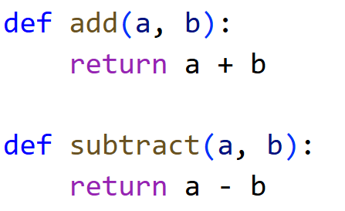
Student B (Feature 2 — Multiplication & Division using AI)
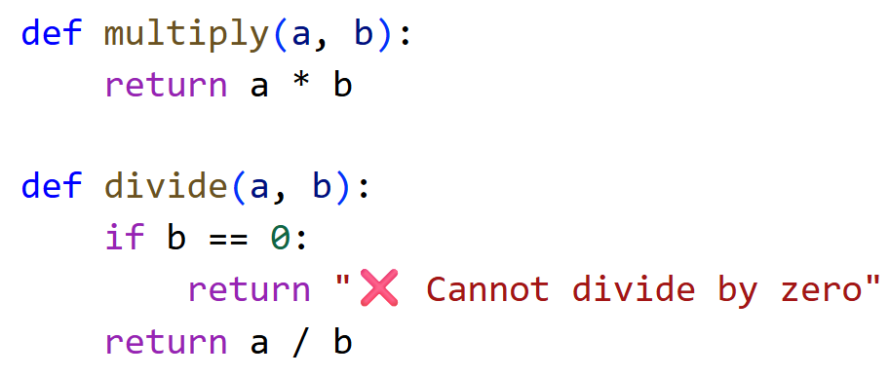
Final Integrated Code (After Merge)
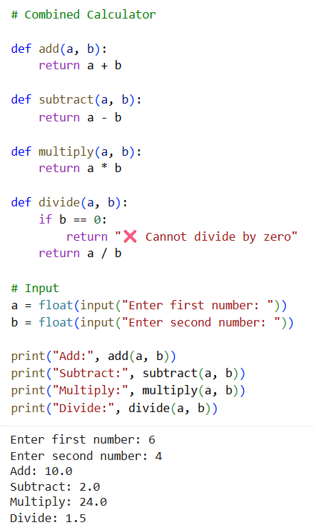
Sample Input/Output:
Final Integrated Code (After Merge)


Code Explanation:
- This task demonstrates collaborative development using Git branches.
- Student A and Student B work on different features independently.
- Student A implements basic operations like addition and subtraction.
- Student B uses AI to implement advanced operations like multiplication and division.
- Each feature is developed in separate branches.
- The features are merged into a single integrated program.
- The final program combines all functionalities and works correctly.
- This approach improves teamwork and efficient development.

Task H: AI-Supported Team Coding Workflow
Prompt:
Simulate a team coding workflow where multiple developers collaborate using AI for suggestions and improvements. Manage code integration using Git branching and merging to produce a final working application.

Code:
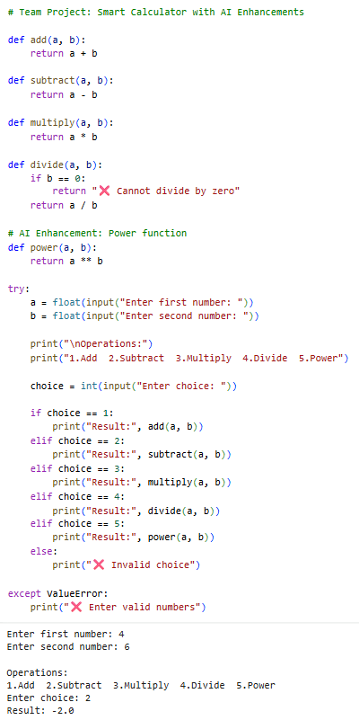
Sample Input/Output:


Code Explanation:

- This task simulates a real-world team coding workflow with AI support.
- Multiple developers contribute different features to the project.
- Basic operations are implemented collaboratively across branches.
- AI is used to suggest and add new functionality like the power operation.
- Git branching allows parallel development without conflicts.
- Changes are merged into a final integrated application.
- Exception handling ensures robustness and reliability.
- This demonstrates efficient team collaboration using AI and version control.

