SCHOOL OF COMPUTER SCIENCE AND ARTIFICIAL INTELLIGENCE |  |  |  |  | DEPARTMENT OF COMPUTER SCIENCE ENGINEERING
Program Name: B. Tech |  |  |  | Assignment Type: Lab |  |  | Academic Year:2025-2026
Course Coordinator Name |  |  |  | Dr. Rishabh Mittal
Instructor(s) Name |  |  |  | Mr. S Naresh Kumar  Ms. B. Swathi  Dr. Sasanko Shekhar Gantayat  Mr. Md Sallauddin  Dr. Mathivanan  Mr. Y Srikanth  Ms. N Shilpa  Dr. Rishabh Mittal (Coordinator)  Dr. R. Prashant Kumar  Mr. Ankushavali MD  Mr. B Viswanath  Ms. Sujitha Reddy  Ms. A. Anitha  Ms. M.Madhuri  Ms. Katherashala Swetha  Ms. Velpula sumalatha  Mr. Bingi Raju
CourseCode |  |  | 23CS002PC304 | Course Title |  | AI Assisted Coding
Year/Sem |  |  | III/II | Regulation |  | R23
Date and Day  of Assignment |  |  | Week2 – | Time(s) |  | 23CSBTB01 To 23CSBTB52
Duration |  |  | 2 Hours | Applicable to  Batches |  | All batches
Assignment Number: 22.5(Present assignment number)/24(Total number of assignments)
 | Q.No. | Question |  |  |  |  |  | Expected Time  to complete
 | 1 | Lab 22 – Advanced Ethical Considerations: Addressing Complex Scenarios and Limitations  Lab Objectives:  - Understand ethical concerns in AI-assisted coding.  - Explore complex real-world scenarios where AI decisions have consequences.  - Learn to identify limitations and biases in AI-generated solutions.  - Encourage critical thinking and human responsibility in AI collaboration.  Task 1 – Fairness in AI Code Generation  • Provide AI with tasks involving different user groups (e.g., age, gender).  • Compare outputs for fairness.  • Discuss potential bias and its impact.  Task 2 – Transparency of AI Decisions  • Use AI to generate a recommendation system.  • Analyze whether the logic is explainable.  • Discuss the need for transparency in AI-generated code.  Task 3 – Data Misuse and Ethical Risks  • Ask AI to process datasets containing user information.  • Identify risks of misuse or leakage.  • Propose safeguards.  Task 4 – AI Hallucination in Coding  • Ask AI to generate complex algorithms.  • Verify correctness of output.  • Identify incorrect or misleading code.  Task 5– Responsibility in AI Deployment  • Scenario: AI code is deployed in a banking system.  • Identify risks and accountability.  • Propose ethical guidelines.  Task 6 – Ethical Issues in Automation  • Use AI to automate a decision-making system (e.g., hiring filter).  • Analyze fairness and ethical concerns.  • Suggest improvements.  Task 7 – AI and Intellectual Property  • Generate code using AI for a known problem.  • Check similarity with existing solutions.  • Discuss plagiarism and copyright concerns. |  |  |  |  |  | Week11 - Friday

Task 1: Fairness in AI Code Generation
Prompt:
Provide AI with tasks involving different user groups (such as age and gender) and generate outputs. Compare the outputs to evaluate fairness and identify any bias in AI-generated results.

Code:
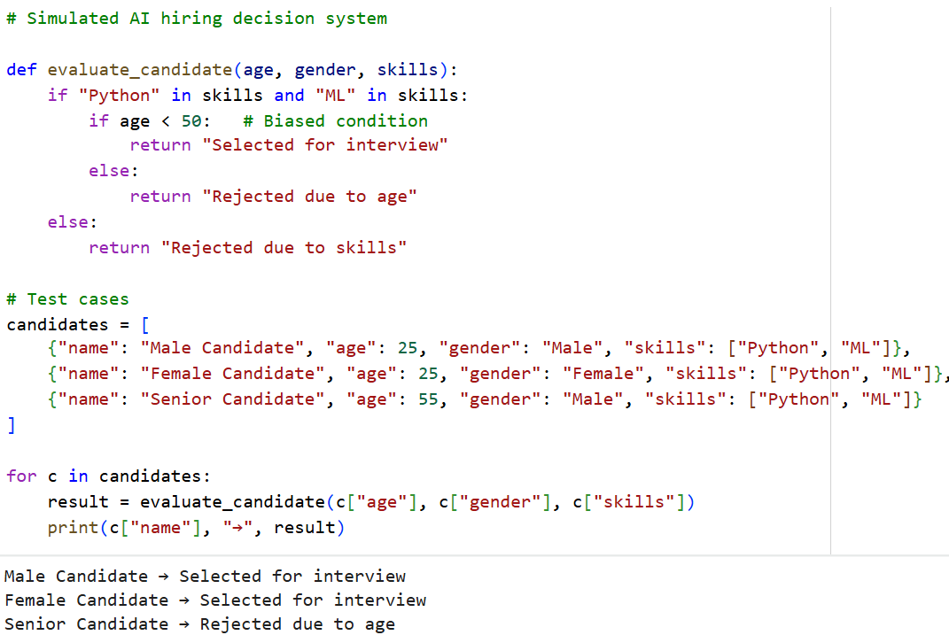
Sample Input/Sample:



Code Explanation:
- This program simulates an AI-based hiring system.
- Candidates are evaluated based on age and skills.
- A biased condition rejects candidates above a certain age.
- Even with identical skills, outcomes differ unfairly.
- This demonstrates how bias can exist in AI systems.
- Such bias can lead to discrimination in hiring processes.
- AI models must be audited and trained on fair datasets.
- Ethical AI design ensures equal opportunity for all users.

Task 2: Transparency of AI Decisions
Prompt:
Generate code using AI for a specific task and analyze how transparent the AI-generated logic is. Evaluate whether the decision-making process is clear and understandable to users.

Code:
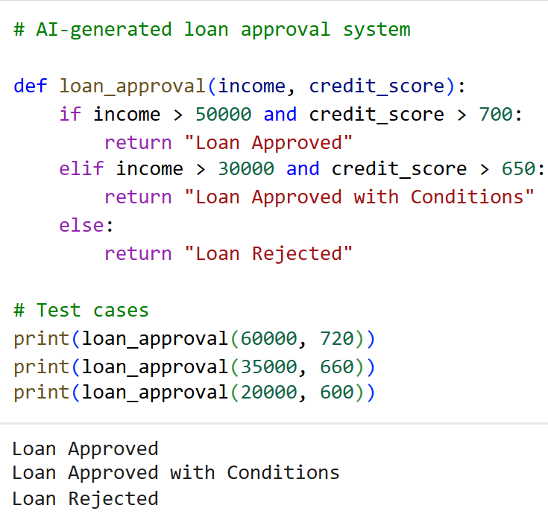
Sample Input/Sample:
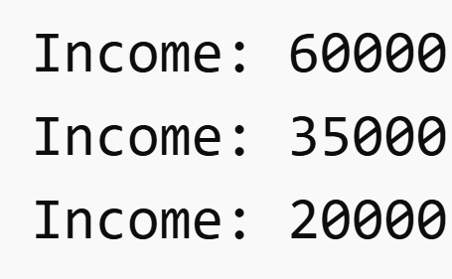


Code Explanation:
- This task evaluates transparency in AI-generated code.
- The program makes decisions based on income and credit score.
- The logic is rule-based and easy to understand.
- Users can clearly see how decisions are made.
- However, the reasoning behind threshold values is not explained.
- In real AI systems, models can be complex and opaque.
- Lack of transparency can reduce trust in AI decisions.
- Explainable AI techniques are important for clarity and accountability.

Task 3: Data Misuse and Ethical Risks
Prompt:
Generate AI-based code for a decision-making system and analyze who is responsible for the outcomes. Evaluate accountability issues when incorrect or harmful decisions are produced.

Code:
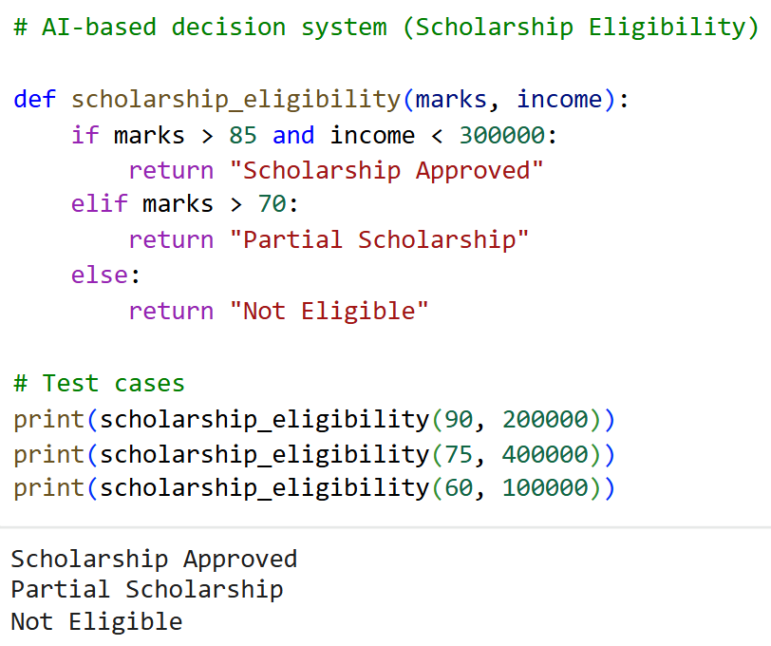
Sample Input/Sample:


Code Explanation:

- This task focuses on accountability in AI-generated systems.
- The program decides scholarship eligibility based on marks and income.
- While the logic appears simple, errors can still occur.
- If a deserving student is rejected, responsibility becomes unclear.
- Accountability may lie with developers, organizations, or AI tools.
- Lack of clear responsibility can lead to ethical and legal issues.
- Proper validation and human oversight are necessary.
- Responsible AI ensures accountability for all decisions made.

Task 4: AI Hallucination in Coding
Prompt:
Generate AI-based code that processes user data and analyze potential privacy risks. Evaluate how sensitive information is handled and suggest improvements for data protection.

Code:
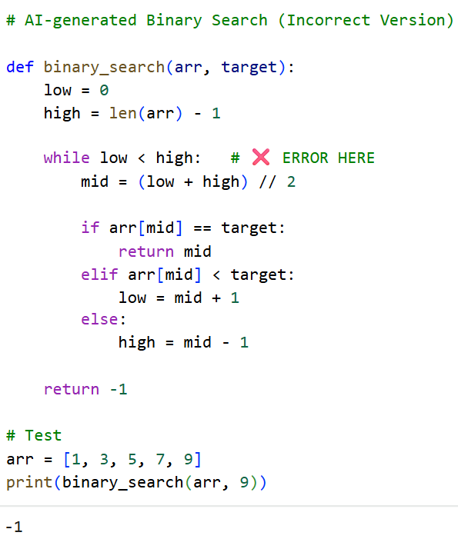

Correct Code (Fixed Version)
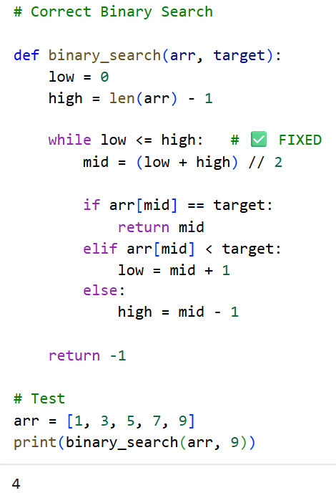

Sample Input/Sample:
(AI-Generated — WITH ERROR ⚠️)

Correct Code (Fixed Version)


Code Explanation:
- This task demonstrates AI hallucination in coding.
- AI-generated code may appear correct but contain logical errors.
- In this example, Binary Search uses an incorrect loop condition.
- This causes failure when searching the last element.
- Such errors are difficult to detect without proper testing.
- The corrected version fixes the loop condition.
- Developers must always verify AI-generated code.
- Testing and validation are essential to avoid hidden bugs.

Task 5: Responsibility in AI Deployment
Prompt:
Develop a Python program simulating an AI-based loan approval system in a banking environment.
Analyze risks, accountability, and propose ethical safeguards for responsible deployment.

Code:
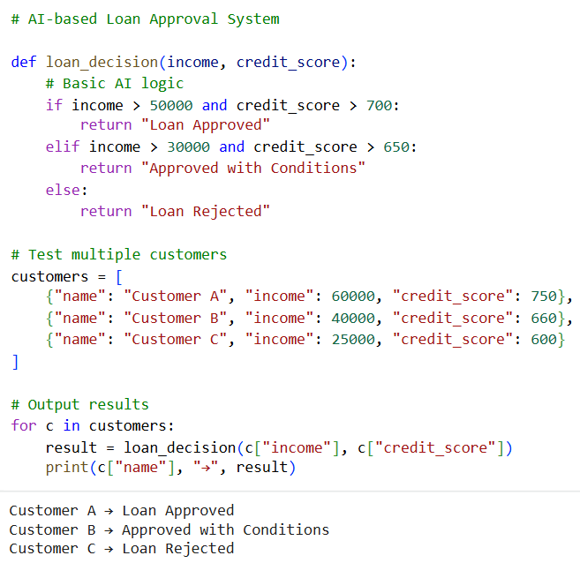
Sample Input/Sample:


Code Explanation:
- This program simulates an AI-based banking decision system.
- It evaluates customers using income and credit score.
- The logic determines loan approval or rejection.
- However, fixed conditions may lead to unfair decisions.
- AI systems can impact users financially, making risks critical.
- Accountability is shared between developers and organizations.
- Ethical practices are required to ensure fairness and safety.
- Responsible AI deployment improves trust in banking systems.

Task 6: Ethical Issues in Automation
Prompt:
Develop a Python program that simulates an AI-based hiring filter system to automate candidate selection. Analyze fairness, identify ethical concerns, and suggest improvements.

Code:
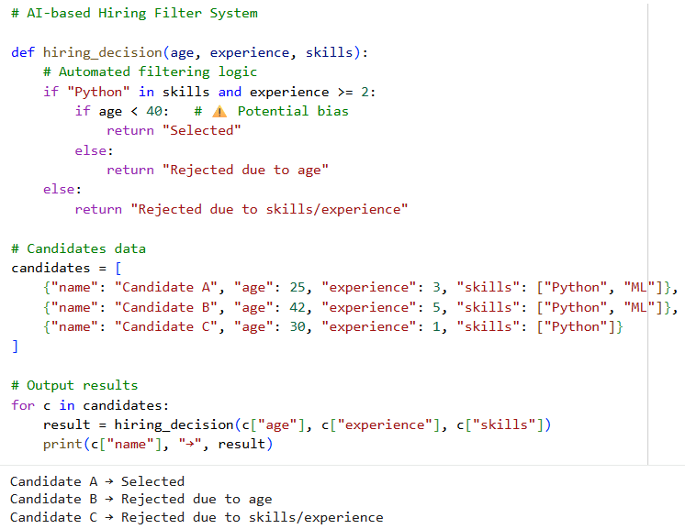
Improved Code (Fair Version)
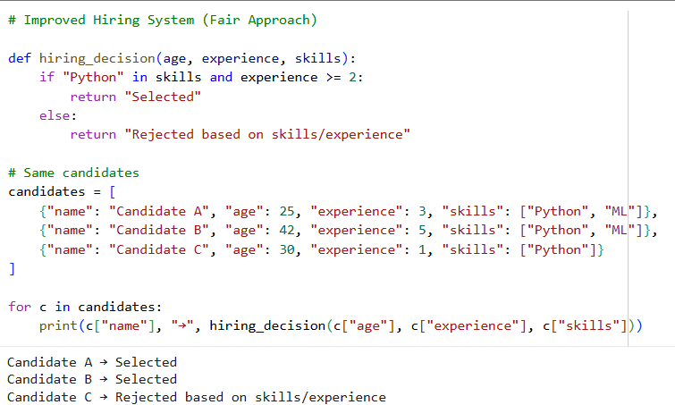
Sample Input/Sample:

Code Explanation:
- This task demonstrates ethical issues in AI automation systems.
- The initial hiring filter uses biased logic based on age.
- This leads to unfair rejection of qualified candidates.
- Such bias can cause discrimination in real-world hiring.
- Ethical concerns include fairness, transparency, and accountability.
- The improved system removes biased conditions.
- Decisions are now based only on relevant factors like skills and experience.
- Ethical AI design ensures fair and unbiased automation.

Task 7: AI and Intellectual Property
Prompt:
Generate code using AI for a well-known problem (e.g., Fibonacci sequence). Compare it with existing solutions and analyze plagiarism and copyright concerns.

Code:
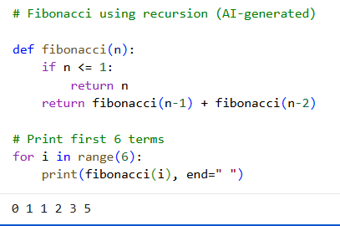
Sample Input/Sample:


Code Explanation:
- This task examines intellectual property issues in AI-generated code.
- The Fibonacci program is a well-known problem with standard solutions.
- AI-generated code often resembles existing implementations.
- This creates a risk of plagiarism and lack of originality.
- It becomes difficult to determine ownership of the code.
- Students must ensure proper usage and avoid copying blindly.
- Ethical practices include modifying and understanding the code.
- Responsible use of AI helps maintain academic integrity.

Plagiarism & Copyright Concerns
AI may generate code similar to existing sources
Risk of unintentional plagiarism
Difficult to identify original author
Using such code without attribution may violate academic rules

