SCHOOL OF COMPUTER SCIENCE AND ARTIFICIAL INTELLIGENCE |  |  |  |  | DEPARTMENT OF COMPUTER SCIENCE ENGINEERING
Program Name: B. Tech |  |  |  | Assignment Type: Lab |  |  | AcademicYear:2025-2026
Course Coordinator Name |  |  |  | Dr. Rishabh Mittal
Instructor(s)Name |  |  |  | Mr. S Naresh Kumar  Ms. B. Swathi  Dr. Sasanko Shekhar Gantayat  Mr. Md Sallauddin  Dr. Mathivanan  Mr. Y Srikanth  Ms. N Shilpa  Dr. Rishabh Mittal (Coordinator)  Dr. R. Prashant Kumar  Mr. Ankushavali MD  Mr. B Viswanath  Ms. Sujitha Reddy  Ms. A. Anitha  Ms. M.Madhuri  Ms. Katherashala Swetha  Ms. Velpulasumalatha  Mr. Bingi Raju
Course Code |  |  | 23CS002PC304 | Course Title |  | AI Assisted Coding
Year/Sem |  |  | III/II | Regulation |  | R23
Date and Day  of Assignment |  |  | Week 7 - Tuesday | Time(s)
Duration |  |  | 2 Hours | Applicable to  Batches |  | 23CSBTB01 To 23CSBTB52
Assignment Number:14.2(Presentassignmentnumber)/24(Totalnumberofassignments)
 | Q.No. | Question |  |  |  |  |  | Expected Time  to complete
 | 1 | Lab 14: Web Design Application – AI-Assisted HTML/CSS/JS Generation  Lab Objectives  - Design functional, visually appealing web applications using HTML, CSS, and JavaScript with AI assistance.  - Apply responsive, accessible, and interactive design principles.  - Create practical UI components for real-world web applications.  - Use AI to optimize layout, UX, and performance.  Task Description 1 – (Landing Page Design)  - Create a simple landing page for a product or service. Include a header, hero section, and footer.  Requirements:  - Use HTML and CSS to structure the page.  - Use AI to suggest layout alignment and typography.  - Ensure the page is responsive across devices.  Task Description 2 – (Theme Toggle Feature)  - Provide a button to switch between light and dark themes..  Requirements:  - Use JavaScript to toggle CSS classes.  - Use AI assistance to manage color contrast and accessibility.  - Ensure theme preference applies instantly on click.  Task Description 3 – (User Feedback Form)  - Create a feedback form with fields: Username, Rating, Comments.  Requirements:  - Use JavaScript to validate required fields.  - Display success or error messages dynamically.  - Use AI to improve form usability and layout.  Task Description - 4 (Image Gallery with JavaScript)  - Task: Display a small image gallery on a web page.  Requirements:  - Use JavaScript to dynamically load images.  - Add next/previous navigation buttons.  - Use AI to optimize layout responsiveness.  Task Description - 5: (Notification Banner)  - Display a notification banner at the top of the page.  Requirements:  - Use JavaScript to show and hide the banner.  - Style the banner using CSS.  - Use AI to ensure smooth transitions and clean UI behavior.  Note: Report should be submitted a word document for all tasks in a single document with prompts, comments & code explanation, and output and if required, screenshots |  |  |  |  |  | Week 7 - Tuesday

Task -1: (Landing Page Design)
Prompt:
Create a responsive landing page for a product or service using HTML and CSS with a header, hero section, and footer. Ensure proper layout alignment, readable typography, and responsiveness across devices.

Code:
<!DOCTYPE html>
<html lang="en">
<head>
<meta charset="UTF-8">
<meta name="viewport" content="width=device-width, initial-scale=1.0">
<title>Product Landing Page</title>

<style>

body{
font-family: Arial, sans-serif;
margin:0;
padding:0;
text-align:center;
}

header{
background:#333;
color:white;
padding:15px;
}

nav a{
color:white;
margin:10px;
text-decoration:none;
}

.hero{
padding:60px;
background:#f4f4f4;
}

.hero h1{
font-size:40px;
}

.hero button{
padding:10px 20px;
background:#007BFF;
color:white;
border:none;
cursor:pointer;
}

footer{
background:#333;
color:white;
padding:10px;
margin-top:20px;
}

@media (max-width:768px){

.hero h1{
font-size:28px;
}

}

</style>

</head>

<body>

<header>
<h2>My Product</h2>
<nav>
<a href="#">Home</a>
<a href="#">Features</a>
<a href="#">Contact</a>
</nav>
</header>

<section class="hero">
<h1>Welcome to Our Product</h1>
<p>Simple solution for your daily needs</p>
<button>Get Started</button>
</section>

<footer>
<p>© 2026 My Product. All rights reserved.</p>
</footer>

</body>
</html>

Sample Input/Output:
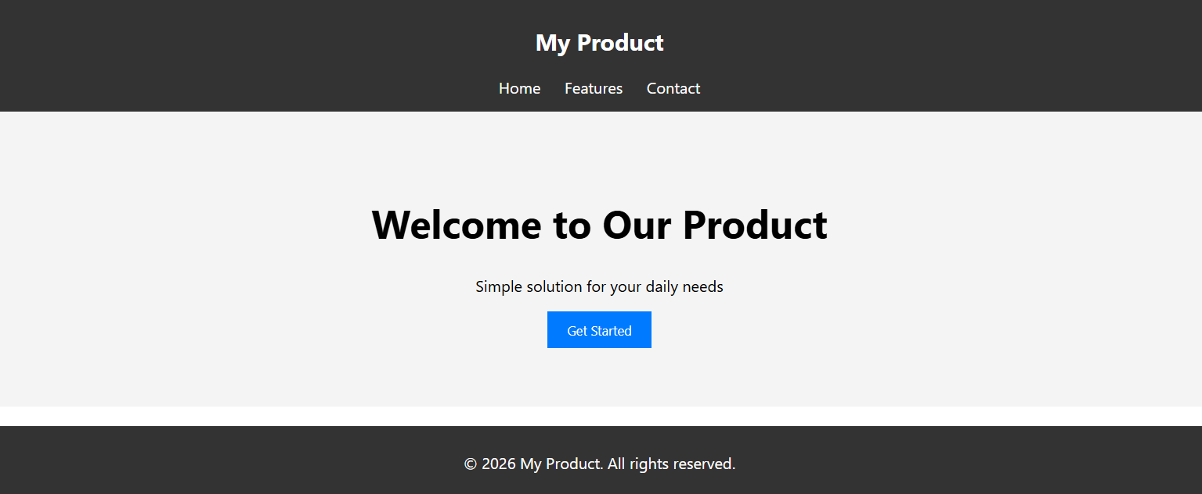

Explanantion:
- This code creates a simple landing page using HTML and CSS.
- The header section contains the website title and navigation links.
- The hero section highlights the product with a heading, description, and call-to-action button.
- The footer section displays copyright information at the bottom of the page.
- CSS is used to style the layout, colors, typography, and spacing.
- The @media query ensures the page is responsive on smaller screens like tablets and mobiles.
- Proper alignment and spacing make the UI visually appealing.
- This structure follows basic web design principles and creates a functional landing page.

Task -2: (Theme Toggle Feature)
Prompt:
Add a button to the landing page that allows users to switch between light and dark themes using JavaScript. Ensure the theme change toggles CSS classes instantly and maintains good color contrast for accessibility.
Code:
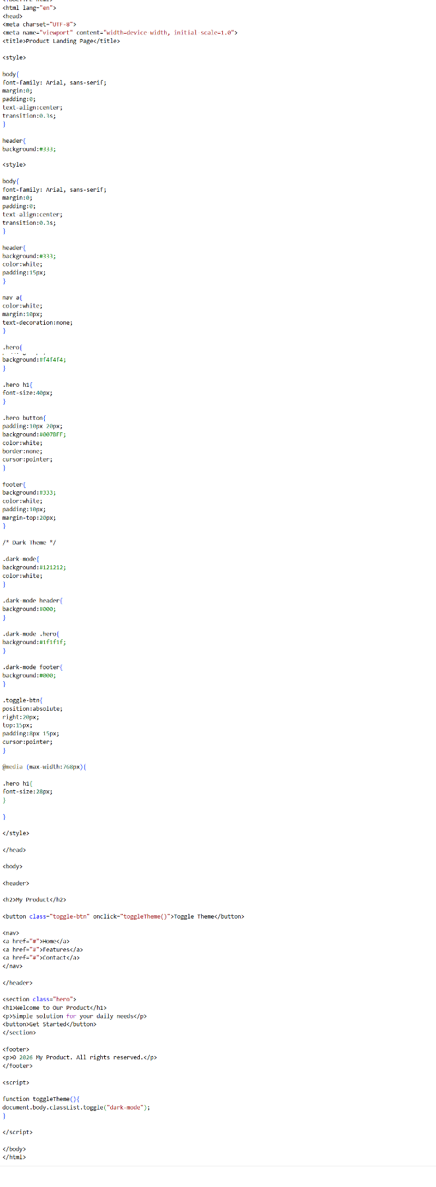
Sample Input/Output:

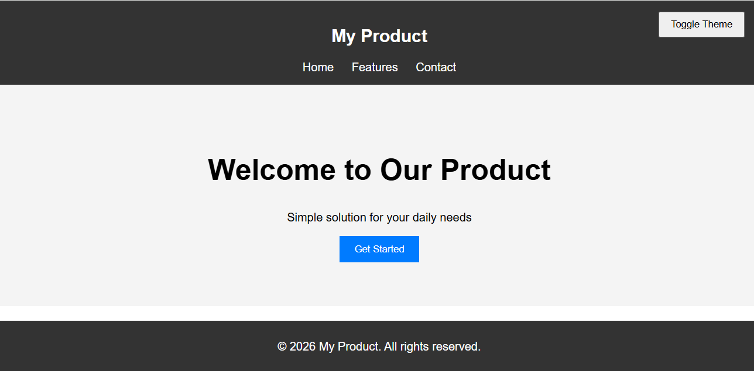

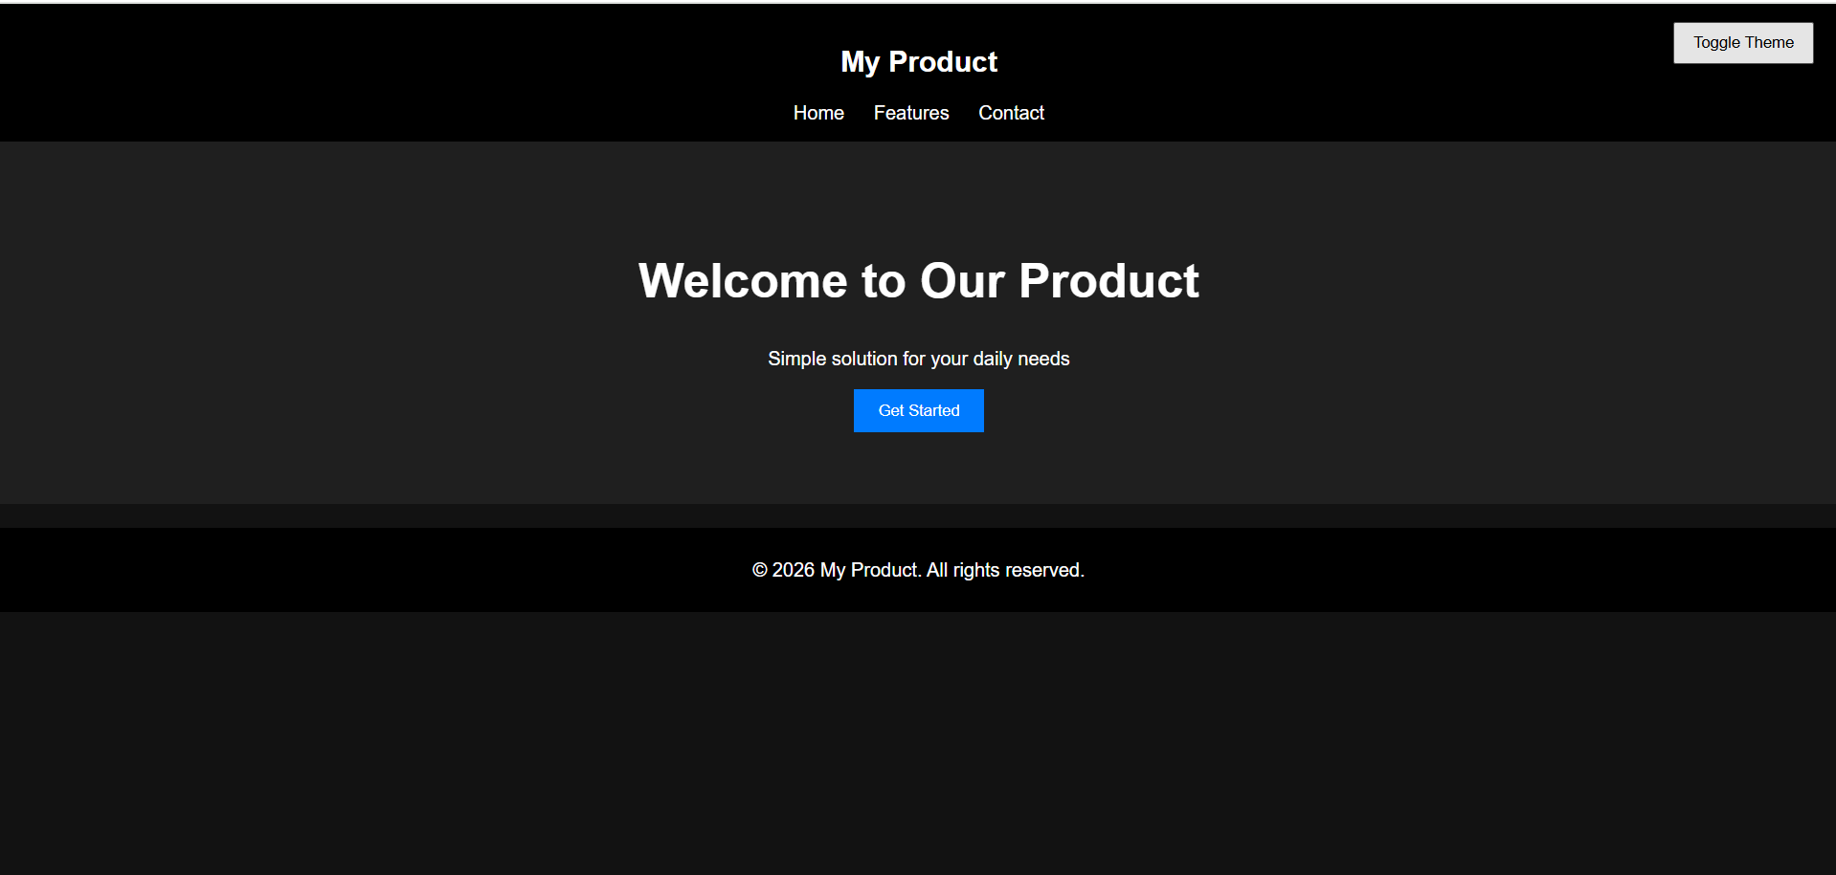

Explanantion:
- This task enhances the landing page by adding a theme toggle feature.
- A button labeled Toggle Theme is added inside the header section.
- JavaScript is used to toggle the dark-mode CSS class on the body element.
- When the class is applied, the page switches to a dark color scheme.
- CSS styles for .dark-mode adjust background colors and text contrast.
- The transition property makes the theme change smooth and visually appealing.
- The feature improves user accessibility by allowing users to select a comfortable viewing mode.
- The theme change happens instantly when the button is clicked.
Task -3: (User Feedback Form)

Prompt:
Create a user feedback form on the webpage with fields for Username, Rating, and Comments. Use JavaScript to validate required fields and display dynamic success or error messages.

Code:
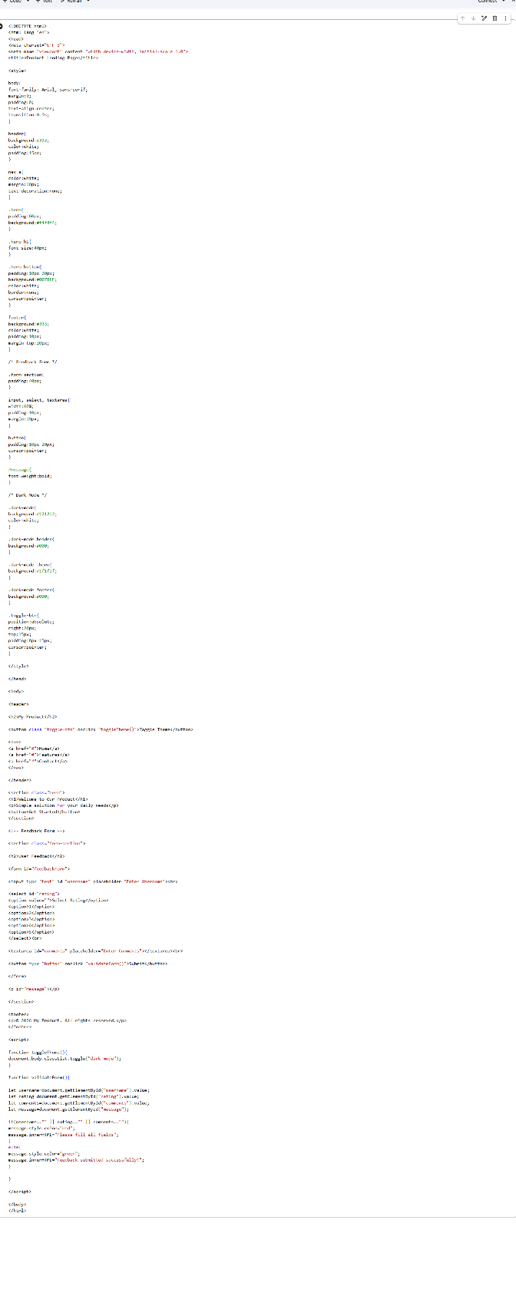

Sample Input/Output:
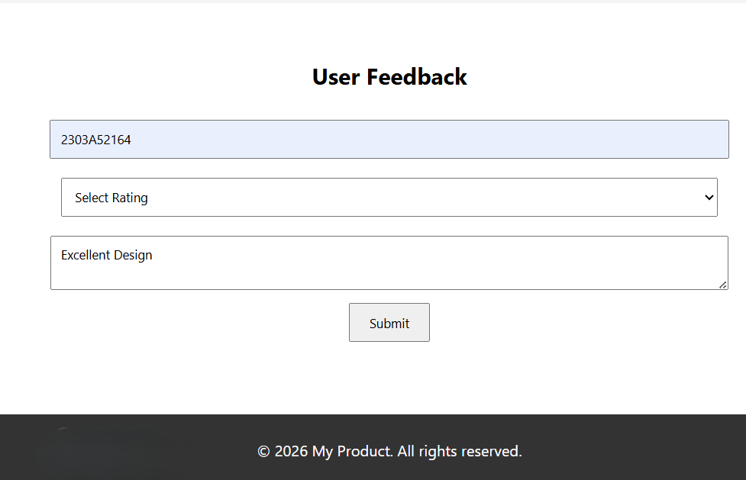

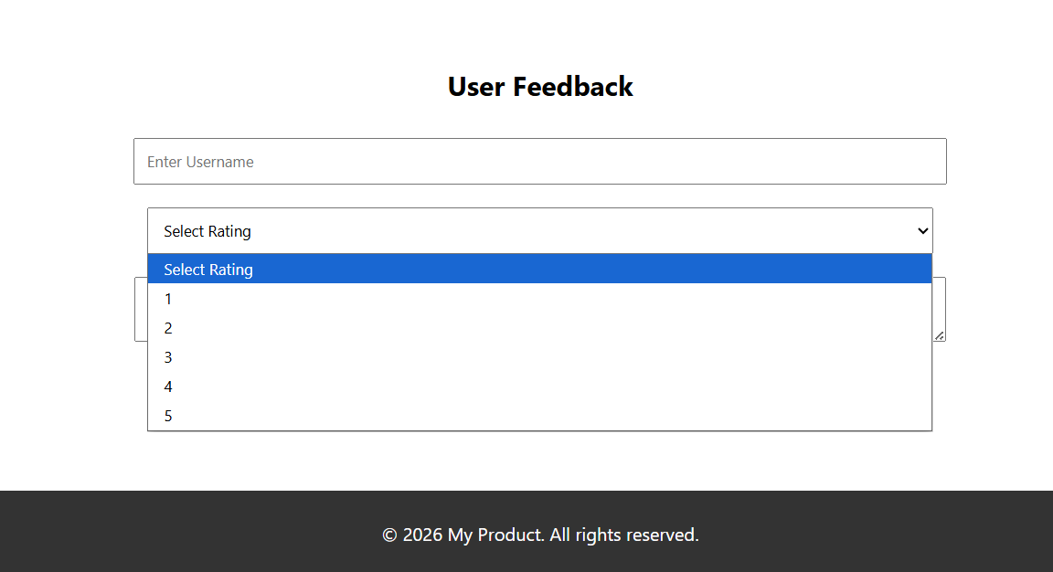

Explanantion:
- This task adds a user feedback form to the existing landing page.
- The form includes three fields: Username, Rating, and Comments.
- HTML is used to create input fields, dropdown selection, and a textarea for comments.
- JavaScript validation checks whether all fields are filled before submission.
- If any field is empty, an error message appears asking the user to complete the form.
- When all fields are correctly filled, a success message is displayed dynamically.
- The feedback form improves interaction and usability of the web application.

Task -4: (Image Gallery with JavaScript)
Prompt:
Add a product gallery section to the website where users can view images of products. Use JavaScript to dynamically load images and provide Next and Previous buttons for navigation.

Code:


Sample Input/Output:
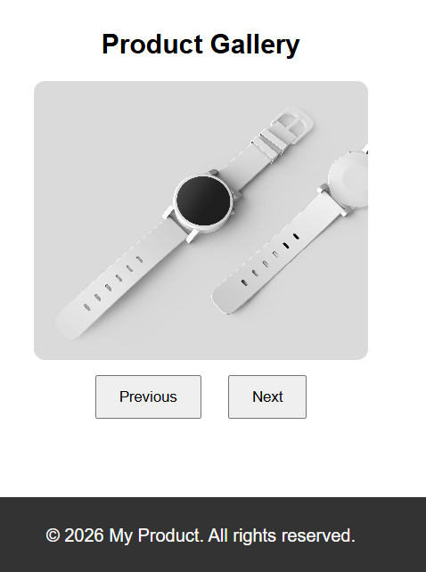

Explanantion:
- This task adds a product image gallery to the existing webpage.
- A new navigation option Product Gallery is added in the header menu.
- When users click the gallery option, the webpage scrolls to the gallery section.
- JavaScript dynamically loads product images stored in an array.
- The gallery displays items such as cups, headphones, gadgets, and watches.
- Next and Previous buttons allow users to navigate through images.
- The gallery layout is styled with CSS for better responsiveness and presentation.
- This feature demonstrates how JavaScript can control dynamic UI elements and user interaction.

Task -5: (Notification Banner)
Prompt:
Add a notification banner at the top of the webpage that can be shown or hidden using JavaScript. Style the banner using CSS and ensure smooth transitions for a clean user interface.

Code:
<!DOCTYPE html>
<html lang="en">
<head>
<meta charset="UTF-8">
<meta name="viewport" content="width=device-width, initial-scale=1.0">
<title>Product Landing Page</title>

<style>

body{
font-family: Arial, sans-serif;
margin:0;
padding:0;
text-align:center;
transition:0.3s;
}

/* Notification Banner */

.banner{
background:#ff9800;
color:white;
padding:10px;
display:flex;
justify-content:space-between;
align-items:center;
}

.banner button{
background:white;
border:none;
padding:5px 10px;
cursor:pointer;
}

/* Header */

header{
background:#333;
color:white;
padding:15px;
}

nav a{
color:white;
margin:10px;
text-decoration:none;
cursor:pointer;
}

/* Hero Section */

.hero{
padding:60px;
background:#f4f4f4;
}

/* Feedback Form */

.form-section{
padding:40px;
}

input,select,textarea{
width:60%;
padding:10px;
margin:10px;
}

/* Gallery */

.gallery{
padding:40px;
display:none;
}

.gallery img{
width:300px;
height:250px;
object-fit:cover;
border-radius:10px;
}

.gallery button{
padding:10px 20px;
margin:10px;
cursor:pointer;
}

/* Footer */

footer{
background:#333;
color:white;
padding:10px;
margin-top:20px;
}

/* Dark Mode */

.dark-mode{
background:#121212;
color:white;
}

.dark-mode header{
background:#000;
}

.dark-mode .hero{
background:#1f1f1f;
}

.dark-mode footer{
background:#000;
}

.toggle-btn{
position:absolute;
right:20px;
top:60px;
padding:8px 15px;
cursor:pointer;
}

</style>

</head>

<body>

<!-- Notification Banner -->

<div class="banner" id="banner">

<span>🔥 Special Offer: Get 20% off on our products today!</span>

<button onclick="hideBanner()">Close</button>

</div>

<header>

<h2>My Product</h2>

<button class="toggle-btn" onclick="toggleTheme()">Toggle Theme</button>

<nav>
<a onclick="showHome()">Home</a>
<a onclick="showGallery()">Product Gallery</a>
<a href="#">Contact</a>
</nav>

</header>

<!-- Hero Section -->

<section class="hero">

<h1>Welcome to Our Product</h1>
<p>Simple solution for your daily needs</p>

</section>

<!-- Feedback Form -->

<section class="form-section">

<h2>User Feedback</h2>

<input type="text" id="username" placeholder="Enter Username"><br>

<select id="rating">
<option value="">Select Rating</option>
<option>1</option>
<option>2</option>
<option>3</option>
<option>4</option>
<option>5</option>
</select><br>

<textarea id="comments" placeholder="Enter Comments"></textarea><br>

<button onclick="validateForm()">Submit</button>

<p id="message"></p>

</section>

<!-- Product Gallery -->

<section class="gallery" id="gallery">

<h2>Product Gallery</h2>

<img id="productImage" src="" alt="product">

<br>

<button onclick="previousImage()">Previous</button>
<button onclick="nextImage()">Next</button>

</section>

<footer>
<p>© 2026 My Product. All rights reserved.</p>
</footer>

<script>

/* Theme Toggle */

function toggleTheme(){
document.body.classList.toggle("dark-mode");
}

/* Notification Banner */

function hideBanner(){
document.getElementById("banner").style.display="none";
}

/* Feedback Form Validation */

function validateForm(){

let username=document.getElementById("username").value;
let rating=document.getElementById("rating").value;
let comments=document.getElementById("comments").value;
let message=document.getElementById("message");

if(username=="" || rating=="" || comments==""){
message.style.color="red";
message.innerHTML="Please fill all fields";
}
else{
message.style.color="green";
message.innerHTML="Feedback submitted successfully!";
}

}

/* Navigation */

function showGallery(){
document.getElementById("gallery").style.display="block";
window.scrollTo(0,document.body.scrollHeight);
}

function showHome(){
document.getElementById("gallery").style.display="none";
window.scrollTo(0,0);
}

/* Image Gallery */

let images=[
"https://images.unsplash.com/photo-1514228742587-6b1558fcf93a",
"https://images.unsplash.com/photo-1517336714731-489689fd1ca8",
"https://images.unsplash.com/photo-1505740420928-5e560c06d30e",
"https://images.unsplash.com/photo-1523275335684-37898b6baf30"
];

let index=0;

let productImage=document.getElementById("productImage");

productImage.src=images[index];

function nextImage(){

index++;

if(index>=images.length){
index=0;
}

productImage.src=images[index];

}

function previousImage(){

index--;

if(index<0){
index=images.length-1;
}

productImage.src=images[index];

}

</script>

</body>
</html>
Sample Input/Output:
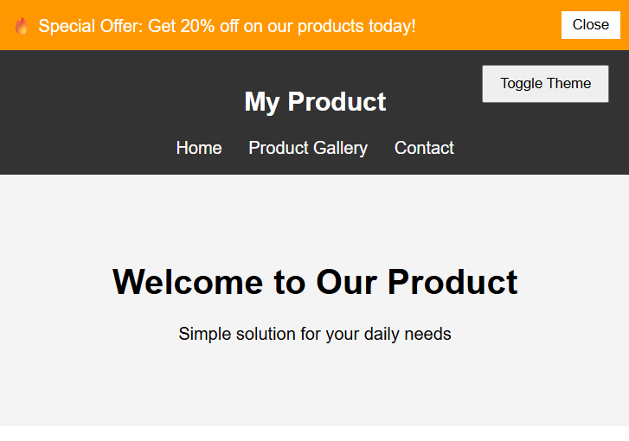

Explanantion:
- This task adds a notification banner at the top of the webpage.
- The banner displays promotional information such as discounts or announcements.
- CSS is used to style the banner with background color, alignment, and spacing.
- A Close button is added so users can hide the notification.
- JavaScript controls the banner visibility using the hideBanner() function.
- When the button is clicked, the banner’s display property changes to none.
- This improves the user experience by allowing users to dismiss notifications easily.
- The feature demonstrates how JavaScript can manage dynamic UI behavior.

