SCHOOL OF COMPUTER SCIENCE AND ARTIFICIAL INTELLIGENCE |  |  |  |  | DEPARTMENT OF COMPUTER SCIENCE ENGINEERING
Program Name: B. Tech |  |  |  | Assignment Type: Lab |  |  | AcademicYear:2025-2026
Course Coordinator Name |  |  |  | Dr. Rishabh Mittal
Instructor(s)Name |  |  |  | Mr. S Naresh Kumar  Ms. B. Swathi  Dr. Sasanko Shekhar Gantayat  Mr. Md Sallauddin  Dr. Mathivanan  Mr. Y Srikanth  Ms. N Shilpa  Dr. Rishabh Mittal (Coordinator)  Dr. R. Prashant Kumar  Mr. Ankushavali MD  Mr. B Viswanath  Ms. Sujitha Reddy  Ms. A. Anitha  Ms. M.Madhuri  Ms. Katherashala Swetha  Ms. Velpulasumalatha  Mr. Bingi Raju
Course Code |  |  | 23CS002PC304 | CourseTitle |  | AI Assisted Coding
Year/Sem |  |  | III/II | Regulation |  | R23
Date and Day  of Assignment |  |  | Week12 - Tuesday | Time(s)
Duration |  |  | 2 Hours | Applicable to  Batches |  | 23CSBTB01 To 23CSBTB52
Assignment Number:24.2(Present assignment number)/24(Total number of assignments)
 | Q.No. | Question |  |  |  |  |  | Expected Time  to complete
 | 1 | Lab 24 – Replit for Mobile Applications  Lab Objectives:  - Explore Replit as a cloud-based IDE for building mobile applications.  - Learn how to leverage AI-assisted coding inside Replit for faster development.  - Understand how to design, test, and deploy simple mobile apps.  - Gain experience in collaborative app development directly from the browser.  Task 1 – Environment Setup  - Create a free Replit account.  - Explore the mobile app development templates (React Native / Flutter / HTML5 hybrid).  - Install required packages or dependencies in the Replit environment.  Task 2 – Basic Mobile App  - Build a simple "Hello App" that displays:  - App Title  - User’s Name (input field + button)  - Greeting message dynamically updated.  - Use AI assistance to generate boilerplate code and explain structure.  Task 3 – Adding Features with AI Assistance  - Enhance the app with:  - Navigation bar (Home, About, Contact).  - Form handling (e.g., user registration page).  - Basic styling with CSS or React Native styles.  - Ask AI in Replit to add inline documentation for each function.  Task 4 – Testing on Mobile  - Run the app in Replit’s mobile preview mode.  - Test responsiveness on different screen sizes.  - Fix UI alignment issues with AI suggestions.  Task 5 – Deployment  - Deploy the app using Replit hosting or export it to a mobile framework (like Expo for React Native).  - Share the deployment link with peers for testing.  Expected Outcomes:  - Students will understand how to use Replit for mobile app development.  - Ability to build a basic functional mobile app with UI, navigation, and user interaction.  - Experience in AI-assisted coding, debugging, and documentation for mobile applications. |  |  |  |  |  | Week 12 - Tuesday

Task 1 :
Prompt:
Set up a Replit environment for mobile application development using HTML5 or React-based templates. Install required dependencies and prepare the workspace for AI-assisted coding.

Code:
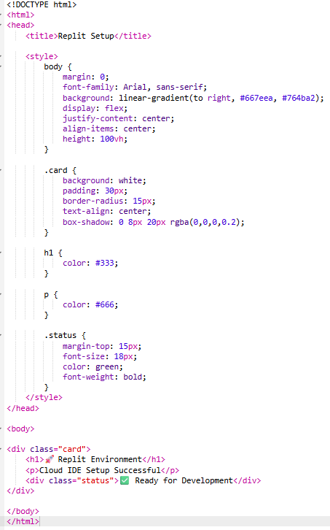

Sample Input/Output:
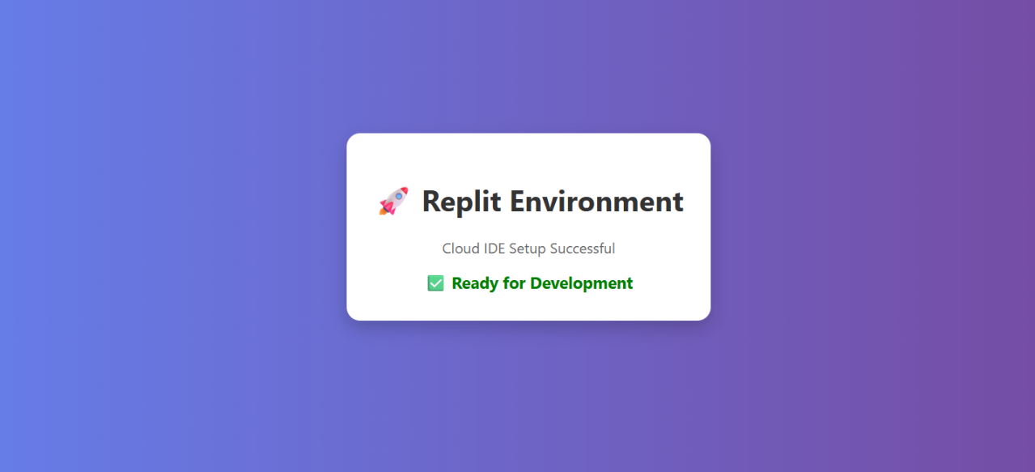

Code Explanation:
- This task sets up the development environment using Replit.
- Replit is a cloud-based IDE that runs in the browser.
- It supports mobile app development using web technologies.
- Templates like HTML, React, or Flutter can be selected.
- The basic test confirms the environment is working.
- No local installation is required.
- AI assistance in Replit helps generate code quickly.
- This setup is required for further tasks.

Task 2 : Basic Mobile App
Prompt:
Build a simple mobile-style web app that displays an app title, takes user input, and shows a dynamic greeting message. Use AI assistance to generate colorful UI and interactive behavior.

Code:
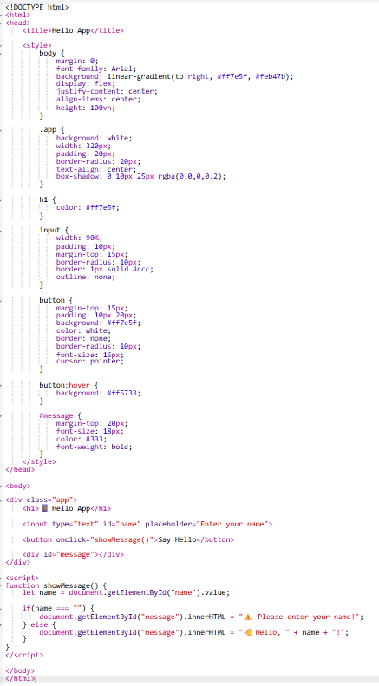

Sample Input/Output:
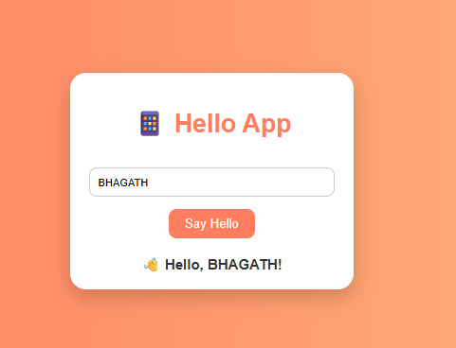

Code Explanation:
- This task builds a simple interactive mobile-style app.
- The UI is designed using HTML and CSS with a gradient background.
- A centered card layout improves visual appearance.
- The input field takes the user’s name.
- A button triggers a JavaScript function.
- The function dynamically updates the greeting message.
- Input validation ensures proper user interaction.
- This demonstrates basic UI + logic integration.

Task 3 : Adding Features with AI Assistance
Prompt:
Enhance the mobile app by adding navigation, form handling, and improved styling using AI assistance. Include inline documentation for each function to improve readability.
Code:
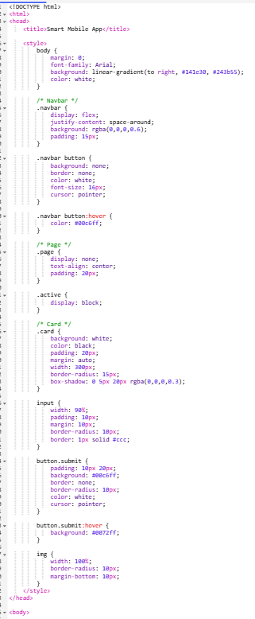

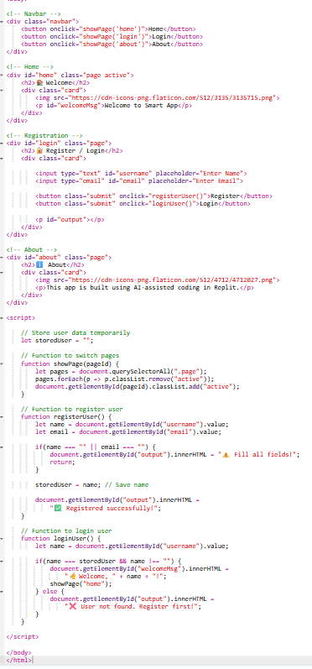

Sample Input/Output:
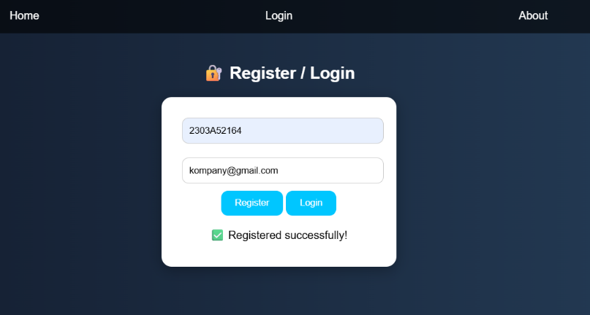
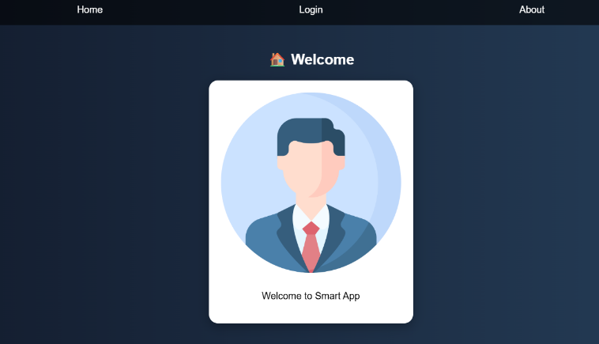
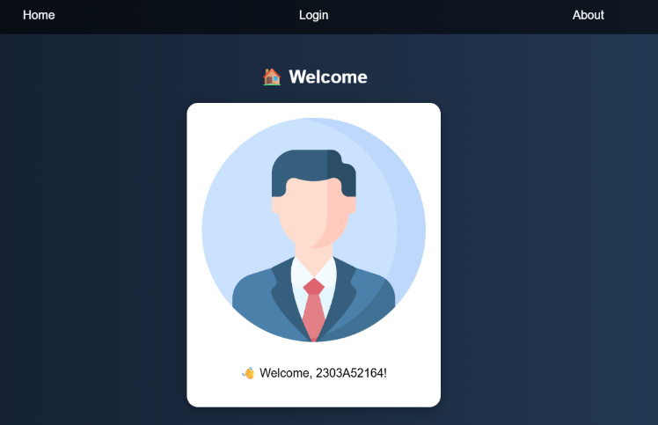

Code Explanation:
- This task enhances the mobile app with additional features.
- A navigation bar allows switching between pages.
- JavaScript is used to control page visibility dynamically.
- A registration form collects user details.
- Input validation ensures correct data entry.
- CSS improves UI with gradients and responsive layout.
- Inline comments explain each function clearly.
- This demonstrates multi-page app behavior in a single file.

Task 4 :
Prompt:
Test the mobile app in Replit’s mobile preview mode and ensure it is responsive across different screen sizes. Fix UI alignment issues using AI suggestions and responsive design techniques.

Code:
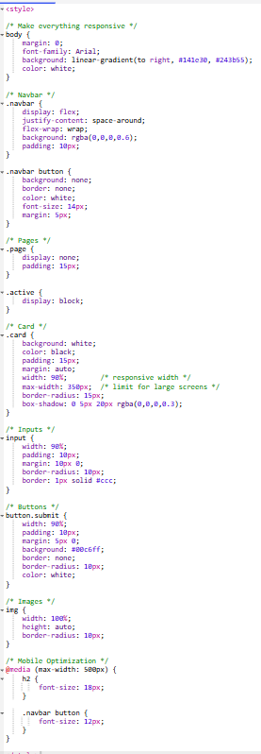

Sample Input/Output:


Code Explanation:
- This task focuses on testing the application on mobile devices.
- Replit provides a mobile preview for testing responsiveness.
- The UI is checked across different screen sizes.
- Issues like overflow and misalignment are identified.
- CSS media queries are used to fix responsiveness.
- Flexible layouts ensure proper display on all devices.
- Images and buttons are resized dynamically.
- This improves user experience across platforms.

Task 5 : Deployment
Prompt:
Deploy the developed mobile web application using Replit hosting and make it accessible via a public link. Test the deployed app and share the link for peer evaluation.

Code:

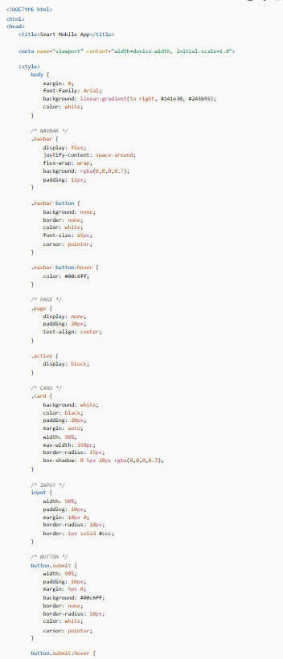

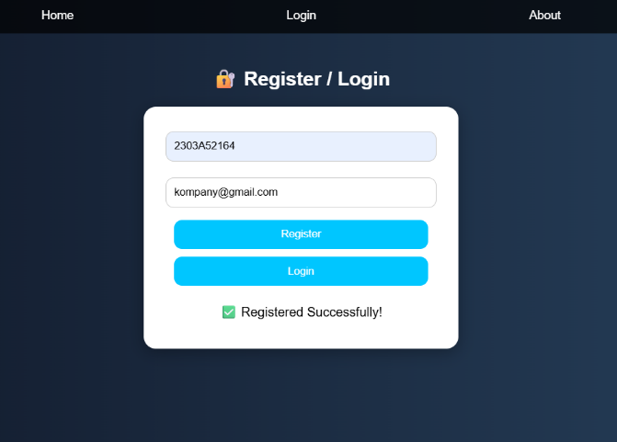
Sample Input/Output:
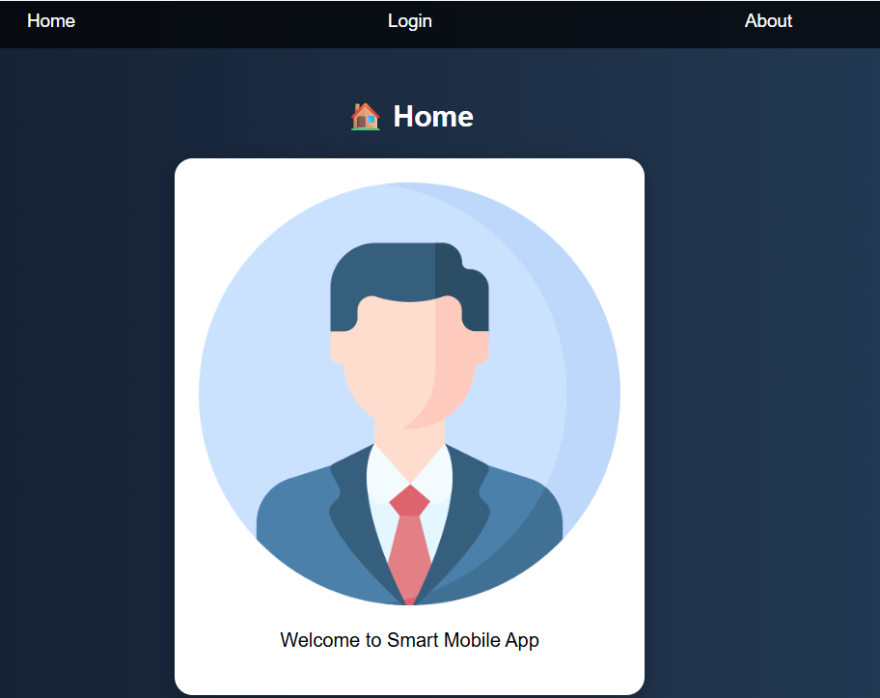
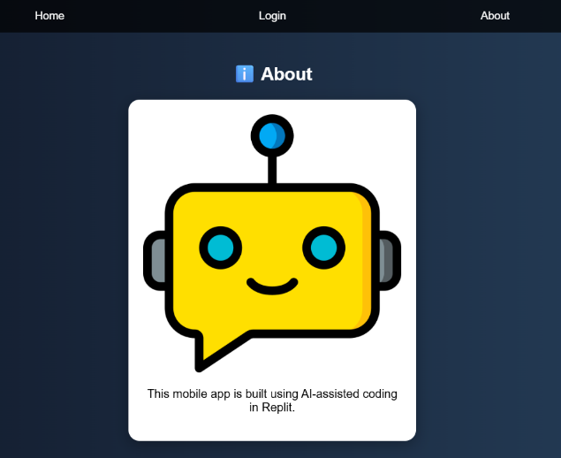
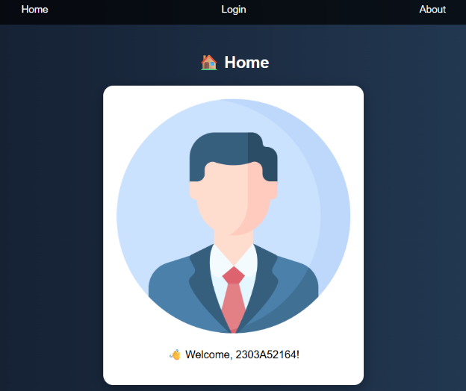

Code Explanation:
- This task focuses on deploying the developed application.
- Replit provides free hosting for web applications.
- The application is made accessible via a public URL.
- Users can test the app in real-time using the link.
- Deployment ensures the app works outside the development environment.
- It allows sharing with peers for feedback.
- AI assistance helped speed up development and debugging.
- This completes the full mobile app development lifecycle.

