SCHOOL OF COMPUTER SCIENCE AND ARTIFICIAL INTELLIGENCE |  |  |  |  | DEPARTMENT OF COMPUTER SCIENCE ENGINEERING
ProgramName:B. Tech |  |  |  | AssignmentType: Lab |  |  | AcademicYear:2025-2026
Course Coordinator Name |  |  |  | Dr. Rishabh Mittal
Instructor(s)Name |  |  |  | Mr. S Naresh Kumar  Ms. B. Swathi  Dr. Sasanko Shekhar Gantayat  Mr. Md Sallauddin  Dr. Mathivanan  Mr. Y Srikanth  Ms. N Shilpa  Dr. Rishabh Mittal (Coordinator)  Dr. R. Prashant Kumar  Mr. Ankushavali MD  Mr. B Viswanath  Ms. Sujitha Reddy  Ms. A. Anitha  Ms. M.Madhuri  Ms. Katherashala Swetha  Ms. Velpulasumalatha  Mr. Bingi Raju
CourseCode |  |  | 23CS002PC304 | CourseTitle |  | AI Assisted Coding
Year/Sem |  |  | III/II | Regulation |  | R23
DateandDay  of Assignment |  |  | Week8 - Tuesday | Time(s)
Duration |  |  | 2 Hours | Applicableto  Batches |  | 23CSBTB01 To 23CSBTB52
AssignmentNumber:16.2(Presentassignmentnumber)/24(Totalnumberofassignments)
 | Q.No. | Question |  |  |  |  |  | ExpectedTime  to complete
 | 1 | Lab 16 – Database Design and Queries: Schema Design and SQL Generation  Lab Objectives:  - Understand schema design principles for relational databases.  - Use AI-assisted tools to generate SQL schema definitions.  - Write and refine SQL queries (CRUD + aggregate operations).  - Explore how AI can optimize queries and ensure normalization.  Task Descrption-1: (Design Database Schema for Student Management System)  Instructions:  - Using AI tools, generate CREATE TABLE statements for a Student Management Database.  - Tables: Students, Courses, Enrollments.  - Include primary keys, foreign keys, and suitable data types.  Ensure the schema follows normalization rules (1NF, 2NF, 3NF).  Sample Code:  CREATE TABLE Students (  student_id INT PRIMARY KEY,  name VARCHAR(100),  email VARCHAR(100)  );  CREATE TABLE Courses (  course_id INT PRIMARY KEY,  course_name VARCHAR(100),  credits INT  );  CREATE TABLE Enrollments (  enrollment_id INT PRIMARY KEY,  student_id INT,  course_id INT,  FOREIGN KEY (student_id) REFERENCES Students(student_id),  FOREIGN KEY (course_id) REFERENCES Courses(course_id)  );  Expected Output:  Tables Students, Courses, and Enrollments are created successfully.  Foreign key constraints are properly enforced.  Task Description- 2: (Insert Sample Records)  Instructions:  - Use AI tools to generate INSERT statements to populate the tables.  - Insert at least 3 students, 4 courses, and 5 enrollment records.  Verify data using SELECT queries.  Sample Code:  INSERT INTO Students VALUES  (1, 'Arjun', 'arjun@gmail.com'),  (2, 'Meera', 'meera@gmail.com'),  (3, 'Rahul', 'rahul@gmail.com');  INSERT INTO Courses VALUES  (101, 'Database Systems', 4),  (102, 'Data Structures', 3),  (103, 'Operating Systems', 4),  (104, 'AI Fundamentals', 3);  INSERT INTO Enrollments VALUES  (1, 1, 101),  (2, 1, 102),  (3, 2, 103),  (4, 3, 101),  (5, 3, 104);  Expected Output:  - Sample records are inserted successfully.  - FROM Students; displays all student records.  - SELECT * FROM Enrollments; displays all enrollments.  Task Description- 3: (Perform CRUD Operations)  Instructions:  Use AI to generate SQL queries for basic CRUD operations:  - Retrieve all courses  - Update a student’s email  - Delete an enrollment record  - Validate the changes using SELECT statements.  Sample Code:  SELECT * FROM Courses;  UPDATE Students  SET email = 'arjun_new@gmail.com'  WHERE student_id = 1;  DELETE FROM Enrollments  WHERE enrollment_id = 5;  Expected Output:  - Updated email is reflected in Students table.  - Deleted enrollment record is removed successfully.  - Remaining data remains unchanged.  Task Description- 4: (Execute Aggregate Queries)  Instructions:  Use AI tools to write aggregate queries:  - Count number of students enrolled per course  - Display courses with more than one student enrolled  Analyze the correctness of results.  Sample Code:  SELECT c.course_name, COUNT(e.student_id) AS student_count  FROM Courses c  JOIN Enrollments e ON c.course_id = e.course_id  GROUP BY c.course_name;  SELECT c.course_name  FROM Courses c  JOIN Enrollments e ON c.course_id = e.course_id  GROUP BY c.course_name  HAVING COUNT(e.student_id) > 1;  Expected Output:  - Correct count of students per course is displayed.  - Courses with multiple enrollments are listed accurately. |  |  |  |  |  | Week8 - Tuesday
Task Description- 5: (Query Optimization)
Instructions:
- Use AI tools to analyze query performance.
- Rewrite inefficient sub queries using JOINs and test both queries for correctness.
Sample Code:
-- Original Query
SELECT * FROM Students
WHERE student_id IN (
SELECT student_id FROM Enrollments WHERE course_id = 101
);

-- Optimized Query
SELECT s.*
FROM Students s
JOIN Enrollments e ON s.student_id = e.student_id
WHERE e.course_id = 101;
Expected Output:
- Both queries return the same set of students.
- Optimized query performs better on large datasets.

This lab allows students to use AI tools like Copilot, Cursor, or Gemini to:
- Generate schema definitions
- Auto-complete insert statements
- Write CRUD and aggregate SQL queries
- Optimize queries and ensure proper normalization

Note: Report should be submitted a word document for all tasks in a single document with prompts, comments & code explanation, and output and if required, screenshots.

Task 1: (Design Database Schema for Student Management System)
Prompt:
Design a relational database schema for a Student Management System using SQL.
Create tables for Students, Courses, and Enrollments with proper primary keys, foreign keys, and normalized structure.

Code:
Create Students Table
CREATE TABLE Students (
student_id INT PRIMARY KEY,
name VARCHAR(100),
email VARCHAR(100)
);

Create Courses Table
CREATE TABLE Courses (
course_id INT PRIMARY KEY,
course_name VARCHAR(100),
credits INT
);

Create Enrollments Table (IMPORTANT ForeignKey)
CREATE TABLE Enrollments (
enrollment_id INT PRIMARY KEY,
student_id INT,
course_id INT,
FOREIGN KEY (student_id) REFERENCES Students(student_id),
FOREIGN KEY (course_id) REFERENCES Courses(course_id)
);
Sample Input/Output:
Create Students Table
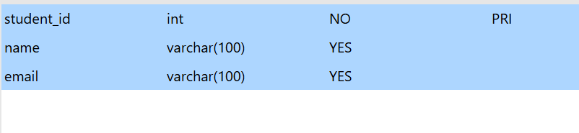

Create Courses Table
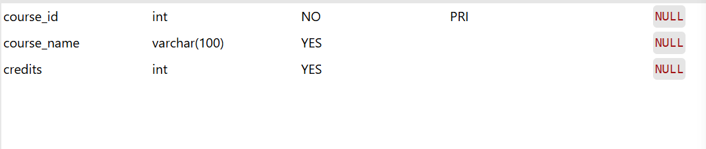
Create Enrollments Table (IMPORTANT ForeignKey)
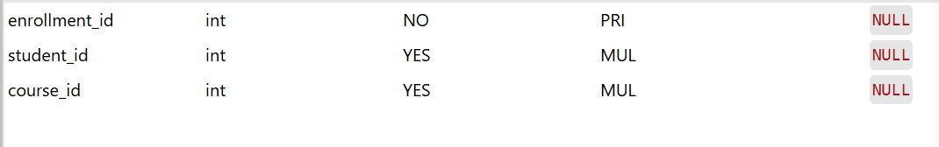

Explanation:
- This task focuses on designing a normalized relational database schema.
- The Students table stores student personal details.
- The Courses table maintains course information and credit values.
- The Enrollments table establishes a many-to-many relationship between students and courses.
- Primary keys uniquely identify each record in the tables.
- Foreign keys enforce data integrity between related tables.
- The schema follows normalization principles to reduce redundancy.
- This structure supports efficient data retrieval and management operations.

Task 2: (Insert Sample Records)
Prompt:
Insert sample records into Students, Courses, and Enrollments tables using SQL queries. Display the inserted data to verify successful database population.

Code:
Insert into Students
INSERT INTO Students VALUES
(1, 'Rahul', 'rahul@gmail.com'),
(2, 'Sneha', 'sneha@gmail.com'),
(3, 'Arjun', 'arjun@gmail.com');

Insert into Courses
INSERT INTO Courses VALUES
(101, 'DBMS', 4),
(102, 'Python', 3),
(103, 'AI', 5);

Insert into Enrollments
INSERT INTO Enrollments VALUES
(1, 1, 101),
(2, 2, 102),
(3, 3, 103);
Sample Input/Output:
Insert into Students
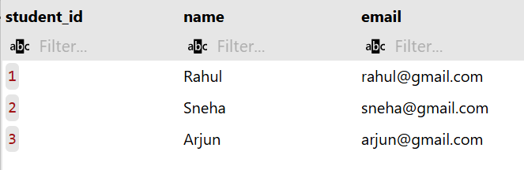
Insert into Courses
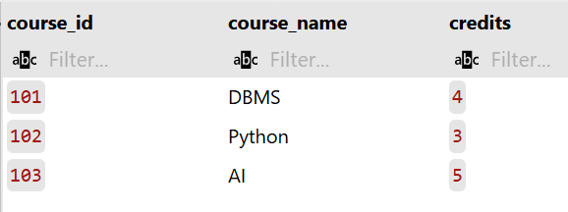

Insert into Courses
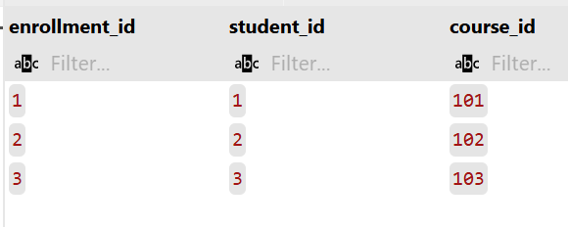

Explanation:
- This task demonstrates how to populate relational tables with sample data.
- INSERT statements are used to add student, course, and enrollment records.
- The Enrollments table references valid student and course IDs ensuring referential integrity.
- Proper ordering of insert operations prevents foreign key constraint errors.
- SELECT queries help verify that the records are stored correctly.
- Displaying table contents confirms successful database transactions.
- This step is essential before performing query operations like joins or updates.
- The populated database now supports real-time academic data management operations.

Task 3: (Perform CRUD Operations)
Prompt:
Write SQL queries to retrieve student details along with their enrolled course information using JOIN operations. Display filtered results based on specific conditions such as course name or credits.

Code:
Update Student Email
UPDATE Students
SET email = 'rahul_new@gmail.com'
WHERE student_id = 1;

Delete Enrollment Record
DELETE FROM Enrollments
WHERE enrollment_id = 3;

Sample Input/Output:
Update Student Email
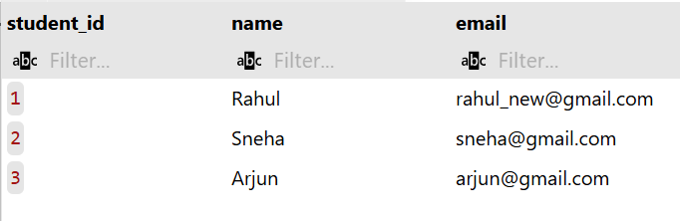

Delete Enrollment Record
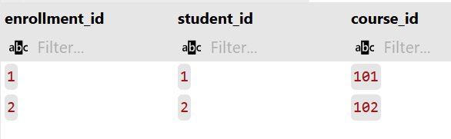

Explanation:
- This task demonstrates execution of fundamental CRUD database operations.
- SELECT query is used to retrieve course information from the Courses table.
- UPDATE query modifies an existing student email ensuring accurate data maintenance.
- DELETE query removes an unwanted enrollment record from the database.
- WHERE clause is used to target specific rows during update and delete operations.
- Validation using SELECT statements confirms successful modification of records.
- These operations are essential for real-time database management systems.
- Proper CRUD handling ensures data consistency and integrity in relational databases.

Task 4: (Execute Aggregate Queries)
Prompt:
Write SQL queries using aggregate functions to analyze course and enrollment data. Calculate total number of students enrolled and average course credits.

Code:
Count Number of Students Enrolled Per Course
SELECT
c.course_name,
COUNT(e.student_id) AS student_count
FROM
Courses c
JOIN
Enrollments e ON c.course_id = e.course_id
GROUP BY
c.course_name;

Display Courses with More Than One Student
SELECT
c.course_name,
COUNT(e.student_id) AS student_count
FROM
Courses c
JOIN
Enrollments e ON c.course_id = e.course_id
GROUP BY
c.course_name
HAVING
COUNT(e.student_id) > 1;

Sample Input/Output:

Count Number of Students Enrolled Per Course
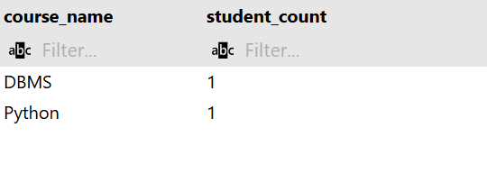

Display Courses with More Than One Student
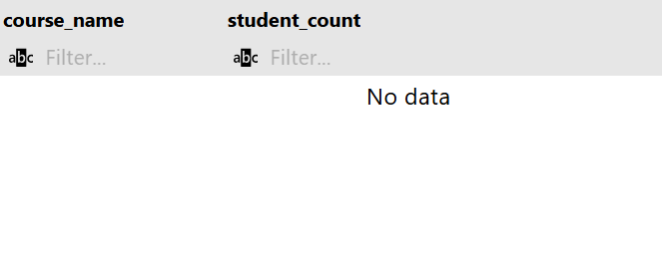
Explanation:

Analysis of Correctness
- The Join: Using JOIN (Internal Join) ensures that only courses with at least one enrollment are counted. If you wanted to see courses with zero students, you would use a LEFT JOIN.
- The Grouping: Grouping by c.course_name is effective, though in a production environment, grouping by c.course_id is safer to avoid merging two different courses that happen to have the same name.
- The Filter: The HAVING clause correctly targets the aggregate COUNT, ensuring the output only lists courses that meet the ‘more than one’ criteria.

Task 5: (Query Optimization)
Prompt:
Create a SQL VIEW to display student names along with their enrolled course names. Use the view to retrieve simplified academic information from multiple related tables.

Code:
The Original Query (Subquery)
SELECT * FROM Students
WHERE student_id IN (
SELECT student_id
FROM Enrollments
WHERE course_id = 101
);

The Optimized Query (JOIN)
SELECT s.*
FROM Students s
JOIN Enrollments e ON s.student_id = e.student_id
WHERE e.course_id = 101;

Sample Input/Output:
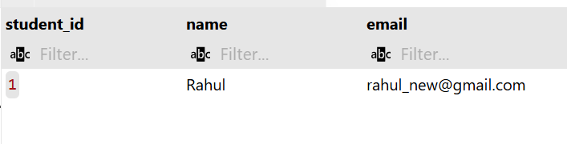

Explanation:
Analysis of Correctness & Performance
Correctness
- Identical Results: Both queries will return the exact same rows from the Students table specifically, those students who have a record in the Enrollments table for course_id = 101.
- Duplicate Handling: Note that if a student is enrolled in the same course multiple times (which shouldn't happen with proper constraints), the JOIN might return duplicate rows, whereas the IN subquery would not. To ensure 100% parity in all scenarios, you could add SELECT DISTINCT s.*.
Why the JOIN is "Optimized"
- Execution Plan: Modern SQL optimizers are very good at handling JOIN operations. They can use "Nested Loop Joins" or "Hash Joins" to find matches much faster than evaluating a list of IDs.
- Indexing: A JOIN makes it very easy for the engine to utilize an index on Enrollments.student_id and Students.student_id.
- Readability: As queries grow more complex (e.g., needing data from 3 or 4 tables), JOIN syntax remains much cleaner and easier to maintain than nested layers of subqueries.

