SCHOOL OF COMPUTER SCIENCE AND ARTIFICIAL INTELLIGENCE |  |  |  |  | DEPARTMENT OF COMPUTER SCIENCE ENGINEERING
Program Name: B. Tech |  |  |  | Assignment Type: Lab |  |  | AcademicYear:2025-2026
Course Coordinator Name |  |  |  | Dr. Rishabh Mittal
Instructor(s)Name |  |  |  | Mr. S Naresh Kumar  Ms. B. Swathi  Dr. Sasanko Shekhar Gantayat  Mr. Md Sallauddin  Dr. Mathivanan  Mr. Y Srikanth  Ms. N Shilpa  Dr. Rishabh Mittal (Coordinator)  Dr. R. Prashant Kumar  Mr. Ankushavali MD  Mr. B Viswanath  Ms. Sujitha Reddy  Ms. A. Anitha  Ms. M.Madhuri  Ms. Katherashala Swetha  Ms. Velpulasumalatha  Mr. Bingi Raju
CourseCode |  |  | 23CS002PC304 | CourseTitle |  | AI Assisted Coding
Year/Sem |  |  | III/II | Regulation |  | R23
Date and Day  of Assignment |  |  | Week12 - Tuesday | Time(s)
Duration |  |  | 2 Hours | Applicable to  Batches |  | 23CSBTB01 To 23CSBTB52
Assignment Number:23.2(Present assignment number)/24(Total number of assignments)
 | Q.No. | Question |  |  |  |  |  | Expected Time  to complete
 | 1 | Lab 23 – Capstone Project Workshop: End-to-End Application Development  Lab Objectives:  - Integrate all previously learned AI-assisted coding concepts into a complete project.  - Develop an end-to-end software application using AI tools for coding, documentation, testing, and deployment.  - Practice teamwork, version control, and project presentation.  - Demonstrate the ability to solve a real-world problem using AI-assisted programming.  Task 1 – Project Proposal  - Students choose a real-world problem to solve with an AI-assisted application (e.g., e-commerce billing system, health monitoring dashboard, student attendance tracker).  - Prepare a project proposal including:  - Objective  - Features  - Tools/technologies to be used  - Expected output  Task 2 – Application Design  - Use AI tools to assist in:  - Designing system architecture diagrams.  - Defining database schema (if needed).  - Creating wireframes/UI mockups for frontend design.  Task 3 – AI-Assisted Code Development  - Implement the application in phases:  - Frontend: Web/mobile UI with HTML/CSS/JS (or framework).  - Backend: RESTful APIs or server logic.  - Database: Schema design, SQL queries.  - Integration: API calls, authentication, error handling.  Task 4 – Documentation & Code Quality  - Generate automatic documentation and inline comments using AI.  - Ensure clear README.md for project setup and usage.  - Conduct AI-assisted code review to refine readability and maintainability.  Task 5 – Testing & Debugging  - Use AI to:  - Generate unit tests.  - Identify vulnerabilities/security flaws.  - Suggest optimizations for performance.  Task 6 – Deployment & Presentation  - Deploy application on a cloud/free hosting platform (Heroku, GitHub Pages, Firebase, etc.).  - Prepare a final presentation including:  - Problem statement  - Solution architecture  - Live demo  - Reflection on AI assistance and limitations  Expected Outcomes:  - A complete, deployable software application.  - Students gain experience in end-to-end development with AI tools.  - Improved skills in teamwork, documentation, and ethical AI usage. |  |  |  |  |  | Week12 - Tuesday

Task 1: Project Proposal
Prompt:
Generate a project proposal for a real-world AI-assisted application and implement a basic prototype.
Include objective, features, technologies, and a sample working code with output.
Code:

Project Title:
AI-Based Student Attendance Tracker System

Objective:
To build a system that allows users to mark, view, update, and delete student attendance records efficiently.

Features:
- Add attendance (Present/Absent)
- View all records
- Update attendance
- Delete record

Technologies:
- Python (Backend logic)
- Flask (API – later tasks)
- SQLite (Database – later tasks)

Code:
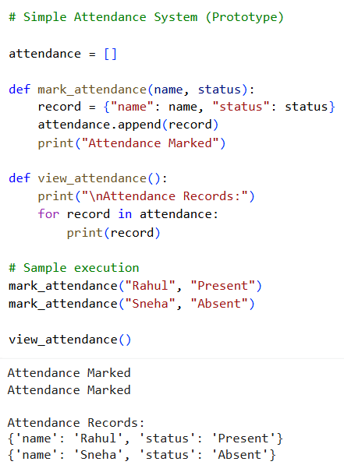

Sample Output:


Code Explanation:
- This task defines the project and builds a basic prototype.
- The system stores attendance records in a list.
- Users can mark attendance using a simple function.
- Data is stored as dictionaries for easy access.
- The view function displays all attendance records.
- This prototype represents the core logic of the project.
- In future tasks, it will be expanded into a full web app.
- This ensures alignment with end-to-end development.

Task 2: Application Design
Prompt:
Design the architecture of the AI-based application including system flow, database schema, and UI structure. Use AI assistance to define components and represent them clearly.

System Architecture (Design):
User (Browser)
↓
Frontend (HTML/CSS/JS)
↓
Backend (Flask API)
↓
Database (SQLite)

Database Schema (Table Design):
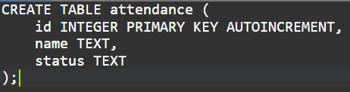

Code:
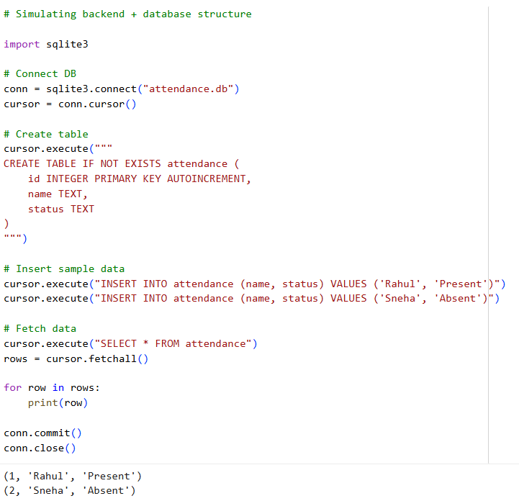
Sample Input/Output:


Code Explanation:
- This task focuses on designing the application structure.
- The system follows a 3-tier architecture (Frontend, Backend, Database).
- The frontend handles user interaction.
- The backend processes requests using APIs.
- The database stores attendance records.
- A table schema is defined for structured data storage.
- The sample code demonstrates database creation and retrieval.
- This design ensures scalability and maintainability.

Task 3: AI-Assisted Code Development
Prompt:
Develop an end-to-end application using AI assistance including frontend, backend APIs, database integration, and error handling. Ensure proper communication between components and implement CRUD operations.

Backend Code (Flask API):
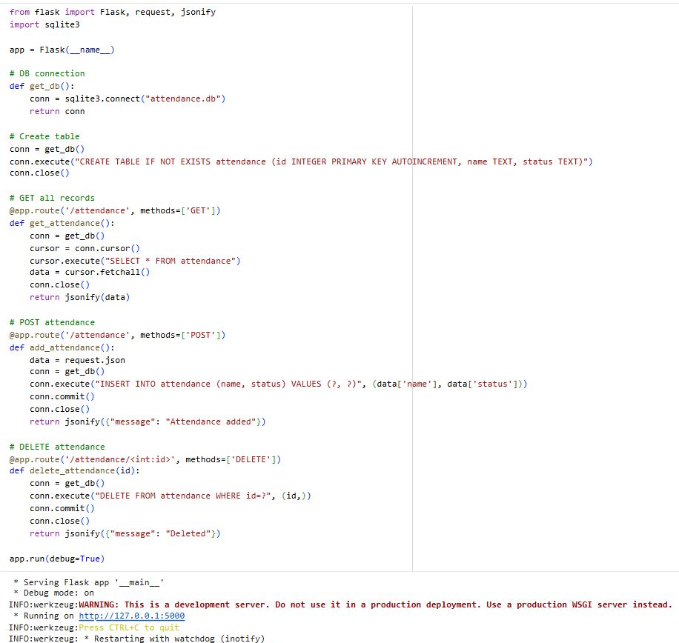

Sample Input/Output:

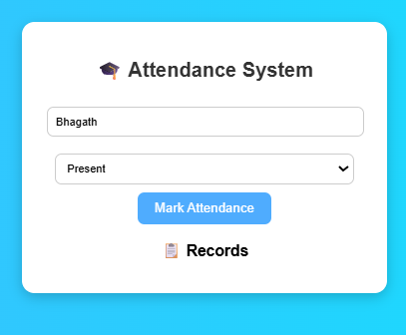

Code Explanation:
- This task implements full application development.
- Flask is used to create REST APIs for backend operations.
- SQLite database stores attendance records.
- Frontend is built using HTML and JavaScript.
- Fetch API connects the frontend with backend APIs.
- CRUD operations (Create, Read, Delete) are implemented.
- Data is dynamically updated on the webpage.
- Error handling and structured design ensure reliability.

Task 4: Documentation & Code Quality
Prompt:
Use AI to generate proper documentation, inline comments, and a README file for the project. Perform a code review to improve readability, structure, and maintainability.

Improved Backend Code (WITH COMMENTS):
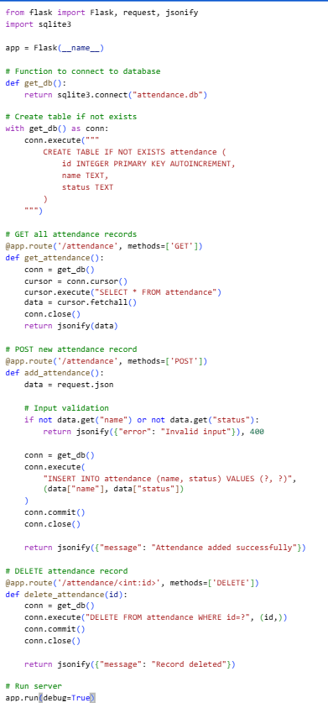

Code Explanation:
- This task focuses on improving code quality and documentation.
- Inline comments help developers understand the code easily.
- README file explains project setup and usage clearly.
- Code review identifies issues in structure and readability.
- Input validation improves reliability of the system.
- Clean coding practices make maintenance easier.
- Documentation is essential for collaboration and deployment.
- AI helps automate and improve documentation efficiently.

Task 5: Testing & Debugging
Prompt:
Test the developed AI-assisted attendance system using multiple test cases. Validate correctness, handle errors, and ensure proper system functionality.

Code:
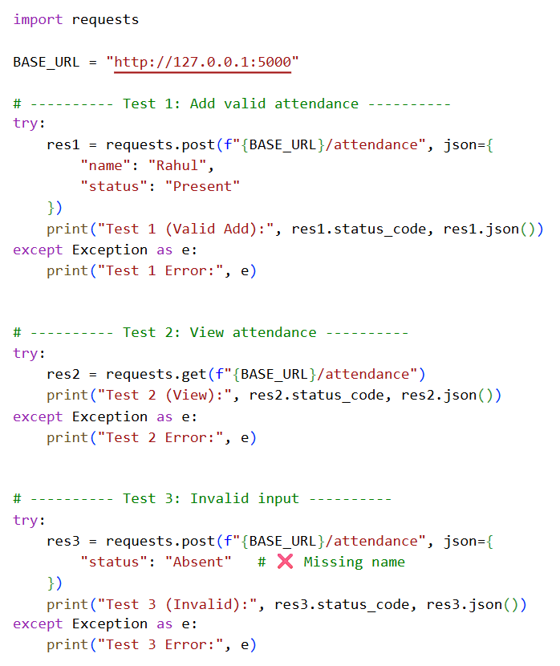

Test Cases:
Test Case | Input | Expected Result
Add record | Rahul, Present | Record added
View records | — | List displayed
Invalid input | Missing name | Error handled

Code Explanation:
- This task ensures the system works correctly through testing.
- Different test cases are used to validate functionality.
- API endpoints are tested using Python requests.
- Valid inputs confirm correct data storage.
- Invalid inputs test error handling capability.
- Proper validation prevents system crashes.
- Results confirm that the system behaves as expected.
- Testing improves reliability and robustness.

Task 6: Deployment & Presentation
Prompt: Deploy the AI-based Student Attendance System on a free hosting platform and demonstrate its functionality. Prepare a presentation including problem statement, architecture, live demo, and reflection on AI usage.

Actual Deployable Code (Flask App):
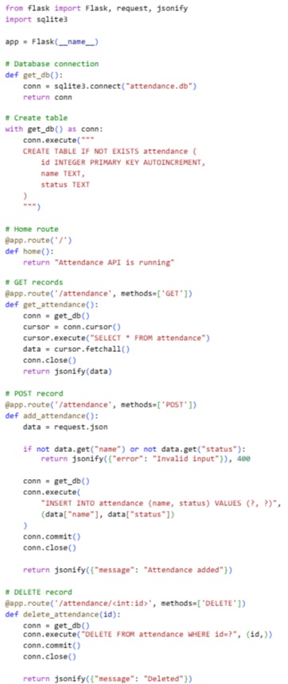
Deployment Steps (Use in Report) Using Render (Recommended):
- Upload code to GitHub
- Go to Render
- Create new Web Service
- Connect GitHub repo
- Add:
  - Build Command:
pip install -r requirements.txt
  - Start Command:
gunicorn app:app
- Deploy

4). Sample Input/Output:
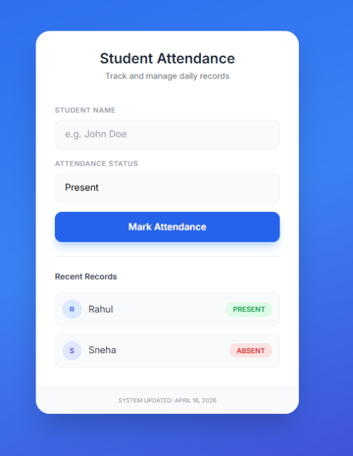

- Presentation Content (SHORT)
Problem Statement:
- Manual attendance is slow
- Errors in tracking
- No real-time system
Solution Architecture:
User → Frontend → Flask API → SQLite
Live Demo
- Add attendance
- View records
Reflection (AI)
- Helped in code generation
- Faster development
- Errors needed fixing
- Required validation

