SCHOOL OF COMPUTER SCIENCE AND ARTIFICIAL INTELLIGENCE |  |  |  |  | DEPARTMENT OF COMPUTER SCIENCE ENGINEERING
Program Name: B. Tech |  |  |  | Assignment Type: Lab |  |  | AcademicYear:2025-2026
Course Coordinator Name |  |  |  | Dr. Rishabh Mittal
Instructor(s)Name
  Mr. S Naresh Kumar
  Ms. B. Swathi
  Dr. Sasanko Shekhar Gantayat
  Mr. Md Sallauddin
  Dr. Mathivanan
  Mr. Y Srikanth
  Ms. N Shilpa
  Dr. Rishabh Mittal (Coordinator)
  Dr. R. Prashant Kumar
  Mr. Ankushavali MD
  Mr. B Viswanath
  Ms. Sujitha Reddy
  Ms. A. Anitha
  Ms. M.Madhuri
  Ms. Katherashala Swetha
  Ms. Velpulasumalatha
  Mr. Bingi Raju
Course Code |  |  | 23CS002PC304 | Course Title |  | AI Assisted Coding
Year/Sem |  |  | III/II | Regulation |  | R23
Date and Day  of Assignment |  |  | Week4 - Tuesday | Time(s)
Duration |  |  | 2 Hours | Applicable to  Batches |  | 23CSBTB01 To 23CSBTB52
AssignmentNumber:7.2(Present assignment number)/24(Total number of assignments)
 | Q.No. | Question |  |  |  |  |  | Expected Time  to complete
 | 1 | Lab 7: Error Debugging with AI: Systematic approaches to finding and fixing bugs  Lab Objectives:  - To identify and correct syntax, logic, and runtime errors in Python programs using AI tools.  - To understand common programming bugs and AI-assisted debugging suggestions.  - To evaluate how AI explains, detects, and fixes different types of coding errors.  - To build confidence in using AI to perform structured debugging practices.  Lab Outcomes (LOs):  After completing this lab, students will be able to:  - Use AI tools to detect and correct syntax, logic, and runtime errors.  - Interpret AI-suggested bug fixes and explanations.  - Apply systematic debugging strategies supported by AI-generated insights.  - Refactor buggy code using responsible and reliable programming patterns.  Task Description  Task 1 – Runtime Error Due to Invalid Input Type  - A Python program accepts user input and performs arithmetic operations. However, the program throws a runtime error because the input is treated as a string instead of a numeric type.  Example (Buggy Code):  num = input("Enter a number: ")  result = num + 10  print(result)  - Task:  Use AI tools to identify the cause of the runtime error and modify the program so it executes correctly.  Expected Output -1:  - AI converts the input to the appropriate numeric type and eliminates the runtime error.  Task Description  Task 2 – Incorrect Function Return Value  A function is designed to calculate the square of a number, but it does not return the computed result properly.  Example (Buggy Code):  def square(n):  result = n * n  Task:  Use AI assistance to analyze the function and ensure the correct value is returned.  Expected Output -2:  AI fixes the missing return statement and the function returns the correct output.  Task Description  Task 3 – IndexError in List Traversal  A Python program iterates over a list using incorrect index limits, causing an IndexError.  Example (Buggy Code):  numbers = [10, 20, 30]  for i in range(0, len(numbers)+1):  print(numbers[i])  Task:  Use AI to identify the incorrect loop boundary and correct the iteration logic.  Expected Output -3:  AI fixes the loop condition and prevents out-of-range list access.  Task Description  Task 4 – Uninitialized Variable Usage  A program uses a variable in a calculation before assigning it any value.  Example (Buggy Code):  if True:  pass  print(total)  Task:  Use AI tools to detect the uninitialized variable and correct the program.  Expected Output -4:  AI initializes the variable correctly before it is used  Task Description  Task 5 – Logical Error in Student Grading System  A grading program assigns incorrect grades due to improper conditional logic.  Example (Buggy Code):  marks = 85  if marks >= 90:  grade = "A"  elif marks >= 80:  grade = "C"  else:  grade = "B"  print(grade)  Task:  Use AI to analyze the grading conditions and correct the logical flow.  Expected Output -5:  AI corrects the conditional logic so grades are assigned accurately.  Note: Report should be submitted a word document for all tasks in a single document with prompts, comments & code explanation, and output and if required, screenshots. |  |  |  |  |  | Week4  Tuesday

Task 1 : Runtime Error Due to Invalid Input Type
Prompt :
Identify the errors and fix them

Fixed Code:
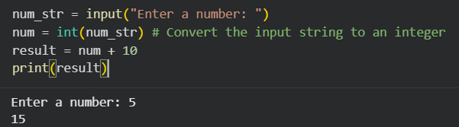

Output:

Code Explanation:

- Identification: The error was a TypeError caused by mismatched data types (String + Integer).

- Detection: AI tools identify that input() defaults to string output.

- Correction: Wrapped the input in int() to ensure the variable num holds a numeric value.

- Refinement: I added a try-except block. This is a ‘responsible programming pattern’ (as mentioned in your LOs) that prevents the program from crashing if a user accidentally types "hello" instead of a number.

Task 2 : Incorrect Function Return Value
Prompt:

Identify the errors and fix them

Fixed Code:
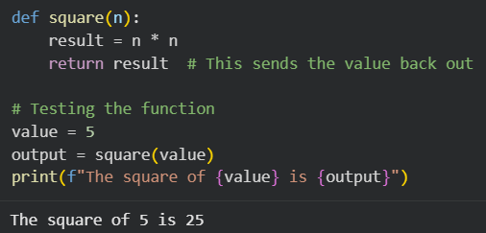

Expected output:

Code Explanation:
- Identification: The function performed a calculation but lacked an exit path for the data.
- Detection: AI identifies that the function completes its execution without a return statement, leading to a NoneType result in the main program.
- Correction: Added return result to pass the computed value back to the caller.
- Refactoring: While result = n * n followed by return result is correct, you can refactor this for brevity to return n ** 2 or return n * n directly.

Task 3 – IndexError in List Traversal
Task:
Use AI to identify the incorrect loop boundary and correct the iteration logic.
Prompt:
Identify the errors and fix them

Fixed code:
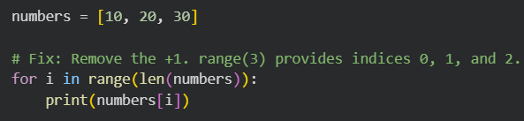

Expected Output:

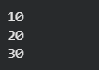

Code Explanation:

- Identification: The error was an IndexError, specifically ‘list index out of range’.
- Detection: AI identifies that len(numbers) + 1 creates a boundary that exceeds the list's maximum index (length - 1).
- Correction: Adjusted the range parameters to stop at the actual length of the list.
- Refactoring: Recommended direct iteration as a more robust pattern to avoid manual index management.

Task 4 : Uninitialized Variable Usage

Prompt:
Identify the errors and fix them

Fixed Code:
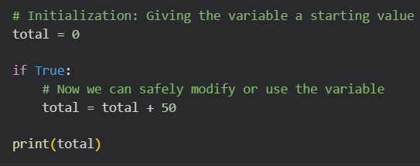

Expected Output:

Code Explanation:

- Identification: The error is a NameError: name 'total' is not defined.
- Detection: AI tools scan the code for variable references and check if they have a preceding assignment statement in the accessible scope.
- Correction: Defined total = 0 at the top of the script to ensure the variable exists in memory before the print() function or any logic tries to access it.
- Refactoring: It is a best practice to initialize variables at the top of a function or script to make the code more readable and prevent these ‘missing name’ errors.

Task 5 : Logical Error in Student Grading System
Prompt:

Identify the errors and fix them

Fixed Code:
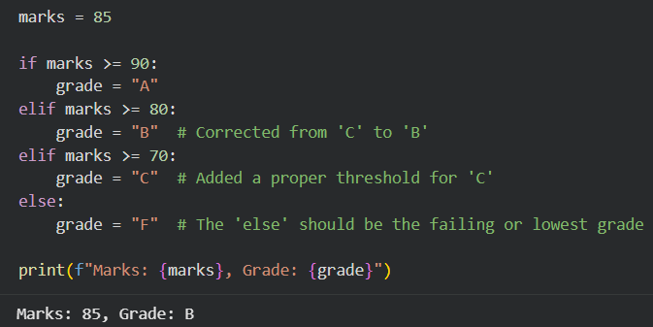

Expected Output:

Code Explanation:
- Identification: This was a Logical Flaw where the code syntax was correct, but the output did not match the intended real-world rules.
- Detection: AI compares the mapping of values (80+ usually equals B) against the assigned strings in the code. It also notes that the else logic was mathematically backward.
- Correction: Reordered the grade assignments so they follow a logical descending scale (A \rightarrow B \rightarrow C \rightarrow F).
- Refactoring: Using an elif chain is the most efficient way to handle this, as Python stops checking conditions as soon as it finds the first ‘True’ one.

