SCHOOL OF COMPUTER SCIENCE AND ARTIFICIAL INTELLIGENCE |  |  |  |  | DEPARTMENT OF COMPUTER SCIENCE ENGINEERING
Program Name: B. Tech |  |  |  | Assignment Type: Lab |  |  | AcademicYear:2025-2026
Course Coordinator Name |  |  |  | Dr. Rishabh Mittal
Instructor(s)Name
  Mr. S Naresh Kumar
  Ms. B. Swathi
  Dr. Sasanko Shekhar Gantayat
  Mr. Md Sallauddin
  Dr. Mathivanan
  Mr. Y Srikanth
  Ms. N Shilpa
  Dr. Rishabh Mittal (Coordinator)
  Dr. R. Prashant Kumar
  Mr. Ankushavali MD
  Mr. B Viswanath
  Ms. Sujitha Reddy
  Ms. A. Anitha
  Ms. M.Madhuri
  Ms. Katherashala Swetha
  Ms. Velpulasumalatha
  Mr. Bingi Raju
CourseCode |  |  | 23CS002PC304 | CourseTitle |  | AI Assisted Coding
Year/Sem |  |  | III/II | Regulation |  | R23
Date and Day  of Assignment |  |  | Week4 - Tuesday | Time(s)
Duration |  |  | 2 Hours | Applicableto  Batches |  | 23CSBTB01 To 23CSBTB52
AssignmentNumber:8.2(Present assignment number)/24(Total number of assignments)
 | Q.No. | Question |  |  |  |  |  | ExpectedTime  to complete
 | 1 | Lab 8: Test-Driven Development with AI – Generating and Working with Test Cases  Lab Objectives:  - To introduce students to test-driven development (TDD) using AI code generation tools.  - To enable the generation of test cases before writing code implementations.  - To reinforce the importance of testing, validation, and error handling.  - To encourage writing clean and reliable code based on AI-generated test expectations.  Lab Outcomes (LOs):  After completing this lab, students will be able to:  - Use AI tools to write test cases for Python functions and classes.  - Implement functions based on test cases in a test-first development style.  - Use unittest or pytest to validate code correctness.  - Analyze the completeness and coverage of AI-generated tests.  - Compare AI-generated and manually written test cases for quality and logic  Task Description  Task 1 – Test-Driven Development for Even/Odd Number Validator  - Use AI tools to first generate test cases for a function is_even(n) and then implement the function so that it satisfies all generated tests.  Requirements:  - Input must be an integer  - Handle zero, negative numbers, and large integers  Example Test Scenarios:  is_even(2) → True  is_even(7) → False  is_even(0) → True  is_even(-4) → True  is_even(9) → False  Expected Output -1  - A correctly implemented is_even() function that passes all AI-generated test cases  Task Description  Task 2 – Test-Driven Development for String Case Converter  - Ask AI to generate test cases for two functions:  - to_uppercase(text)  - to_lowercase(text)  Requirements:  - Handle empty strings  - Handle mixed-case input  - Handle invalid inputs such as numbers or None  Example Test Scenarios:  to_uppercase("ai coding") → "AI CODING"  to_lowercase("TEST") → "test"  to_uppercase("") → ""  to_lowercase(None) → Error or safe handling  Expected Output -2  - Two string conversion functions that pass all AI-generated test cases with safe input handling.  Task Description  Task 3 – Test-Driven Development for List Sum Calculator  - Use AI to generate test cases for a function sum_list(numbers) that calculates the sum of list elements.  Requirements:  - Handle empty lists  - Handle negative numbers  - Ignore or safely handle non-numeric values  Example Test Scenarios:  sum_list([1, 2, 3]) → 6  sum_list([]) → 0  sum_list([-1, 5, -4]) → 0  sum_list([2, "a", 3]) → 5  Expected Output 3  - A robust list-sum function validated using AI-generated test cases.  Task Description  Task 4 – Test Cases for Student Result Class  - Generate test cases for a StudentResult class with the following methods:  - add_marks(mark)  - calculate_average()  - get_result()  Requirements:  - Marks must be between 0 and 100  - Average ≥ 40 → Pass, otherwise Fail  Example Test Scenarios:  Marks: [60, 70, 80] → Average: 70 → Result: Pass  Marks: [30, 35, 40] → Average: 35 → Result: Fail  Marks: [-10] → Error  Expected Output -4  A fully functional StudentResult class that passes all AI-generated test  Task Description  Task 5 – Test-Driven Development for Username Validator  Requirements:  - Minimum length: 5 characters  - No spaces allowed  - Only alphanumeric characters  Example Test Scenarios:  is_valid_username("user01") → True  is_valid_username("ai") → False  is_valid_username("user name") → False  is_valid_username("user@123") → False  Expected Output 5  A username validation function that passes all AI-generated test cases.  Note: Report should be submitted a word document for all tasks in a single document with prompts, comments & code explanation, and output and if required, screenshots |  |  |  |  |  | Week4 - Wednesday

Task 1 – Test-Driven Development for Even/Odd Number Validator

Prompt:

Write a set of pytest test cases for a function is_even(n). The tests should cover positive even and odd numbers, zero, negative numbers, and very large integers. Additionally, include test cases for invalid inputs like floats, strings, and None, where the expected result is -1. Use assert is_even(x) is True/False for boolean checks and == -1 for invalid inputs.

Code:

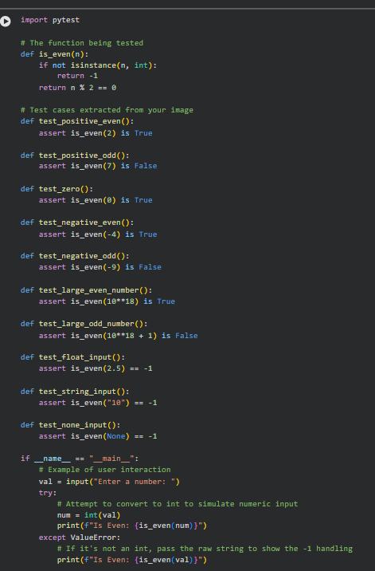

Sample Input/Output:

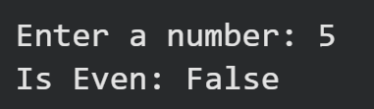

Code Explanation:

- Logic: The code uses the modulo operator % to determine if a number is even.
- Data Validation: It specifically checks if the input is an integer using isinstance().
- Error Handling: Per your screenshot, if the input is a float, string, or None, it returns -1 instead of crashing.
- Testing Tool: It uses the pytest framework to verify that both valid numbers and invalid inputs behave as expected.

Task 2 – Test-Driven Development for String Case Converter

Prompt:

Write two Python functions, to_uppercase(text) and to_lowercase(text). For both functions, include safe input handling: if the input is not a string, return -2. Otherwise, return the converted string. Following the functions, write a series of assert statements to test: mixed-case strings, empty strings, integer inputs (returning -2), and None inputs (returning -2). Finally, print a success message if all assertions pass.

Code:

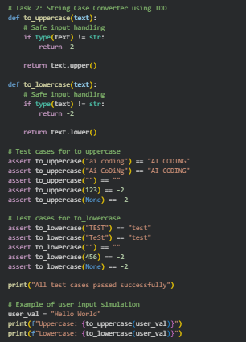

Sample Input/Output:

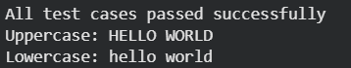

Code Explanation:

- Type Checking: The code uses if type(text) != str to identify non-string inputs like numbers or None.
- Error Return Value: Instead of crashing, the function returns -2 for any invalid data types to ensure safe handling.
- Built-in Methods: It utilizes Python's .upper() and .lower() methods to handle the actual case conversion.
- Validation: The assert statements directly compare the function output against expected results to verify correctness for both normal and edge cases

Task 3 – Test-Driven Development for List Sum Calculator

Prompt:

Write a Python function sum_list(numbers) that returns the total of all numeric elements in a list, skipping strings or other types. Include print statements for test scenarios: sum_list([1, 2, 3]), sum_list([]), sum_list([-1, 5, -4]), and sum_list([2, 'a', 3]). Ensure the final output matches the terminal style shown in the lab instructions.

Code:

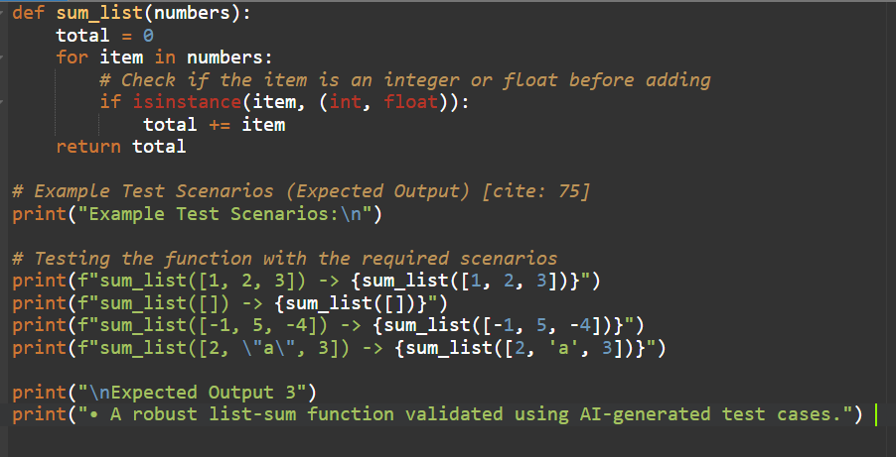

Sample Input/Output:

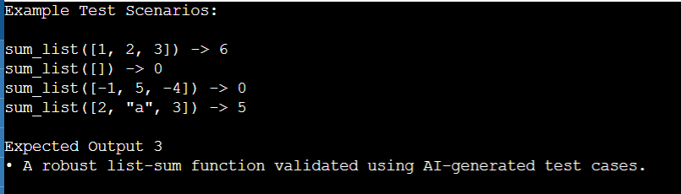

Code Explanation:

- Initialization: The total is set to 0 at the start to ensure an empty list returns zero.
- Filtering: It uses isinstance to check if an element is a number, which allows it to safely skip strings like "a".
- Looping: A for loop iterates through every item, adding only valid numeric values to the total.
- Output Formatting: The print statements use f-strings to match the exact "Example Test Scenario" format required by the lab document.

Task 4 – Test Cases for Student Result Class

Prompt:

Write a Python class StudentResult with methods add_marks(mark), calculate_average(), and get_result(). Ensure add_marks raises a TypeError for non-numeric values and a ValueError for marks outside the 0-100 range. get_result should return 'Pass' if the average is 40 or higher, otherwise 'Fail'. Include test cases that print the average and result for marks [60, 70, 80] and [30, 35, 40], and use a try-except block to print 'Error' when adding a mark of -10

Code:

class StudentResult:
def __init__(self):
# Initialize an empty list to store marks
self.marks = []

def add_marks(self, mark):
# Validation: Check if input is a number
if not isinstance(mark, (int, float)):
raise TypeError("Mark must be a number")

# Validation: Check if mark is within valid range (0-100)
if mark < 0 or mark > 100:
raise ValueError("Mark must be between 0 and 100")

self.marks.append(mark)

def calculate_average(self):
# Handle case where no marks have been added yet
if not self.marks:
return 0
return sum(self.marks) / len(self.marks)

def get_result(self):
# Determine pass/fail status based on average
average = self.calculate_average()
return "Pass" if average >= 40 else "Fail"

# --- Test Case 1: Pass scenario ---
sr1 = StudentResult()
sr1.add_marks(60)
sr1.add_marks(70)
sr1.add_marks(80)
print(sr1.calculate_average()) # Expected: 70.0
print(sr1.get_result()) # Expected: Pass

# --- Test Case 2: Fail scenario ---
sr2 = StudentResult()
sr2.add_marks(30)
sr2.add_marks(35)
sr2.add_marks(40)
print(sr2.calculate_average()) # Expected: 35.0
print(sr2.get_result()) # Expected: Fail

# --- Test Case 3: Invalid Mark Handling ---
sr3 = StudentResult()
try:
sr3.add_marks(-10)
except ValueError:
# Per the assignment requirement, print 'Error' for invalid marks
print("Error")

Sample Input/Output:
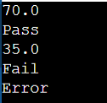

Code Explanation:

- Encapsulation: The class uses an internal list self.marks to keep track of student scores.
- Data Validation: The add_marks method uses isinstance for type checking and a range check (0-100) to prevent invalid data from being processed.
- Logic: The get_result method uses a "ternary operator" (a one-line if-else) to return "Pass" or "Fail" based on the threshold of 40.
- Error Handling: A try-except block is implemented in the test cases to catch specifically the ValueError raised by negative marks and print a simple "Error" message as requested.

Task 5 – Test-Driven Development for Username Validator

Prompt:

Write a Python function is_valid_username(username) that returns False if the length is less than 5, contains spaces, or is not alphanumeric. Otherwise, return True. Then, create a list of test cases including 'user01', 'ai', 'user name', and 'user@123' with their expected boolean results. Use a for-loop to run these tests, printing the result of each in the format 'is_valid_username(input) -> result' and ending with an 'All test cases passed' message

Code:

def is_valid_username(username: str) -> bool:
# Rule 1: Minimum length of 5 characters [cite: 100]
if len(username) < 5:
return False

# Rule 2: No spaces allowed [cite: 101]
if " " in username:
return False

# Rule 3: Only alphanumeric characters
if not username.isalnum():
return False

return True

# Test cases derived from assignment requirements
test_cases = [
("user01", True),
("ai", False),
("user name", False),
("user@123", False),
("Admin5", True)
]

# Run tests
for username, expected in test_cases:
result = is_valid_username(username)
print(f"is_valid_username('{username}') -> {result}")
assert result == expected

print("\nAll test cases passed")

Sample Input/Output:

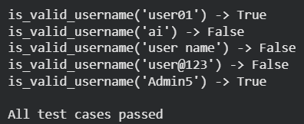

Code Explanation:

- Sequential Validation: The function checks each rule one by one using if statements, returning False immediately if any rule is broken.
- String Methods: It uses the built-in .isalnum() method to efficiently check for letters and numbers while excluding symbols.
- Testing Automation: A list of tuples stores both the input and the expected outcome, allowing a single loop to validate multiple scenarios.
- Assertion: The assert statement ensures that if the code ever fails a test, it will stop and signal an error, guaranteeing the code's reliability.

