AI ASSISTANT CODING
ASSIGNMENT-3.2

Name : M. Sriram
Enrollment no: 2303A52165
Batch: 34
Semester: VI
Branch: CSE(AIML)

Lab 3: Prompt Engineering – Improving Prompts and Context Management

Task Description-1
• Progressive Prompting for Calculator Design: Ask the AI to design a simple calculator program by initially providing only the function name. Gradually enhance the prompt by adding comments and usage examples.
Expected Output-1
• Comparison showing improvement in AI-generated calculator logic and structure.
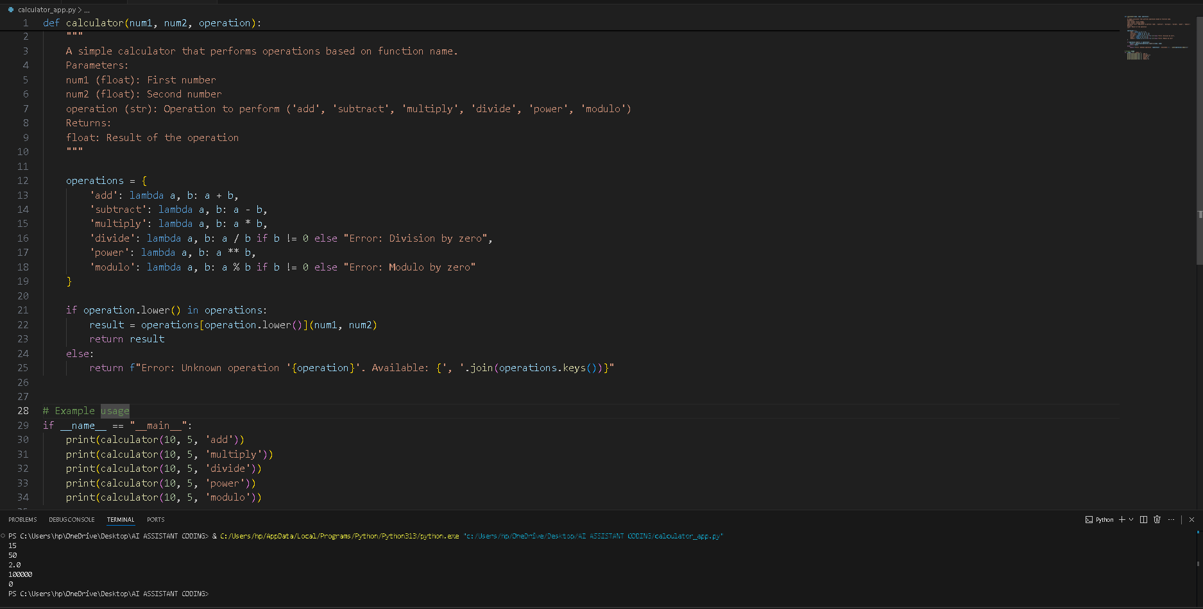
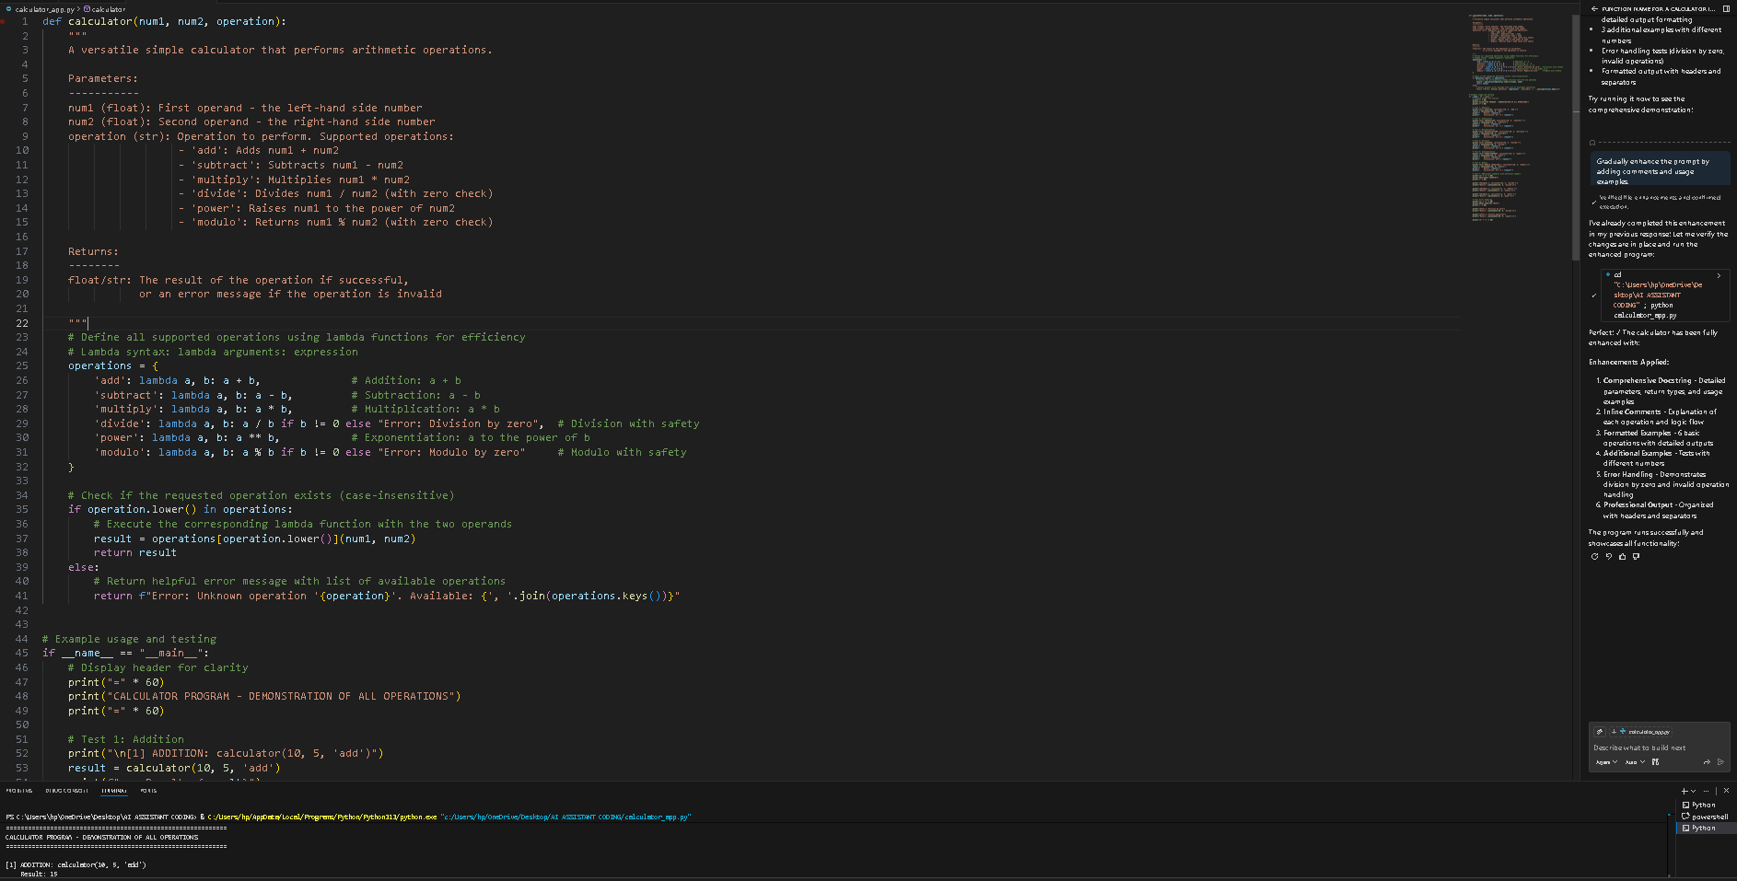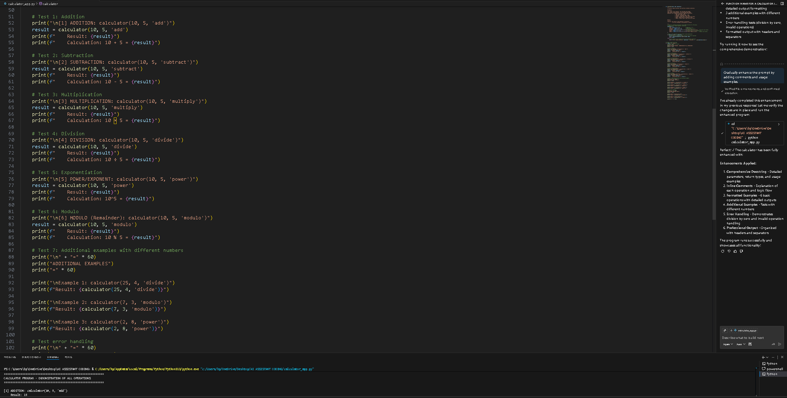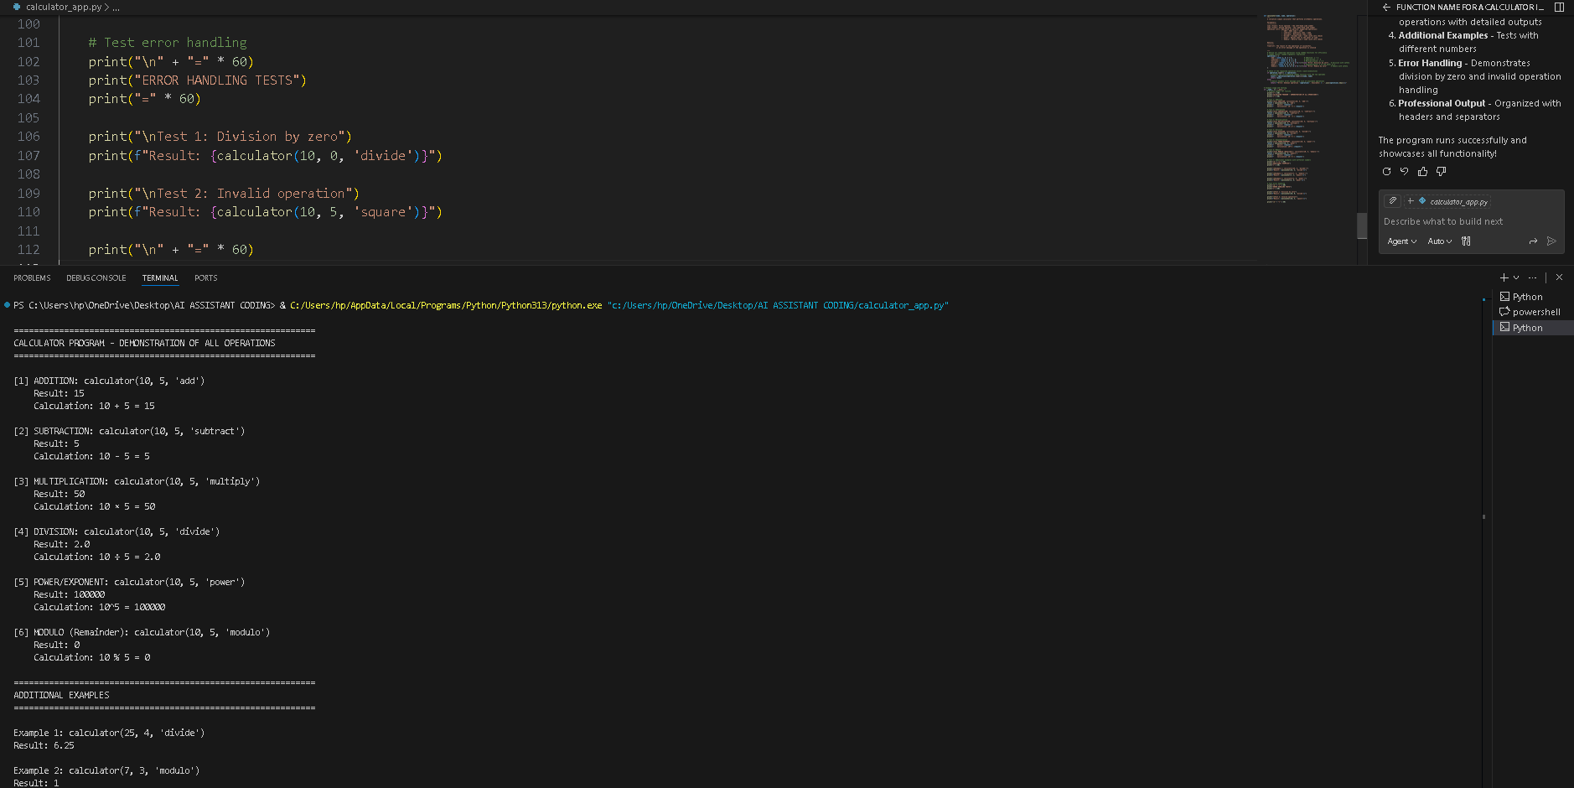
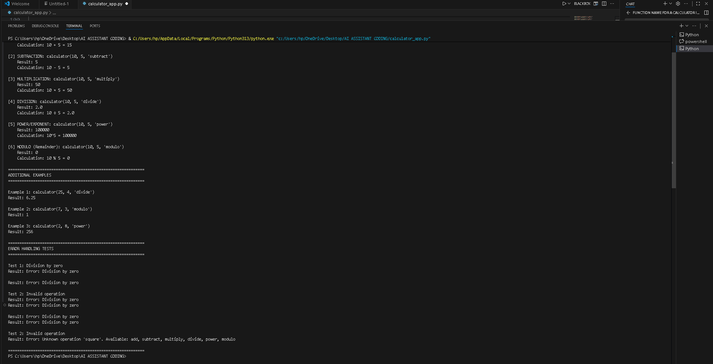
Task Description-2
• Refining Prompts for Sorting Logic: Start with a vague prompt for sorting student marks, then refine it to clearly specify sorting order and constraints.
Expected Output-2
• AI-generated sorting function evolves from ambiguous logic to an accurate and efficient implementation

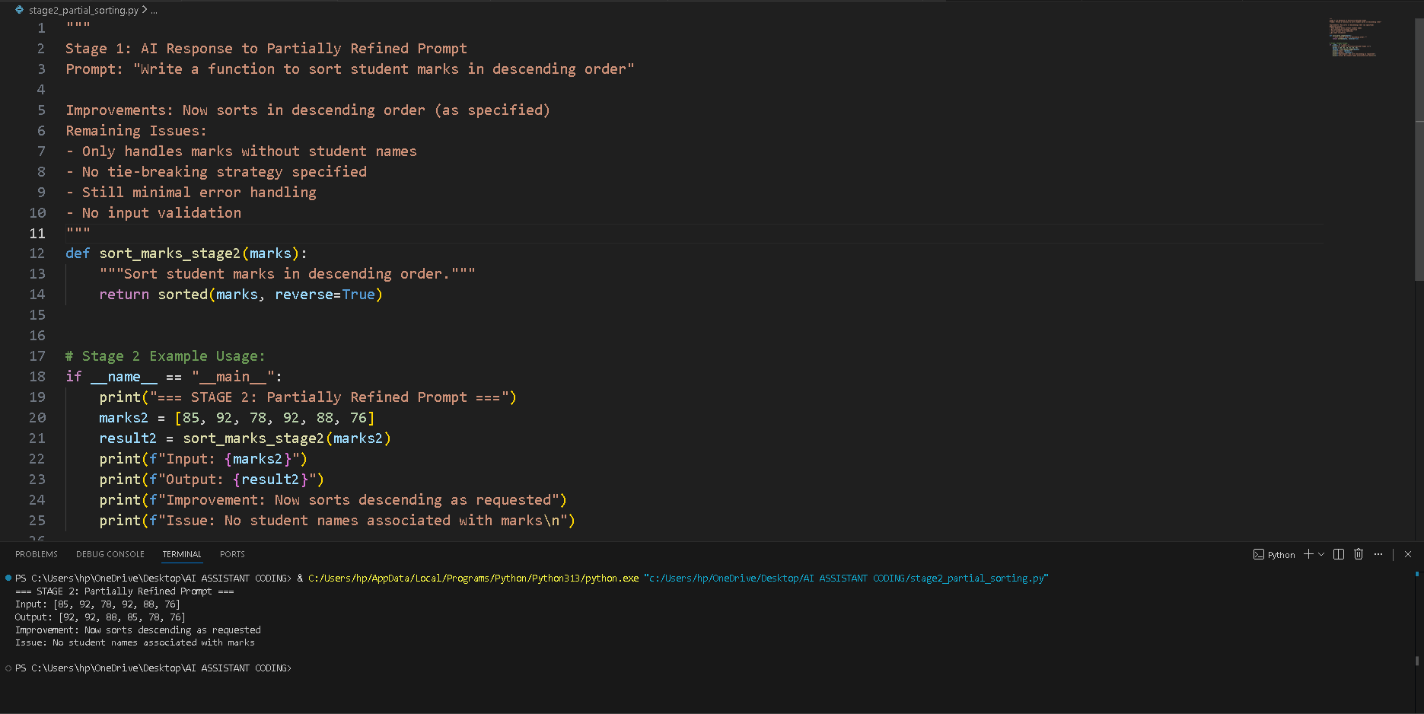

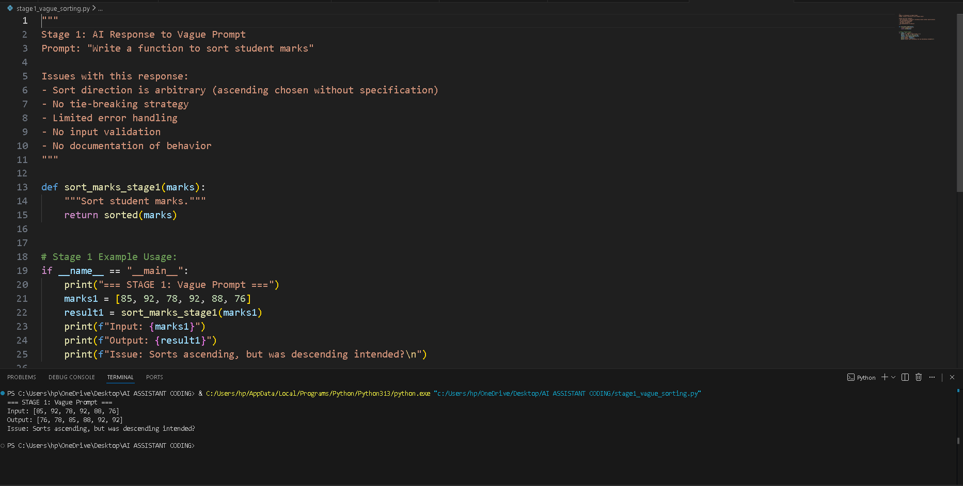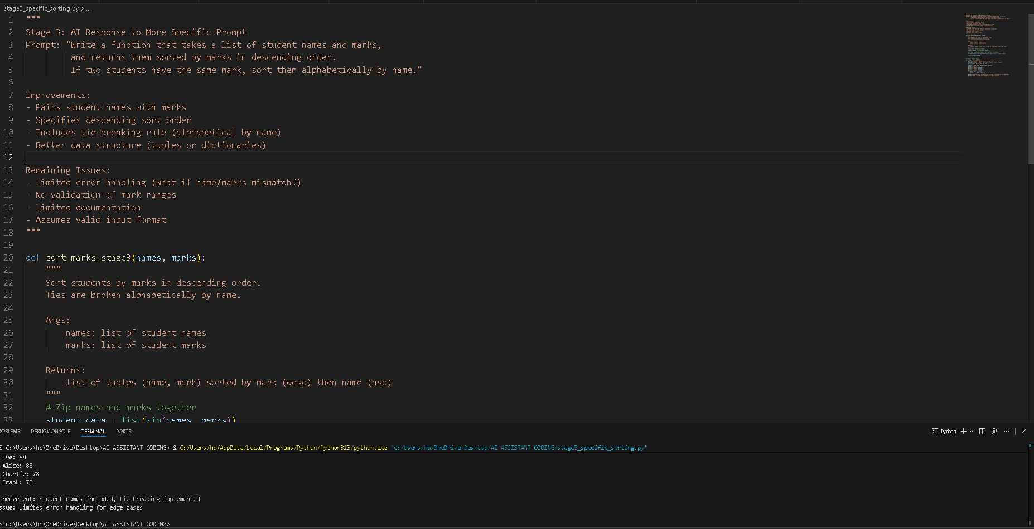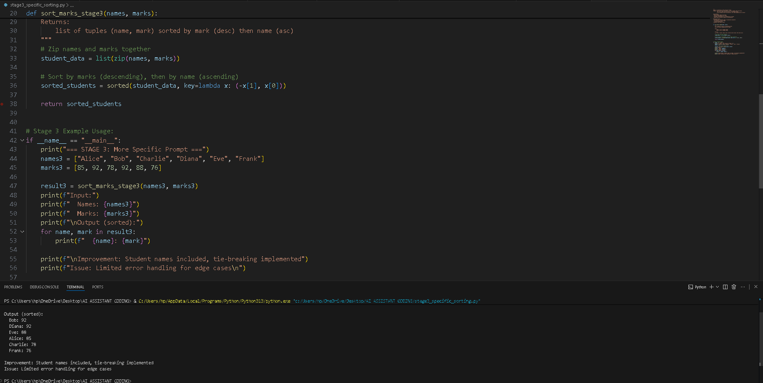
Task Description-3
• Few-Shot Prompting for Prime Number Validation: Provide multiple input output examples for a function that checks whether a number is prime. Observe how few-shot prompting improves correctness.
Expected Output-3
• Improved prime-checking function with better edge-case handling.

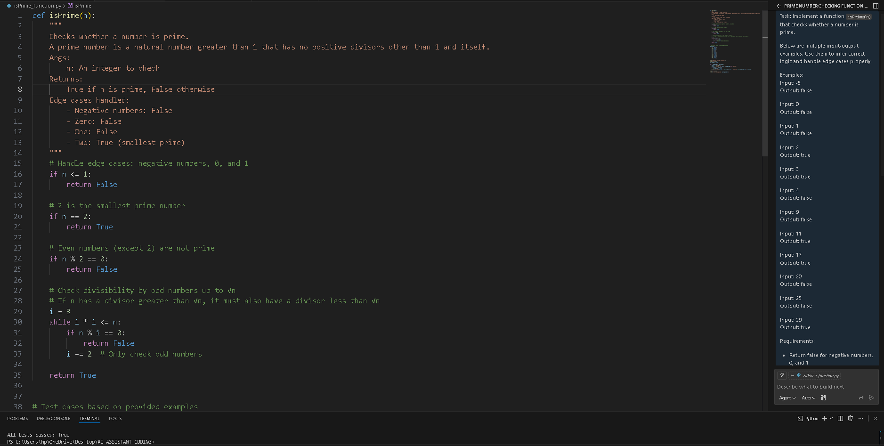

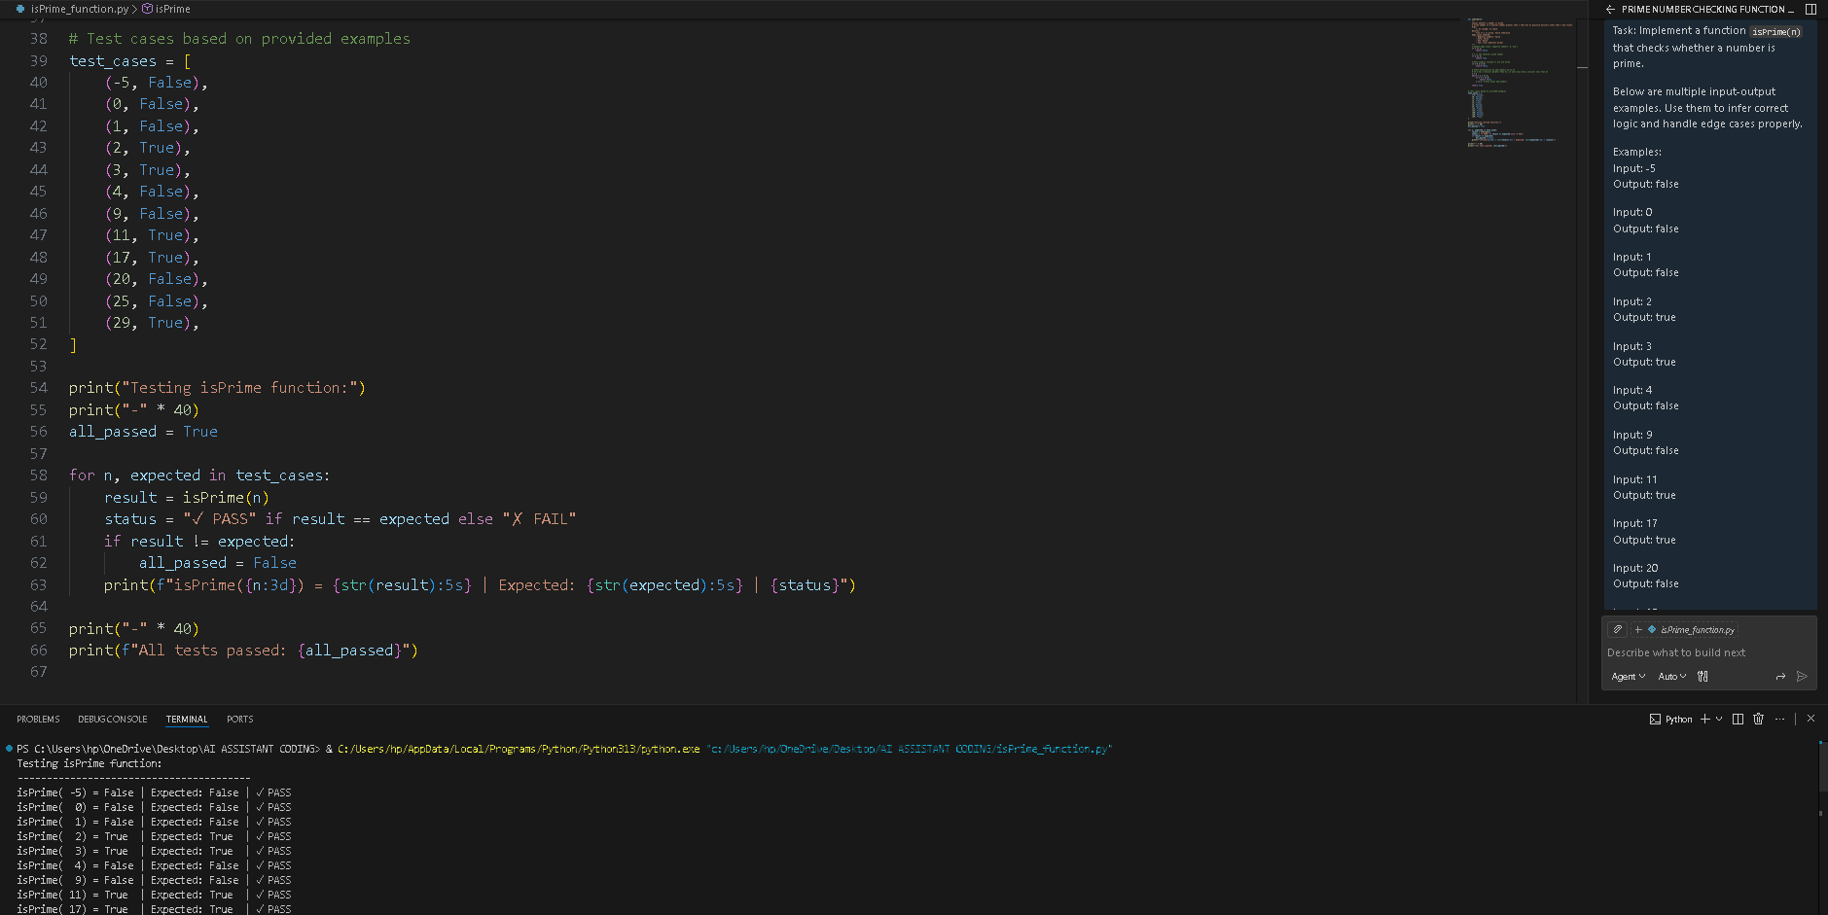

Task Description-4
• Prompt-Guided UI Design for Student Grading System: Create a user interface for a student grading system that calculates total marks, percentage, and grade based on user input.
Expected Output-4
• Well-structured UI code with accurate calculations and clear output display.
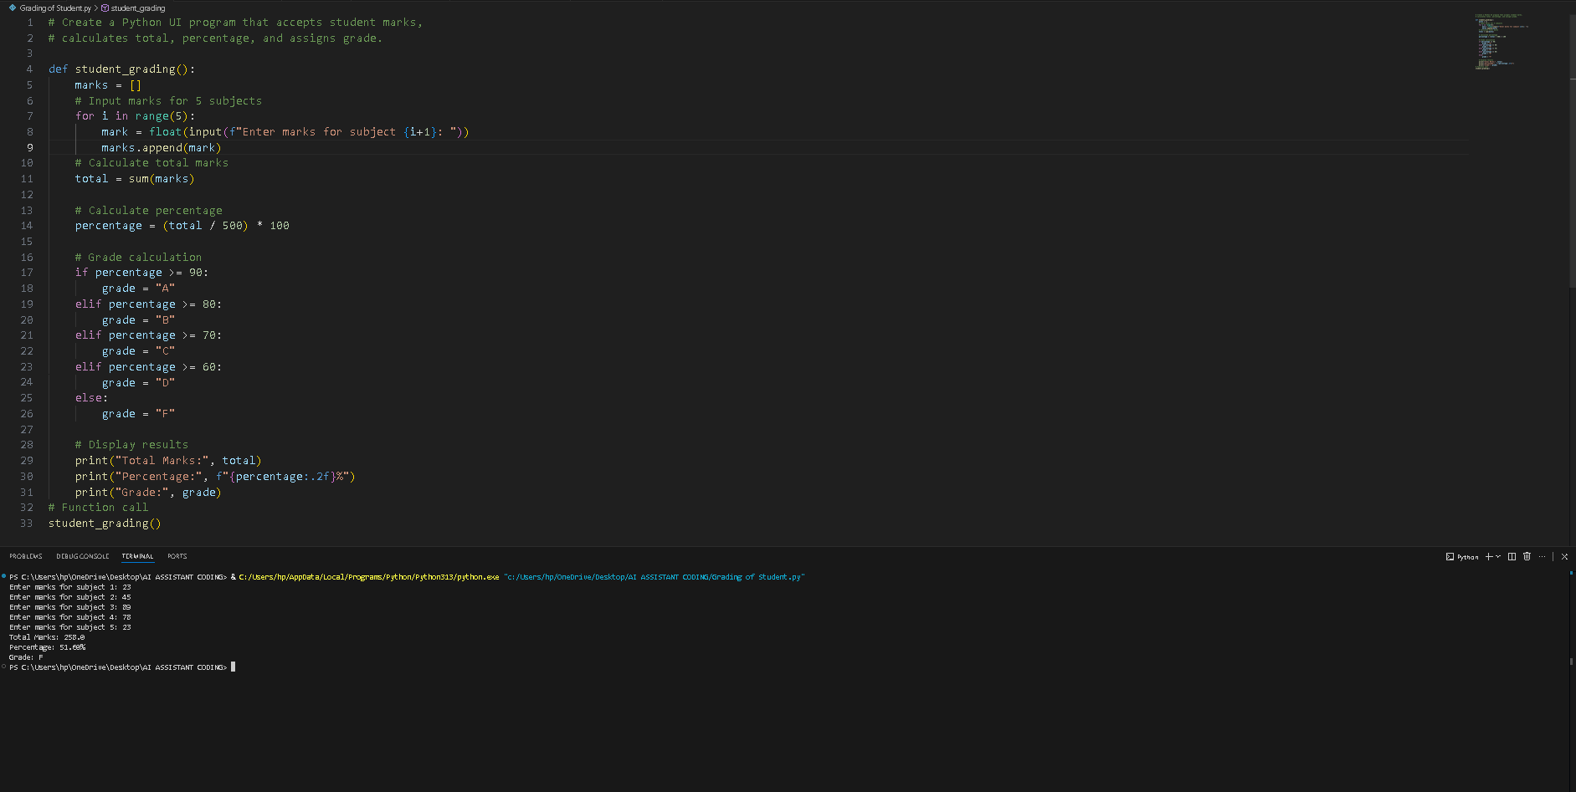
Task Description-5
• Analyzing Prompt Specificity in Unit Conversion Functions: Improving a Unit
Conversion Function (Kilometers to Miles and Miles to Kilometers) Using Clear Instructions.
Expected Output-5
• Analysis of code quality and accuracy differences across multiple prompt variations.

