AI ASSISTANT CODING
ASSIGNMENT-5.5

Name : M. Sriram
Enrollment no: 2303A52165
Batch: 34
Semester: VI
Branch: CSE(AIML)

Lab 5: Ethical Foundations – Responsible AI Coding Practices
Task Description #1 (Transparency in Algorithm Optimization)
Task: Use AI to generate two solutions for checking prime numbers:
• Naive approach(basic)
• Optimized approach
Prompt:
“Generate Python code for two prime-checking methods and
explain how the optimized version improves performance.”

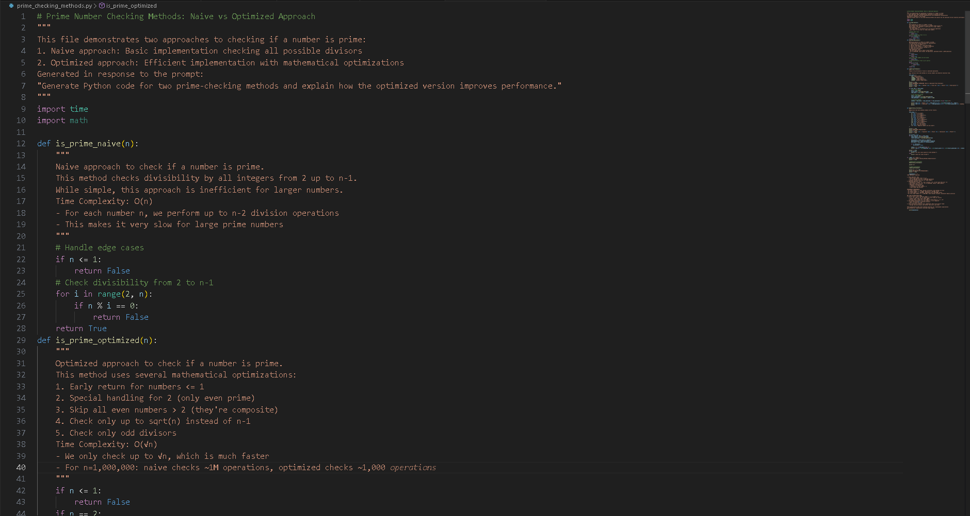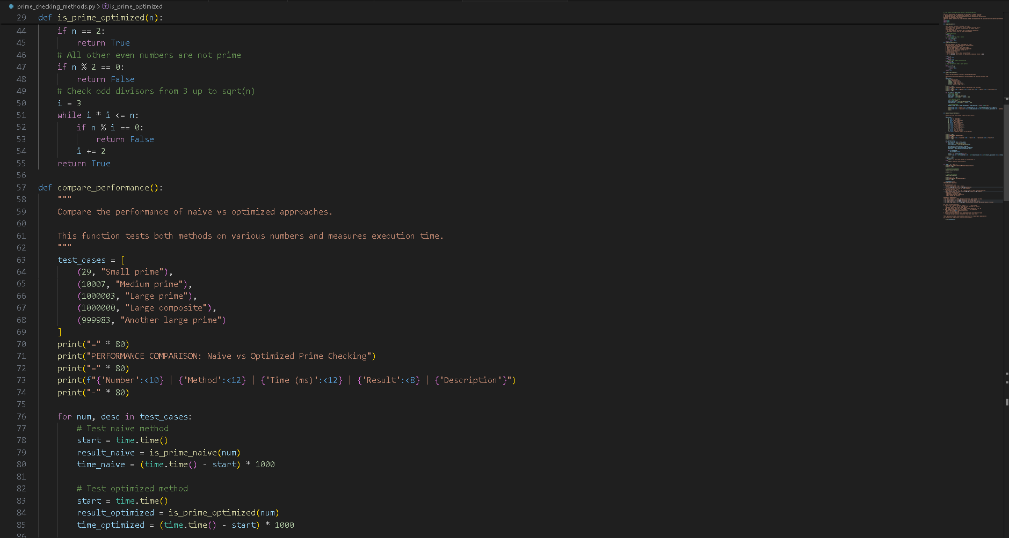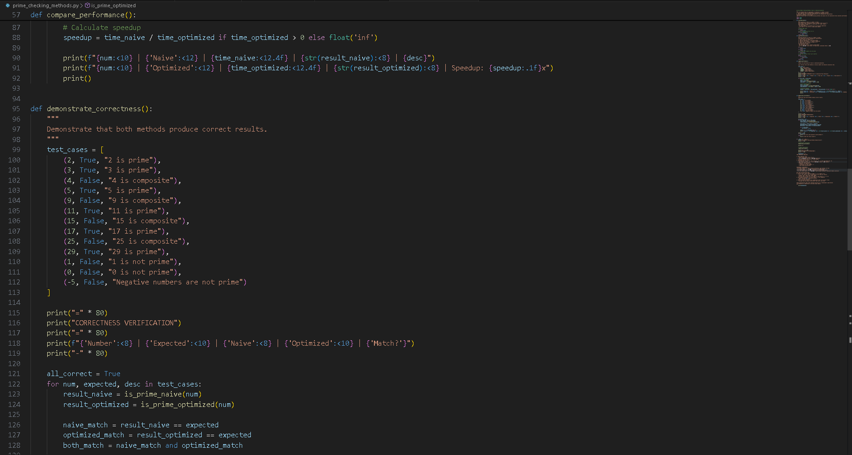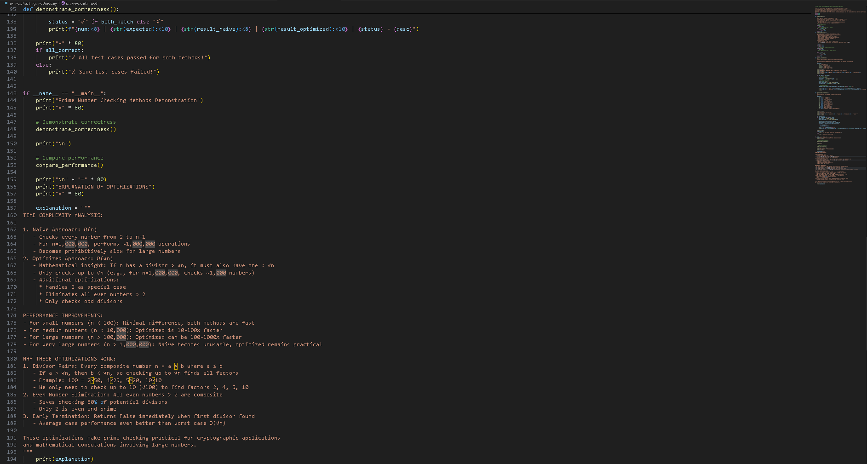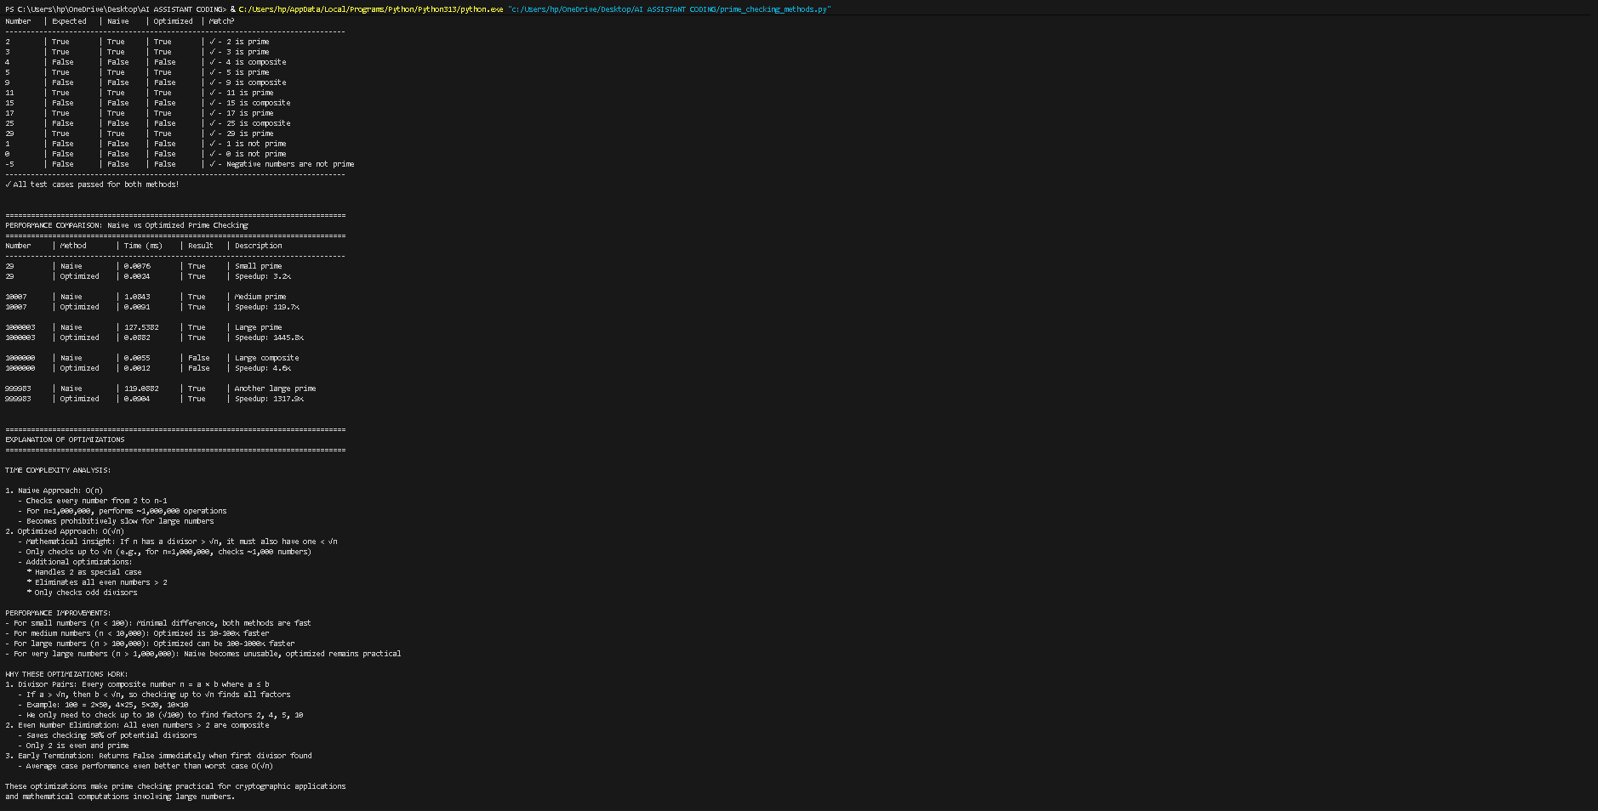
Task Description #2 (Transparency in Recursive Algorithms)
Objective: Use AI to generate a recursive function to calculate Fibonacci numbers.
Instructions:
1. Ask AI to add clear comments explaining recursion.
2. Ask AI to explain base cases and recursive calls.
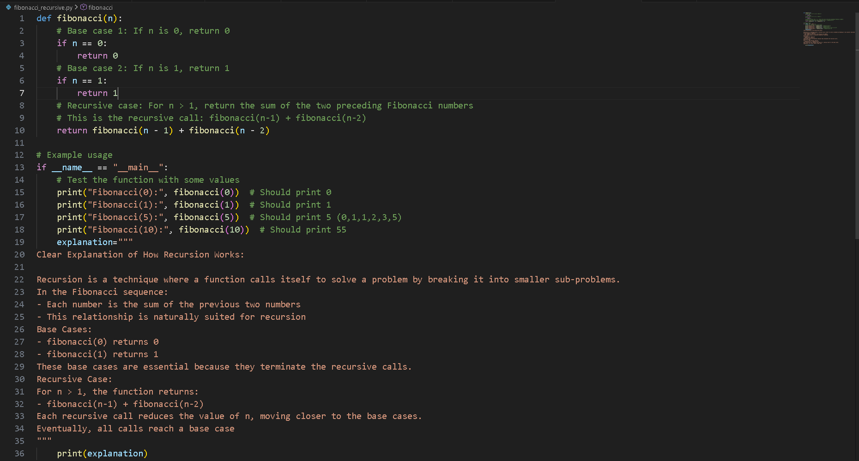

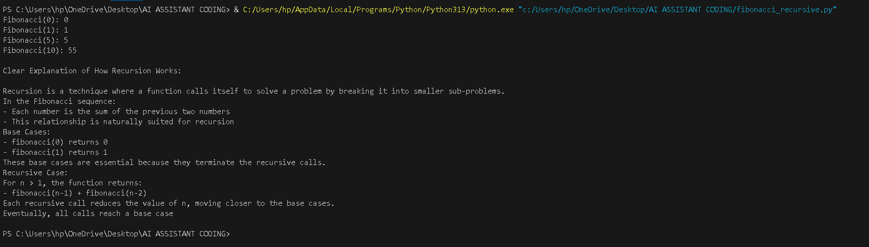 Task Description #3 (Transparency in Error Handling)
Task: Use AI to generate a Python program that reads a file and processes data.
Prompt:
“Generate code with proper error handling and clear explanations for each exception.”

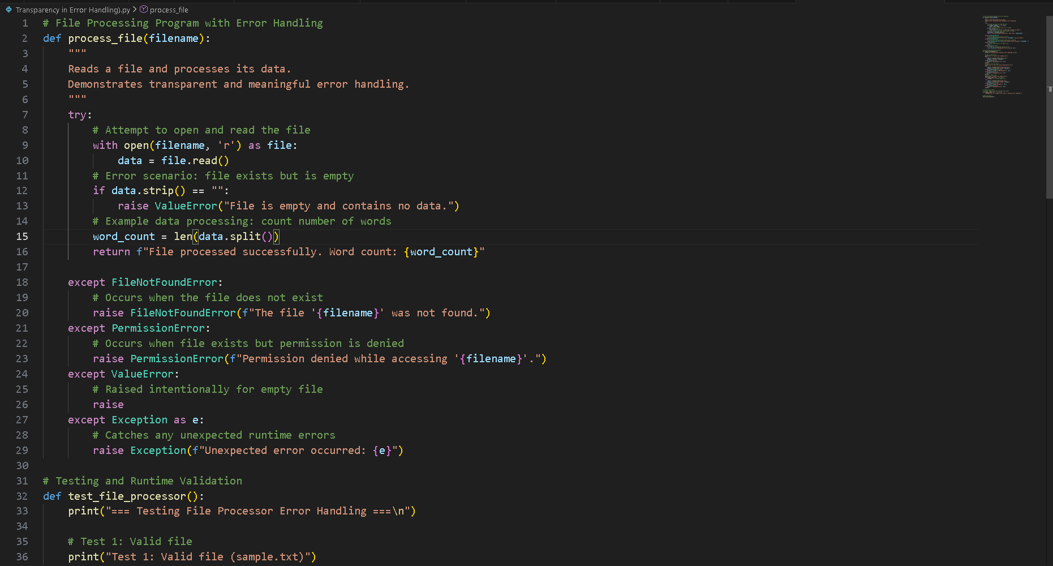 ‘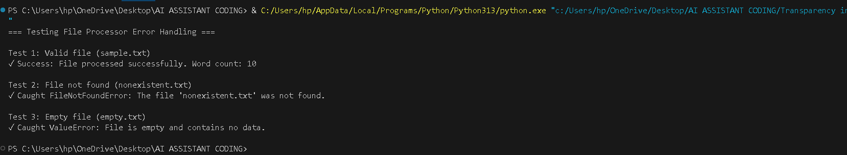

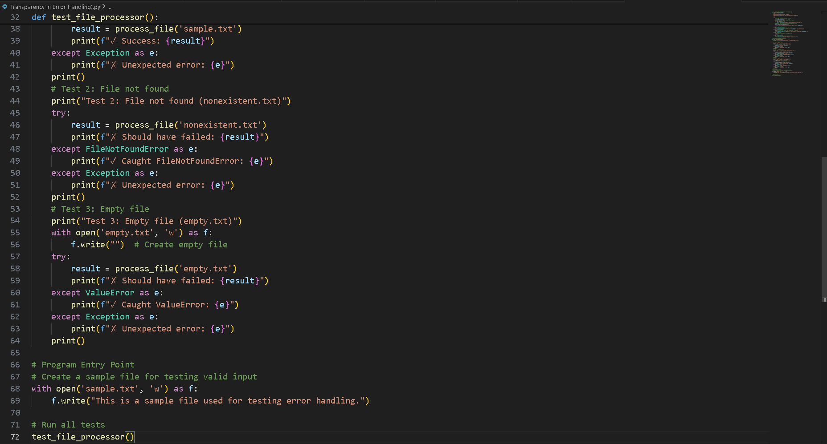
Task Description #4 (Security in User Authentication)
Task: Use an AI tool to generate a Python-based login system.
Analyze: Check whether the AI uses secure password handling practices.
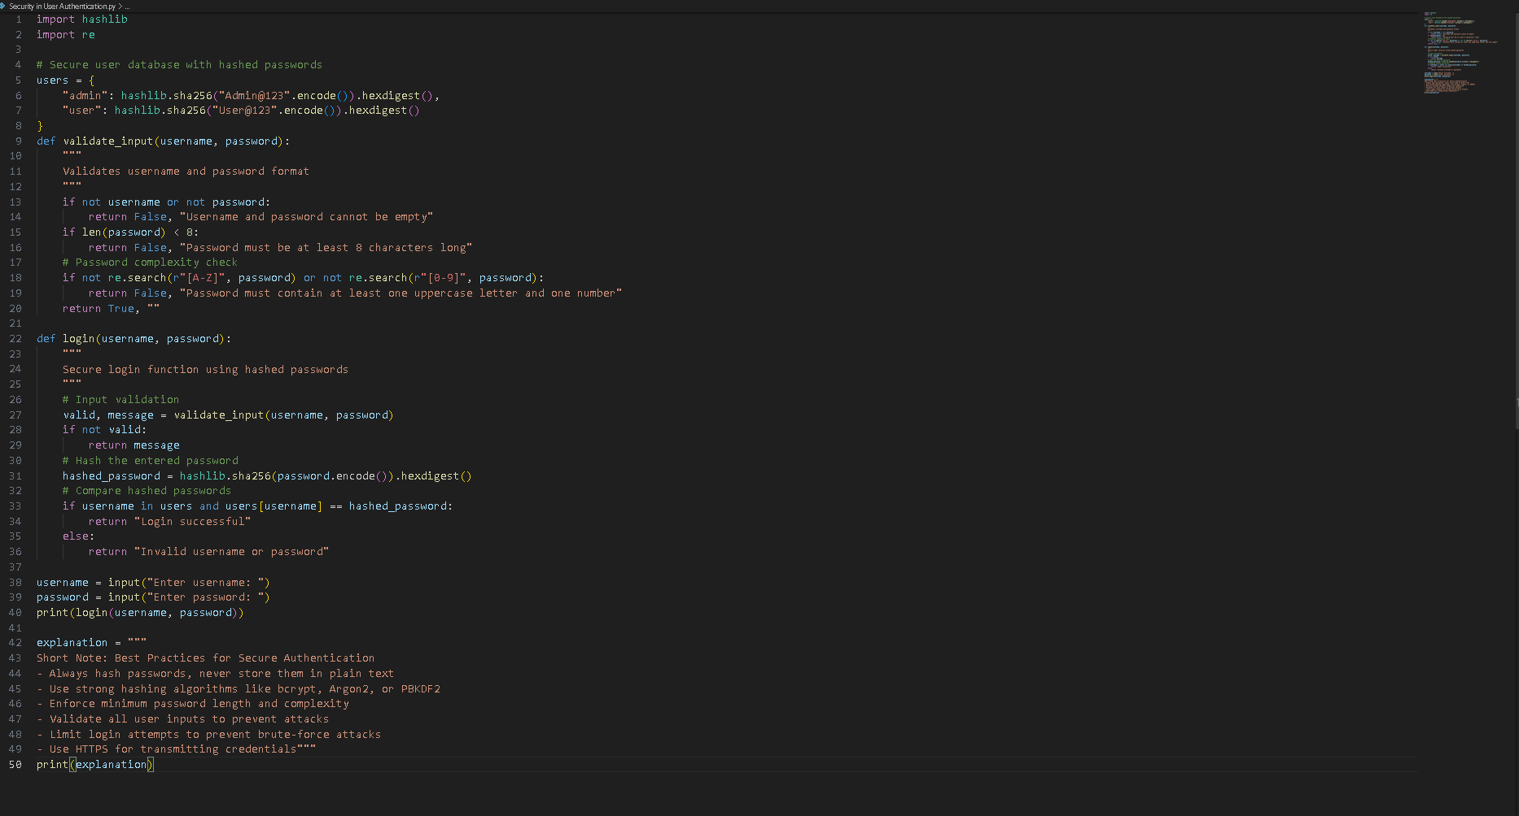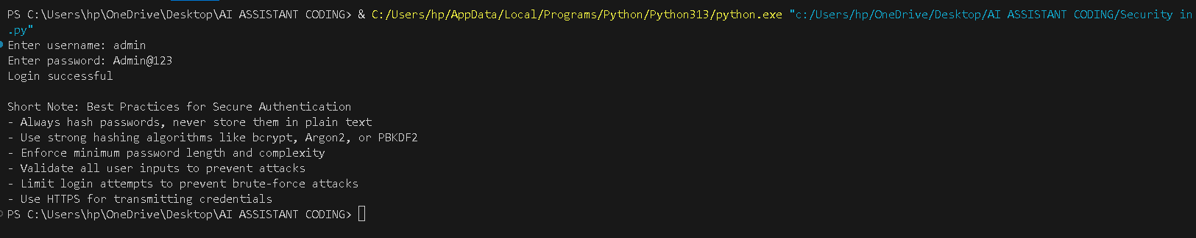

Task Description #5 (Privacy in Data Logging)
Task: Use an AI tool to generate a Python script that logs user activity (username, IP address, timestamp).
Analyze: Examine whether sensitive data is logged unnecessarily or insecurely.

