Lab Assignment 3 – AI Assistant Coding
2303A52173
K SAI PRANEETH
Task 1: AI-Generated Logic for Reading Consumer Details
Prompt used:
# Generate a python code in which create a list of customer data, where each customer is represented by a dictionary containing their number, name, previous unit reading, current unit reading, and customer type (domestic or commercial). Then, iterate through this list to calculate the units consumed for each customer and print out their details including customer number, name, previous units, current units, units consumed, and customer type.
Code:

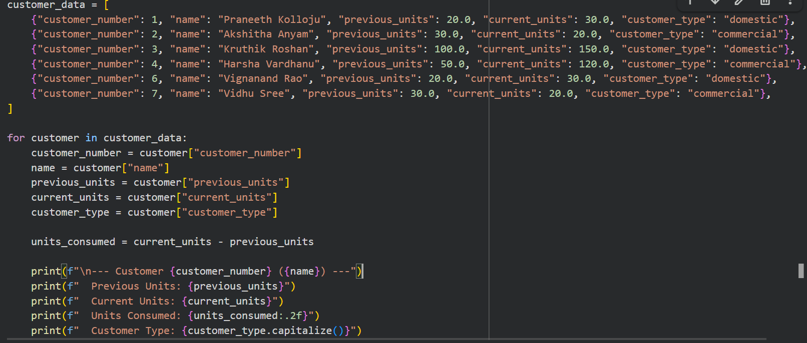
Output:

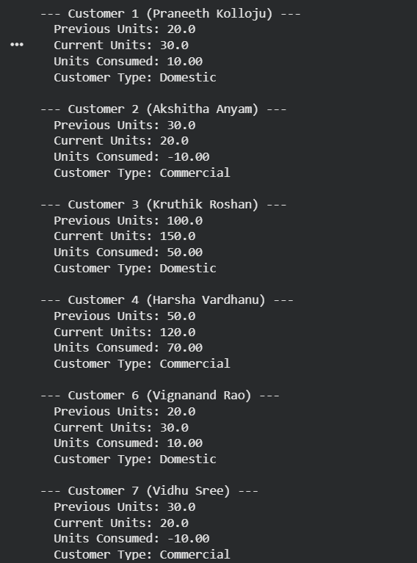

Justification:

This task helps in understanding the basic working of an electricity billing system. It focuses on taking correct consumer details like previous units, current units, and customer type. Using these values, the program calculates the units consumed in a simple way. Writing the logic directly in the main program makes it easy to understand for beginners. Using a loop avoids writing the same code again and again. This task prepares us for calculating the electricity bill in the next steps.

Task 2: Energy Charges Calculation Based on Units Consumed
Prompt used:
Based on existing customer data, define energy charge rates for 'domestic', 'commercial', and 'industrial' customer types, assuming a default for 'industrial' if not explicitly provided. Then, process the customer data to calculate 'Energy Charge (EC)' for each customer by applying the appropriate rate based on their 'customer_type' and 'units_consumed'. Ensure the calculation handles negative 'units_consumed' by setting the 'Energy Charge (EC)' to zero in such cases. Finally, print out the customer details including customer number, name, previous units, current units, units consumed, customer type, and the calculated 'Energy Charge (EC)' for each customer, formatted for clear readability.
Code:
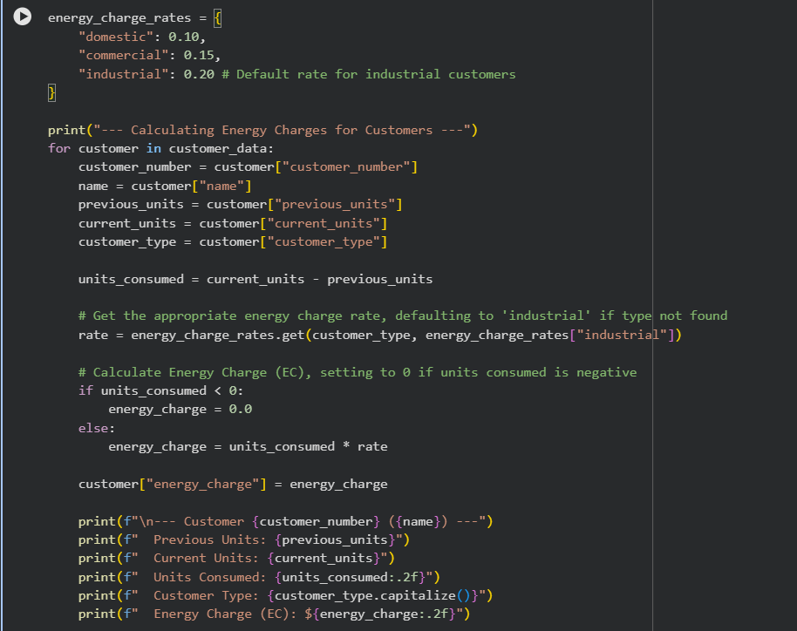

Output:

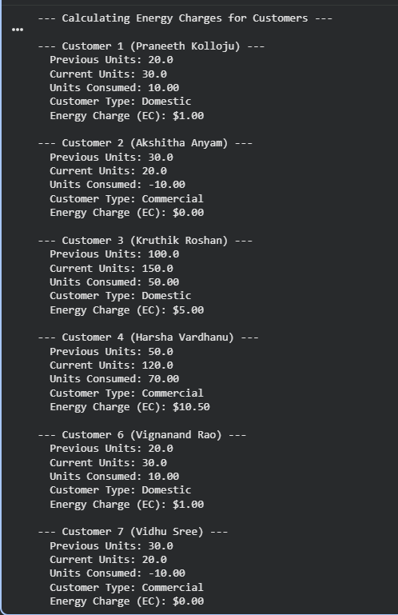

Justification:
This task extends the previous program by adding energy charge calculation based on customer type and units consumed. Different rates are applied for domestic, commercial, and industrial consumers to reflect real electricity billing systems. Conditional statements are used to decide the correct charge for each customer. AI prompts help simplify and optimize the calculation logic, making the code easier to read. This task improves understanding of decision-making logic in practical applications

Task 3: Modular Design Using AI Assistance
Prompt used:
#Generate the python code using modular Python program using functions to calculate Energy Charges (EC) and Fixed Charges (FC) for each customer
Code:
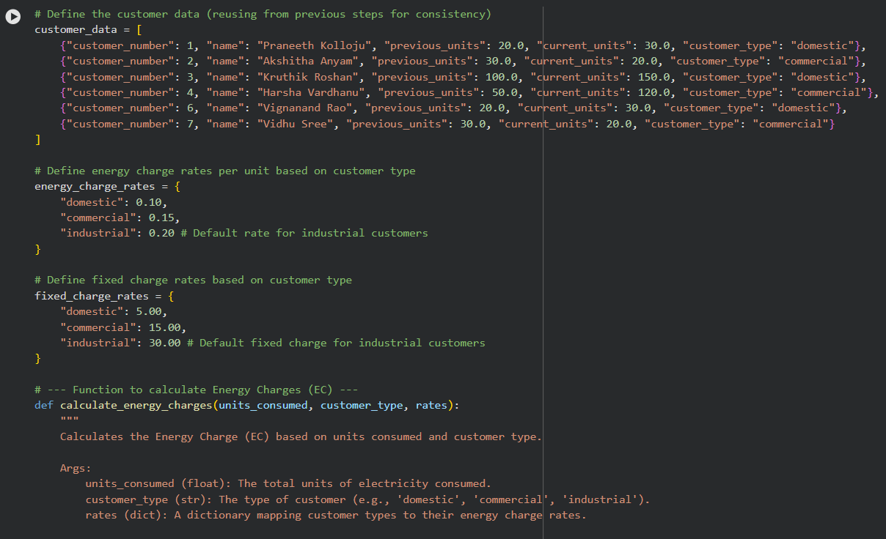

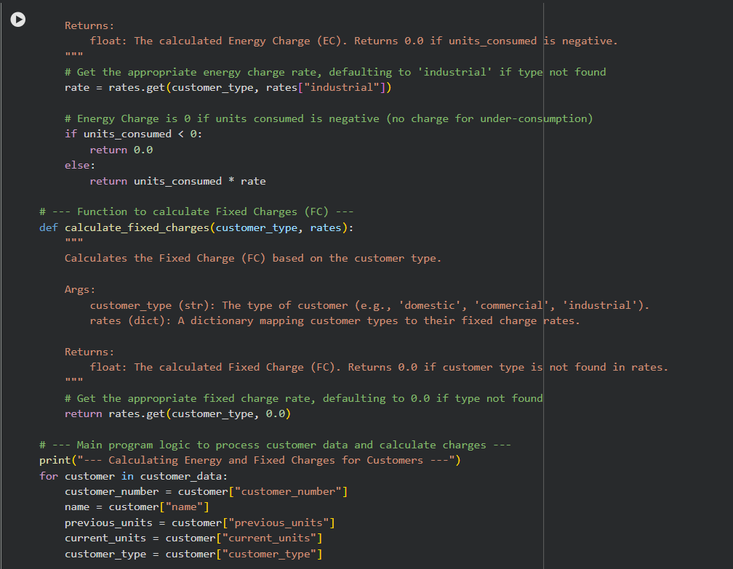
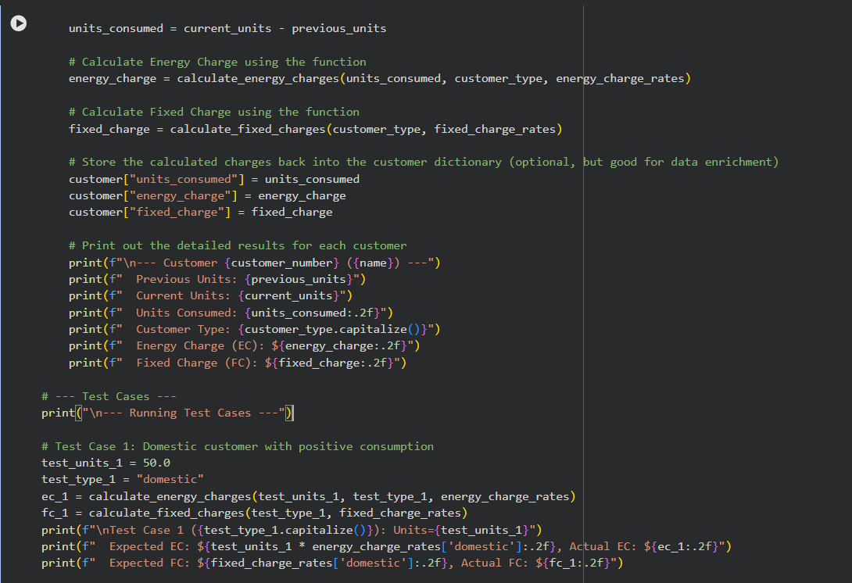

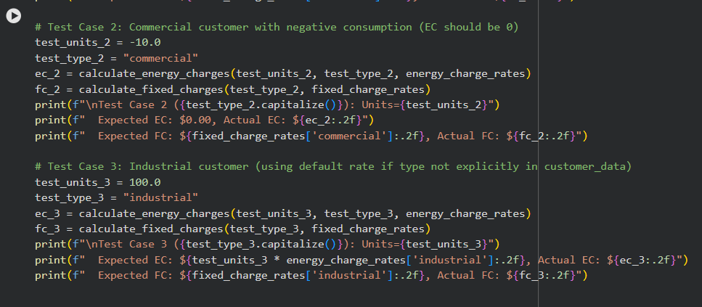

Output:
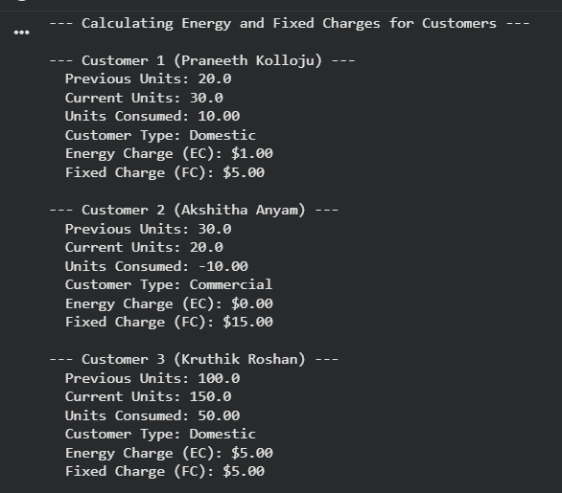

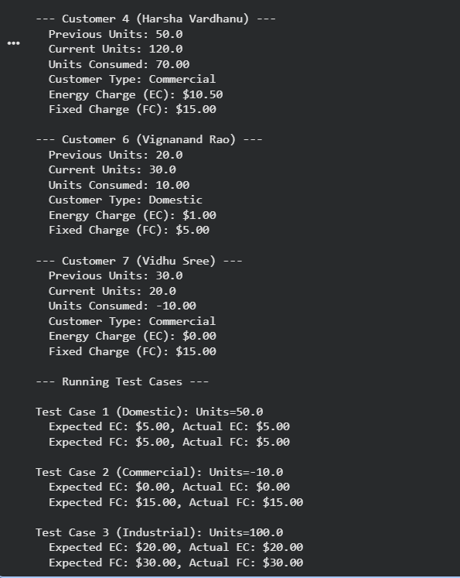
Justification:
This task focuses on organizing the billing logic using functions so the same code can be reused for multiple consumers. Separating energy charge and fixed charge calculations makes the program cleaner and easier to maintain. Using functions also improves clarity and reduces repetition in the code.
Task 4: Calculation of Additional Charges
Prompt used:
#Generate the python code for calculating addtionals charges like ( FC ) Fixed Charges, (CC ) Customer Charges,( ED) Electricity Duty (percentage of EC)
Code:

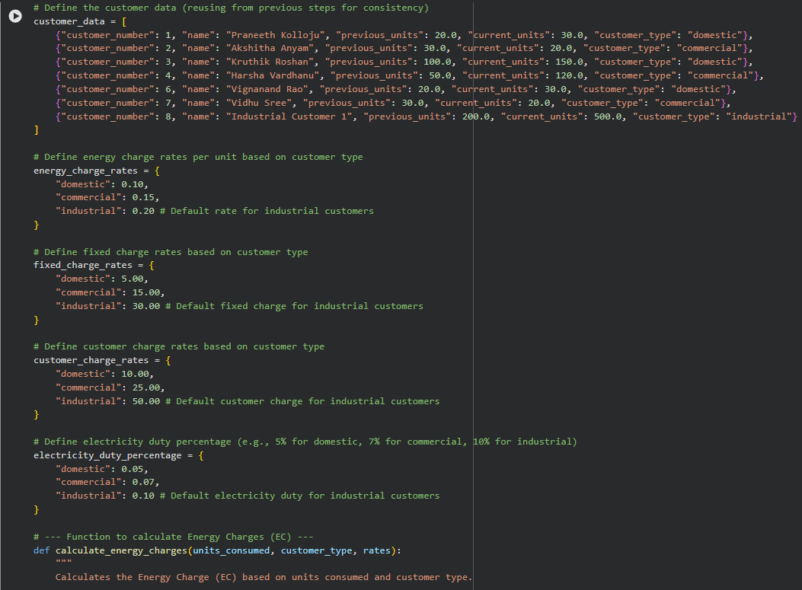

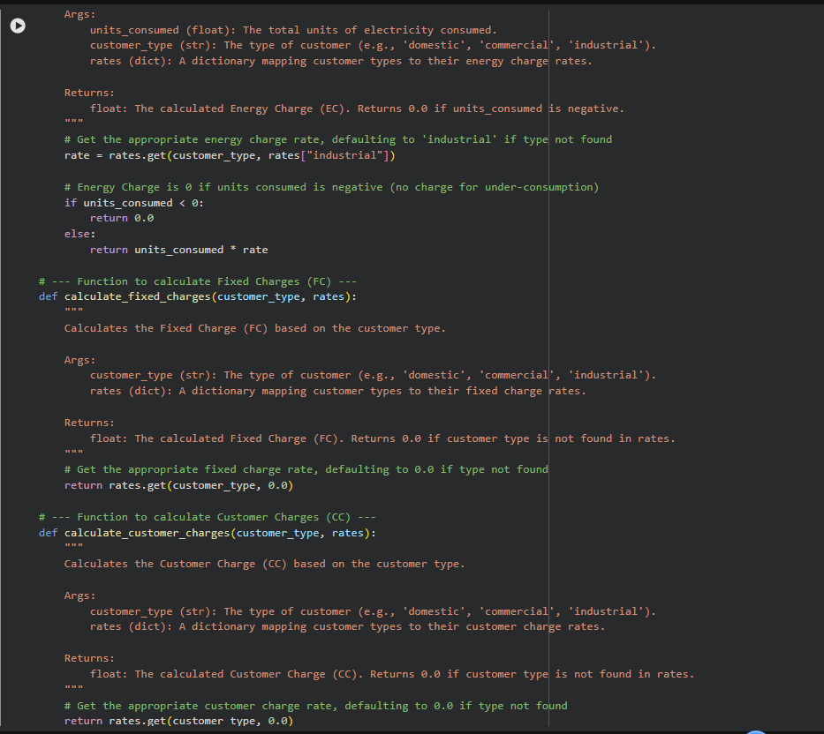
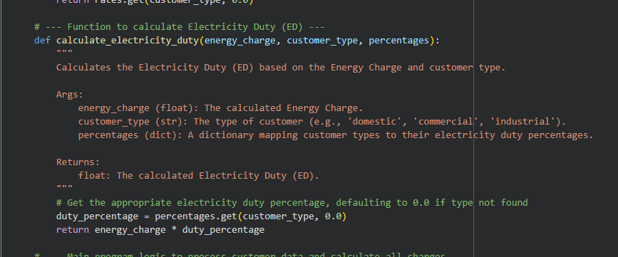

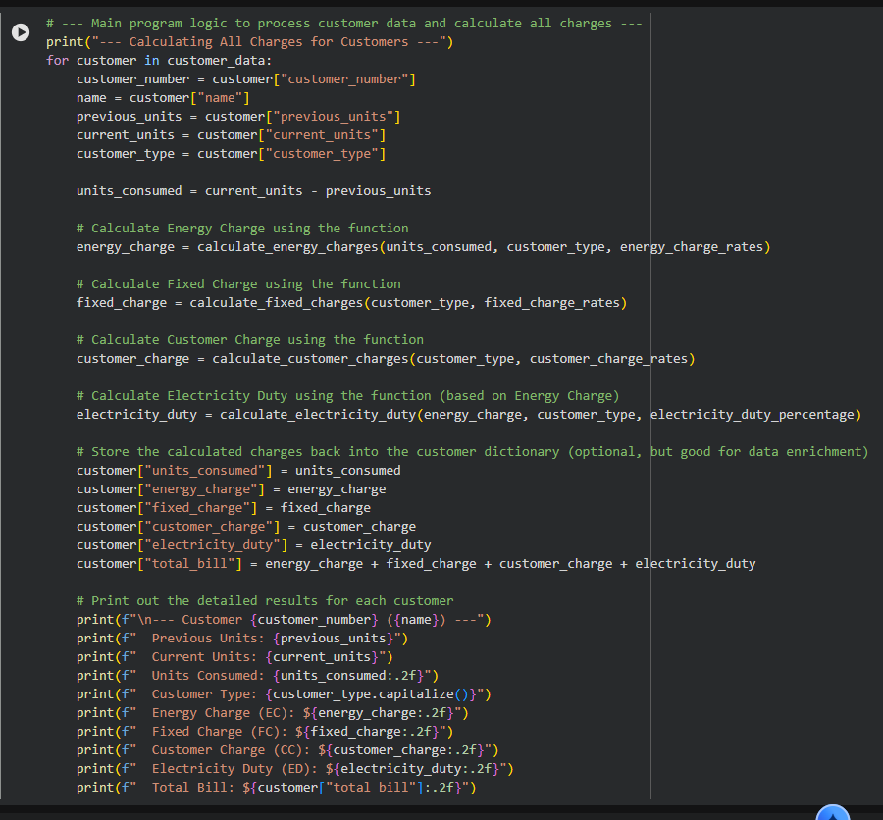
Output:
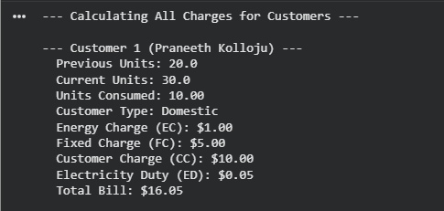

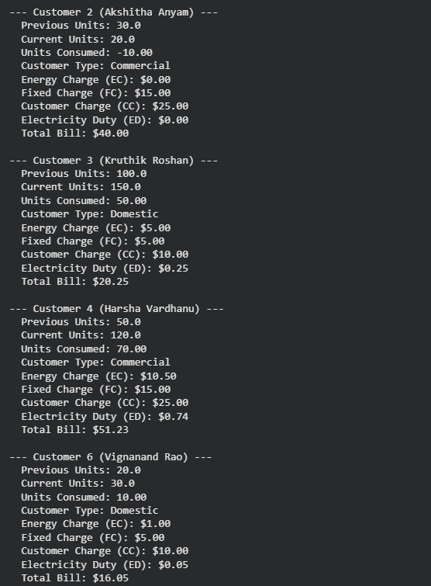
Justification:
This task adds extra charges like fixed charges, customer charges, and electricity duty to make the bill more realistic. Calculating these charges helps improve billing accuracy and reflects how actual electricity bills are prepared. Using AI prompts simplifies the logic and ensures all charges are calculated correctly
Task 5: Final Bill Generation and Output Analysis
Prompt used:
#Generate the final Python code to Calculate total bill where the Total Bill = EC + FC + CC + ED
Code:
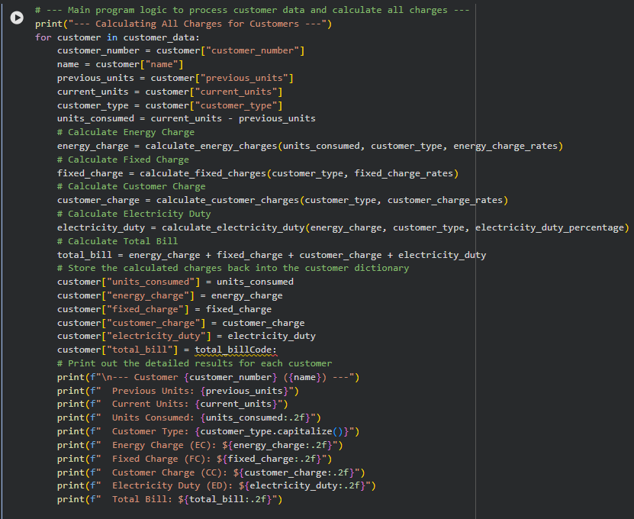
Output:

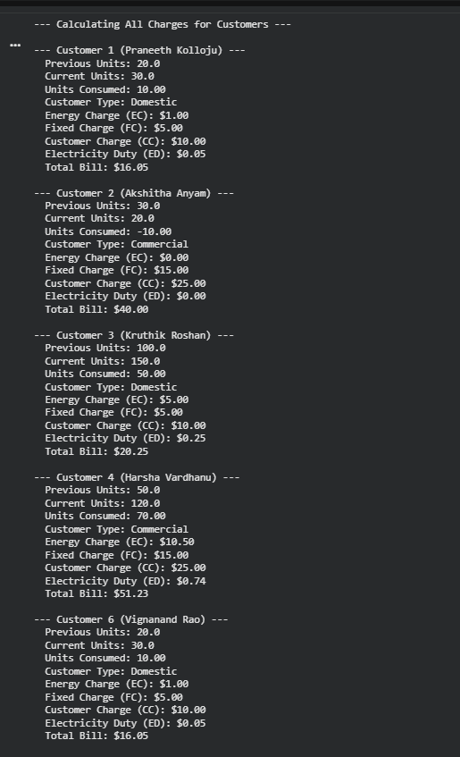

Justification:
This task focuses on generating the final electricity bill by combining all calculated charges into a total amount. Displaying each charge separately makes the bill easy to read and understand. The program ensures accuracy by clearly following the billing formula. Clean formatting improves readability and gives a real electricity bill feel. Overall, this task shows how a complete and practical billing application works in real-world scenarios

