Lab Assignment 9– AI Assistant Coding
2303A52173
K SAI PRANEETH
Task 1: Auto-Generating Function Documentation in a Shared Codebase.
Prompt used:
#Generate a calculator with multiple functions. Using a python script without any docstrings.
#Generate Google-style function docstrings for each function where it should clearly explain which function is doing what and what values it returning and a brief explanation of every function.
Code:
Without Docstrings:
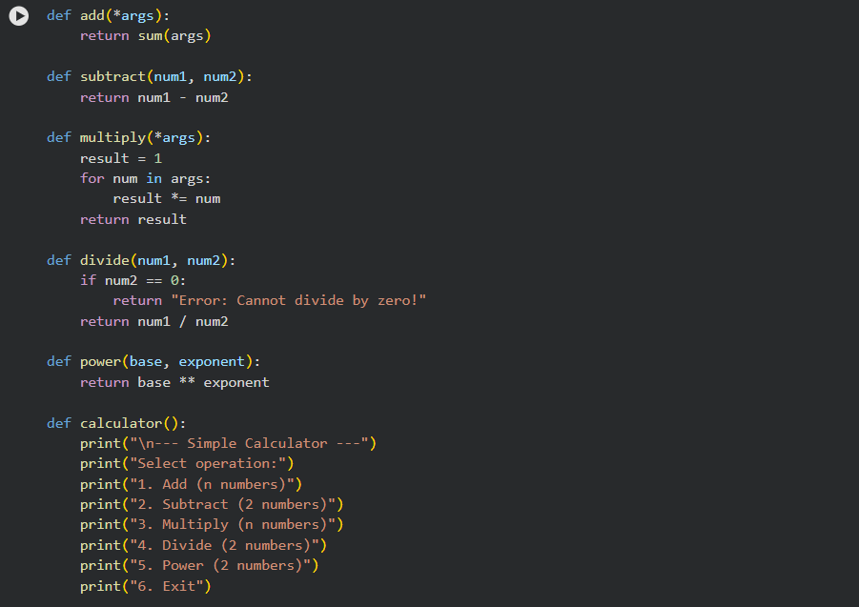
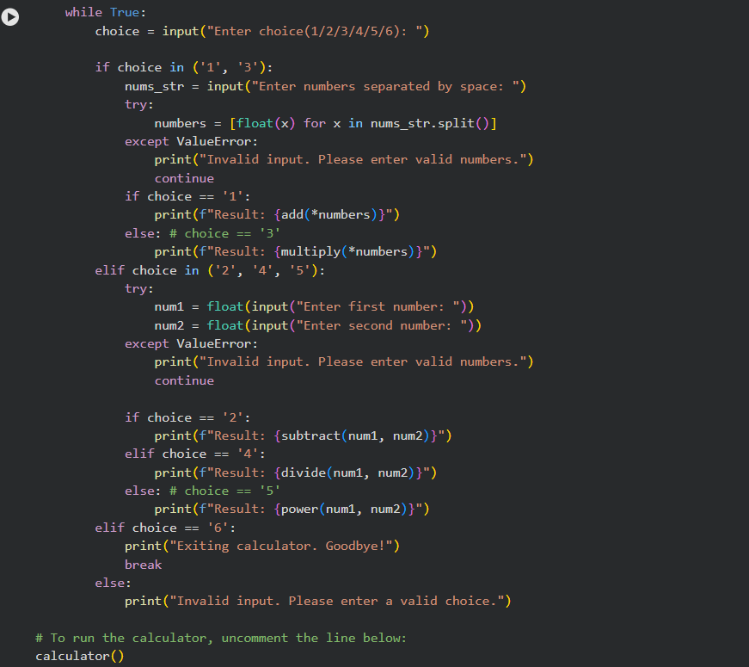
With Docstrings: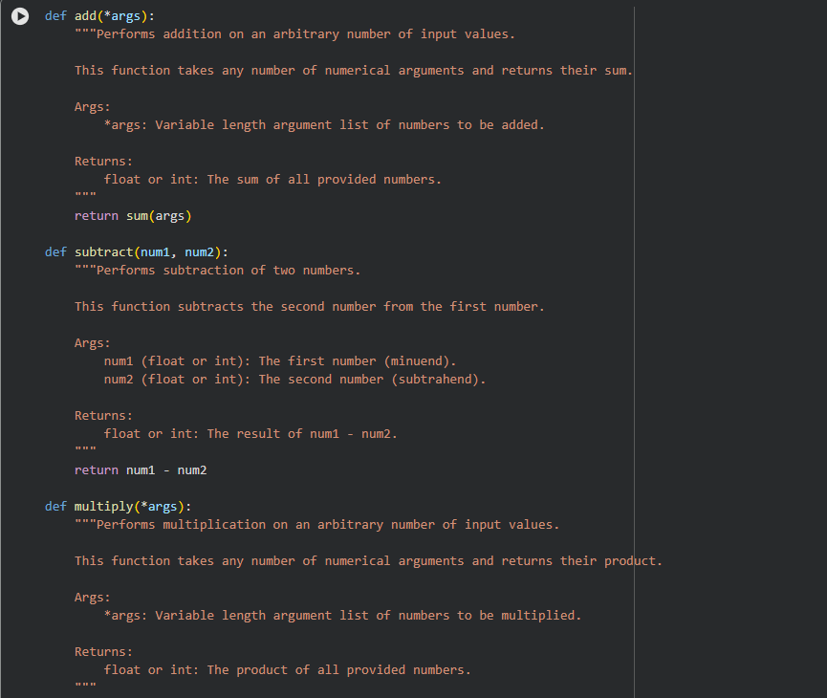
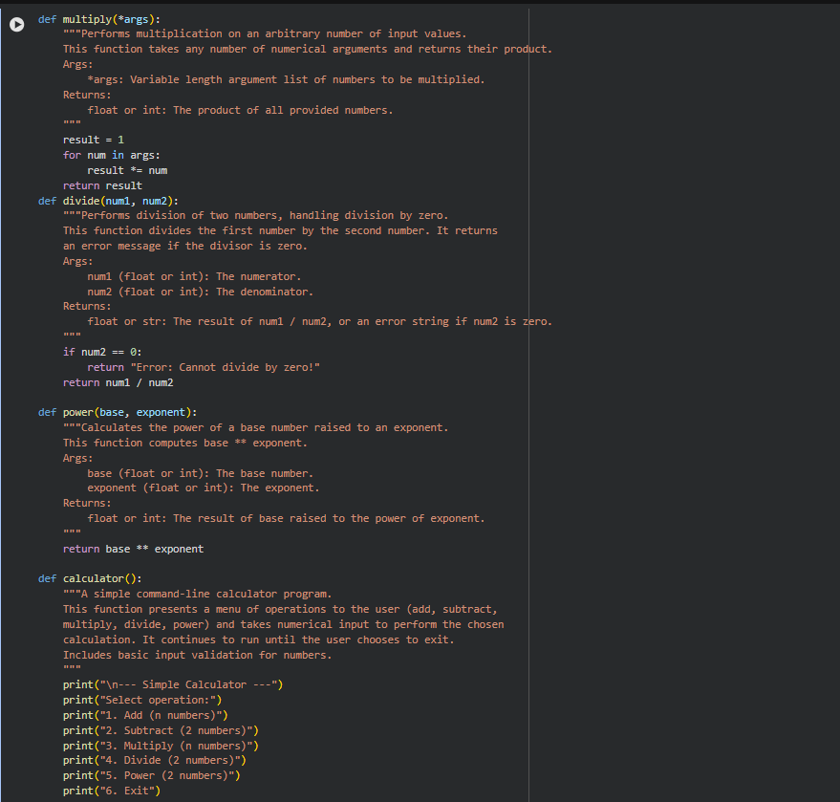
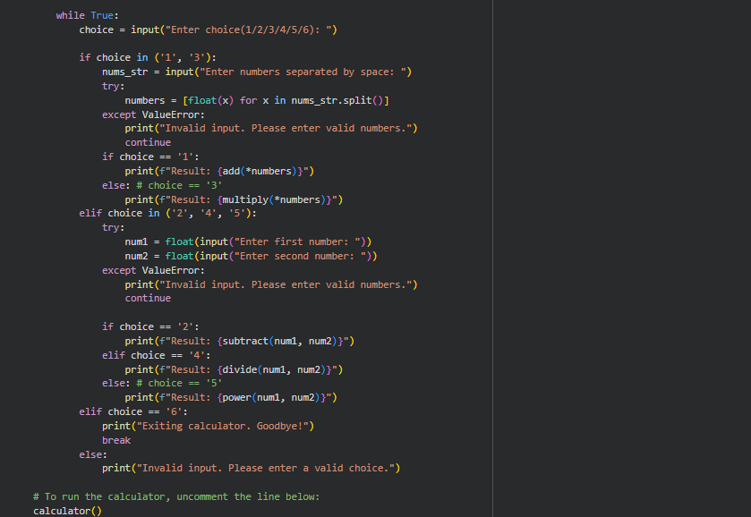
Output:
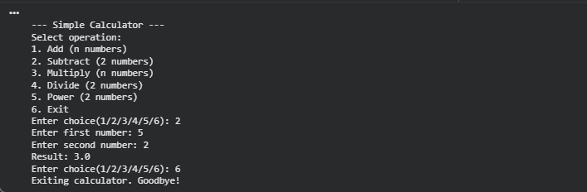
Justification:
Providing code both with and without docstrings, offers flexibility. Docstrings are crucial for readability and maintenance in collaborative projects, while a version without them might be preferred for concise examples or when code size is a critical factor. Generating them in separate cells allows for easy comparison or use in different scenarios without altering previous work

Task 2: Enhancing Readability Through AI-Generated Inline
Comments.
Prompt used:
#Generate a python script in which it contains loops, conditional logic and Algorithms without inline comments or docstrings.
#Generate inline comments only for complex or non- obvious logic but on syntax of the function.
Code:
Without Docstrings:

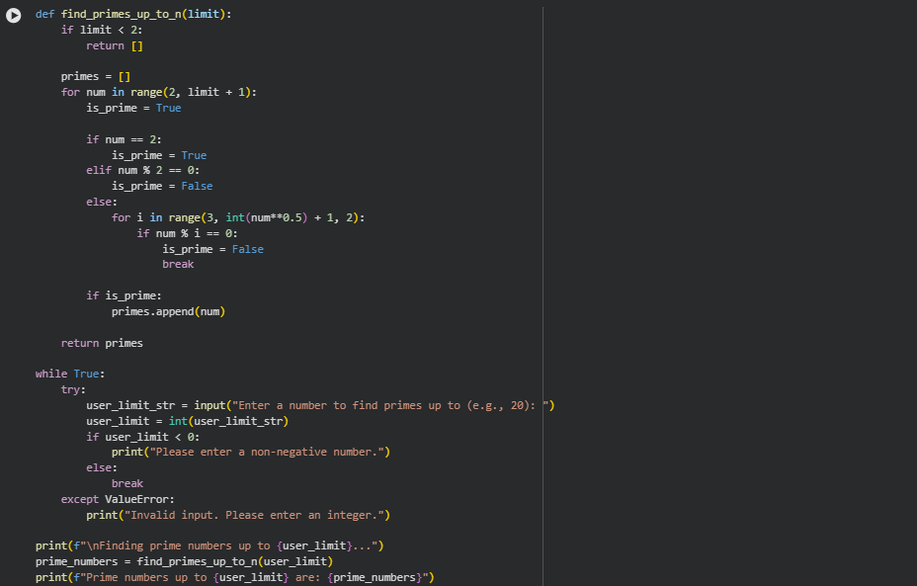

With inline comments:
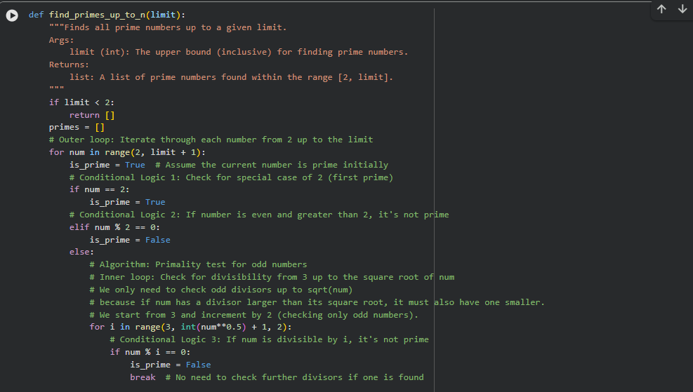

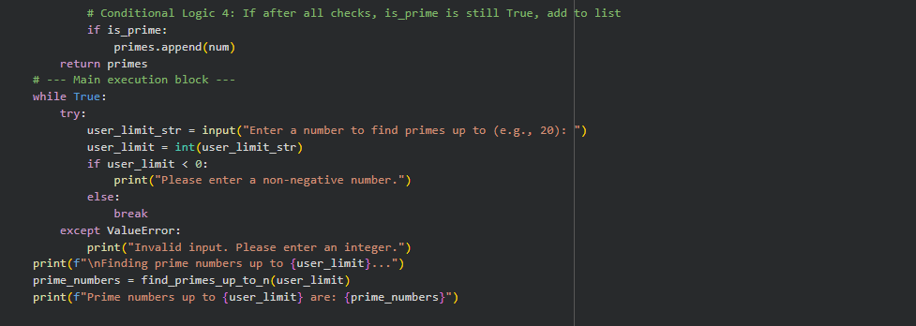
Output:
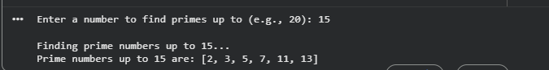
Justification:
This last version demonstrates adding inline comments selectively, focusing only on complex or non-obvious logic, which is a common practice for maintaining code clarity without over-commenting basic syntax. This approach caters to different readability needs during development.
Task 3: Generating Module-Level Documentation for a PythonPackage.
Prompt used:
#Generate a python script in which it contains loops, conditional logic and Algorithms without inline comments or docstrings.
#Generate a module-level docstring at the top of the file that includes The purpose of the module ,Required libraries , a brief description and short example

Code:
Without module-level docstring:

With module-level docstring:
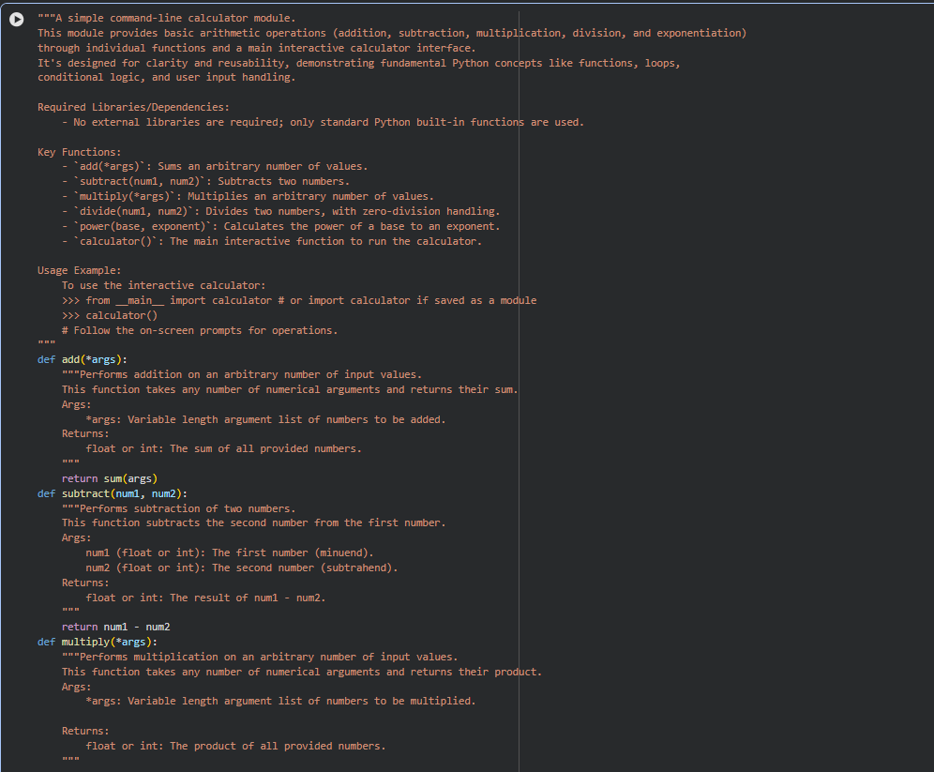
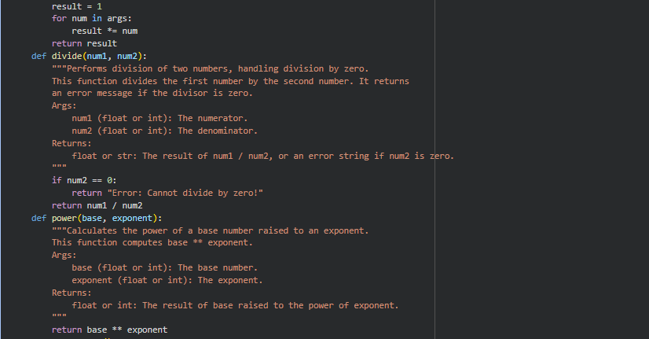

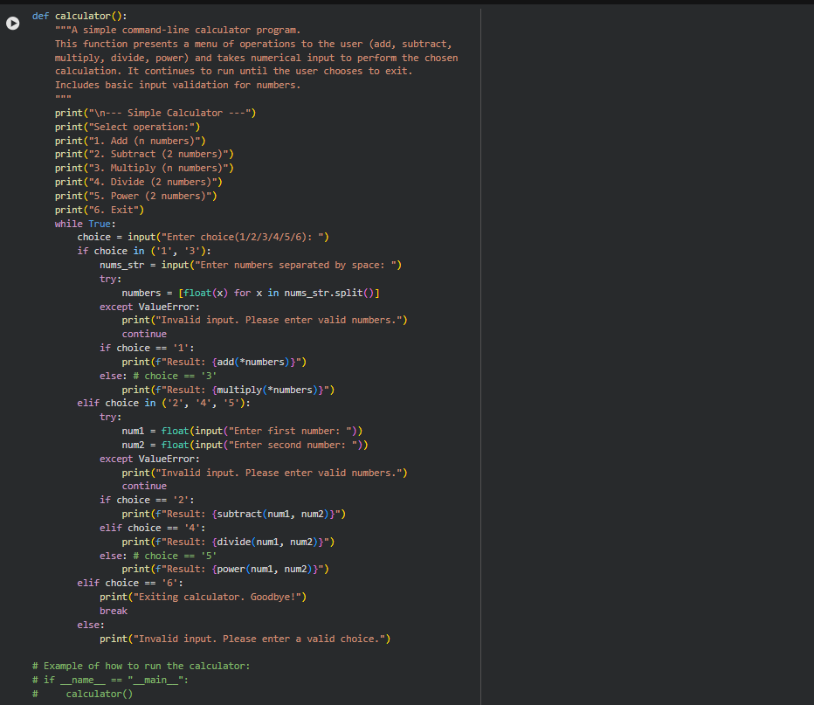
Output:

Justification:
This task helps make the code easier for people to understand the moment they open the file. Instead of guessing what the module does, developers get a clear idea of its purpose, requirements, and how to use it. It saves time for new team members and reduces confusion. Overall, it makes the code more friendly, professional, and ready to be shared.

Task 4: Converting Developer Comments into Structured Docstrings.
Prompt used:
#Create a simple Python function with detailed inline comments explaining its purpose, arguments, and logic. Then, convert these inline comments into a structured Google-style docstring and remove the original inline comments. Finally, summarize the benefits of using docstrings for code readability and maintainability
Code:
With inline comments:
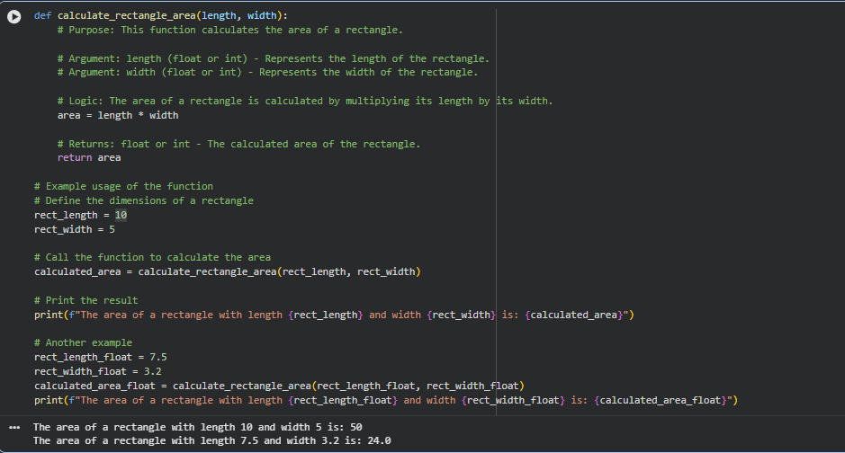
With Google-style docstrings:
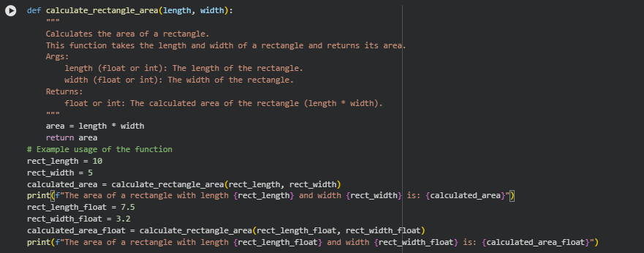
Output:

Justification:
The benefits of using docstrings were highlighted, including improved readability, enhanced maintainability, automated documentation generation, interactive help support, facilitated code collaboration, and self-contained information within the code.
Task 5: Building a Mini Automatic Documentation Generator.
Prompt used:
#Design a simple Python utility that reads a .py file, automatically detects functions and classes, and inserts placeholder Google-style docstrings for each detected function or class. The goal is documentation scaffolding, not perfect documentation. The solution should be suitable for execution in Google Colab.
Code:
Tool-Mini Automatic Documentation Generator.
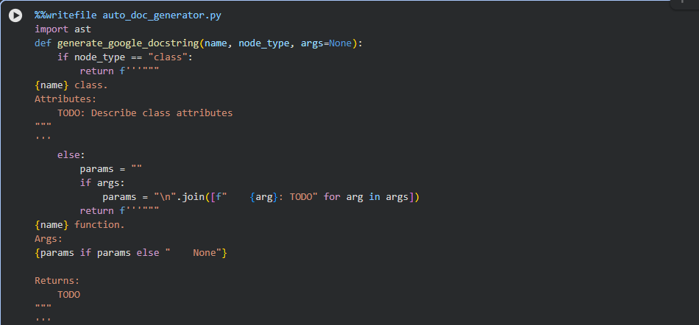

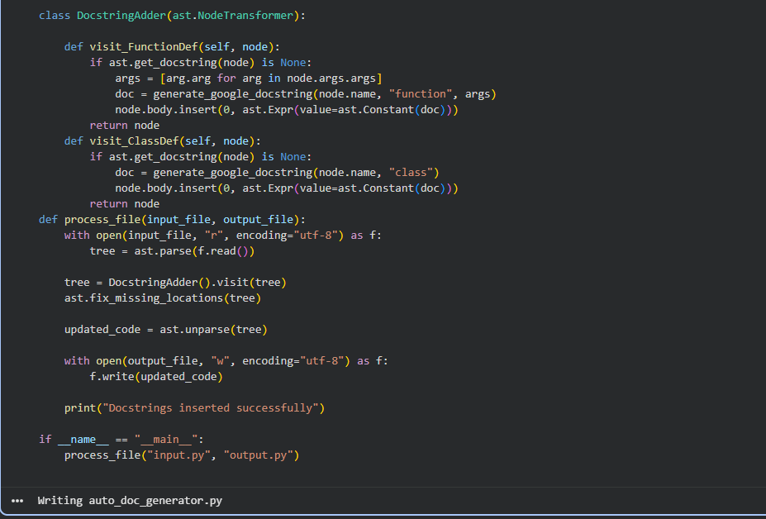
Input file (undocumented code):
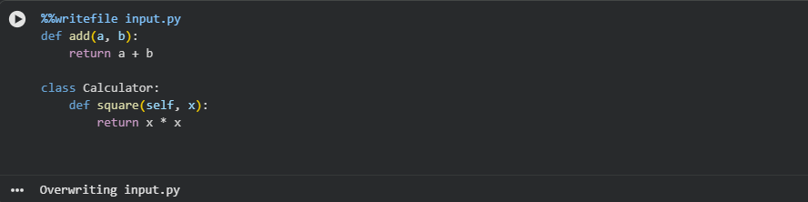
Tool:
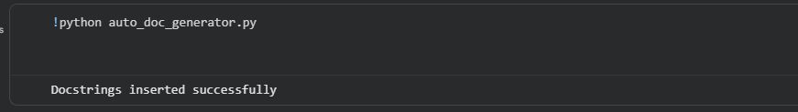

Output file (documented code):
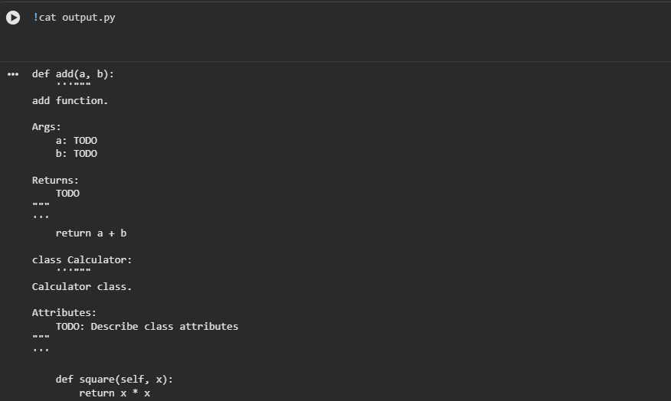
Justification:
Using AI-assisted logic, the above tool automatically reads Python files, detects functions and classes, and inserts Google-style docstrings, demonstrating documentation automation. This reduces the manual effort required from developers and helps maintain consistent documentation standards. The tool acts as a starting point for developers to quickly understand and improve code documentation

