Lab Assignment 5 – AI Assistant Coding
2303A52173
K SAI PRANEETH
Task 1: Privacy and Data Security in AI-Generated Code
Prompt used:
#Generate a simple python login system which take first registration and then login with username and password and the user should be asked to do the task that he wants to perfrom weather he has to register or login or exit the system
Code:
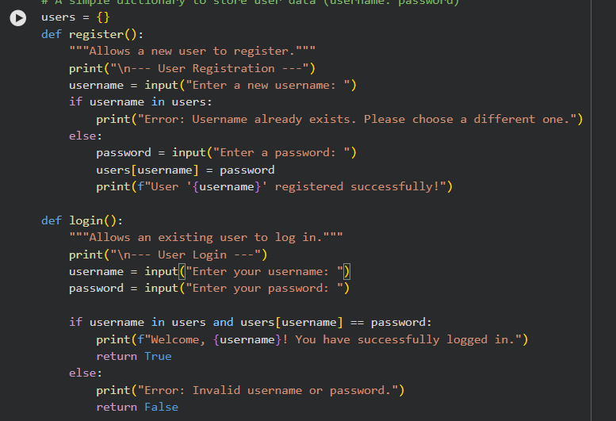

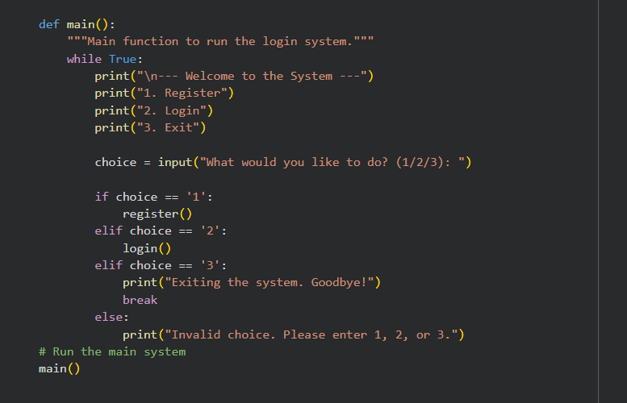
Output:
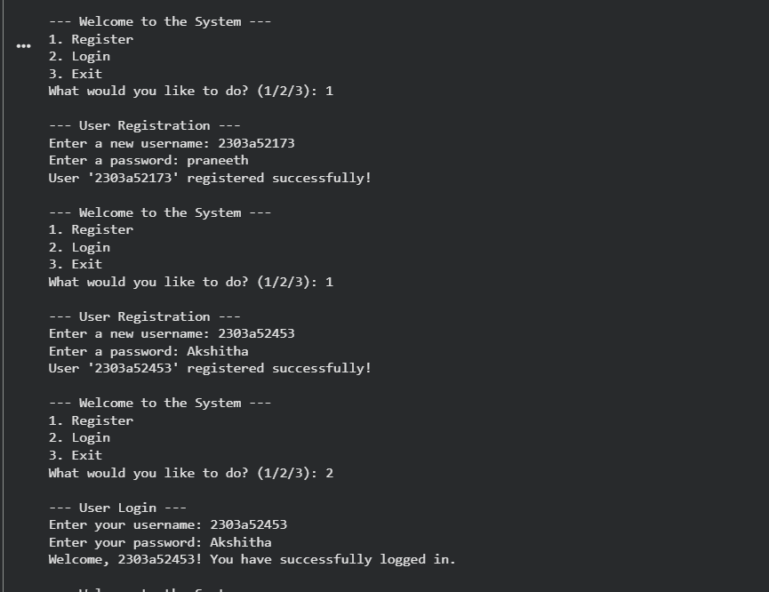
Justification:
The given login system stores and verifies passwords in plain text, which creates serious privacy and security risks. AI-generated code like this can expose user credentials if not reviewed carefully. This task highlights the importance of analyzing and improving such code using secure practices. It reinforces the developer’s responsibility to protect user data and ensure ethical AI usage.
Task 2: Bias Detection in AI-Generated Decision Systems
Prompt used:
#Generate a python code for loan approval system where all the parameter should take from user and based on the parameters make desicion as approved or not. Parameters are Name ,Age, Salary, Credit score.
Code:
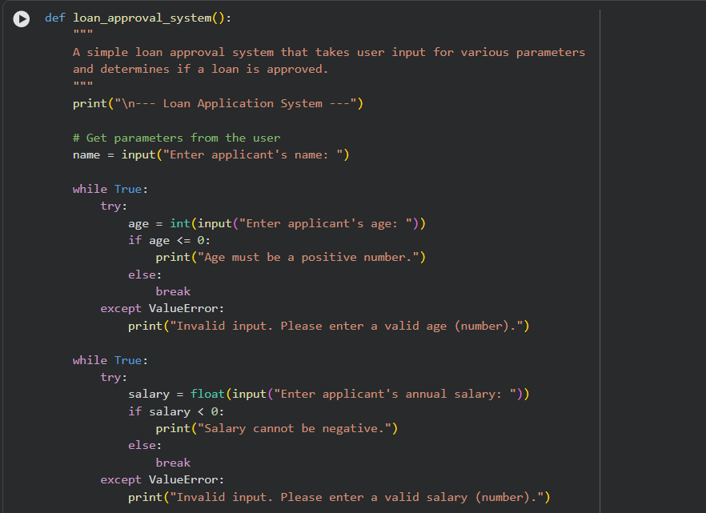

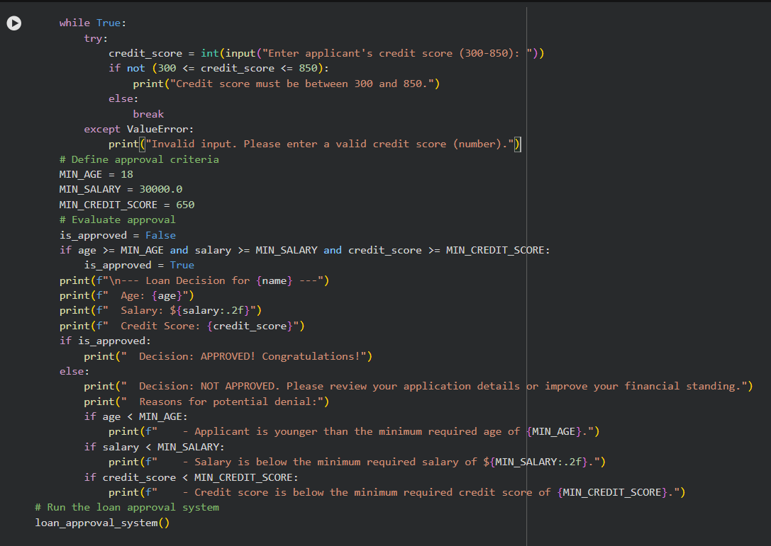
Output:
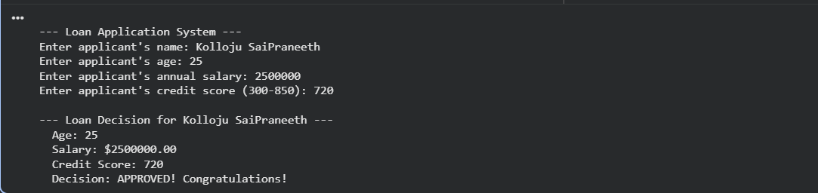
Justification:
This loan approval system uses fixed thresholds for age, salary, and credit score, which may introduce unfair bias or oversimplified decision-making. AI-generated decision logic like this can unintentionally exclude certain groups without proper context or explanation. This task highlights the need to evaluate fairness, transparency, and inclusiveness in automated decisions. Human oversight is essential to ensure ethical and responsible AI-based financial systems

Task 3: Transparency and Explainability in AI-Generated Code (Recursive Binary Search)
Prompt used:
#Generate a python code in which implements Binary Search using recursion in a sorted list where take input from user and also give step-by-step explanation of the recursive logic using inline comments.
Code:
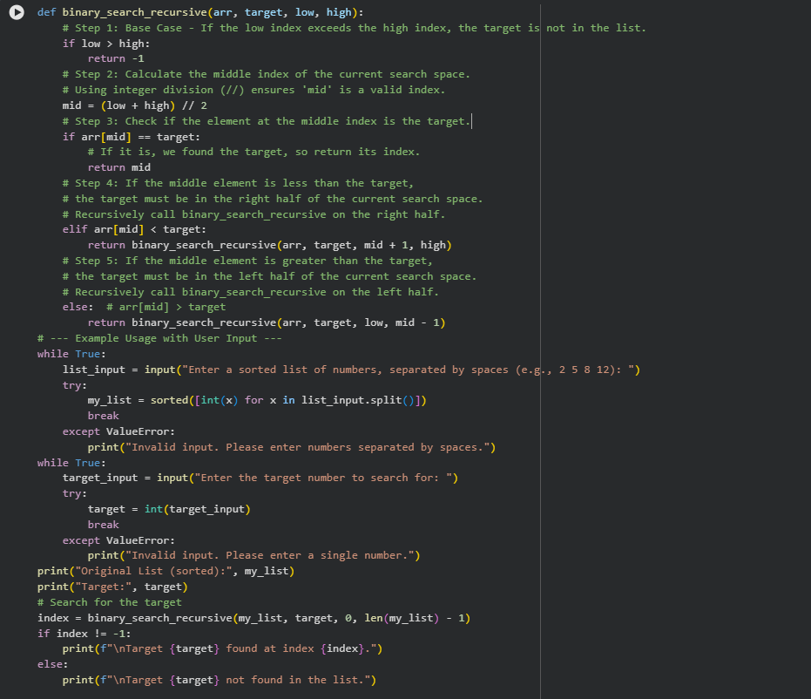
Output:


Justification:
This code implements recursive binary search to efficiently find a target element in a sorted list .It repeatedly divides the search space into halves, reducing time complexity to O(log n).The base case ensures termination when the element is not found. User input handling makes the program interactive and robust against invalid inputs.
Task 4: Ethical Evaluation of AI-Based Scoring Systems
Prompt used:
#Generate the python code in which create job applicant scoring system based on features such as Skills, Experience, Education. Dont consider Name in features.
Code:
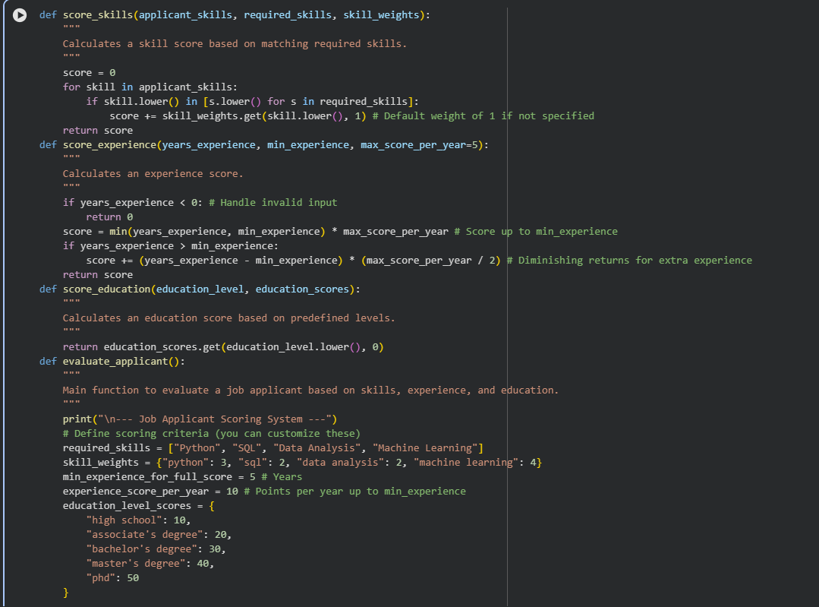

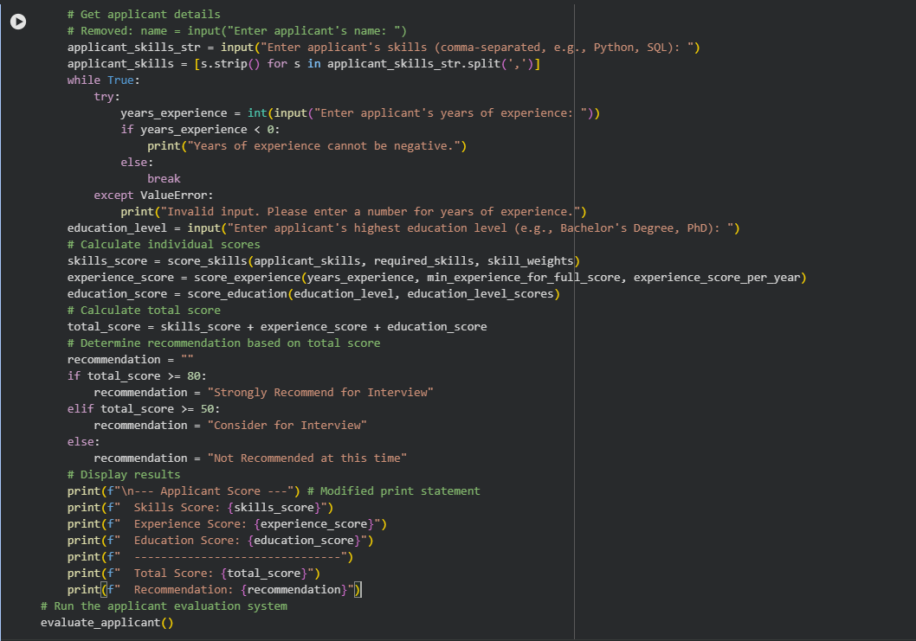
Output:
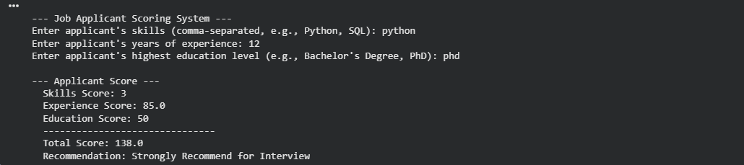
Justification:
This code implements a job applicant scoring system that objectively evaluates candidates based on skills, experience, and education.
Each component is scored with clear rules, including weighted skills, diminishing returns for extra experience, and predefined education scores.
The total score determines a recommendation for interview, ensuring transparency and fairness by excluding personal attributes like name or gender.

Task 5: Inclusiveness and Ethical Variable Design
Prompt used:
Create a Python employee management system that stores employee details including name, gender (male/female), job title, and salary. Add a function that gives different benefits: maternity leave for females and paternity leave for males. Use Mr./Mrs. titles based on gender when displaying employee information. user input should be taken for adding employees and displaying their details along with the benefits they are entitled to.
Code: 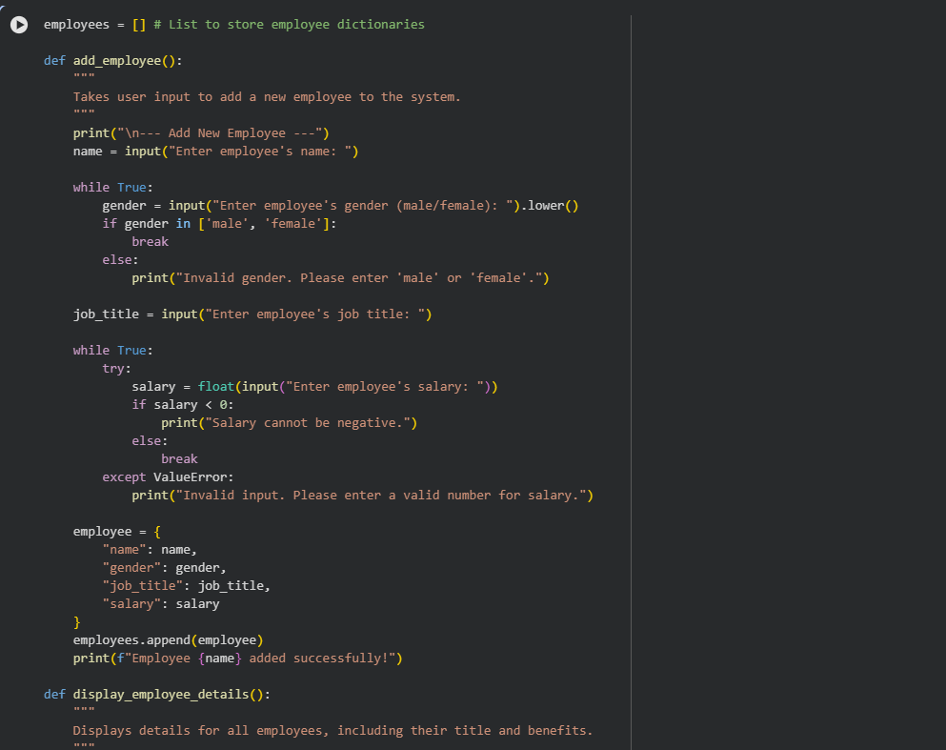

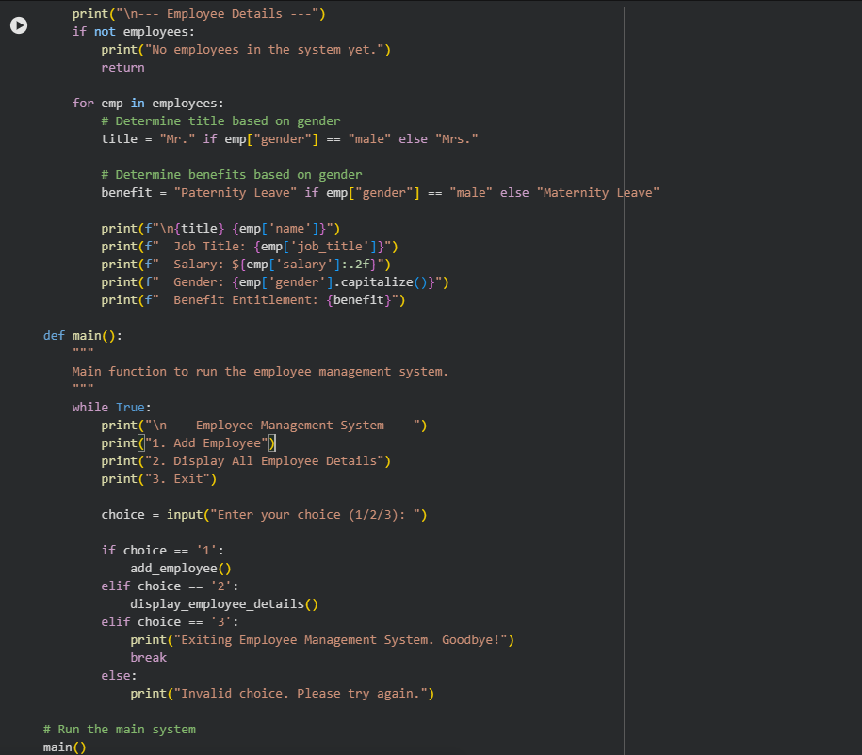
Output:
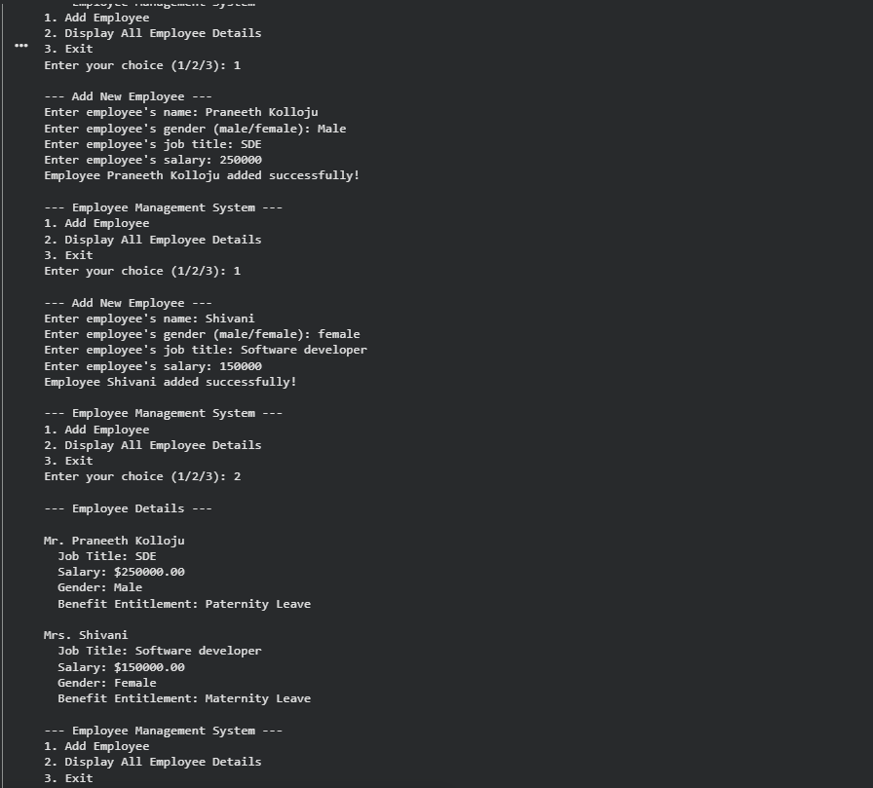
Justification:
This code implements a basic employee management system that allows adding and displaying employee details with proper input validation.
However, it uses gender-specific logic for titles (“Mr./Mrs.”) and benefits (“Paternity/Maternity Leave”), which introduces non-inclusive assumptions. The output clearly demonstrates how gender directly affects displayed titles and entitlements, highlighting potential ethical and inclusiveness concerns.

